
Scholarly
Institution Management and Classroom Operations System
Project Documentation
Full-stack web application built with Laravel, Vue.js, Inertia, MySQL, Firebase, and WhatsApp Cloud API integration.
Project Name | Scholarly
Project Type | Academic full-stack web application
Prepared By | Shakif Niaz
Student ID | To be added
Supervisor | To be added
Department | Software Engineering Department
Submission Date | August 2026
Development Status | Working local prototype with seeded institute data
This document follows Scholarly's green and deep-ink interface palette. No running headers or footers are used.

Acknowledgement
This project was completed as a practical full-stack web application for managing institutional academic operations. The development process involved database design, role-based dashboards, real-time classroom communication, routine generation, proxy management, and external service integration.
The application was developed with attention to real school workflows rather than a narrow CRUD-only pattern. This documentation records the design decisions, implementation details, testing results, current limitations, and future improvements needed to move the system from a local prototype into a production-ready product.

Table of Contents
Chapter 1: Introduction
Chapter 2: System Analysis and Requirements
Chapter 3: System Design
Chapter 4: Technology Stack and Environment Setup
Chapter 5: Implementation
Chapter 6: Testing
Chapter 7: Results and Screenshots
Chapter 8: Limitations and Future Work
Chapter 9: Conclusion
Chapter 10: References and Appendices
Appendix A: Complete Design Artifacts
Appendix B: Detailed Route and Data Dictionary
Appendix C: Test Evidence and Submission Checklist

Executive Summary
Scholarly is a web-based school operations platform designed to help an institution manage academic work that can become fragmented across paper registers, spreadsheet files, chat groups, and disconnected manual processes. The system focuses on routine generation, teacher and classroom management, proxy class planning, leave requests, noticeboard communication, exam scheduling, classroom assignments, class tests, and WhatsApp routine update messaging.
The project uses Laravel 12 as the backend framework, Vue 3 as the frontend framework, Inertia.js as the bridge between server-side routing and client-side screens, MySQL for persistent institutional data, Firebase for live classroom streams, and Vite for the build pipeline. The current local dataset includes 20 teacher profiles, 10 class sections, 1 active routine, 8 noticeboard posts, 3 leave requests, 1 exam schedule, 2 proxy runs, and 12 seeded classroom posts in Firebase.
Chapter 1: Introduction
1.1 Background
Small and mid-sized schools often manage routine creation, proxy class assignment, notices, exam schedules, classroom posts, and teacher leave through separate manual processes. A routine may be stored in a spreadsheet, notices may be shared verbally or through messaging groups, and proxy work may be rearranged at the last moment with limited visibility.
Scholarly provides a single web application where an institution can define teachers and class sections, create an academic routine, generate proxy plans for absent teachers, publish notices, schedule exams, manage leave requests, and operate classroom feeds for assignments and class tests.
1.2 Problem Statement
Many school workflows are handled across disconnected tools. Because the data is not connected, changes in one area do not automatically reflect in the rest of the system. Scholarly solves this by centralizing academic operations in a structured Laravel and Vue application with role-based access and live classroom updates.
1.3 Objectives
Main objective: build a web-based institution management system that allows school administrators, teachers, and students to coordinate routines, classrooms, notices, leave, exams, and proxy work from a unified platform.
- Implement secure registration and login with Laravel authentication and Firebase-aware account flows.
- Provide role-based dashboards for administrators, teachers, and students.
- Allow administrators to manage teachers, class sections, join codes, and institution settings.
- Create, import, activate, rename, regenerate, and delete academic routines.
- Support proxy routine planning for absent teachers, including approval and WhatsApp update preparation.
- Provide noticeboard and staff notice workflows with urgency, visibility, acknowledgement, and read-count tracking.
- Support teacher leave requests, exam scheduling, live classroom feeds, and mobile-friendly navigation.
1.4 Scope and Limitations
The current scope includes institution setup, users, teacher profiles, class sections, routine generation, proxy planning, exam scheduling, leave management, noticeboard communication, classroom activity, dashboard summaries, search, settings, and WhatsApp Cloud API message logging. The system does not yet include payroll, biometric attendance, production deployment automation, or complete report export for every module.
1.5 Document Organization
The remaining chapters describe requirements, design, technology stack, implementation, testing, results, limitations, conclusion, references, and appendices.
Chapter 2: System Analysis and Requirements
2.1 Existing System Study
The closest existing process is a manual school administration workflow. Routines are commonly prepared using spreadsheets or paper tables. Teacher information is maintained separately from routine data. Proxy classes are often arranged through direct messages or informal staff communication. This creates duplicated work and weak visibility.
2.2 Requirement Gathering Method
Requirements were gathered through iterative project development, direct testing of school administration scenarios, and repeated interface feedback. The project was adjusted after practical issues appeared, such as mobile sidebar spacing, teacher-name synchronization, login behavior after Firebase was added, and WhatsApp Cloud API error handling.
2.3 Functional Requirements
ID | Requirement | User Role
FR-01 | Register an administrator, teacher, or student account. | Guest
FR-02 | Log in and route the user to the correct role dashboard. | All users
FR-03 | Manage institution profile, teachers, class sections, and settings. | Admin
FR-04 | Create, import, activate, rename, regenerate, and delete routines. | Admin
FR-05 | Generate proxy plans and prepare WhatsApp routine messages. | Admin
FR-06 | Publish institutional and staff notices. | Admin, Teacher
FR-07 | Submit and review leave requests. | Teacher, Admin
FR-08 | Create exam schedules with halls, time slots, subjects, and invigilators. | Admin
FR-09 | View classroom feeds, assignments, class tests, comments, and submissions. | Teacher, Student
FR-10 | Use responsive role-aware navigation on desktop and mobile. | All users
2.4 Non-Functional Requirements
Performance | Pages should load quickly on local development and normal broadband connections. Vite builds production assets for optimized delivery.
Security | Passwords are hashed by Laravel. Authenticated routes are protected by middleware. Firebase tokens are used where live services are involved.
Usability | The interface uses a consistent sidebar, role-specific menus, clear forms, responsive cards, and mobile adjustments.
Maintainability | The backend uses Laravel controllers, services, Eloquent models, migrations, and configuration files. The frontend uses Vue single-file components and composables.
Reliability | External WhatsApp failures are caught and logged instead of crashing the application.
2.5 Use Case Diagram
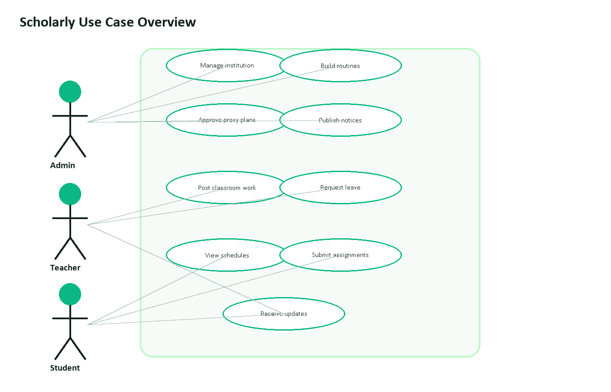
Figure 1: Main use cases for administrators, teachers, and students.
This figure identifies the three primary user roles and the system actions available to each role. It shows that Scholarly is centered on administrative setup, teacher classroom work, student participation, and shared schedule updates.
Actor | Use Cases | Expected Outcome
Admin | Manage institution, teachers, class sections, routines, proxy plans, notices, exam schedules, and settings. | The institution can run the academic workflow from one dashboard.
Teacher | View assigned schedule, post classroom work, create assignments and class tests, request leave, read notices, and receive routine updates. | Teachers can manage class work and remain updated about schedule changes.
Student | Join class section, view classroom posts, check deadlines, submit work, read notices, and view schedules. | Students can follow academic work without relying on separate chat groups.
2.6 Data Flow Diagram
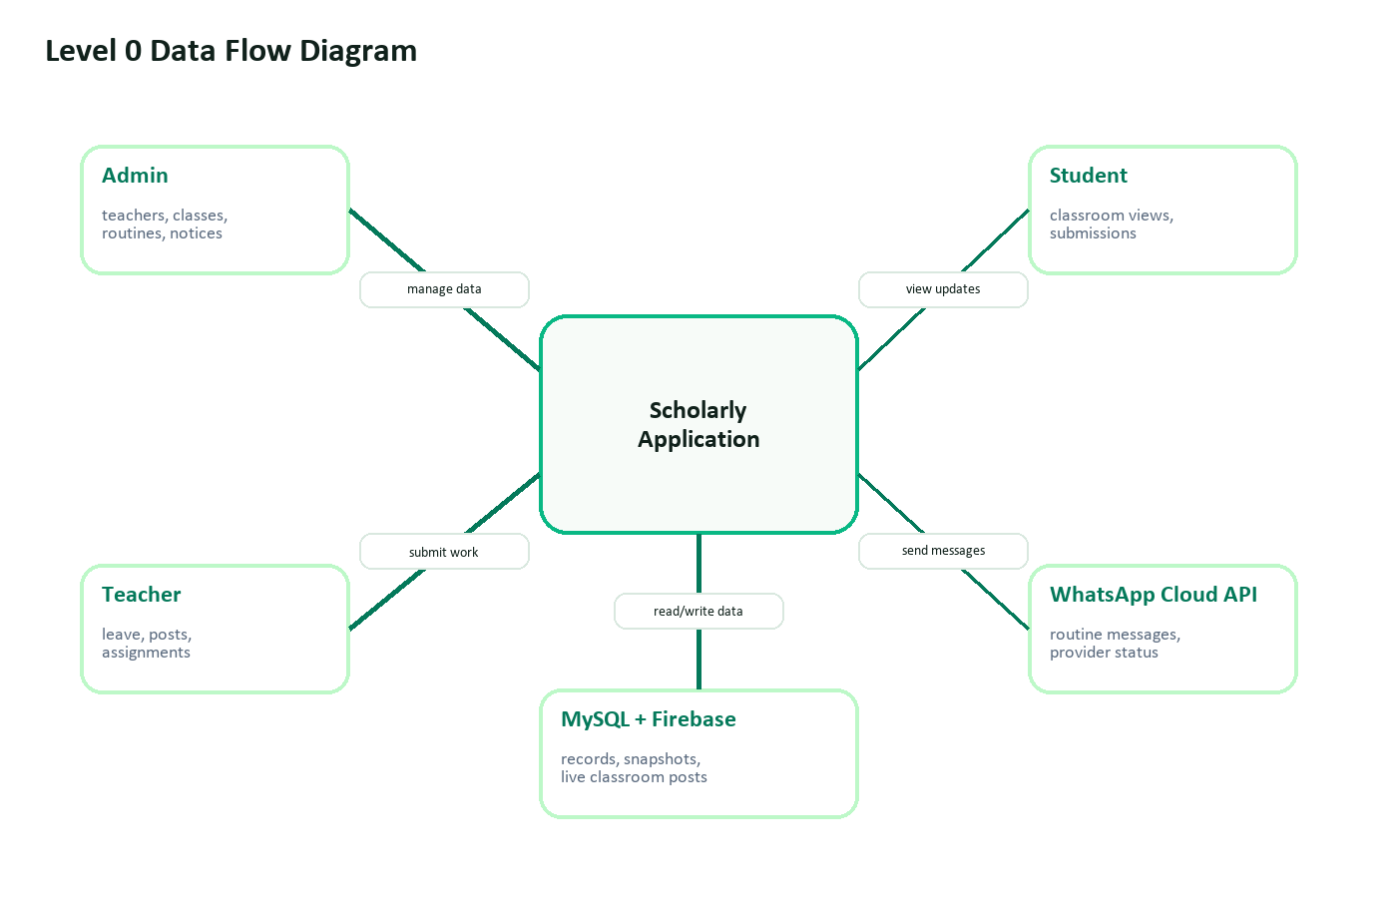
Figure 2: Level 0 data flow between users, Scholarly, storage, and WhatsApp Cloud API.
This figure explains how information enters and leaves the application. Administrators, teachers, and students interact with Scholarly, while the system reads and writes records to MySQL and Firebase and sends routine messages through the WhatsApp Cloud API.
Chapter 3: System Design
3.1 System Architecture
Scholarly uses a Laravel monolith with an Inertia-powered Vue frontend. Laravel owns routing, authorization, validation, database persistence, and server-side responses. Vue handles interactive pages in resources/js and communicates through Inertia visits, Axios requests, and Firebase listeners where real-time classroom data is required.
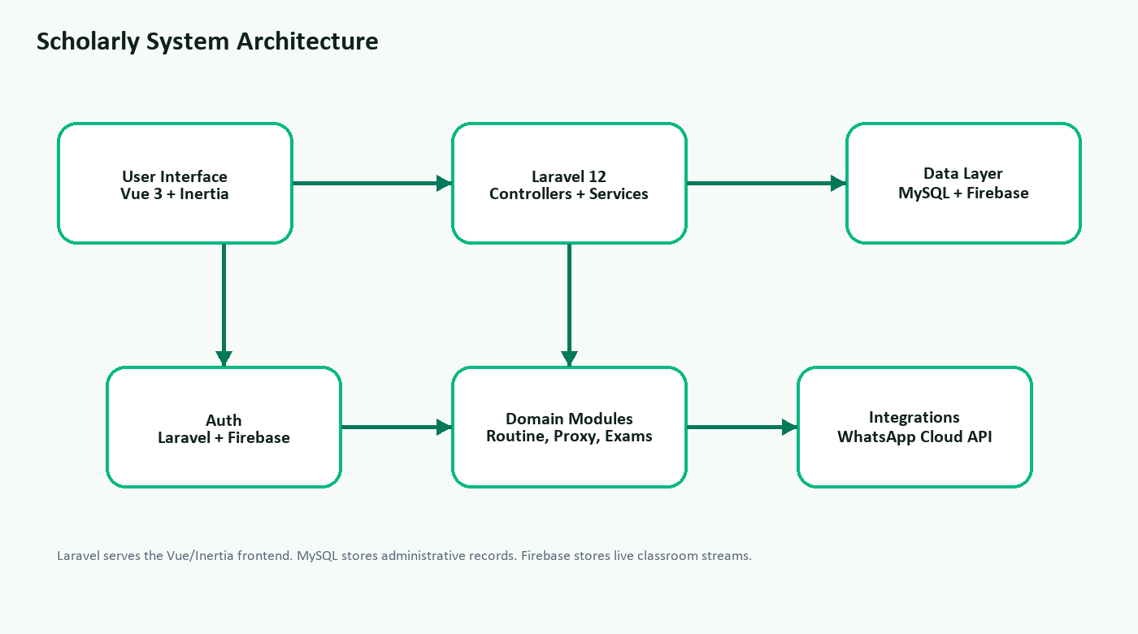
Figure 3: High-level architecture of Scholarly.
This figure shows the layered application structure. Vue and Inertia form the user interface, Laravel handles controllers and services, MySQL and Firebase store data, and the WhatsApp integration sends approved routine updates.
3.2 Entity Relationship Diagram
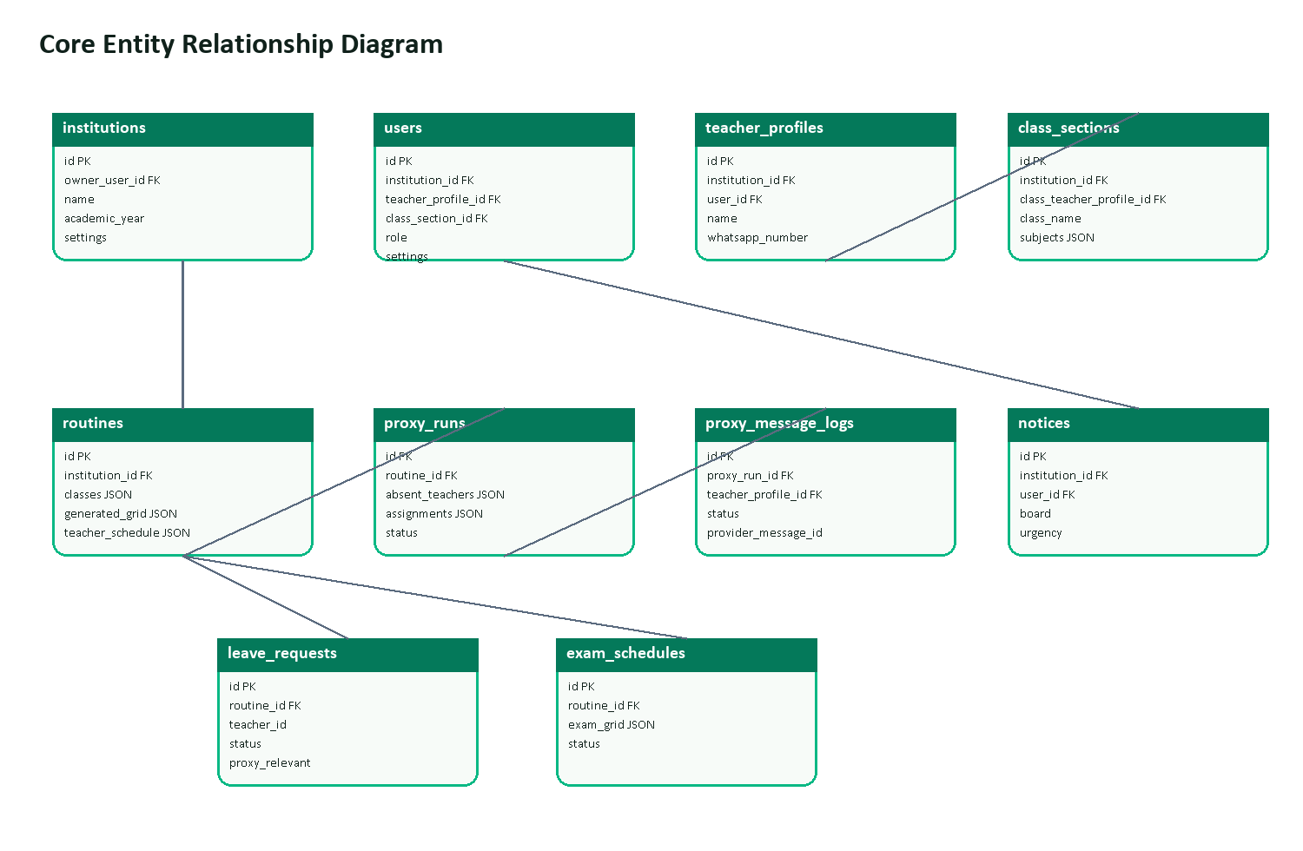
Figure 4: Core relational entities used by the Laravel backend.
This figure maps the main database entities and their relationships. It highlights how institutions connect to users, teacher profiles, class sections, routines, notices, leave requests, exam schedules, proxy runs, and WhatsApp message logs.
3.3 Model Relationship Diagram
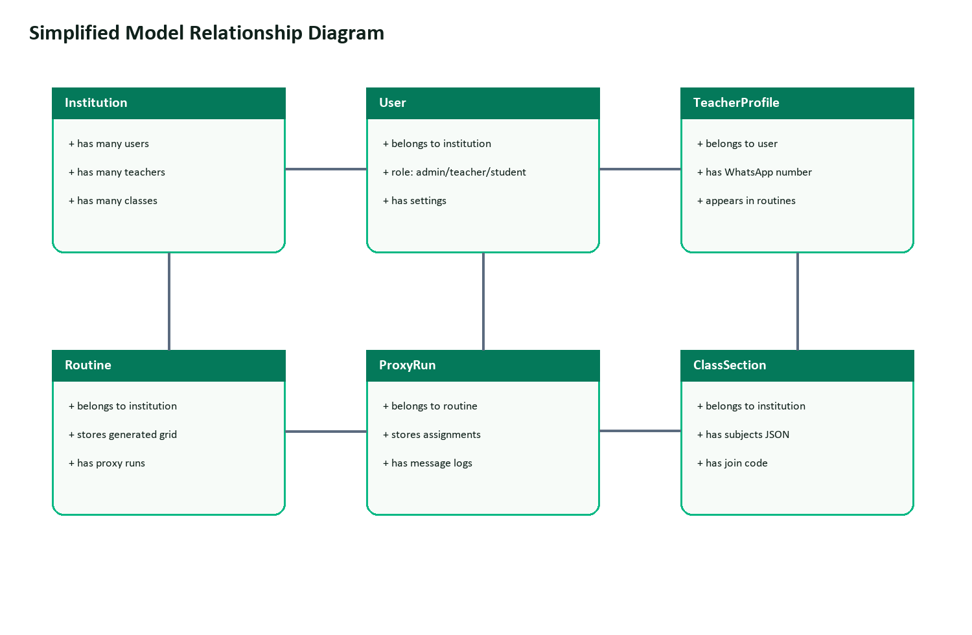
Figure 5: Simplified model relationships used by the application layer.
This figure presents the same domain in a simpler model-oriented view. It focuses on the Laravel application relationships that developers use when retrieving institution, user, teacher, routine, proxy, and class-section data.
3.4 Database Schema
Table | Main Columns | Purpose
users | name, email, firebase_uid, password, role, institution_id, settings | Stores login accounts and role links.
institutions | owner_user_id, name, short_name, phone, email, address, academic_year, settings | Stores institution-level profile and defaults.
teacher_profiles | institution_id, user_id, name, whatsapp_number, join_code, status | Stores teacher directory and WhatsApp details.
class_sections | institution_id, class_teacher_profile_id, class_name, section_name, join_code, subjects | Stores class-section directory and assigned subjects.
routines | institution_id, name, status, days, periods, classes, teachers, generated_grid | Stores generated academic routines and schedule snapshots.
proxy_runs | routine_id, date, day_label, status, absent_teachers, assignments, proxy_generated_grid | Stores proxy routine outputs.
notices | institution_id, user_id, board, title, message, urgency, visibility | Stores institutional and staff notices.
leave_requests | institution_id, routine_id, teacher_id, start_date, end_date, status | Stores leave request workflow data.
exam_schedules | institution_id, routine_id, halls, time_slots, exam_grid, status | Stores exam scheduling data.
proxy_message_logs | proxy_run_id, teacher_profile_id, whatsapp_number, status, provider_message_id | Stores WhatsApp send history.
3.5 Route and API Design
The project primarily uses web routes with Inertia responses instead of a separate public REST API. Selected JSON endpoints support notifications, search, and WhatsApp previews. The active route list contains 79 routes.
Method | Endpoint | Purpose | Auth
GET | /dashboard | Render role-specific dashboard. | Yes
GET, POST | /login | Render login screen and create session. | No
GET, POST | /register | Render registration screen and create account. | No
GET, POST | /routines | List and create routines. | Yes
GET, POST | /proxy-manager | List and generate proxy runs. | Yes
GET | /proxy-manager/{proxyRun}/whatsapp-preview | Return prepared WhatsApp messages as JSON. | Yes
POST | /proxy-manager/{proxyRun}/whatsapp | Send WhatsApp routine updates and log results. | Yes
GET, POST | /noticeboard | List and publish notices. | Yes
GET, POST | /leave-requests | List and create leave requests. | Yes
GET, POST | /exam-schedule | List and create exam schedules. | Yes
GET | /classroom | Render classroom stream context. | Yes
GET | /notifications | Return notification center JSON payload. | Yes
GET | /search/features | Return searchable feature and classroom items. | Yes
3.6 Frontend Component Structure
resources/js
app.js
Layouts/AppLayout.vue
Layouts/GuestLayout.vue
Components/AppSidebar.vue
Components/AppTopbar.vue
Components/ApplicationLogo.vue
Pages/Auth/Login.vue
Pages/Auth/Register.vue
Pages/Dashboard.vue
Pages/TeacherDashboard.vue
Pages/StudentDashboard.vue
Pages/Routines/Create.vue
Pages/Routines/Show.vue
Pages/ProxyManager/Index.vue
Pages/Classroom/Index.vue
Pages/Noticeboard/Index.vue
Pages/ExamSchedule/Index.vue
Pages/Settings/Index.vue
Composables/useDashboardClassroomFeed.js
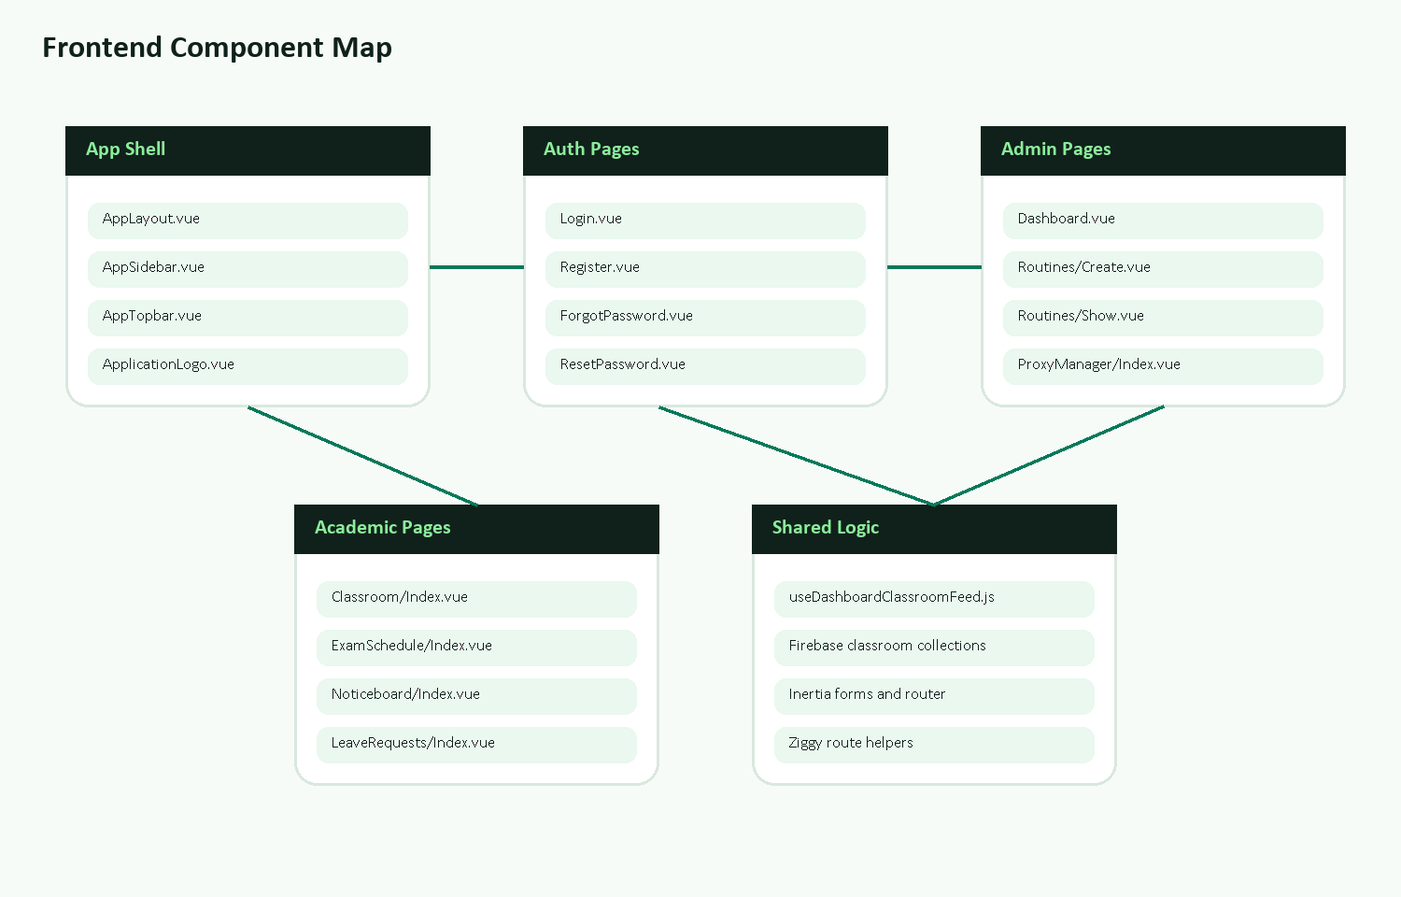
Figure 6: Frontend component grouping for the Vue and Inertia interface.
This figure organizes the main Vue files by responsibility. It separates the app shell, authentication screens, admin pages, academic pages, and shared frontend logic so the interface structure is easier to understand.
3.7 Sequence Diagram: Authentication
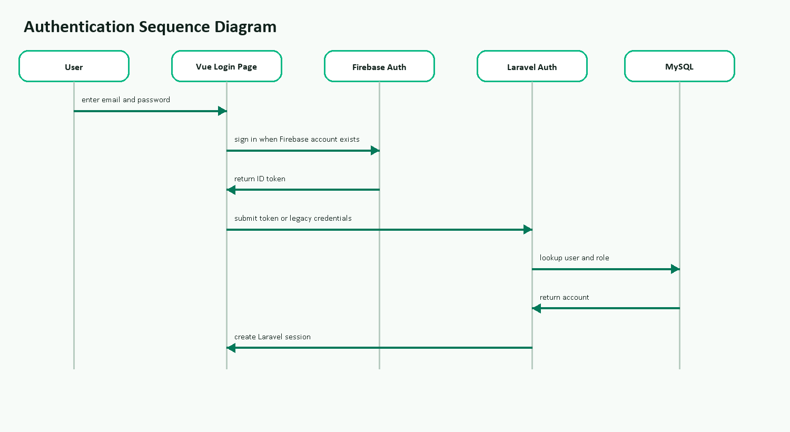
Figure 7: Authentication flow for Firebase-aware and legacy local accounts.
This figure traces the login process from the user interface to Firebase, Laravel, and MySQL. It shows how Scholarly supports both Firebase-backed accounts and older local accounts that existed before Firebase was added.
3.8 Workflow Diagram: Proxy Routine
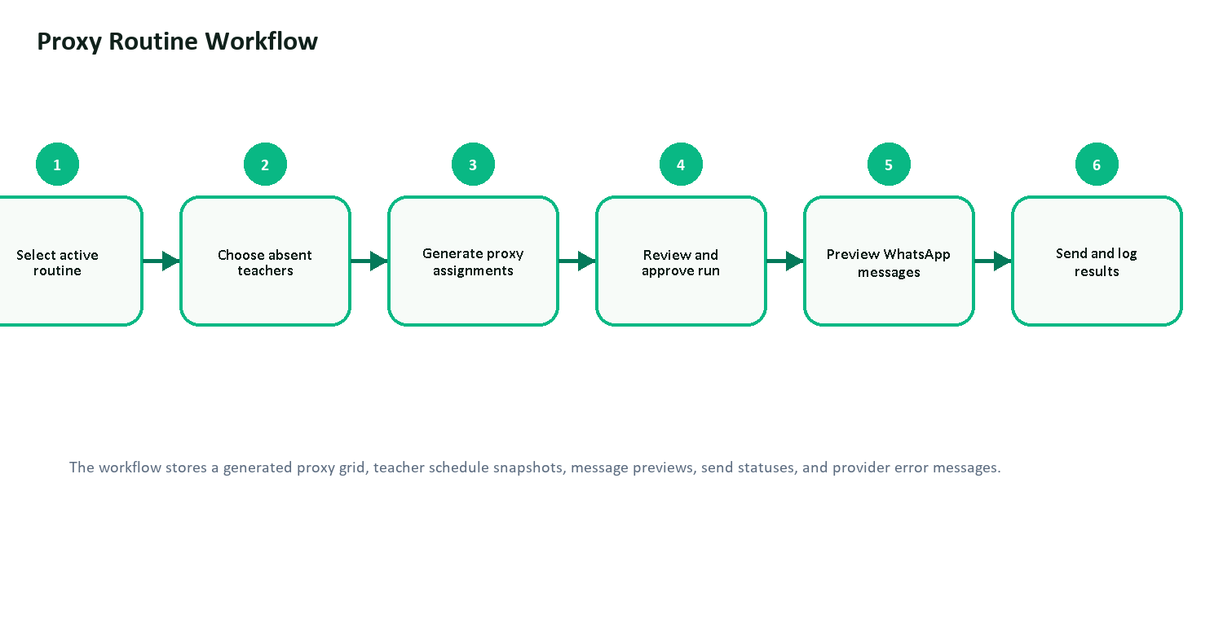
Figure 8: Proxy routine generation, approval, preview, and WhatsApp logging flow.
This figure explains the proxy-management workflow from routine selection to final message logging. It shows how an administrator selects absent teachers, generates assignments, approves the run, previews WhatsApp messages, and records delivery results.
3.9 Wireframes and UI Mockups
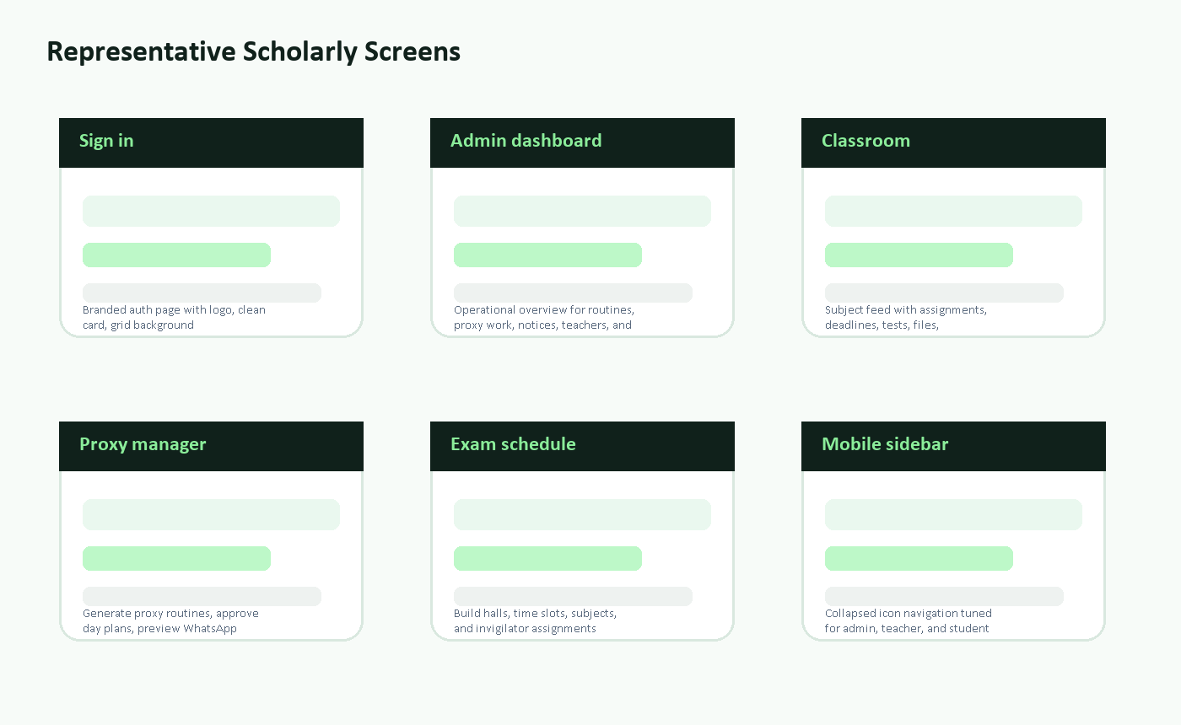
Figure 9: Branded representation of the main screens included in the final application.
This figure gives a compact visual overview of the major Scholarly screens. It represents the sign-in page, admin dashboard, classroom feed, proxy manager, exam schedule, and responsive mobile sidebar.
Chapter 4: Technology Stack and Environment Setup
4.1 Technology Stack
Layer | Technology | Version or Package | Purpose
Backend framework | Laravel | 12.x | Routing, controllers, validation, services, Eloquent ORM, sessions.
Language | PHP | 8.2.12 | Backend runtime.
Frontend framework | Vue.js | 3.4.x | Interactive single-file components.
Bridge | Inertia.js | 2.x | Connects Laravel routes with Vue pages.
Database | MySQL | Local MySQL through XAMPP | Persistent relational storage.
Authentication | Laravel auth, Sanctum, Firebase | Sanctum 4.x, Firebase 12.x | Session auth plus Firebase-aware flows.
Styling | Tailwind CSS | 3.2.x | Responsive utility-first UI styling.
Build tool | Vite | 7.x | Development server and production asset compilation.
External service | WhatsApp Cloud API | Graph API v25.0 | Routine update messaging.
4.2 Development Environment
Operating system | Windows development environment
PHP | 8.2.12
Composer | 2.8.12
Node.js | 24.16.0
npm | 11.13.0
Local server | php artisan serve at http://127.0.0.1:8000
Frontend server | Vite on port 5174 when hot reload is enabled
Database | MySQL, configured through Laravel .env
4.3 Installation Steps
git clone <repository-url> scholarly
cd scholarly
composer install
cmd /c npm install
copy .env.example .env
php artisan key:generate
php artisan migrate --seed
php artisan serve
cmd /c npm run dev
4.4 Environment Variables
APP_NAME=Scholarly
APP_ENV=local
APP_KEY=<generated application key>
APP_URL=http://127.0.0.1:8000
DB_CONNECTION=mysql
DB_DATABASE=<database name>
FIREBASE_API_KEY=<firebase web api key>
FIREBASE_AUTH_DOMAIN=<firebase auth domain>
FIREBASE_PROJECT_ID=<firebase project id>
WHATSAPP_API_VERSION=v25.0
WHATSAPP_PHONE_NUMBER_ID=<whatsapp phone number id>
WHATSAPP_ACCESS_TOKEN=<token hidden>
WHATSAPP_DRY_RUN=false
Chapter 5: Implementation
5.1 Backend Implementation
The backend is organized around Laravel controllers and service classes. Controllers validate user input, enforce route access through middleware, and return Inertia pages or redirects. Eloquent models represent persistent entities and define casts for JSON fields such as routine grids, teacher schedules, proxy assignments, institution settings, and notification settings.
Authentication and role routing
Authentication is based on Laravel Breeze-style session login with additional Firebase-aware behavior. The login page can submit a Firebase ID token for Firebase-backed accounts. Local legacy users can still authenticate through the Laravel database, which was necessary because the institute dataset existed before Firebase was added.
// resources/js/app.js
createInertiaApp({
resolve: (name) => resolvePageComponent(
`./Pages/${name}.vue`,
import.meta.glob('./Pages/**/*.vue')
),
setup({ el, App, props, plugin }) {
return createApp({ render: () => h(App, props) })
.use(plugin)
.use(ZiggyVue)
.mount(el);
},
});
Routine and proxy management
The routine module stores school days, periods, classes, teachers, generation rules, generated grid data, teacher schedules, and metrics. ProxyRunController uses a ProxyEngine service to create a substitute plan for absent teachers, then stores both the proxy grid and teacher schedule snapshots.
// ProxyRunController@store, simplified
$routine = Routine::findOrFail($data['routineId']);
$generated = $engine->generate($routine, $data);
$proxyGrid = $this->proxyGridForRun($routine, $generated['day'], $generated['assignments']);
$proxySchedule = $this->teacherScheduleFromGrid($routine, $proxyGrid);
ProxyRun::create([
'routine_id' => $routine->id,
'day_label' => $generated['day'],
'assignments' => $generated['assignments'],
'proxy_generated_grid' => $proxyGrid,
'proxy_teacher_schedule' => $proxySchedule,
'metrics' => $generated['metrics'],
]);
WhatsApp routine messaging
WhatsAppRoutineMessenger prepares teacher-specific schedule messages from an approved proxy run. It normalizes Bangladeshi phone numbers, skips teachers without numbers, respects personal WhatsApp notification settings, catches connection errors, records provider IDs, and stores failure messages returned by Meta.
5.2 Frontend Implementation
The frontend is built with Vue single-file components under resources/js. AppLayout.vue and AppSidebar.vue provide the shell for authenticated pages. GuestLayout.vue wraps login, registration, password reset, and verification pages. Each page component receives props from Laravel through Inertia and submits changes with Inertia router calls or forms.
// ProxyManager/Index.vue, simplified
router.post(`/proxy-manager/${run.id}/whatsapp`, {
messages: whatsappDialog.value.messages,
}, {
preserveScroll: true,
onSuccess: () => closeWhatsAppDialog(),
onError: () => {
whatsappDialog.value.error = 'Could not send WhatsApp messages.';
},
});
5.3 Authentication Flow
- The user opens /login and enters email and password.
- The Vue login component checks Firebase configuration and legacy account status.
- For Firebase accounts, the component signs in through Firebase and sends the ID token to Laravel.
- For legacy local accounts, the component submits credentials directly to Laravel.
- Laravel validates the account, creates a session, and redirects to /dashboard.
- DashboardController detects the role and returns the correct dashboard data.
5.4 Notable Challenges and Solutions
Challenge | Resolution
Teacher name synchronization | The update flow was expanded to synchronize related JSON snapshots in routines, proxy runs, leave records, and exam schedules.
Collapsed sidebar spacing | The sidebar spacing was adjusted by role and collapsed state so icons fit without requiring a scrollable collapsed sidebar.
Firebase migration and legacy login | A local-only legacy login path was added for users with no firebase_uid.
WhatsApp API failures | The messenger service now catches timeouts, OAuth errors, and provider failures, then logs the response.
Vite hot file blank page | Removing stale public/hot markers forces Laravel back to built assets when Vite is not needed.
Chapter 6: Testing
6.1 Testing Approach
Testing used manual click-through testing, Laravel feature tests, PHP syntax checks, route inspection, Vite production builds, and targeted database checks. The latest production frontend build completed successfully. The Laravel test suite reported 43 passing tests and 3 failing tests.
6.2 Test Cases
Test ID | Description | Input or Action | Expected Result | Status
TC-01 | Login page rendering | GET /login | Login screen loads. | Pass
TC-02 | Admin dashboard access | Authenticated admin opens /dashboard | Operations dashboard is returned. | Pass
TC-03 | Teacher dashboard context | Authenticated teacher opens /dashboard | Teacher schedule and classroom context are returned. | Pass
TC-04 | Student dashboard isolation | Authenticated student opens /dashboard | Only the student class context is returned. | Pass
TC-05 | Search permissions | Teacher and student search classrooms | Only allowed classroom subjects are shown. | Pass
TC-06 | Settings permissions | Teacher or student attempts admin cleanup | Request is blocked. | Pass
TC-07 | WhatsApp opt-out | Teacher disables WhatsApp updates | Routine message is skipped. | Pass
TC-08 | Production frontend build | cmd /c npm run build | Vite compiles assets successfully. | Pass
TC-09 | Default auth login test | PHPUnit Breeze login test | Expected authenticated state. | Fail - update for Firebase-aware flow
TC-10 | Default registration test | PHPUnit Breeze registration test | Expected authenticated state. | Fail - update for Firebase token requirement
TC-11 | Default root response test | GET / | Expected 200. | Fail - app redirects by design
6.3 Bug Tracking
Significant fixes included teacher-name propagation across schedule snapshots, WhatsApp timeout and request exception handling, phone-number normalization for Bangladesh numbers, stale Vite hot-file recovery, and mobile sidebar spacing adjustments.
Chapter 7: Results and Screenshots
The current prototype demonstrates a functional multi-role school operations system with realistic data. The local institute dataset contains 14 users, 20 teachers, 10 class sections, 1 active academic routine, 8 notices, 3 leave requests, 1 exam schedule, 2 proxy runs, 227 WhatsApp message log records, and 12 Firebase classroom posts seeded for presentation.

Figure 10: Representative screen set for the final Scholarly interface.
This figure summarizes the visible result of the implementation. It is included in the results chapter to connect the designed modules with the screens that users interact with during normal use.
Screen | What the user sees | Notable result
Login | Large Scholarly brand area, fading grid background, white sign-in card. | Local legacy account and Firebase-aware account paths are supported.
Registration | Role selector for admin, teacher, and student, plus institution or join-code fields. | The form supports different onboarding paths by role.
Admin dashboard | Summary cards, routine status, proxy work, notices, analytics links. | Administrators can reach all operational modules from one shell.
Routine view | Generated class grid and teacher schedule. | Routine data is stored as structured JSON snapshots.
Proxy manager | Absent teacher selection, generated proxy assignments, approval state, WhatsApp preview. | Approved runs can generate teacher-specific routine messages.
Classroom | Subject feed with updates, assignments, class tests, comments, and submissions. | Live posts use Firebase collections scoped by institution.
Noticeboard | Institutional and staff notices with urgency and acknowledgement. | Visibility rules separate all-user and teacher-only communication.
Exam schedule | Halls, time slots, subjects, invigilator options, and generated exam grid. | Exam schedule data is reusable and editable.
Chapter 8: Limitations and Future Work
8.1 Current Limitations
- WhatsApp routine messages currently depend on Meta allowed recipient rules during development mode.
- Some default authentication tests need to be rewritten to reflect the current Firebase-aware authentication flow.
- Classroom posts are stored in Firebase, so offline classroom access is limited without a local synchronization layer.
- The application is currently configured for local development rather than a hardened production deployment.
- Automated browser screenshot capture is not yet part of the test pipeline.
- Advanced exports, printed reports, and PDF generation are not implemented for every module.
8.2 Future Work
- Implement WhatsApp utility templates for routine updates and proxy notifications.
- Add production deployment configuration with queue workers, scheduled jobs, environment separation, and monitoring.
- Add full automated browser tests for login, routine generation, proxy approval, notice creation, and classroom posting.
- Add report exports for routines, proxy plans, leave summaries, exam schedules, and classroom deadlines.
- Add parent accounts, attendance, marks entry, result publication, and guardian-facing notifications.
- Improve classroom offline resilience by mirroring essential classroom post metadata to MySQL.
- Add multi-language support for Bangla and English interfaces.
Chapter 9: Conclusion
Scholarly was built as a practical full-stack school operations platform, not only as a demonstration of CRUD pages. The system connects institution setup, users, teacher profiles, class sections, routines, proxy planning, notices, leave requests, exam schedules, classroom activity, settings, notifications, and WhatsApp message logging into one role-based application.
The project met its main objective by delivering a working Laravel and Vue application that can support administrative, teacher, and student workflows. The implementation also exposed realistic engineering concerns: data migration after Firebase was introduced, stale generated schedule snapshots after teacher changes, external API failure handling, responsive sidebar behavior, and development-mode WhatsApp limitations.
The most valuable lesson from the project is that institutional systems depend on consistency across modules. A teacher name, routine cell, notice visibility rule, or proxy message can affect several screens at once. Building Scholarly required attention to that connected behavior.
Chapter 10: References and Appendices
10.1 References
- Laravel Documentation. https://laravel.com/docs
- Vue.js Documentation. https://vuejs.org/guide
- Inertia.js Documentation. https://inertiajs.com
- Tailwind CSS Documentation. https://tailwindcss.com/docs
- Firebase Documentation. https://firebase.google.com/docs
- WhatsApp Business Platform Documentation. https://developers.facebook.com/docs/whatsapp
- Vite Documentation. https://vite.dev/guide
- Lucide Icons Documentation. https://lucide.dev
10.2 Appendices
Appendix A: Project Metrics
Users | 14
Teacher profiles | 20
Class sections | 10
Routines | 1
Active routine | New Academic Routine
Active routine days | 5
Active routine periods | 9
Notices | 8
Leave requests | 3
Exam schedules | 1
Proxy runs | 2
WhatsApp logs | 227
Firebase classroom posts | 12 seeded demo posts
Appendix B: Build and Test Summary
Frontend build | cmd /c npm run build completed successfully.
Laravel tests | 43 passed, 3 failed.
Known failing tests | Default auth login, default registration, and default root response expectations need updates.
Route inventory | php artisan route:list reported 79 routes.
Appendix C: Important Commands
php artisan route:list
php artisan test
php artisan config:clear
php artisan view:clear
cmd /c npm run build
php artisan serve
Final Submission Checklist
- Replace Student ID and Supervisor on the cover page before final submission.
- Open the DOCX in Microsoft Word and update the table of contents if page numbers are required by the institution.
- Add real browser screenshots if the evaluator requires literal screenshots rather than screen descriptions.
- Do not expose real Firebase or WhatsApp secrets in the submitted document.
- Export to PDF after final edits and confirm formatting before submission.
Appendix A: Complete Design Artifacts
This appendix repeats the design artifacts as standalone deliverables so the documentation remains self-contained even when reviewed separately from the source code.

A.1 Use Case Diagram

Appendix Figure A1: Complete use case diagram.
The complete use case diagram shows the user roles and the main actions each role performs inside Scholarly.

A.2 Level 0 Data Flow Diagram

Appendix Figure A2: Complete data flow diagram.
The complete data flow diagram shows how user actions, database storage, Firebase classroom records, and WhatsApp delivery interact.

A.3 System Architecture Diagram

Appendix Figure A3: Complete architecture diagram.
The complete architecture diagram shows the frontend, backend, storage, domain modules, authentication layer, and external integration layer.

A.4 Entity Relationship Diagram

Appendix Figure A4: Complete entity relationship diagram.
The complete ERD shows the core database tables and the relationships that support Scholarly's institution, routine, classroom, and messaging modules.

A.5 Model Relationship Diagram

Appendix Figure A5: Complete model relationship diagram.
The complete model relationship diagram simplifies the database view into the main Laravel model relationships used in implementation.

A.6 Authentication Sequence Diagram

Appendix Figure A6: Complete authentication sequence diagram.
The complete sequence diagram explains how login requests move between the user, Vue, Firebase, Laravel, and MySQL.

A.7 Proxy Routine Workflow Diagram

Appendix Figure A7: Complete proxy routine workflow diagram.
The complete workflow diagram shows the full proxy routine process from choosing absences to sending and logging WhatsApp messages.

A.8 Frontend Component Map

Appendix Figure A8: Complete component map.
The complete component map groups the Vue files by responsibility so the frontend structure can be reviewed quickly.

A.9 UI Mockup Board

Appendix Figure A9: Complete UI mockup board.
The complete UI mockup board summarizes the major screens and demonstrates the visual direction of the Scholarly interface.

Appendix B: Detailed Route and Data Dictionary
B.1 Detailed Data Dictionary
Entity | Attribute | Type | Description
users | firebase_uid | string, nullable | Links a Laravel user to a Firebase authentication account.
users | role | string | Controls admin, teacher, or student navigation and permissions.
users | settings | json | Stores notification preferences and user-level UI settings.
institutions | academic_year | string | Current academic year label shown in institution-level workflows.
institutions | settings | json | Stores institute-wide preferences, branding, and notification defaults.
teacher_profiles | whatsapp_number | string, nullable | Bangladesh-format teacher phone number used for WhatsApp routine updates.
class_sections | subjects | json | List of subjects connected to a class section.
routines | generated_grid | json | Generated weekly class routine grid.
routines | teacher_schedule | json | Teacher-specific schedule snapshot derived from the routine grid.
proxy_runs | assignments | json | Generated proxy class assignments for an absence event.
proxy_message_logs | status | string | Message status such as sent, skipped, or failed.
notices | visibility | string | Controls whether notices target all users, teachers, or selected audiences.
exam_schedules | exam_grid | json | Final exam schedule grid including subjects, halls, and invigilators.
B.2 Route Coverage Matrix
Module | Routes | Controller or Page
Authentication | /login, /register, /forgot-password, /reset-password | Auth controllers and Vue auth pages
Dashboard | /dashboard | DashboardController with role-specific Vue pages
Routines | /routines, /routines/create, /routines/{routine} | RoutineController and Routines Vue pages
Proxy Manager | /proxy-manager, /proxy-manager/{proxyRun}/whatsapp-preview, /proxy-manager/{proxyRun}/whatsapp | ProxyRunController and WhatsAppRoutineMessenger
Teachers | /teachers | Teacher directory management
Class Sections | /classrooms | Class section directory management
Classroom Feed | /classroom | Firebase-backed classroom stream
Noticeboard | /noticeboard, /staffroom | Notice creation, visibility, and acknowledgement
Leave Requests | /leave-requests | Leave workflow and proxy relevance
Exam Schedule | /exam-schedule | Exam schedule builder and generated grid
Settings | /settings | Institution and user preference management
Search and Notifications | /search/features, /notifications | JSON endpoints for global navigation and notification center
Appendix C: Test Evidence and Submission Checklist
C.1 Command Evidence
Command | Result | Notes
cmd /c npm run build | Passed | Vite production build completed successfully.
php artisan route:list | Passed | 79 routes available in the local application.
php artisan test | 43 passing, 3 failing | The failing tests are stale default auth/root tests that need updating for the Firebase-aware flow and redirecting root route.
DOCX package scan | Passed | No old brand text and no em dash or en dash characters were found.
Header/footer scan | Passed | Word header and footer XML parts contain no visible text.
C.2 Final Artifact Checklist
Required Artifact | Included in Document
Cover page | Yes
Acknowledgement | Yes
Table of contents | Yes
Introduction and objectives | Yes
Functional and non-functional requirements | Yes
Use case diagram | Yes
Data flow diagram | Yes
Architecture diagram | Yes
Entity relationship diagram | Yes
Database schema and data dictionary | Yes
Route and API design | Yes
Frontend component structure | Yes
Authentication sequence diagram | Yes
Proxy workflow diagram | Yes
UI mockups and screen result table | Yes
Testing approach and test cases | Yes
Limitations, future work, conclusion, references | Yes

