EchoNet
Feature Update v3
Marketplace & Admin System + Home Property Portal
Stores • Products • Categories • Orders • Payment • Property Listings • Bookings • Agent Profiles • Admin Control

Version 3.0 | March 2026 | Confidential — EchoNet Internal

Table of Contents

1 Platform Architecture — v3 Overview ··· 3
2 Marketplace System ··· 4
2.1 Admin Dashboard ··· 4
2.2 Category Management ··· 5
2.3 User Management ··· 5
2.4 Product Oversight & Monitoring ··· 6
2.5 Marketplace Page (Browse & Buy) ··· 7
2.6 My Store — User Storefront ··· 8
2.7 Purchase & Order System ··· 9
2.8 Payment Integration (SSLCommerz) ··· 10
2.9 Moderator Dashboard ··· 11
3 Home Property Portal ··· 12
3.1 Property Listings Page ··· 12
3.2 Property Detail Page ··· 13
3.3 List Your Property — Owner Dashboard ··· 14
3.4 Booking & Enquiry System ··· 15
3.5 Agent Profile System ··· 16
3.6 Saved Properties & Wishlist ··· 16
4 Data Models — Full Schema ··· 17
4.1 Marketplace Models ··· 17
4.2 Property Models ··· 19
5 Role-Based Access Control (RBAC) ··· 21
6 REST API Endpoint Reference ··· 22
7 Folder Structure Update ··· 23
8 Security & Performance ··· 24
9 Future Enhancements ··· 25

1. Platform Architecture — v3 Overview

EchoNet v3 is a three-layer platform: a social media network (v1/v2), an e-commerce marketplace, and a home property portal — all sharing the same user accounts, authentication system, notification infrastructure, and admin controls. The diagram below shows how the three domains interconnect.

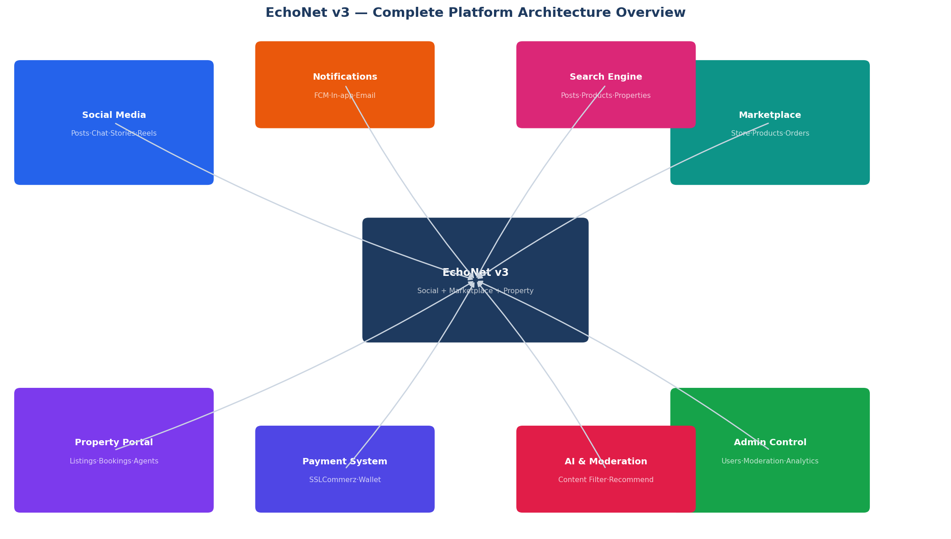
Figure 1 — EchoNet v3 Complete Platform Architecture

Layer | Domain | Core Modules
Social (v1/v2) | Social Media | Posts, Comments, Stories, Reels, Chat, Video Calls, Follow System, Feed Algorithm
New — v3A | Marketplace | Stores, Products, Categories, Orders, Payments, Moderation
New — v3B | Property Portal | Listings, Property Details, Bookings, Enquiries, Agent Profiles, Saved Properties
Shared | Platform Core | Users, Auth (Better-Auth + JWT), Notifications (FCM), Search, Admin Dashboard, BullMQ Queues

2. Marketplace System

The EchoNet Marketplace transforms every user into a potential seller. Users create their own stores, upload products under admin-defined categories, and sell to other users — all within the social platform. This section documents the Admin Dashboard, Category Management, Marketplace page, My Store, Order system, Payment integration, and Moderator Dashboard.

2.1 Admin Dashboard
The Admin Dashboard is the central command panel for the entire platform — covering both the marketplace and property systems in one unified interface.

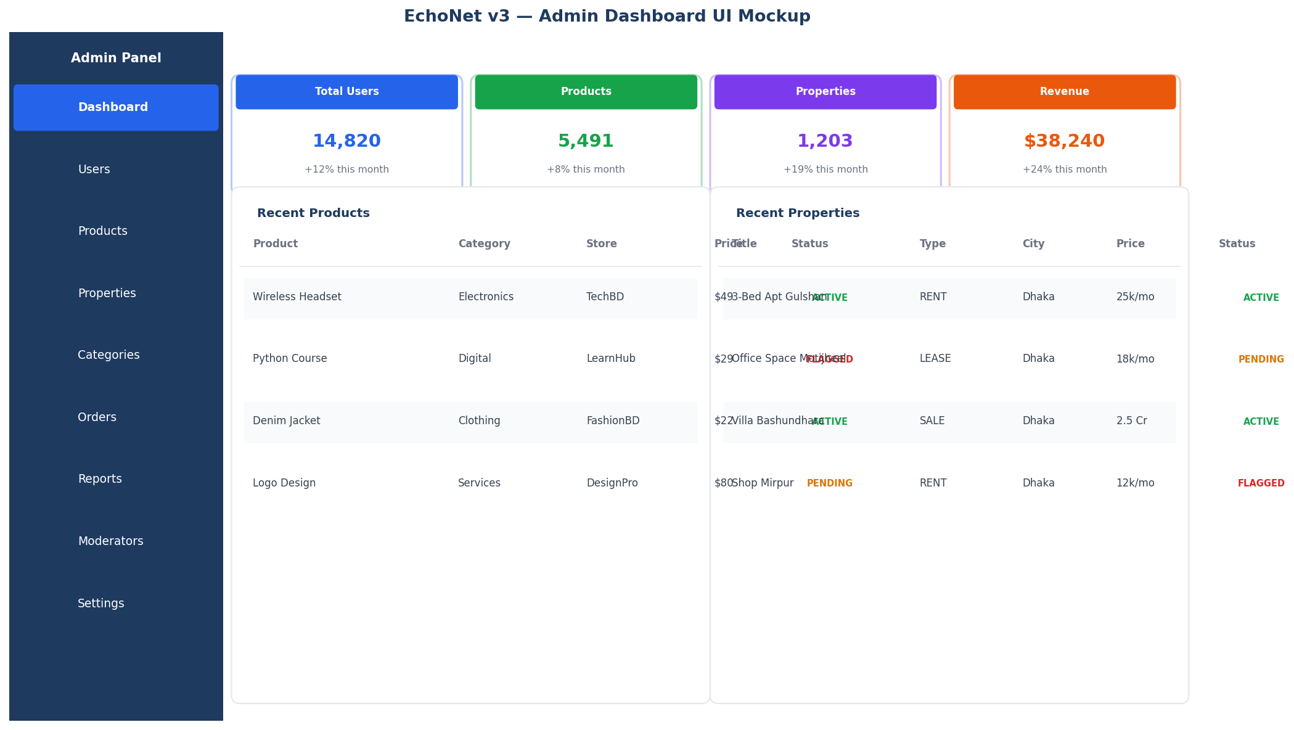
Figure 2 — Admin Dashboard UI Mockup (Marketplace + Property)

Dashboard Stat Cards
Metric | Source | Refresh Rate
Total Users | COUNT from users table | Real-time (Redis counter)
Total Products | COUNT from products WHERE deletedAt IS NULL | Every 5 minutes
Total Properties | COUNT from properties WHERE status = ACTIVE | Every 5 minutes
Total Revenue | SUM from payments WHERE status = SUCCESS | Every 15 minutes

Admin Navigation Sections
- Dashboard — stat cards + recent items at a glance
- Users — full user list, roles, suspend, delete, activity logs
- Products — all marketplace products with status filters
- Properties — all property listings with approval queue
- Categories — marketplace category tree management
- Orders — all platform orders with status tracking
- Reports — flagged content queue for review
- Moderators — manage moderator accounts and permissions
- Settings — platform config, feature flags, payment keys

2.2 Category Management
Only admins can create and manage product categories. Every product uploaded by a user must belong to exactly one admin-defined category. Categories support a two-level hierarchy (parent → sub-category).

Category Schema
model Category {
id String @id @default(uuid())
name String @unique
slug String @unique // auto-generated, URL-safe
description String?
iconUrl String?
parentId String? // null = top-level
parent Category? @relation('SubCategories', fields: [parentId], references: [id])
children Category[] @relation('SubCategories')
products Product[]
createdBy String // must be ADMIN role
createdAt DateTime @default(now())
updatedAt DateTime @updatedAt
}

Default Seed Categories
Category | Slug | Sub-categories
Electronics | electronics | Phones, Laptops, Accessories, Smart Home, Cameras
Clothing & Fashion | clothing | Men, Women, Kids, Footwear, Traditional Wear
Digital Products | digital | Courses, Templates, Software, eBooks, Graphics
Services | services | Design, Development, Writing, Marketing, Consulting
Food & Groceries | food | Organic, Snacks, Beverages, Dairy, Household
Books & Stationery | books | Textbooks, Fiction, Academic, Notebooks, Art Supplies
Home & Living | home | Furniture, Decor, Kitchen, Garden, Bedding

Admin Category Actions
- POST /admin/categories — create new top-level or sub-category
- PUT /admin/categories/:id — edit name, slug, icon, description
- DELETE /admin/categories/:id — only allowed if no active products are assigned
- Products in a deleted category must be re-assigned before deletion is permitted

2.3 User Management
Action | Endpoint | Effect
View all users | GET /admin/users | Paginated list with role, status, join date
Search users | GET /admin/users?q= | Filter by name, email, role
Suspend user | PUT /admin/users/:id/suspend | Sets isSuspended = true; blocks all actions
Unsuspend user | PUT /admin/users/:id/unsuspend | Restores access
Change role | PUT /admin/users/:id/role | User → Moderator → Admin (one-way recommended)
Permanently delete | DELETE /admin/users/:id | Hard delete + cascade (use with caution)
View activity | GET /admin/users/:id/activity | Paginated ActivityLog for the user

2.4 Product Oversight & Monitoring
Admins see every product uploaded on the platform with full filter capabilities. They can remove, flag, or change the status of any product regardless of which store it belongs to.

Product Status | Meaning | Who Sets It
PENDING | Newly uploaded — awaiting admin approval (optional) | System on upload
ACTIVE | Visible on the marketplace page | Admin approval / Auto
INACTIVE | Hidden by the seller — not purchasable | Store owner
FLAGGED | Reported by users — queued for admin review | Auto on N reports
REJECTED | Admin removed — seller notified by notification | Admin action

- Admin can bulk-action: approve, reject, or flag multiple products at once
- Flagged products are hidden from marketplace until reviewed
- ProductFlag threshold: 5 user reports auto-flags a product
- Soft-delete on rejection — product data retained for 30 days for appeals

2.5 Marketplace Page (Browse & Buy)
The public marketplace page displays all active products across all stores. It is accessible to all authenticated users and supports browsing, filtering, searching, and purchasing.

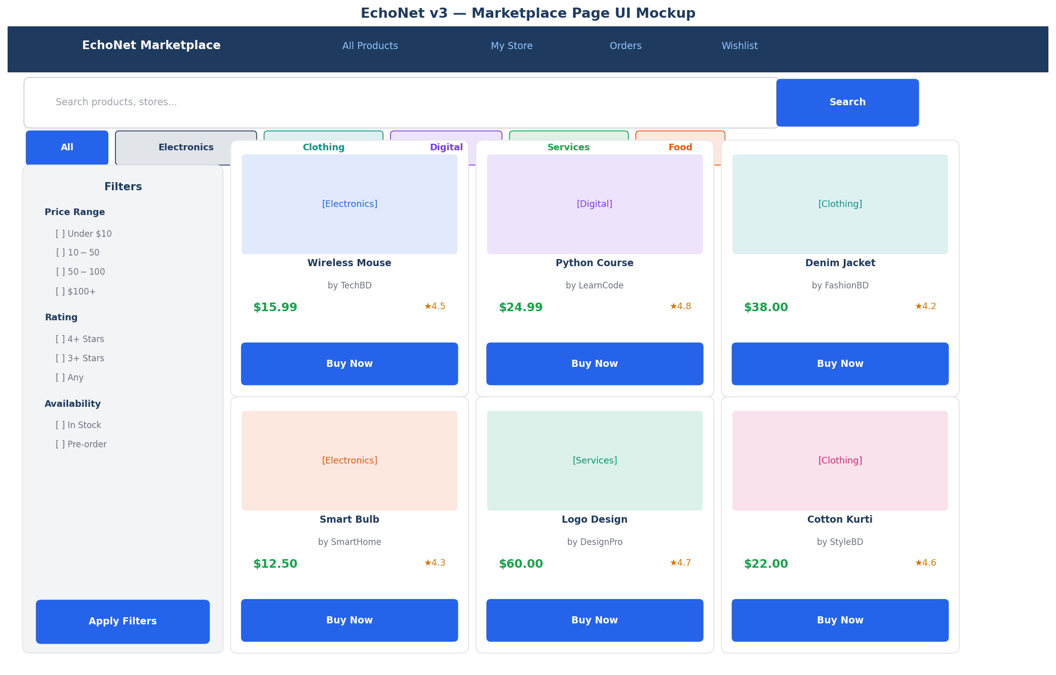
Figure 3 — Marketplace Page UI Mockup

Page Features
Feature | Detail
Category filter tabs | Horizontal pill tabs — click to filter by category; 'All' shows everything
Left filter panel | Price range, Rating (stars), Availability (in-stock / pre-order), Sort order
Search bar | Full-text search using PostgreSQL tsvector on product title + description
Product cards | Image, title, seller store name, price, star rating, Buy Now button
Pagination | Cursor-based — 20 products per page; infinite scroll on mobile
Featured row | Admin-promoted products shown in a highlighted carousel at the top
Wishlist save | Heart icon on each card — saves to user's wishlist (SavedProduct table)

Product Card Fields
- Product image (cover photo from ProductImage where isCover = true)
- Title (truncated at 60 characters)
- Price with currency
- Seller store name — linked to the store's public page
- Star rating average (computed from ProductReview)
- In Stock / Out of Stock badge
- Buy Now button — initiates checkout flow

2.6 My Store — User Storefront
Every user automatically has access to create a store. The My Store page is both a public-facing storefront (visible to all users) and a private management dashboard (only the owner can edit).

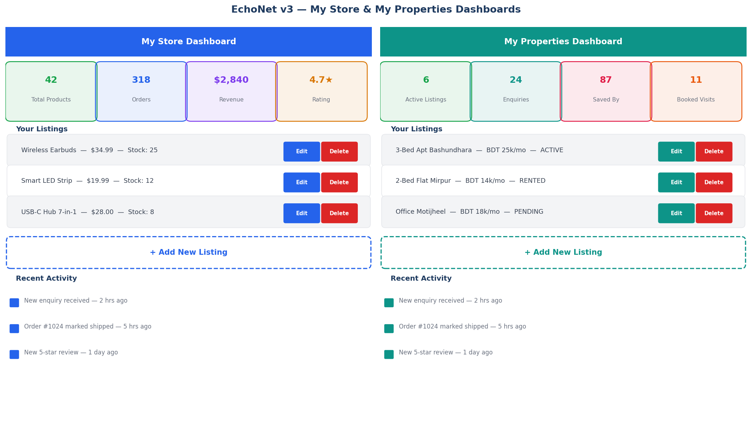
Figure 4 — My Store & My Properties User Dashboards

Store Schema
model Store {
id String @id @default(uuid())
ownerId String @unique // one store per user
name String @unique
description String?
logoUrl String?
bannerUrl String?
isActive Boolean @default(true)
followersCount Int @default(0)
createdAt DateTime @default(now())
updatedAt DateTime @updatedAt
owner User @relation(fields: [ownerId], references: [id])
products Product[]
orders Order[]
followers StoreFollow[]
}

Store Public Page Sections
- Store banner + logo + name + description
- Follower count + Follow / Unfollow button
- Product grid (all active products from this store)
- Store ratings aggregate (average across all product reviews)
- About section — owner info, member since date

Product Upload Form
model Product {
id String @id @default(uuid())
storeId String
categoryId String
title String
description String
price Decimal
stock Int @default(0)
images String[] // array of CDN URLs (max 8 images)
status ProductStatus @default(ACTIVE)
deletedAt DateTime? // soft delete
createdAt DateTime @default(now())
updatedAt DateTime @updatedAt
store Store @relation(fields: [storeId], references: [id])
category Category @relation(fields: [categoryId], references: [id])
orderItems OrderItem[]
reviews ProductReview[]
flags ProductFlag[]
}

enum ProductStatus { PENDING ACTIVE INACTIVE FLAGGED REJECTED }

2.7 Purchase & Order System
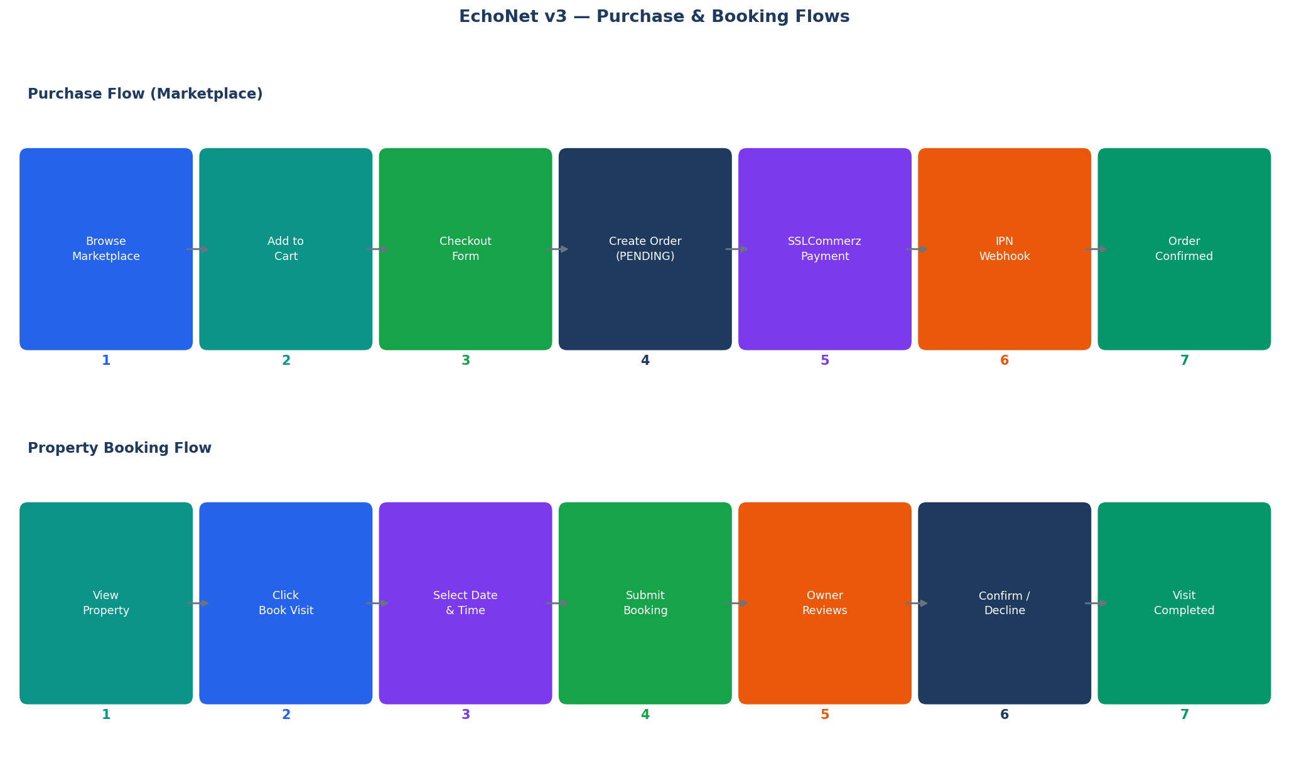
Figure 5 — Purchase Flow & Property Booking Flow

Order Schema
model Order {
id String @id @default(uuid())
buyerId String
storeId String
status OrderStatus @default(PENDING)
totalAmount Decimal
paymentRef String? // SSLCommerz transaction ID
shippingAddress Json // { name, phone, address, city, zip }
createdAt DateTime @default(now())
buyer User @relation(fields: [buyerId], references: [id])
store Store @relation(fields: [storeId], references: [id])
items OrderItem[]
payment Payment?
}

enum OrderStatus { PENDING PAID PROCESSING SHIPPED DELIVERED CANCELLED REFUNDED }

model OrderItem {
id String @id @default(uuid())
orderId String
productId String
quantity Int
unitPrice Decimal // snapshot at time of purchase
subtotal Decimal
order Order @relation(fields: [orderId], references: [id])
product Product @relation(fields: [productId], references: [id])
}

Order Status Lifecycle
Status | Trigger | Actor
PENDING | Order created; payment not yet confirmed | System
PAID | SSLCommerz IPN webhook confirms payment | Payment gateway
PROCESSING | Seller marks order as being prepared | Store owner
SHIPPED | Seller adds tracking number and marks shipped | Store owner
DELIVERED | Buyer confirms delivery OR auto after 7 days | Buyer / System
CANCELLED | Buyer or seller cancels before shipping | Buyer or Seller
REFUNDED | Admin initiates refund after cancellation | Admin

2.8 Payment Integration (SSLCommerz)
model Payment {
id String @id @default(uuid())
orderId String @unique
provider String @default('SSLCOMMERZ')
transactionId String @unique
amount Decimal
currency String @default('BDT')
status PaymentStatus @default(PENDING)
paidAt DateTime?
metadata Json? // raw SSLCommerz response
createdAt DateTime @default(now())
order Order @relation(fields: [orderId], references: [id])
}

enum PaymentStatus { PENDING SUCCESS FAILED REFUNDED }

Integration Steps
- POST /payments/initiate — server creates SSLCommerz session; returns payment URL
- User redirected to SSLCommerz hosted page to complete payment
- On success, SSLCommerz sends IPN POST to /payments/ipn (public, no auth)
- Server validates IPN signature, sets Order.status = PAID, Payment.status = SUCCESS
- BullMQ notification-queue job dispatched to notify buyer and seller
- Failure: Order remains PENDING for 30 minutes then auto-cancelled

SSLCommerz Environment Variables
Variable | Description
SSLCOMMERZ_STORE_ID | Your SSLCommerz store ID
SSLCOMMERZ_STORE_PASSWORD | Your SSLCommerz password
SSLCOMMERZ_IS_LIVE | false (sandbox) or true (production)
SSLCOMMERZ_SUCCESS_URL | POST-payment redirect — your domain/payment/success
SSLCOMMERZ_FAIL_URL | On failure — your domain/payment/failed
SSLCOMMERZ_CANCEL_URL | On cancellation — your domain/payment/cancelled
SSLCOMMERZ_IPN_URL | Webhook — your domain/api/v1/payments/ipn

2.9 Moderator Dashboard
The Moderator Dashboard handles content safety for both social posts and marketplace products. Moderators cannot suspend users or manage categories — those remain admin-only actions.

Section | Moderator Can | Moderator Cannot
Post Moderation | View, edit, delete, flag any post | Delete user accounts
Product Review | Review flagged products, remove violations | Create categories
User Monitoring | View user activity, escalate to admin | Suspend or delete users
Reports Queue | Review and resolve user-submitted reports | Change user roles
Content Flagging | Flag suspicious posts and products | Access payment data

3. Home Property Portal

The EchoNet Property Portal is a fully featured real estate listing system built into the platform. Users can browse, search, filter, save, and enquire about properties for sale, rent, and lease. Property owners and verified agents can list properties with full details, images, amenity checklists, and a map location pin.

3.1 Property Listings Page
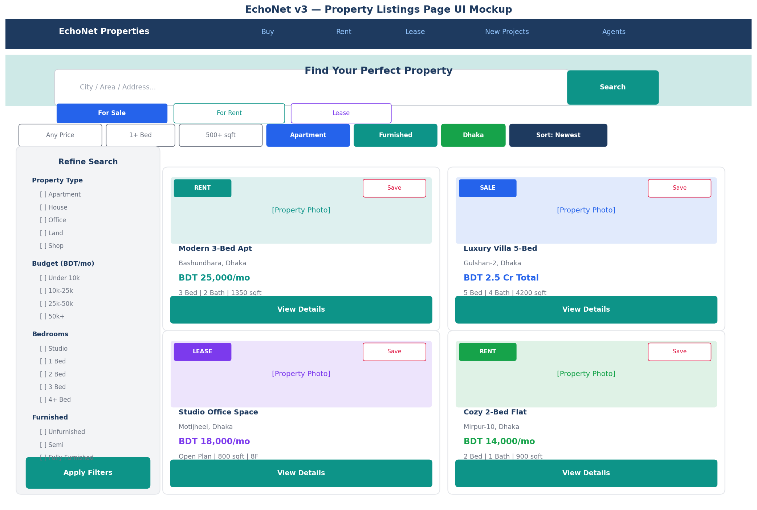
Figure 6 — Property Listings Page UI Mockup

Page Components
Component | Description
Hero search bar | City / area / address text search with For Sale / For Rent / Lease toggle tabs
Filter sidebar | Property type, budget range, bedrooms, furnished level — with Apply button
Filter pills row | Quick-access chips for common filters: area, furnished, sort order
Property card grid | Responsive 2-column (desktop) / 1-column (mobile) card layout
Map view toggle | Switch between card grid and full-map view (Leaflet.js / Google Maps)
Sort options | Newest, Price Low–High, Price High–Low, Most Viewed, Most Saved

Property Card Fields
- Cover photo (PropertyImage where isCover = true)
- Badge: RENT / SALE / LEASE with colour coding
- Save / Heart button (adds to SavedProperty)
- Property title (truncated at 55 chars)
- Location — area + city
- Price — formatted with unit (per month or total)
- Key specs — bedrooms, bathrooms, floor area in sqft
- View Details button → Property Detail Page

3.2 Property Detail Page
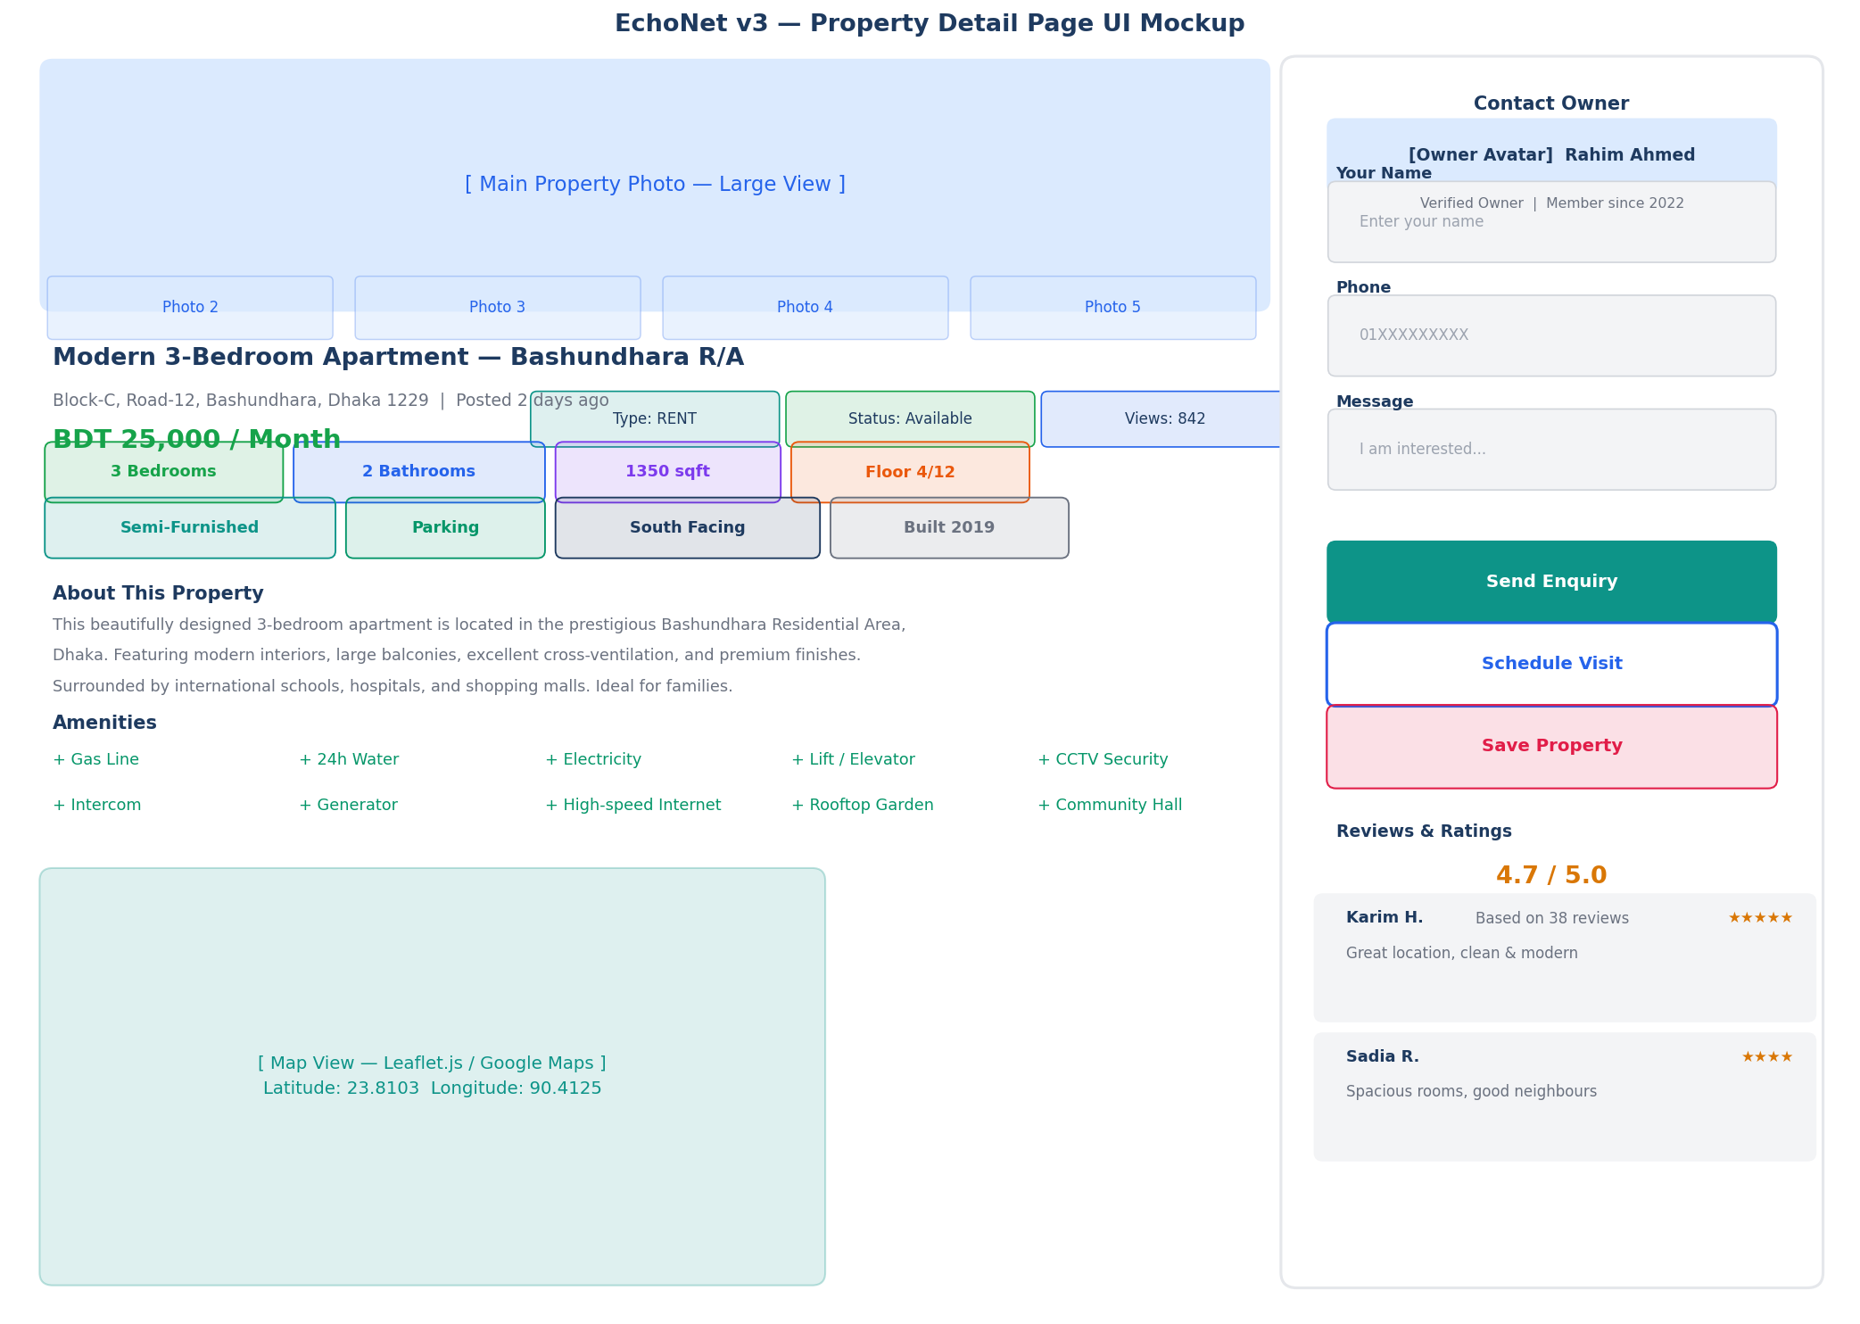
Figure 7 — Property Detail Page UI Mockup

Detail Page Sections
Section | Content
Image Gallery | Large main photo + thumbnail row; click to open full-screen lightbox
Title & Location | Property title, full address, city, area (neighbourhood)
Price & Status | Price with unit, listing type badge, availability status, view count
Spec Chips | Bedrooms, bathrooms, floor area, floor number, furnished level, facing, built year
Description | Rich text property description (max 2000 chars)
Amenities Checklist | Grid of available amenities: Gas, Water, Lift, CCTV, Generator, Gym, Pool, etc.
Location Map | Embedded Leaflet.js map centred on property latitude/longitude with pin
Contact Sidebar | Owner/agent name, avatar, enquiry form, Schedule Visit button, Save button
Reviews & Ratings | Star rating average + paginated review list with reviewer names
Similar Properties | Horizontally scrollable row of 4 similar listings (same city + category)

3.3 List Your Property — Owner Dashboard
Any authenticated user can list a property. The listing form is a multi-step wizard that collects all required information before submission.

Multi-Step Listing Form
Step | Fields Collected
Step 1 — Basic Info | Title, listing type (Rent/Sale/Lease), property category (Apartment/House/etc.), city, area, full address
Step 2 — Property Details | Bedrooms, bathrooms, floor area (sqft), floor number, total floors, parking, facing direction, year built, available from date
Step 3 — Amenities | Multi-select checklist: Gas, Electricity, Water supply, Lift, Security guard, CCTV, Generator, Internet, Gym, Pool, Rooftop, Community Hall
Step 4 — Pricing | Price amount, price unit (per month / total price), negotiable flag
Step 5 — Photos | Upload 1–10 images; drag to reorder; select cover photo; min 1 required
Step 6 — Review & Submit | Summary of all entered data; submit for activation

Property Status After Submission
- Default status: ACTIVE (auto-approve) or PENDING (if admin approval enabled)
- Owner receives in-app notification when status changes
- Owner can deactivate, edit, or soft-delete their listing at any time
- Sold/Rented properties can be marked accordingly — removed from active feed

3.4 Booking & Enquiry System

Schedule a Visit (Booking)
model Booking {
id String @id @default(uuid())
propertyId String
userId String // the visitor
visitDate DateTime
visitTime String // e.g. '10:00 AM'
message String?
status BookingStatus @default(PENDING)
createdAt DateTime @default(now())
property Property @relation(fields: [propertyId], references: [id])
user User @relation(fields: [userId], references: [id])
}

enum BookingStatus { PENDING CONFIRMED DONE CANCELLED NO_SHOW }

Send an Enquiry (Direct Message to Owner)
model PropertyEnquiry {
id String @id @default(uuid())
propertyId String
senderId String
message String
phone String?
isRead Boolean @default(false)
createdAt DateTime @default(now())
property Property @relation(fields: [propertyId], references: [id])
sender User @relation(fields: [senderId], references: [id])
}

Booking Flow
- Visitor clicks 'Schedule Visit' on property detail page
- Selects date and preferred time slot from calendar picker
- Adds an optional message and submits the booking form
- POST /bookings creates record with status PENDING
- Property owner receives push notification + in-app notification
- Owner confirms or declines via their My Properties dashboard
- Visitor is notified of confirmation or decline
- After visit: owner marks booking as DONE; visitor can leave a review

3.5 Agent Profile System
Verified real estate agents can have a special AgentProfile linked to their user account. Agent listings are distinguished with a Verified Agent badge on the property card.

model AgentProfile {
id String @id @default(uuid())
userId String @unique
licenseNo String
agencyName String?
totalListings Int @default(0)
totalSales Int @default(0)
isVerified Boolean @default(false)
bio String?
createdAt DateTime @default(now())
user User @relation(fields: [userId], references: [id])
properties Property[]
}

- Agent verification: admin reviews license number and approves via admin panel
- Agent public profile page: /agents/:id — shows all their active listings
- Non-agent users can still list their own properties (owner self-listing)
- Future: agent subscription tier for featured listings and priority placement

3.6 Saved Properties & Wishlist
model SavedProperty {
id String @id @default(uuid())
userId String
propertyId String
createdAt DateTime @default(now())
user User @relation(fields: [userId], references: [id])
property Property @relation(fields: [propertyId], references: [id])
@@unique([userId, propertyId]) // prevent duplicate saves
}

- POST /saved-properties/:propertyId — save (upsert)
- DELETE /saved-properties/:propertyId — unsave
- GET /saved-properties — user's saved properties list (paginated)
- Saved properties are private — only visible to the owner
- Heart icon on property cards reflects saved state for the current user

4. Data Models — Full Schema

4.1 Marketplace Models
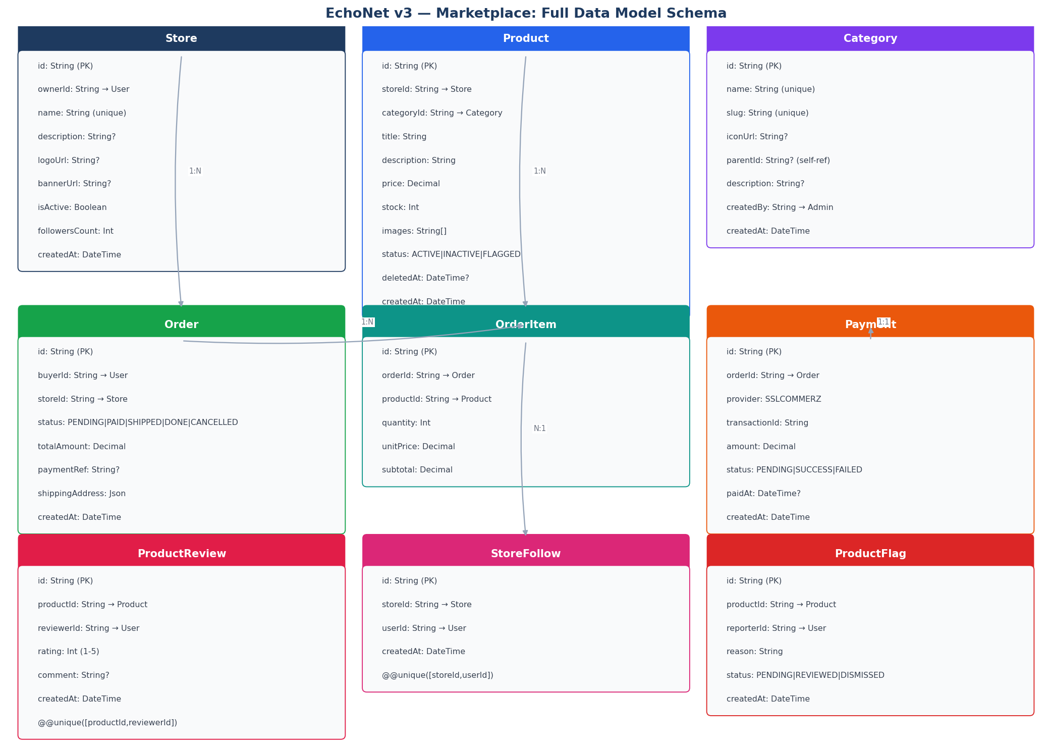
Figure 8 — Marketplace Data Model Entity Relationships

Model | Purpose | Key Relations
Store | User's personal storefront | User (owner) → many Products, Orders, StoreFollow
Category | Admin-managed product taxonomy | Self-referential for sub-categories; one-to-many with Product
Product | Individual item for sale | Store → Category → many OrderItem, ProductReview, ProductFlag
Order | A purchase transaction | Buyer (User) + Store → many OrderItem + one Payment
OrderItem | Line items within an order | Order → Product (price snapshot at purchase time)
Payment | Payment record from gateway | Order (1:1) → SSLCommerz transaction data
ProductReview | Buyer rating after purchase | Reviewer (User) + Product; unique per pair
StoreFollow | User following a store | User + Store; unique per pair
ProductFlag | User reporting a product | Reporter (User) + Product; unique per pair

4.2 Property Models
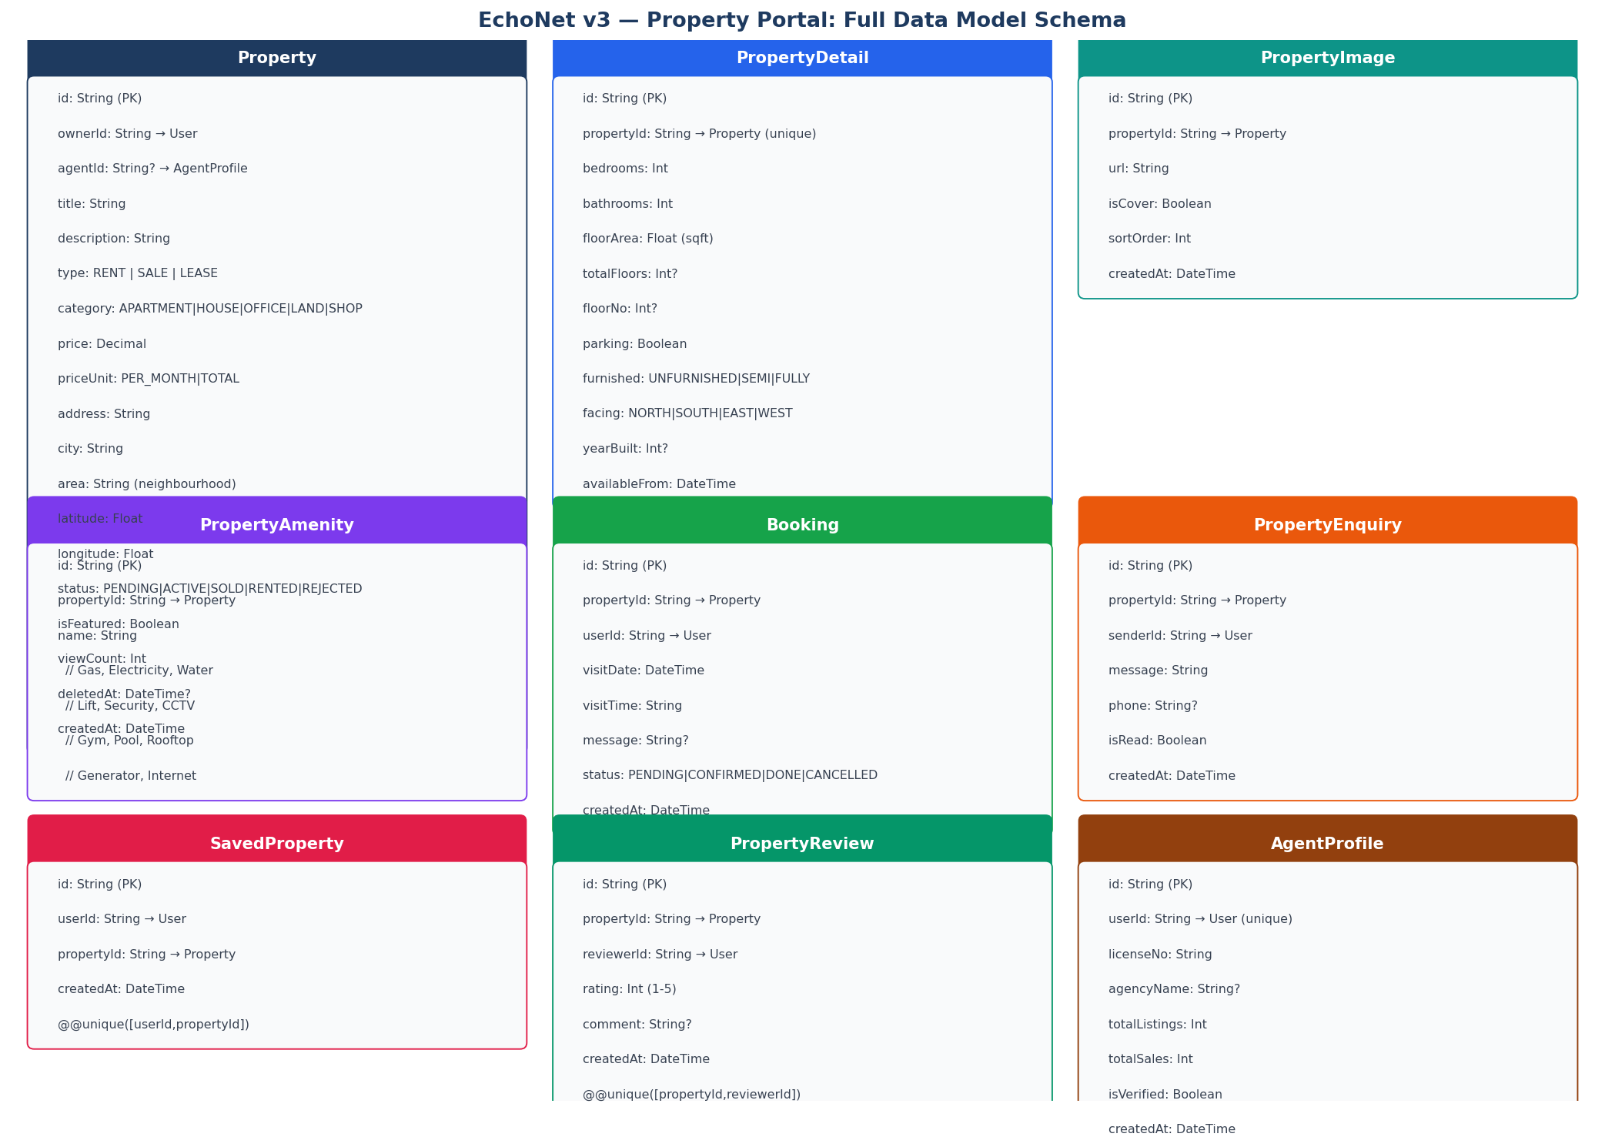
Figure 9 — Property Portal Data Model Entity Relationships

Model | Purpose | Key Relations
Property | Core property listing record | User (owner) / AgentProfile → many images, amenities, bookings
PropertyDetail | Extended specs (1:1 with Property) | Bedrooms, bathrooms, area, floor, furnished, facing, built year
PropertyImage | Photos for a property | Property → many images; isCover flag for thumbnail
PropertyAmenity | Available amenities checklist | Property → many named amenity records
Booking | Visit scheduling | Property + User (visitor) → visit date/time + status lifecycle
PropertyEnquiry | Direct message to owner | Sender (User) → Property owner; isRead flag
SavedProperty | User wishlist | User + Property; unique pair; private to user
PropertyReview | Post-visit rating | Reviewer (User) + Property; unique per pair; 1–5 stars
AgentProfile | Verified real estate agent | User (1:1); license, agency, verified badge

5. Role-Based Access Control (RBAC)

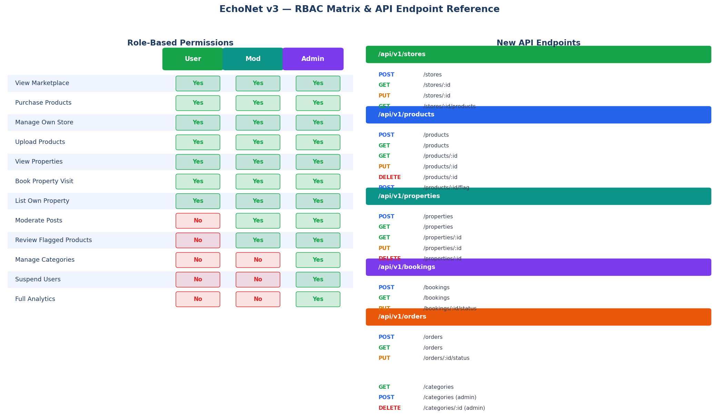
Figure 10 — RBAC Permission Matrix & API Endpoint Map

Feature / Action | User | Moderator | Admin
View & Browse Marketplace | Yes | Yes | Yes
Purchase Products | Yes | Yes | Yes
Create & Manage Own Store | Yes | Yes | Yes
Upload / Edit Own Products | Yes | Yes | Yes
View & Browse Properties | Yes | Yes | Yes
Book Property Visit | Yes | Yes | Yes
List & Manage Own Property | Yes | Yes | Yes
Send Property Enquiry | Yes | Yes | Yes
Moderate Posts (edit/delete any) | No | Yes | Yes
Review & Remove Flagged Products | No | Yes | Yes
Manage Categories (CRUD) | No | No | Yes
Suspend or Delete Users | No | No | Yes
Change User Roles | No | No | Yes
Approve / Reject Properties | No | No | Yes
Verify Agent Profiles | No | No | Yes
Access Full Platform Analytics | No | No | Yes

6. REST API Endpoint Reference

6.1 Marketplace Endpoints
Group | Endpoint | Method | Auth
Stores | POST /api/v1/stores | POST | Yes — create store
 | GET /api/v1/stores/:id | GET | No — public store page
 | PUT /api/v1/stores/:id | PUT | Yes — owner only
 | GET /api/v1/stores/:id/products | GET | No — public
 | POST /api/v1/stores/:id/follow | POST | Yes — follow/unfollow
Products | GET /api/v1/products | GET | No — browse marketplace
 | POST /api/v1/products | POST | Yes — seller only
 | GET /api/v1/products/:id | GET | No — product detail
 | PUT /api/v1/products/:id | PUT | Yes — owner only
 | DELETE /api/v1/products/:id | DELETE | Yes — soft delete
 | POST /api/v1/products/:id/flag | POST | Yes — report product
Categories | GET /api/v1/categories | GET | No
 | POST /api/v1/categories | POST | Admin only
 | PUT/DELETE /api/v1/categories/:id | PUT/DELETE | Admin only
Orders | POST /api/v1/orders | POST | Yes — create order
 | GET /api/v1/orders | GET | Yes — my orders
 | PUT /api/v1/orders/:id/status | PUT | Yes — seller/admin
Payments | POST /api/v1/payments/initiate | POST | Yes
 | POST /api/v1/payments/ipn | POST | Public — webhook
 | GET /api/v1/payments/:orderId | GET | Yes — owner/admin

6.2 Property Endpoints
Group | Endpoint | Method | Auth
Properties | GET /api/v1/properties | GET | No — browse
 | POST /api/v1/properties | POST | Yes — list property
 | GET /api/v1/properties/:id | GET | No — detail page
 | PUT /api/v1/properties/:id | PUT | Yes — owner/agent
 | DELETE /api/v1/properties/:id | DELETE | Yes — soft delete
Bookings | POST /api/v1/bookings | POST | Yes — schedule visit
 | GET /api/v1/bookings | GET | Yes — my bookings
 | PUT /api/v1/bookings/:id/status | PUT | Yes — owner confirms
Enquiries | POST /api/v1/enquiries | POST | Yes — send message
 | GET /api/v1/enquiries | GET | Yes — owner receives
Saved | POST /api/v1/saved-properties/:id | POST | Yes — save
 | DELETE /api/v1/saved-properties/:id | DELETE | Yes — unsave
 | GET /api/v1/saved-properties | GET | Yes — my wishlist
Agents | GET /api/v1/agents | GET | No — agent directory
 | GET /api/v1/agents/:id | GET | No — agent profile
Reviews | POST /api/v1/properties/:id/reviews | POST | Yes — after visit
 | GET /api/v1/properties/:id/reviews | GET | No
Admin | PUT /api/v1/admin/properties/:id/approve | PUT | Admin only
 | PUT /api/v1/admin/agents/:id/verify | PUT | Admin only

7. Folder Structure Update

The following new folders and files are added to the existing monorepo structure from v1/v2. Only additions are shown — existing structure remains unchanged.

7.1 Backend — New Route Files (apps/server/src/routes/)
routes/
stores.routes.ts — store CRUD + follow
products.routes.ts — product CRUD + flag + review
categories.routes.ts — admin category management
orders.routes.ts — order creation + status updates
payments.routes.ts — SSLCommerz initiate + IPN webhook
properties.routes.ts — property CRUD + search + filter
bookings.routes.ts — visit scheduling + status
enquiries.routes.ts — property enquiry messaging
saved-properties.routes.ts — wishlist management
agents.routes.ts — agent profiles + verification

7.2 Backend — New Service Files (apps/server/src/services/)
services/
store.service.ts — store business logic
product.service.ts — product lifecycle + flag handling
order.service.ts — order creation + status machine
payment.service.ts — SSLCommerz SDK wrapper + IPN validation
property.service.ts — property listing + search + geo filter
booking.service.ts — visit scheduling + conflict detection
property-search.service.ts — full-text + filter + sort pipeline

7.3 Frontend — New Pages (apps/web/app/(main)/)
(main)/
marketplace/
page.tsx — marketplace browse page
[productId]/page.tsx — product detail page
store/
page.tsx — my store dashboard
new/page.tsx — create store form
[storeId]/page.tsx — public store page
orders/
page.tsx — my orders list
[orderId]/page.tsx — order detail + tracking
properties/
page.tsx — property listings browse
[propertyId]/page.tsx — property detail page
new/page.tsx — multi-step listing form
my-properties/
page.tsx — owner property dashboard
bookings/
page.tsx — my bookings list
saved-properties/
page.tsx — saved / wishlist page
agents/
page.tsx — agent directory
[agentId]/page.tsx — agent public profile

8. Security & Performance

Concern | Implementation
Product / Property ownership | Middleware checks req.user.id === resource.ownerId before any PUT/DELETE
IPN webhook security | Validate SSLCommerz IPN signature using store password hash; reject unverified requests
File upload validation | Accept only image/jpeg, image/png, image/webp; max 5 MB per file; MIME sniff check
Payment amount tampering | Order totalAmount locked at creation; IPN amount validated against DB — mismatch = reject
Soft delete everywhere | Products, properties, orders use deletedAt — no permanent data loss; 30-day recovery window
Full-text search index | PostgreSQL GIN index on property title + description + area tsvector columns
Geo proximity filter | Index on (latitude, longitude); Haversine formula for 'properties near me' queries
Marketplace pagination | Cursor-based on (createdAt, id) — prevents OFFSET degradation at high product counts
Image CDN | All images stored in cloud storage (S3/R2) and served via CDN — not from Express server
Rate limiting | POST /payments/initiate: 5 requests per user per minute; listing create: 10 per hour
Admin audit log | Every admin action (suspend, delete, approve, verify) logged to ActivityLog with metadata

9. Future Enhancements

Feature | Domain | Priority | Complexity
Sponsored / Featured products | Marketplace | High | Medium
Discount codes & coupons | Marketplace | High | Medium
Product variants (size, colour) | Marketplace | Medium | High
Seller withdrawal / wallet | Marketplace | Medium | High
Bulk product CSV import | Marketplace | Low | Medium
Featured property placement | Property | High | Low
3D virtual property tour | Property | Medium | Very High
Rent payment through platform | Property | High | High
Mortgage calculator widget | Property | Medium | Low
Verified property badge | Property | High | Low
Agent subscription plans | Property | Medium | Medium
Price history chart per property | Property | Low | Medium
Neighbourhood score / heatmap | Property | Medium | High
Multi-currency support | Platform | Low | High
AI price recommendation | Marketplace + Property | Low | Very High

EchoNet Feature Update v3 | Marketplace & Property Portal | Confidential | Version 3.0 | March 2026

