EchoNet
Feature Update v2 — Technical Documentation
Follow System • Feed Algorithm • Stories • Groups • Reactions • Search • Hashtags • PWA • AI • Ads

Version 2.0 | March 2026 | Confidential

Table of Contents

1 Feature Roadmap & Phases ··· 3
2 Phase 1 — Must-Have Features ··· 4
2.1 Follow / Friend System ··· 4
2.2 News Feed Algorithm ··· 5
2.3 Advanced User Profile ··· 6
2.4 Search System ··· 6
2.5 Hashtag System ··· 7
2.6 Saved Posts ··· 7
2.7 Notifications Upgrade ··· 8
3 Phase 2 — Advanced Engagement Features ··· 9
3.1 Stories (24h Ephemeral) ··· 9
3.2 Reels / Short Video ··· 10
3.3 Group System ··· 10
3.4 Business Pages ··· 11
3.5 Live Streaming ··· 11
3.6 Reaction System ··· 11
3.7 Share Post Feature ··· 12
3.8 Tagging System ··· 12
4 Phase 3 — Pro / Scale Features ··· 13
5 New Data Models — Full Schema ··· 14
6 System Architecture Update ··· 16
7 REST API Endpoint Reference ··· 17
8 BullMQ Async Queue System ··· 18
9 Backend Improvements ··· 19
10 Future Enhancements Backlog ··· 21

1. Feature Roadmap & Development Phases

EchoNet v2 transforms the platform into a full-featured social ecosystem. Features are organised into four delivery phases, each building on the previous. The diagram below shows the complete roadmap at a glance.

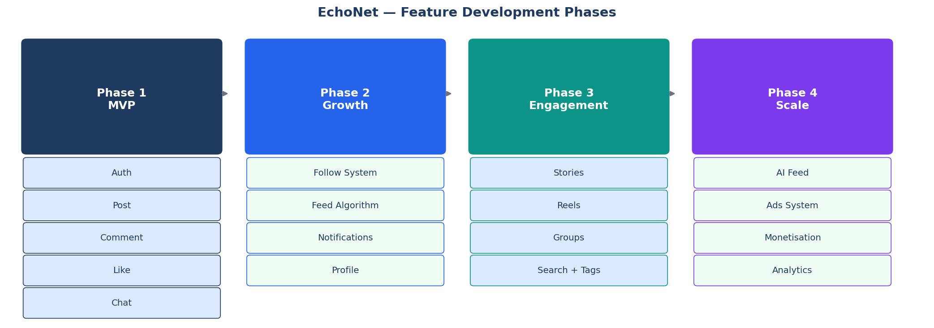
Figure 1 — EchoNet v2 Feature Development Phases

Phase | Focus | Core Features | Goal
Phase 1 | MVP+ | Follow system, Feed algorithm, Advanced profile, Search, Hashtags, Saved posts, Notifications | Immediate
Phase 2 | Engagement | Stories, Reels, Groups, Pages, Live streaming, Reactions, Shares, Tagging | Next sprint
Phase 3 | Viral | AI feed, Content moderation AI, E2E chat encryption, Ads, Monetisation, Analytics, PWA | Mid-term
Phase 4 | Scale | Multi-language, Email system, Super admin dashboard, Queue infra, Block/Report | Long-term

2. Phase 1 — Must-Have Features

2.1 Follow / Friend System
A follow system is the foundational social graph. It determines whose content appears in the feed, who can interact with private profiles, and drives the relationship-weight in the feed algorithm.

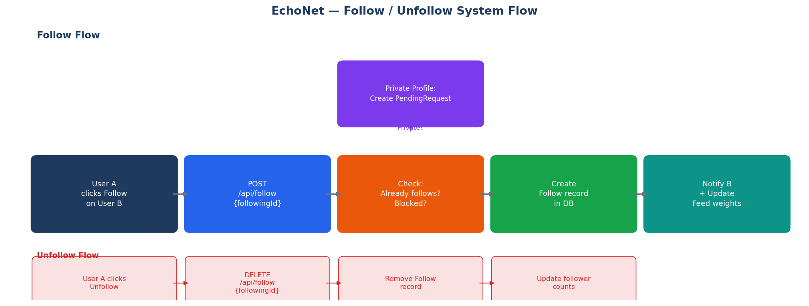
Figure 2 — Follow / Unfollow Flow Diagram

Prisma Schema
model Follow {
id String @id @default(uuid())
followerId String
followingId String
status FollowStatus @default(ACCEPTED)
createdAt DateTime @default(now())

follower User @relation('UserFollowing', fields: [followerId], references: [id])
following User @relation('UserFollowers', fields: [followingId], references: [id])

@@unique([followerId, followingId])
}

enum FollowStatus { PENDING ACCEPTED }

Key Behaviours
- Public profiles: follow request auto-accepted (status = ACCEPTED immediately)
- Private profiles: status starts as PENDING; target must accept via POST /follow/accept/:id
- Mutual follow detection surfaces a 'Friends' badge on profile pages
- Unfollow permanently deletes the Follow record
- Follow counts derived via Prisma _count — not stored as columns

2.2 News Feed Algorithm
The chronological feed is replaced with a scored ranking system. Every candidate post receives a composite score. Higher scores are served first.

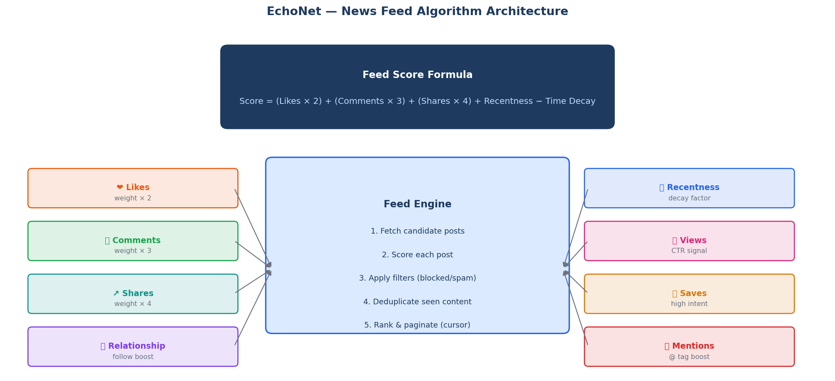
Figure 3 — Feed Algorithm Architecture & Scoring Signals

Scoring Formula
// TypeScript implementation
function scorePost(post: PostWithStats, relation: RelationType): number {
const recentness = Math.max(0, 48 - hoursSince(post.createdAt));
const timePenalty = hoursSince(post.createdAt) * 0.5;
const relBoost = relation === 'CLOSE_FRIEND' ? 2.0
: relation === 'FOLLOWS' ? 1.3 : 1.0;

return (
(post.likeCount * 2) +
(post.commentCount * 3) +
(post.shareCount * 4) +
(post.saveCount * 5) +
recentness
) * relBoost - timePenalty;
}

Feed Pipeline Steps
- Fetch candidate posts from followed users (last 72 hours)
- Score each post using the formula above
- Filter out blocked users and flagged/inactive content
- Deduplicate seen posts using a Redis Set per viewer
- Sort by score descending; return cursor-paginated results (page size: 20)

2.3 Advanced User Profile System
Profile Field | Type | Description
coverPhotoUrl | String? | Full-width banner image at the top of the profile page
bio | String? | Short personal description (max 160 characters)
website | String? | External link shown on profile
workplaces | Json? | Array of { company, role, startYear, endYear }
education | Json? | Array of { institution, degree, graduationYear }
location | String? | City / country display text
isPrivate | Boolean | Controls whether follow requests need approval
followersCount | Int | Cached count — updated on each follow/unfollow event
followingCount | Int | Cached count — updated on each follow/unfollow event
postsCount | Int | Cached total post count for the user

Profile tabs to implement: Posts, Media (images/video only), Tagged, Saved (private), About.

2.4 Search System
Full-text search across users, posts, and hashtags. Phase 1 uses PostgreSQL built-in full-text search. Phase 3 can migrate to Elasticsearch for advanced relevance ranking.

PostgreSQL Full-Text Search Setup
-- Add tsvector generated column + GIN index to posts
ALTER TABLE posts
ADD COLUMN search_vector tsvector
GENERATED ALWAYS AS (to_tsvector('english', coalesce(content, ''))) STORED;

CREATE INDEX idx_posts_search ON posts USING GIN (search_vector);

-- Search query example
SELECT * FROM posts
WHERE search_vector @@ plainto_tsquery('english', $1)
ORDER BY ts_rank(search_vector, plainto_tsquery('english', $1)) DESC
LIMIT 20;

Search Type | Endpoint | Searchable Fields | Index Strategy
Users | GET /search?q=&type=users | name, username, bio | B-tree on name; GIN tsvector on bio
Posts | GET /search?q=&type=posts | content, hashtags | GIN tsvector on content
Hashtags | GET /search?q=&type=tags | tag name | B-tree unique index on tag

2.5 Hashtag System

Prisma Schema
model Hashtag {
id String @id @default(uuid())
tag String @unique // stored lowercase, no # prefix
postCount Int @default(0)
createdAt DateTime @default(now())
posts PostHashtag[]
}

model PostHashtag {
id String @id @default(uuid())
postId String
hashtagId String
post Post @relation(fields: [postId], references: [id])
hashtag Hashtag @relation(fields: [hashtagId], references: [id])
@@unique([postId, hashtagId])
}

Processing Flow
- On post create/edit, extract tags: content.match(/#(\w+)/g)
- Upsert each Hashtag (create if missing, increment postCount)
- Create PostHashtag join records linking post to each hashtag
- Trending endpoint: SELECT tag ORDER BY postCount DESC WHERE updated in past 24h

2.6 Saved Posts (Bookmark System)
model SavedPost {
id String @id @default(uuid())
userId String
postId String
user User @relation(fields: [userId], references: [id])
post Post @relation(fields: [postId], references: [id])
createdAt DateTime @default(now())
@@unique([userId, postId])
}

- POST /saved/:postId — save a post (upsert, no duplicate error)
- DELETE /saved/:postId — unsave a post
- GET /saved — paginated list of current user's saved posts
- Saved collections are private — only the owner can view them

2.7 Notifications System Upgrade
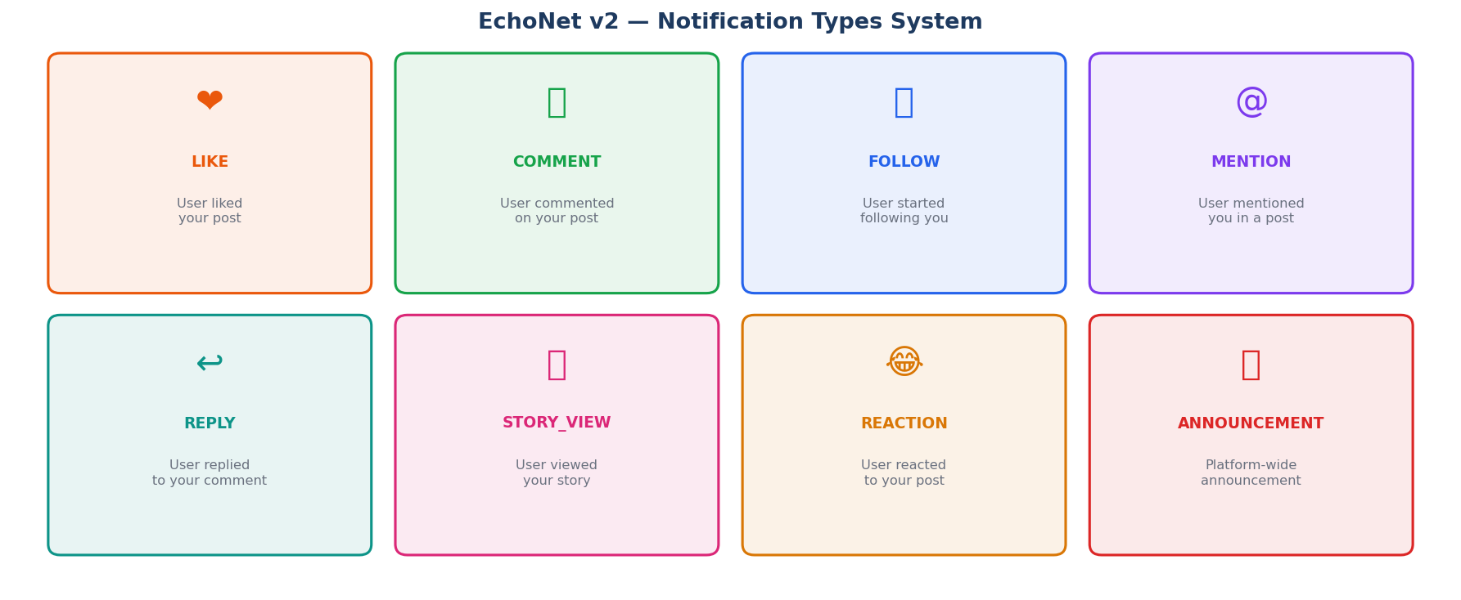
Figure 4 — All Notification Types in EchoNet v2

Type | Trigger Event | Recipient | Push + In-App
LIKE | User likes a post | Post author | Yes
REACTION | User reacts (Love/Haha/etc.) | Post author | Yes
COMMENT | User comments on a post | Post author | Yes
REPLY | User replies to a comment | Comment author | Yes
FOLLOW | User follows another user | Target user | Yes
FOLLOW_REQUEST | Follow on private profile | Target user | Yes
MENTION | @username in post or comment | Mentioned user | Yes
STORY_VIEW | User views a story | Story author | In-app only
ANNOUNCEMENT | Admin broadcasts message | All users | Yes
SHARE | User shares your post | Post author | Yes

3. Phase 2 — Advanced Engagement Features

3.1 Stories — 24-Hour Ephemeral Content
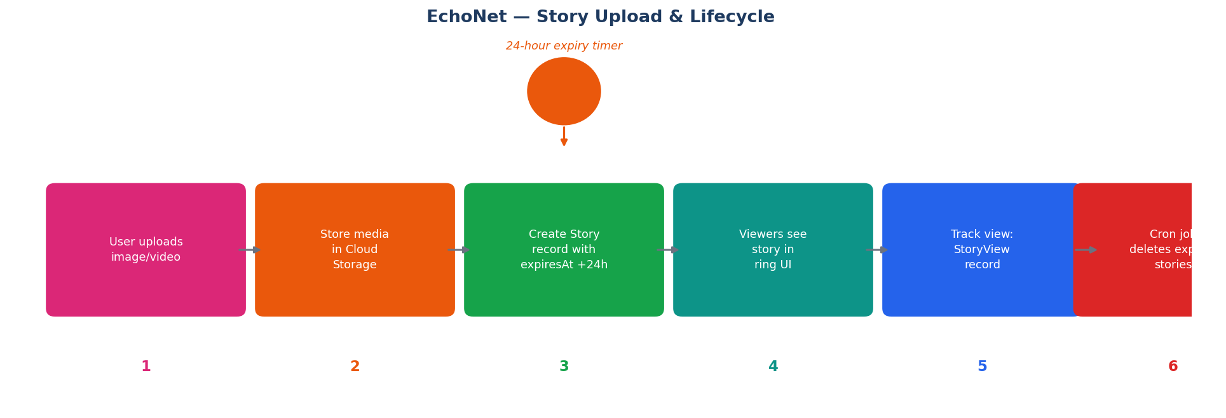
Figure 5 — Story Upload & 24-Hour Expiry Lifecycle

Prisma Schema
model Story {
id String @id @default(uuid())
authorId String
mediaUrl String
mediaType MediaType // IMAGE | VIDEO
caption String?
expiresAt DateTime // set to: createdAt + 24 hours
viewCount Int @default(0)
createdAt DateTime @default(now())
author User @relation(fields: [authorId], references: [id])
views StoryView[]
}

model StoryView {
id String @id @default(uuid())
storyId String
viewerId String
viewedAt DateTime @default(now())
@@unique([storyId, viewerId]) // one view record per user per story
}

Expiry Cron Job (BullMQ)
// Register repeatable cleanup job — runs every hour
storyCleanupQueue.add('cleanup', {}, {
repeat: { every: 3_600_000 } // 1 hour in ms
});

// Worker processor
storyCleanupWorker.process(async () => {
const deleted = await prisma.story.deleteMany({
where: { expiresAt: { lt: new Date() } }
});
console.log(`Cleaned up ${deleted.count} expired stories`);
});

3.2 Reels / Short Video
Aspect | Specification
Max duration | 60 seconds per reel
Aspect ratio | 9:16 vertical — enforced client-side before upload
Max file size | 50 MB (MP4, H.264 codec)
Storage & CDN | Cloud storage with HLS transcoding via media queue worker
Feed type | Separate GET /reels endpoint — vertical infinite scroll UI
Engagement | Likes, comments, shares, and reactions identical to regular posts
Data model | Extends Post: add isReel: Boolean and duration: Int (seconds) fields

3.3 Group System
model Group {
id String @id @default(uuid())
name String
description String?
coverUrl String?
privacy GroupPrivacy // PUBLIC | PRIVATE
createdBy String
createdAt DateTime @default(now())
creator User @relation(fields: [createdBy], references: [id])
members GroupMember[]
}

model GroupMember {
id String @id @default(uuid())
groupId String
userId String
role GroupRole // ADMIN | MODERATOR | MEMBER
joinedAt DateTime @default(now())
@@unique([groupId, userId])
}

Endpoint | Method | Description
/groups | POST | Create a new group
/groups/:id | GET | Get group details + member count
/groups/:id/join | POST | Join public group or send request for private
/groups/:id/posts | GET | Paginated group post feed
/groups/:id/posts | POST | Create a post inside the group
/groups/:id/members | GET | List all members (paginated)
/groups/:id/members/:userId | DELETE | Remove a member (group admin only)

3.4 Business Pages
- Pages are a special User sub-type: add type: PERSONAL | PAGE to the User model
- Pages use followers-only model (no mutual follow) — identical to Instagram for Business
- Page admins can boost posts through the Ads system (Phase 3)
- Separate GET /pages/:id endpoint for public page feed and about section
- Page analytics available to owners: reach, impressions, follower growth over time

3.5 Live Streaming
Component | Technology | Notes
Signalling | Socket.IO | Add live:start, live:join, live:end events to existing server
Media transport | WebRTC SFU (Mediasoup/LiveKit) | Broadcaster sends once; SFU fans out to all viewers
Fallback for large audiences | HLS via RTMP ingest | Use MediaMTX as RTMP-to-HLS relay for 100+ viewers
Real-time comments | Socket.IO room (live:{streamId}) | All viewers emit and receive comments in real time
VOD replay | Optional HLS recording | Store HLS segments to cloud storage after stream ends
Live viewer count | Redis INCR/DECR counter | Broadcast updated count every 5 seconds via socket

3.6 Reaction System (Multi-Type)
The simple Like model is upgraded to a multi-type reaction. The Like table is renamed to Reaction with a type discriminator enum.

enum ReactionType { LIKE LOVE HAHA SAD ANGRY WOW }

model Reaction {
id String @id @default(uuid())
userId String
postId String?
commentId String?
type ReactionType
createdAt DateTime @default(now())

user User @relation(fields: [userId], references: [id])
post Post? @relation(fields: [postId], references: [id])
comment Comment? @relation(fields: [commentId], references: [id])

@@unique([userId, postId]) // one reaction per user per post
@@unique([userId, commentId]) // one reaction per user per comment
}

3.7 Share Post Feature
model Share {
id String @id @default(uuid())
sharerId String
originalPostId String
shareType ShareType // TIMELINE | GROUP | CHAT | EXTERNAL
targetId String? // groupId or conversationId for non-timeline shares
caption String?
createdAt DateTime @default(now())
}

enum ShareType { TIMELINE GROUP CHAT EXTERNAL }

3.8 Tagging System
model PostTag {
id String @id @default(uuid())
postId String
userId String // the tagged person
x Float? // optional photo coords (0.0 - 1.0 normalised)
y Float?
post Post @relation(fields: [postId], references: [id])
user User @relation(fields: [userId], references: [id])
@@unique([postId, userId])
}

- Tagged users receive a TAGGED notification; post appears in their Tagged profile tab
- Users can remove their own tag: DELETE /posts/:postId/tags/me
- Users can restrict who can tag them via profile privacy settings

4. Phase 3 — Pro / Scale Features

Feature | Priority | Description | Technology
Feed Personalisation AI | High | ML model trained on user interactions to rank For You feed | TensorFlow.js / Python microservice
Content Moderation AI | High | Auto-flag toxic comments; NSFW image detection before storage | OpenAI Moderation API / Google Vision
End-to-End Encrypted Chat | High | Signal Protocol for DMs; server cannot read messages | libsodium / @signalapp/libsignal-client
Ads System | Medium | Sponsored posts injected into feed; cost-per-impression model | Custom ad server + SSLCommerz billing
Creator Monetisation | Medium | Subscriptions, paid posts, tip jar (bKash/Nagad) | SSLCommerz + Subscription model
Analytics Dashboard | Medium | Creators see reach, impressions, follower growth charts | Chart.js + PostgreSQL aggregation queries
Progressive Web App | Medium | Installable on Android/iOS; offline post drafting | next-pwa + service worker + IndexedDB
Multi-language (Bangla + English) | Low | Bengali + English UI; RTL-safe layouts | next-intl with bn and en locales
Email System | High | Verification, password reset, and digest emails | Nodemailer + SMTP (SendGrid / SES)
Super Admin Dashboard | High | User stats, moderation queue, graphs, CSV export | Admin Next.js route + Recharts

5. New Data Models — Full Schema Reference

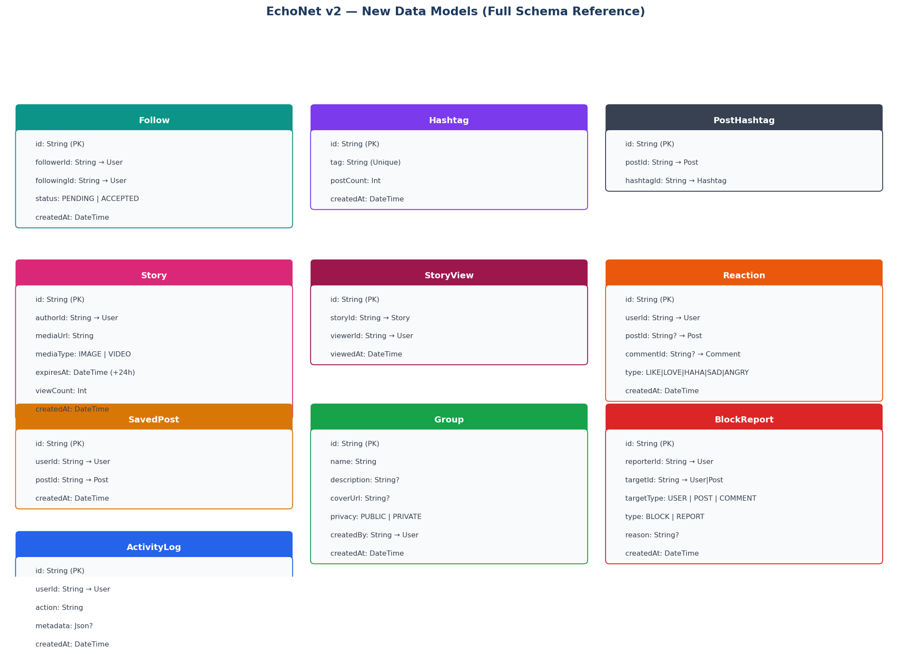
Figure 6 — All New Prisma Models for EchoNet v2

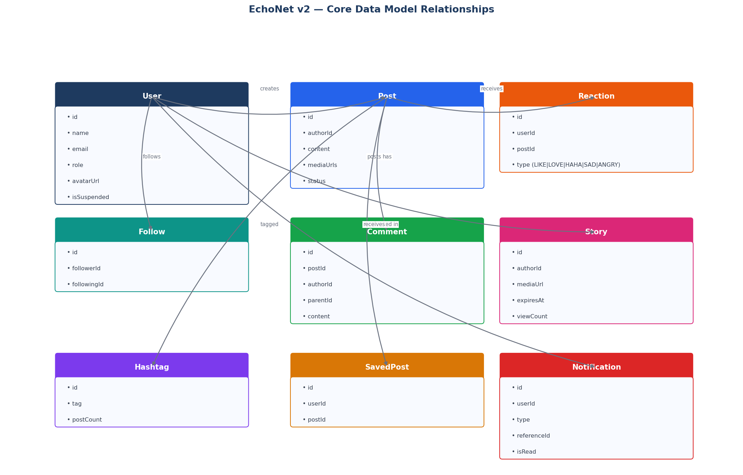
Figure 7 — Core Entity Relationship Overview

5.1 New Models Summary Table
Model | Purpose | Key Relations
Follow | Social graph — who follows whom | User (follower) → User (following)
Hashtag | Trend tracking for topics | Many-to-many with Post via PostHashtag
PostHashtag | Join table for post-hashtag relation | Post ↔ Hashtag
Story | 24-hour ephemeral media | User (author) → many StoryView
StoryView | Tracks who viewed each story | Story ↔ User (viewer)
Reaction | Multi-type engagement (6 types) | User → Post or Comment
SavedPost | Bookmark system for posts | User → Post (unique pair)
Share | Sharing posts to timeline/group/chat | User → Post (original)
Group | Community spaces with posts | User (creator) → GroupMember
GroupMember | Group membership + role | Group ↔ User
PostTag | Tagging friends in posts and photos | Post ↔ User (tagged person)
ActivityLog | Audit trail of all user actions | User → logged action string
BlockReport | Block or report users / content | User (reporter) → any target entity

6. System Architecture Update

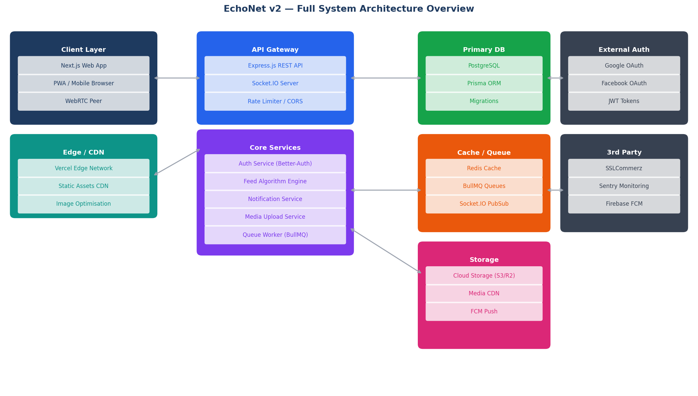
Figure 8 — EchoNet v2 Full System Architecture

6.1 New Architectural Components
Component | Description | Phase
BullMQ Worker Cluster | Processes notification, email, and media queues asynchronously | 1
Feed Engine Service | Dedicated module that scores and ranks feed posts per viewer | 1
Cron Job Service | Story expiry cleanup, trending hashtag recalculation, cache warmup | 1
Media Transcoding Worker | Converts uploaded video to HLS; generates image thumbnails | 2
Live Streaming SFU | Mediasoup/LiveKit Selective Forwarding Unit for many-to-many video | 2
AI Moderation Microservice | Python FastAPI service running content moderation ML models | 3
Ad Server | Injects sponsored posts into feed based on targeting rules | 3
Email Service | Nodemailer with SendGrid/SES for all transactional email delivery | 3

7. REST API Endpoint Reference

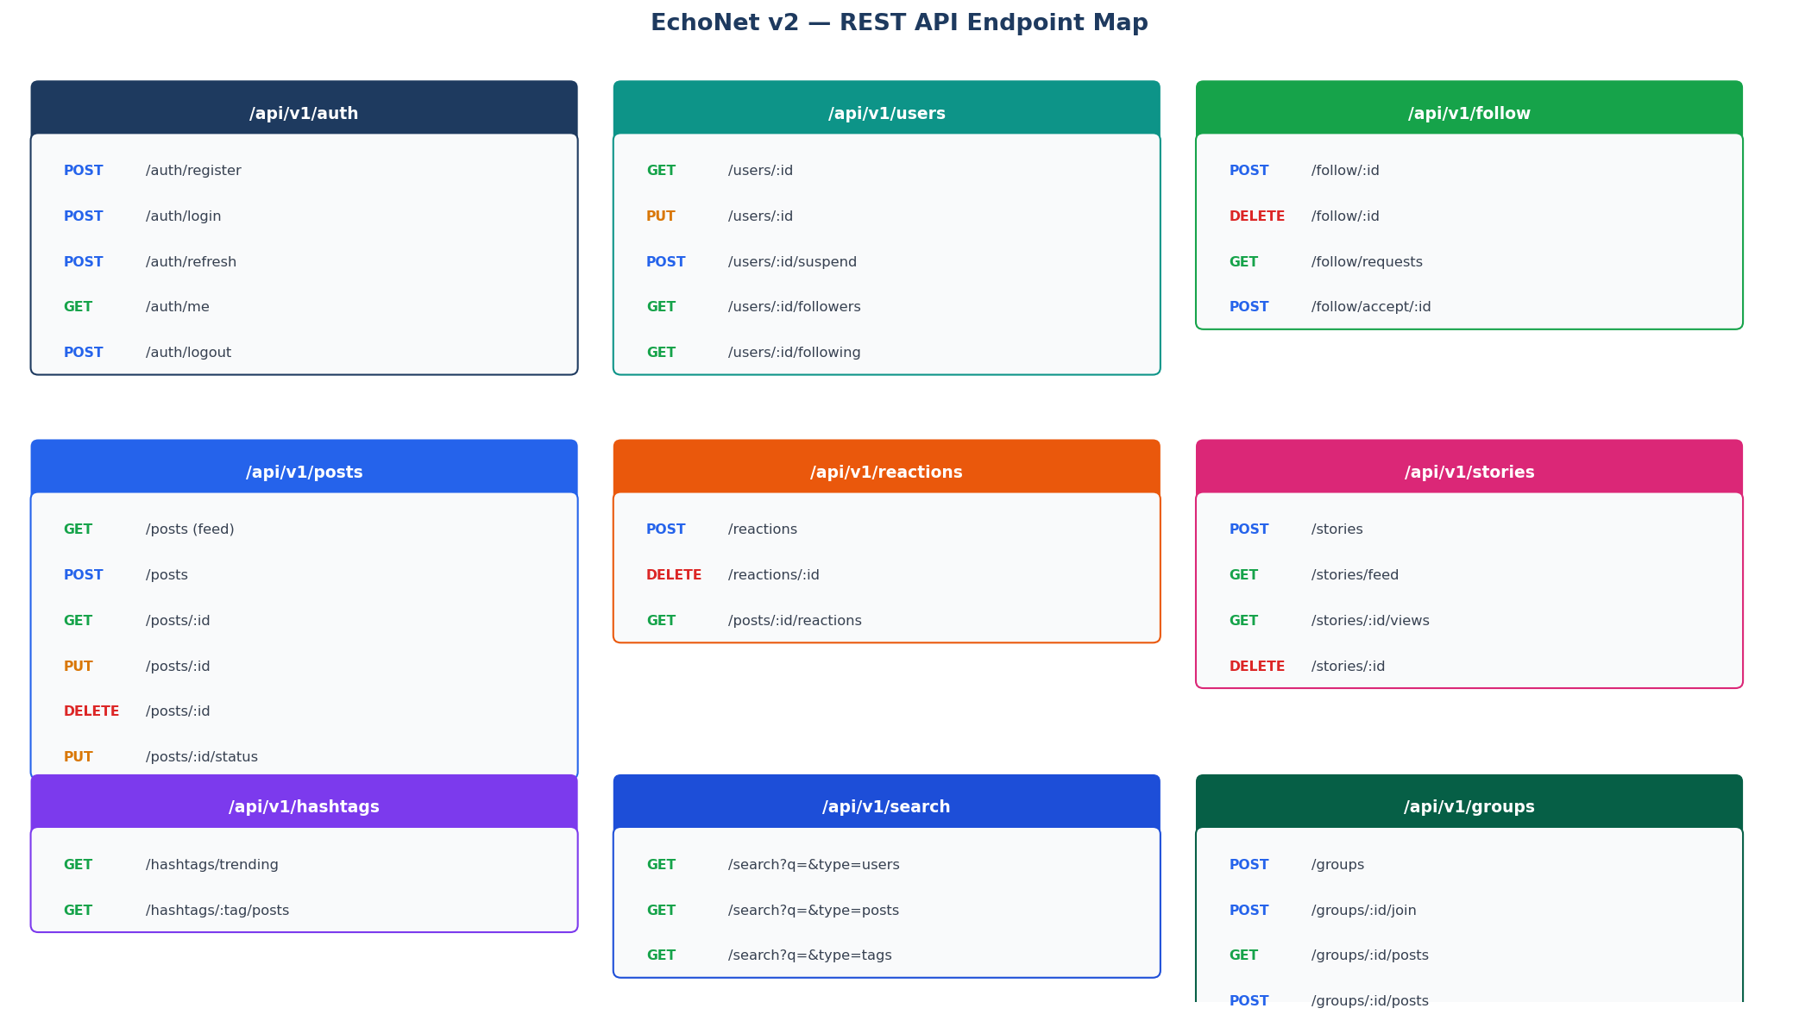
Figure 9 — EchoNet v2 API Endpoint Map

7.1 New Endpoint Groups
Group | Base Path | HTTP Methods | Auth Required
Follow | POST/DELETE /follow/:id | POST, DELETE, GET | Yes
Reactions | POST/DELETE /reactions | POST, DELETE, GET | Yes
Stories | POST/GET /stories | POST, GET, DELETE | Yes
Hashtags | GET /hashtags | GET | Trending: No — Feed: Yes
Search | GET /search | GET | No
Saved Posts | POST/GET /saved | POST, DELETE, GET | Yes
Groups | POST/GET /groups | POST, GET, PUT, DELETE | Yes
Shares | POST /shares | POST, GET | Yes
Post Tags | POST /posts/:id/tags | POST, DELETE, GET | Yes
Reels | GET/POST /reels | GET, POST | View: No — Post: Yes
Pages | POST/GET /pages | POST, GET, PUT | Yes
Analytics | GET /analytics/me | GET | Yes (owner only)

8. BullMQ Async Queue System

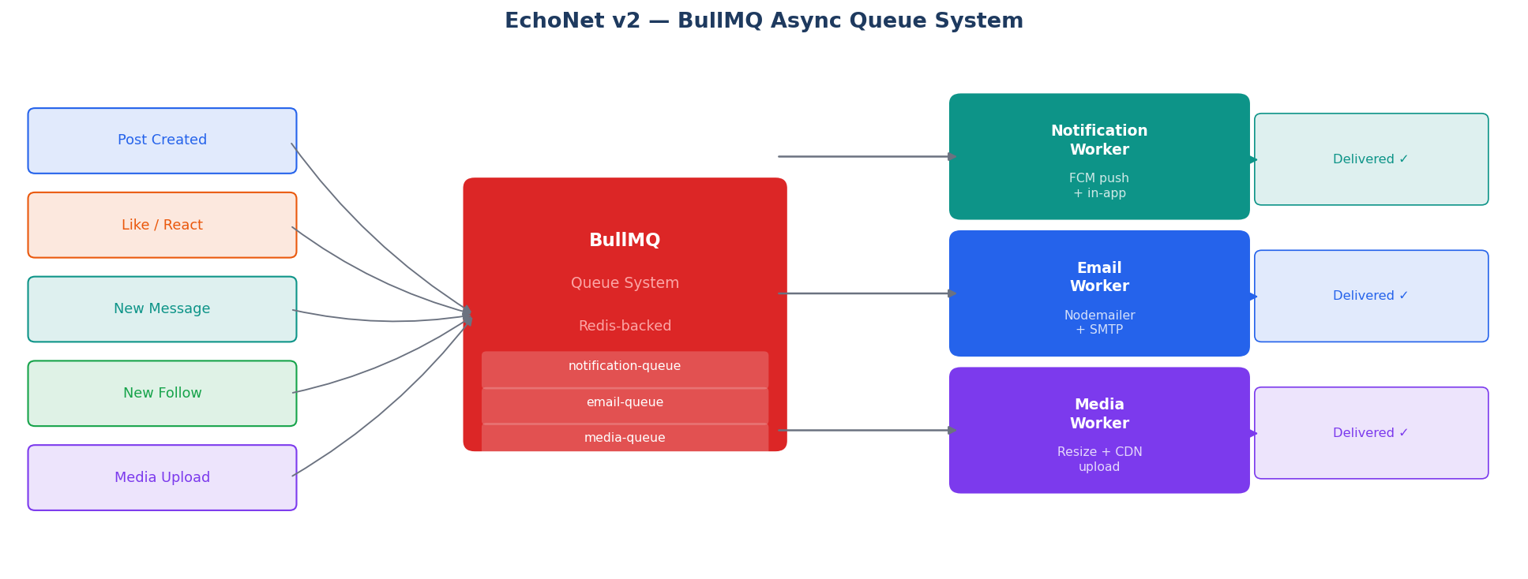
Figure 10 — BullMQ Queue Flow with Redis Backend

8.1 Queue Definitions
// queue-names.ts
export const QUEUES = {
NOTIFICATION: 'notification-queue',
EMAIL: 'email-queue',
MEDIA: 'media-queue',
STORY_CLEANUP: 'story-cleanup-queue',
FEED_WARMUP: 'feed-warmup-queue',
} as const;

// Example: dispatch a notification job
await notificationQueue.add('push', {
userId: recipientId,
type: 'LIKE',
referenceId: postId,
message: `${actor.name} liked your post`,
}, { attempts: 3, backoff: { type: 'exponential', delay: 2000 } });

Queue | Job Types | Worker Actions | Retry Policy
notification-queue | push, in-app | FCM push + Prisma notification insert | 3 attempts, exponential backoff
email-queue | verify, reset, digest | Nodemailer via SMTP relay | 3 attempts, 5 s fixed delay
media-queue | transcode, thumbnail | FFmpeg resize + CDN upload | 2 attempts, 30 s delay
story-cleanup-queue | cleanup | Prisma deleteMany expired stories | 1 attempt, hourly cron
feed-warmup-queue | warm | Pre-compute feed scores for active users | 1 attempt, every 15 min

9. Backend Improvements

9.1 Soft Delete System
All user-generated content is soft-deleted: the record is hidden but not physically removed. This enables content recovery, admin review, and full audit trails.
// Add deletedAt to: Post, Comment, Story, Message
deletedAt DateTime? // null = active; non-null = soft-deleted

// Prisma middleware — auto-exclude deleted records from all queries
prisma.$use(async (params, next) => {
const models = ['Post', 'Comment', 'Story', 'Message'];
if (models.includes(params.model!) && params.action === 'findMany') {
params.args.where = { ...params.args.where, deletedAt: null };
}
return next(params);
});

9.2 Block / Report System
model BlockReport {
id String @id @default(uuid())
reporterId String
targetId String // userId, postId, or commentId
targetType TargetType // USER | POST | COMMENT
type ActionType // BLOCK | REPORT
reason String?
status ReportStatus @default(PENDING) // PENDING | REVIEWED | DISMISSED
createdAt DateTime @default(now())
}

- Blocked users: their posts are hidden from the blocker's feed; DMs disabled between them
- Reports go into the admin moderation queue in the Super Admin Dashboard
- Auto-suspend threshold: 10 valid reports against a user triggers an auto-review flag

9.3 Activity Log
model ActivityLog {
id String @id @default(uuid())
userId String
action String // e.g. 'POST_CREATED', 'USER_SUSPENDED', 'LOGIN'
metadata Json? // { postId, ip, userAgent, ... }
createdAt DateTime @default(now())
user User @relation(fields: [userId], references: [id])

@@index([userId, createdAt])
}

- Logged actions: login, logout, post/comment/story create, follow, suspension, role change
- Available in Super Admin Dashboard for compliance auditing
- Retained for 90 days; older entries are archived to cold storage (S3 Glacier / R2)

9.4 Database Index Strategy
Index Name | Table | Column(s) | Reason
idx_posts_author_date | posts | (authorId, createdAt DESC) | Fast profile post timeline feed
idx_posts_search | posts | search_vector (GIN) | Full-text search on post content
idx_follow_follower | follows | followerId | Feed candidate post lookup
idx_follow_following | follows | followingId | Follower list queries
idx_reactions_post | reactions | postId | Aggregate reaction counts per post
idx_notif_user_read | notifications | (userId, isRead) | Unread notification badge count
idx_stories_expires | stories | expiresAt | Cron cleanup and active story filter
idx_activity_user_date | activity_logs | (userId, createdAt) | User activity timeline queries
idx_hashtags_tag | hashtags | tag (unique B-tree) | O(log n) hashtag lookup by name
idx_savedposts_user | saved_posts | (userId, createdAt DESC) | Paginated saved posts feed

10. Future Enhancements Backlog

Feature | Phase | User Impact | Build Complexity
Stories — music/sticker overlays | 3 | High | Medium
Collaborative posts (co-authors) | 3 | Medium | High
Event system (create / RSVP) | 3 | High | High
Polls inside posts | 2 | Medium | Low
Verified badge (blue tick) | 3 | High | Low
Creator tipping (bKash / Nagad) | 4 | High | Medium
AR camera filters for Stories | 4 | Medium | Very High
Offline read mode (PWA) | 3 | Medium | Medium
Voice messages in chat | 3 | High | Medium
Post translation (Bangla to English) | 4 | High | Medium
Location check-in on posts | 3 | Medium | Low
Dark mode | 2 | High | Low
Mutual friend suggestions | 2 | High | Medium
Post boosting / Paid reach | 4 | High | High
Super Admin CSV data export | 3 | Medium | Low

EchoNet Feature Update v2 | Confidential | Version 2.0 | March 2026

