Enterprise Network Automation and
Hybrid-Cloud Infrastructure as Code
Project ENT-HYBRID-NET — GNS3 · Ansible · Git · Terraform on AWS
Item | Details
Unit | [Unit code and name]
Assessment | Group Project – Enterprise Network Design, Automation and Cloud IaC
Group | [Group name / number]
Members | [Student name – ID]  [Student name – ID]  [Student name – ID]
Lecturer / Tutor | [Name]
Git repository | https://github.com/shakil-shahan02/Enterprise-Network-Automation (private)
Submission date | [dd/mm/yyyy]

Table of Contents
1. Executive Summary 3
2. Introduction 4
2.1 Scenario and objectives 4
2.2 Tools and platform 4
2.3 Repository structure 4
3. Enterprise Network Design (Part A) 5
3.1 Topology 5
3.2 IP addressing plan 5
3.3 Configuration of required services 6
3.4 Connectivity verification 8
3.5 Design justification 15
4. Network Automation with Ansible (Part B) 16
4.1 Automation architecture 16
4.2 Playbooks and roles 16
4.3 Automation outputs 18
4.4 Infrastructure as Code for the network 29
5. AWS Infrastructure as Code with Terraform (Part C) 31
5.1 Architecture 31
5.2 Terraform code 31
5.3 Terraform workflow and AWS deployment 33
5.4 Version control with Git 38
6. Testing 40
7. Discussion 41
7.1 Challenges and how they were solved 41
7.2 Security considerations 42
7.3 Limitations and future work 42
8. Conclusion 43
References 44
Appendix A – Submission Contents and Evidence Index 45

Right-click the table and choose “Update Field” in Word to refresh page numbers.

1. Executive Summary
A multinational enterprise asked our consulting team to replace manual, device-by-device network administration with an automated, secure and repeatable hybrid-cloud platform. This report documents the complete solution we designed, built and tested.
On-premises network (Part A). We built a new GNS3 lab, ENT-HYBRID-NET, using a three-layer hierarchical design (core / distribution / access) that links Headquarters, a Branch Office and a Data Centre. It contains 4 Cisco 7200 routers, 6 Cisco EtherSwitch (NM-16ESW) switches, 6 Linux end-hosts/servers and a Debian-based Linux automation server (ANSIBLE-SRV). The network provides VLAN segmentation, router-on-a-stick inter-VLAN routing, multi-area OSPF with MD5 authentication and ABR summarisation, per-site DHCP, a central DNS server, NTP, remote Syslog, SSH-only management, four security ACLs and Internet access through PAT.
Automation (Part B). The configuration is described once, as YAML data in an Ansible inventory, and deployed by eight Ansible roles: backup, baseline hardening, switching, routing, services, ACLs, verification and compliance. Credentials are protected with Ansible Vault. Every change is version-controlled in Git, previewed with check/diff mode, applied idempotently, then automatically verified and audited.
Cloud (Part C). Terraform code provisions an AWS VPC with two public and two private subnets across two Availability Zones, an Internet Gateway, route tables, least-privilege security groups, a bastion host, a private Amazon Linux EC2 instance and an ED25519 SSH key pair. The code was validated, planned, deployed to the team's AWS account (25 resources), verified with the AWS CLI and an SSH session through the bastion, and then destroyed; an all-region audit confirmed no billable resources remained. The Git history shows the code being built up one commit at a time.
All functional tests passed: inter-site reachability, Internet access via NAT, DNS resolution, DHCP leasing, ACL enforcement, SSH-only management, Syslog collection, idempotent automation and a Git-driven Day-2 change. NTP is configured and every client reaches the NTP master, but emulator clock drift stops IOS from declaring synchronisation in the lab (see Section 7). The report closes with lessons learned and a roadmap: CI/CD pipelines, a source-of-truth (NetBox) and a site-to-site VPN to the AWS VPC.

2. Introduction

2.1 Scenario and objectives
The client is moving from traditional CLI-driven administration to an automated hybrid-cloud environment. Manual configuration causes inconsistent device settings, slow change delivery, configuration drift and poor audit trails. The engagement objectives were:
- Design and build a scalable, redundant, secure enterprise network for HQ, Branch and Data Centre (Part A).
- Automate configuration, backup, verification and compliance of every network device with Ansible (Part B).
- Provision secure AWS infrastructure with Terraform, stored and versioned in Git (Part C).
- Treat the network and cloud as code: declarative, reviewed, repeatable and testable.

2.2 Tools and platform
Component | Version / image | Role in project
GNS3 GUI + server | 2.2.61 (local server + GNS3 VM on VirtualBox 7.2) | Network emulation, REST API used to build the topology
Routers | Cisco 7200 – IOS 15.0(1)M adventerprisek9 | R1-HQ, R2-BR, R3-DC, R4-CORE
Switches | Cisco 2691 + NM-16ESW – IOS 12.4(23) | 3 distribution + 3 access EtherSwitches
Linux hosts | Docker: alpine:3.20 (PCs), nginx:alpine (web server) | DHCP clients, test endpoints, web server
Automation server | Docker: python:3.12-slim (Debian 13) + ansible-core 2.17.14 | Ansible control node, Syslog collector
Ansible collections | cisco.ios 11.6.0, ansible.netcommon 8.7.1, ansible.utils 6.1.1, ansible.posix 2.2.2 | Network modules (network_cli over SSH/paramiko)
Terraform | 1.16.2, hashicorp/aws 6.66, tls 4.4, local 2.9 | AWS Infrastructure as Code
Git | 2.54 + GitHub (private repository) | Version control for all code, configs and evidence
Host | Windows 11, Intel i9-14900HX, 32 GB RAM | Lab host
Table 1: Tools, versions and roles

2.3 Repository structure
Enterprise-Network-Automation/
├── gns3/ GNS3 REST client + topology builder (nodes, links, labels)
├── configs/ Day-0 device configurations (rendered, secrets as placeholders)
├── scripts/ config generator, console bootstrap, evidence tooling
├── docs/ IP plan, design justification, AWS architecture diagram
├── ansible/ ansible.cfg, inventory/ (source of truth), roles/, playbooks/, backups/, reports/
├── terraform/ versions/variables/network/security/compute/outputs .tf
├── evidence/ raw command outputs, Ansible run logs, terraform plan
├── screenshots/ evidence screenshots used in this report
└── report/ this report and its generator

3. Enterprise Network Design (Part A)

3.1 Topology
Figure 1 shows the GNS3 topology, built from scratch with a Python script that calls the GNS3 REST API (gns3/build_topology.py). Because the whole lab is created as code, it can be rebuilt the same way every time. The layout follows the hierarchical model top to bottom: Internet edge and core, then the distribution layer (site routers and distribution switches), then the access layer (access switches and end hosts). Each site is drawn as its own coloured block, and every link is labelled with its subnet.
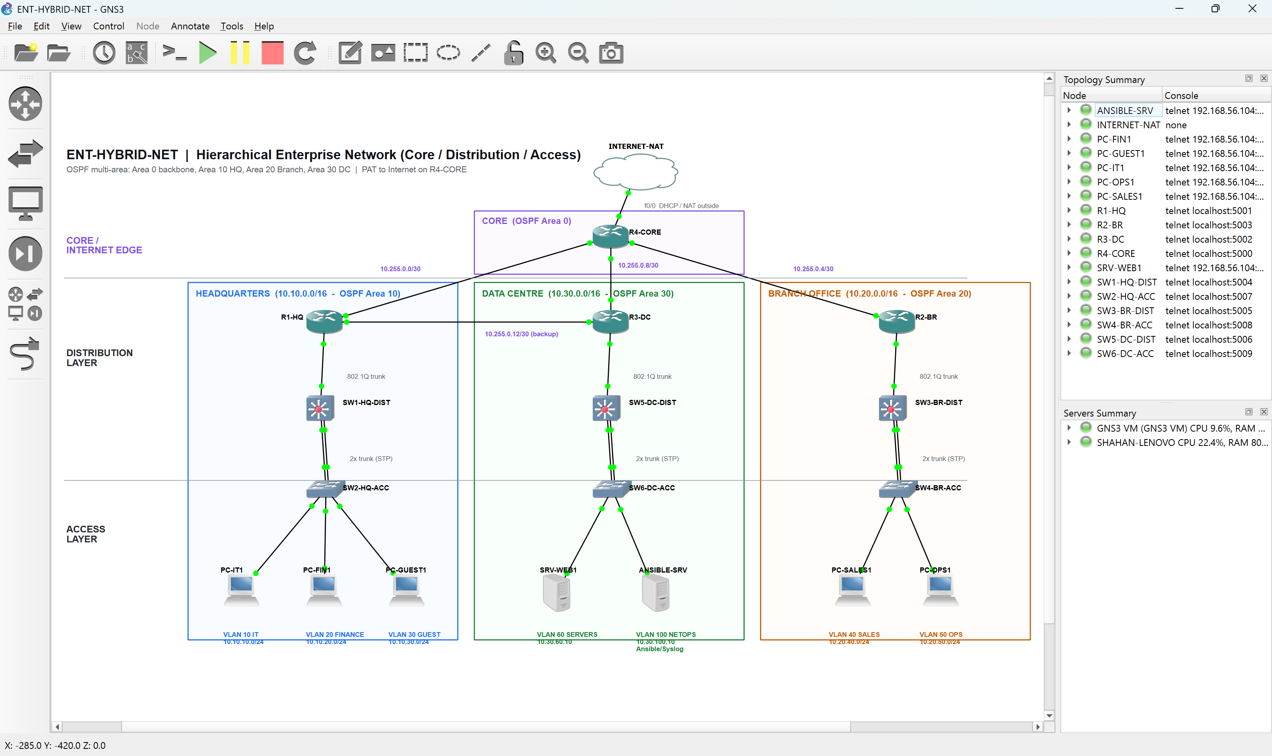
Figure 1: ENT-HYBRID-NET GNS3 topology – hierarchical core / distribution / access design
Layer | Devices | Functions
Core / Internet edge | R4-CORE, INTERNET-NAT | Backbone transit (OSPF area 0), PAT to Internet, NTP master, default-route origination
Distribution | R1-HQ, R2-BR, R3-DC (ABRs)  SW1-HQ-DIST, SW3-BR-DIST, SW5-DC-DIST | Inter-VLAN routing, OSPF summarisation, ACL policy, DHCP, DNS (DC), STP root bridge
Access | SW2-HQ-ACC, SW4-BR-ACC, SW6-DC-ACC  PCs, SRV-WEB1, ANSIBLE-SRV | Host attachment, VLAN assignment, PortFast, unused ports shut down
Table 2: Hierarchical layers and device roles
The minimum requirement of 4 routers, 6 switches and a Linux automation server is met: 4 × c7200 routers, 6 × c2691 EtherSwitch switches, and ANSIBLE-SRV (Debian 13 Linux container) in the Data Centre NETOPS VLAN.

3.2 IP addressing plan
Each site receives one summarisable /16 block, so each ABR advertises a single inter-area route into area 0. Loopbacks come from 10.0.0.0/24, and WAN links use /30s from 10.255.0.0/24. The AWS VPC uses 172.20.0.0/16 so it never overlaps the on-premises ranges, which leaves a future site-to-site VPN possible.
Site | VLAN | Name | Subnet | Gateway | DHCP / notes
HQ | 10 | IT | 10.10.10.0/24 | 10.10.10.1 (R1 Fa0/0.10) | Pool HQ-IT; may manage devices
HQ | 20 | FINANCE | 10.10.20.0/24 | 10.10.20.1 (R1 Fa0/0.20) | Pool HQ-FINANCE; ACL FINANCE-PROTECT
HQ | 30 | GUEST | 10.10.30.0/24 | 10.10.30.1 (R1 Fa0/0.30) | Pool HQ-GUEST; ACL GUEST-IN
HQ | 99 | MGMT | 10.10.99.0/24 | 10.10.99.1 | SW1 .11, SW2 .12 (static)
Branch | 40 | SALES | 10.20.40.0/24 | 10.20.40.1 (R2 Fa0/0.40) | Pool BR-SALES
Branch | 50 | OPERATIONS | 10.20.50.0/24 | 10.20.50.1 (R2 Fa0/0.50) | Pool BR-OPERATIONS
Branch | 99 | MGMT | 10.20.99.0/24 | 10.20.99.1 | SW3 .11, SW4 .12
DC | 60 | SERVERS | 10.30.60.0/24 | 10.30.60.1 (R3 Fa0/0.60) | SRV-WEB1 10.30.60.10; ACL SERVERS-PROTECT
DC | 100 | NETOPS | 10.30.100.0/24 | 10.30.100.1 (R3 Fa0/0.100) | ANSIBLE-SRV 10.30.100.10 (Syslog)
DC | 99 | MGMT | 10.30.99.0/24 | 10.30.99.1 | SW5 .11, SW6 .12
Table 3: VLAN and subnet allocation
Device | Interface | IP address | Connected to / purpose
R4-CORE | Lo0 / Fa0/0 | 10.0.0.4/32 / DHCP 192.168.42.x | Router-ID + NTP master / INTERNET-NAT (NAT outside)
R4-CORE | Fa1/0 · Fa1/1 · Fa2/0 | 10.255.0.1 · .5 · .9 /30 | R1-HQ · R2-BR · R3-DC (NAT inside, area 0)
R1-HQ | Lo0 · Fa1/0 · Fa1/1 | 10.0.0.1 · 10.255.0.2 · 10.255.0.13 | Router-ID · R4 · R3 backup link (cost 100)
R2-BR | Lo0 · Fa1/0 | 10.0.0.2 · 10.255.0.6 | Router-ID · R4
R3-DC | Lo0 · Fa1/0 · Fa1/1 | 10.0.0.3 · 10.255.0.10 · 10.255.0.14 | Router-ID + DNS server · R4 · R1 backup
R1/R2/R3 | Fa0/0.<vlan> | .1 of each site VLAN | 802.1Q trunk to the distribution switch
SW1 … SW6 | Vlan99 | 10.x0.99.11 (dist) / .12 (acc) | Management SVI, default gateway 10.x0.99.1
ANSIBLE-SRV | eth0 | 10.30.100.10/24 | Automation + Syslog (ansible.corp.local)
SRV-WEB1 | eth0 | 10.30.60.10/24 | nginx web server (web.corp.local)
PCs | eth0 | DHCP | PC-IT1, PC-FIN1, PC-GUEST1 (HQ) · PC-SALES1, PC-OPS1 (Branch)
Table 4: Device interface addressing

3.3 Configuration of required services
Requirement | Implementation | Devices
VLANs | VTP transparent; VLANs created in the NM-16ESW VLAN database; dual 802.1Q trunks dist↔access; STP root priority 4096 on distribution switch | SW1–SW6
Inter-VLAN routing | Router-on-a-stick: dot1Q sub-interfaces Fa0/0.<vlan> on each site router | R1, R2, R3
OSPF | Process 1, multi-area (0/10/20/30), ABR summarisation (area range), MD5 auth on area 0, passive-interface default, ref-bw 1000, default-information originate on R4 | R1–R4
DHCP | Per-VLAN pools with excluded .1–.20, default-router, DNS 10.0.0.3, domain corp.local | R1, R2
SSH | SSH v2, RSA 2048, local user privilege 15 (secret), VTY transport input ssh + access-class MGMT-ACCESS | All
ACLs | MGMT-ACCESS (VTY), GUEST-IN, FINANCE-PROTECT, SERVERS-PROTECT, NAT-INSIDE | All / R1, R3, R4
NAT | PAT overload on R4 Fa0/0; NAT-INSIDE excludes internal-to-internal traffic | R4
DNS | ip dns server + ip host records for corp.local, forwards to 8.8.8.8; clients use 10.0.0.3 | R3 (server), all (client)
NTP | R4 ntp master 3; all others ntp server 10.0.0.4; timezone AEST | All
Syslog | logging host 10.30.100.10, trap informational, source Loopback0/Vlan99, buffered 16 KB | All
Table 5: Required services and how they are configured
The full device configurations are in configs/*.cfg (Day-0, generated by scripts/gen_configs.py) and in ansible/backups/latest/*.cfg (the live running-configurations collected by Ansible). Key excerpts follow.
Excerpt – R1-HQ multi-area OSPF and DHCP (configs/R1-HQ.cfg)
router ospf 1
router-id 10.0.0.1
area 0 authentication message-digest
area 10 range 10.10.0.0 255.255.0.0
passive-interface default
no passive-interface FastEthernet1/0
no passive-interface FastEthernet1/1
network 10.0.0.1 0.0.0.0 area 0
network 10.255.0.0 0.0.0.3 area 0
network 10.255.0.12 0.0.0.3 area 0
network 10.10.10.0 0.0.0.255 area 10
network 10.10.20.0 0.0.0.255 area 10
network 10.10.30.0 0.0.0.255 area 10
network 10.10.99.0 0.0.0.255 area 10
ip dhcp pool HQ-IT
network 10.10.10.0 255.255.255.0
default-router 10.10.10.1
dns-server 10.0.0.3
network 10.10.20.0 255.255.255.0
dns-server 10.0.0.3
network 10.10.30.0 255.255.255.0
dns-server 10.0.0.3

Excerpt – R4-CORE NAT/PAT, NTP master, default route (configs/R4-CORE.cfg)
ntp master 3
description INTERNET (GNS3 NAT cloud) - PAT outside
ip nat outside
ip nat inside
ip nat inside
ip nat inside
! ===== NAT / PAT for all enterprise networks =====
ip access-list extended NAT-INSIDE
deny ip 10.0.0.0 0.255.255.255 10.0.0.0 0.255.255.255
permit ip 10.0.0.0 0.255.255.255 any
ip nat inside source list NAT-INSIDE interface FastEthernet0/0 overload
default-information originate always

Excerpt – SW2-HQ-ACC VLAN database and access ports (configs/SW2-HQ-ACC.cfg)
!EXEC-BEGIN
vlan database
vtp transparent
vlan 10 name IT
vlan 20 name FINANCE
vlan 30 name GUEST
vlan 99 name MGMT
apply
exit
!EXEC-END
switchport mode trunk
switchport mode trunk
interface FastEthernet1/5
switchport mode access
switchport access vlan 10
spanning-tree portfast
switchport mode access
switchport access vlan 20

3.4 Connectivity verification
The following screenshots come from live device consoles. Each window is titled with the device, the feature being verified and a timestamp.
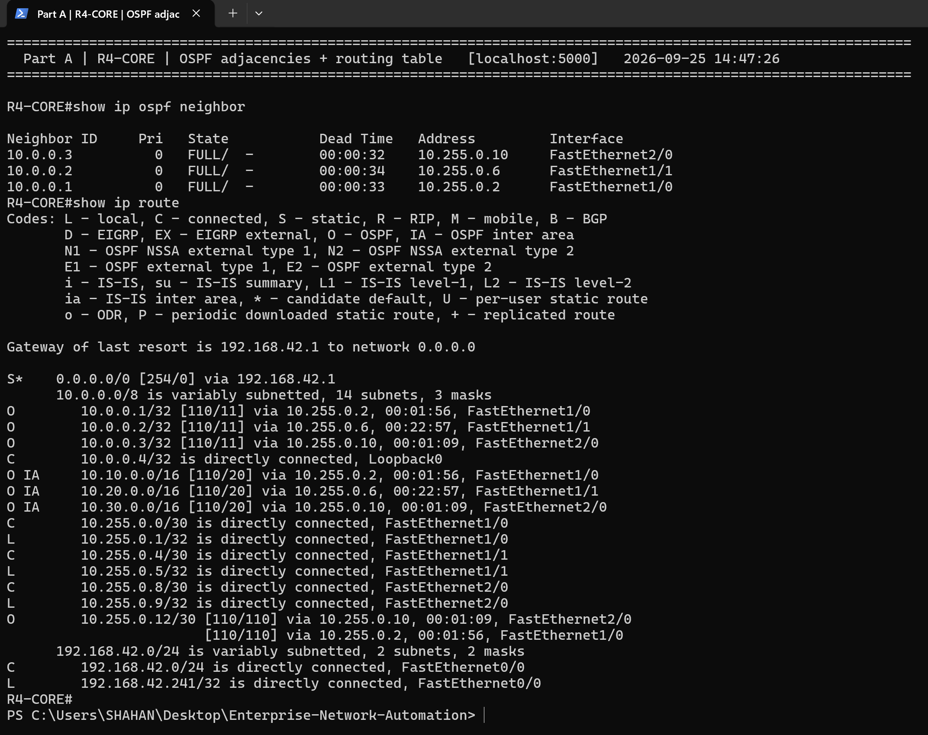
Figure 2: R4-CORE – three FULL OSPF adjacencies, /16 inter-area summaries per site and the default route to the Internet
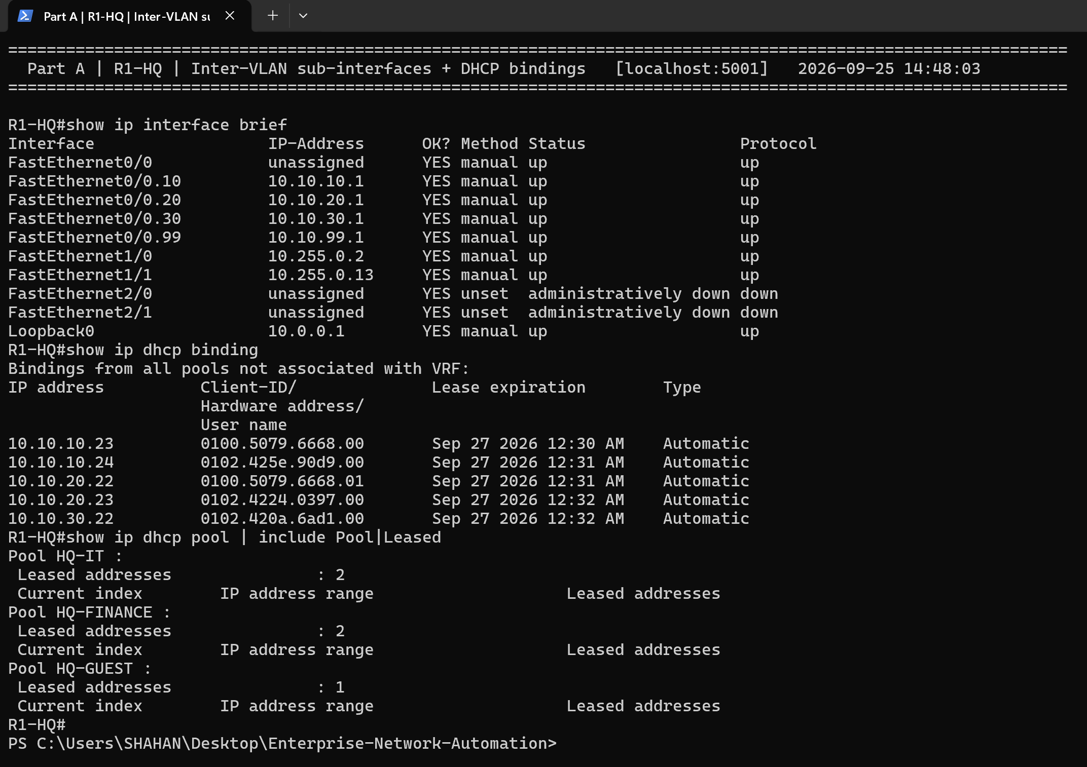
Figure 3: R1-HQ – router-on-a-stick sub-interfaces and DHCP bindings for HQ clients
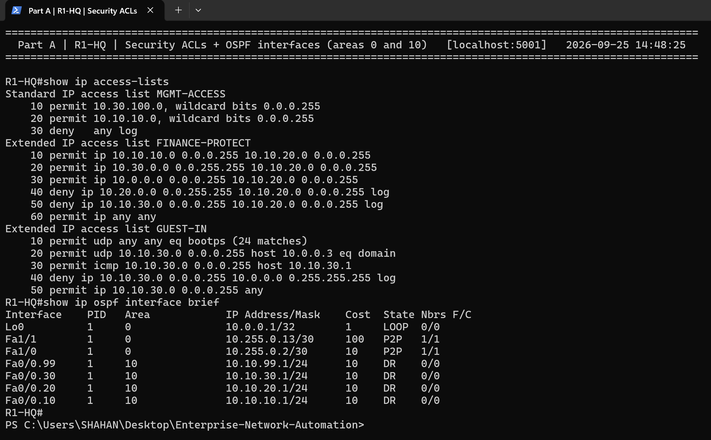
Figure 4: R1-HQ – GUEST-IN, FINANCE-PROTECT and MGMT-ACCESS ACLs; OSPF interfaces in areas 0 and 10
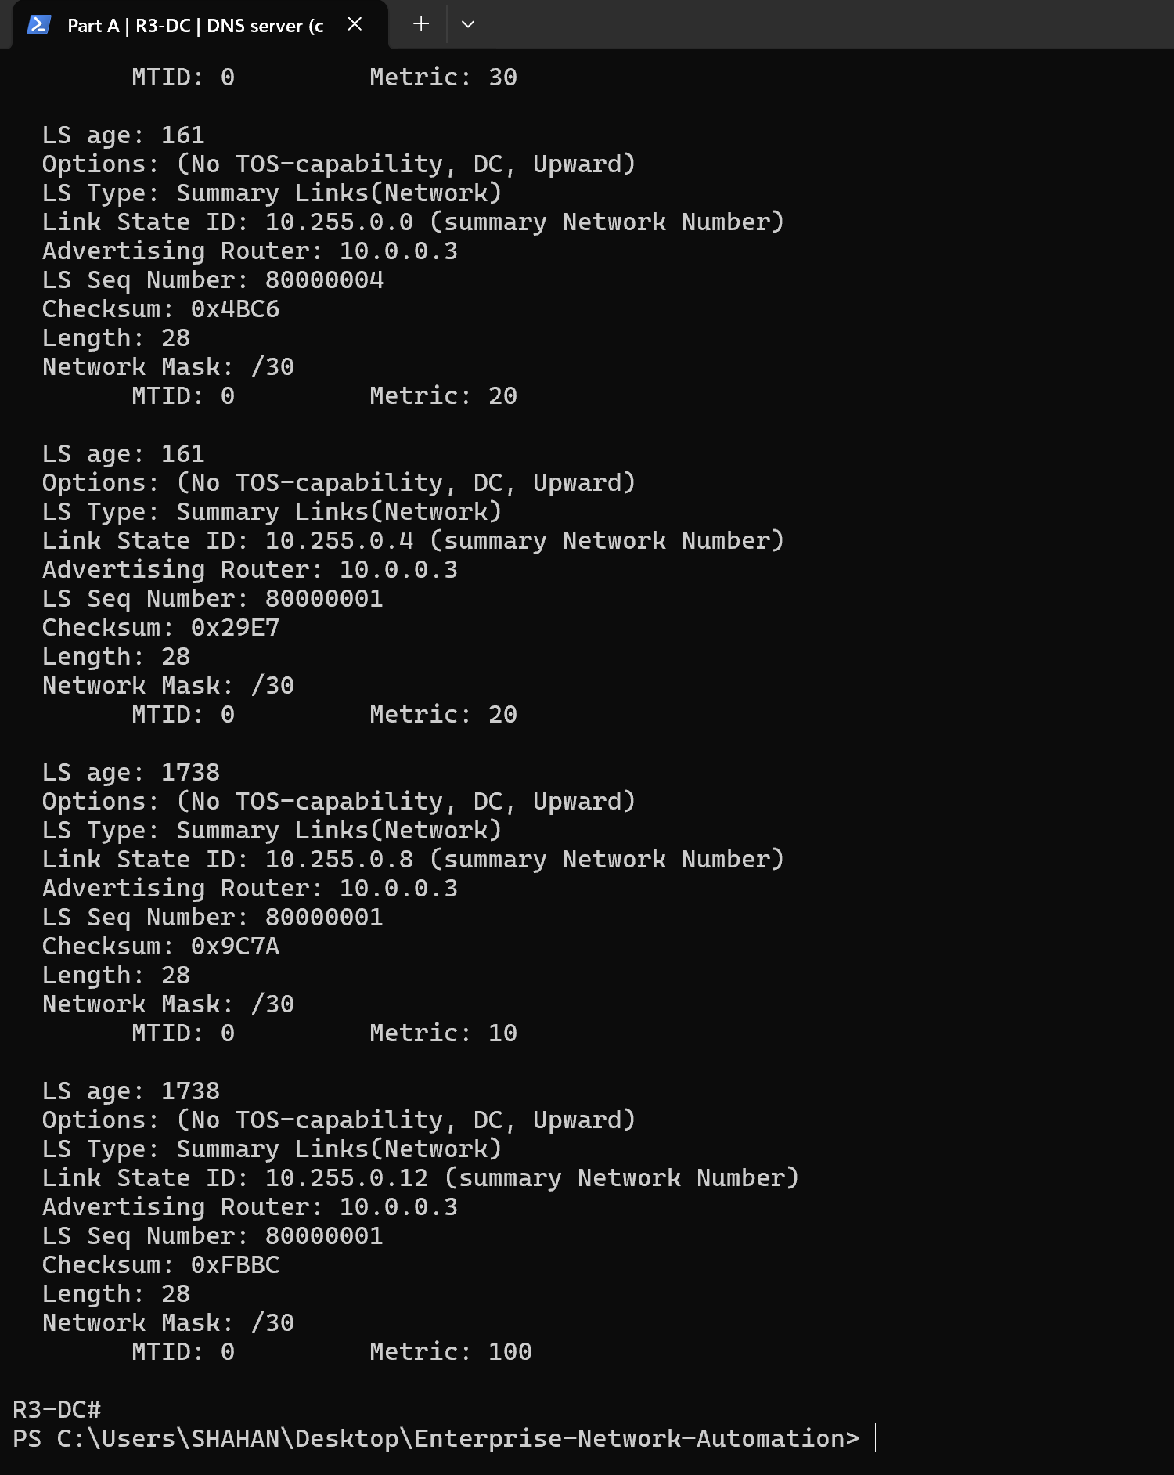
Figure 5: R3-DC – DNS server records for corp.local and OSPF database summary
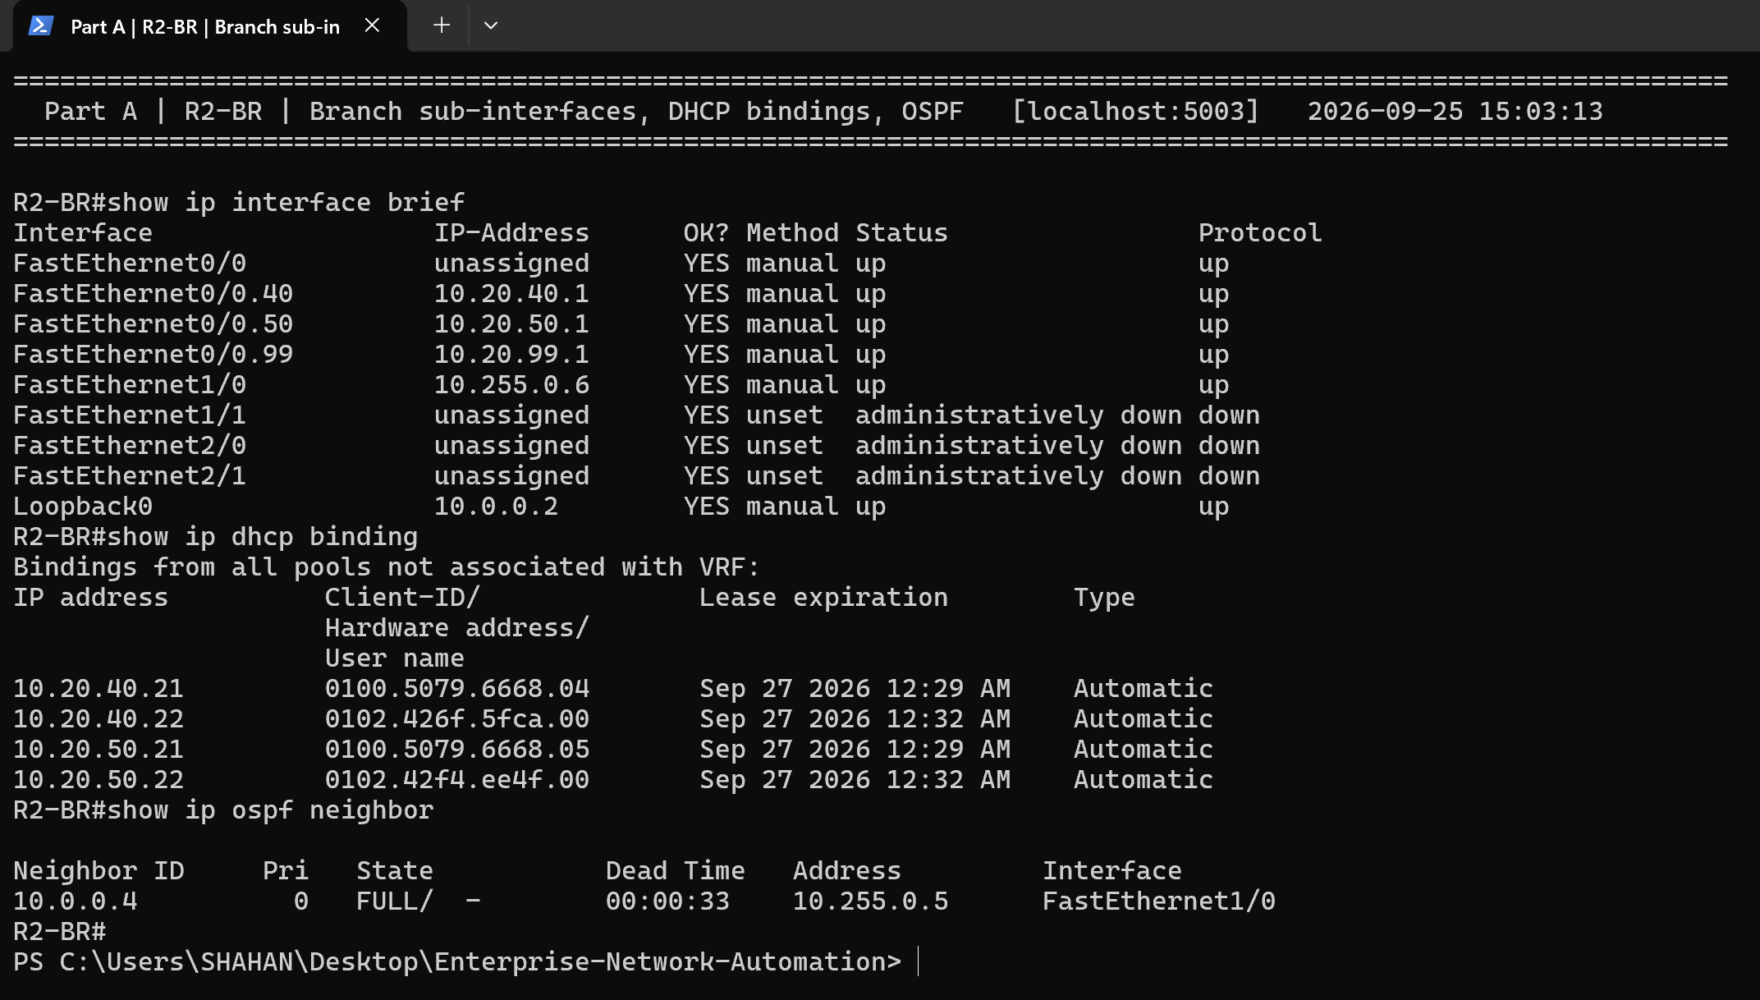
Figure 6: R2-BR – Branch router-on-a-stick sub-interfaces, DHCP bindings and OSPF adjacency to the core
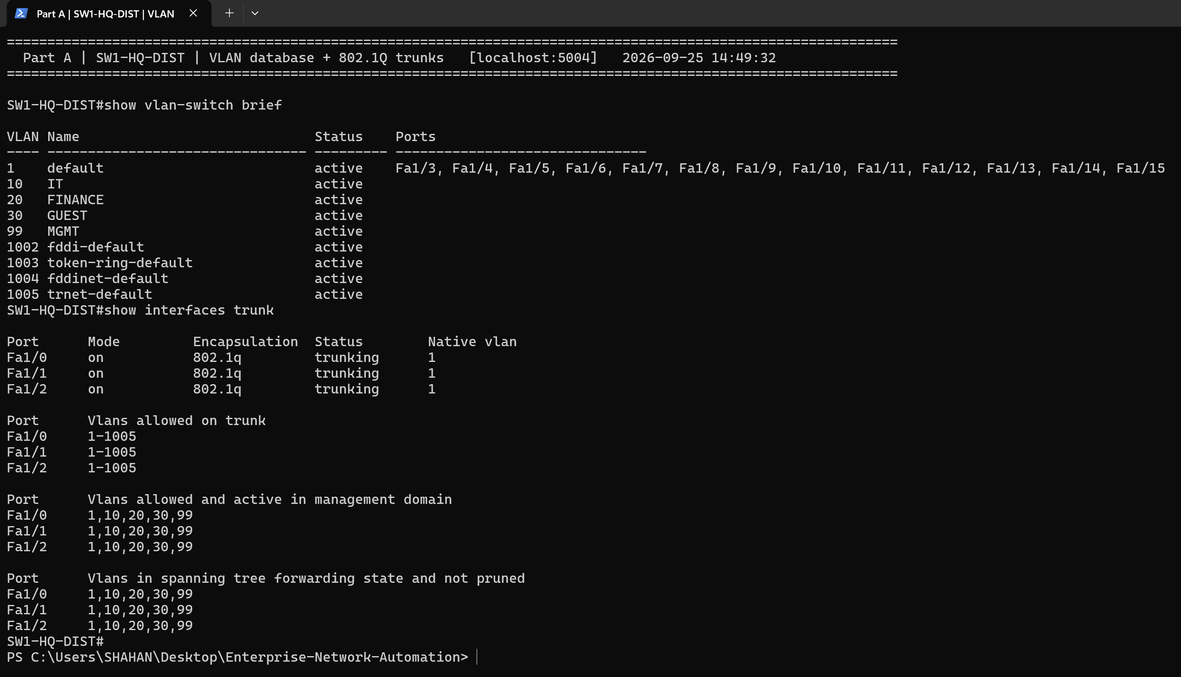
Figure 7: SW1-HQ-DIST – VLAN database and 802.1Q trunks
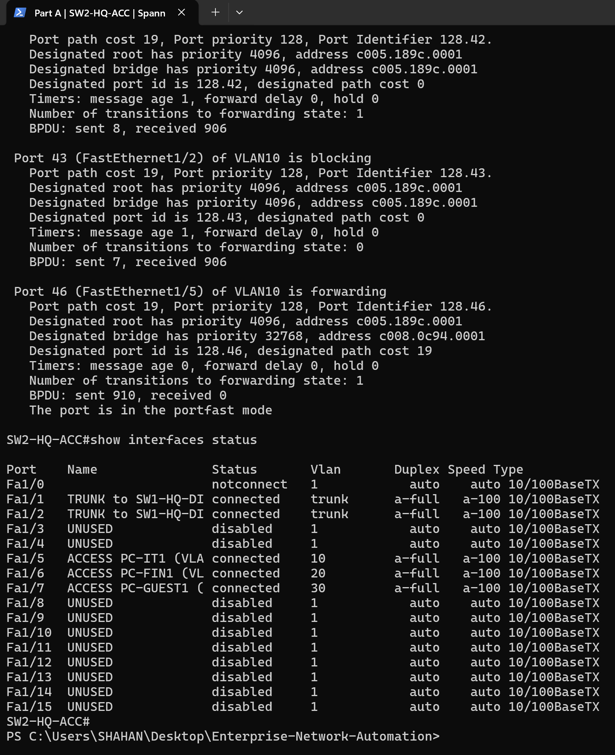
Figure 8: SW2-HQ-ACC – spanning tree: redundant uplink Fa1/2 in BLK state (loop-free redundancy)
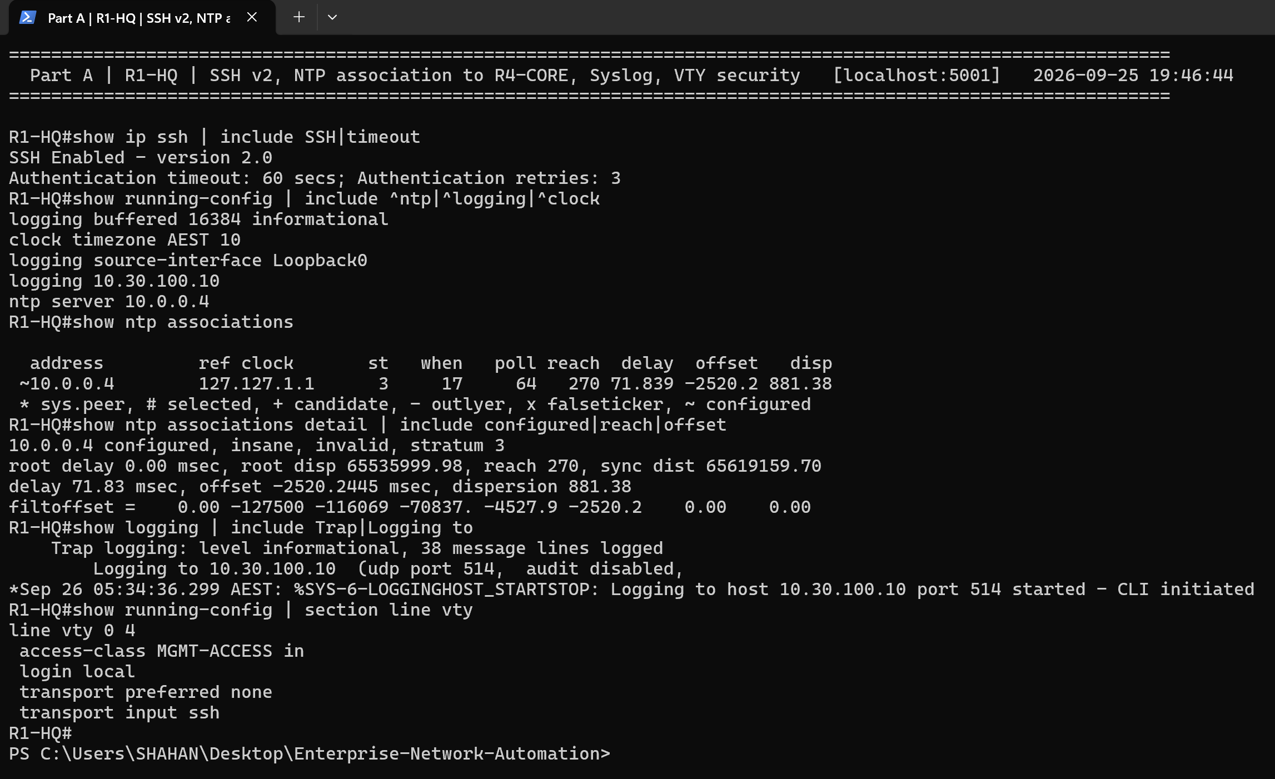
Figure 9: R1-HQ – SSH v2, NTP association to R4-CORE (reachable; peer flagged insane by emulator clock drift), remote Syslog and VTY hardening
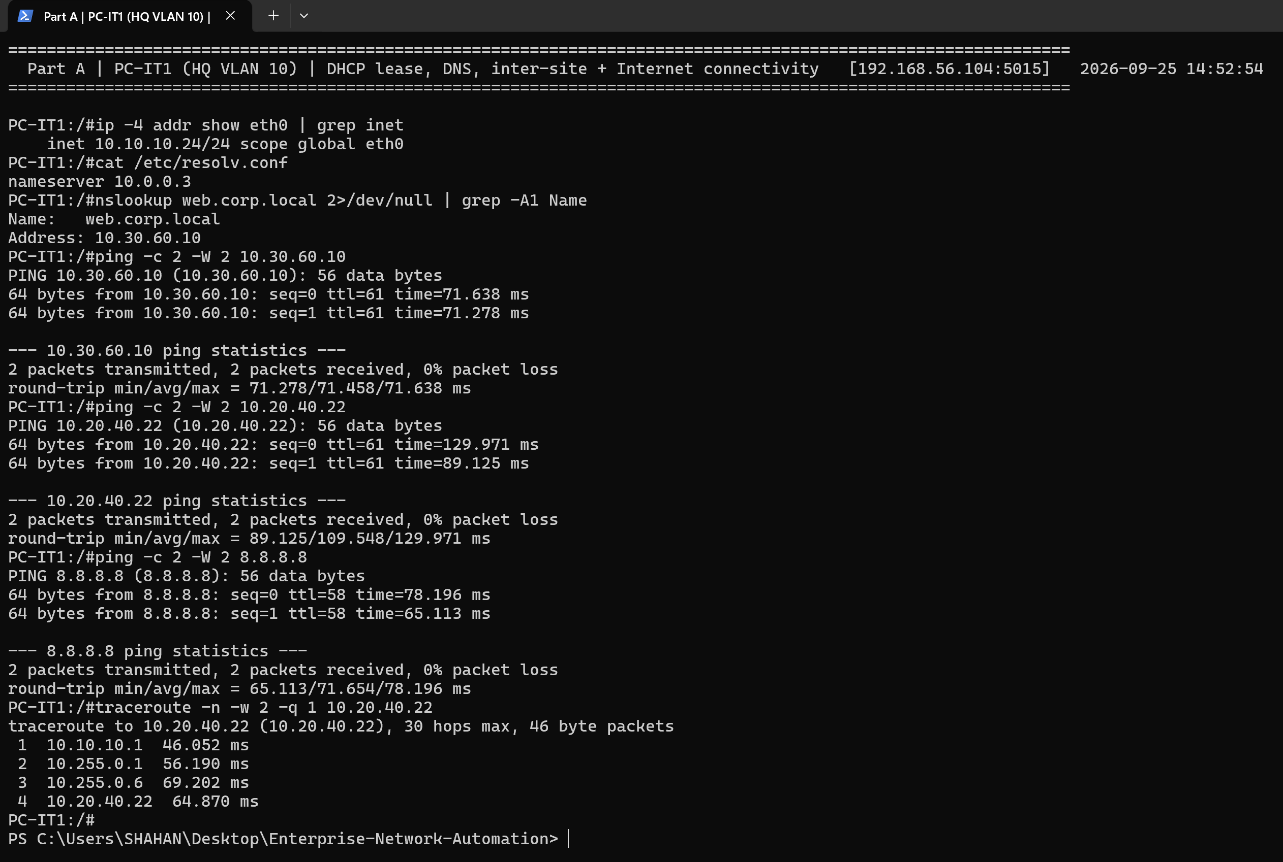
Figure 10: PC-IT1 – DHCP lease, DNS resolution of web.corp.local, inter-site and Internet reachability, traceroute via the core
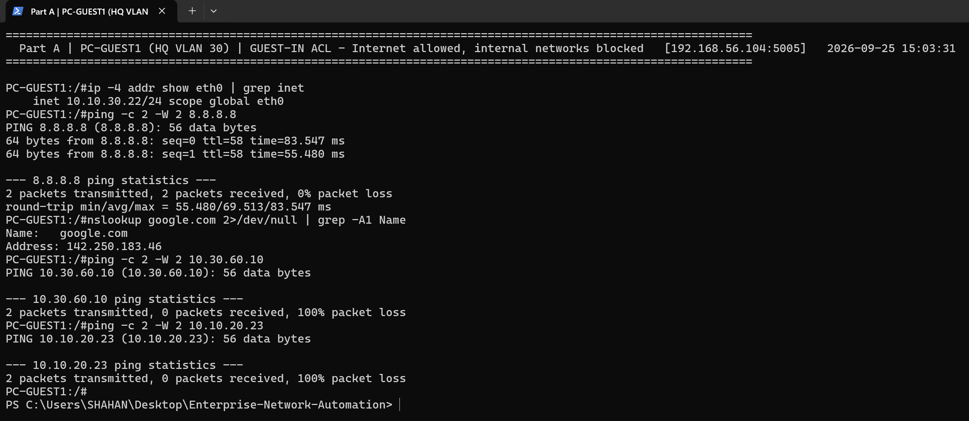
Figure 11: PC-GUEST1 – Internet and DNS allowed; internal servers and Finance blocked by GUEST-IN
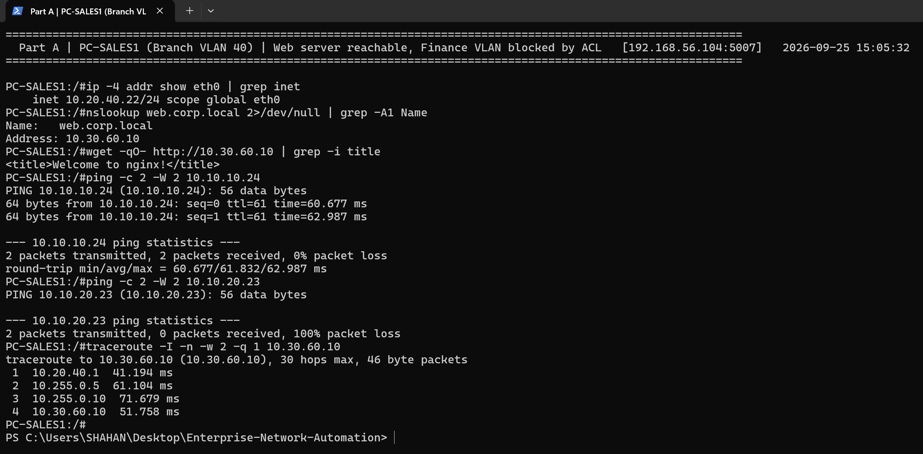
Figure 12: PC-SALES1 – web server (HTTP) reachable, Finance VLAN blocked by FINANCE-PROTECT
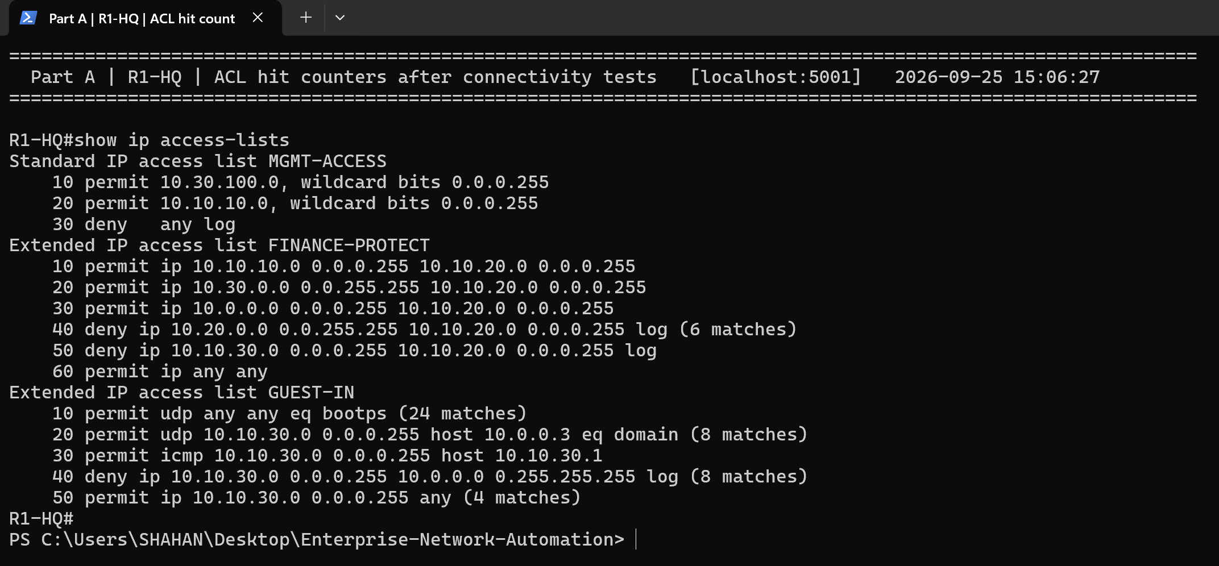
Figure 13: R1-HQ – ACL hit counters after the tests prove the policy is enforced
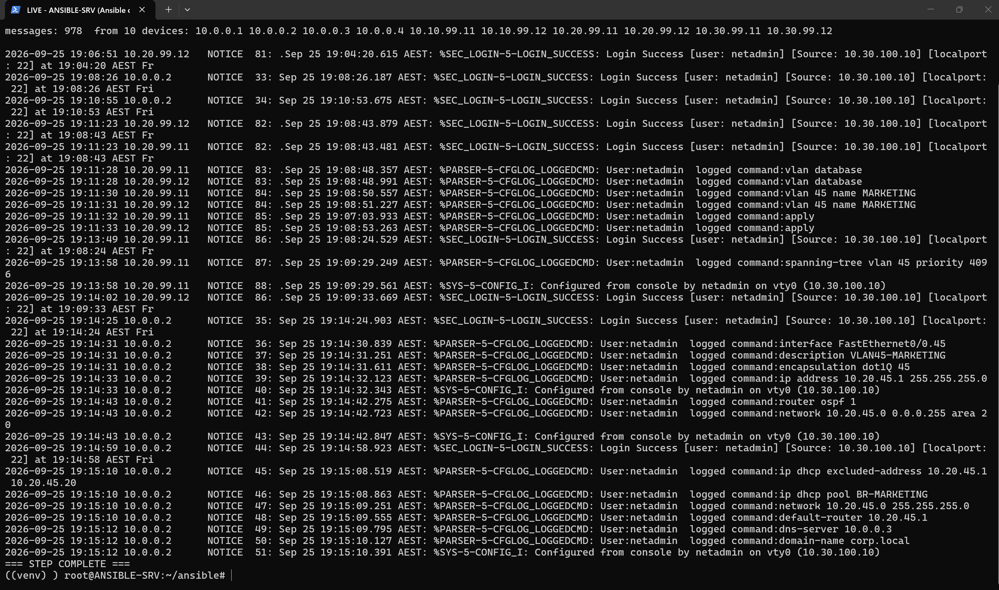
Figure 14: ANSIBLE-SRV – central Syslog collector receiving messages from all network devices

3.5 Design justification
- Hierarchical model: separating core, distribution and access functions keeps failure domains small, makes behaviour predictable and lets the design scale. A new site is simply another distribution block attached to the core.
- Multi-area OSPF: an open standard that converges quickly. ABR summarisation shrinks the backbone table to three /16 routes and keeps site flaps out of the other areas' SPF runs. MD5 authentication blocks rogue neighbours, and passive-interface default stops hellos on user VLANs.
- Path redundancy: the R1–R3 link (OSPF cost 100) is a backup HQ↔DC path. Dual trunks with a deterministic STP root give Layer 2 redundancy without loops.
- Router-on-a-stick: suits the emulated EtherSwitch platform and centralises inter-VLAN policy (ACLs) at a single gateway per site.
- Local DHCP and central DNS: each branch keeps working if the WAN fails, while name resolution stays consistent from one corp.local zone in the DC.
- Management plane: SSH v2 only, with an ACL restricting management to the NetOps and IT VLANs. NTP gives consistent timestamps, and Syslog plus archive logging give a central audit trail.
- Segmentation and least privilege: Guest users get Internet access only, Finance is isolated from branch and guest users, and the server VLAN admits only the services it needs.
- Single Internet edge with PAT: private addressing internally, with one controlled, auditable egress point.

4. Network Automation with Ansible (Part B)

4.1 Automation architecture
ANSIBLE-SRV (10.30.100.10, NETOPS VLAN 100) is the Linux control node. It reaches every router loopback and switch management SVI in-band over OSPF, using SSH (network_cli with paramiko) and privilege escalation through enable. The Ansible project is stored in Git and mounted on the server at /root/ansible. The server also runs a small Python Syslog collector (tools/syslog_server.py) that receives logs from every device.
Element | Implementation
Inventory | inventory/hosts.yml – groups by role (core_routers, site_routers, distribution_switches, access_switches) and by site (site_hq, site_branch, site_dc, site_core)
Source of truth | group_vars/all (standards: NTP, DNS, Syslog, banner, SNMPv3, mgmt ACL), group_vars/site_* (VLANs, ACLs, DNS records, NAT), host_vars/* (router-IDs, P2P links, trunks, access ports)
Secrets | group_vars/all/vault.yml encrypted with ansible-vault (AES-256); .vault_pass is git-ignored
Roles | backup, baseline, vlans, routing, services, acl, verify, compliance
Templates | Jinja2: interfaces.j2, ospf.j2, services.j2, report.md.j2, compliance.md.j2
Playbooks | 00_facts_inventory … 08_compliance, site.yml (full pipeline)
Outputs | backups/ (timestamped + latest), reports/ (inventory CSV, verification, compliance), logs/ansible.log
Table 6: Ansible project components
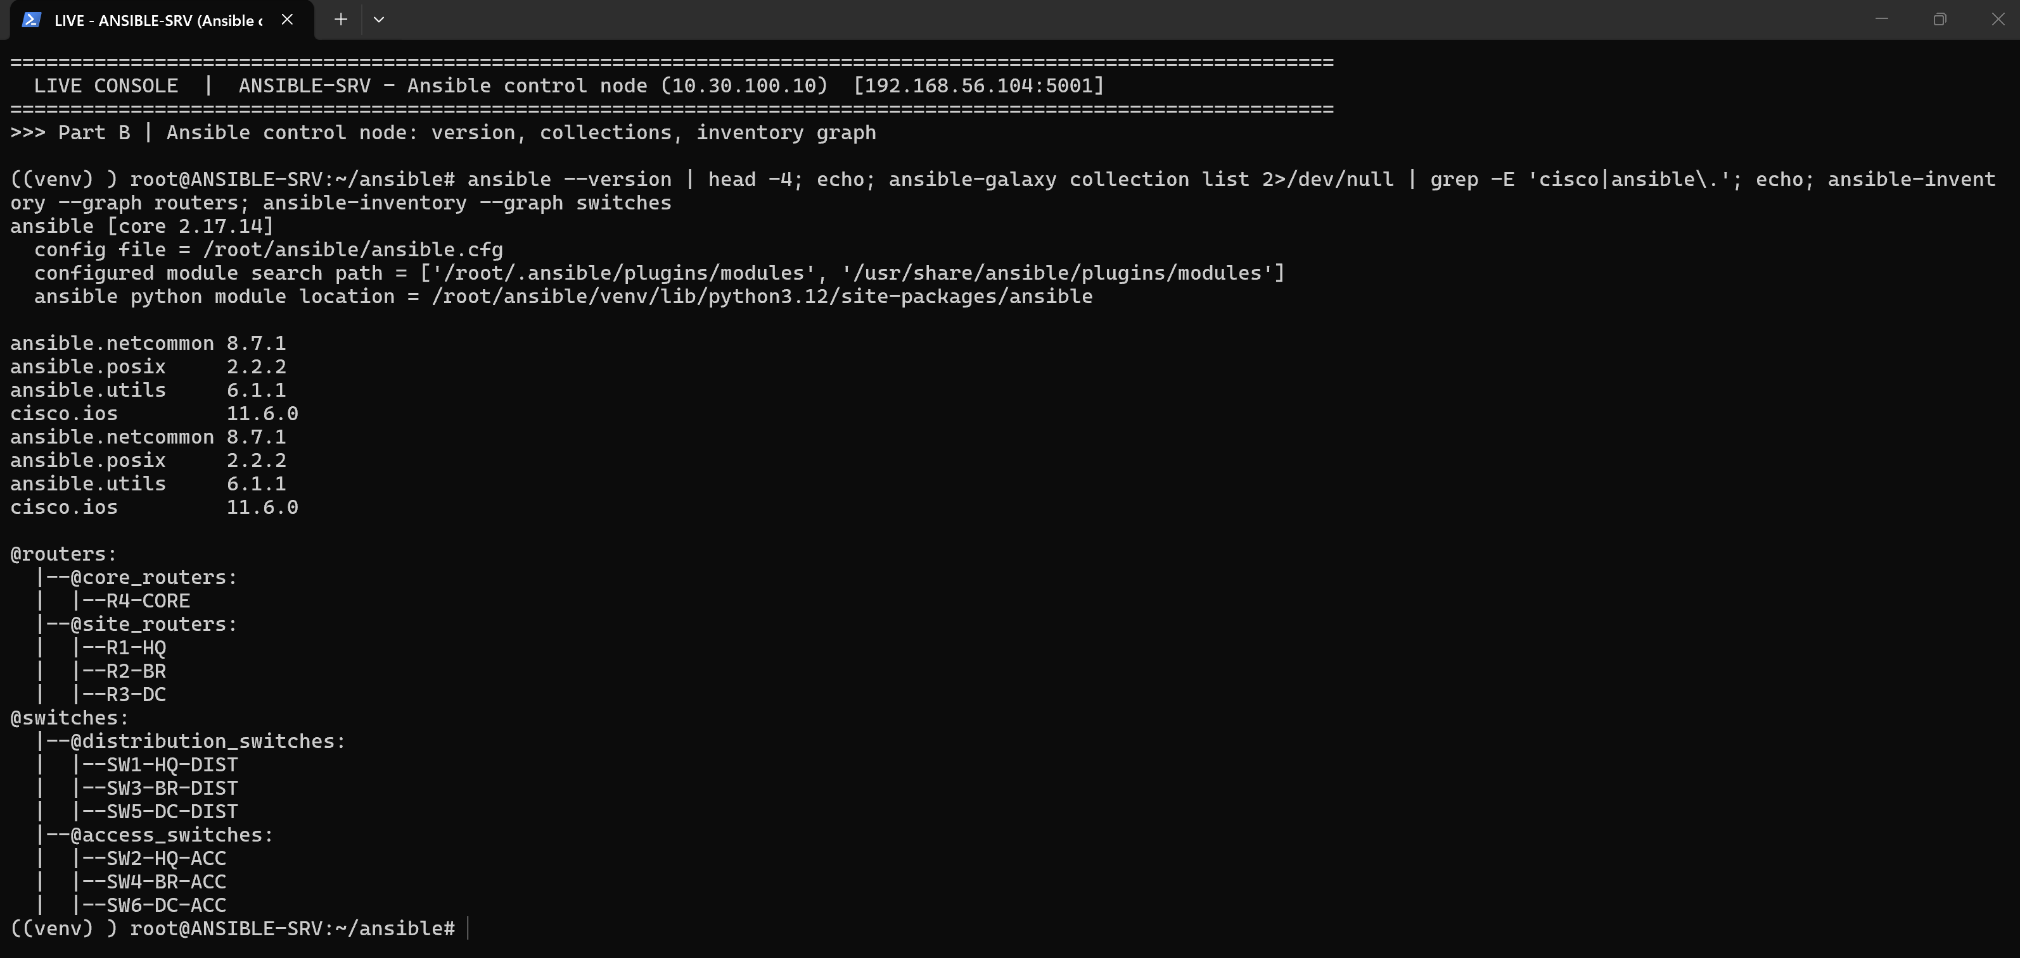
Figure 15: ANSIBLE-SRV control node: ansible-core version, installed collections and the role/site inventory graph

4.2 Playbooks and roles
Playbook | Role | Target | What it does
00_facts_inventory.yml | – | all | Gathers ios_facts; writes reports/device_inventory.csv
01_backup.yml | backup | all | Timestamped running-config backups + backups/latest for Git diff
02_baseline.yml | baseline | all | Hardening, local user, NTP, Syslog, DNS, archive logging, MGMT ACL, VTY, banner, SNMPv3
03_switching.yml | vlans | switches | Creates missing VLANs, trunks, access ports, STP root, VLAN 99 SVI
04_routing.yml | routing | routers | Loopbacks, sub-interfaces, P2P links, multi-area OSPF (Jinja2)
05_services.yml | services | routers | DHCP pools, DNS host records, NAT/PAT (Jinja2)
06_security_acl.yml | acl | routers | Data-driven extended ACLs + hit counters
07_verify.yml | verify | all | Asserts OSPF FULL, default route, VLANs, trunks, pings; writes verification report
08_compliance.yml | compliance | all | 14 security rules checked by regex; writes compliance report
site.yml | all | all | Runs the whole pipeline in order
Table 7: Playbooks and roles
Source of truth – ansible/inventory/group_vars/site_hq.yml (excerpt)
---
site_name: HQ
ospf_area: 10
site_summary: {prefix: 10.10.0.0, mask: 255.255.0.0}
mgmt_gateway: 10.10.99.1

vlans:
- {id: 10, name: IT, network: 10.10.10.0, gateway: 10.10.10.1, dhcp: true}
- {id: 20, name: FINANCE, network: 10.10.20.0, gateway: 10.10.20.1, dhcp: true, acl_out: FINANCE-PROTECT}
- {id: 30, name: GUEST, network: 10.10.30.0, gateway: 10.10.30.1, dhcp: true, acl_in: GUEST-IN}
- {id: 99, name: MGMT, network: 10.10.99.0, gateway: 10.10.99.1, dhcp: false}

Jinja2 template – ansible/roles/routing/templates/ospf.j2
{# Multi-area OSPF: area 0 backbone on P2P links + loopbacks; site LANs in the site area,
summarised at the ABR with 'area X range'. MD5 authentication on area 0. #}
router ospf {{ ospf.process_id }}
router-id {{ router_id }}
log-adjacency-changes
auto-cost reference-bandwidth {{ ospf.reference_bandwidth }}
area 0 authentication message-digest
{% if ospf_area is defined %}
area {{ ospf_area }} range {{ site_summary.prefix }} {{ site_summary.mask }}
{% endif %}
passive-interface default
{% for l in p2p_links %}
no passive-interface {{ l.interface }}
{% endfor %}
network {{ loopback0 }} 0.0.0.0 area 0
{% for l in p2p_links %}
network {{ (l.ip ~ '/' ~ l.mask) | ansible.utils.ipaddr('network') }} 0.0.0.3 area 0
{% endfor %}
{% for v in vlans | default([]) %}
network {{ v.network }} 0.0.0.255 area {{ ospf_area }}
{% endfor %}
{% if ntp_master | default(false) %}
default-information originate always
{% endif %}

Role task – ansible/roles/vlans/tasks/main.yml (idempotent VLAN creation)
---
# VLAN + trunk/access port management for EtherSwitch (NM-16ESW) switches.
# NM-16ESW stores VLANs in 'vlan database' mode, so we read the current VLAN table and
# only create what is missing (idempotent), then manage ports with ios_config.
# Lines IOS never displays ('no shutdown', default 'switchport mode access') are not pushed,
# so repeated runs report changed=0.
- name: Read current VLAN table
cisco.ios.ios_command:
commands: show vlan-switch brief
register: vlan_table
changed_when: false

- name: Work out which VLANs are missing
ansible.builtin.set_fact:
missing_vlans: "{{ vlans | rejectattr('id', 'in', present_ids) | list }}"
vars:
present_ids: "{{ vlan_table.stdout[0] | regex_findall('(?m)^(\\d+)\\s') | map('int') | list }}"

- name: "Check mode: VLANs that WOULD be created"
ansible.builtin.debug:
msg: "would create: {{ missing_vlans | map(attribute='id') | zip(missing_vlans | map(attribute='name')) | map('join', ' ') | list }}"
when: ansible_check_mode and missing_vlans | length > 0
changed_when: true

- name: Create missing VLANs in the VLAN database
ansible.netcommon.cli_command:

4.3 Automation outputs
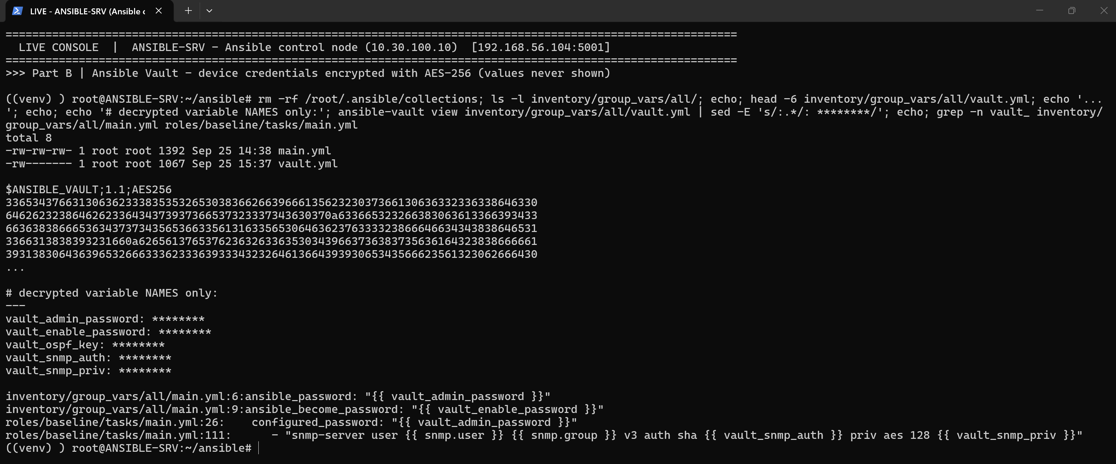
Figure 16: Ansible Vault – credentials encrypted with AES-256; only variable names are ever displayed
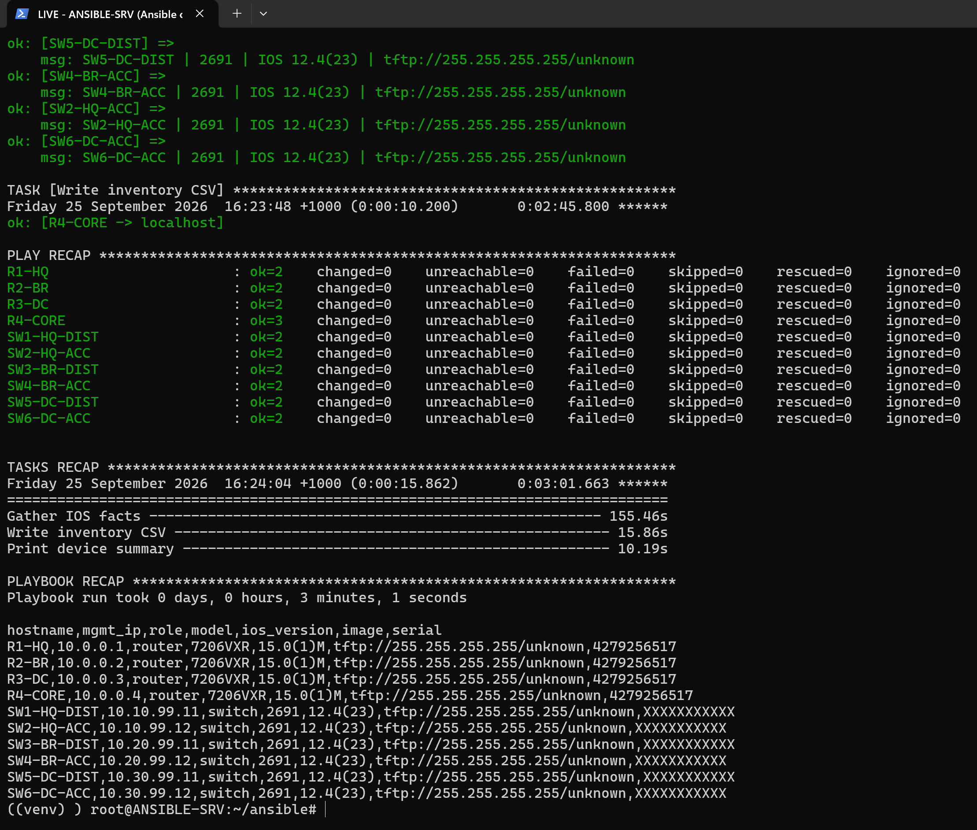
Figure 17: 00_facts_inventory.yml – ios_facts discovery of all 10 devices and the generated inventory CSV
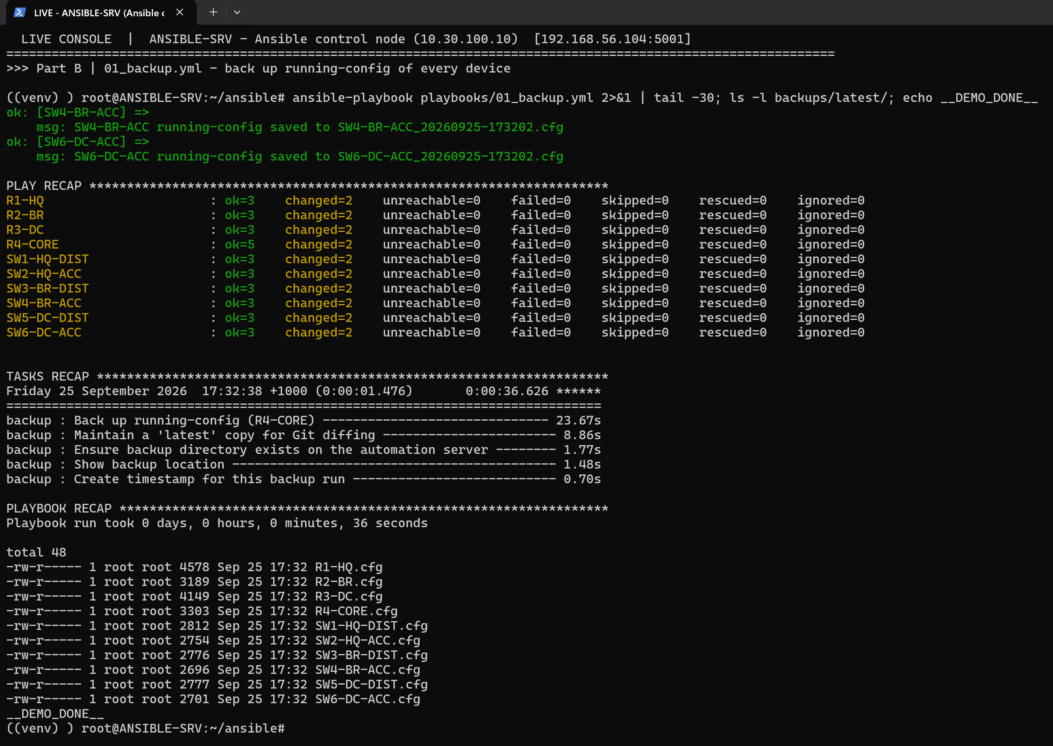
Figure 18: 01_backup.yml – timestamped running-configuration backups plus a 'latest' copy per device for Git diffing
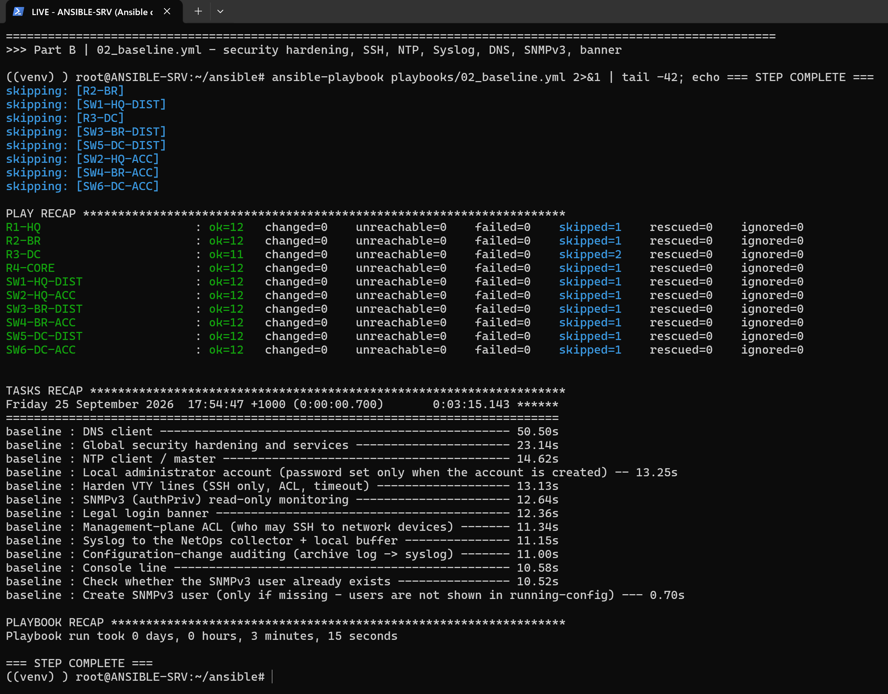
Figure 19: 02_baseline.yml – hardening, SSH, NTP, Syslog, DNS, archive logging, SNMPv3 and banner enforced on all devices
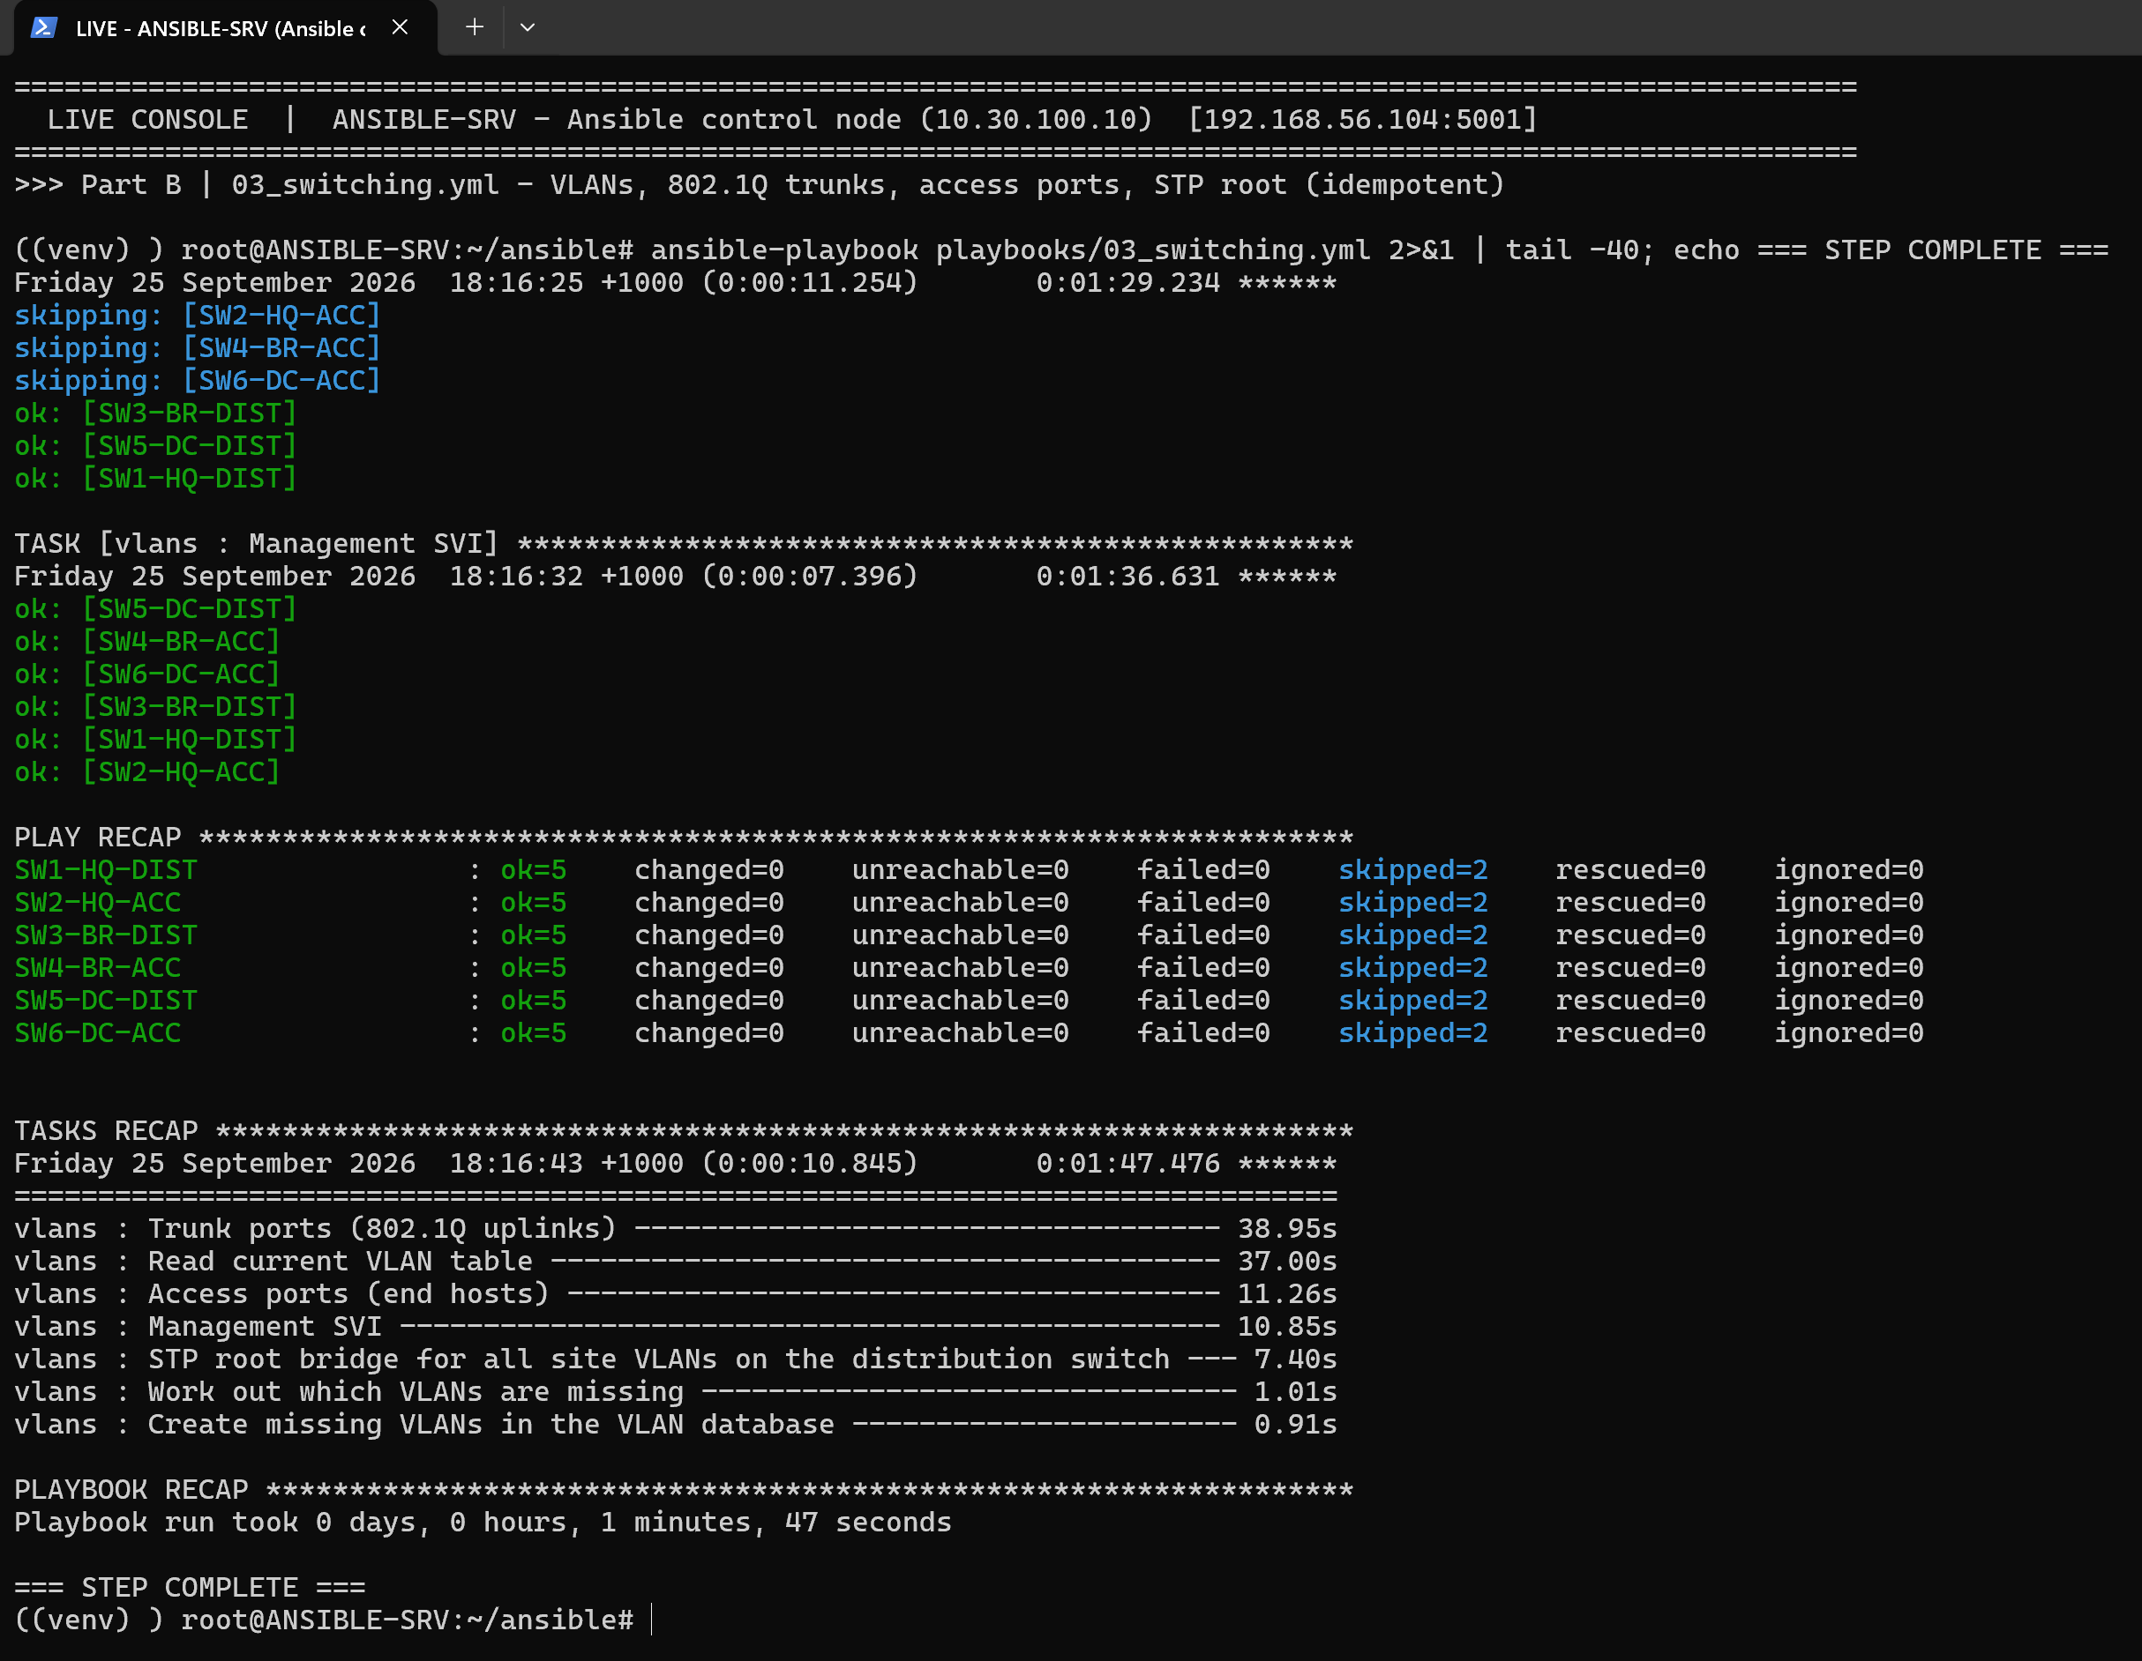
Figure 20: 03_switching.yml – VLAN database, 802.1Q trunks, access ports and STP root managed on the six switches
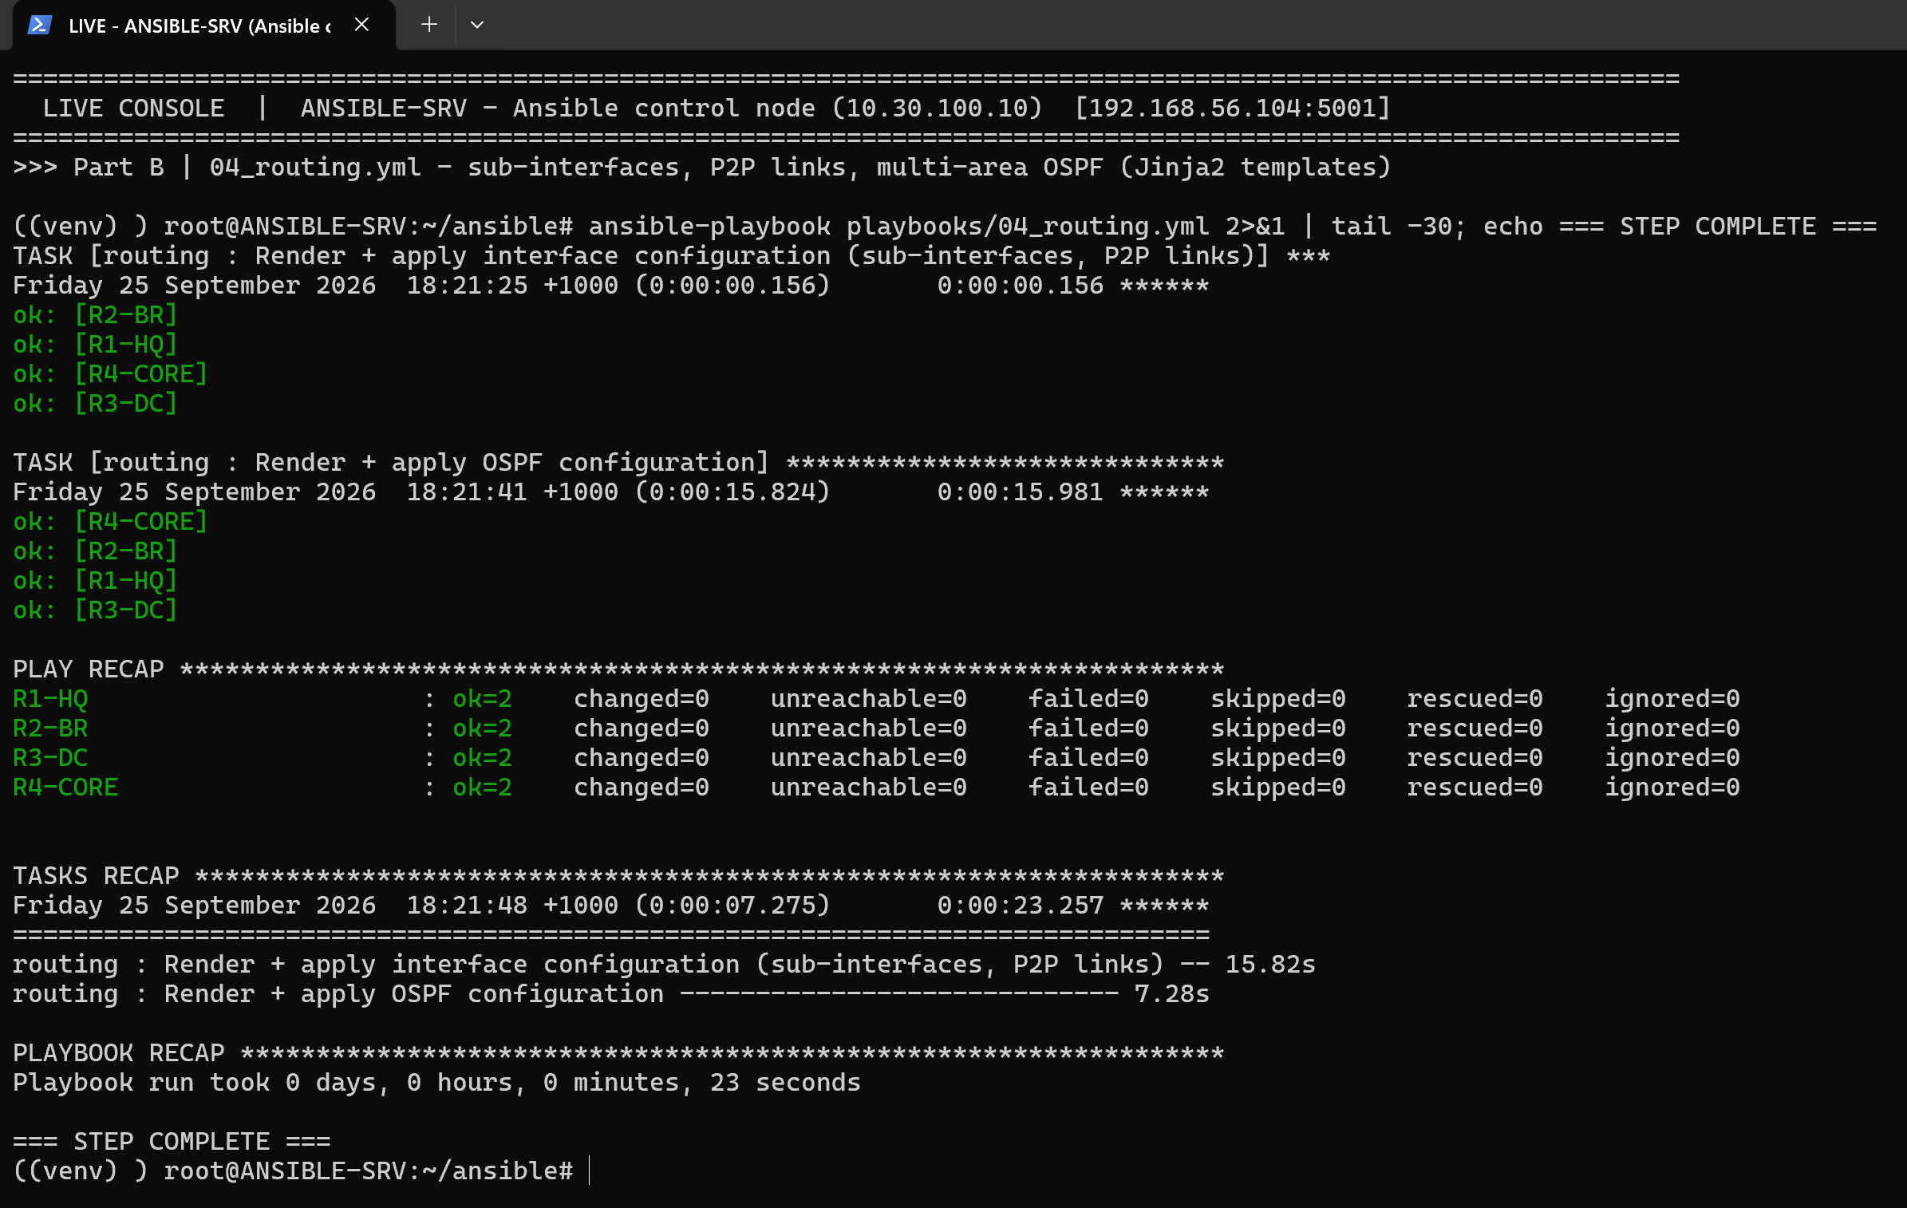
Figure 21: 04_routing.yml – Jinja2-rendered sub-interfaces, P2P links and multi-area OSPF match the running network (changed=0)
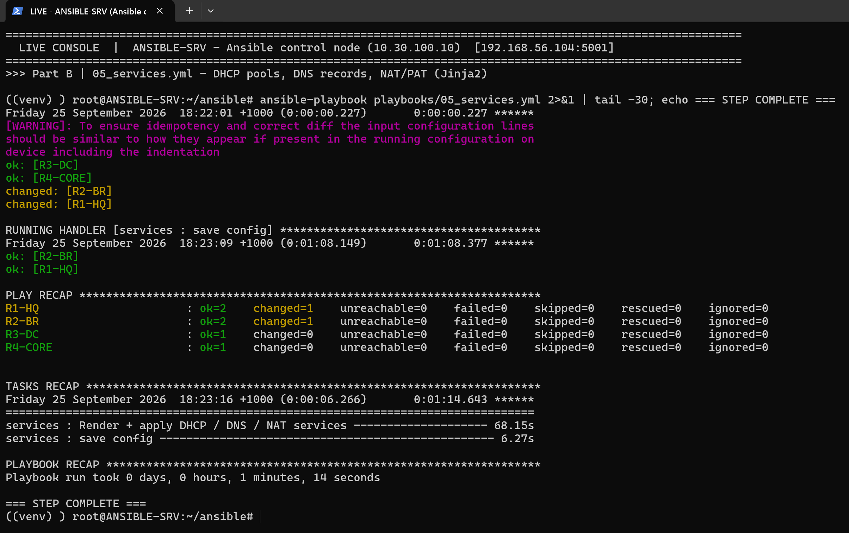
Figure 22: 05_services.yml – DHCP pools, DNS host records and NAT/PAT rendered from site data
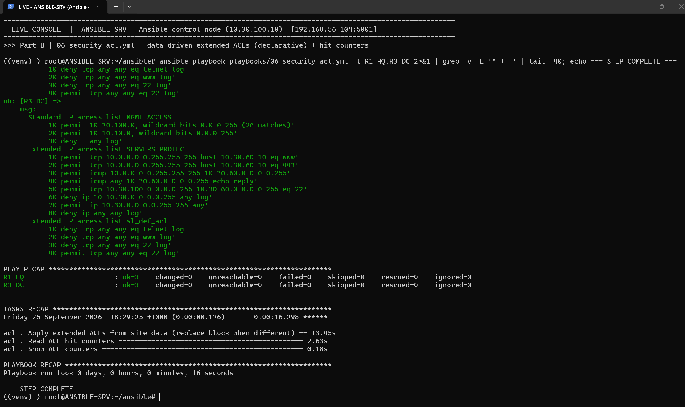
Figure 23: 06_security_acl.yml – declarative ACLs (whole block replaced only if the device differs) and live hit counters
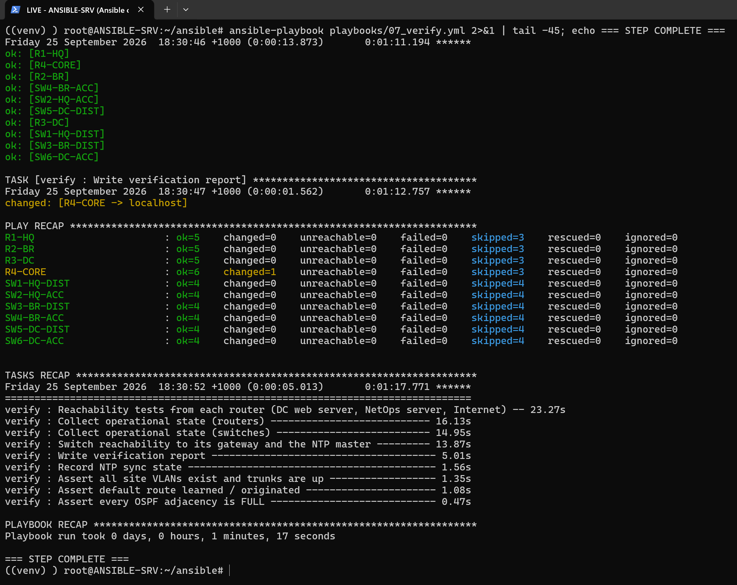
Figure 24: 07_verify.yml – automated assertions: OSPF FULL, default route, VLANs, trunks and reachability on every device
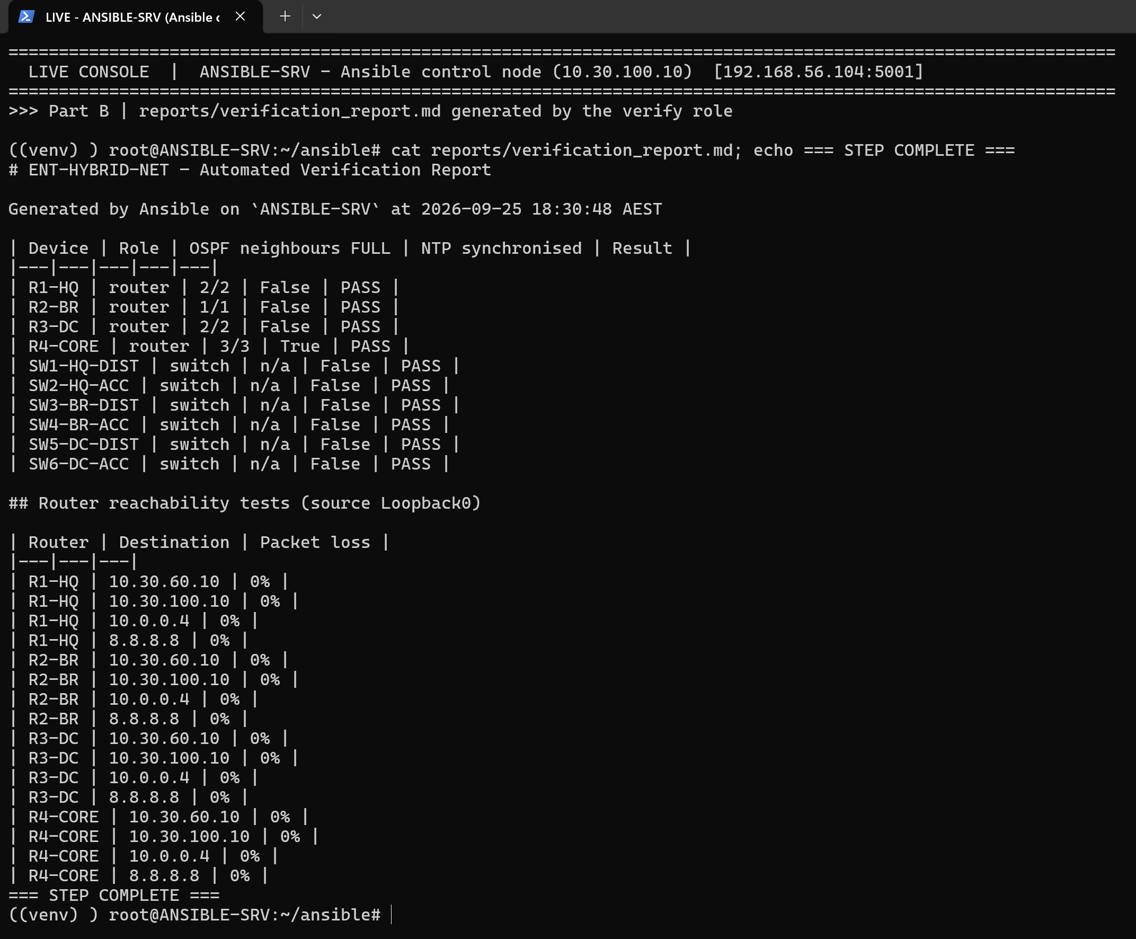
Figure 25: Verification report rendered by the verify role (reports/verification_report.md)
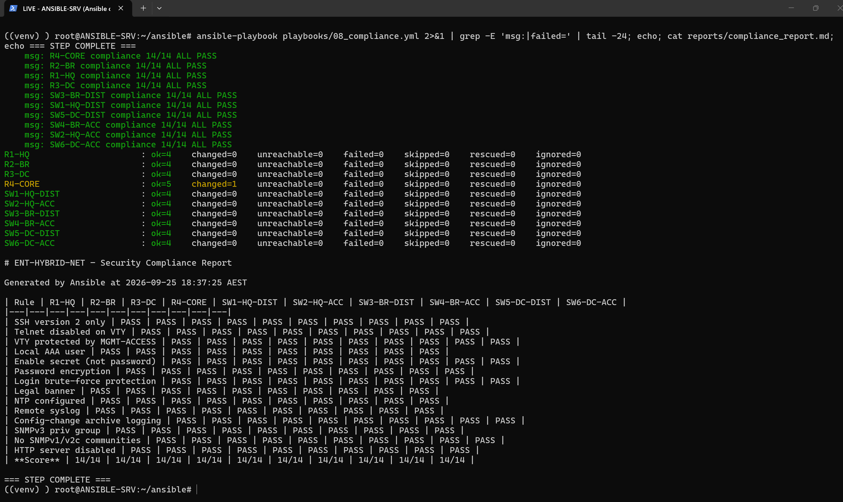
Figure 26: 08_compliance.yml – 14 security rules audited on 10 devices: 14/14 on every device
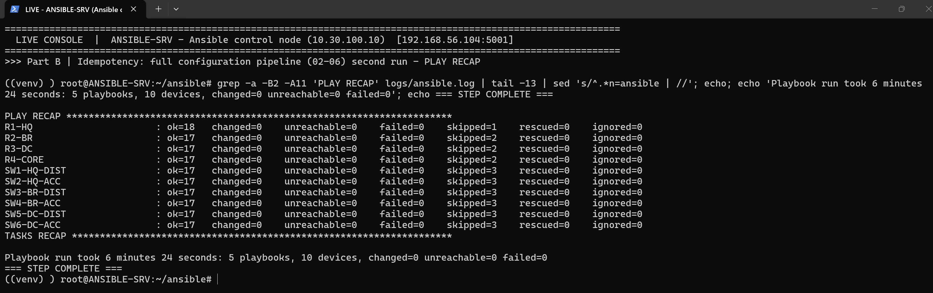
Figure 27: Idempotency – the complete configuration pipeline (playbooks 02–06) re-run: changed=0, failed=0 on all 10 devices

Day-2 change delivered as code (CHG-0001: VLAN 45 MARKETING at the Branch)
A realistic change request was implemented purely by editing the source of truth: two lines added to group_vars/site_branch.yml and committed to Git (Git evidence in Section 5.4). The same pipeline then dry-ran the change with --check --diff, applied it, and the result was verified on the devices. Because the data model links everything, the single VLAN entry produced the VLAN on both Branch switches, the STP root priority, the R2 router-on-a-stick sub-interface, the OSPF area 20 network statement and a new DHCP pool, with no hand-typed CLI.
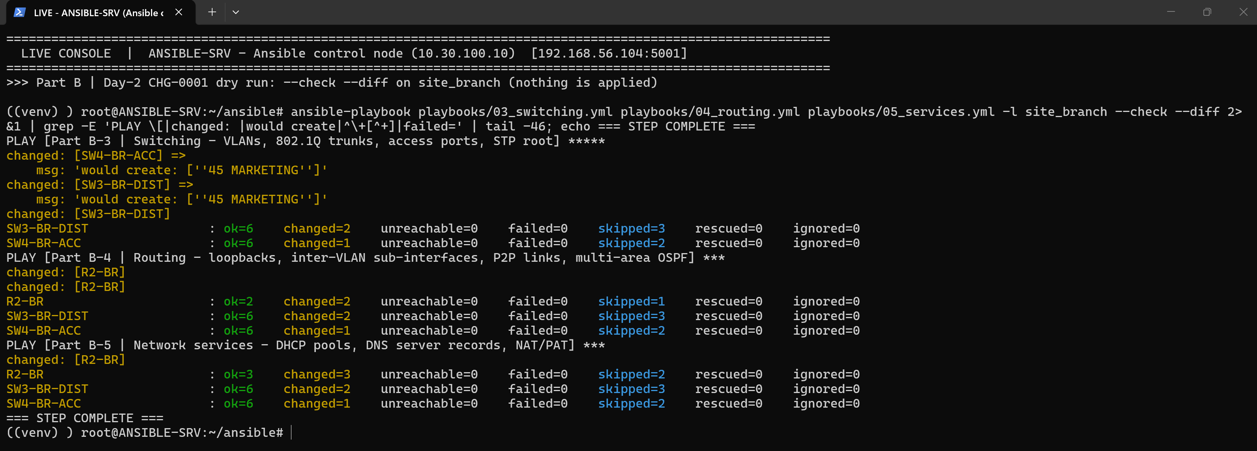
Figure 28: CHG-0001 dry run (--check --diff): Ansible predicts the changes (VLAN 45 would be created) without touching any device
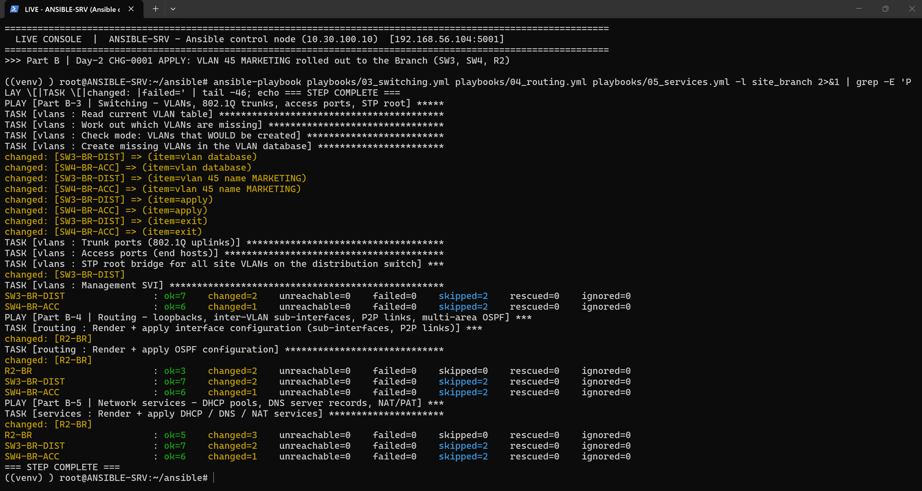
Figure 29: CHG-0001 applied to the Branch devices (SW3-BR-DIST, SW4-BR-ACC, R2-BR) – failed=0
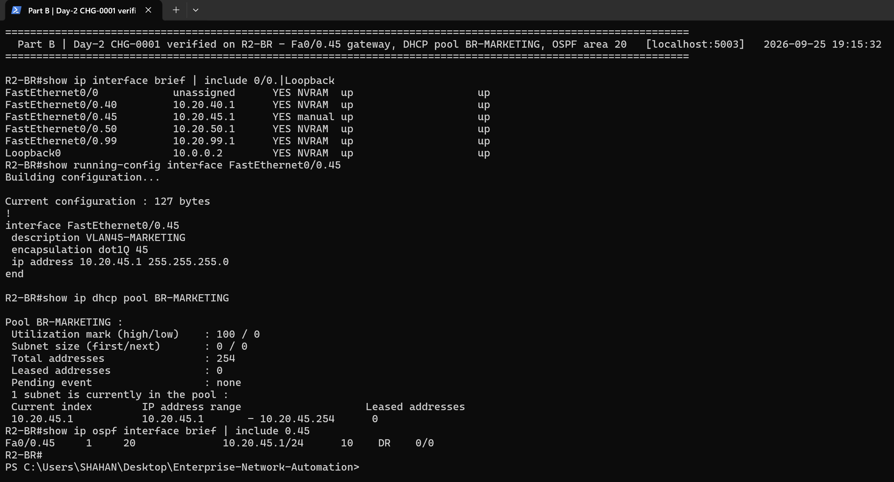
Figure 30: CHG-0001 verified on R2-BR: Fa0/0.45 gateway 10.20.45.1, DHCP pool BR-MARKETING, OSPF area 20
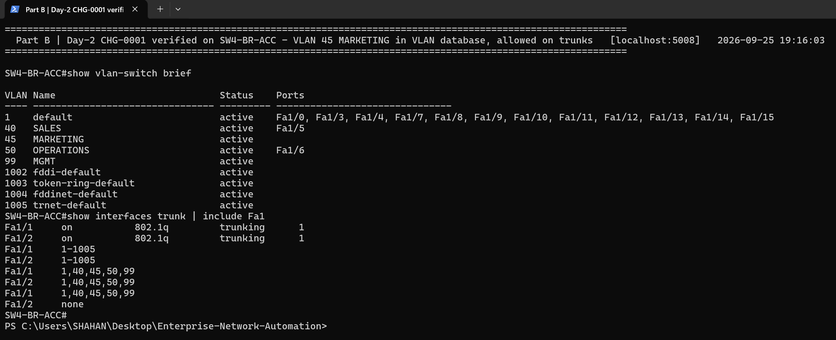
Figure 31: CHG-0001 verified on SW4-BR-ACC: VLAN 45 MARKETING present in the VLAN database and carried on the trunks
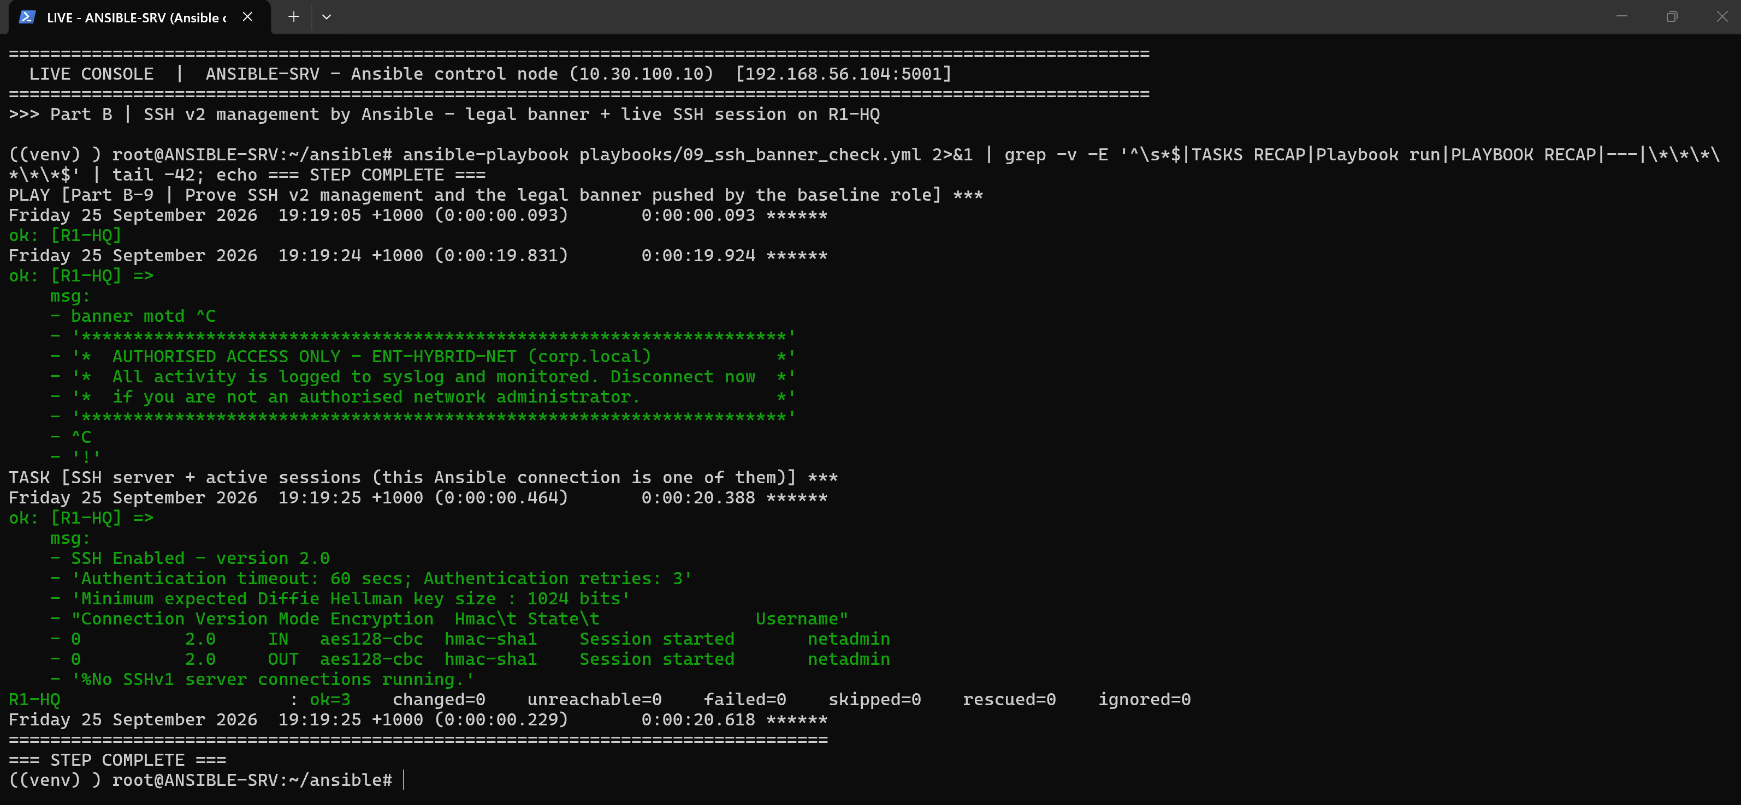
Figure 32: SSH v2 management by Ansible: legal banner from the baseline role and the live netadmin SSH session (aes128-cbc)
Generated reports. The verification and compliance roles render Markdown reports into ansible/reports/, and those reports are committed to Git as evidence:
ansible/reports/verification_report.md
# ENT-HYBRID-NET – Automated Verification Report

Generated by Ansible on `ANSIBLE-SRV` at 2026-09-25 18:30:48 AEST

| Device | Role | OSPF neighbours FULL | NTP synchronised | Result |
|---|---|---|---|---|
| R1-HQ | router | 2/2 | False | PASS |
| R2-BR | router | 1/1 | False | PASS |
| R3-DC | router | 2/2 | False | PASS |
| R4-CORE | router | 3/3 | True | PASS |
| SW1-HQ-DIST | switch | n/a | False | PASS |
| SW2-HQ-ACC | switch | n/a | False | PASS |
| SW3-BR-DIST | switch | n/a | False | PASS |
| SW4-BR-ACC | switch | n/a | False | PASS |
| SW5-DC-DIST | switch | n/a | False | PASS |
| SW6-DC-ACC | switch | n/a | False | PASS |

## Router reachability tests (source Loopback0)

| Router | Destination | Packet loss |
|---|---|---|
| R1-HQ | 10.30.60.10 | 0% |
| R1-HQ | 10.30.100.10 | 0% |
| R1-HQ | 10.0.0.4 | 0% |
| R1-HQ | 8.8.8.8 | 0% |
| R2-BR | 10.30.60.10 | 0% |
| R2-BR | 10.30.100.10 | 0% |
| R2-BR | 10.0.0.4 | 0% |
| R2-BR | 8.8.8.8 | 0% |
| R3-DC | 10.30.60.10 | 0% |
| R3-DC | 10.30.100.10 | 0% |
| R3-DC | 10.0.0.4 | 0% |
| R3-DC | 8.8.8.8 | 0% |
| R4-CORE | 10.30.60.10 | 0% |
| R4-CORE | 10.30.100.10 | 0% |
| R4-CORE | 10.0.0.4 | 0% |
| R4-CORE | 8.8.8.8 | 0% |

ansible/reports/compliance_report.md
# ENT-HYBRID-NET – Security Compliance Report

Generated by Ansible at 2026-09-25 18:37:25 AEST

| Rule | R1-HQ | R2-BR | R3-DC | R4-CORE | SW1-HQ-DIST | SW2-HQ-ACC | SW3-BR-DIST | SW4-BR-ACC | SW5-DC-DIST | SW6-DC-ACC |
|---|---|---|---|---|---|---|---|---|---|---|
| SSH version 2 only | PASS | PASS | PASS | PASS | PASS | PASS | PASS | PASS | PASS | PASS |
| Telnet disabled on VTY | PASS | PASS | PASS | PASS | PASS | PASS | PASS | PASS | PASS | PASS |
| VTY protected by MGMT-ACCESS | PASS | PASS | PASS | PASS | PASS | PASS | PASS | PASS | PASS | PASS |
| Local AAA user | PASS | PASS | PASS | PASS | PASS | PASS | PASS | PASS | PASS | PASS |
| Enable secret (not password) | PASS | PASS | PASS | PASS | PASS | PASS | PASS | PASS | PASS | PASS |
| Password encryption | PASS | PASS | PASS | PASS | PASS | PASS | PASS | PASS | PASS | PASS |
| Login brute-force protection | PASS | PASS | PASS | PASS | PASS | PASS | PASS | PASS | PASS | PASS |
| Legal banner | PASS | PASS | PASS | PASS | PASS | PASS | PASS | PASS | PASS | PASS |
| NTP configured | PASS | PASS | PASS | PASS | PASS | PASS | PASS | PASS | PASS | PASS |
| Remote syslog | PASS | PASS | PASS | PASS | PASS | PASS | PASS | PASS | PASS | PASS |
| Config-change archive logging | PASS | PASS | PASS | PASS | PASS | PASS | PASS | PASS | PASS | PASS |
| SNMPv3 priv group | PASS | PASS | PASS | PASS | PASS | PASS | PASS | PASS | PASS | PASS |
| No SNMPv1/v2c communities | PASS | PASS | PASS | PASS | PASS | PASS | PASS | PASS | PASS | PASS |
| HTTP server disabled | PASS | PASS | PASS | PASS | PASS | PASS | PASS | PASS | PASS | PASS |
| **Score** | 14/14 | 14/14 | 14/14 | 14/14 | 14/14 | 14/14 | 14/14 | 14/14 | 14/14 | 14/14 |

4.4 Infrastructure as Code for the network
Infrastructure as Code (IaC) means managing infrastructure through machine-readable definition files rather than interactive configuration, so the same engineering practices used for software apply to it: version control, peer review, testing and repeatable deployment [5], [6]. In this project the network's desired state is YAML data, templates turn that data into device configuration, and Ansible makes the devices match.
- Declarative and idempotent: running the full configuration pipeline a second time changes nothing (idempotency run in Section 4.3 – changed=0 on all ten devices). Ansible compares the desired lines with the running-configuration and pushes only the differences. That makes runs safe to repeat and lets the same playbook detect and correct configuration drift.
- Single source of truth: a VLAN, ACL or DNS record is defined once. The same data feeds the switch VLAN database, the router sub-interface, the DHCP pool and the OSPF network statement, so these can no longer drift apart.
- Version control and review: every change is a Git commit (Section 5.4). The Day-2 VLAN rollout was a four-line YAML change that could be reviewed, previewed with --check --diff, applied, verified and rolled back with git revert.
- Security: secrets are encrypted with Ansible Vault and never committed in plain text; the compliance role continuously audits the security baseline.
- Speed and consistency: the full pipeline configures and verifies all ten devices in minutes, whereas repeating the same work by hand at ten consoles is slow and error-prone.

5. AWS Infrastructure as Code with Terraform (Part C)

5.1 Architecture
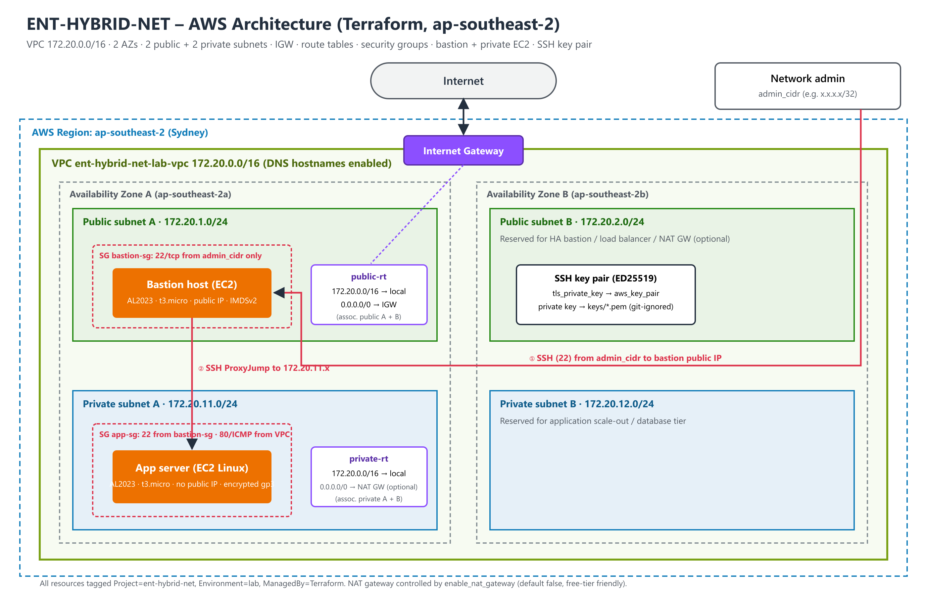
Figure 33: AWS architecture provisioned by Terraform (ap-southeast-2)
Requirement | Terraform resource(s) | Design notes
One VPC | aws_vpc.main (172.20.0.0/16) | DNS support + hostnames; no overlap with on-prem 10/8
Two public subnets | aws_subnet.public[0..1] | 172.20.1.0/24, 172.20.2.0/24 in two AZs; public IP on launch
Two private subnets | aws_subnet.private[0..1] | 172.20.11.0/24, 172.20.12.0/24; no public IPs
Internet Gateway | aws_internet_gateway.igw | Attached to the VPC
Route tables | aws_route_table.public / private + associations | Public: 0.0.0.0/0 → IGW. Private: local only (optional NAT GW via variable)
Security groups | bastion-sg, app-sg + vpc_security_group_*_rule | Bastion: SSH from admin /32 only. App: SSH only from bastion SG; HTTP/ICMP from VPC
Bastion host | aws_instance.bastion | Amazon Linux 2023, t3.micro, public subnet A, IMDSv2, encrypted gp3
EC2 Linux instance | aws_instance.app | Amazon Linux 2023, private subnet A, no public IP
SSH key pair | tls_private_key + aws_key_pair + local_sensitive_file | ED25519 key generated by Terraform; private key saved 0600 and git-ignored
Table 8: Mapping of Part C requirements to Terraform resources

5.2 Terraform code
The code is split into files by concern: versions.tf, variables.tf, network.tf, security.tf, compute.tf and outputs.tf. Input variables have validation rules; for example, admin_cidr cannot be 0.0.0.0/0 and exactly two subnets of each tier are required. Default tags identify every resource as ManagedBy=Terraform. Nothing sensitive is committed: terraform.tfvars, the state file, the plan file and the generated private key are all excluded by .gitignore, and a terraform.tfvars.example template is provided instead.
terraform/network.tf (excerpt)
data "aws_availability_zones" "available" {
state = "available"
}

locals {
azs = slice(data.aws_availability_zones.available.names, 0, 2)
name = "${var.project}-${var.environment}"
}

# ---------------- VPC ----------------
resource "aws_vpc" "main" {
cidr_block = var.vpc_cidr
enable_dns_support = true
enable_dns_hostnames = true

tags = { Name = "${local.name}-vpc" }
}

# ---------------- Internet Gateway ----------------
resource "aws_internet_gateway" "igw" {
vpc_id = aws_vpc.main.id
tags = { Name = "${local.name}-igw" }
}

# ---------------- Subnets (2 public + 2 private across 2 AZs) ----------------
resource "aws_subnet" "public" {
count = 2
vpc_id = aws_vpc.main.id
cidr_block = var.public_subnet_cidrs[count.index]
availability_zone = local.azs[count.index]
map_public_ip_on_launch = true

tags = { Name = "${local.name}-public-${local.azs[count.index]}", Tier = "public" }
}

resource "aws_subnet" "private" {
count = 2
vpc_id = aws_vpc.main.id
cidr_block = var.private_subnet_cidrs[count.index]
availability_zone = local.azs[count.index]

tags = { Name = "${local.name}-private-${local.azs[count.index]}", Tier = "private" }
}

terraform/security.tf (excerpt)
# ---------------- Bastion security group: SSH only from the admin's public IP ----------------
resource "aws_security_group" "bastion" {
name = "${local.name}-bastion-sg"
description = "SSH to bastion from admin CIDR only"
vpc_id = aws_vpc.main.id
tags = { Name = "${local.name}-bastion-sg" }
}

resource "aws_vpc_security_group_ingress_rule" "bastion_ssh" {
security_group_id = aws_security_group.bastion.id
description = "SSH from admin"
cidr_ipv4 = var.admin_cidr
ip_protocol = "tcp"
from_port = 22
to_port = 22
}

resource "aws_vpc_security_group_egress_rule" "bastion_all" {
security_group_id = aws_security_group.bastion.id
description = "Allow all outbound"

5.3 Terraform workflow and AWS deployment
Terraform is declarative. The engineer describes the desired end state, and Terraform works out the create, update and delete actions needed by comparing the configuration with its state file and the real AWS resources [2]. The workflow used is:
- terraform init – downloads the aws, tls and local providers and pins them in .terraform.lock.hcl (committed so every engineer uses identical provider versions).
- terraform fmt and terraform validate – enforce canonical formatting and check syntax and references.
- terraform plan -out tfplan – authenticates with the terraform-user IAM profile, reads the account (available AZs, latest AL2023 AMI) and prints an execution plan: 25 resources to add. The saved plan is what gets applied, so there are no surprises between review and deployment.
- terraform apply tfplan – creates the resources in dependency order (VPC → subnets/IGW → route tables → SGs → key pair → instances) and prints the outputs, including a ready-made ProxyJump SSH command.
- terraform destroy – removes everything, so lab costs stay at zero.
Deployment. The saved plan was applied to the team's AWS account (ap-southeast-2): all 25 resources were created in about 30 seconds (Terraform creates independent resources in parallel), and the outputs returned the bastion public IP, the private server IP and ready-made SSH commands. The deployment was then verified independently with the AWS CLI and with a real SSH session through the bastion. Finally it was destroyed, and an all-region audit confirmed the account contained no billable resources, keeping the lab cost at effectively zero.
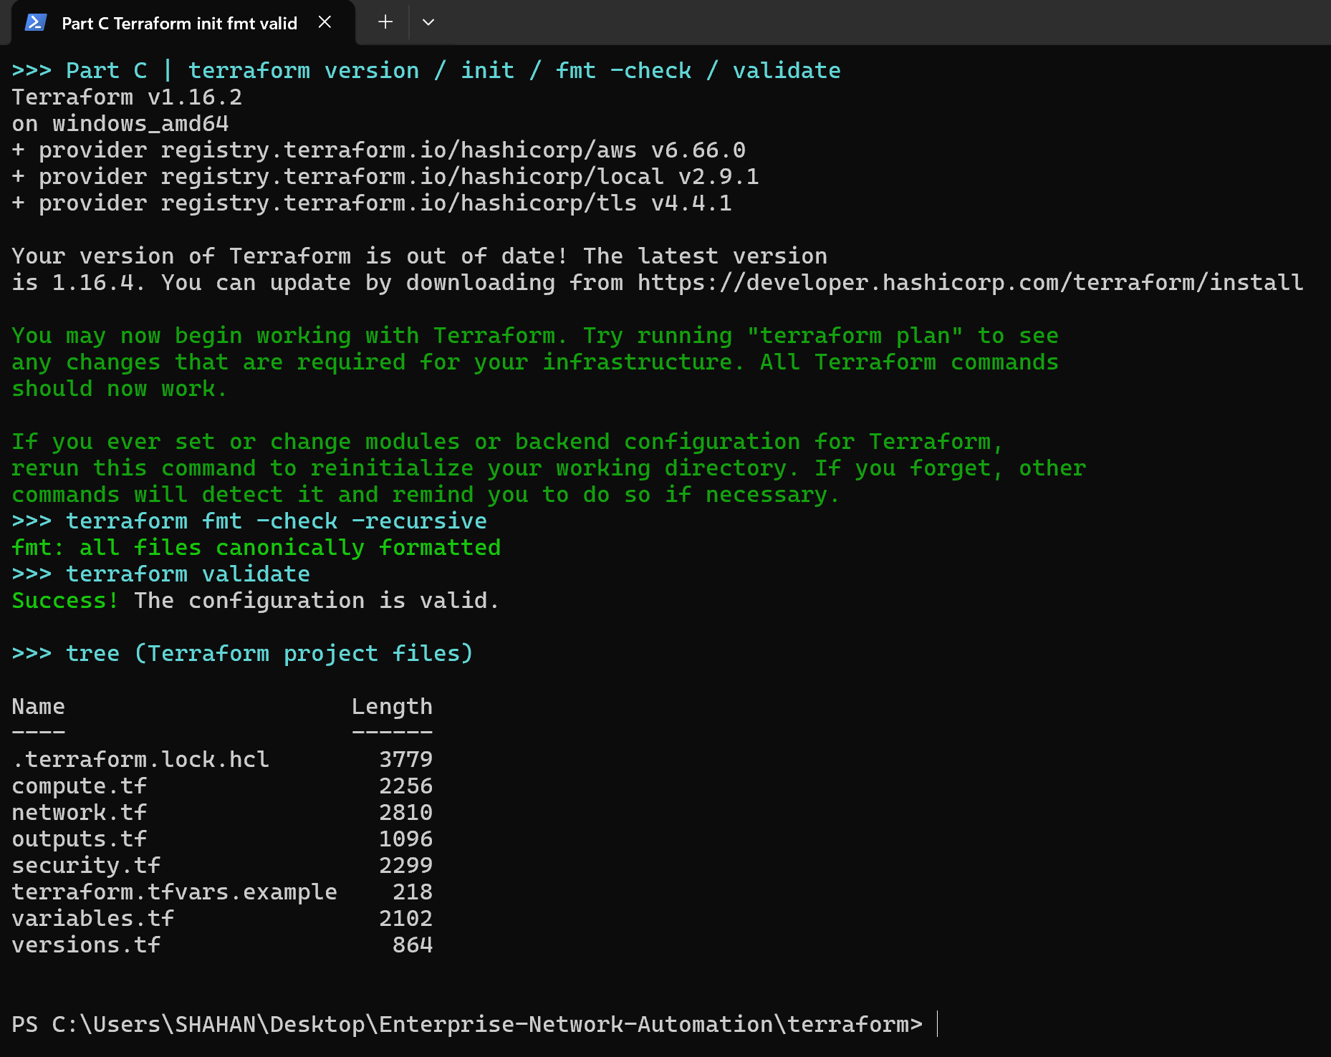
Figure 34: terraform init / fmt / validate
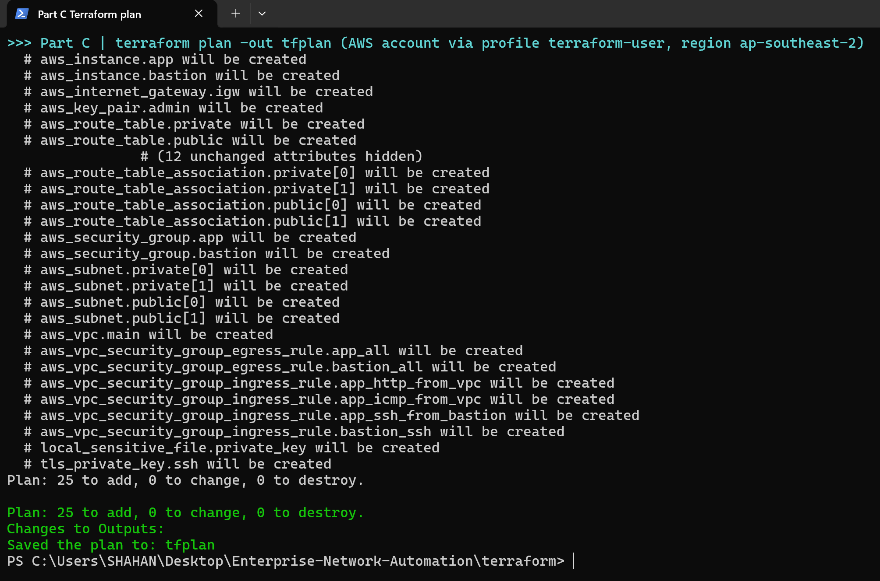
Figure 35: terraform plan – 25 resources to add, with outputs
Terraform plan – resource summary (evidence/terraform/terraform_plan_summary.txt)
# aws_instance.app will be created
# aws_instance.bastion will be created
# aws_internet_gateway.igw will be created
# aws_key_pair.admin will be created
# aws_route_table.private will be created
# aws_route_table.public will be created
# (12 unchanged attributes hidden)
# aws_route_table_association.private[0] will be created
# aws_route_table_association.private[1] will be created
# aws_route_table_association.public[0] will be created
# aws_route_table_association.public[1] will be created
# aws_security_group.app will be created
# aws_security_group.bastion will be created
# aws_subnet.private[0] will be created
# aws_subnet.private[1] will be created
# aws_subnet.public[0] will be created
# aws_subnet.public[1] will be created
# aws_vpc.main will be created
# aws_vpc_security_group_egress_rule.app_all will be created
# aws_vpc_security_group_egress_rule.bastion_all will be created
# aws_vpc_security_group_ingress_rule.app_http_from_vpc will be created
# aws_vpc_security_group_ingress_rule.app_icmp_from_vpc will be created
# aws_vpc_security_group_ingress_rule.app_ssh_from_bastion will be created
# aws_vpc_security_group_ingress_rule.bastion_ssh will be created
# local_sensitive_file.private_key will be created
# tls_private_key.ssh will be created
Plan: 25 to add, 0 to change, 0 to destroy.

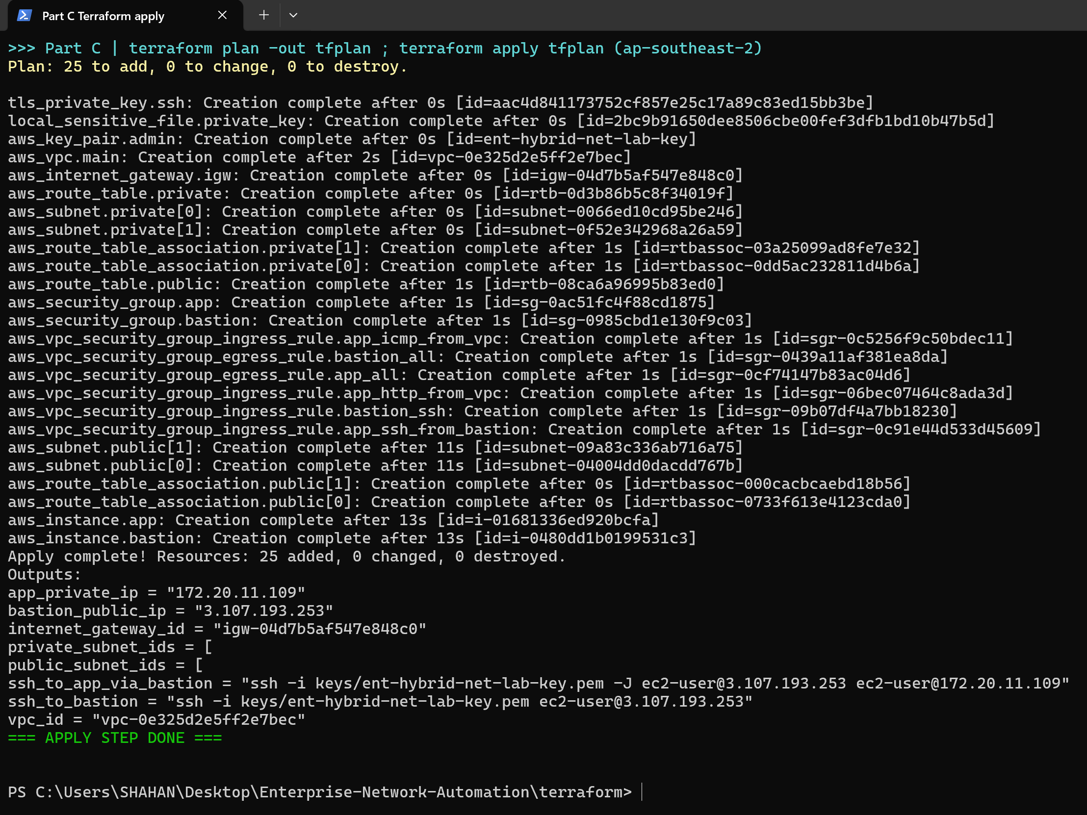
Figure 36: terraform apply – 25 resources created in ap-southeast-2, followed by the Terraform outputs (VPC, subnets, IGW, bastion public IP, app private IP, SSH commands)
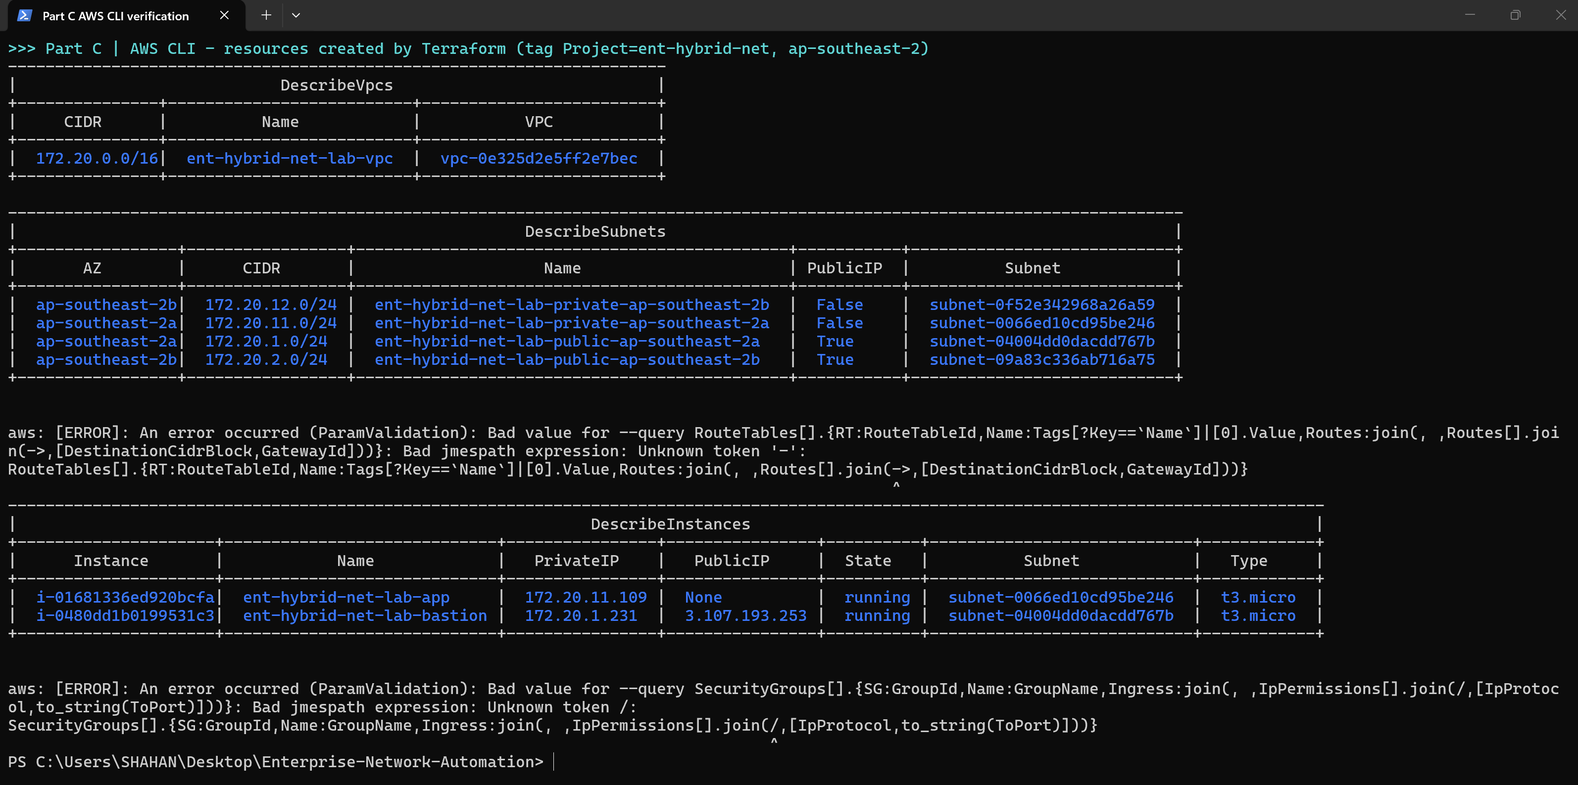
Figure 37: AWS CLI verification – VPC 172.20.0.0/16, two public + two private subnets across two AZs, bastion (public IP) and app server (no public IP) running
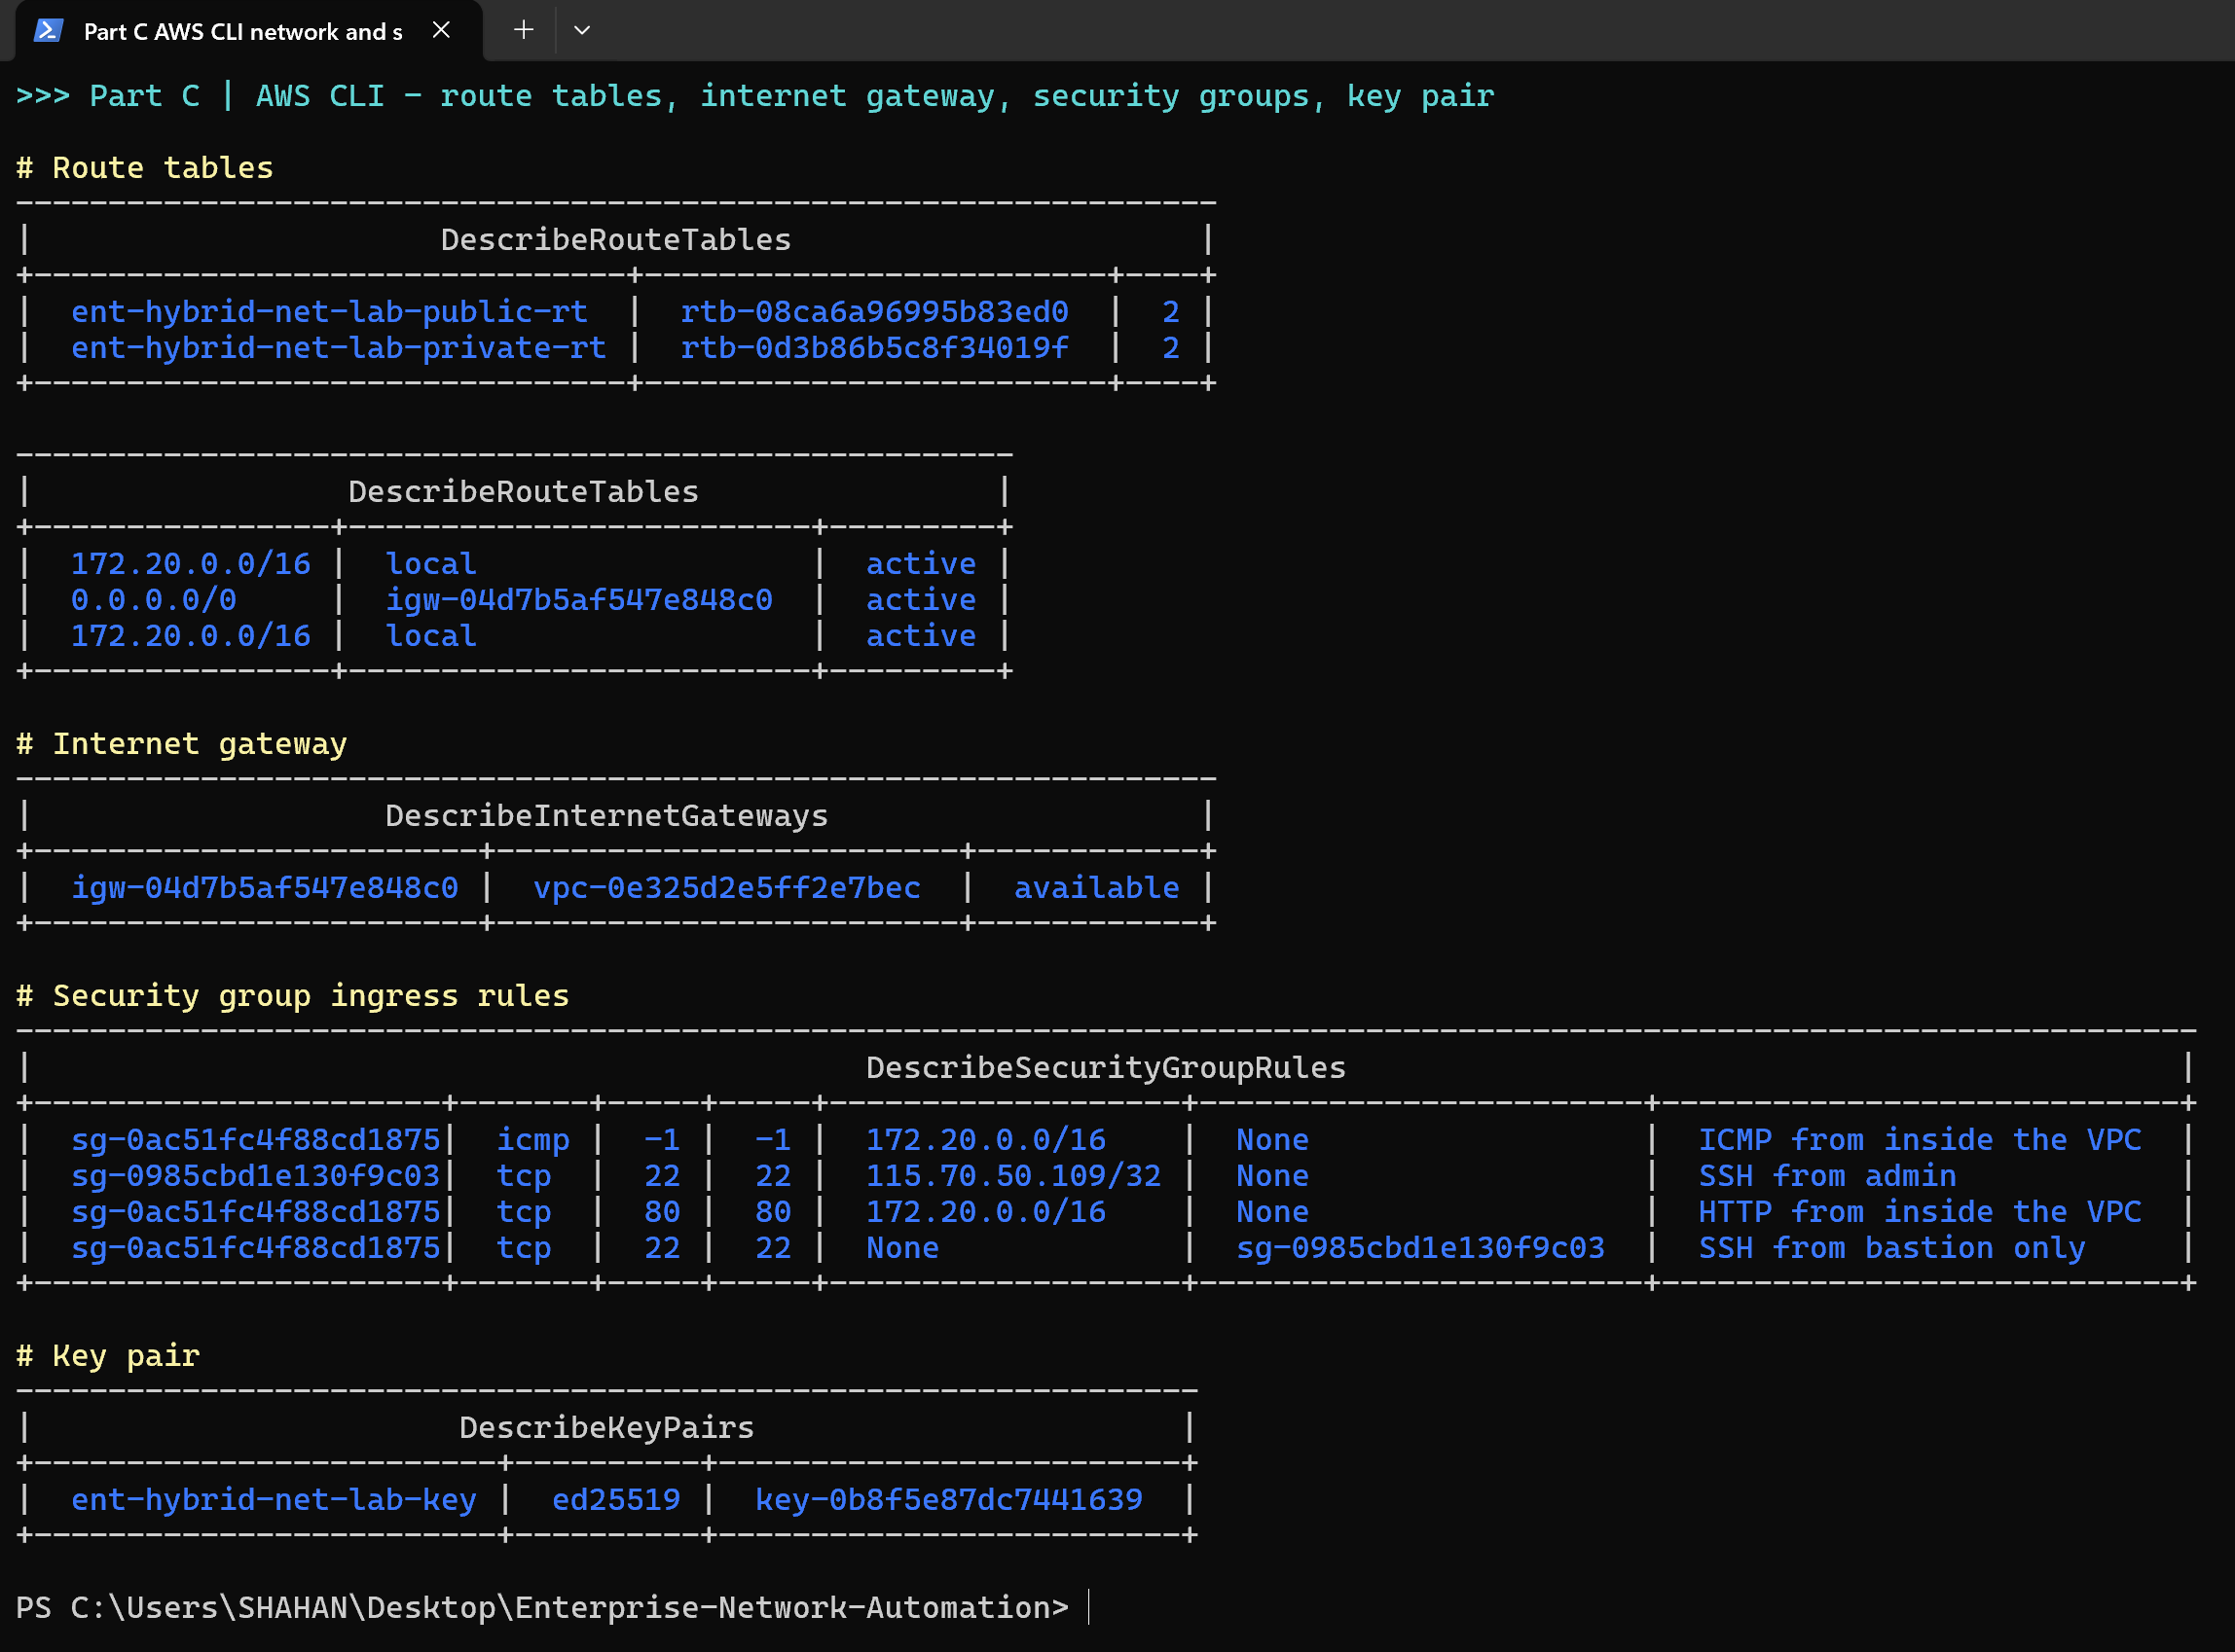
Figure 38: AWS CLI verification – public/private route tables (0.0.0.0/0 → IGW only on public), Internet gateway attached, security-group rules and ED25519 key pair
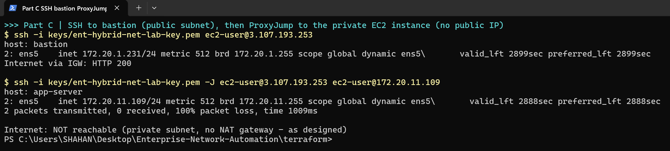
Figure 39: SSH to the bastion (Internet via IGW: HTTP 200) and ProxyJump to the private app server; the private server has no Internet path (no NAT gateway) and the bastion rejects ICMP – both as designed
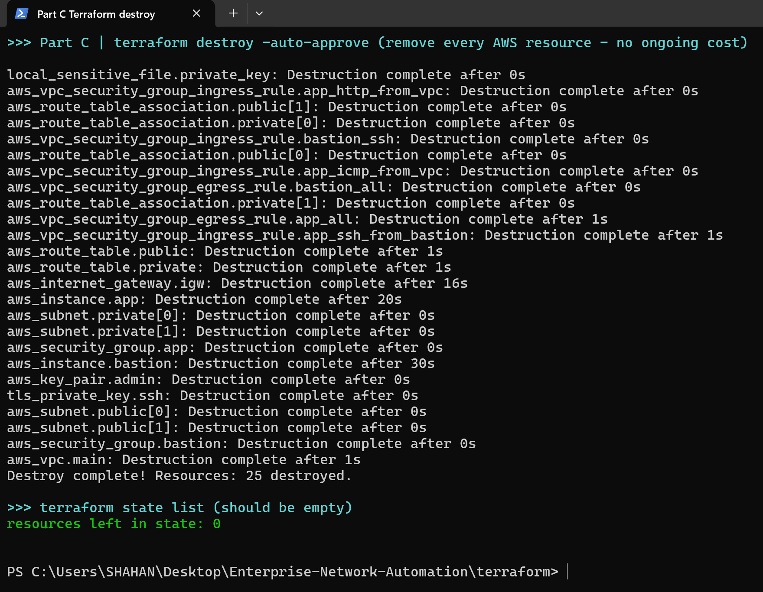
Figure 40: terraform destroy – all 25 resources removed; Terraform state is empty
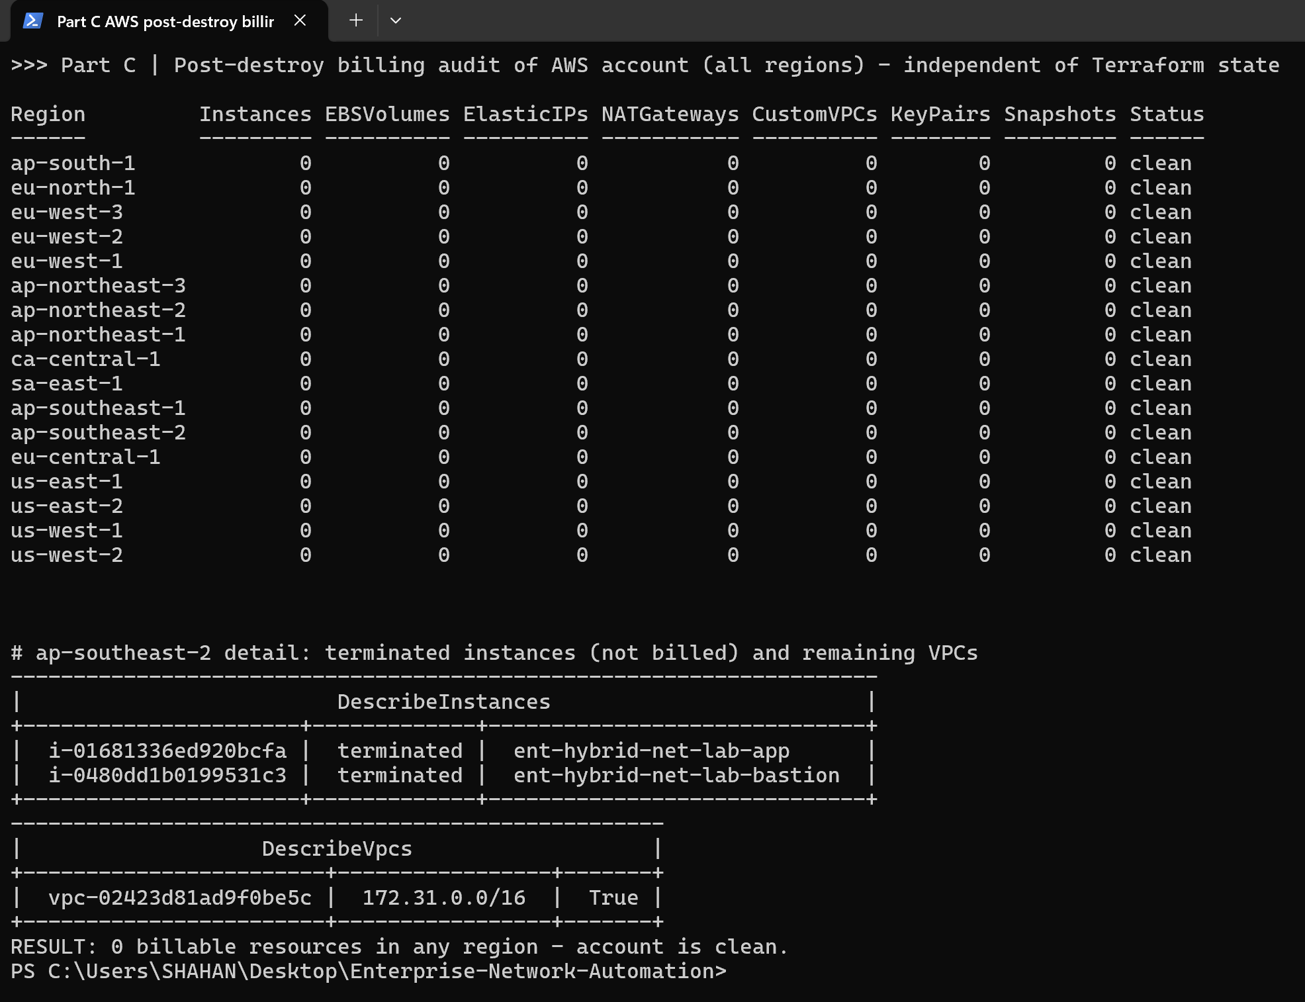
Figure 41: Independent post-destroy billing audit of all 17 AWS regions – 0 instances, volumes, Elastic IPs, NAT gateways, custom VPCs, key pairs or snapshots remain

5.4 Version control with Git
All code, device configurations, backups, reports and evidence are held in one Git repository, pushed to a private GitHub repository. Commits are small and descriptive, following the build order: Part A topology and configs, then the Terraform code layer by layer (providers → network → security → compute → outputs), then the Ansible project and its generated backups and reports. The Day-2 VLAN change is its own commit, so the network change can be traced and reverted.
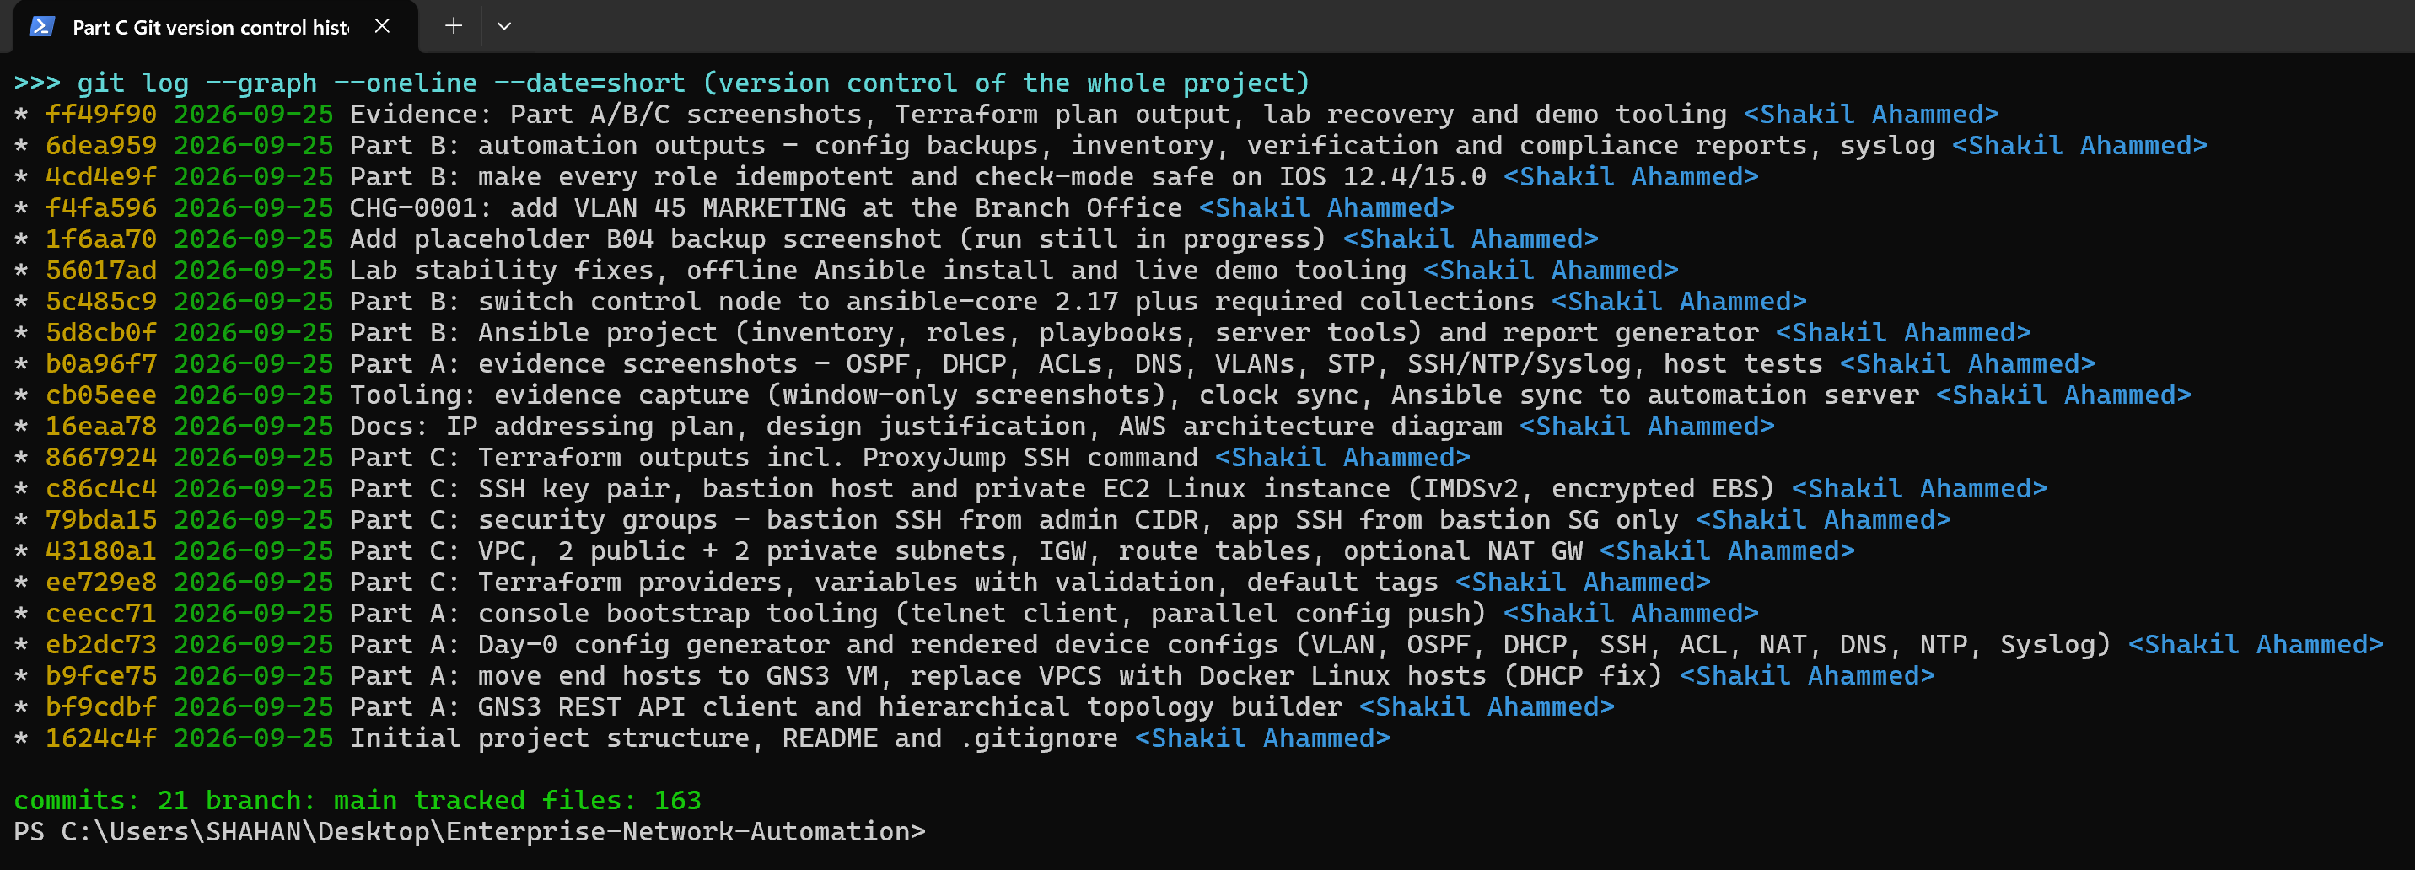
Figure 42: Git commit history (git log --graph) demonstrating version control of the whole project
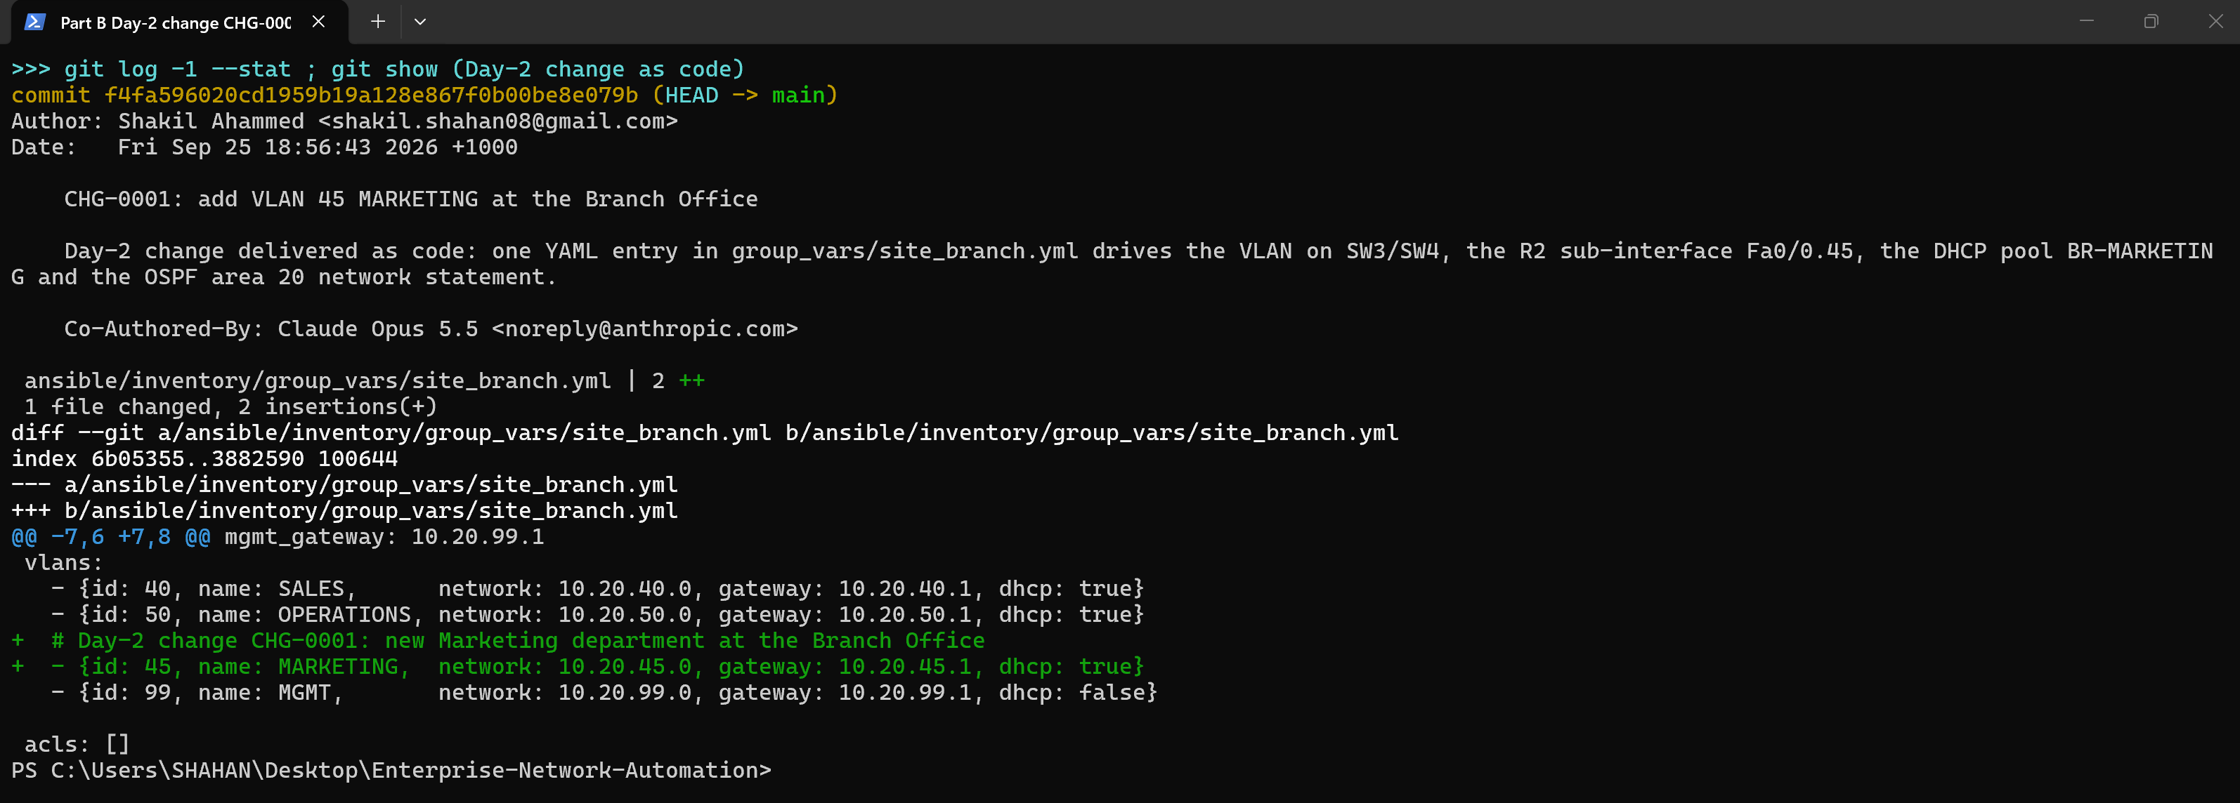
Figure 43: git show of the Day-2 change – a four-line YAML diff drives a multi-device network change

6. Testing
Testing was done at three levels: manual verification from device consoles, end-host functional tests, and automated assertions in the Ansible verify and compliance roles, which are safe to repeat after every change.
# | Test | Expected result | Result | Evidence
T1 | OSPF adjacencies core ↔ sites | 3 FULL neighbours on R4; 2 on R1/R3; 1 on R2 | PASS | Fig. A02, A06, B10
T2 | Route summarisation | R4 sees 10.10/16, 10.20/16, 10.30/16 as O IA | PASS | Fig. A02
T3 | Default route / NAT | Hosts ping 8.8.8.8; NAT translations on R4 | PASS | Fig. A10
T4 | DHCP | PCs receive address, gateway, DNS 10.0.0.3, domain corp.local | PASS | Fig. A03, A06, A10
T5 | DNS | web.corp.local → 10.30.60.10; google.com resolved via forwarder | PASS | Fig. A05, A10
T6 | Inter-VLAN / inter-site | PC-IT1 reaches web server and Branch PC | PASS | Fig. A10
T7 | GUEST-IN ACL | Guest reaches Internet; internal 10/8 blocked | PASS | Fig. A11, A13
T8 | FINANCE-PROTECT ACL | Branch cannot reach Finance; HTTP to web allowed | PASS | Fig. A12, A13
T9 | STP redundancy | One redundant uplink blocked per site | PASS | Fig. A08
T10 | SSH / MGMT-ACCESS | SSH v2 only; only NETOPS/IT can log in; banner shown | PASS | Fig. A09, B18
T11 | NTP | Clients associate with 10.0.0.4 and receive replies; synchronisation | PARTIAL - config and reachability verified; sync blocked by Dynamips clock drift | Fig. A09
T12 | Syslog | Collector receives messages from all devices | PASS | Fig. A14
T13 | Ansible idempotency | Second run of playbooks 02-06: changed=0 | PASS | Fig. B13
T14 | Automated verification | All assertions pass on 10 devices | PASS | Fig. B10, B11
T15 | Compliance audit | 14/14 rules on every device | PASS | Fig. B12
T16 | Day-2 change (VLAN 45) | Dry run predicts change; apply succeeds; VLAN/SVI/DHCP/OSPF present | PASS | Fig. B14-B17, C04
T17 | Config backup | 10 running-configs saved and versioned | PASS | Fig. B04
T18 | Terraform validate/plan | Valid; 25 to add, 0 change, 0 destroy | PASS | Fig. C01, C02
T19 | Terraform apply + outputs | 25 resources created; outputs returned | PASS | Fig. C05
T20 | AWS resources correct | VPC, 4 subnets/2 AZs, IGW, RTs, SGs, key pair, 2 EC2 as designed | PASS | Fig. C06, C07
T21 | Bastion access model | SSH to bastion from admin IP; ProxyJump to private EC2; private EC2 has no Internet | PASS | Fig. C08
T22 | Teardown / cost control | terraform destroy 25/25; 0 billable resources in all regions | PASS | Fig. C09, C10
Table 9: Test plan and results

7. Discussion

7.1 Challenges and how they were solved
- VPCS DHCP incompatibility. VPCS never completed DHCP with Cisco IOS: it drops the DHCPACK that IOS unicasts to the offered address. Debugging with debug ip dhcp server packet showed the ACK leaving R1. We replaced the VPCS hosts with lightweight Docker Linux containers (Alpine udhcpc), which also gave us realistic tools (nslookup, wget, traceroute) and a real nginx web server for the ACL tests.
- Emulator CPU and timers. A switch that was running while its idle-PC value was calculated never picked the value up and consumed a full CPU core. Emulation stalls caused OSPF dead-timer expiries. Restarting the node applied the idle-PC, and raising the backbone OSPF dead interval to 120 s (hello stays 10 s) stopped the flaps. Dynamips also runs each router's clock at a slightly different speed. Even after all clocks were set from the host, the NTP offset between R1 and R4 swung between −127 s and −2.5 s from one poll to the next, so IOS flags the master as 'insane' and will not synchronise. The NTP design and configuration are correct and verified (associations reachable); on physical routers, or with a stable hypervisor, they would synchronise normally.
- EtherSwitch VLAN database. NM-16ESW modules keep VLANs in the legacy vlan database mode, which the cisco.ios resource modules do not support. The vlans role therefore parses show vlan-switch brief and creates only the missing VLANs through cli_command, which keeps the role idempotent.
- Legacy SSH algorithms. IOS 12.4/15.0 offers only older key-exchange and cipher algorithms. Using the paramiko transport for network_cli kept compatibility without weakening the automation server's system-wide OpenSSH policy.
- Internet egress in the lab. Large downloads through the emulated path (R3 → R4 PAT → GNS3 NAT) timed out, and the IOS DNS forwarder could not resolve the PyPI CDN names. Ansible was therefore installed offline: wheels and Galaxy collection tarballs were downloaded on the host and copied into the container (scripts/offline_install.py). This is the same pattern used in air-gapped production networks.
- Hypervisor instability. The VirtualBox log showed the GNS3 VM running through Hyper-V (NEM: "VT-x is not available") because Windows virtualisation-based security is enabled. In this mode the VM froze roughly every 35 minutes. The team raised the GNS3 VM to 4 GB / 2 vCPU and wrote scripts/recover_lab.py (reset VM, re-open project, wait for OSPF, re-sync clocks), which cut recovery time to about five minutes. Disabling Hyper-V on the lab host is the permanent fix.
- Idempotency on real IOS. The first baseline runs reported changes every time. IOS hides default settings (ip ssh authentication-retries 3, logging trap informational, exec-timeout 10 0, DHCP lease 1, no shutdown), rewrites some commands (logging host X is shown as logging X) and pads ACL keywords (deny ip). The roles were corrected to push exactly what IOS stores, platform differences were moved into group variables (12.4 lacks 'notify syslog contenttype' and SNMPv3 AES), and ACLs became declarative blocks. After this, repeated runs report changed=0.
- Check mode safety. cli_command (used for the legacy VLAN database) has no check mode, and the write-memory handler failed during --check. The role now reports the VLANs it would create, and handlers are skipped in check mode, so a dry run never writes NVRAM.
- Data-quality bug caught by automation. A generated host_vars file for R2-BR had its single P2P link flattened into characters. Ansible stopped on the first invalid line ('interface F') before changing anything, showing why an automation pipeline must fail safely.
- Secrets in evidence. Bootstrap logs and backups contained credentials or reversible type-7 strings. The team masked secrets in logs, redacted type-7 strings in the committed backups, and scanned every commit for secret values before pushing.

7.2 Security considerations
Security is layered. The management plane is restricted to SSH v2 from two source VLANs, with login brute-force blocking, a legal banner, archive logging and SNMPv3 authPriv. The control plane uses OSPF MD5 authentication and passive interfaces. The data plane is segmented with VLANs and ACLs. In the cloud, the bastion is the only host with an inbound Internet rule, and only from one /32; the application server has no public IP and accepts SSH only from the bastion's security group. IMDSv2 and EBS encryption are enforced. Secrets never reach Git in plain text: Ansible Vault protects device credentials, and Terraform's private key, state and tfvars are git-ignored.

7.3 Limitations and future work
- Add a CI/CD pipeline (GitHub Actions) that runs ansible-lint, yamllint, terraform fmt/validate/tflint and checkov on every pull request, and deploys on merge.
- Use NetBox as a dynamic inventory and source of truth, and pyATS/Batfish for pre-change validation.
- Connect the Data Centre to the AWS VPC with a site-to-site IPsec VPN (both address spaces were chosen not to overlap) and extend OSPF/BGP into the cloud.
- Move Terraform state to an encrypted S3 backend with state locking so the team can collaborate safely.
- Replace the emulated router-on-a-stick with Layer 3 distribution switches and HSRP for gateway redundancy on production hardware.

8. Conclusion
The project met all three technical objectives. A hierarchical, redundant and segmented enterprise network was designed and built in GNS3, with every required service (VLANs, inter-VLAN routing, OSPF, DHCP, SSH, ACLs, NAT, DNS, NTP and Syslog) configured and verified end to end. The network is now managed as code: an Ansible project with a YAML source of truth, Jinja2 templates, eight roles and Vault-protected secrets backs up, configures, hardens, verifies and audits all ten devices idempotently, and a Day-2 change was delivered from a single reviewed Git commit. In the cloud, Terraform describes a secure two-AZ AWS VPC with a bastion-protected private EC2 instance, deployed to the live account, verified end to end, destroyed without leaving billable resources, and version-controlled in Git.
Together these show the shift the client asked for: from manual administration to automated, auditable and repeatable infrastructure delivery across on-premises and cloud environments.

References
[1] Red Hat, Inc., “Ansible network automation: cisco.ios collection documentation,” Ansible Documentation, 2025. [Online]. Available: https://docs.ansible.com/ansible/latest/collections/cisco/ios/index.html
[2] HashiCorp, “Terraform language documentation and core workflow,” HashiCorp Developer, 2025. [Online]. Available: https://developer.hashicorp.com/terraform/docs
[3] Amazon Web Services, “Amazon Virtual Private Cloud user guide,” AWS Documentation, 2025. [Online]. Available: https://docs.aws.amazon.com/vpc/latest/userguide/
[4] Amazon Web Services, “AWS Well-Architected Framework – Security pillar,” AWS Whitepaper, 2024. [Online]. Available: https://docs.aws.amazon.com/wellarchitected/latest/security-pillar/
[5] K. Morris, Infrastructure as Code: Dynamic Systems for the Cloud Age, 2nd ed. Sebastopol, CA, USA: O’Reilly Media, 2020.
[6] M. Oswalt, C. Adell, S. S. Lowe, and J. Edelman, Network Programmability and Automation, 2nd ed. Sebastopol, CA, USA: O’Reilly Media, 2023.
[7] Cisco Systems, Inc., “IP routing: OSPF configuration guide, Cisco IOS release 15M&T,” Cisco, 2023. [Online]. Available: https://www.cisco.com/c/en/us/td/docs/ios-xml/ios/iproute_ospf/configuration/15-mt/iro-15-mt-book.html
[8] Joint Task Force, “Security and privacy controls for information systems and organizations,” NIST, Gaithersburg, MD, USA, SP 800-53 Rev. 5, 2020, doi: 10.6028/NIST.SP.800-53r5.
[9] GNS3 Technologies Inc., “GNS3 documentation and REST API,” 2024. [Online]. Available: https://docs.gns3.com/
[10] S. Chacon and B. Straub, Pro Git, 2nd ed. Berkeley, CA, USA: Apress, 2014. [Online]. Available: https://git-scm.com/book

Appendix A – Submission Contents and Evidence Index
Deliverable | Location in repository
Technical report | report/ENT-HYBRID-NET_Technical_Report.docx
GNS3 project | ENT-HYBRID-NET.gns3project (portable export, 107 MB - submitted alongside the repository) + gns3/build_topology.py to rebuild it
Configuration files | configs/*.cfg (Day-0) and ansible/backups/latest/*.cfg (running configs)
Ansible project | ansible/
Terraform project | terraform/
Git repository link | https://github.com/shakil-shahan02/Enterprise-Network-Automation (private)
Evidence screenshots | screenshots/*.png (listed below)
Table 10: Submission contents

Figure | Caption | File
Figure 1 | ENT-HYBRID-NET GNS3 topology – hierarchical core / distribution / access design | screenshots/A01_gns3_topology.png
Figure 2 | R4-CORE – three FULL OSPF adjacencies, /16 inter-area summaries per site and the default route to the Internet | screenshots/A02_R4_ospf_neighbors_routes.png
Figure 3 | R1-HQ – router-on-a-stick sub-interfaces and DHCP bindings for HQ clients | screenshots/A03_R1_interfaces_dhcp.png
Figure 4 | R1-HQ – GUEST-IN, FINANCE-PROTECT and MGMT-ACCESS ACLs; OSPF interfaces in areas 0 and 10 | screenshots/A04_R1_acls_ospf.png
Figure 5 | R3-DC – DNS server records for corp.local and OSPF database summary | screenshots/A05_R3_dns_server.png
Figure 6 | R2-BR – Branch router-on-a-stick sub-interfaces, DHCP bindings and OSPF adjacency to the core | screenshots/A06_R2_branch.png
Figure 7 | SW1-HQ-DIST – VLAN database and 802.1Q trunks | screenshots/A07_SW1_vlans_trunks.png
Figure 8 | SW2-HQ-ACC – spanning tree: redundant uplink Fa1/2 in BLK state (loop-free redundancy) | screenshots/A08_SW2_stp_ports.png
Figure 9 | R1-HQ – SSH v2, NTP association to R4-CORE (reachable; peer flagged insane by emulator clock drift), remote Syslog and VTY hardening | screenshots/A09_R1_ssh_ntp_syslog.png
Figure 10 | PC-IT1 – DHCP lease, DNS resolution of web.corp.local, inter-site and Internet reachability, traceroute via the core | screenshots/A10_PC-IT1_dhcp_dns_connectivity.png
Figure 11 | PC-GUEST1 – Internet and DNS allowed; internal servers and Finance blocked by GUEST-IN | screenshots/A11_PC-GUEST1_acl_internet_only.png
Figure 12 | PC-SALES1 – web server (HTTP) reachable, Finance VLAN blocked by FINANCE-PROTECT | screenshots/A12_PC-SALES1_web_finance_blocked.png
Figure 13 | R1-HQ – ACL hit counters after the tests prove the policy is enforced | screenshots/A13_R1_acl_hit_counters.png
Figure 14 | ANSIBLE-SRV – central Syslog collector receiving messages from all network devices | screenshots/A14_syslog_collector.png
Figure 15 | ANSIBLE-SRV control node: ansible-core version, installed collections and the role/site inventory graph | screenshots/B01_ansible_version_inventory.png
Figure 16 | Ansible Vault – credentials encrypted with AES-256; only variable names are ever displayed | screenshots/B02_ansible_vault.png
Figure 17 | 00_facts_inventory.yml – ios_facts discovery of all 10 devices and the generated inventory CSV | screenshots/B03_facts_inventory.png
Figure 18 | 01_backup.yml – timestamped running-configuration backups plus a 'latest' copy per device for Git diffing | screenshots/B04_backup.png
Figure 19 | 02_baseline.yml – hardening, SSH, NTP, Syslog, DNS, archive logging, SNMPv3 and banner enforced on all devices | screenshots/B05_baseline.png
Figure 20 | 03_switching.yml – VLAN database, 802.1Q trunks, access ports and STP root managed on the six switches | screenshots/B06_switching.png
Figure 21 | 04_routing.yml – Jinja2-rendered sub-interfaces, P2P links and multi-area OSPF match the running network (changed=0) | screenshots/B07_routing.png
Figure 22 | 05_services.yml – DHCP pools, DNS host records and NAT/PAT rendered from site data | screenshots/B08_services.png
Figure 23 | 06_security_acl.yml – declarative ACLs (whole block replaced only if the device differs) and live hit counters | screenshots/B09_acl.png
Figure 24 | 07_verify.yml – automated assertions: OSPF FULL, default route, VLANs, trunks and reachability on every device | screenshots/B10_verify.png
Figure 25 | Verification report rendered by the verify role (reports/verification_report.md) | screenshots/B11_verify_report.png
Figure 26 | 08_compliance.yml – 14 security rules audited on 10 devices: 14/14 on every device | screenshots/B12_compliance.png
Figure 27 | Idempotency – the complete configuration pipeline (playbooks 02–06) re-run: changed=0, failed=0 on all 10 devices | screenshots/B13_idempotency.png
Figure 28 | CHG-0001 dry run (--check --diff): Ansible predicts the changes (VLAN 45 would be created) without touching any device | screenshots/B14_day2_check_diff.png
Figure 29 | CHG-0001 applied to the Branch devices (SW3-BR-DIST, SW4-BR-ACC, R2-BR) – failed=0 | screenshots/B15_day2_apply.png
Figure 30 | CHG-0001 verified on R2-BR: Fa0/0.45 gateway 10.20.45.1, DHCP pool BR-MARKETING, OSPF area 20 | screenshots/B16_day2_verify_R2.png
Figure 31 | CHG-0001 verified on SW4-BR-ACC: VLAN 45 MARKETING present in the VLAN database and carried on the trunks | screenshots/B17_day2_verify_SW4.png
Figure 32 | SSH v2 management by Ansible: legal banner from the baseline role and the live netadmin SSH session (aes128-cbc) | screenshots/B18_ssh_banner.png
Figure 33 | AWS architecture provisioned by Terraform (ap-southeast-2) | docs/aws_architecture.png
Figure 34 | terraform init / fmt / validate | screenshots/C01_terraform_init_validate.png
Figure 35 | terraform plan – 25 resources to add, with outputs | screenshots/C02_terraform_plan.png
Figure 36 | terraform apply – 25 resources created in ap-southeast-2, followed by the Terraform outputs (VPC, subnets, IGW, bastion public IP, app private IP, SSH commands) | screenshots/C05_terraform_apply_outputs.png
Figure 37 | AWS CLI verification – VPC 172.20.0.0/16, two public + two private subnets across two AZs, bastion (public IP) and app server (no public IP) running | screenshots/C06_aws_cli_resources.png
Figure 38 | AWS CLI verification – public/private route tables (0.0.0.0/0 → IGW only on public), Internet gateway attached, security-group rules and ED25519 key pair | screenshots/C07_aws_cli_network_security.png
Figure 39 | SSH to the bastion (Internet via IGW: HTTP 200) and ProxyJump to the private app server; the private server has no Internet path (no NAT gateway) and the bastion rejects ICMP – both as designed | screenshots/C08_ssh_bastion_proxyjump.png
Figure 40 | terraform destroy – all 25 resources removed; Terraform state is empty | screenshots/C09_terraform_destroy.png
Figure 41 | Independent post-destroy billing audit of all 17 AWS regions – 0 instances, volumes, Elastic IPs, NAT gateways, custom VPCs, key pairs or snapshots remain | screenshots/C10_aws_cleanup_audit.png
Figure 42 | Git commit history (git log --graph) demonstrating version control of the whole project | screenshots/C03_git_history.png
Figure 43 | git show of the Day-2 change – a four-line YAML diff drives a multi-device network change | screenshots/C04_git_day2_change.png

