STEP:1 Download [php_xdebug-3.1.5-7.4-vc15-x86_64.dll](https://xdebug.org/files/php_xdebug-3.1.5-7.4-vc15-x86_64.dll)

STEP:2 Move the downloaded file to C:\xampp\php\ext, and rename it to php_xdebug.dll

STEP:3 Add the following lines in php.ini file

[xdebug]

zend_extension="C:\xampp\php\ext\php_xdebug.dll"

xdebug.mode=debug

xdebug.client_host=127.0.0.1

xdebug.client_port="9003"

STEP:4 Remove or comment any other line starts with zend_extension

STEP:5 To configure phpstorm settings, go to Language and frameworks. Click on PHP set up CLI Interpreter like following  
  
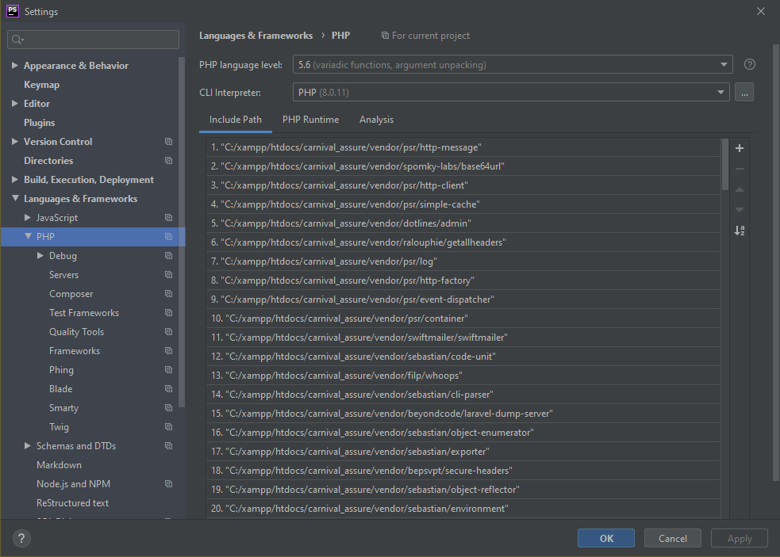

STEP:6 Beside CLI Interpreted click the … menu to access interpreter settings and update as following. If Xdebug is installed properly, you will see the Debugger info under executable field. 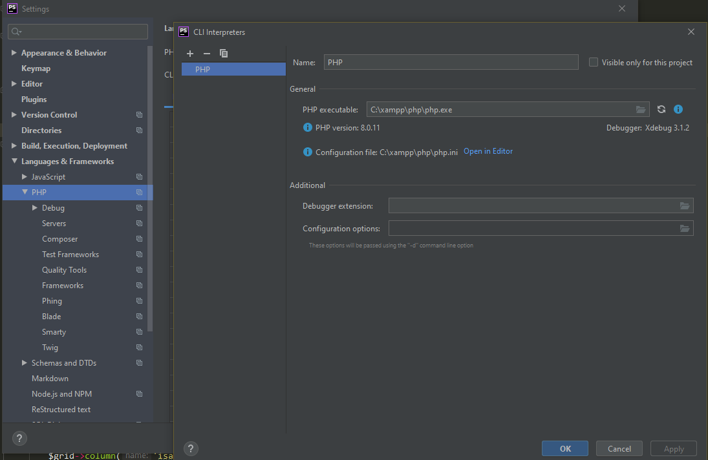

STEP:7 Under PHP click Debug and set the Debug port as following

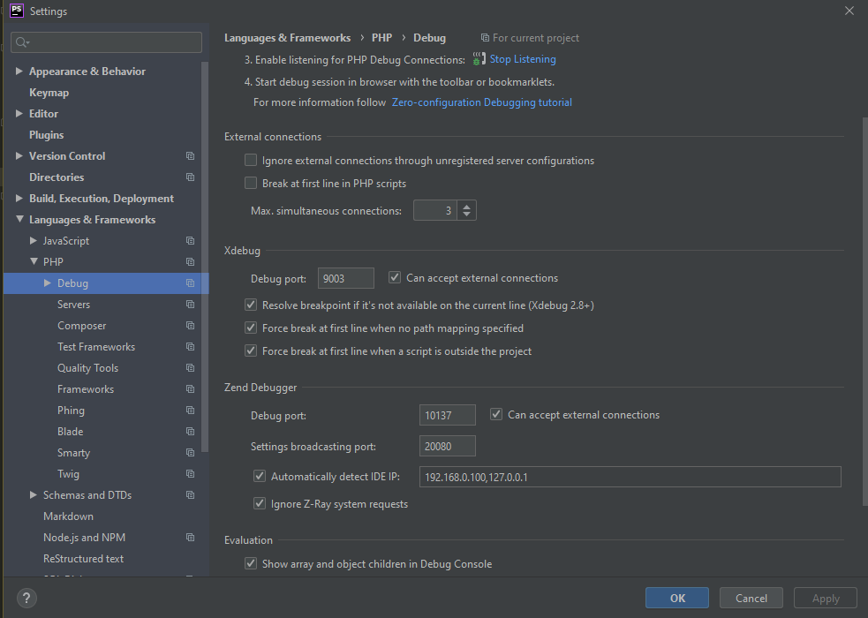

STEP:8 Final configure your local server for individual project. For new project you just need to do this part every time   
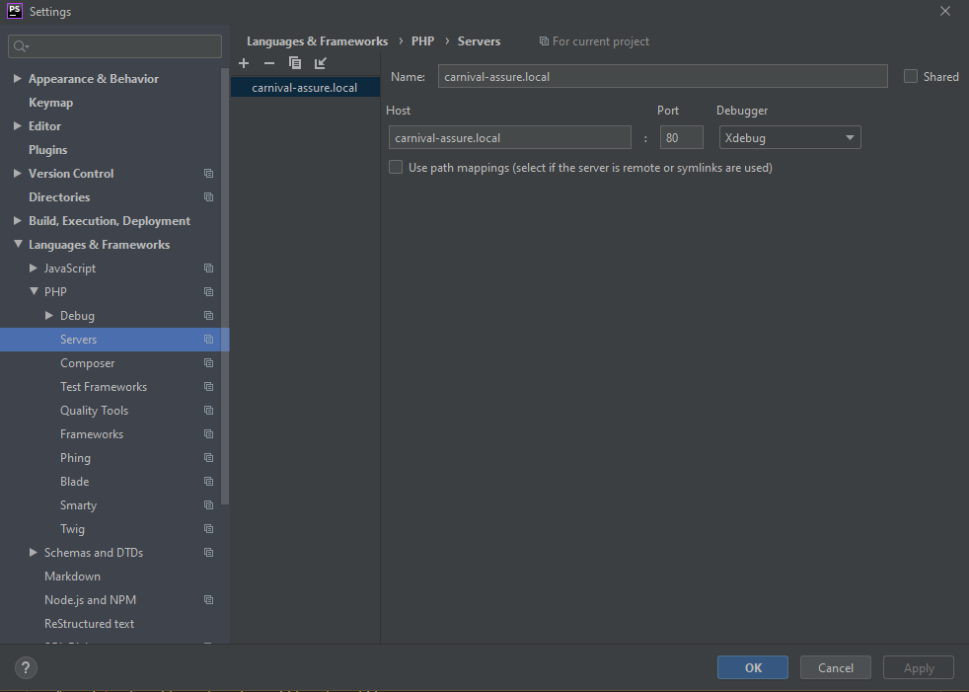

STEP 9: Finally install xdebug extension in your browser of choice. Enable it. In php storm make sure listening is on

For browsers supporting chrome extension, following can be used   
[Xdebug helper - Chrome Web Store (google.com)](https://chrome.google.com/webstore/detail/xdebug-helper/eadndfjplgieldjbigjakmdgkmoaaaoc)

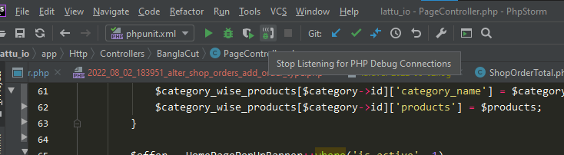

STEP 10: Now when you run the project it will stop at the breakpoint and you will see the details in debug panel on lower toolbar. Now when you run the project it will stop at the breakpoint and you can debug from debug panel

