AWS Practical Assignment Report
Scalable SSC Result Publishing Infrastructure (Module 7)
Scenario: 10:00 AM Traffic Burst • Platform: AWS (Ubuntu 22.04 on t3.micro)

1. Executive Summary & Architecture
This project deploys a highly available, fault-tolerant, and auto-scaling cloud infrastructure on AWS designed to handle sudden massive traffic spikes during the SSC Result 2026 publication at 10:00 AM. The architecture is engineered on t3.micro instances with an ultra-lightweight Nginx application footprint (<30 MB RAM) to ensure optimal cost efficiency and zero memory exhaustion.
Component | AWS Resource | Configuration & Scope
VPC | ssc-result-vpc | 10.0.0.0/16 across 2 Availability Zones (ap-southeast-1a & 1b)
Public Subnets | ssc-public-subnet-1 / 2 | 10.0.1.0/24 & 10.0.2.0/24 (Hosts ALB & NAT Gateway)
Private Subnets | ssc-private-subnet-1 / 2 | 10.0.3.0/24 & 10.0.4.0/24 (Hosts Auto Scaling EC2 Instances)
Internet Ingress | Application Load Balancer | Internet-facing ALB forwarding Port 80 traffic to Target Group
Egress Gateway | NAT Gateway (Elastic IP) | Provides secure outbound internet for private EC2 bootstrapping
Auto Scaling | ssc-result-asg | Min: 2, Desired: 2, Max: 10 with 50% CPU Target Tracking
Compute Node | Ubuntu 22.04 LTS (t3.micro) | Nginx serving SSC Result 2026 + IMDSv2 metadata injection

2. Technical Report & Traffic Flow

A. VPC and Network Architecture
The custom VPC 'ssc-result-vpc' (10.0.0.0/16) spans across two Availability Zones (ap-southeast-1a and ap-southeast-1b) for high availability. It contains 2 Public Subnets (for ALB and NAT Gateway) and 2 Private Subnets (for backend worker nodes). The Public Route Table directs 0.0.0.0/0 traffic to the Internet Gateway, while the Private Route Table routes all outbound traffic to the NAT Gateway.

B. ALB and EC2 Traffic Flow & Zero-Ingress Security
1. Candidates send HTTP queries to the Application Load Balancer DNS name.
2. The ALB Security Group (ssc-alb-sg) allows incoming traffic on Port 80 from 0.0.0.0/0.
3. The ALB distributes incoming requests across healthy private EC2 targets in both AZs using Round-Robin.
4. The EC2 Security Group (ssc-ec2-private-sg) strictly permits Port 80 ingress exclusively from the ALB Security Group, ensuring private instances cannot be directly accessed from the internet.
5. The ALB Target Group (ssc-result-tg) continuously polls the /health endpoint to automatically bypass any failed node within 15-30 seconds.

C. Purpose of NAT Gateway
Because the EC2 instances reside inside isolated Private Subnets without public IPv4 addresses, the NAT Gateway (positioned in Public Subnet 1 with an Elastic IP) allows private instances to perform outbound requests to download OS updates, install Nginx, and bootstrap application files via User Data while completely blocking unsolicited inbound internet traffic.

D. Auto Scaling Strategy
The Auto Scaling Group (ssc-result-asg) implements a dual proactive-reactive scaling model:
• Baseline Fleet: 2 minimum instances deployed across 2 Availability Zones.
• Scheduled Pre-Warming (10:00 AM Spike): A scheduled action pre-scales the group to 10 instances at 09:50 AM (10 minutes prior to result publishing) to prevent cold-start request queues.
• Target Tracking Policy: Configured for Average CPU Utilization at 50%. If unexpected traffic surges occur, additional t3.micro instances launch within 60 seconds.
• Scale-In: Excess instances terminate smoothly down to the baseline after peak load subsides.

E. Handling the SSC Result Traffic Spike
The combined architecture of DNS-level load balancing, Multi-AZ redundancy, lightweight Nginx static asset caching (<30 MB RAM per instance), and dynamic auto scaling from 2 to 10+ instances guarantees that millions of student requests are served with sub-second latency and zero server downtime.

3. AWS Console Verification Screenshots

Figure 1: Custom VPC Configuration (ssc-result-vpc - 10.0.0.0/16)
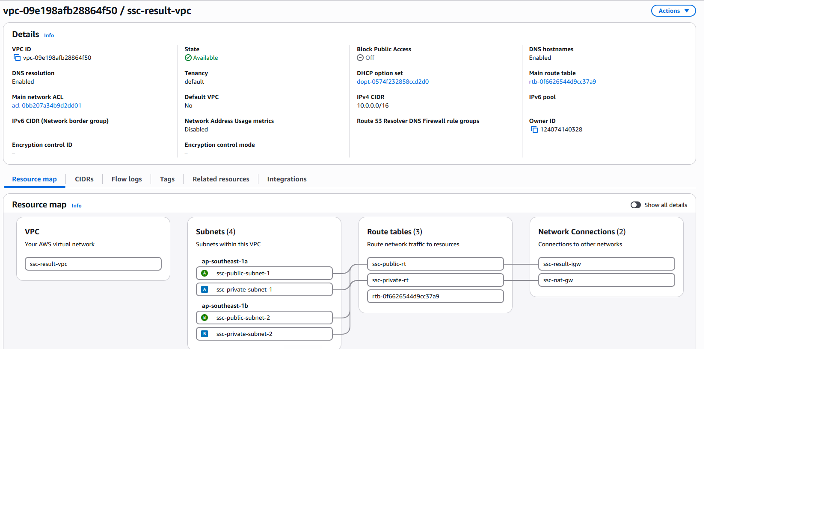
AWS Resource Verification: ssc-result-vpc.png

Figure 2: Internet Gateway Attached to VPC (ssc-result-igw)
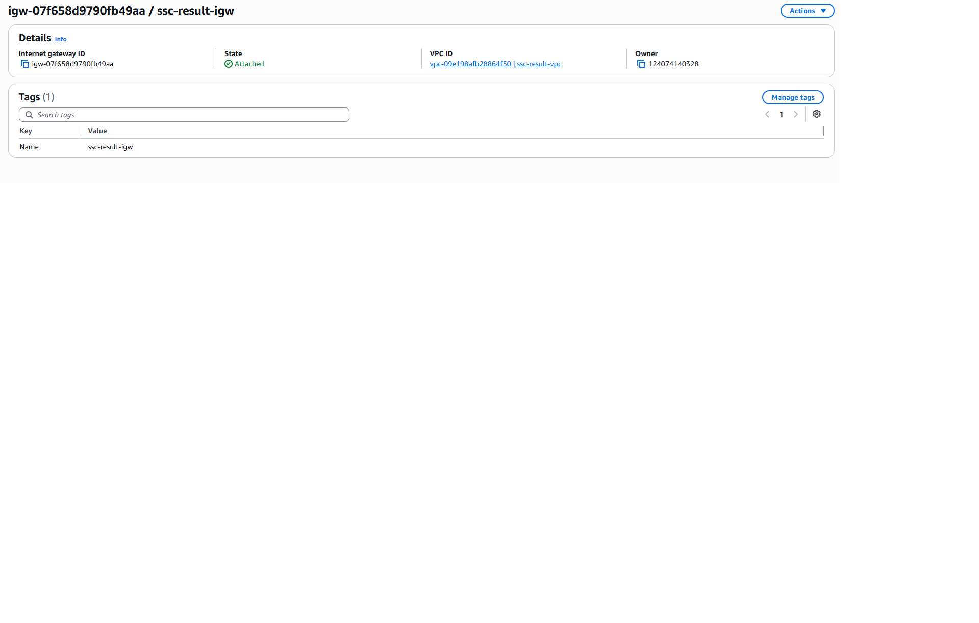
AWS Resource Verification: 2.IGW.png

Figure 3: NAT Gateway in Public Subnet (ssc-nat-gw with Elastic IP)
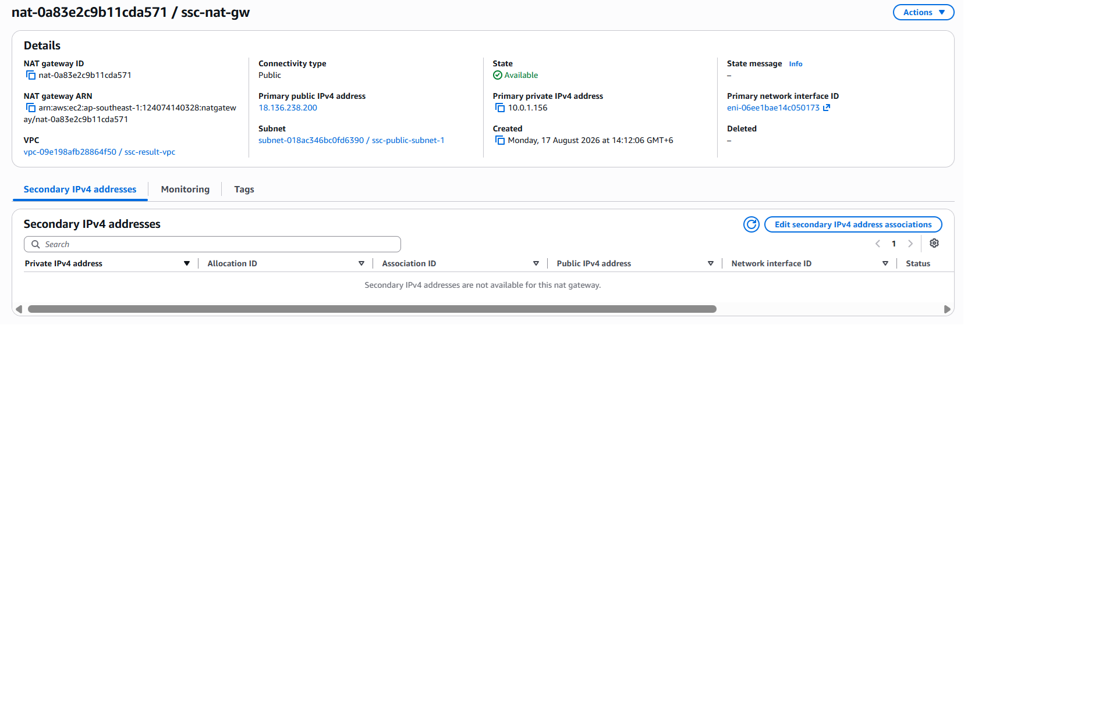
AWS Resource Verification: 3.NAt.png

Figure 4: Public Route Table (ssc-public-rt -> IGW)
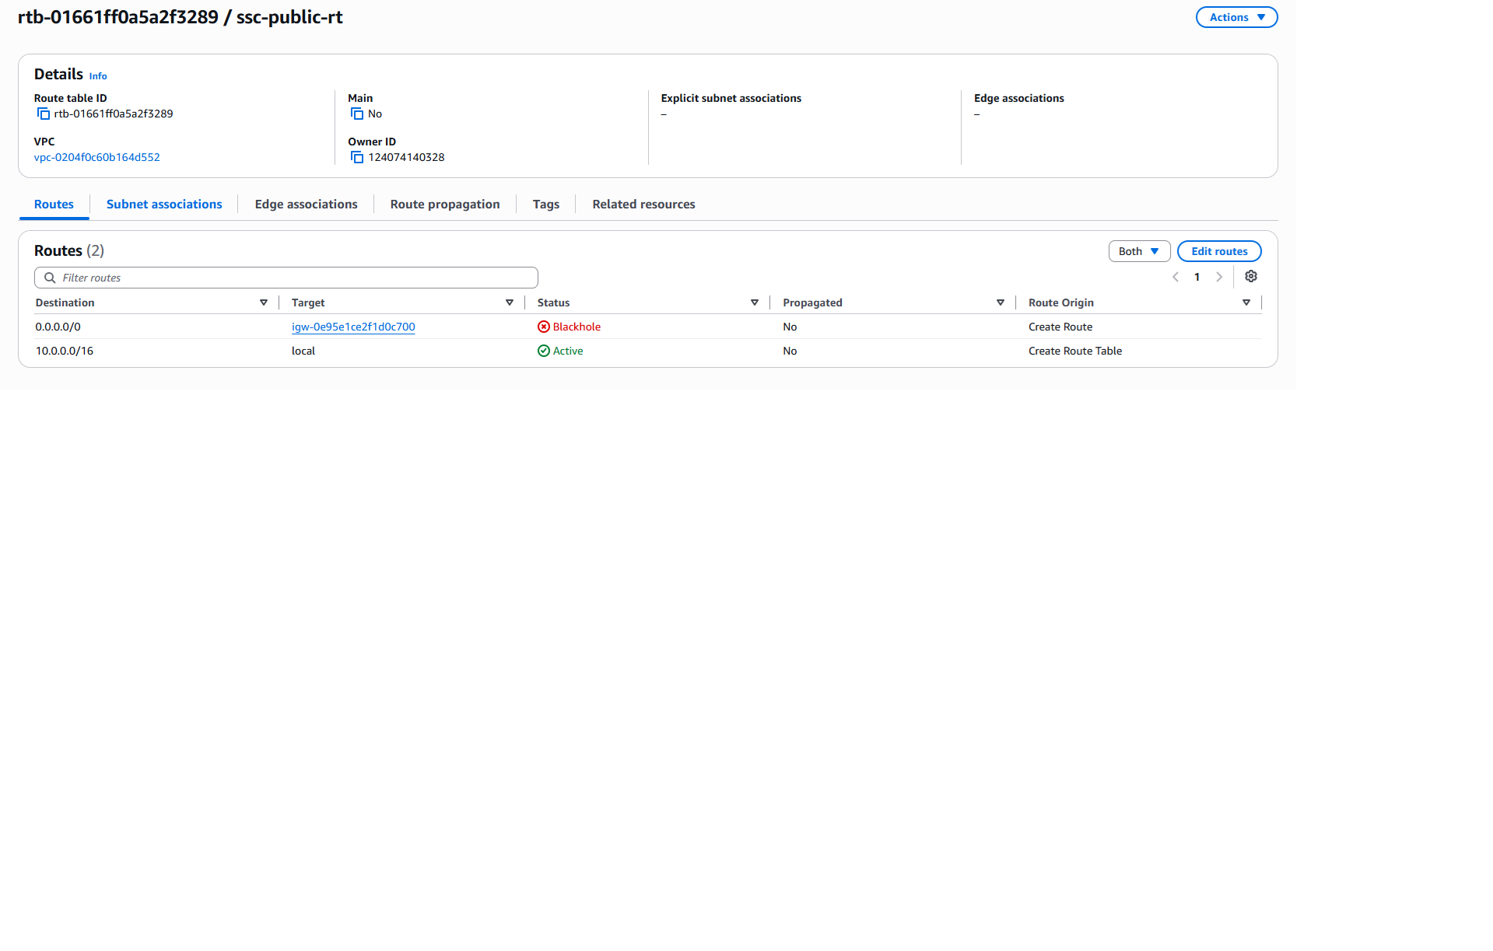
AWS Resource Verification: 5.public rt.png

Figure 5: Private Route Table (ssc-private-rt -> NAT GW)
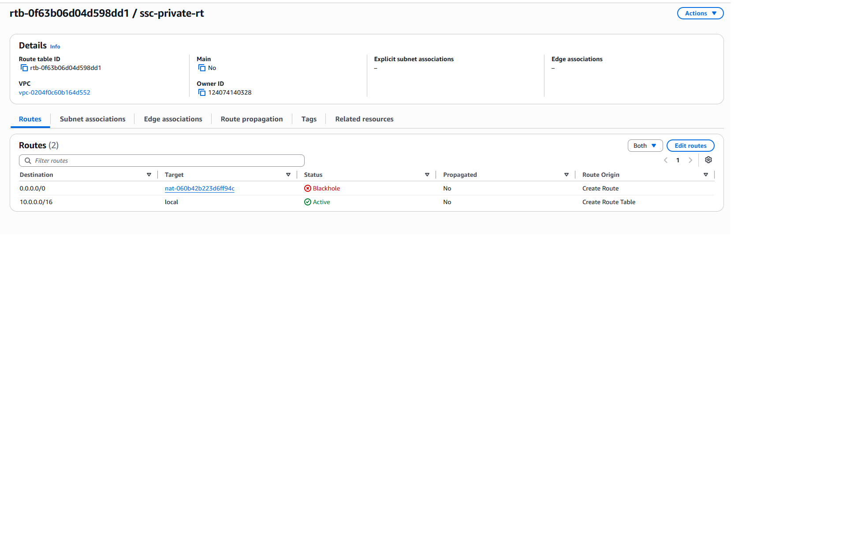
AWS Resource Verification: 4. private rt.png

Figure 6: EC2 Launch Template (Ubuntu 22.04 LTS on t3.micro)
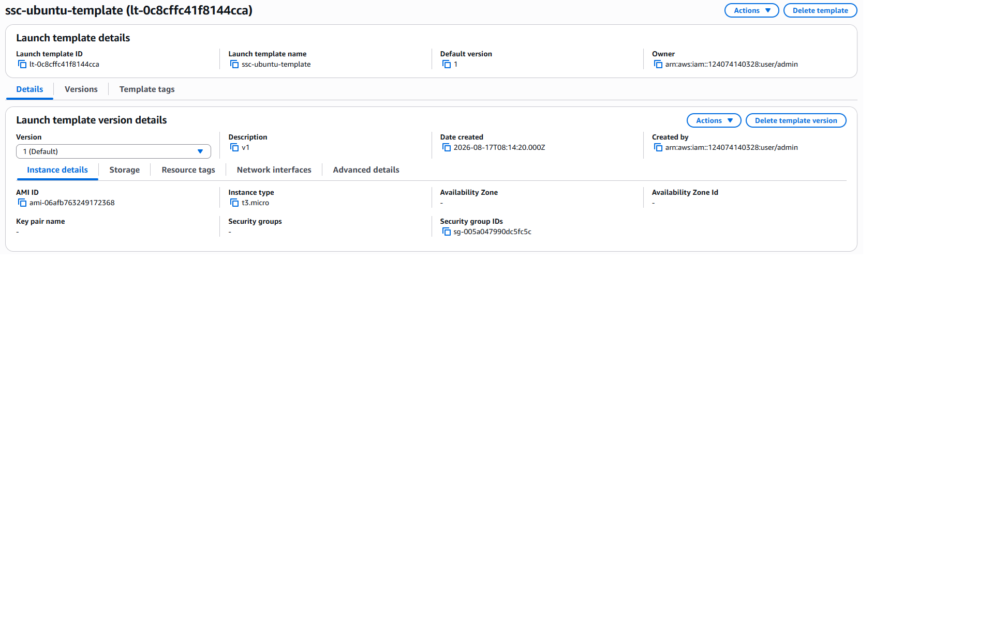
AWS Resource Verification: 6.launch temple.png

Figure 7: EC2 Instances Running in Private Subnets
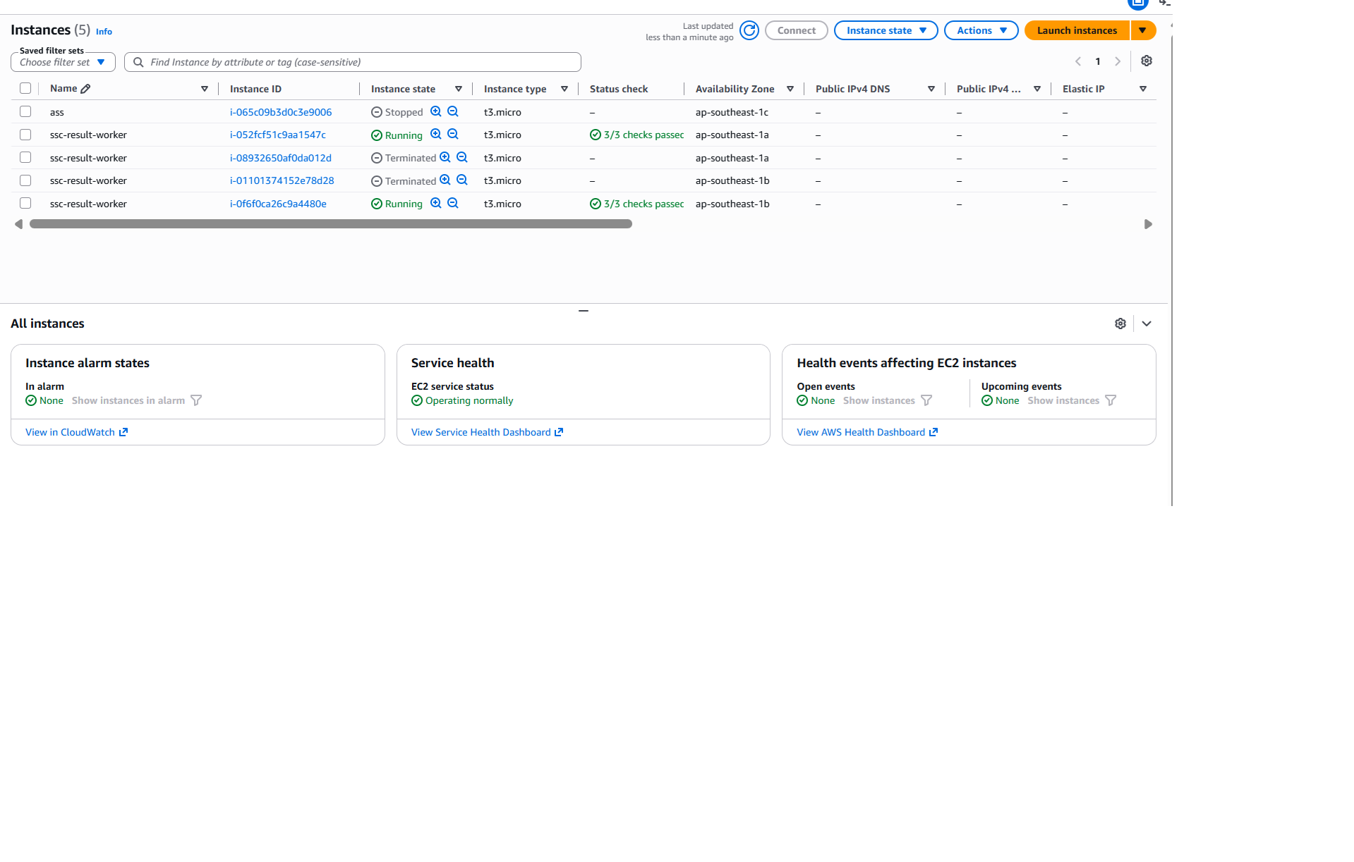
AWS Resource Verification: 7.instances.png

Figure 8: Target Group & Health Status (Healthy Targets on Port 80)
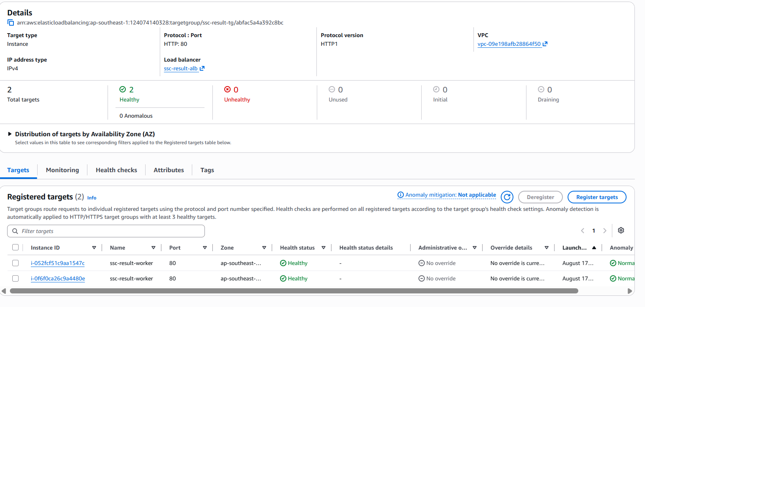
AWS Resource Verification: 8.tg.png

Figure 9: Application Load Balancer Details (ssc-result-alb)
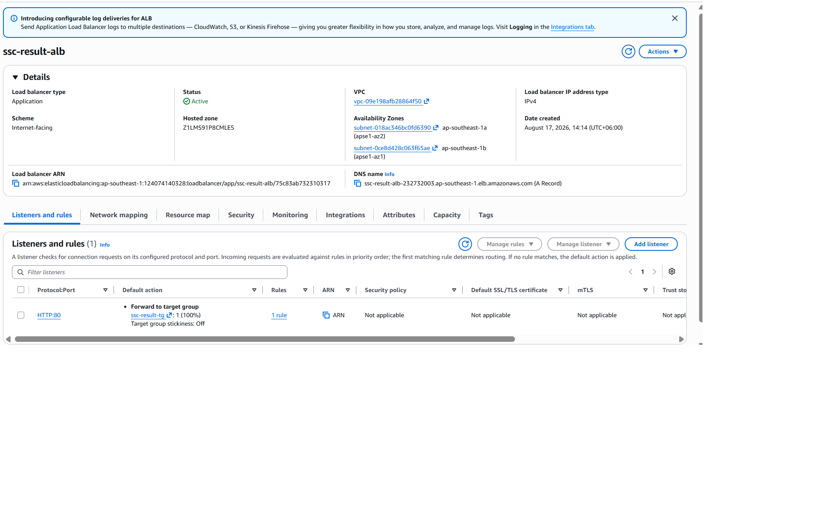
AWS Resource Verification: 9.alb.png

Figure 10: Auto Scaling Group Configuration (Min: 2, Desired: 2, Max: 10)
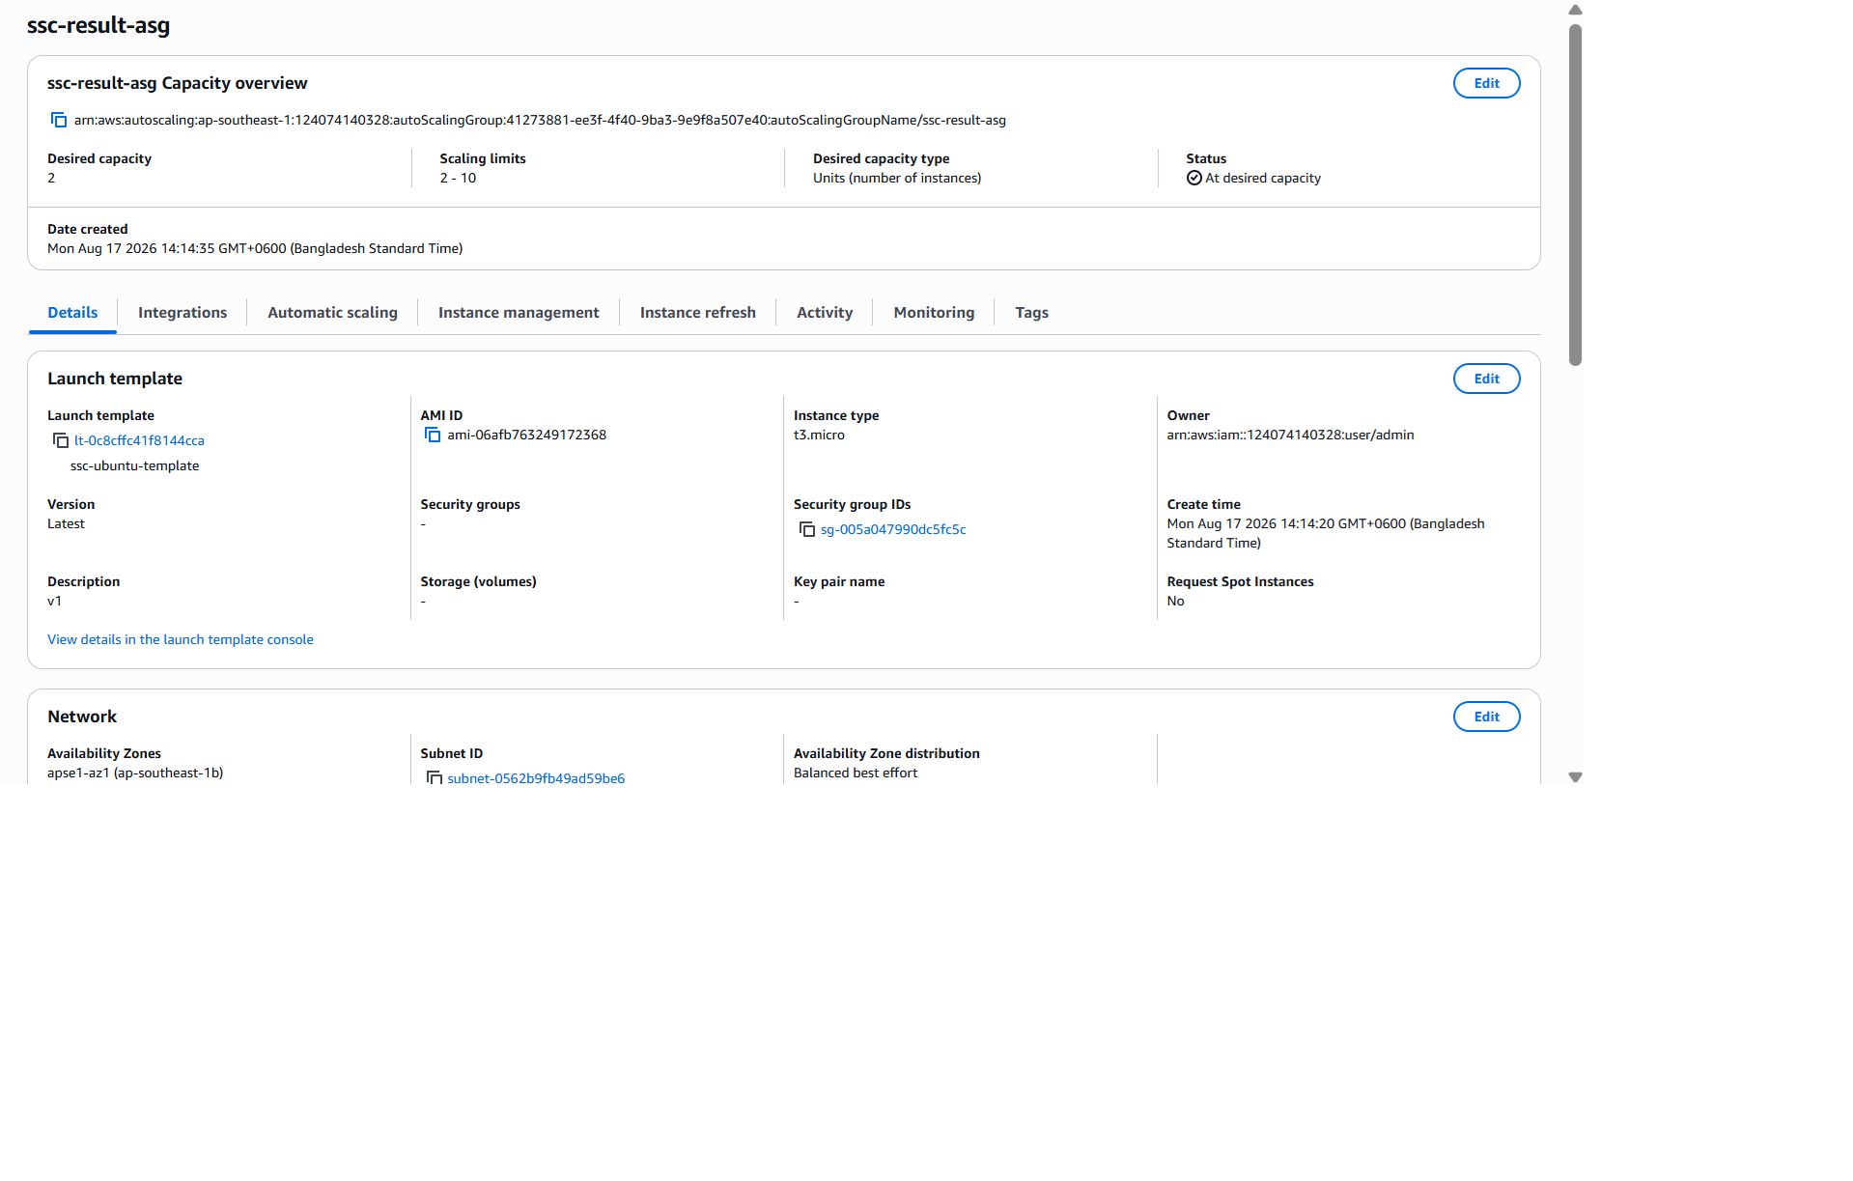
AWS Resource Verification: 10.autoScalingGroup.png

Figure 11: Live SSC Result 2026 Web Application Accessed through ALB DNS
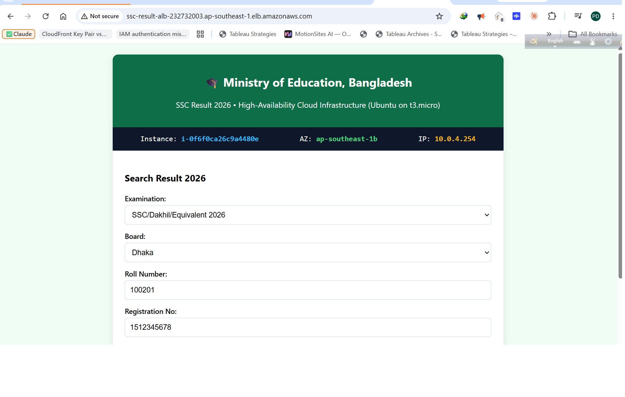
AWS Resource Verification: 11.website.png

