**Mocap for ASL**

**Summary:** For English to ASL sign generation motion capture (mocap) devices (electronic hand gloves and Kinect camera) can be used. We have two electronic gloves: e.g.

* Acceleglove
* Flex glove
* Microsoft Kinect device.

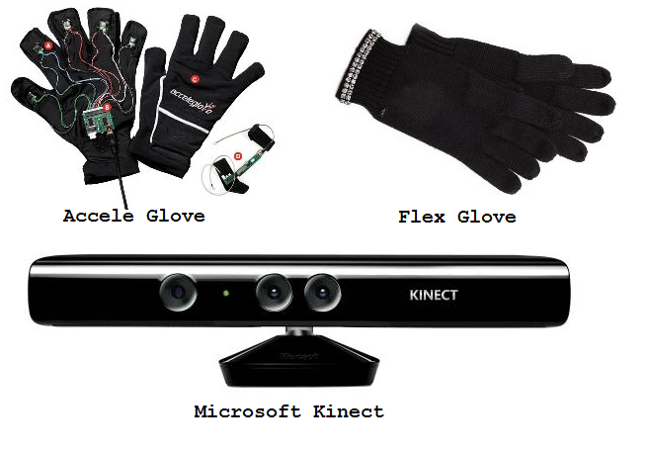

Figure 1: Motion Capture Devices

Gloves can be used for capturing hand shapes, and palm orientation, and Kinect can be used for recording movement of hand direction . In order to complete the mocap process we started Acceleglove and Kinect capturing. In capturing motion data and animate those data into a virtual character’s motion, we got some results and had some issues. Those are described below.

**Status of Acceleglove:**

* We completed whole setup to receive the signals (X,Y,X) captured values from each fingers from the glove using IDRT SDK.
* We wrote client server code to receive those signals and then map those signal data to our virtual character's joint units (called register)
* Glove data was running on server side and virtual character was running in client side and receiving stream signals.
* We stopped there.

**Issues of Acceleglove:**

* Capturing signals from the gloves showed some finger movement delay. Signals could be visualized by SDK's GUI showed in Figure 2.
* Strength for capturing signals for right hand middle finger was too weak. It could be visualized from the SDK GUI as well as from the motion of virtual character.
* For each finger in the glove has X, Y, Z values where each finger for character has 3 joints values.
* We could not go through the whole mapping process as we could not fix finger movement delay and middle finger signal strength issues.



Figure 2: Acceleglove Visualizer GUI

**Status of 2nd glove:**

* I have connected the device with the PC.
* This glove has no SDK.
* Then we stop there.

**Issues of 2nd glove:**

* I talked with Mukul, he used this device in C++ project ASL to English project.
* There is no clear explanation how to receive that glove signal in our C# English to ASL project. We had only Mukuls C++ code.

**Status of Kinect:**

* I have connected and setup the Kinect with PC
* The signal we received from the SDK for skeleton recognition was almost 95% and real-time.
* Then we stop there.

**Issues of Kinect:**

* We had to find out how to map Kinect detected joint signals (X,Y, Z) to characters joints (registers) properly.