IDEATION PHASE
Define the Problem Statements
Date
Team ID | SWTID-2026-5461
Project Name | AI Study Buddy
Maximum Marks | 2 Marks

Customer Problem Statement Template:
Create a problem statement to understand the student's point of view. For AI Study Buddy, the problem statement focuses on the challenges students face while finding study explanations, organizing learning materials, preparing questions, and getting personalized study support.
A well-articulated problem statement helps the project team understand what students are trying to achieve, the difficulties they experience, and how an AI-based study assistant can support their learning process.
AI Study Buddy – Problem Context
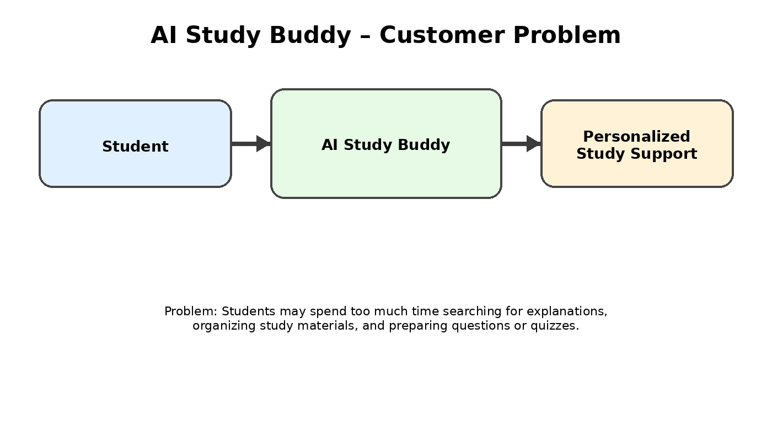
Example: Customer Problem Statements
Problem Statement | I am (Customer) | I’m trying to | But / Because | Which makes me feel
PS-1 | A college student | understand difficult topics quickly | I need to search through many sources for clear explanations | confused and time-pressured
PS-2 | A college student | organize study materials and revise | my notes and resources are spread across different places | disorganized and stressed
PS-3 | A college student | practice with questions and quizzes | creating suitable questions takes extra time | less prepared for assessments

Proposed AI Study Buddy Problem Statement
Students often need quick explanations, organized study materials, summaries, and practice questions, but finding and preparing these resources can take significant time. AI Study Buddy is proposed as a web-based study assistant that can help students interact with their study materials and receive AI-supported learning assistance.

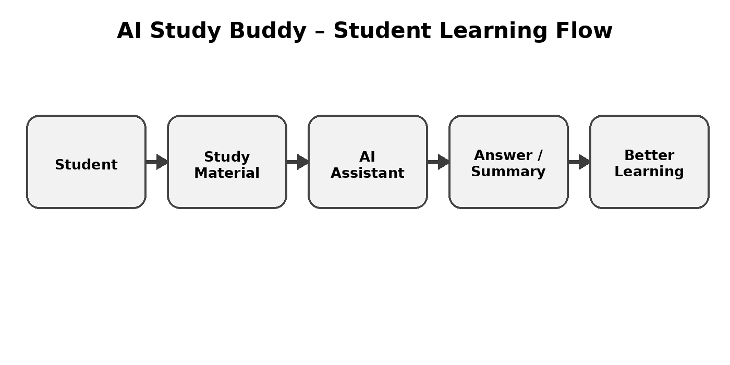
Project Type / Technology Context
Project Type: AI-powered web application / backend project. Planned backend technologies: JavaScript, Node.js, Express.js, MongoDB/Mongoose, JWT authentication, bcryptjs, file upload, and Google Generative AI.
Reference
https://miro.com/templates/customer-problem-statement/

