IDEATION PHASE
Empathize & Discover
Date
Team ID | SWTID-2026-5461
Project Name | AI Study Buddy
Maximum Marks | 4 Marks

Empathy Map Canvas:
An empathy map is a simple, easy-to-digest visual that captures knowledge about a user's behaviours and attitudes. For AI Study Buddy, the empathy map is used to understand the student's needs, feelings, actions, challenges, and learning goals.
Creating an effective AI Study Buddy solution requires understanding the true learning problems faced by students. This exercise helps the project team consider the student's perspective, along with the student's goals and challenges.

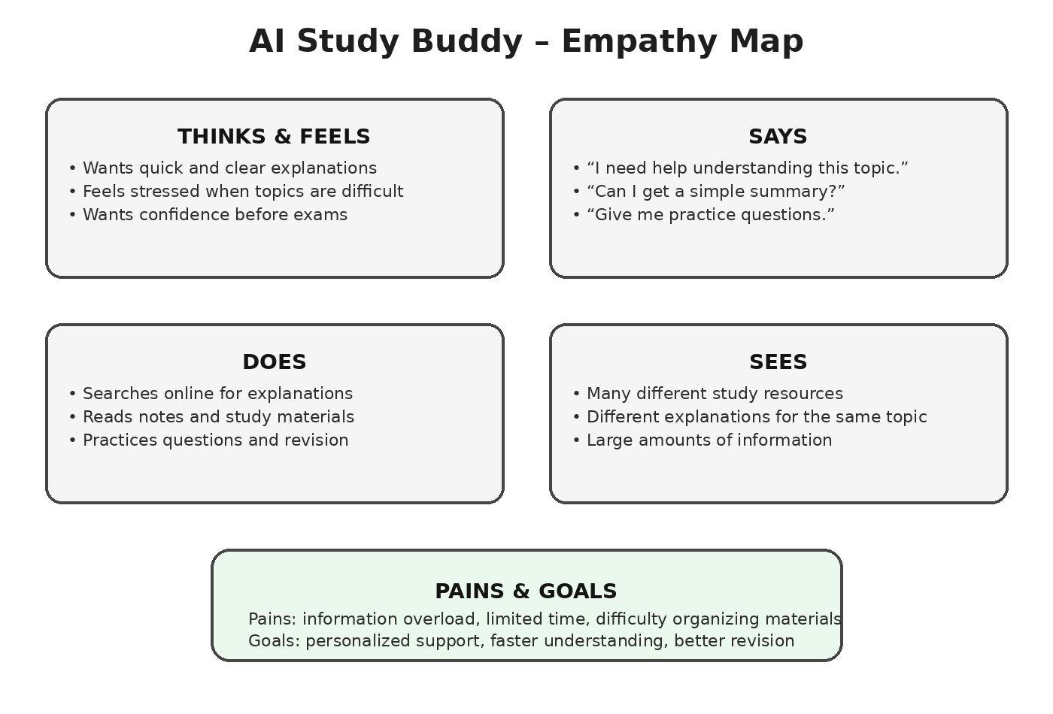
AI Study Buddy – Empathy Map Details
Empathy Area | Student Perspective
Thinks & Feels | Wants quick explanations, feels stressed by difficult topics, and wants confidence before exams.
Says | Needs help understanding topics, asks for simple summaries, and wants practice questions.
Does | Searches online, reads study materials, takes notes, and practices questions.
Sees | Many study resources, different explanations, and large amounts of information.
Pains | Information overload, limited study time, and difficulty organizing learning materials.
Goals | Personalized study support, faster understanding, organized materials, and better revision.

Project Type
AI-powered web application / backend project designed to provide students with AI-supported study assistance using their learning materials.

