IDEATION PHASE
Brainstorm & Idea Prioritization Template
Date
Team ID | SWTID-2026-5461
Project Name | AI Study Buddy
Maximum Marks | 4 Marks

Brainstorm & Idea Prioritization Template:
Brainstorming provides a free and open environment that encourages team members to participate in the creative thinking process and identify practical solutions. For AI Study Buddy, the team focused on common student learning problems such as difficulty understanding study materials, finding quick explanations, revising effectively, and maintaining a structured study process.
The selected concept is an AI-powered study assistant that allows students to work with their study materials, ask questions, receive AI-generated explanations, and use learning-support features such as summaries and quizzes. The idea is designed to make individual study more interactive and organized.
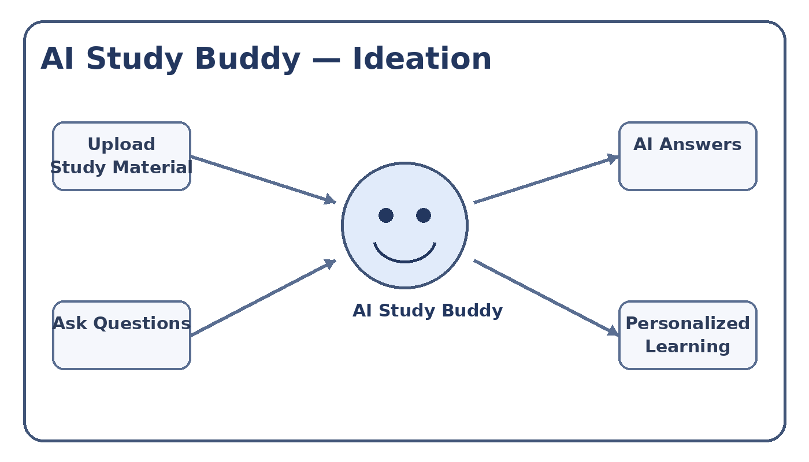
Figure 1: AI Study Buddy brainstorming concept
Step-1: Team Gathering, Collaboration and Select the Problem Statement
Problem Statement
Students often have study materials in different formats but may not have an easy way to interact with those materials, ask questions, revise important concepts, and receive immediate learning support. AI Study Buddy addresses this problem by providing a centralized AI-based study companion.
Brainstormed Ideas
Idea | Description
AI Question Answering | Students can ask questions related to their study content and receive AI-generated explanations.
Study Material Management | Students can upload and organize learning materials for use during study sessions.
Automatic Summaries | Long study content can be converted into shorter revision-friendly summaries.
Quiz Generation | The system can generate practice questions from study material.
Personalized Study Support | The assistant can provide learning guidance based on the student's questions and study activity.

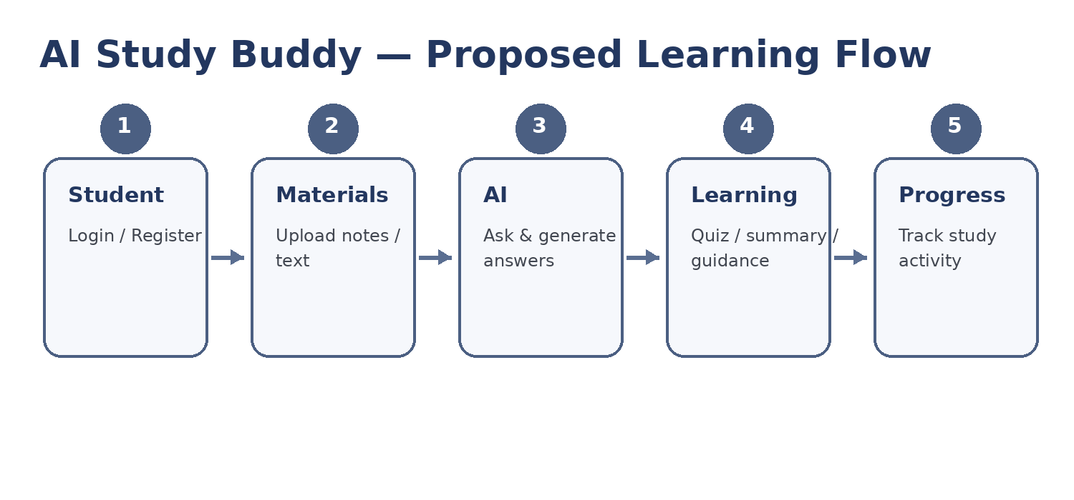
Figure 2: Proposed AI Study Buddy learning flow
Selected Project Concept
AI Study Buddy — a web-based AI study assistant that helps students manage study materials, interact with learning content, ask questions, and receive AI-powered learning assistance.
Proposed Technology Context
The current project is planned as a JavaScript backend application using Node.js and Express, with MongoDB/Mongoose for data management, JWT-based authentication, file upload support, bcryptjs for password security, and the Google Generative AI SDK for AI-powered features.
Reference
https://www.mural.co/templates/brainstorm-and-idea-prioritization

