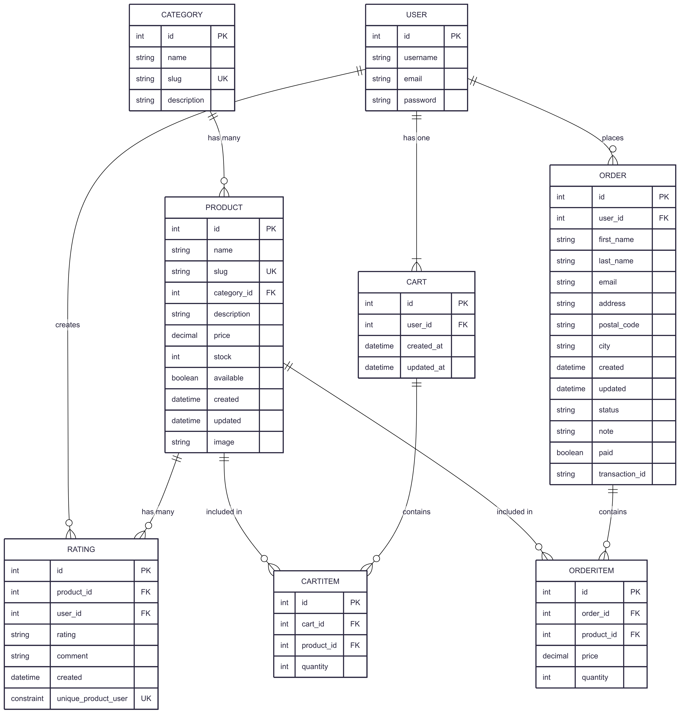

Entity Relationship Diagram of E-commerce Platform

**ERD Diagram Short Description**

This Entity-Relationship Diagram (ERD) outlines the database schema for a single-vendor e-commerce platform. It models the core entities and their relationships, including products, categories, users, shopping carts, orders, and ratings. The diagram ensures data integrity by defining primary keys (PK), foreign keys (FK), and unique constraints (UK), allowing the system to track customer actions from Browse products to making a purchase and leaving a review. It is a foundational blueprint for developing the database layer of the e-commerce application.

Here is a quick overview of which tables are related and the nature of their connections:

| Table A | Relationship | Table B | Description |
| --- | --- | --- | --- |
| **Category** | has many | **Product** | A product belongs to exactly one category, but a category can contain many products. |
| **User** | has one | **Cart** | Each user has their own unique shopping cart. |
| **User** | places | **Order** | A user can place many orders, but each order belongs to one user. |
| **User** | creates | **Rating** | A user can create many ratings for different products. |
| **Product** | has many | **Rating** | A product can receive many ratings from different users. |
| **Product** | included in | **CartItem** | A product can be added to many different shopping cart items. |
| **Product** | included in | **OrderItem** | A product can be included in many different order items after a purchase. |
| **Cart** | contains | **CartItem** | A shopping cart can contain many items. Each item is tied to a specific cart. |
| **Order** | contains | **OrderItem** | An order contains many ordered items. Each item is tied to a specific order. |