We will create a gift product

On the red area I will create the option name and price

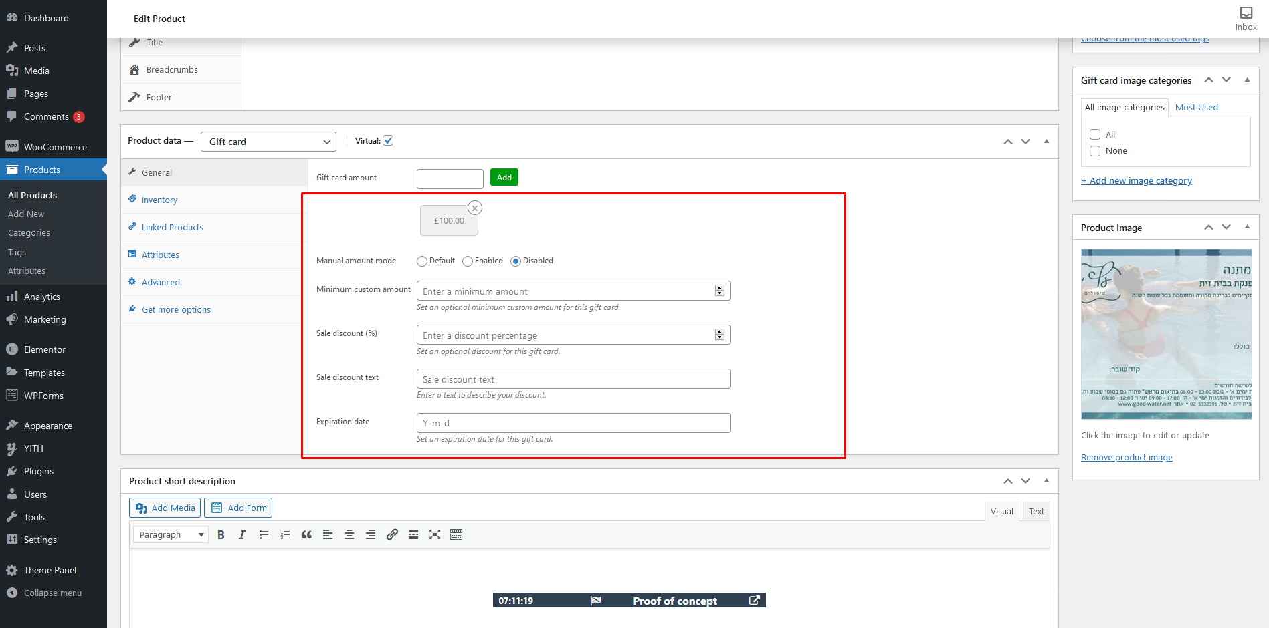

Then I will modify this layout like old site has with live text change

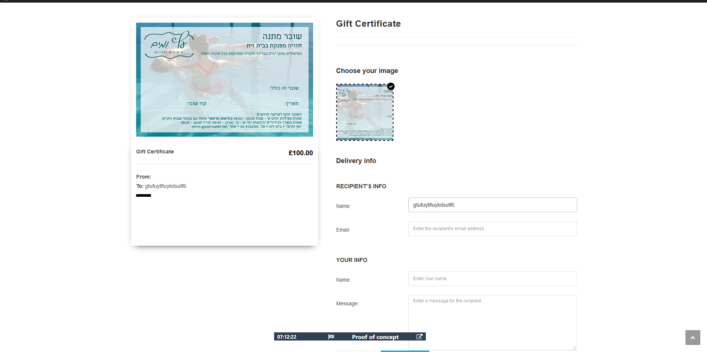

This plugin generate pdf but I will change the design