Bangladesh Army University of Engineering and Technology



**Thesis progress report**

Title: Land registration with blockchain

**Submitted To**

### Md. Almash Alam

Lecturer, CSE

BAUET

**Submitted by**

S. M. Shakil Ahmed

ID: 16104025

Md. Nur-A-Alam Khan

ID: 16104032

Dept: CSE

**Title: Land Registration with Blockchain**

What is a blockchain?

Open, distributed ledger that can record transaction between two parties efficiently and in a verifiable and permanent way.

Distributed ledger

A distributed ledger is a consensus of replicated, shared, and synchronized digital data geographically spread across multiple sites, countries, or institutions. There is no central administrator or centralized data storage.

**Distributed ledger**

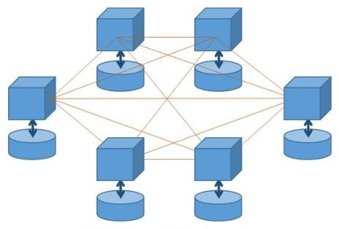

Fig 1: Distributed ledger

Peer-to-peer (P2P) network

A peer-to-peer (P2P) network is group of computers, each of which acts as a node for sharing files within the group. Instead of having a central server to act as a shared drive, each computer acts as the server for the files stored upon it. When a P2P network is established over the Internet, a central server can be used to index files, or a distributed network can be established where the sharing of files is split between all the users in the network that are storing a given file.

Once connected to the network, P2P software allows you to search for files on other people's computers. Meanwhile, other users on the network can search for files on your computer, but typically only within a single folder that you have designated to share. While P2P networking makes file sharing easy and convenient, is also has led to a lot of software piracy and illegal music downloads. Therefore, it is best to be on the safe side and only download software and music from legitimate websites.

**Peer-to-Peer network**

Nodes hold ledger of facts + history of updates

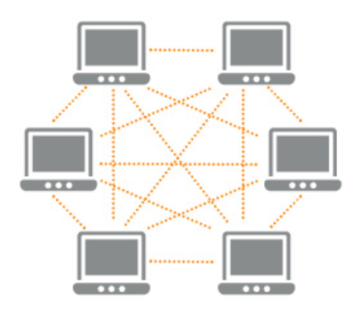

Fig 2: Peer-to-peer network

Decentralized

Decentralized means that there is no single point where the decision is made. Every node makes a decision for its own behavior and the resulting system behavior’s is the aggregate response.

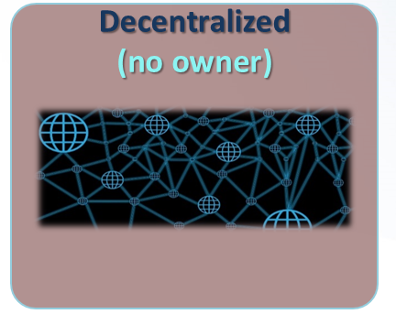

Fig 3: Decentralized

Secure

Distributed System Security Architecture or is a computer security architecture that provides a suite of functions including login, authentication, and access control in a distributed system.

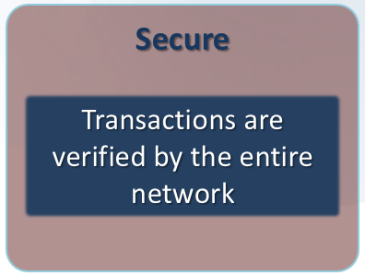

Fig 4: Secure

How blockchain works?

1. A node starts a transaction by first creating and then digitally signing it with its private key (created via cryptography). A transaction can represent various actions in a blockchain. Most commonly, this is a data structure that represents transfer of value between users on the blockchain network. Transaction data structure usually consists of some logic of transfer of value, relevant rules, source and destination addresses, and other validation information.
2. A transaction is propagated (flooded) by using a flooding protocol, called Gossip protocol, to peers that validate the transaction based on preset criteria. Usually, more than one node are required to verify the transaction.
3. Once the transaction is validated, it is included in a block, which is then propagated onto the network. At this point, the transaction is considered confirmed.
4. The newly created block now becomes part of the ledger, and the next block links itself cryptographically back to this block. This link is a hash pointer. At this stage, the transaction gets its second confirmation and the block gets its first confirmation.
5. Transactions are then reconfirmed every time a new block is created. Usually, six confirmations in the network are required to consider the transaction final.

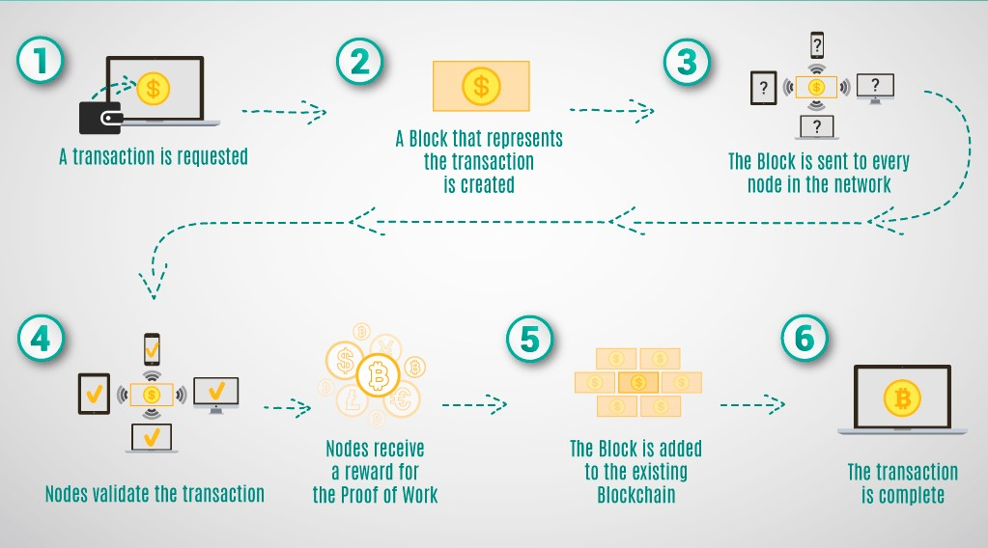

[Fig 4: How Blockchain works](https://coincodecap.com/)

Land registration system in Bangladesh

Every person, who has ownership rights of immovable property and is recorded as such in records of rights or other public documents in which record of ownership is entered or maintained, is considered, as legal owner of immovable property and is entitled to transfer such property, either wholly or in part. Any person though not the owner of immovable property but legally authorized by its owner to transfer the same is also competent to transfer such property. Possessor of immovable property may claim ownership of the property. However, more possession of an immovable property does not mean that the person is the real owner of the property. Title of immovable property, as you would appreciate, may be acquired either through purchase, long-term lease, gift or by way of inheritance etc. In order to ascertain the real owner in possession who can sale the property, it is particularly necessary to examine the records of rights or other public documents in which record of ownership is entered or maintained.

**1. Confirm the record of rights from the Land Office**  
Land administration system in Bangladesh separates records of ownership and records of revenue as such. We have Land Records Offices for land records, surveys, publication and maintenance of records under the directorate of land records and survey, Ministry of Land. Bangladesh also has Land Revenue Offices under Ministry of Land. There are 11 administrative offices in each upozila (sub district). There are 64 districts in Bangladesh but only 61 of them have registration facility.  
Three hill districts do not have registration centers. In Dhaka, the district land registration office has 13 Sub-registrar offices under the Ministry of Law.

**2.Check & Verify Bia Deeds, Khatiayans & Mutation of the property in favor of the Seller**  
If the present Seller obtained the land through Purchase, the present purchaser should first see all such Sale Deeds (Bia Deed) to ascertain chain of ownership and it is desirable that at least 25 years chain of ownership should be clearly determined.  
The second step is to seek documents in the form of Khatain from the Seller. The purchaser should check the Khatiayan records (C.S., S.A. R.S., B.S./City Jarip) as supplied by the seller and needs to verify through the lawyers whether documents supplied establishes ownership (either through purchase or inheritance) in favor of the seller. It is to be noted that draft/Khosra Khatiyan supplied by the seller is not eligible to verify the record and purchaser should ask for copies of certified/printed Khatiyan.  
Purchaser also should verify the Khatiyan with the records at the Deputy Collectors Office (there has been long tradition of fabrication of Khatiayans by prospective sellers). Specific importance should be given to the last two Khatiyan of the concerned property.

**3. Physical Survey**  
Most importantly, the Purchaser should conduct physical survey of the land. This will also provide the current conditions and verify the possession of the land. Verification of payment of Ground Rate of the Property Purchaser should also ask the Seller to furnish record of payment of updated Ground Rent for the prospective land. It is to be noted here that if the Ground Rate is not clear, the sub registrar’s office may refuse to register the property in favor of the seller.

**4. Multiple Sellers & Attorney**  
In case of land is recorded in the name of the predecessor of the seller, Warishan certificate, issued by the representative of the local government in favor of the sellers has to be checked.  
Also, if the land is sold by some of the successors (Not all), Registered Deed of Partition/Bia Deed has to be checked.  
In case the land is sold by authorized attorney, Registered Power of Attorney is required.  
Obtain the non-encumbrance certificate from the relevant sub-registry office.  
The buyer should check the legal status of the land (mortgaged or leased or ownership) at the relevant Sub-registry office. From January 2012 onwards, both Sub-registry and Land Revenue Offices provide non-encumbrance certificates. Sometimes land report is required.  
A land report gives an idea about the current status and ownership of the land that may include chain of ownership, land tax, land record, registry status etc., whereas a non-encumbrance certificate is used in property transactions as an evidence of entitlement of the property.

**5. Prepare deed of transfer and pay stamp duty**  
A lawyer may prepare the transfer deed, but it can also be prepared by the parties themselves. The deed must be prepared in stamped paper that should cost 3% of the property value to get it. This represents the stamp duty. In addition, any Baina Deed executed between seller & purchaser needs to be registered as well Pay capital gains tax, registration fee, VAT and other taxes at a designated bank, Registration fee is payable to the bank in favor of the sub-registry office and the receipt is to be presented at the moment of applying for registration.  
The buyer has to pay the local government tax to the concerned city corporation or municipality offices.

**6. Apply for registration at the relevant Sub-registry**  
At this stage, the buyer may apply for registration at the concerned Sub-Registry Office, presenting the receipts of payment of the registration and other fees. A certified registration document is obtained within a week for the buyer’s record. The original sale deed/certificate requires about six months to be obtained.  
Register the change in ownership at the Land Revenue Office  
the change of ownership must be registered in the Land Revenue Office. The property is recorded under the name of the new owner, who is responsible for paying the land taxes from the day the property is transferred. An application is required to be made to the concerned AC with particulars of the property. The assistant commissioner will forward the same to the concerned Tahsil office who are responsible for conducting the relevant survey and providing a report to assistant commissioner of land. Upon satisfaction of the report, AC Land will issue Mutation Khatiyan in the name of the new owner along with a Duplicate Carbon Receipt (DCR). In the application form the applicant must clearly mention the name and address of the applicant and the transferor, detail description of the land and its surrounding boundary, size, nature and identification of the land, registered deed number and date of such registration. Moreover, the applicant ought to affix copy of main deed, via deed, copy of Khatiyan, receipt of payment of land development tax, proof of means to acquire the ownership i.e. partition deed, copy of the decree or judgment obtained from competent court (if any), passport size photograph of the applicant etc. with the application. It is noteworthy to state that no middleman or extra money is necessary to do mutation of land. However, now 60 days is fixed to finish the whole process of mutation in metropolitan area and 45 days for any other region.  
If the AC (Land) refuses to mutate the name of the applicant for default of document or for any other reason whatsoever, the aggrieved applicant can apply to the Additional Deputy Commissioner (Revenue) within 30 days from the date of such refusal. However, anyone can apply further to the Additional Divisional Commissioner (Revenue) within next 30 days against the impugned decision of the Additional Deputy Commissioner. Finally, the complainant has another forum to appeal to Land Appeal Board within 90 days against an impugned order given by its immediate inferior authority. A person can also file a request for review within 30 days from the date of first refusal, however in that circumstances, right of appeal is lost.

**7. Recording the Land in latest survey (B.S./City jarip)**   
The land purchased should be recorded, if possible, under the latest survey (i.e. B.S. Jarip or City Jarip) if the said surveys are being conducted in the locality the land is situated in the name of the present owner.  
Additional requirements for Specific kind of land/s (Waqf, Lease, Khas Land)  
1. In case of Waqf property, prior permission of Waqf Administrator is mandatory to transfer or mortgage the property, also the Sale Deed has to be executed by the authorized mutually.  
2. In case of Lease property from RAJUK/CDA (Rajdhani Unnayan Kartripakkha) every time the property is transferred, permission from Ministry of Housing & Public Works is required.  
3. In case of Khas land, the property cannot be sold or mortgaged. This matter must be inquired before purchasing of any kind of land whether the land is Khas land or not.  
4. In case of land of Shikosthi Jorip (river-eroded Land), it is very difficult to get mutation of that specific land. Therefore, it is to be inquired whether the land is under Shikosthi Jorip or not.

Drawbacks

* **More Time Consuming**
* **Less Secure**
* **No Transparency**
* **Easily Changeable**
* ***Corruption***

The land administration in Bangladesh is highly corrupt. A survey led by TIB (Transparency International Bangladesh) in 2012 shows that 54.8% of the households that received services from the land administration paid bribe and unregulated money. The survey also shows that the households in Bangladesh paid TK 2,261.2 Crore during the period between May 2011 and April 2012 as bribe or illegal money in land administration sector! It was found in the survey that 16.6% of the households received services from land administration sector and among them 59% were victims of corruption and harassment.

Proposed System

1. building incorporates many key benefits of the technology, such as: an immutable history of transactional records, so no one can ever doubt the authenticity; records are permanently linked to the system so no one can ever tamper with or forge a record of their own; and these records can be seen by any party, at any time. It is powerful and validating.
2. For the proof of concept, we are leveraging the inherent benefits of the Ethereum blockchain, with a focus on smart contracts. This will create a single source of truth of ownership status, and history of a property. The buyer will be assured that the land being bought is the correct plot, and that the seller is unequivocally the owner, reducing the potential for disputes, as well as the costs and time involved, for any given transaction proceed to the government services offices as they normally would to register the sale deed, which they have in their possession.
3. The government office will then enter the sale deed into their system, one that is now powered by the blockchain technology. This blockchain-enhanced system then takes over and registers the sale deed in the presence of the buyer and seller. It will also process the sign-offs by both the buyer and seller and push the transaction to the approval stage. After the transaction is approved, an automatic transfer of ownership is completed. In addition, importantly, the system will be able to handle land titles with multiple owners.
4. From the administrator’s perspective, there are significant transparency, accuracy and efficiency gains to be had. They will now be able to view and monitor the state of the property and sale deed in near real-time, as well as have instant access to a complete and permanent transactional history for each property and sale deed.

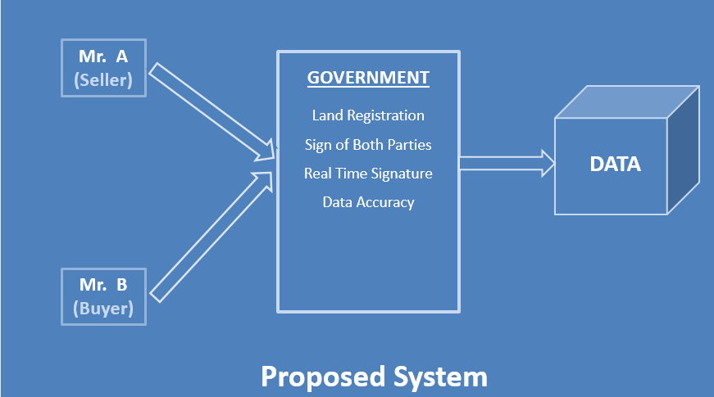

Fig 5: Proposed System

Technology to be used

1. **Ethereum**

* an open software platform built on blockchain technology that enables developers to build decentralized applications.
* aims to completely reinvent how the internet functions
* Ethereum’s vision is to create a “World Computer”
* Ethereum has a native cryptocurrency called Ether (ETH)
* Run on Ethereum Virtual Machine(EVM)

1. **Solidity**

* High-Level Human-Readable Programming Language
* Can Run on Ethereum Virtual Machine(EVM)
* All logic and contract will be written in solidity language.

1. **Metamask**

MetaMask is a bridge that allows you to visit the distributed web of tomorrow in your browser today. It allows you to run Ethereum dApps right in your browser without running a full Ethereum node.

MetaMask (https://metamask.io/) is a browser extensions that lets you run dApps without being part of the Ethereum network as a Ethereum Node. Instead, it lets you connect to another Ethereum Node called INFURA (https://infura.io/) and run smart contracts on that Node. MetaMask manages your Ethereum wallet, which contains your Ethers (or money), and allows you to send and receive Ethers through a dApp of interest. It is a pretty neat tool.

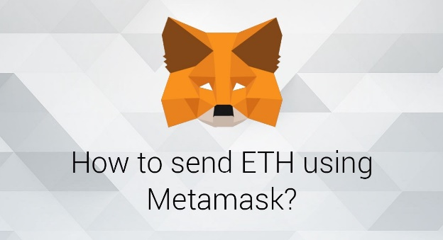

Fig 6: Metamask

1. **Ganache**

Ganache, previously Testrpc, is a virtual blockchain which sets up 10 default Etheruem addresses, complete with private keys and all, and pre-loads them with 100 simulated Ether each. There is no "mining" per-se with Ganache - instead, it immediately confirms any transaction coming its way. This makes iterative development possible - you can write unit tests for your code which execute on this simulated blockchain, deploy smart contracts, play around, call functions, and then tear it all down for further simulation or new tests, returning all addresses to their initial state of 100 Ether.

Ganache comes in two flavors: CLI and UI. You can decide which one you want to download on their download page. My recommendation is the UI version purely because of simplicity.

When you fire it up, it will default to a certain port and IP address. Usually for the UI version (which I'll assume we're using throughout the rest of this post) that's localhost:7545 or 127.0.0.1:7545 while the CLI version tends to go with port 8545.

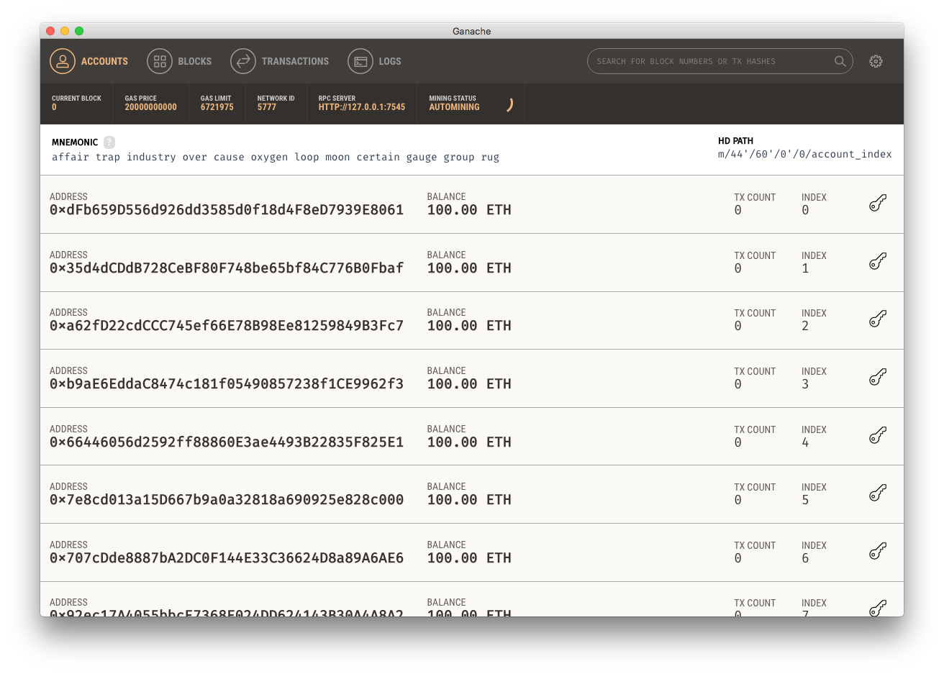

Fig 7: Ganache

Conclusion

Land administration system in Bangladesh is corrupt, inefficient, and unreliable and inherently contains systematic weaknesses. **The blockchain is the only solution.** No one has demonstrated a trustworthy solution for creating, enacting, verifying, storing and securing digital contracts.