**A survey of malware detection using deep learning**

**Operating System:** MacOS, Windows, iOS, Android, and Linux.

**Dataset:** standard benchmark dataset.

**Methods:** Explainable Machine Learning (XAI) or Interpretable Machine Learning (IML)

Comparative performance summary of Transfer Learning models for malware image classification:

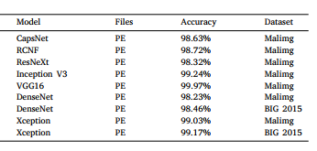

Fine-tuned pre-trained models applied on different malware image datasets:

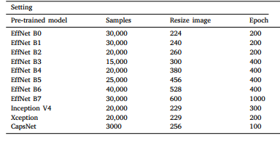

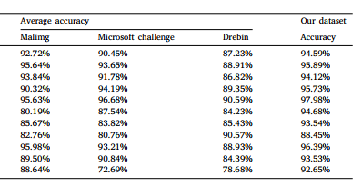

State-of-the-art deep learning models:

