

***INSTITUTE OF INFORMATION TECHNOLOGY***

***JAHANGIRNAGAR UNIVERSITY***

**Number of Exam :** 02

**Submission Date :** 25/01/2023

**Course Tittle :** Software Engineering Lab

**Course Code :** ICT - 3202

**Submitted To Submitted By**

Dr. Shamim Al Mamun Md. Shakil Hossain

Professor Roll – 2023

IIT – JU 3nd year 2nd Semester

IIT – JU

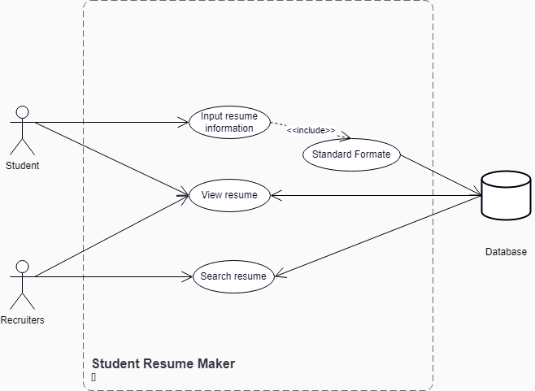**Class Diagram**

**Sequence Diagram**

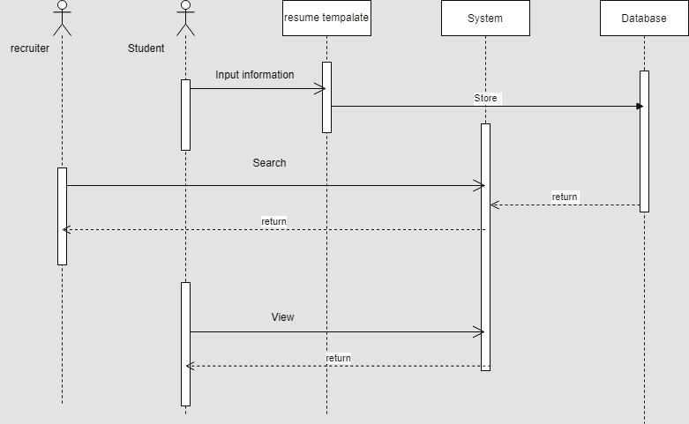

**Class Diagram**

