SPI and I2C Interview Preparation Handbook
Theory, waveforms, Linux APIs, driver concepts, debugging, and interview Q&A
How to use this document: Read the comparison and theory first, then practice explaining timing diagrams aloud. For coding interviews, focus on the user-space examples, kernel driver flows, error handling, and debugging sections.

Table of Contents
- High-level comparison
- SPI theory and signaling
- I2C theory and signaling
- Linux user-space code examples
- Linux kernel driver perspective
- Device tree examples
- Debugging and bring-up checklist
- Common bugs and interview questions

1. High-Level Comparison
SPI and I2C are short-distance synchronous serial buses used to connect processors, microcontrollers, sensors, memories, PMICs, ADCs, DACs, displays, and board-management devices. Both use a clock line, but their topology, addressing model, electrical behavior, software model, and debugging failure modes differ significantly.
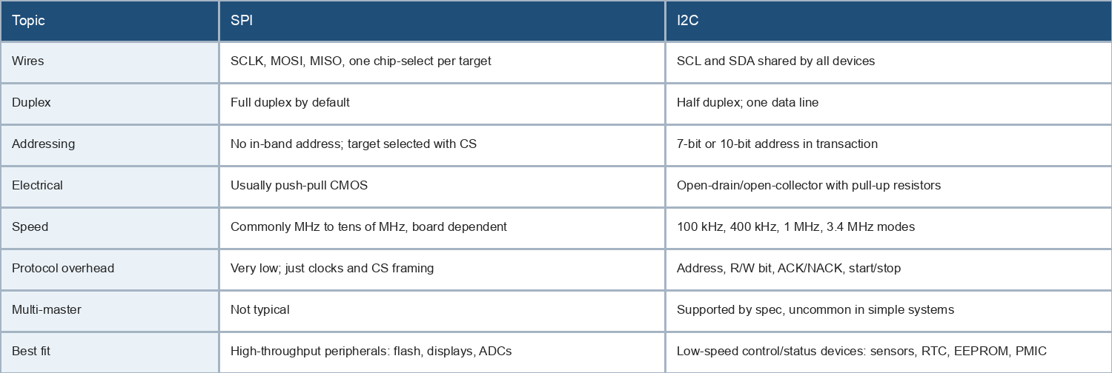

Interview framing
- SPI is simpler electrically and faster, but consumes more pins and lacks standard addressing.
- I2C saves pins and supports many devices on two wires, but requires pull-ups, ACK handling, arbitration, and bus recovery knowledge.
- When asked to choose one, discuss throughput, pin budget, device count, board length, power, latency, and driver support.

2. SPI Theory
SPI, Serial Peripheral Interface, is a synchronous serial bus. A controller drives the serial clock and selects one target using chip-select. Data shifts simultaneously from controller to target on MOSI and from target to controller on MISO.
SPI point-to-point bus
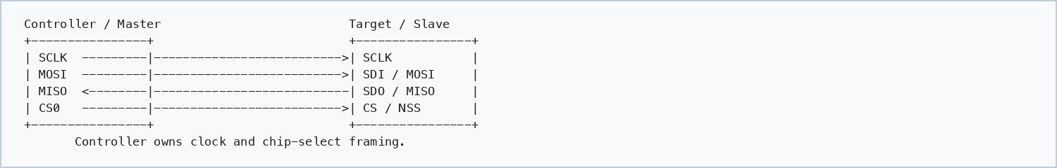

SPI bus with multiple chip-selects
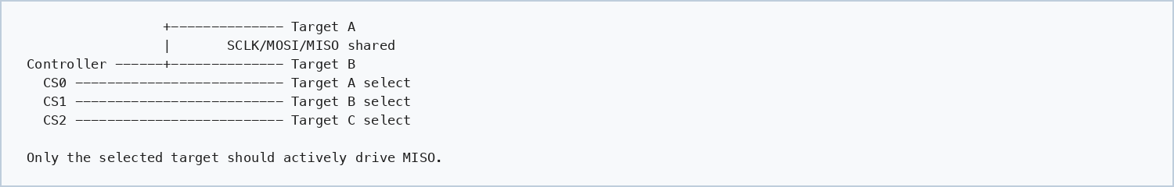

SPI terminology
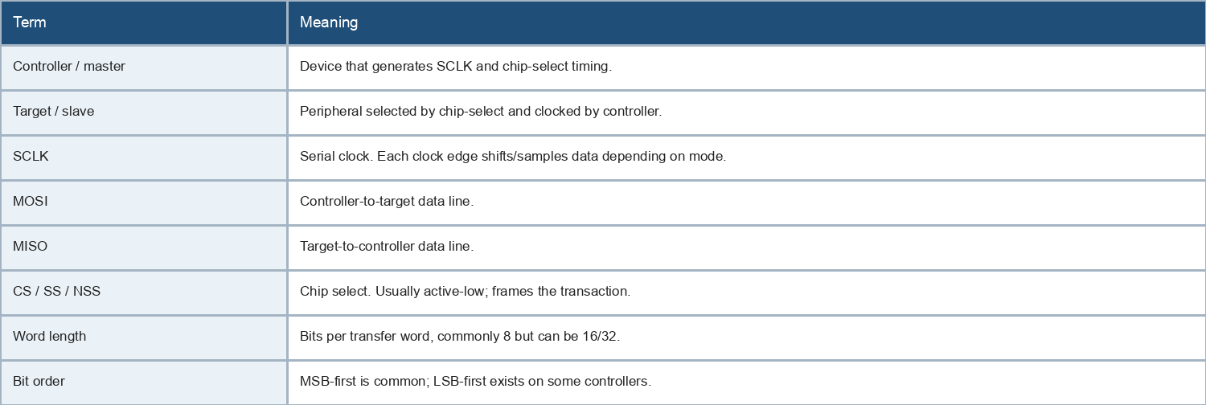

Clock polarity and phase
SPI mode is defined by CPOL and CPHA. CPOL controls idle clock level. CPHA controls which clock edge samples data.
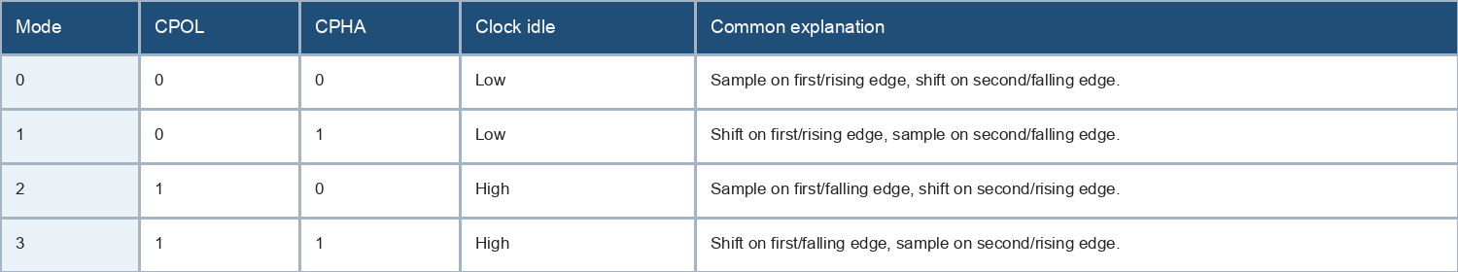

SPI mode 0 timing sketch
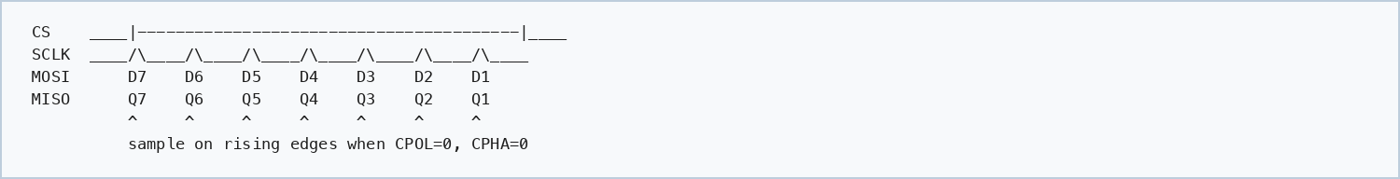

SPI transaction model
- The controller asserts chip-select.
- The controller clocks out command/address/dummy/data bytes.
- Transmit and receive happen at the same time. Even a read operation transmits dummy bytes to generate clocks.
- The controller deasserts chip-select to end the frame unless the protocol requires CS to stay active across multiple transfers.
- SPI has no built-in ACK, address, retry, or error correction. Higher-level device protocol defines meaning.

SPI advantages and limitations
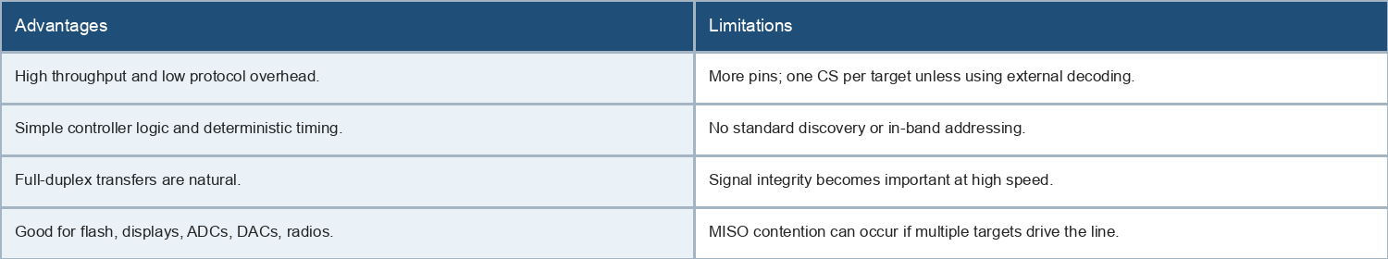

3. I2C Theory
I2C, Inter-Integrated Circuit, is a two-wire synchronous serial bus using SCL for clock and SDA for bidirectional data. Devices share the same bus and are selected by an address transmitted in-band.
I2C shared bus
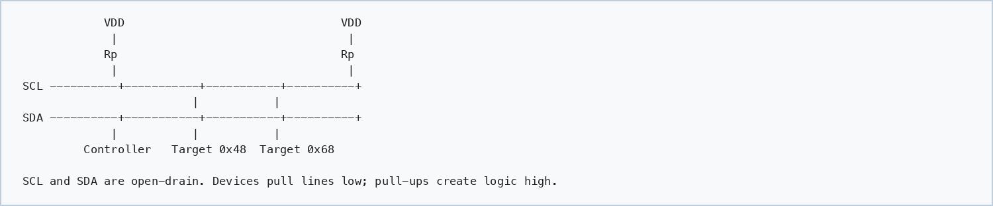

Open-drain behavior
- I2C devices do not actively drive a high level on SDA/SCL; they release the line and pull-up resistors bring it high.
- Any device can pull the line low, which enables ACK, clock stretching, and arbitration.
- Pull-up value affects rise time, power, and maximum speed. Too weak causes slow rising edges; too strong increases current and may exceed device drive capability.

Start, stop, address, ACK
I2C basic write frame
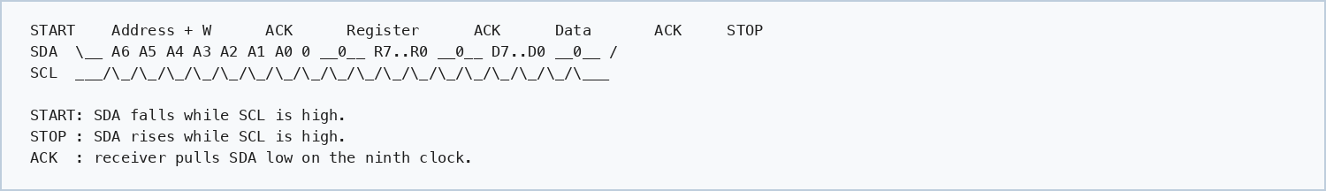

I2C common register read using repeated start
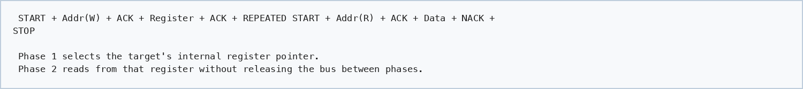

I2C addressing
- 7-bit addressing is most common. The byte on the wire is address shifted left by one plus the R/W bit.
- Example: 7-bit address 0x48 appears as 0x90 for write and 0x91 for read on the bus.
- 10-bit addressing exists but is less common in board-level peripherals.
- Address conflicts require alternate strap pins, multiplexers, or separate buses.

Clock stretching and arbitration
- Clock stretching lets a target hold SCL low to slow the controller while it prepares data.
- Multi-master arbitration relies on open-drain signaling: a controller that releases SDA high but observes low loses arbitration.
- Many embedded systems use single-master I2C, but interviewers may test whether you know arbitration exists.

I2C advantages and limitations
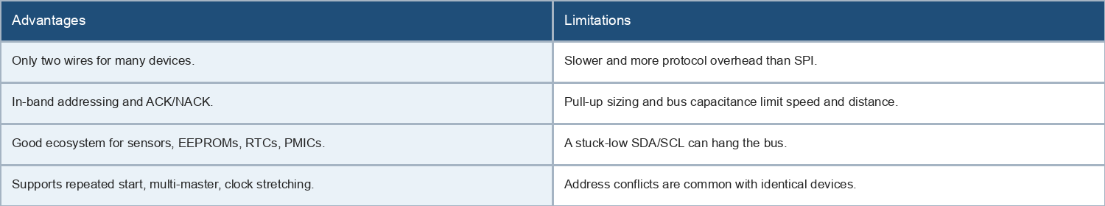

4. Linux User-Space Code

SPI using spidev
Linux exposes some SPI devices through /dev/spidevB.C when enabled by board configuration. The application configures mode, bits per word, and speed using ioctl(), then performs full-duplex transfers.
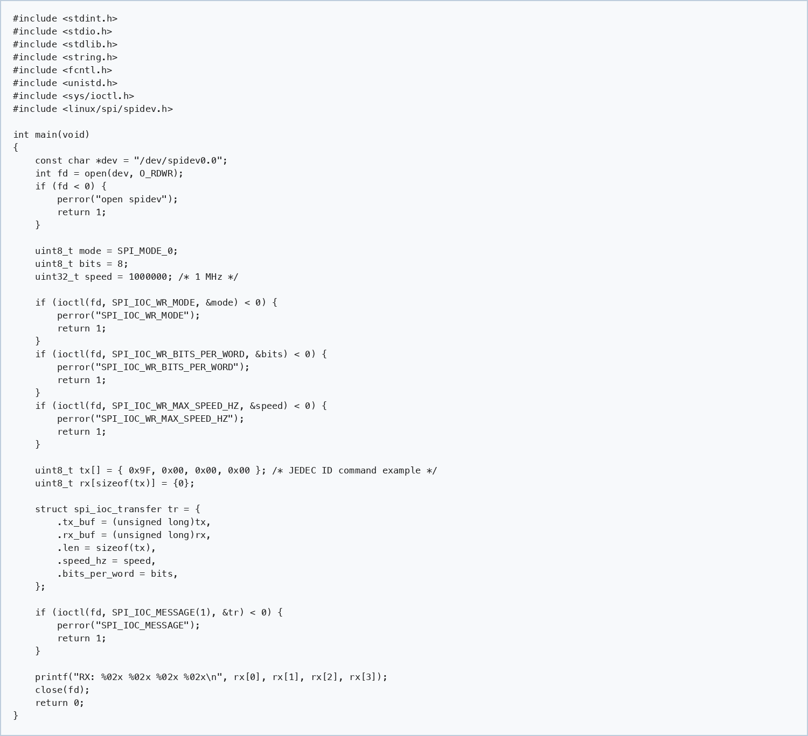

SPI code talking points
- SPI reads still transmit bytes because the controller must generate clocks.
- rx[0] may be dummy or undefined depending on the device protocol.
- Use SPI_IOC_MESSAGE(N) for one or more transfers under one chip-select assertion if cs_change is not set.
- Mode mismatch is one of the most common causes of shifted or corrupted data.

I2C using i2c-dev
Linux exposes I2C adapters through /dev/i2c-N when i2c-dev is enabled. Simple SMBus helpers work for many register devices; I2C_RDWR is needed for combined transactions with repeated start.
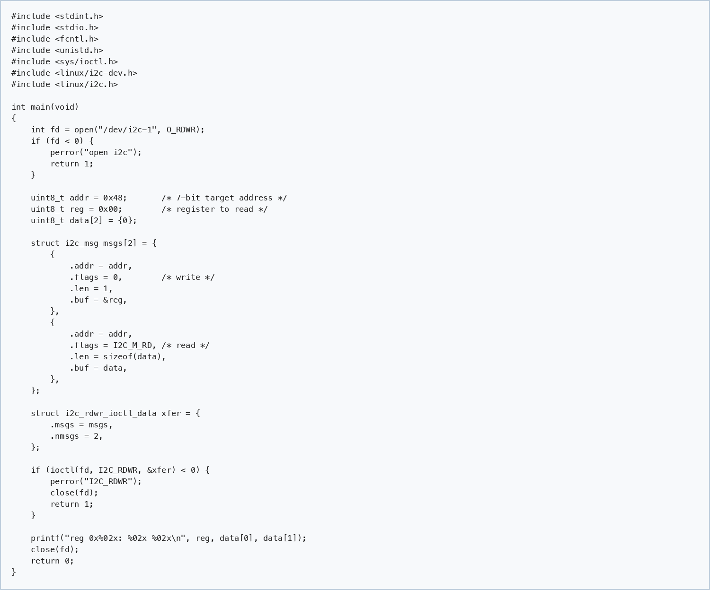

I2C code talking points
- Pass the 7-bit address to Linux APIs, not the left-shifted 8-bit address byte.
- I2C_RDWR with two messages creates a write-register then repeated-start read transaction.
- A NACK usually appears as an ioctl failure; confirm address, power, pull-ups, and bus number.
- Some devices require delays after reset, conversion start, EEPROM write, or power mode changes.

5. Linux Kernel Driver Perspective

SPI kernel driver skeleton
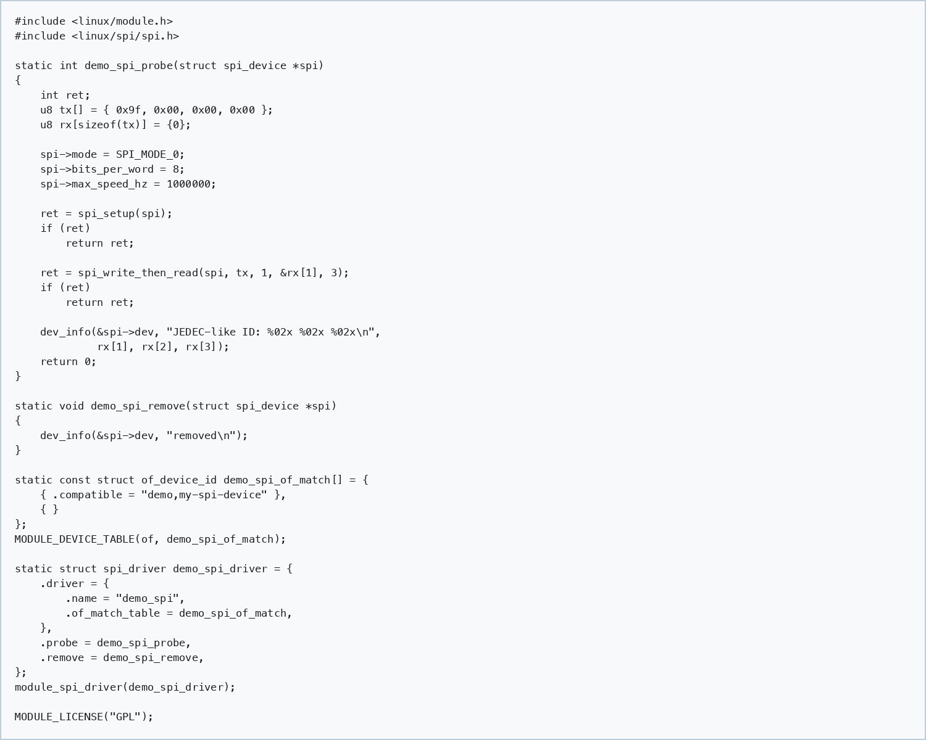

I2C kernel driver skeleton
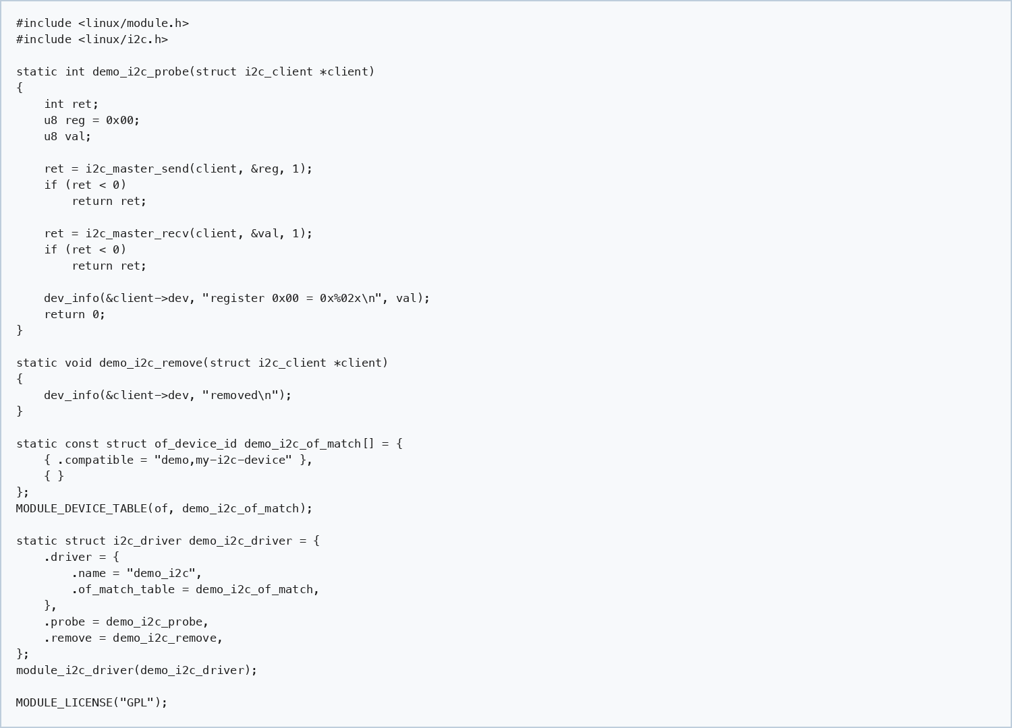

Kernel interview note: For real register-map devices, Linux drivers often use regmap. regmap abstracts register reads/writes over I2C, SPI, MMIO, and adds caching, locking, endianness handling, and debugfs visibility.

regmap examples
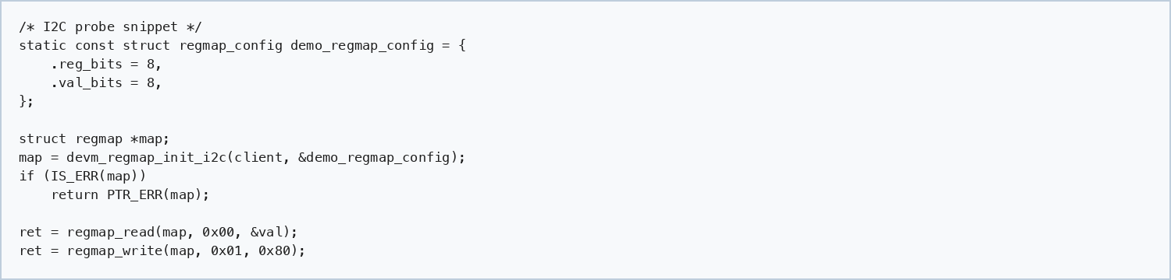

6. Device Tree Examples

SPI device tree
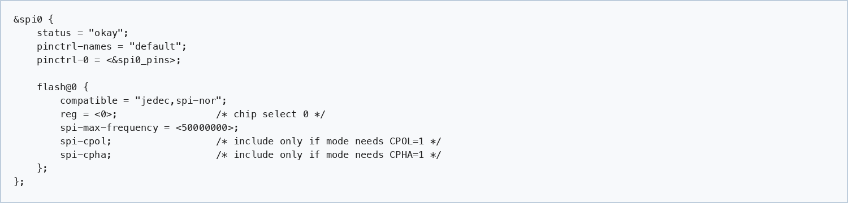

I2C device tree
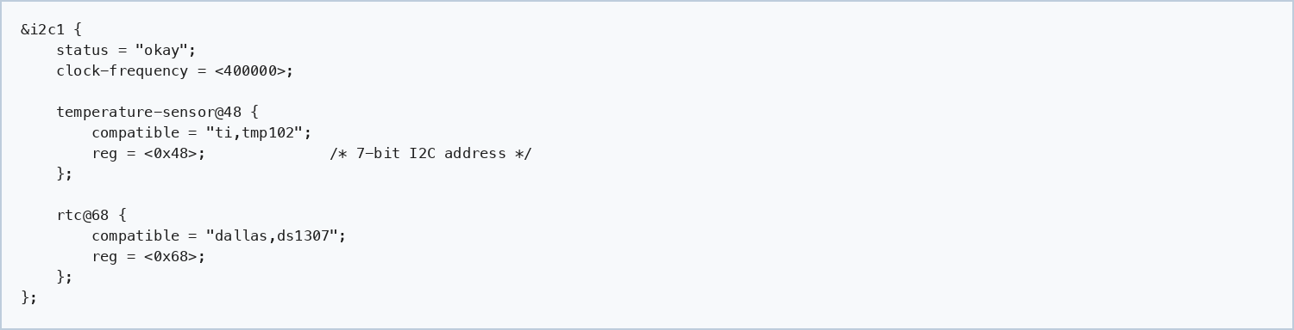

Device tree interview checklist
- For SPI, reg usually means chip-select number under the SPI controller node.
- For I2C, reg is the 7-bit device address.
- compatible controls driver matching.
- spi-max-frequency protects the target from being clocked too fast.
- clock-frequency on an I2C controller configures bus speed, not target address.
- Pinmux, regulators, reset GPIOs, interrupts, and clocks often matter as much as the bus node.

7. Debugging and Bring-Up

General workflow
- Confirm power rails, reset pins, enable GPIOs, and reference clocks.
- Confirm pinmux and board schematic match the software bus instance.
- Check device tree compatible, address/chip-select, speed, and mode.
- Use logic analyzer traces to verify wire-level behavior.
- Lower bus speed during bring-up.
- Check kernel logs with dmesg and driver probe messages.
- Check /sys/bus/spi/devices, /sys/bus/i2c/devices, and relevant debugfs entries.

SPI debugging checklist
- No clock: controller not enabled, pinmux wrong, transfer not submitted, runtime PM issue.
- No MISO: target not selected, wrong CS polarity, target in reset, MISO pin conflict.
- Data shifted by one bit: wrong CPHA or sampling edge.
- All 0xff: MISO pulled high or target not driving.
- All 0x00: MISO pulled low, target held reset, or bus contention.
- Works slow but fails fast: signal integrity, setup/hold timing, drive strength, trace length.

I2C debugging checklist
- No ACK: wrong 7-bit address, device unpowered, missing pull-ups, wrong bus, reset asserted.
- SDA stuck low: target wedged mid-transaction, bad device, short, or missing recovery.
- SCL stuck low: target clock stretching forever, short, controller issue.
- Slow rise time: pull-ups too weak or bus capacitance too high.
- Address confusion: datasheets sometimes show 8-bit write/read values instead of 7-bit address.
- Intermittent errors: marginal pull-ups, long wires, noise, power sequencing, level shifting.
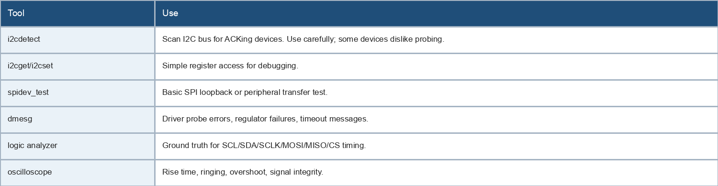

8. Common Interview Questions

Conceptual questions
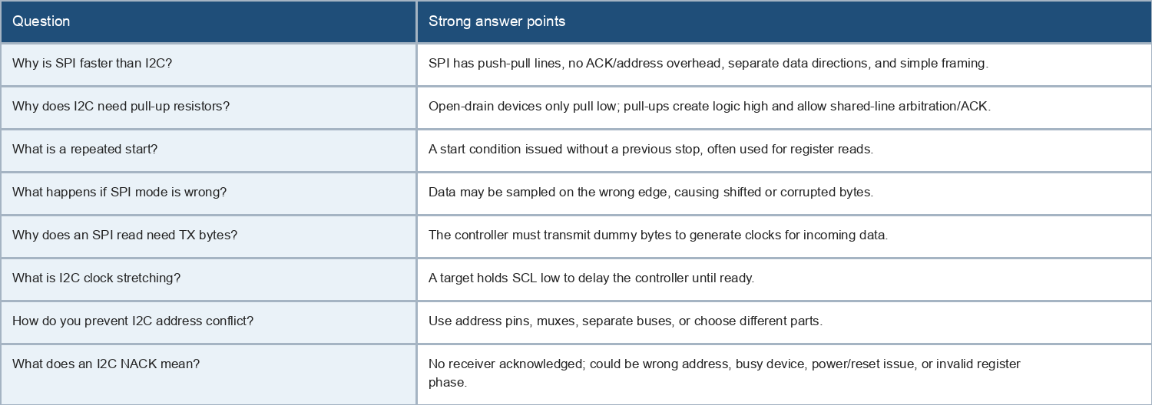

Linux/driver questions
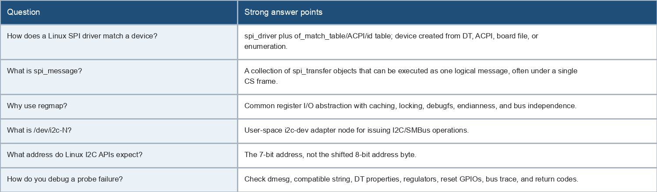

Scenario questions
- A sensor does not respond on I2C. Explain your debug flow from power to logic analyzer.
- SPI flash returns 0xff for every byte. List possible root causes.
- An I2C device works at 100 kHz but not 400 kHz. What do you check?
- Two I2C devices have the same fixed address. What board/software options exist?
- A SPI ADC returns data shifted by one bit. What configuration is suspicious?
- A target holds SDA low after a reset. How can the controller recover the bus?

Short answers to memorize
- SPI selects by chip-select; I2C selects by address.
- SPI is usually full-duplex; I2C is half-duplex.
- I2C lines idle high because of pull-ups.
- I2C ACK is the ninth clock bit.
- Repeated start is essential for many register reads.
- Wrong SPI CPOL/CPHA often looks like bit-shifted data.
- Linux I2C addresses are normally written as 7-bit values.
- regmap is preferred for many Linux register-based SPI/I2C drivers.

9. Quick Reference
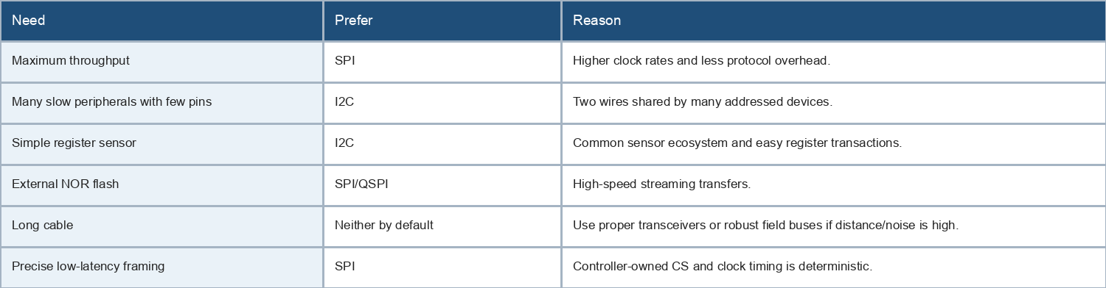

10. Practice Prompts
- Draw an I2C register read with repeated start and explain every ACK/NACK.
- Draw SPI mode 0 timing and explain CPOL/CPHA.
- Write pseudocode to read a two-byte register over I2C.
- Explain why an SPI RX buffer changes even when you think you are only writing.
- Explain how Linux binds a device tree node to an I2C or SPI driver.
- Explain how you would recover an I2C bus with SDA stuck low.

