SPI and I2C Baby Steps
A very gradual path from zero to interview-ready basics

How To Read This
Do not try to memorize everything first. Read one step, cover the page, and explain it in your own words. Then move to the next step.
- First learn what problem SPI and I2C solve.
- Then learn the wires.
- Then learn how one byte moves.
- Then learn how Linux code talks to devices.
- Finally practice interview answers.

Step 1: Why Do We Need Buses?
A processor often needs to talk to small chips on the same board: sensors, flash memory, real-time clocks, power chips, displays, ADCs, and DACs.
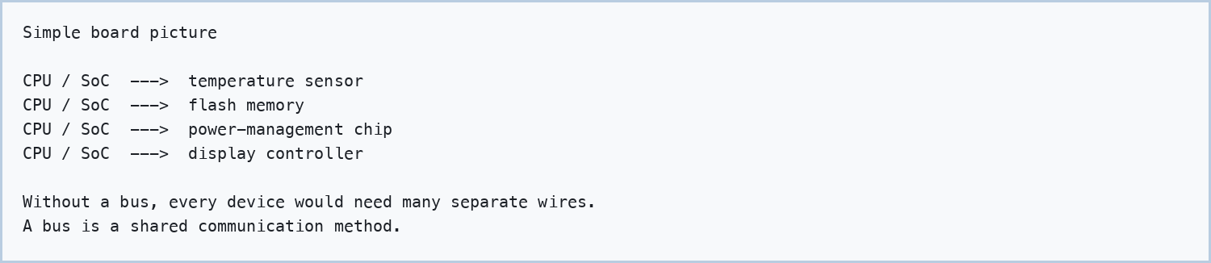

Checkpoint: What problem does a bus solve? Answer: It lets chips communicate using a standard set of wires and rules.

Step 2: The Big Difference
SPI and I2C are both serial buses, meaning bits move one after another. The easiest first difference is this: SPI uses more wires and is usually faster. I2C uses only two shared wires and is usually slower.
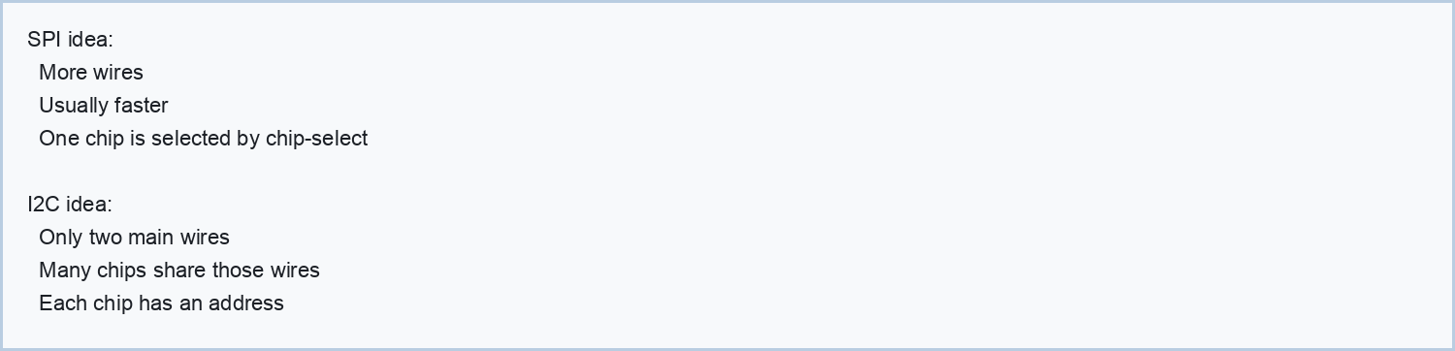

Checkpoint: Which one saves pins? Answer: I2C, because many devices share SCL and SDA.

Step 3: SPI Wires
Start with one SPI controller and one SPI target. Older documents say master/slave; modern terms are controller/target.
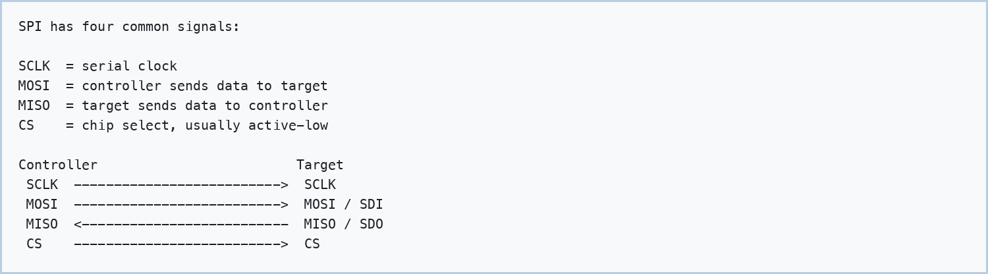

Checkpoint: Who creates the SPI clock? Answer: The controller.

Step 4: SPI Chip Select
SPI does not send an address like I2C. Instead, the controller pulls one chip-select line active to choose the device.
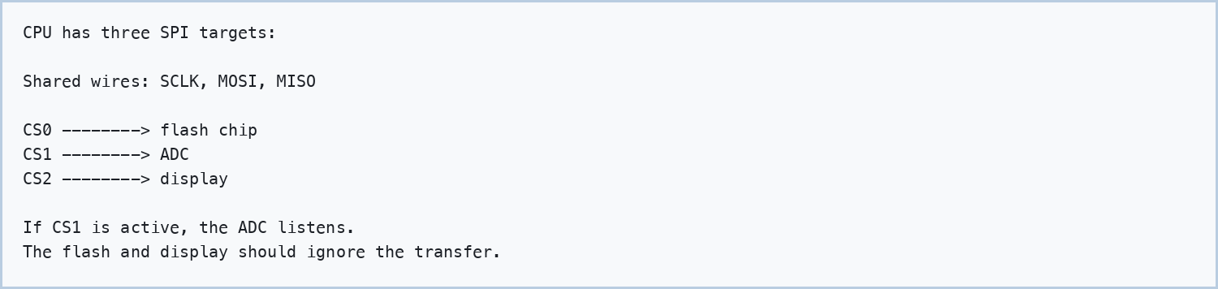

Checkpoint: How does SPI choose a device? Answer: By asserting that device's chip-select line.

Step 5: SPI Sends And Receives At The Same Time
SPI is commonly full-duplex. Every clock can move one bit from controller to target and one bit from target to controller.
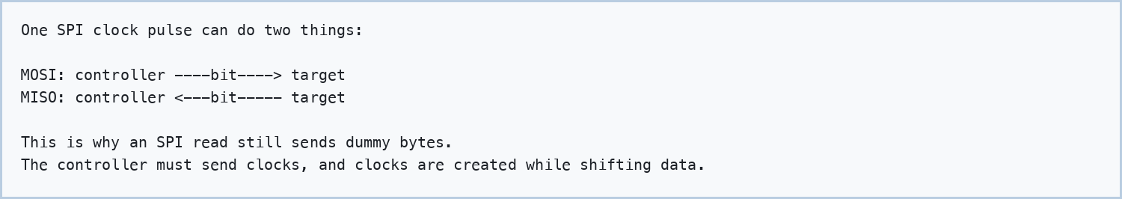

Checkpoint: Why does SPI read often transmit dummy bytes? Answer: To generate clock pulses so the target can shift data back.

Step 6: SPI Mode, Slowly
SPI devices must agree about when data is sampled. CPOL controls the idle clock level. CPHA controls which clock edge is used for sampling.
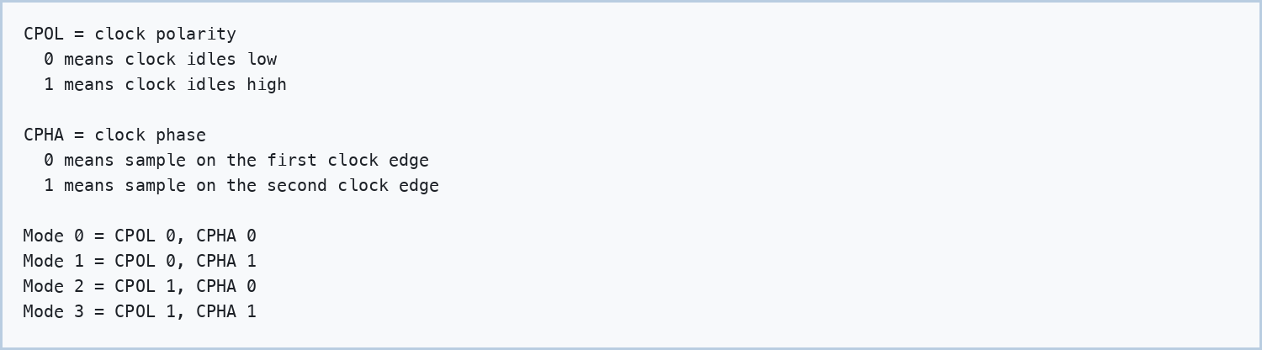

Checkpoint: What happens if SPI mode is wrong? Answer: The receiver may sample at the wrong time, causing shifted or corrupted data.

Step 7: I2C Wires
I2C uses two main wires. Both are shared by all devices on the bus.
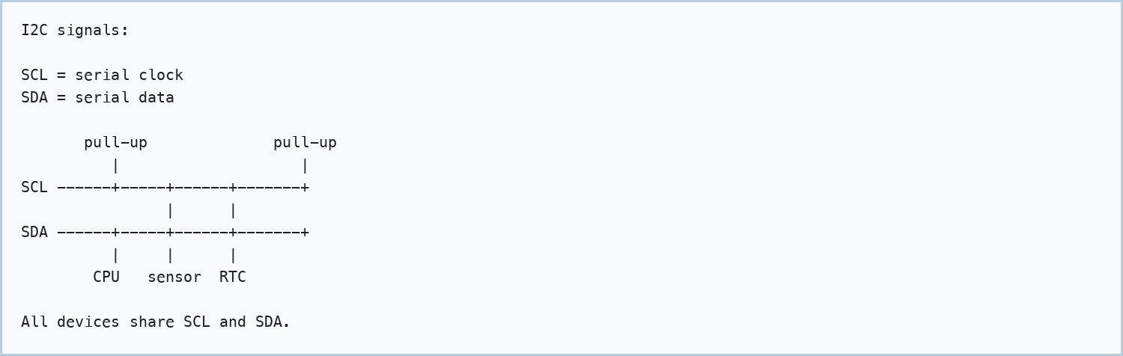

Checkpoint: What are the two I2C wires called? Answer: SCL and SDA.

Step 8: I2C Uses Addresses
Because all devices share the same two wires, the controller must say which device it wants. It does this by sending an address.
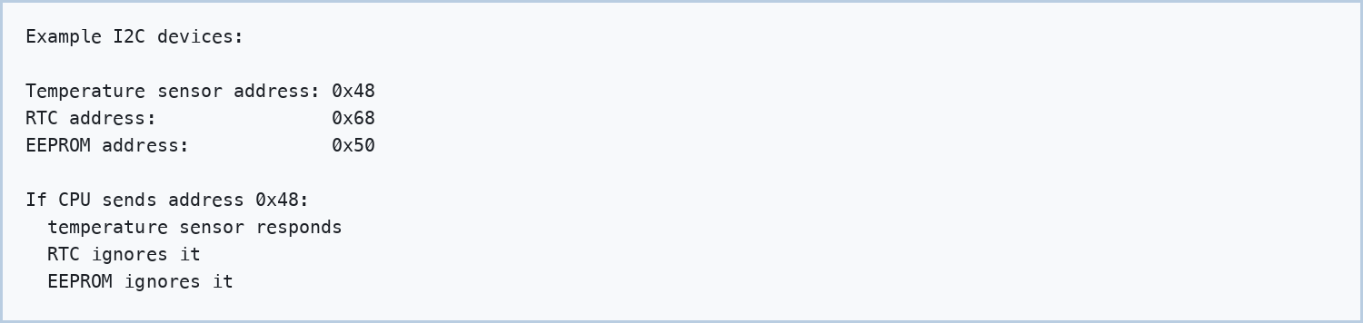

Checkpoint: How does I2C choose a device? Answer: By sending the device's address on the bus.

Step 9: Why I2C Needs Pull-Ups
I2C lines are open-drain. A device can pull the line low, but it does not drive the line high. Pull-up resistors bring the line back high.
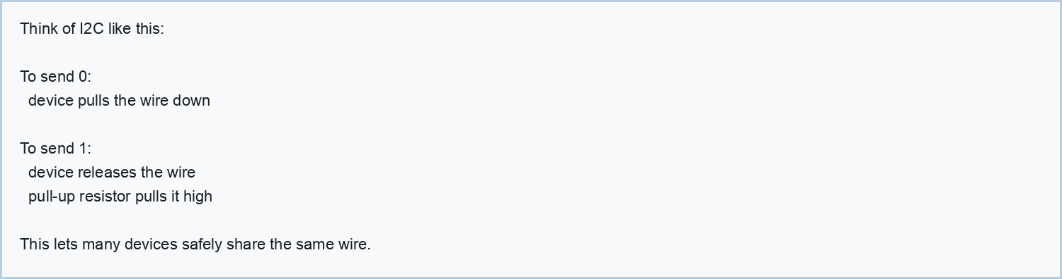

Checkpoint: Why are pull-ups needed? Answer: Because I2C devices release the line for high; the resistor creates the high level.

Step 10: Start, Stop, ACK
I2C has more protocol rules than SPI. Three important ones are start, stop, and ACK.
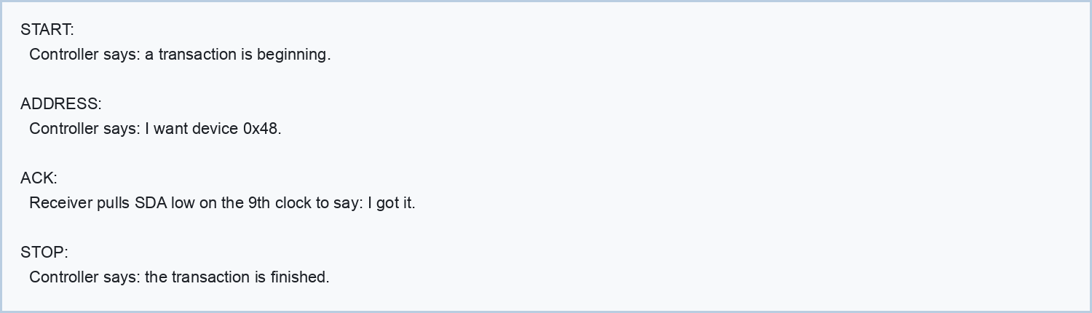

Checkpoint: What does ACK mean? Answer: The receiver acknowledged that byte.

Step 11: A Simple I2C Register Read
Many I2C chips have internal registers. To read one register, software usually writes the register number first, then reads the data.
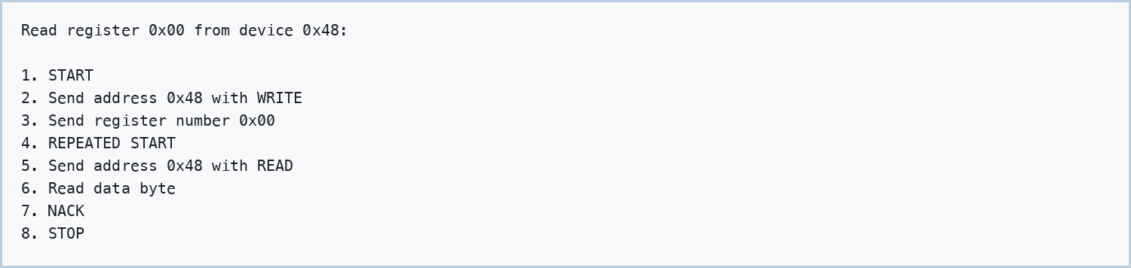

Checkpoint: Why write before reading? Answer: To tell the target which internal register we want.

Step 12: SPI User-Space Code, Tiny First
In Linux, simple SPI testing can use spidev. This example shows the shape, not a full production program.
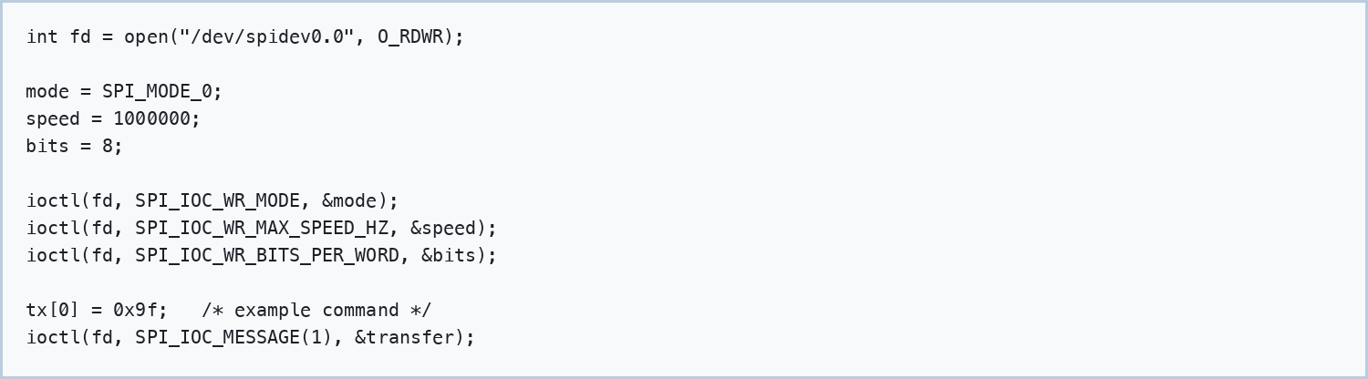

- open() selects the Linux device node.
- ioctl() configures SPI settings.
- SPI_IOC_MESSAGE sends the transfer.
- Mode and speed must match the target chip datasheet.

Step 13: I2C User-Space Code, Tiny First
In Linux, /dev/i2c-N represents an I2C adapter. Use the 7-bit address, not the shifted 8-bit address byte.
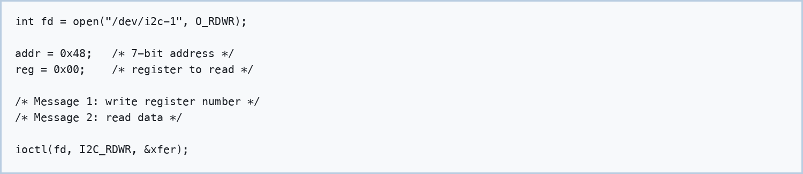

- The bus number is in /dev/i2c-1.
- The device address might be 0x48.
- A register read often uses two messages.
- I2C_RDWR can create a repeated-start transaction.

Step 14: Kernel Driver View
A Linux kernel driver usually has a probe function. Probe runs when the kernel matches a device description to a driver.
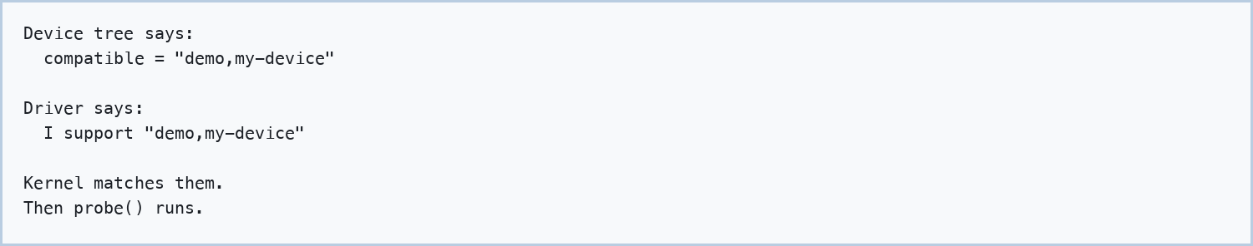

For many register-based SPI/I2C devices, kernel drivers use regmap. regmap is a helper layer for reading and writing registers.
Checkpoint: What does probe() mean? Answer: The driver was matched to a device and is initializing it.

Step 15: Device Tree Basics
Device tree tells the kernel what hardware exists on the board. For SPI, reg usually means chip-select. For I2C, reg means address.
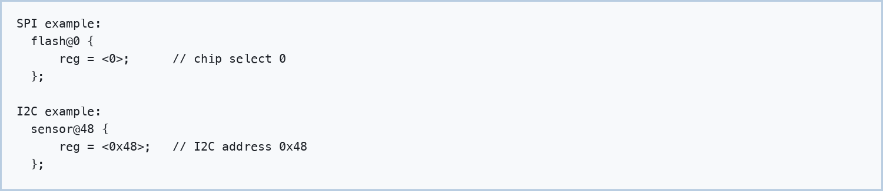

Checkpoint: In I2C device tree, what does reg usually mean? Answer: The I2C device address.

Step 16: Debugging SPI
- Check power and reset.
- Check pinmux.
- Check chip-select polarity.
- Check SPI mode.
- Lower the speed.
- Use a logic analyzer on SCLK, MOSI, MISO, and CS.
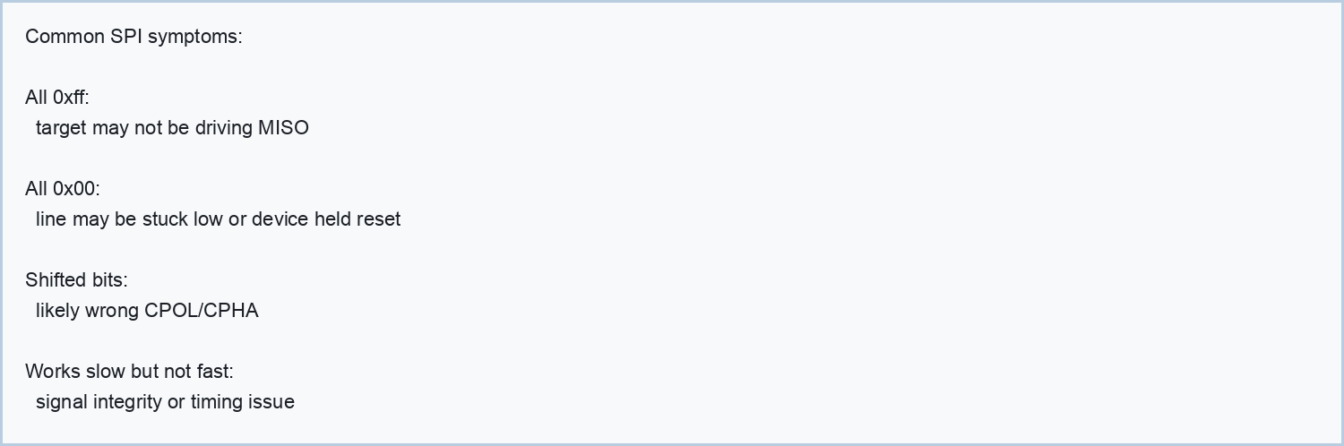

Step 17: Debugging I2C
- Check power and reset.
- Check pull-up resistors.
- Check the 7-bit address.
- Check the bus number.
- Try a slower bus speed.
- Use a logic analyzer on SCL and SDA.
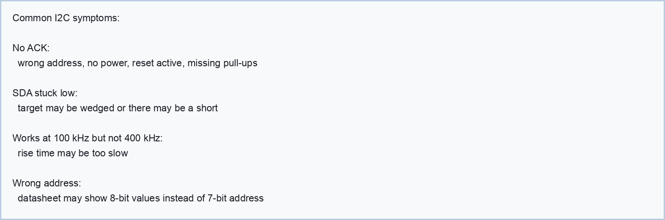

Step 18: Interview Answers In Simple Words
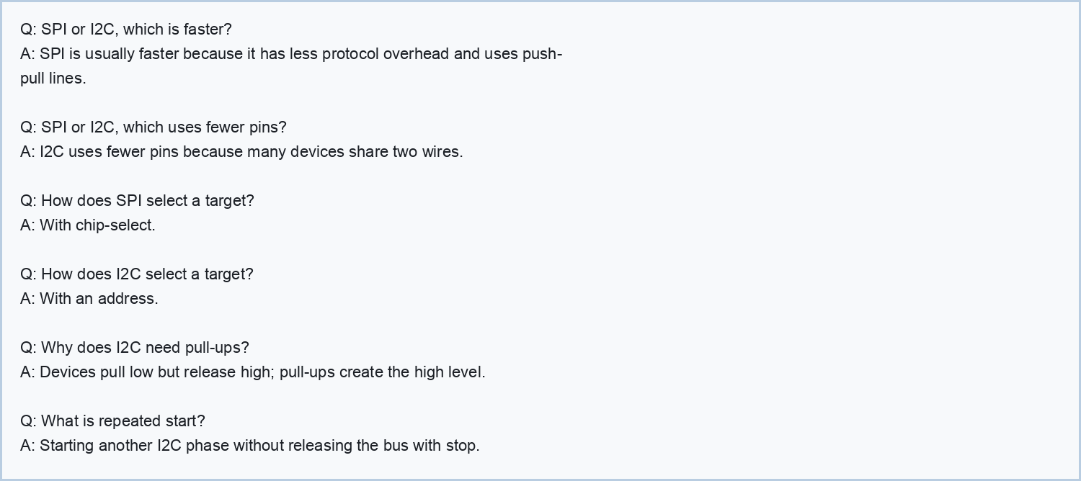

Step 19: Final Mental Model
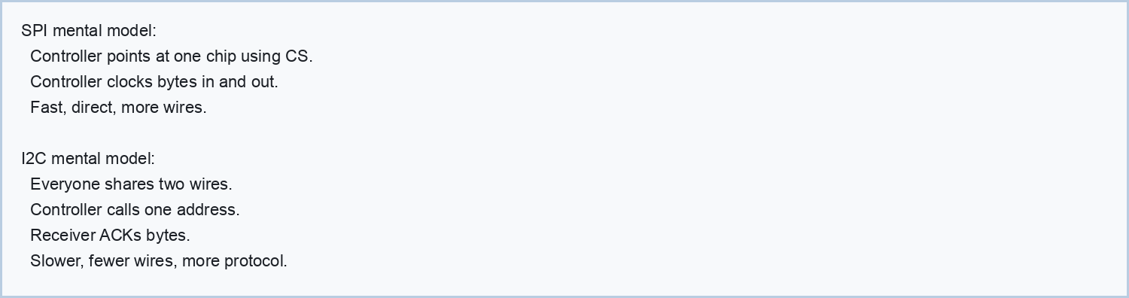

Practice Plan
- Draw SPI with SCLK, MOSI, MISO, and CS from memory.
- Draw I2C with SCL, SDA, pull-ups, and three devices.
- Explain why SPI read needs dummy transmit bytes.
- Explain I2C start, address, ACK, repeated start, and stop.
- Explain one SPI bug and one I2C bug.
- Say the difference between SPI chip-select and I2C address.

