Face Detection from Low Resolution and Low Light Pictures Using Machine Learning Algorithm

MD Mehedi Hasaan Shakil

A Thesis in the Partial Fulfillment of the Requirements

for the Award of Bachelor of Computer Science and Engineering (BCSE)



Department of Computer Science and Engineering

College of Engineering and Technology

IUBAT – International University of Business Agriculture and Technology

Fall 2022

Face Detection from Low Resolution and Low Light Pictures Using Machine Learning Algorithm

Md Mehedi Hassan Shakil

A Thesis in the Partial Fulfillment of the Requirements for the Award of Bachelor of Computer Science and Engineering (BCSE)

The thesis has been examined and approved,

\_\_\_\_\_\_\_\_\_\_\_\_\_\_\_\_\_\_\_\_\_\_\_\_\_\_\_\_\_

Prof. Dr. Utpal Kanti Das

Chairman

\_\_\_\_\_\_\_\_\_\_\_\_\_\_\_\_\_\_\_\_\_\_\_\_\_\_\_\_\_

Dr. Muhammad Hasibur Rashid Chayon

Co-supervisor, Coordinator and Associate Professor

\_\_\_\_\_\_\_\_\_\_\_\_\_\_\_\_\_\_\_\_\_\_\_\_\_\_\_\_\_

Suhala Lamia

Supervisor and Lecturer

Department of Computer Science and Engineering

College of Engineering and Technology

IUBAT – International University of Business Agriculture and Technology

Fall 2022

## **Letter of Transmittal**

3 January 2023

The Chair

Thesis Defense Committee

Department of Computer Science and Engineering

IUBAT–International University of Business Agriculture and Technology

4 Embankment Drive Road, Sector 10, Uttara Model Town

Dhaka 1230, Bangladesh

**Subject:** Letter of Transmittal.

Dear Sir,

With due respect, this is my pleasure to present my thesis report entitled “Face Detection from Low Resolution and Low Light Pictures Using Machine Learning Algorithm”. I have prepared this report as partial fulfillment of the requirement for the degree of Bachelor of Computer Science and Engineering. It was certainly a good opportunity to work on this paper to actualize my theoretical knowledge in the practical arena. Now, I am looking forward to your kind appraisal regarding this thesis report. I will remain deeply grateful to you if you kindly go through this report and evaluate my performance.

I hope that you would find the report comprehensive and competent augmented.

Yours sincerely,

\_\_\_\_\_\_\_\_\_\_\_\_\_

MD Mehedi Hassan Shakil

19103040

## **Student’s Declaration**

This is Md Mehedi Hassan Shakil declare that the work Presented in this thesis paper titled “Face Detection from Low Resolution and Low Light Pictures Using Machine Learning Algorithm” is the result of detecting a person from several angled and foggy with hazy image. I have used several algorithms to remove the haze and hog as well as recognize a person. This is mainly recognizing a person from the picture gotten by CCTV. Suhala Lamia, Lecturer Department of Computer Science and Engineering, IUBAT. I am ensuring that No parts of this report have been submitted anywhere for any degree, diploma or certificate.

\_\_\_\_\_\_\_\_\_\_\_\_\_

MD Mehedi Hassan Shakil

19103040

## **Supervisor’s Certification**

This is to certify that the thesis report on “Face Detection from Low Resolution and Low Light Pictures Using Machine Learning Algorithm” has been carried out by MD Mehedi Hassan Shakil bearing ID#19103040 student of Department of Computer Science and Engineering of IUBAT-International University of Business Agriculture and Technology, as a partial fulfillment of the requirement for the degree in Bachelor of Computer Science and Engineering. The report has been prepared under my guidance and is a record of work carried out successfully. To the best of my knowledge and as per her declaration, no parts of this report have been submitted anywhere for any degree, diploma or certificate. Now he is permitted to submit the report. I wish her success in future endeavors.

\_\_\_\_\_\_\_\_\_\_\_\_\_\_\_\_\_\_\_\_\_\_\_\_\_\_\_\_\_\_\_

Suhala Lamia

Supervisor and Lecturer

Department of Computer Science and Engineering

IUBAT–International University of Business Agriculture and Technology

## **Abstract**

Detecting faces in images is the first step of any face application such as face recognition, face localization and face expression. The performance of face detection systems directly effects on correct operating of mentioned applications. Because faces are non-rigid and have high variation in scale, color, pose and lighting condition, designing an automatic system to overcome all mentioned problems is difficult. Machine learning has been shown that is one of the most successful tools to build high performance face detection systems. Due to huge number of studies in this area, studying all works in this field is tedious. The purpose of this short review paper is to present, categorize and evaluate some new face detection techniques using four conventional learning machines. The performance and the other evaluation parameters of these methods compare with each other in order to introduce significant techniques and also to state advantages and disadvantages of related works. With the marvelous increase in video and image database there is an incredible need of automatic understanding and examination of information by the intelligent systems as manually it is getting to be plainly distant. Face plays a major role in social intercourse for conveying identity and feelings of a person. Human beings have not tremendous ability to identify different faces than machines. So, automatic face detection system plays an important role in face recognition, facial expression recognition, head-pose estimation, human–computer interaction etc. Face detection is a computer technology that determines the location and size of a human face in a digital image. Face detection has been a standout amongst topics in the computer vision literature. This paper presents a comprehensive survey of various techniques explored for face detection in digital images. Different challenges and applications of face detection are also presented in this paper. At the end, different standard databases for face detection are also given with their features. Furthermore, we organize special discussions on the practical aspects towards the development of a robust face detection system and conclude this paper with several promising directions for future research.

## **Acknowledgments**

During my work on this thesis, many people supported me from technical, organizational and personal perspective. At this point, I would like to express my gratitude to them. First and foremost, I would like to thank God for giving me the strength to finish this work. The satisfaction that accompanies the successful completion of this thesis would be incomplete without the mention of people whose ceaseless cooperation made it possible, whose constant guidance and encouragement crown all efforts with success. I am grateful to my honorable thesis supervisor Suhala Lamia Lecturer, Department of Computer Science and Engineering, IUBAT, for the guidance, inspiration and constructive suggestions which were helpful in the preparation of this thesis. I also convey special thanks and gratitude to Dr. Hasibur Rashid Chayon, Associate Professor & Coordinator, Department of Computer Science and Engineering, IUBAT for his co-supervision and advice.

**Table of Contents**

**Letter of Transmittal** iii

**Student’s Declaration** iv

**Supervisor’s Certification** v

**Abstract** vi

**Acknowledgments** viiii

**List of Figures** xi

**List of Tables** xii

**Chapter 1. Introduction** 1

**Chapter 2. Literature Review** 4

2.1 Key Concepts, Theories and Studies 4

2.2 Limitations 4

**Chapter 3. Research Methodology** 6

3.1 Ensemble Learning 6

3.2Stacking 8

3.3 Random Forest 9

3.4 AdaBoost 10

3.5 Gradient Boosting 12

**Chapter 4. Result and Discussion** 14

**Chapter 5. Conclusion** 16

**References** 17

## **List of Figures**

Figure 1.1 Facial Recognition by Sensor. 1

Figure 1.2 Image Processing Data Flow. 2

Figure 2.1 Human Face Detection Model Structure 4

Figure 2.2 Proposed System. 5

Figure 3.1 Classification patterns based on Ensemble Learning. 6

Figure 3.2 Begging of Ensemble. 7

Figure 3.3 Prediction Making of Stacking. 8

Figure 3.4 Prediction Flow of Random Forest. 9

Figure 3.5 Pixels Capture Section……………………………………………………………11

Figure 3.6 Schematic Diagram of Cascade Classifier. 11

Figure 3.7 GB-Based Image Dehazing. 12

## **List of Tables**

Table 4.1 Experimental Results of Face Detection Methods Using Machine Learning…......15

## **Chapter 1. Introduction**

Automatic human face detection is one of the interesting categories in biometric knowledge which has attracted much attention recently. The goal of this task is to identify faces in a still image or video regardless of variations such as pose, illumination, occlusion and expression. Many applications have adopted face detection. For instance, human computer interaction (HCI), computer surveillance, biometrics, web search engines and digital video indexing are some of the applications which use face detection.



Figure 1.1 Facial Recognition by sensor

Figure 1.1 Facial Recognition by sensos show the technique how face detection actually works. The main challenges using face detection are pose, illumination, occlusion and facial expression. Another problem is high-cost computation time which have faced face detection applications with a lot of problems in real time purposes. Several different approaches have been presented by the researchers including Template-Base methods, Feature-Based methods, Appearance-Based methods and Components-Based methods. Template-Based methods use the correlation values between standard pattern and input image to detect face used this approach for locating human faces. Although Template-Based techniques are simple to implement but variation in pose, scale and shape of images decreased detection rate. The goal of Feature-Based methods is to extract invariant features of images. The relationship between components of faces such as eye, nose, hair and mouth based on a statistical model determined existing a face in an image. The major drawback of this approach is if the images influenced by occlusion or noise, detecting faces will be very difficult. The two other approaches, Appearance Based and Component-Based are more robust against changes in illumination, pose and partial occlusion and have been more successful compared with previous approaches. Both of the mentioned approaches apply learning machine to train examples. Two interesting survey works have been presented in and until 2002.In these surveys a detailed review of techniques to detect faces in a single image is presented. Also benchmarking database and evaluation criteria are discussed. In this paper several new face detection techniques are categorized based on four conventional machine learning as a classifier to classify faces and non-faces. The methods are compared with each other to evaluate different techniques. This paper is presented in five sections. Section 2 gives a detailed review of face detection concepts and challenges. Four known learning machine algorithms discussed in section 3. Then in section 4 performance and evaluation criteria are presented. One of the fundamental techniques that enable such natural Human–Computer Interaction (HCI) is face detection. Face detection is the step stone to all facial analysis algorithms, including the face alignment, face modelling, face relighting, face recognition, face verification or authentication, head pose tracking, facial expression tracking/recognition, gender/age recognition, and many more. So, computers can understand face clearly, after that they begin to truly understand people’s thoughts and intentions. Given a digital image, the primary goal of face detection is to determine whether or not there are any faces in the image. This appears as a trivial task for human beings, but it is a very challenging task for computers, and has been one of the top studied research topics in the past few decades. The difficulty associated with face detection can be attributed to many variations in scale, location, orientation (in-plane rotation), pose (out-of-plane rotation), facial expression, lighting conditions, occlusions, etc. A lot of reports are available for face detection in the literature. The field of face detection has made considerable progress in the past decade. Mukherjee et al. (2017) have discussed the formulation for both the methods, i.e., using hand-crafted features followed by training a simple classifier and an entirely modern approach of learning features from data using neural networks. Ren et al. (2017) have presented a method for real time detection and tracking of the human face. The proposed method combines the Convolution Neural Network detection and the Kalman filter tracking. Convolution Neural Network is used to detect the face in the video, which is more accurate than traditional detection method. When the face is largely deflected or severely occluded, Kalman filter tracking is utilized to predict the face position. They try to increase the face detection rate, while meeting the real time requirements. Luo et al. (2018) have suggested deep cascaded detection method that iteratively exploits bounding-box regression, a localization technique, to approach the detection of potential faces in images. They also consider the inherent correlation of classification and bounding-box regression and exploit it to further increase overall performance.

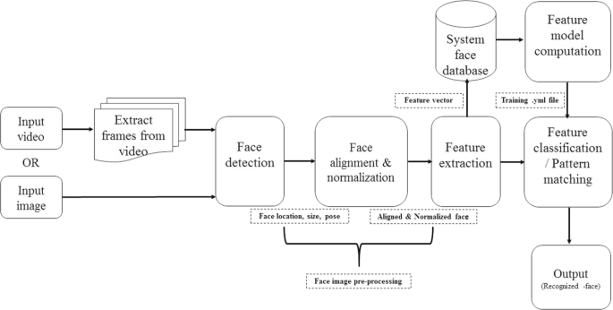

Figure 1.2 Image processing data flow

Figure 1.2 showed the data flow of Image processing. Their method leverages cascaded architecture with three stages of carefully designed deep convolutional networks to predict the existence of faces. TensorFlow is a machine learning system that operates on large scale and in heterogeneous environments. Tensor-Flow uses dataflow graphs to represent computation, shared state, and the operations that mutate that state. It maps the nodes of a dataflow graph across many machines in a cluster, and within a machine across multiple computing devices, including multicore CPUs, general purpose GPUs, and custom-designed ASICs known as Tensor Processing Units (TPUs). This architecture gives flexibility to the application developer: whereas in previous “parameter server” designs the management of shared state is built into the system. TensorFlow enables developers to experiment with novel optimizations and training algorithms. TensorFlow supports a variety of applications, with a focus on training and inference on deep neural networks. Several Google services use TensorFlow in production. They describe the TensorFlow dataflow model and demonstrate the compelling performance that Tensor-Flow achieves for several real-world applications.

## **Chapter 2. Literature Review**

I have used two research paper for my further research. Face detection techniques: a review, Face Detection and Recognition Algorithm in Digital Image Based on Computer Vision Sensor.

**2.1** **Key Concepts, Theories and Studies**

In “Face Detection and Recognition Algorithm in Digital Image Based on Computer Vision Sensor” the authors present a computer vision model.



Figure 2.1 Human face detection model structure

Figure 2.1 shows the structure of the face detection model. The extraction of Haar’s rectangular features and the strong classifier based on AdaBoost are an important part of face detection. The Haar feature is composed of several identical rectangles, which are distinguished by the black and white difference of colors, and the feature values of the Haar features are defined by the pixel values of the rectangle. Regarding the number of rectangular features, Papa Georgiou et al. proposed a formula. It can be seen from the above formula that the number of features is huge, and the OpenCV method solves this problem by introducing an integral image method. Calculated by the formula, it is where is the cumulative value for each row, the initial value of, and is the initial value of.

**2.2 Limitations**

This system is only applicable for fog free images. This system is not used for critical angled picture.



Figure 2.2 Proposed System

Figure 2.2 Proposed System showed the poor image quality facial recognition's effectiveness.

Image quality affects how well facial-recognition algorithms work. Even high-definition

video is, at best, 1080p (progressive scan); usually, it is 720p. These values are equivalent to about 2MP and 0.9MP, respectively, while an inexpensive digital camera attains 15MP. The difference is quite noticeable. When a face-detection algorithm finds a face in an image or in a still from a video capture, the relative size of that face compared with the enrolled image size. An already small image size, coupled with a target distant from the camera, means that the detected face is only 100 to 200 pixels on a side. Further, having to scan an image for varying face sizes is a processor- intensive activity. Most algorithms allow specification of a face-size range to help eliminate false positives on detection and speed up image processing. When a face is enrolled in the recognition software, usually multiple angles are used (profile, frontal and 45-degree are common). Anything less than a frontal view affects the algorithm’s capability to generate a template for the face. The more direct the image (both enrolled and probe image) and the higher its resolution, the higher the score of any resulting matches. Even though high-definition video is quite low in resolution when compared with digital camera images, it still occupies significant amounts of disk space. so usually only a fraction (10 percent to 25 percent) is actually run through a recognition system. To minimize total processing time, agencies can use clusters of computers. However, adding computers involves considerable data transfer over a network, which can be bound by input-output

restrictions, further limiting processing speed

## **Chapter 3. Research Methodology**

**3.1 Ensemble learning**

Ensemble learning is a general meta approach to machine learning that seeks better predictive performance by combining the predictions from multiple models.

Although there are a seemingly unlimited number of ensembles that you can develop for your predictive modeling problem, there are three methods that dominate the field of ensemble learning. So much so, that rather than algorithms per se, each is a field of study that has spawned many more specialized methods.

The three main classes of ensemble learning methods are bagging, stacking, and boosting, and it is important to both have a detailed understanding of each method and to consider them on your predictive modeling project.

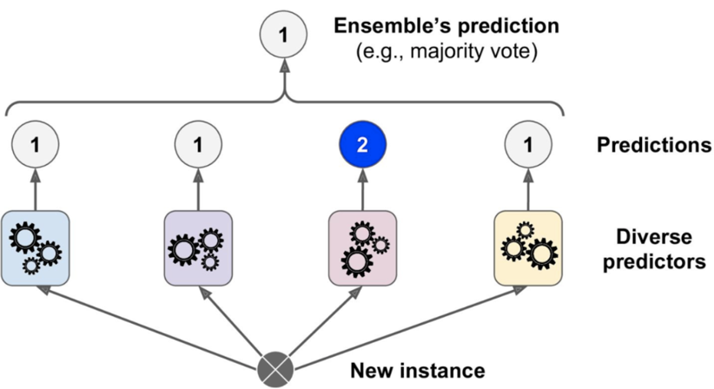

Figure 3.1 Classification patterns based on Ensemble Learning

As can be seen in fig. 3.1 suppose two set of examples belong to face and non-face. Line H3 doesn't separate the examples, line H2 can separate examples but with small margin and H3

separate with maximum margin while EL minimizes an upper bound on expected generalization error. Osuna et al. used two test sets including 10 million patterns of 19˟19 pixels for face detection and showed their system can apply about 30 times faster than system was introduced by Sung and Poggio. Also, SVM has been applied for detecting faces in wavelet domain in. Figure.3.1 Five states is trained with the sequence of observation vectors Yungmin Li et al. presented combinational method using Eigenface and EL in order to increase speed of detection and pose estimation in multi-view images. But, before that, you need a gentle introduction to these approaches and the key ideas behind each method prior to layering on math and code.

In this tutorial, you will discover the three standard ensemble learning techniques for machine learning.

After completing this tutorial, you will know:

* Bagging involves fitting many decision trees on different samples of the same dataset and averaging the predictions.
* Stacking involves fitting many different models types on the same data and using another model to learn how to best combine the predictions.
* Boosting involves adding ensemble members sequentially that correct the predictions made by prior models and outputs a weighted average of the predictions.

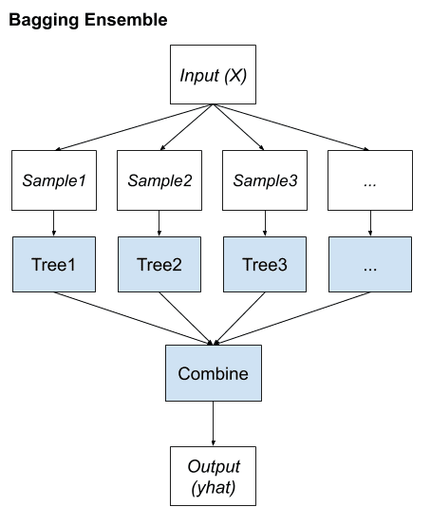

Figure 3.2 Begging of Ensemble

Figure 3.2 states the Begging of Ensemble. This typically involves using a single machine learning algorithm, almost always an unpruned decision tree, and training each model on a different sample of the same training dataset. The predictions made by the ensemble members are then combined using simple statistics, such as voting or averaging.

**3.2 Stacking**

Stacking is an ensemble learning technique to combine multiple classification models via a meta-classifier. The individual classification models are trained based on the complete training set; then, the meta-classifier is fitted based on the outputs -- meta-features -- of the individual classification models in the ensemble. The meta-classifier can either be trained on the predicted class labels or probabilities from the ensemble.

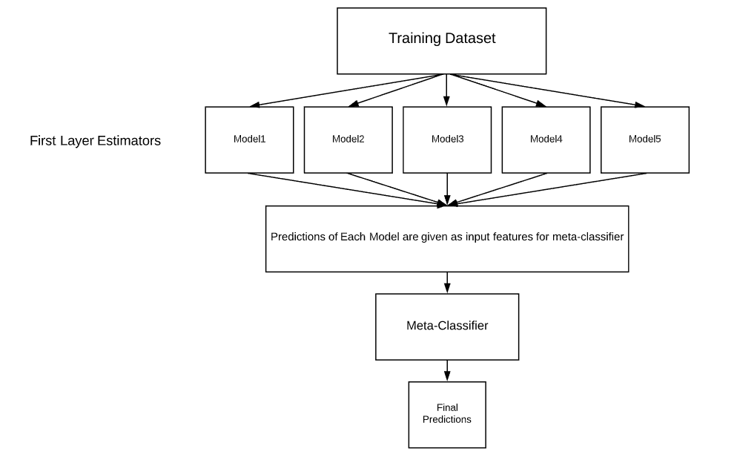

Figure 3.3 Prediction Making of Stacking

Figure 3.3 states the Prediction Making of Stacking. Most of the Machine-Learning and Data science competitions are won by using Stacked models. They can improve the existing accuracy that is shown by individual models. We can get most of the Stacked models by choosing diverse algorithms in the first layer of architecture as different algorithms capture different trends in training data by combining both of the models can give better and accurate results. The meta-model is trained on the predictions made by base models on out-of-sample data. That is, data not used to train the base models is fed to the base models, predictions are made, and these predictions, along with the expected outputs, provide the input and output pairs of the training dataset used to fit the meta-model.The outputs from the base models used as input to the meta-model may be real value in the case of regression, and probability values, probability like values, or class labels in the case of classification.The most common approach to preparing the training dataset for the meta-model is via [k-fold cross-validation](https://machinelearningmastery.com/k-fold-cross-validation/) of the base models, where the [out-of-fold predictions](https://machinelearningmastery.com/out-of-fold-predictions-in-machine-learning/) are used as the basis for the training dataset for the meta-model.The training data for the meta-model may also include the inputs to the base models, e.g. input elements of the training data. This can provide an additional context to the meta-model as to how to best combine the predictions from the meta-model.Once the training dataset is prepared for the meta-model, the meta-model can be trained in isolation on this dataset, and the base-models can be trained on the entire original training dataset.Stacking is appropriate when multiple different machine learning models have skill on a dataset, but have skill in different ways. Another way to say this is that the predictions made by the models or the errors in predictions made by the models are uncorrelated or have a low correlation.

Base-models are often complex and diverse. As such, it is often a good idea to use a range of models that make very different assumptions about how to solve the predictive modeling task, such as linear models, decision trees, support vector machines, neural networks, and more. Other ensemble algorithms may also be used as base-models, such as random forests.

**3.3 Random Forest**

Random Forest is a popular machine learning algorithm that belongs to the supervised learning technique. It can be used for both Classification and Regression problems in ML. It is based on the concept of ensemble learning, which is a process of combining multiple classifiers to solve a complex problem and to improve the performance of the model.

As the name suggests, "Random Forest is a classifier that contains a number of decision trees on various subsets of the given dataset and takes the average to improve the predictive accuracy of that dataset." Instead of relying on one decision tree, the random forest takes the prediction from each tree and based on the majority votes of predictions, and it predicts the final output.

.

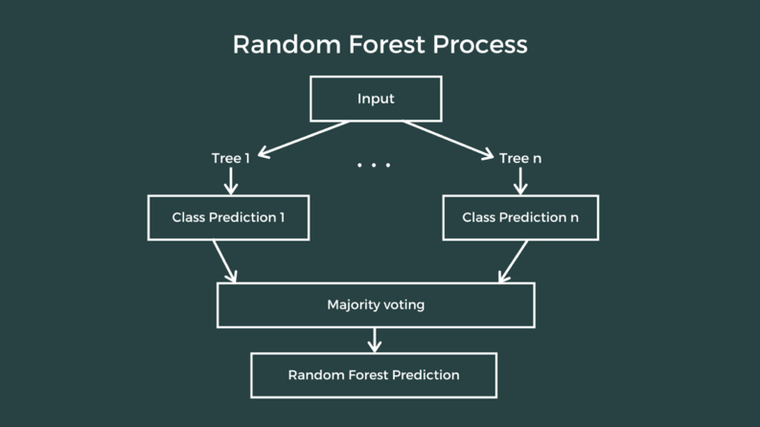

Figure 3.4 Prediction Flow of Random Forest

Figure 3.4 shows the Prediction Flow of Random Forest. Input layer is considered for input images, output layer is considered for determining face and non-face images and hidden layer adjusts weights of input layer to minimize error for training task based on desired output. It’s probably much easier to understand how a decision tree works through an example.

Imagine that our dataset consists of the numbers at the top of the figure to the left. We have two 1s and five 0s (1s and 0s are our classes) and desire to separate the classes using their features. The features are color (red vs. blue) and whether the observation is underlined or not. So how can we do this?

Color seems like a pretty obvious feature to split by as all but one of the 0s are blue. So we can use the question, “Is it red?” to split our first node. You can think of a node in a tree as the point where the path splits into two — observations that meet the criteria go down the Yes branch and ones that don’t go down the No branch.

The No branch (the blues) is all 0s now so we are done there, but our Yes branch can still be split further. Now we can use the second feature and ask, “Is it underlined?” to make a second split.

The two 1s that are underlined go down the Yes subbranch and the 0 that is not underlined goes down the right subbranch and we are all done. Our decision tree was able to use the two features to split up the data perfectly. Victory!

**3.4 AdaBoost**

One of the interesting works on face detection presented by Viola and Jones. In contrast to many face detection systems which focused on pixels intensities, they applied a new image representation called the "integral image" to compute selected features very rapidly. Different shape and size of rectangular features namely Haar like features used to capture features from images. Some of the rectangle features is shown in fig 5. A small set of Haar like features selected by AdaBoost algorithm to classify faces and non-faces in training task. Each weak classifier, classify the limit number of examples but the number of examples which have not classified correctly by the detector, transferred to next weak classifier. So, A linear combination of weak classifiers constructed strong classifier in order to increase accuracy and reducing computation time. The results showed that the approach of Viola and Jones detect 93.7% of examples with 422 false positive using MIT+CMU database that is more accurate than Rowley et al. proposed system. On the other hand viola's system was 15 time faster than Rowley et al.'s system. A fast multi view face detection was developed following their previous work of viola and Jones which utilized frontal faces for detection. The first reliable method for non-upright face detection system belongs to Rowley et al. They designed two neural network classifiers, the former was considered for pose detection and the latter was only a conventional face detector .A similar two stage face detector including decision tree classifier and face classifier was designed by Viola and Jones for multi-view face detection. The proposed system divides spaces to different classes based on various poses and then training applied for each pose. For nonface windows any detector returns false. The results of Viola and Jones in comparison with work of Rowley et al. shows similar accuracy and false positive but in term of speed Viola and Jones acts better. Li et al. presented a real time multi view face detection inspired by viola and Jones research. They used float boost algorithm which was useful for steady training of AdaBoost algorithm. Also, they applied coarse to fine and simple to complex architecture in order to increase detection rate in non-frontal faces. A component-Based approach was developed by Goldman et al. to detect faces in the presence of partial occlusion. In the first step facial components extracted individually then face localization and topology verification applied in the next step. Left eye, right eye, nose and mouth were detected by the component detector They used Haar like features and AdaBoost as a classifier due to one of the fastest algorithms for training data. A specific Graph model are considered to detect relationship between face components in term of size and position. To evaluate proposed system, AR and BioID databases are utilized and TPR (True Positive Rate) and FPR (False Positive Rate) are calculated. Their results are shown that component-Based approach achieved higher robustness especially in presence of partial occlusion and out of plane rotation in comparison with holistic approach face detection developed by Viola and Jones.



Figure 3.5 Pixels Capture Section

Figure 3.4 showed the sum of the pixels captured in white sections subtracts from grey pixels captured sections (a) and(B) two rectangular features (C) three rectangular feature and (D) four rectangular features. Their algorithm covers large RIP and ROP images. Using coarse-to-fine strategy, the entire face space divided to smaller subspace. To train the nodes of tree structure, Vector Boosting applied. Their results demonstrate high speed and performance detection. Li et al. (2004) proposed a Float Boost algorithm to backtrack all the learned features and also learning a boosted classifier for achieving minimum error rate. Besides this algorithm a novel statistical model used to lead fewer weak classifiers than original AdaBoost which provides lower error rates in both training and testing task. Their multi-view face detection system achieved a speed of 5–8 frames per second with detection rate lower than frontal face detection.



Figure 3.6 Schematic diagram of cascade classifier

Figure 3.5 showed the schematic diagram of cascade classifier. The first classifier rejects a large number of negative examples. The next classifier tries to reject misclassified examples from the previous classifiers. A statistical learning method presented by Peng and Quiang (2007) to extract features and constructing classifiers for multi-view face detection. They used a recursive nonparametric discriminant analysis (RNDA). The RNDA relaxes Gaussian assumption of Fisher discriminant analysis which handle more general complexity. Combining RNDA features with AdaBoost form a multi-view face detector. The time consumption to train examples is a drawback of this method because of large vector elements for an image. To solve this problem RNDA proposed to search feature in transformed features space which is lower dimensionality than original space. They analyze the Multiview face detection on CMU profile test set containing 208 images with 347 profile faces. The result showed that they obtained 90 % detection rate with over 800 false detections. Ruan and Yin (2009) applied facial features and AdaBoost algorithm for multi-pose face detection. In their method using skin color information, region of interest segmented. After detecting eyes and mouth by geometric features the face candidates are verified by AdaBoost algorithm. Their experimental results show that detection accuracy improved and also their proposed method is robust to facial expression and occlusion. Huang et al. (2005) proposed a new boosting algorithm namely Vector Boosting as a novel tree-structured Multiview face detector. Have been proposed a PSOAdaBoost algorithm, a combination of an optimization method called Particle Swarm Optimization and AdaBoost algorithm to develop AdaBoost algorithm for increasing accuracy and speed of computation. AdaBoost algorithm uses exhaustive search to find the best features to construct weak classifier. Combination of the small set of weak classifier constructs strong classifier which is used to classify face and non-face patterns. Time consumption of exhausting search from AdaBoost algorithm is a serious problem for real time object detection purposes. SO is an optimization tools developed by Kennedy and Ebehart. The best features and threshold decision determine by PSO. Comparing with the other forms of AdaBoost, PSO AdaBoost shows increment in computation speed and detection rate on a test set.

**3.5 Gradient Boosting**

A Gradient Boosting Machine or GBM combines the predictions from multiple decision trees to generate the final predictions. Keep in mind that all the weak learners in a gradient boosting machine are decision trees. But if we are using the same algorithm, then how is using a hundred decision trees better than using a single decision tree? How do different decision trees capture different signals/information from the data? Here is the trick – the nodes in every decision tree take a different subset of features for selecting the best split. This means that the individual trees aren’t all the same and hence they are able to capture different signals from the data.

Additionally, each new tree takes into account the errors or mistakes made by the previous trees. So, every successive decision tree is built on the errors of the previous trees. This is how the trees in a gradient boosting machine algorithm are built sequentially.

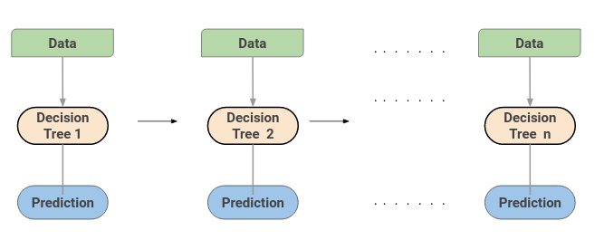

Figure 3.7 GB-Based Image Dehazing

Figure 3.6 illustrates the process used to obtain A. With Gradient Boosting we have a generalization of boosting techniques in which is possible to optimize the meta-learner based on an arbitrary differentiable loss function. What does it mean?

It means that changes everything! As we have seen in AdaBoost, the meta-learner is optimized based on the misclassified observations by the weak learners, in Gradient Boosting the meta-learner is optimized (with tecniques like the almighty gradient descent) based upon a loss function. Like this one (the least square loss function):

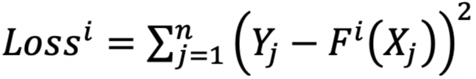

Where Y is the real value of the target variable and F(X) is the prediction of the meta-learner function, based on the values of the variables associated to the evaluated target value Y. Gradient tree boosting is an additive ensemble learning approach that uses decision trees as weak learners. Additive means that the trees are added one after the other. Previous trees remain unchanged. When adding subsequent trees, [gradient descent](https://scikit-learn.org/stable/modules/sgd.html" \t "_blank) is used to minimize the loss. Gradient Boosting (GB) is similar to AdaBoost in that it, too, is a sequential training technique. The difference between AdaBoost and GB is that GB does not give incorrectly classified items more weight. Instead, GB software optimizes the loss function by generating base learners sequentially so that the present base learner is always more effective than the previous one. This method attempts to generate accurate results initially instead of correcting errors throughout the process, like AdaBoost. For this reason, GB software can lead to more accurate results. Gradient Boosting can help with both classification and regression-based problems.

## **Chapter 4. Result and Discussion**

In this paper we have presented a short review paper of new face detection techniques. Unfortunately, due to lack of standard tools to evaluate approaches and different databases used by researchers, exact comparing methods is not feasible. To discuss and to assess presented methods, some of evaluation parameters are considered for comparing techniques with each other. Table 1 describes the reported performance of some different approach and different machine learning as a classifier for face detection systems. As can be seen from this table, various databases have been used. From table 1 it is clear that the performance of all methods over 90% and this means that face detection for frontal images have been solved largely but in term of partially occlusion or multi-view face detection a few of the works have been successful. According to table 1 Comparing SVM and neural network shows that SVM obtain better performance in term of detection rate and false detection. To detail this comparison, we can say that SVM achieves generalization performance but some kind of neural networks such as multiple layer perceptron (MLPs) are able to minimize error rate on training examples, there is no guarantee that this will translate into good performance on test data. On the other hand, SVMs use structural risk minimization while MLPs minimize the mean square error on training examples or use empirical risk minimization. In other word using structural risk minimization gives an upper bound on the expected generalization error. To minimize expected classification error, SVM separate hyperplane while estimating optimal hyperplane implicated to solve linearly constrained quadratic programming problem which is time and memory consumption. On the other hand, neural network is a powerful tool to classify complex class conditional density of image patterns but designing network including number of nodes and layers and training rate is complicated.

Table 4.1 Experimental Results of Face Detection Methods Using Machine Learning

|  |  |  |  |  |
| --- | --- | --- | --- | --- |
| **Test No** | **Random Forest** | **Adaboost** | **Gradient Boost** | **Stacking** |
| 1 | 94.21% | 79.34% | 91.62% | 99.2% |
| 2 | 93.23% | 87.34% | 83.67% | 90.30% |
| 3 | 91.62% | 96.78% | 97.5% | 96.78% |
| 4 | 87.34% | 87.45% | 79.23% | 93.67% |
| 5 | 79.34% | 76.56% | 94.21% | 98.45% |
| 6 | 89.35% | 89.45% | 89.345 | 92.56% |
| 7 | 97.50% | 88.89% | 79.87% | 97.89% |
| 8 | 93.32% | 96.45% | 79.34% | 96.56% |
| 9 | 83.67% | 78.43% | 94.56% | 98.23% |
| 10 | 97.45% | 79.23% | 87.34% | 97.34% |

From table 4.1 we can see that it obtain 97.60% detection rate on database. Although as a classifier have been applied in a wide range of applications specially in 1D application such as voice recognition but due to have two major drawback including high sensitivity to image noise and large dimension of the observation vector that causes complexity computation and time consumption, used less in face detection and recognition. AdaBoost is one of the fastest algorithm which took popularity for object detection systems and has been used in a wide range of image applications recently. Due to utilizing new image representation called "integral image" to compute the values of pixels in a specific area, AdaBoost reduces time of computation and consequently speed detection will be increased. But exhaustive search for searching small set of efficient features and finding optimum threshold is still disadvantage of AdaBoost algorithm..

## **Chapter 5. Conclusion**

In recent years face detection has achieved considerable attention from researchers in bio-

metrics, pattern recognition, and computer vision groups. There is countless security, and

forensic applications requiring the use of face recognition technologies. As you can see,

face detection system is very important in our day to day life. Among the entire sorts of

biometric, face detection and recognition system is the most accurate. In this article, we have

presented a survey of face detection techniques. It is exciting to see face detection techniques

be increasingly used in real-world applications and products. Applications and challenges

of face detection also discussed which motivated us to do research in face detection. The

most straightforward future direction is to further improve the face detection in presence of

some problems like face occlusion and non-uniform illumination. Current research focuses

in ﬁeld of face detection and recognition is the detection of faces in presence of occlusion and

non-uniform illumination. A lot of work has been done in face detection, but not in presence

123

Face detection techniques: a review

of problem of presence of occlusion and non-uniform illumination. If it happens, it will help a

lot to face recognition, face expression recognition etc. Currently many companies providing

facial biometric in mobile phone for purpose of access. In future it will be used for payments,

security, healthcare, advertising, criminal identiﬁcation etc.

References

In recent years face detection has achieved considerable attention from researchers in bio-

metrics, pattern recognition, and computer vision groups. There is countless security, and

forensic applications requiring the use of face recognition technologies. As you can see,

face detection system is very important in our day to day life. Among the entire sorts of

biometric, face detection and recognition system is the most accurate. In this article, we have

presented a survey of face detection techniques. It is exciting to see face detection techniques

be increasingly used in real-world applications and products. Applications and challenges

of face detection also discussed which motivated us to do research in face detection. The

most straightforward future direction is to further improve the face detection in presence of

some problems like face occlusion and non-uniform illumination. Current research focuses

in ﬁeld of face detection and recognition is the detection of faces in presence of occlusion and

non-uniform illumination. A lot of work has been done in face detection, but not in presence

123

Face detection techniques: a review

of problem of presence of occlusion and non-uniform illumination. If it happens, it will help a

lot to face recognition, face expression recognition etc. Currently many companies providing

facial biometric in mobile phone for purpose of access. In future it will be used for payments,

security, healthcare, advertising, criminal identiﬁcation etc.

References

In recent years face detection has achieved considerable attention from researchers in bio-

metrics, pattern recognition, and computer vision groups. There is countless security, and

forensic applications requiring the use of face recognition technologies. As you can see,

face detection system is very important in our day to day life. Among the entire sorts of

biometric, face detection and recognition system is the most accurate. In this article, we have

presented a survey of face detection techniques. It is exciting to see face detection techniques

be increasingly used in real-world applications and products. Applications and challenges

of face detection also discussed which motivated us to do research in face detection. The

most straightforward future direction is to further improve the face detection in presence of

some problems like face occlusion and non-uniform illumination. Current research focuses

in ﬁeld of face detection and recognition is the detection of faces in presence of occlusion and

non-uniform illumination. A lot of work has been done in face detection, but not in presence

123

Face detection techniques: a review

of problem of presence of occlusion and non-uniform illumination. If it happens, it will help a

lot to face recognition, face expression recognition etc. Currently many companies providing

facial biometric in mobile phone for purpose of access. In future it will be used for payments,

security, healthcare, advertising, criminal identiﬁcation etc.

References

In recent years face detection has achieved considerable attention from researchers in bio-

metrics, pattern recognition, and computer vision groups. There is countless security, and

forensic applications requiring the use of face recognition technologies. As you can see,

face detection system is very important in our day to day life. Among the entire sorts of

biometric, face detection and recognition system is the most accurate. In this article, we have

presented a survey of face detection techniques. It is exciting to see face detection techniques

be increasingly used in real-world applications and products. Applications and challenges

of face detection also discussed which motivated us to do research in face detection. The

most straightforward future direction is to further improve the face detection in presence of

some problems like face occlusion and non-uniform illumination. Current research focuses

in ﬁeld of face detection and recognition is the detection of faces in presence of occlusion and

non-uniform illumination. A lot of work has been done in face detection, but not in presence

123

Face detection techniques: a review

of problem of presence of occlusion and non-uniform illumination. If it happens, it will help a

lot to face recognition, face expression recognition etc. Currently many companies providing

facial biometric in mobile phone for purpose of access. In future it will be used for payments,

security, healthcare, advertising, criminal identiﬁcation etc.

References

In recent years face detection has achieved considerable attention from researchers in biometrics, pattern recognition, and computer vision groups. There is countless security, and forensic applications requiring the use of face recognition technologies. As you can see, face detection system is very important in our day-to-day life. Among the entire sorts of biometric, face detection and recognition system are the most accurate. In this article, we have presented a survey of face detection techniques. It is exciting to see face detection techniques be increasingly used in real-world applications and products. Applications and challenges of face detection also discussed which motivated us to do research in face detection. The most straightforward future direction is to further improve the face detection in presence of some problems like face occlusion and non-uniform illumination. Current research focuses in field of face detection and recognition is the detection of faces in presence of occlusion and non-uniform illumination. A lot of work has been done in face detection, but not in presence 123 Face detection techniques: a review of problem of presence of occlusion and non-uniform illumination. If it happens, it will help a lot to face recognition, face expression recognition etc. Currently many companies providing facial biometric in mobile phone for purpose of access. In future it will be used for payments, security, healthcare, advertising, criminal identification etc. In this paper we have summarized new methods for face detection systems based on four conventional machine learning algorithms. We have found that although detecting multiple frontal faces in images have been applicable but still detection faces in complex background with arbitrary viewpoint and different expression and occlusion need more attention. Also, some optimization method can be applied in face detection algorithm to find best features and reduce time of feature selection. Among existing methods for detecting faces in images, techniques using boosting algorithm are more effective for real time object detection.

## **References**

A.Rajagopalan, K.Kumar, J.Karlekar, R.Manivasakan, M.Patil,U.Desai, P.Poonacha, and S.Chaudhuri (2018) *Finding Faces in Photograph proc.* 6thedn IEEE: Int'l Conf.

A.V.nefian and M.H.HIII (2006) *Face Detection and Recognition Using Hidden Markove Models*. IEEE: Int'l conf. Image Processing, vol, pp.141-145

A.W.Mohemmed, M. Zhang and M. Johnston (2009) *Particle Swarm Optimization Based AdaBoost for Face Detection.* Herverd: Herdverd University Press

B.Heisele et al (2001) *Component-Based face detection* IEEE: Int. Conf. Computer Vision and Pattern Recognition, Vol. 1,pp.657-662

C.A. waring and X.Liu (2005) *Face detection using Spectral Histograms and SVM.* IEEE: Trans. On Systems,Man and Cybernetics-part B:Cybernetics vol.35No.3

C.Garcia, M.delakis (2004) *Convolutional Face Finder:A Neural Architecture for Fast and Robust face Detection.* IEEE: Trans. On Pattern Analysis and Machine Intelligence",vol.26

C.Papageorgiou, M. Oren, and T. Poggio (1998) *A General Framework for Object Detection*. 6thedn IEEE: Int’l Conf. Computer Vision, pp. 555-562

C. Huang,H.Z. Ai,Y.Li, and S.H. Lao (C. Huang,H.Z. Ai,Y.Li,and S.H. Lao(2005) *Vector Boosting for Rotation Invariant Multi-View Face Detection* 10thedn IEEE: int'l conf.

C.Tsai,et al(2006) *Face detection using eigenface and neural network.*

E.Osuna,R.freund,and F.Girosi (1997) *Training Support Vector Machines:An Application to Face Detection*" IEEE: conf.computer vision and pattern recognition ,pp.130-136

J. Ruan and J.Yin," *Multi-pose Face Detection using Facial Features and AdaBoost Algorithm.* 2nd edn. Barcelona: Unary publication

R. Feraud, O.J. Bernier, J.-E. Villet, and M. Collobert (2001) *A Fast and Accurate Face Detector Based on Neural Networks.* IEEE: Trans. On Pattern Analysis and Machine Intelligence, vol. 22, no. 1, pp. 42-53, Jan.