1. **Use case description**

* **View Project Status** (Shakir Rabbani)
* **Actor:** Student
* **Preconditions:**
  + The student must have an assigned project.
* **Inputs:**
  + Project ID
* **Main Success Scenario:**

1. The student logs in and navigates to project status.
2. The system displays project details.

* **Outputs:**
  + Project progress report.
* **Postconditions:**
  + The student views the latest project updates.
  + **Assign Project to Students** (Shakir Rabbani)
* **Actor:** Supervisor
* **Preconditions:**
  + Available projects must exist.
* **Inputs:**
  + Student ID
  + Project ID
* **Main Success Scenario:**

1. The supervisor selects a student and assigns a project.
2. The system updates the student’s record.

* **Outputs:**
  + Assignment confirmation.
* **Postconditions:**
  + The student is linked to the project.
  + **Review Submitted Work Product** (Shakir Rabbani)
* **Actor:** Supervisor
* **Preconditions:**
  + A student must have submitted a work product.
* **Inputs:**
  + Submission ID
* **Main Success Scenario:**

1. The supervisor selects a submission.
2. The supervisor reviews and provides feedback.

* **Outputs:**
  + Feedback notification.
* **Postconditions:**
  + Feedback is stored.
* **Assign Grades** (Shakir Rabbani)
* **Actor:** Supervisor
* **Preconditions:**
  + The project must be completed.
* **Inputs:**
  + Submission ID
  + Grade
* **Main Success Scenario:**
  + The supervisor assigns a grade.
  + The system updates the student’s record.
* **Outputs:**
  + Grade notification.
* **Postconditions:**
  + The grade is stored.
* **Approve or Reject Work Product** (Shakir Rabbani)
* **Actor:** Supervisor
* **Preconditions:**
  + A work submission must exist.
* **Inputs:**
  + Submission ID
  + Approval or Rejection Decision
* **Main Success Scenario:**
  + The supervisor selects a submission.
  + The supervisor approves or rejects it.
* **Outputs:**
  + Notification to the student.
* **Postconditions:**
  + The decision is recorded.

1. **System sequence diagram**

* **View Project Status** (Shakir Rabbani)

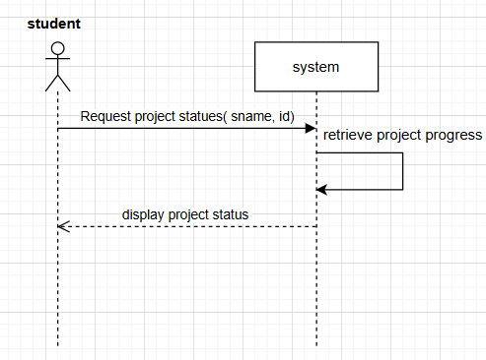

* **Assign Project to Students** (Shakir Rabbani)

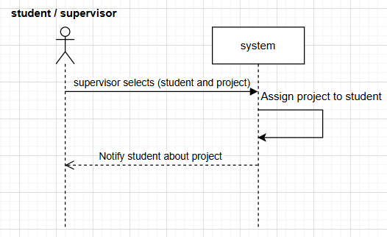

* **Review Submitted Work Product** (Shakir Rabbani)

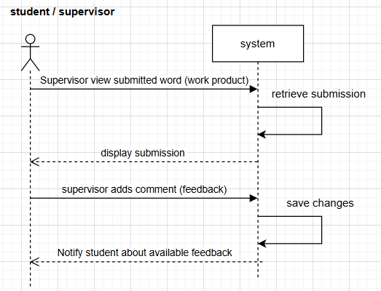

* **Assign Grades** (Shakir Rabbani)

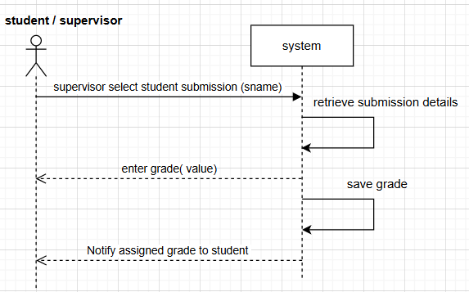

* **Approve or Reject Work Product** (Shakir Rabbani)

