# Usecase description

**1. Login/Register**

* **Actor:** Student, Supervisor, Administrator
* **Preconditions:**
  + User must have valid credentials to log in.
* **Inputs:**
  + Username/Email
  + Password
  + Role (Student, Supervisor, Administrator)
* **Main Success Scenario:**
  1. The user enters login credentials.
  2. The system validates the credentials.
  3. If valid, the user is granted access.
* **Alternative Flow:**
  + If the credentials are incorrect, the system displays an error message.
  + If too many failed attempts occur, the account is locked.
* **Outputs:**
  + Success message upon login.
  + Error message if login fails.
* **Postconditions:**
  + The user is logged in successfully.

**2. Upload Work Product**

* **Actor:** Student
* **Preconditions:**
  + The student must be assigned a project.
* **Inputs:**
  + Work file (PDF, DOCX, ZIP)
  + Student ID
  + Project ID
* **Main Success Scenario:**
  1. The student logs in and navigates to the project submission page.
  2. The student selects and uploads a work product file.
  3. The system validates and stores the file.
  4. The system notifies the supervisor.
* **Alternative Flow:**
  + If the file format is incorrect, the system rejects the upload.
* **Outputs:**
  + Confirmation message after successful upload.
* **Postconditions:**
  + The work product is stored and accessible for review.

**3. Receive Supervisor Feedback**

* **Actor:** Student, Supervisor
* **Preconditions:**
  + A work submission must exist.
* **Inputs:**
  + Submission ID
  + Supervisor Feedback
* **Main Success Scenario:**
  1. The supervisor logs in and selects a submission.
  2. The supervisor adds feedback.
  3. The system stores the feedback and notifies the student.
  4. The student logs in to view feedback.
* **Outputs:**
  + Notification to the student.
* **Postconditions:**
  + The feedback is recorded.

**4. Manage Schedule**

* **Actor:** Student, Supervisor
* **Preconditions:**
  + The project must have deadlines assigned.
* **Inputs:**
  + Project ID
  + Task Schedule
* **Main Success Scenario:**
  + The user logs in and accesses the schedule.
  + The user adds or updates scheduled tasks.
* **Outputs:**
  + Updated project schedule.
* **Postconditions:**
  + The updated schedule is stored.

**5.** **Submit Project Versions**

* **Actor:** Student
* **Preconditions:**
  + A project must exist.
* **Inputs:**
  + Updated work file
* **Main Success Scenario:**
  1. The student logs in and selects a project.
  2. The student uploads a new version.
  3. The system increments the version number.
* **Outputs:**
  + Confirmation message.
* **Postconditions:**
  + The submission is stored.

# System sequence diagram

1. Login

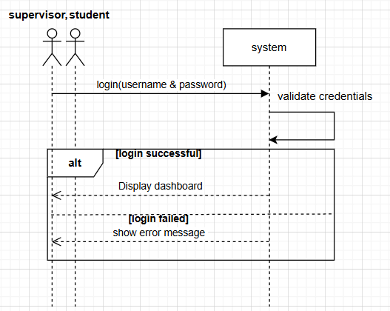

1. Upload Work Submission

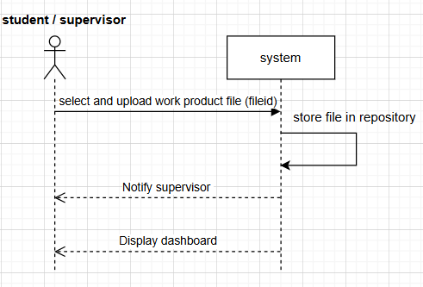

1. Receive Supervisor Feedback

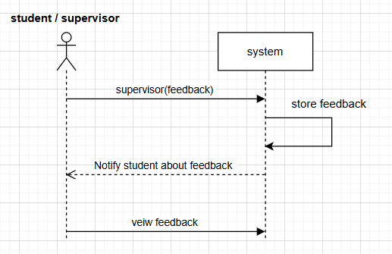

1. Manage Schedule

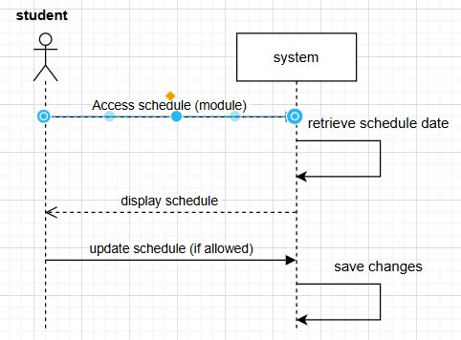

1. Submit Project Version

