

|  |  |  |  |  |  |  |  |  |
| --- | --- | --- | --- | --- | --- | --- | --- | --- |
|  | | | | | | | | |
|  | | **Project Plan** | | | | |  | |
|  |  | | | | | | |  |
|  | | | |  |  | | | |
|  | | | | **University Project Management System** |  | | | |
|  | | | | Group Members  Inam karim 04072212031  **Software Construction (CS-322)**  Submitted to:  **DR. ONAIZA MAQBOOL** |  | | | |
|  | | |  | | |  | | |

**QUAID-I-AZAM UNIVERSITY ISLAMABAD**

**DEPARTMENT OF COMPUTER SCIENCE**

This is to clarify that the semester project entitled as

**UNIVERSITY PROJECT MANAGEMENT SYSTEM**

Is the Bonafide record of semester project work done by

**INAM KARIM**

**SHAKIR RABBANI (team lead)**

**AFTAB SHABAN**

**of BSCS during Spring-2025**

**__________________ ___________________**

Supervisor Head of Department

**Declaration**

We affirm that this Semester project entitled as University Project Management being submitted in fulfillment for the award of 5th semester of **bachelor’s in computer science** is the original work carried out by us.

___________ ___________ _____________

Inam Karim Shakir Rabbani Aftab Shaban

**Preface**

The Department of Computer Science requires a management system to streamline the final semester project process. This project will manage project registrations, facilitate communication between students and supervisors, and provide a structured platform for document submissions and feedback.

The intended users of this project documentation are the faculty members and administrative staff overseeing final semester projects, as well as technical personnel responsible for maintaining the system.

**Table of Contents**

1. Project Overview 4

a. Case study 4

2. Usecase description 4

1. View Project Versions 4

2. List of Students 4

3. Manage Users 4

4. Manage Notifications 5

5. Define Project Deadlines 5

3. System sequence diagram 6

4. Data Dictionary 8

1. **Project Overview**
2. **Case study**

The Department of Computer Science wants to develop a project management system. Every semester, the department offers projects to final semester students. These projects are registered by students with supervisors. This project deals with communication between a student and supervisor during the project. It allows all projects to be loaded and supervisors to be defined. Subsequently, throughout the semester, the website can be used for uploading work products (by student) and feedback (by supervisor). The website allows multiple versions of a single work product to be submitted.

# Usecase description

## View Project Versions

* **Actor:** Student, Supervisor
* **Preconditions:**
  + The student must have submitted at least one version.
* **Inputs:**
  + Project ID
* **Main Success Scenario:**
* Supervisor requests project versions.
* System retrieves versions.
* System displays project versions.
* **Outputs:**
  + List of project versions.

## List of Students

* **Actor:** Supervisor
* **Preconditions:**
  + Students must be registered.
* **Inputs:**
  + Supervisor ID
* **Main Success Scenario:**
* Administrator requests student list.
* System retrieves the list.
* System displays student details.
* **Outputs:**
  + List of students.

## Manage Users

* **Actor:** Administrator
* **Preconditions:**
  + Admin privileges required.
* **Inputs:**
  + User details
* **Main Success Scenario:**
  + The admin adds or modifies user accounts.
  + System updates user records.
  + System confirms the update.
* **Outputs:**
  + Confirmation message.

## Manage Notifications

* **Actor:** System
* **Preconditions:**
  + A relevant event occurs.
* **Inputs:**
  + Notification Type
* **Main Success Scenario:**
* Administrator selects notification settings.
* Administrator updates notification settings.
* System stores changes.
* System displays confirmation
* **Outputs:**
  + Notification sent.

## Define Project Deadlines

* **Actor:** Supervisor
* **Preconditions:**
  + The project must be registered.
* **Inputs:**
  + Deadline Date
* **Main Success Scenario:**
  + Administrator selects project deadlines.
  + Administrator sets new deadlines.
  + System stores deadlines.
  + System notifies students and supervisors.
* **Outputs:**
  + Deadline notification

# System sequence diagram

1. View Project Versions

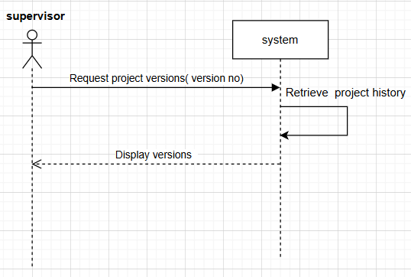

1. List of Students

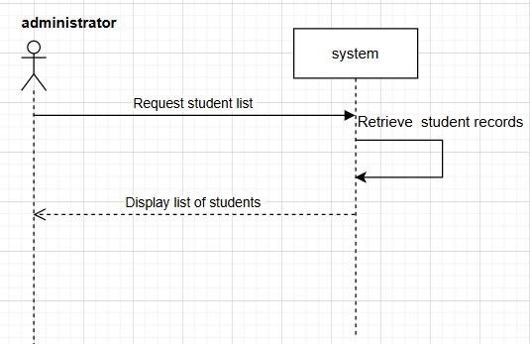

1. Manage Users

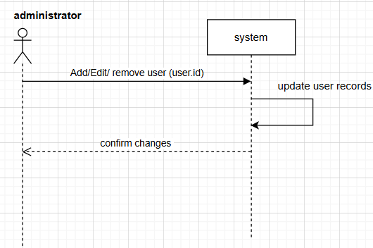

1. Manage Notifications

1. Define Project Deadlines

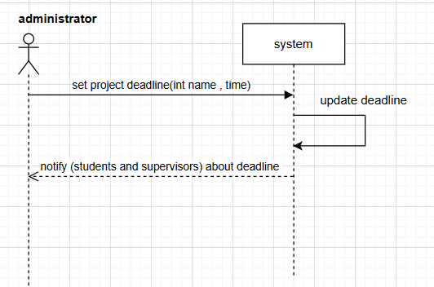

# Data Dictionary

1. **View Project Versions**

|  |  |  |  |  |
| --- | --- | --- | --- | --- |
| **Field Name** | **Description** | **Data Type** | **Length** | **Conditions** |
| version_id | Unique ID for project version | INT | 10 | Primary Key, Auto-increment |
| submission_id | ID of the work submission | INT | 10 | Foreign Key (References submissions table) |
| version_number | Version number | INT | 3 | Default: 1, Must be ≥ 1 |
| file_path | Location of the uploaded version | STRING | 255 | Cannot be NULL |
| upload_date | Date and time of version submission | DATETIME | N/A | Must follow 'YYYY-MM-DD HH:MM:SS' format |

1. **List of Students**

|  |  |  |  |  |
| --- | --- | --- | --- | --- |
| **Field Name** | **Description** | **Data Type** | **Length** | **Conditions** |
| student_id | Unique ID for the student | INT | 10 | Primary Key, Auto-increment |
| name | Student's full name | STRING | 100 | Cannot be NULL |
| email | Student's email address | STRING | 100 | Must be a valid email format |
| registration_number | Student's university registration number | STRING | 20 | Must be unique |
| assigned_project_id | ID of the assigned project | INT | 10 | Foreign Key (References projects table) |

1. **Manage Users**

|  |  |  |  |  |
| --- | --- | --- | --- | --- |
| **Field Name** | **Description** | **Data Type** | **Length** | **Conditions** |
| user_id | Unique identifier for each user | INT | 10 | Primary Key, Auto-increment |
| username | User's login name | STRING | 50 | Must be unique |
| email | User's email address | STRING | 100 | Must be a valid email format |
| password | User's encrypted password | STRING | 255 | Must be hashed |
| role | User role (Student, Supervisor, Admin) | ENUM | N/A | Values: 'Student', 'Supervisor', 'Admin' |
| status | Account status | ENUM | N/A | Values: 'Active', 'Inactive' |

1. **Manage Notifications**

|  |  |  |  |  |
| --- | --- | --- | --- | --- |
| **Field Name** | **Description** | **Data Type** | **Length** | **Conditions** |
| notification_id | Unique ID for notification | INT | 10 | Primary Key, Auto-increment |
| user_id | ID of the recipient | INT | 10 | Foreign Key (References users table) |
| message | Notification content | STRING | N/A | Cannot be NULL |
| status | Notification status | ENUM | N/A | Values: 'Unread', 'Read' |
| timestamp | Date and time of notification | DATETIME | N/A | Must follow 'YYYY-MM-DD HH:MM:SS' format |

1. **Define Project Deadlines**

|  |  |  |  |  |
| --- | --- | --- | --- | --- |
| **Field Name** | **Description** | **Data Type** | **Length** | **Conditions** |
| deadline_id | Unique ID for project deadline | INT | 10 | Primary Key, Auto-increment |
| project_id | ID of the assigned project | INT | 10 | Foreign Key (References projects table) |
| deadline_date | Submission deadline | DATE | N/A | Must follow 'YYYY-MM-DD' format |
| description | Details about the deadline | STRING | 255 | Optional field |