Shakir Ali

100268078

CPSC 1150 assignment 2

1.

a. (A’B’C’) + (A’BC’) + (AB’C’)

b. C’(A’B’+A’B+AB’) = C’(A’(B’+ B)+AB’) = C’(A’+AB’)

Distributive Distributive Identity

c.

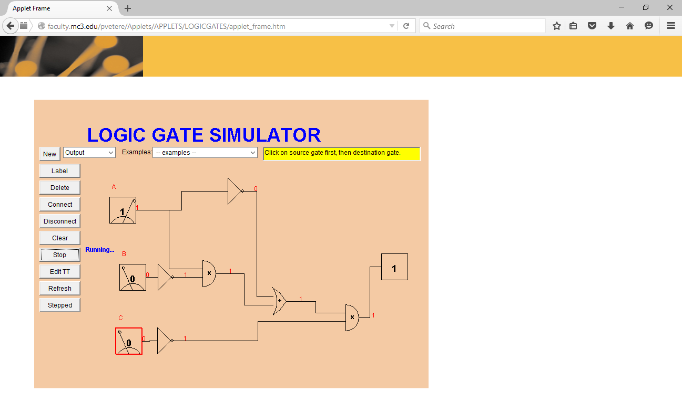

d. It would take 3 for nots, 6 for ands, and 3 for ors so 12 transistors

It would take 7 for nots + 18 for ands + 6 for ors so 31 transistors for original circuit

3.

b.

|  |  |  |  |
| --- | --- | --- | --- |
|  | Computer System i | Computer System ii | Which component is better and why? |
| CPU Type and Speed (Benchmark value) | Dual Core 64-bit 2.66 Ghz | Dual Core 64-bit 1.6 Ghz | System 1 is better because much faster than 2nd |
| Amount of RAM | 4GB @ 800Mhz | 2GB @ 1066 Mhz | System 1 is better if we consider the Amount of RAM |
| HDD Capacity | 500GB @ 5400RPM | 320 GB @ 5400RPM | System 1 is better because larger size |
| Graphics Card | 512MB ATI Mobility Radeon Graphic | Integrated Intel HD | System 1 is better because dedicated GPU |
|  |  |  |  |
| Monitor Size and Resolution | 15.6"  @ 1366 x 768 | 14 “ @ 1366 x 768 | System 1 is better because larger display |
| Weight | 5.6lbs | 5.07 lbs | System 2 because it is lighter |
|  |  |  |  |
| Total System Cost | $300 | $299.99 | System 2 because it is 0.01 $ cheaper |

c. I would go with System 1 because apart from more compatible, similar weight class and almost same price, it has a much faster processor and dedicated GPU.