

The Experiment Report of
Deep Learning

College: Software Engineering
Subject: Deep Learning
E-mail: shakirfr7@icloud.com
Tutor: Ming Kui tan
Date-submitted:2017.12.30
1. Topic: Logistic Regression, Linear Classification and stochastic gradient descent
2. Time: 25-12-2017
3. Reporter: Shakir Farukh Riaz
4. Purposes:
- Further understanding of logistic regression, linear classification and stochastic gradient decent.
- Compare and understand the relationship and difference between gradient descent and stochastic gradient descent, as well as the logistic regression and linear classification under large scale data-set.
- Understand the principles of the SVM and practice this process on large scale data.
5. Data sets and data analysis:
- a9a Data (Experiment one)
- a9a.t Data (Experiment two)

6. Experimental steps:
Experiment: 01
Logistic Regression and Stochastic Gradient Descent
- Load the training set and validation set.
- Initialize logistic regression model parameters, you can consider initializing zeros, random numbers or normal distribution.
- Select the loss function and calculate its derivation.
- Calculate gradient toward loss function from partial samples.
- Update model parameters using different optimized methods(NAG，RMSProp，AdaDelta and Adam).
- Select the appropriate threshold, mark the sample whose predict scores greater than the threshold as positive, on the contrary as negative. Predict under validation set and get the different optimized method loss.
- Repeat step 4 to 6 for several times, and drawing graph of different output methods and with the number of iterations.
Experiment: 02
Linear Classification and Stochastic Gradient Descent
- Load the training set and validation set.
- Initialize SVM model parameters, you can consider initializing zeros, random numbers or normal distribution.
- Select the loss function and calculate its derivation, find more detail in PPT.
- Calculate gradient toward loss function from partial samples.
- Update model parameters using different optimized methods(NAG，RMSProp，AdaDelta and Adam).
- Select the appropriate threshold, mark the sample whose predict scores greater than the threshold as positive, on the contrary as negative. Predict under validation set and get the different optimized method loss ，， and .
- Repeat step 4 to 6 for several times, and drawing graph of different methods and with the number of iterations.
8. Selection of validation (hold-out, cross-validation, k-folds cross-validation, etc.):
9. The initialization method of model parameters:
The SVM model is being updated by using different optimizing methods like NAG, RMSProp, AdaDelta and Adam.
10. The selected loss function and its derivatives:
11. Experimental results and curve
Linear regression:
import numpyfrom collections import defaultdict
In聽[2]:
class Model(object):
def __init__(self, n_features):
self.params = numpy.random.random(size=(n_features, 1))
self.diffs = numpy.zeros((n_features, 1))
self.recorder = defaultdict(list)

def train(self, X, y):
pass

def validate(self, X, y):
self.__loss__(X, y, "validation")

def predict(self, X):
pass

def __calculate_gradient__(self, params=None):
pass

def __loss__(self, X, y, key):
pass
In聽[3]:
class SVMClassifier(Model):
def __init__(self, n_features, C):
super(SVMClassifier, self).__init__(n_features=n_features)
self.C = C
self.X_train = None
self.y_train = None

def train(self, X, y):
self.X_train = X
self.y_train = y

def predict(self, X):
return numpy.where(numpy.dot(X, self.params) > 0, 1, -1)

def __calculate_gradient__(self, params=None):
if params is None:
params = self.params
h = 1 - self.y_train * numpy.dot(self.X_train, params)
y_mask = numpy.where(h > 0, self.y_train, 0)
self.diffs = params - self.C * numpy.dot(self.X_train.transpose(), y_mask)

def __loss__(self, X, y, key):
loss = numpy.sum(self.params * self.params) \
+ self.C * numpy.sum(numpy.maximum(1 - y * numpy.dot(X, self.params), 0))
self.recorder[key].append(loss)
In聽[4]:
class Optimizer(object):
def __init__(self, model):
self.model = model
self.color = None

def step(self):
pass
In聽[5]:
class SGD(Optimizer):
def __init__(self, model, learning_rate, momentum=None):
super(SGD, self).__init__(model=model)
self.color = "r"
self.learning_rate = learning_rate
self.momentum = momentum
if momentum is not None:
self.v = numpy.zeros_like(self.model.diffs)

def step(self):
self.model.__calculate_gradient__()
if self.momentum is None:
self.model.params -= self.learning_rate * self.model.diffs
else:
self.v = self.momentum * self.v + self.learning_rate * self.model.diffs
self.model.params -= self.v
In聽[6]:
class NAG(Optimizer):
def __init__(self, model, learning_rate, momentum):
super(NAG, self).__init__(model=model)
self.color = "y"
self.learning_rate = learning_rate
self.momentum = momentum
self.v = numpy.zeros_like(self.model.diffs)

def step(self):
self.model.__calculate_gradient__(params=self.model.params - self.momentum * self.v)
self.v = self.momentum * self.v + self.learning_rate * self.model.diffs
self.model.params -= self.v
In聽[7]:
class RMSProP(Optimizer):
def __init__(self, model, leaning_rate, weight_decay):
self.color = "c"
super(RMSProP, self).__init__(model=model)
self.G = numpy.zeros_like(self.model.diffs)
self.learning_rate = leaning_rate
self.weight_decay = weight_decay
self.epsilon = 1e-8

def step(self):
self.model.__calculate_gradient__()
self.G = self.weight_decay * self.G + (1 - self.weight_decay) * self.model.diffs * self.model.diffs
self.model.params -= self.learning_rate / numpy.sqrt(self.G + self.epsilon) * self.model.diffs
In聽[8]:
class AdaDelta(Optimizer):
def __init__(self, model, gamma):
super(AdaDelta, self).__init__(model=model)
self.color = "b"
self.gamma = gamma
self.G = numpy.zeros_like(self.model.diffs)
self.delta = numpy.zeros_like(self.model.diffs)
self.delta_theta = numpy.zeros_like(self.model.diffs)
self.epsilon = 1e-4

def step(self):
self.model.__calculate_gradient__()
self.G = self.gamma * self.G + (1 - self.gamma) * self.model.diffs * self.model.diffs
self.delta_theta = -(numpy.sqrt(self.delta + self.epsilon)
/ numpy.sqrt(self.G + self.epsilon)) * self.model.diffs
self.model.params += self.delta_theta
self.delta = self.gamma * self.delta + (1 - self.gamma) * self.delta_theta * self.delta_theta
In聽[9]:
class Adam(Optimizer):
def __init__(self, model, beta, gamma, eta):
super(Adam, self).__init__(model=model)
self.color = "m"
self.beta = beta
self.gamma = gamma
self.eta = eta
self.m = numpy.zeros_like(self.model.diffs)
self.G = numpy.zeros_like(self.model.diffs)
self.epsilon = 1e-8

def step(self):
self.model.__calculate_gradient__()
self.m = self.beta * self.m + (1 - self.beta) * self.model.diffs
self.G = self.gamma * self.G + (1 - self.gamma) * self.model.diffs * self.model.diffs
alpha = self.eta * (numpy.sqrt(1 - self.gamma)) / (1 - self.beta)
self.model.params -= alpha * self.m / numpy.sqrt(self.G + self.epsilon)
In聽[10]:
import requests
train_set = requests.get("https://www.csie.ntu.edu.tw/~cjlin/libsvmtools/datasets/binary/a9a")validation_set = requests.get("https://www.csie.ntu.edu.tw/~cjlin/libsvmtools/datasets/binary/a9a.t")
In聽[11]:
from io import BytesIOfrom sklearn.datasets import load_svmlight_file
X_train, y_train = load_svmlight_file(BytesIO(train_set.content), n_features=123)X_val, y_val = load_svmlight_file(BytesIO(validation_set.content), n_features=123)X_train = X_train.toarray()X_val = X_val.toarray()
In聽[12]:
n_samples_train, n_features_train = X_train.shapeX_train = numpy.concatenate((X_train, numpy.ones(shape=(n_samples_train, 1))), axis=1)y_train = y_train.reshape((n_samples_train, 1))
n_samples_val, n_features_val = X_val.shapeX_val = numpy.concatenate((X_val, numpy.ones(shape=(n_samples_val, 1))), axis=1)y_val = y_val.reshape((n_samples_val, 1))
In聽[13]:
optimizers = [
SGD(model=SVMClassifier(n_features=123 + 1, C=1), learning_rate=0.00001, momentum=0.5),
NAG(model=SVMClassifier(n_features=123 + 1, C=1), learning_rate=0.0001, momentum=0.9),
RMSProP(model=SVMClassifier(n_features=123 + 1,C=1),leaning_rate=0.1,weight_decay=0.9),
AdaDelta(model=SVMClassifier(n_features=123 + 1,C=1), gamma=0.95),
Adam(model=SVMClassifier(n_features=123 + 1,C=1),beta=0.9,gamma=0.999,eta=0.1)]
In聽[14]:
max_epoch = 100batch_size = 10000for epoch in range(max_epoch):
indexes = numpy.random.randint(0, n_samples_train, size=batch_size)
for optimizer in optimizers:
optimizer.model.train(X_train[indexes], y_train[indexes])
optimizer.step()
optimizer.model.validate(X_val, y_val)
from sklearn.metrics import classification_report
print("-" * 20 + optimizers[0].model.__class__.__name__ + "-" * 20)for optimizer in optimizers:
print("-" * 24 + optimizer.__class__.__name__ + "-" * 24)
print(classification_report(y_val,
optimizer.model.predict(X_val),
target_names=["positive", "negative"],
digits=3))
--------------------SVMClassifier--------------------
------------------------SGD------------------------
precision recall f1-score support

positive 0.866 0.920 0.892 12435
negative 0.676 0.538 0.599 3846

avg / total 0.821 0.830 0.823 16281

------------------------NAG------------------------
precision recall f1-score support

positive 0.863 0.950 0.904 12435
negative 0.759 0.514 0.613 3846

avg / total 0.839 0.847 0.836 16281
------------------------RMSProP------------------------
precision recall f1-score support
positive 0.920 0.849 0.883 12435
negative 0.609 0.760 0.676 3846
avg / total 0.846 0.828 0.834 16281

------------------------AdaDelta------------------------
precision recall f1-score support
positive 0.872 0.935 0.902 12435
negative 0.726 0.556 0.630 3846
avg / total 0.838 0.846 0.838 16281

------------------------Adam------------------------
precision recall f1-score support
positive 0.879 0.929 0.903 12435
negative 0.719 0.585 0.645 3846
avg / total 0.841 0.848 0.842 16281
In聽[15]:
import matplotlib.pyplot as plt%matplotlib inlineplt.figure(figsize=(16,9))plt.xlabel("epoch")plt.ylabel("loss")plt.title(optimizers[0].model.__class__.__name__)for optimizer in optimizers:
plt.plot(optimizer.model.recorder["validation"], color=optimizer.color, label=optimizer.__class__.__name__)plt.legend()plt.show(

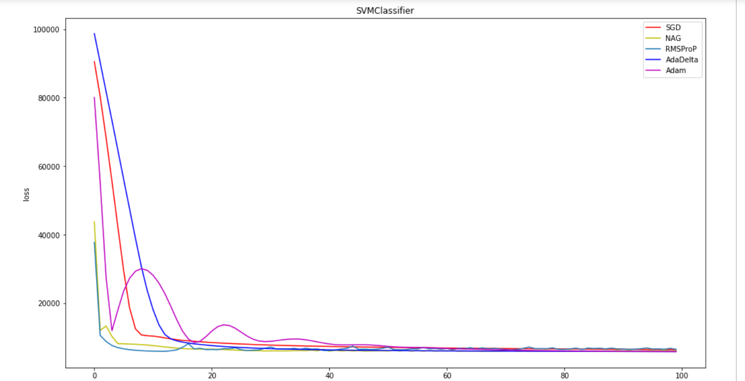
Logistic Regression:
port numpyfrom collections import defaultdict
In聽[2]:
class Model(object):
def __init__(self, n_features):
self.params = numpy.random.random(size=(n_features, 1))
self.diffs = numpy.zeros((n_features, 1))
self.recorder = defaultdict(list)

def train(self, X, y):
pass

def validate(self, X, y):
self.__loss__(X, y, "validation")

def predict(self, X):
pass

def __calculate_gradient__(self, params=None):
pass

def __loss__(self, X, y, key):
pass
In聽[3]:
class LogisticRegressionClassifier(Model):
def __init__(self, n_features):
super(LogisticRegressionClassifier, self).__init__(n_features=n_features)
self.X_train = None
self.y_train = None

def train(self, X, y):
self.X_train = X
self.y_train = y

def predict(self, X):
return numpy.where(numpy.dot(X, self.params) > 0, 1, 0)

def __calculate_gradient__(self, params=None):
if params is None:
params = self.params
y_hat = 1 / (1 + numpy.exp(-numpy.dot(self.X_train, params)))
self.diffs = numpy.dot(self.X_train.transpose(), (y_hat - self.y_train))

def __loss__(self, X, y, key):
y_hat = 1 / (1 + numpy.exp(-numpy.dot(X, self.params)))
loss = -numpy.average(y * numpy.log(y_hat) + (1 - y) * numpy.log(1 - y_hat))
self.recorder[key].append(loss)
In聽[4]:
class Optimizer(object):
def __init__(self, model):
self.model = model
self.color = None

def step(self):
pass
In聽[5]:
class SGD(Optimizer):
def __init__(self, model, learning_rate, momentum=None):
super(SGD, self).__init__(model=model)
self.color = "r"
self.learning_rate = learning_rate
self.momentum = momentum
if momentum is not None:
self.v = numpy.zeros_like(self.model.diffs)

def step(self):
self.model.__calculate_gradient__()
if self.momentum is None:
self.model.params -= self.learning_rate * self.model.diffs
else:
self.v = self.momentum * self.v + self.learning_rate * self.model.diffs
self.model.params -= self.v
In聽[6]:
class NAG(Optimizer):
def __init__(self, model, learning_rate, momentum):
super(NAG, self).__init__(model=model)
self.color = "y"
self.learning_rate = learning_rate
self.momentum = momentum
self.v = numpy.zeros_like(self.model.diffs)

def step(self):
self.model.__calculate_gradient__(params=self.model.params - self.momentum * self.v)
self.v = self.momentum * self.v + self.learning_rate * self.model.diffs
self.model.params -= self.v
In聽[7]:
class RMSProP(Optimizer):
def __init__(self, model, leaning_rate, weight_decay):
self.color = "c"
super(RMSProP, self).__init__(model=model)
self.G = numpy.zeros_like(self.model.diffs)
self.learning_rate = leaning_rate
self.weight_decay = weight_decay
self.epsilon = 1e-8

def step(self):
self.model.__calculate_gradient__()
self.G = self.weight_decay * self.G + (1 - self.weight_decay) * self.model.diffs * self.model.diffs
self.model.params -= self.learning_rate / numpy.sqrt(self.G + self.epsilon) * self.model.diffs
In聽[8]:
class AdaDelta(Optimizer):
def __init__(self, model, gamma):
super(AdaDelta, self).__init__(model=model)
self.color = "b"
self.gamma = gamma
self.G = numpy.zeros_like(self.model.diffs)
self.delta = numpy.zeros_like(self.model.diffs)
self.delta_theta = numpy.zeros_like(self.model.diffs)
self.epsilon = 1e-4

def step(self):
self.model.__calculate_gradient__()
self.G = self.gamma * self.G + (1 - self.gamma) * self.model.diffs * self.model.diffs
self.delta_theta = -(numpy.sqrt(self.delta + self.epsilon)
/ numpy.sqrt(self.G + self.epsilon)) * self.model.diffs
self.model.params += self.delta_theta
self.delta = self.gamma * self.delta + (1 - self.gamma) * self.delta_theta * self.delta_theta
In聽[9]:
class Adam(Optimizer):
def __init__(self, model, beta, gamma, eta):
super(Adam, self).__init__(model=model)
self.color = "m"
self.beta = beta
self.gamma = gamma
self.eta = eta
self.m = numpy.zeros_like(self.model.diffs)
self.G = numpy.zeros_like(self.model.diffs)
self.epsilon = 1e-8

def step(self):
self.model.__calculate_gradient__()
self.m = self.beta * self.m + (1 - self.beta) * self.model.diffs
self.G = self.gamma * self.G + (1 - self.gamma) * self.model.diffs * self.model.diffs
alpha = self.eta * (numpy.sqrt(1 - self.gamma)) / (1 - self.beta)
self.model.params -= alpha * self.m / numpy.sqrt(self.G + self.epsilon)
In聽[10]:
import requests
train_set = requests.get("https://www.csie.ntu.edu.tw/~cjlin/libsvmtools/datasets/binary/a9a")validation_set = requests.get("https://www.csie.ntu.edu.tw/~cjlin/libsvmtools/datasets/binary/a9a.t")
In聽[11]:
from io import BytesIOfrom sklearn.datasets import load_svmlight_file
X_train, y_train = load_svmlight_file(BytesIO(train_set.content), n_features=123)X_val, y_val = load_svmlight_file(BytesIO(validation_set.content), n_features=123)X_train = X_train.toarray()X_val = X_val.toarray()
In聽[12]:
n_samples_train, n_features_train = X_train.shapeX_train = numpy.concatenate((X_train, numpy.ones(shape=(n_samples_train, 1))), axis=1)y_train = y_train.reshape((n_samples_train, 1))
n_samples_val, n_features_val = X_val.shapeX_val = numpy.concatenate((X_val, numpy.ones(shape=(n_samples_val, 1))), axis=1)y_val = y_val.reshape((n_samples_val, 1))
In聽[13]:
y_train = numpy.where(y_train == -1, 0, y_train)y_val = numpy.where(y_val == -1, 0, y_val)optimizers = [
SGD(model=LogisticRegressionClassifier(n_features=123 + 1), learning_rate=0.00001, momentum=0.5),
NAG(model=LogisticRegressionClassifier(n_features=123 + 1), learning_rate=0.00001, momentum=0.5),
RMSProP(model=LogisticRegressionClassifier(n_features=123 + 1), leaning_rate=0.1, weight_decay=0.9),
AdaDelta(model=LogisticRegressionClassifier(n_features=123 + 1), gamma=0.95),
Adam(model=LogisticRegressionClassifier(n_features=123 + 1), beta=0.9, gamma=0.999, eta=0.1)]
In聽[14]:
max_epoch = 100batch_size = 10000for epoch in range(max_epoch):
indexes = numpy.random.randint(0, n_samples_train, size=batch_size)
for optimizer in optimizers:
optimizer.model.train(X_train[indexes], y_train[indexes])
optimizer.step()
optimizer.model.validate(X_val, y_val)
from sklearn.metrics import classification_report
print("-" * 20 + optimizers[0].model.__class__.__name__ + "-" * 20)for optimizer in optimizers:
print("-" * 24 + optimizer.__class__.__name__ + "-" * 24)
print(classification_report(y_val,
optimizer.model.predict(X_val),
target_names=["positive", "negative"],
digits=3))
--------------------LogisticRegressionClassifier--------------------
------------------------SGD------------------------
precision recall f1-score support

positive 0.854 0.922 0.887 12435
negative 0.661 0.492 0.564 3846

avg / total 0.809 0.820 0.811 16281

------------------------NAG------------------------
precision recall f1-score support

positive 0.847 0.918 0.881 12435
negative 0.636 0.465 0.537 3846

avg / total 0.797 0.811 0.800 16281

------------------------RMSProP-----------------------
precision recall f1-score support
positive 0.840 0.971 0.901 12435
negative 0.811 0.404 0.539 3846
avg / total 0.833 0.837 0.815 16281

------------------------AdaDelta------------------------
precision recall f1-score support
positive 0.870 0.937 0.902 12435
negative 0.729 0.549 0.626 3846
avg / total 0.837 0.845 0.837 16281

------------------------Adam-----------------------
precision recall f1-score support
positive 0.879 0.930 0.904 12435
negative 0.723 0.587 0.648 3846
avg / total 0.842 0.849 0.843 16281
In聽[15]:
import matplotlib.pyplot as plt%matplotlib inlineplt.figure(figsize=(16,9))plt.xlabel("epoch")plt.ylabel("loss")plt.title(optimizers[0].model.__class__.__name__)for optimizer in optimizers:
plt.plot(optimizer.model.recorder["validation"], color=optimizer.color, label=optimizer.__class__.__name__)plt.legend()plt.show()
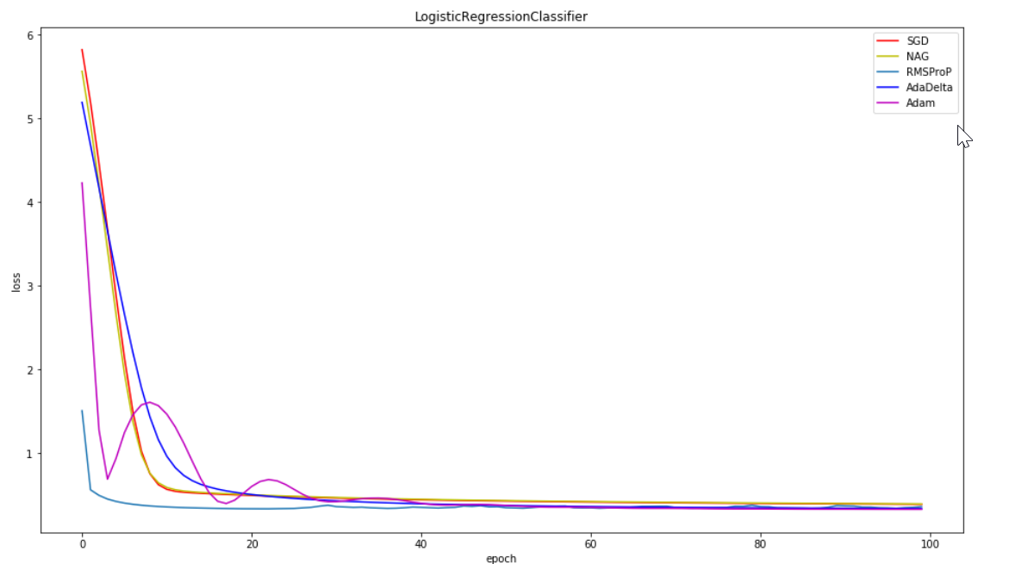

- Results analysis:
For second experiment the estimated updated methods have different curves at different , which indicates its SVM gradient descent and at different values:
max_epoch = 100
batch_size = 10000
13. Similarities and differences between logistic regression and linear classification:
The logistic regression is called as a linear classifier because it produces a decision boundary which is linear in nature. So, the classification makes by logistic regression is linear classification only.
Regression: given a set of data, find the best relationship that represents the set of data.
Classification: given a known relationship, identify the class that the data belongs to.
We can see that regression and classification start from opposing ends: to find a pattern or to find the pattern that it belongs to.
14. Summary:
Logistic regression measures the relationship between the categorical dependent variable and one or more independent variables by estimating probabilities using a logistic function, which is the cumulative logistic distribution. Thus, it treats the same set of problems as prohibit regression using similar techniques, with the latter using a cumulative normal distribution curve instead.
A linear classifier achieves this by making a classification decision based on the value of a linear combination of the characteristics. An object's characteristics are also known as feature values and are typically presented to the machine in a vector called a feature vector.
Classification problems try to determine group membership by deriving probabilities. The first technique ever used was linear discriminant analysis (LDA), proposed by Sir R.A. Fisher in 1936—he used to classify irises. I do not understand it fully, but believe that it used linear regression to derive probabilities for each group, and then used a Mahalanobis distance measure to assign to the closest group.
Classification Problems, Classification is a central topic in machine learning that has to do with teaching machines how to group together data by criteria. Classification is the process where computers group data together based on predetermined characteristics — this is called supervised learning.

