

**The Experiment Report of**

***Machine Learning***

**College Software College**

**Subject Software Engineering**

**Members Shakir Farukh Riaz**

**Student ID 201722800021**

**E-mail Shakirfr7@icloud.com**

**Tutor**   **Mr.Mingkuai**

**Date submitted**  **2017-12-08**

1. **Topic:** Linear Regression, Linear Classification and Gradient Descent.
2. **Time:** NA.
3. **Reporter:** Shakir Farukh Riaz.
4. **Purposes:** Realize the process of optimization and adjusting parameters.
5. **Data sets and data analysis:** Housing in LIBSVM Data, Australian in LIBSVM Data.
6. **Experimental steps:**

* **Linear Regression and Gradient Descent:**

1. Load the experiment data. You can use [load_svmlight_file](http://scikit-learn.org/stable/modules/generated/sklearn.datasets.load_svmlight_file.html) function in sklearn library.
2. Divide data set, into training set and validation set using train test split function. Test set is not required in this experiment.
3. Initialize linear model parameters. You can choose to set all parameter into zero, initialize it randomly or with normal distribution.
4. Choose loss function and derivation: Find more detail in PPT.
5. Calculate gradient  toward loss function from all samples.
6. Denote the opposite direction of gradient  as .
7. Update model: .  is learning rate, a hyper-parameter that we can adjust.
8. Get the loss  under the training set and  by validating under validation set.
9. Repeat step 5 to 8 for several times, and **drawing graph of  as well as  with the number of iterations**.

* **Linear Classification and Gradient Descent:**

1. Load the experiment data.
2. Divide data set into training set and validation set.
3. Initialize SVM model parameters. You can choose to set all parameter into zero, initialize it randomly or with normal distribution.
4. Choose loss function and derivation: Find more detail in PPT.
5. Calculate gradient  toward loss function from all samples.
6. Denote the opposite direction of gradient  as .
7. Update model: .  is learning rate, a hyper-parameter that we can adjust.
8. ****Select the appropriate threshold, mark the sample whose predict scores greater than the threshold as positive, on the contrary as negative.**** Get the loss  under the train set and  by validating under validation set.
9. Repeat step 5 to 8 for several times, and ****drawing graph of  as well as  with the number of iterations****.

**7. Code:**(Fill in the contents of 8-12 respectively for linear regression and linear classification)

1. **Selection of validation (hold-out, cross-validation, k-folds cross-validation, etc.):**

* Cross-validation was used to validate the experiment.

1. **The initialization method of model parameters:**

* Method of model parameter used = Set to zeros

1. **The selected loss function and its derivatives:**

* **Loss:**
* **Derivative:**

1. **Experimental results and curve:**

Hyper-parameter selection (η, epoch, etc.):

Assessment Results (based on selected validation):

Predicted Results (Best Results):

Loss curve:

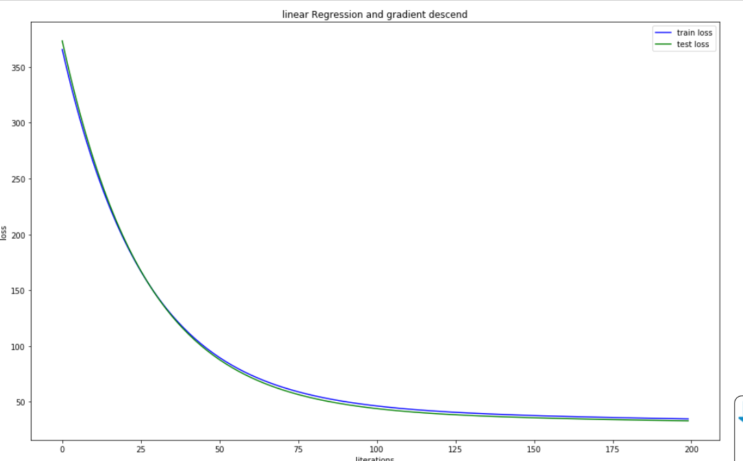

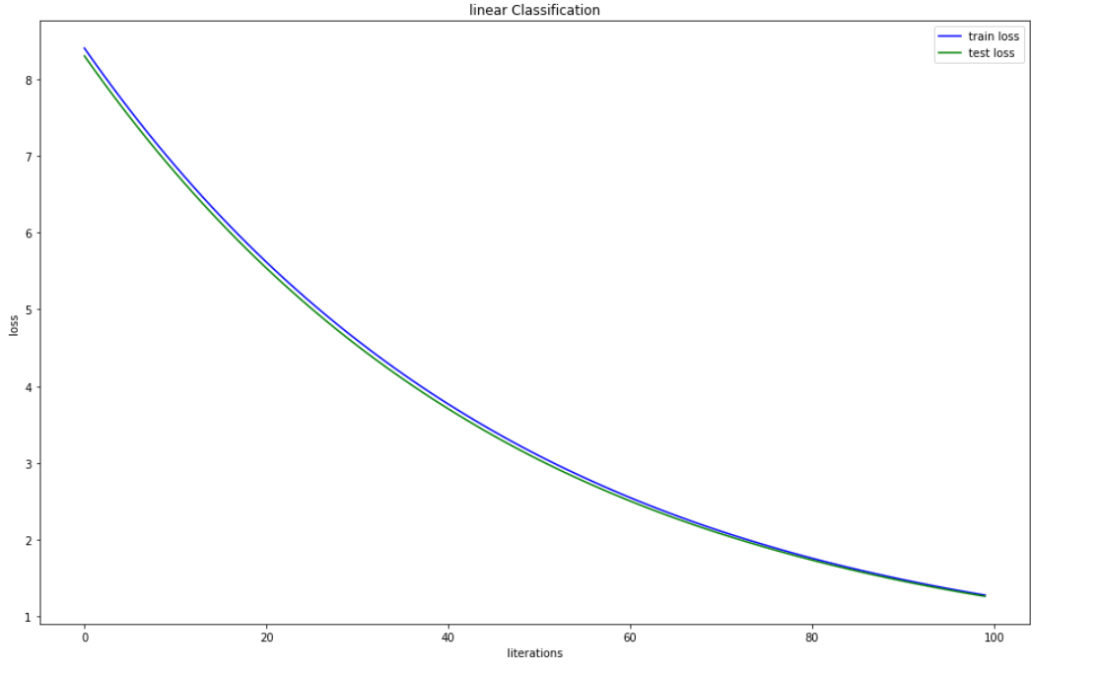

1. **Results analysis:**

The train curve is very similar to the test curve.

1. **Similarities and differences between linear regression and linear classification:**

Regression is continuous, the classification is discrete, which is the difference. The similarity is that all are classified.

1. **Summary: I have got lots in this experiment,thanks to the teacher**