**Installation Document for File system**  
  
Software required:  
  
1. Postgresql 13.5  
2. Python 3.10.0  
3. Django  
  
Steps:  
  
SQL ::  
  
1. Install postgres  
2. The default user will be “postgres” which is what we are using.  
3. Open pgadmin 4

4. Create db named testDB

5. Inside public schema, right click tables and open query tool

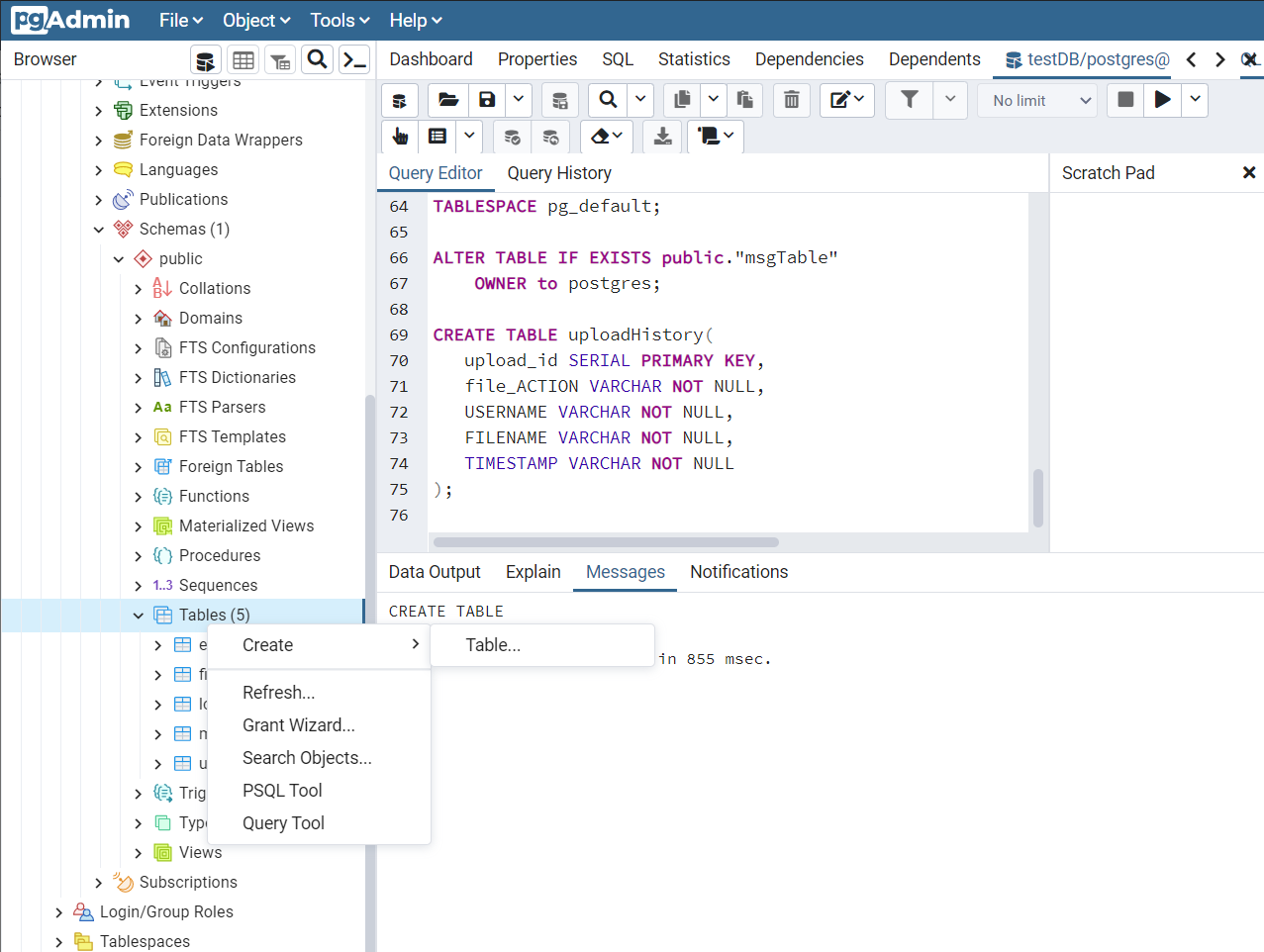

6. Paste the sql script(createTables.sql) and run to create tables  
  
7. Please ensure that every script runs smoothly.

8. From the project directory, find the password.txt file and enter your postgreSQL password  
  
  
Django Setup:  
  
1. Install the following packages in python  
  
pytest-shutil

cryptography

wsgiref

psycopg2

django-user-agents

selenium

2. Modify the file-path for the shared directory path. Please point it to an empty directory in your local computer.   
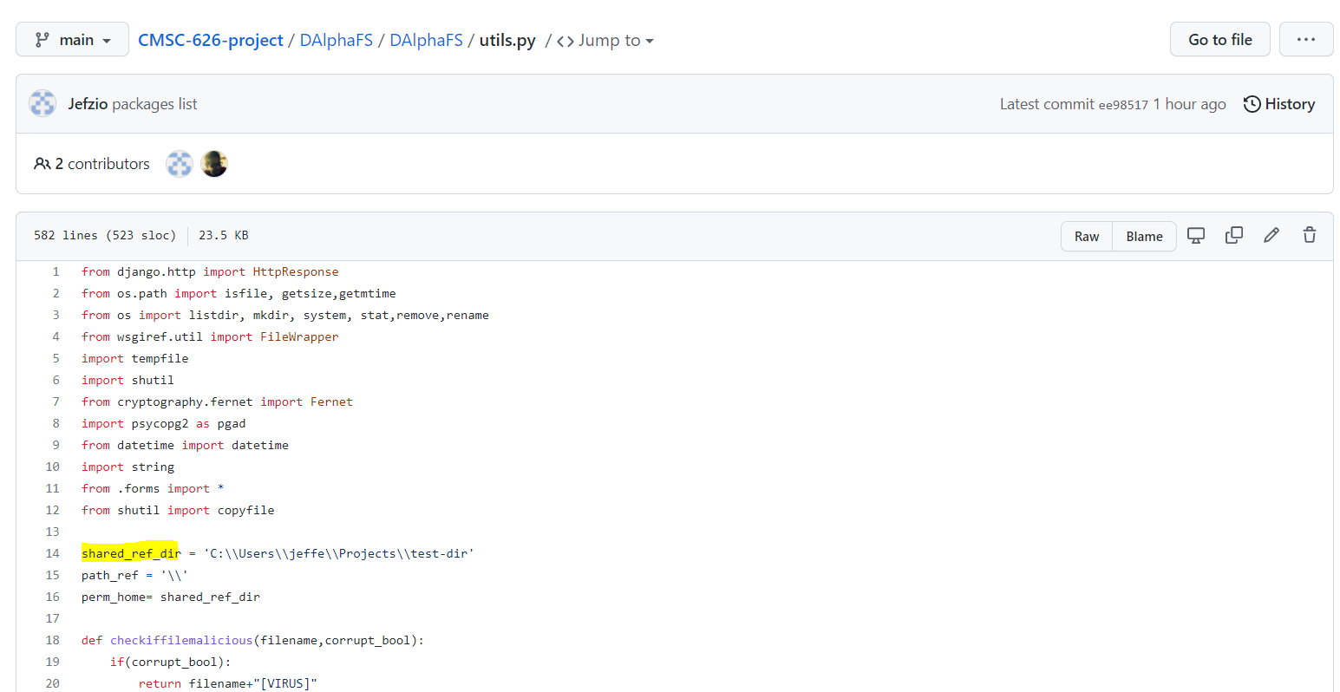  
  
3. From the project directory, find the password.txt file and enter your postgreSQL password (CMSC-626-project/DAlphaFS/password.txt)