PhishGuard AI
Intelligent Phishing Email Detection & Classification System

Member 2 — Report Sections
Dataset Description · Logistic Regression · GRU
Field | Detail
Author | Nishen Madawa
Student ID | CIT-24-01-0256
Group | Neural Nexus (Group 16)
Module | CCS3356 — Natural Language Processing
Institution | Sri Lanka Technology Campus
Models | Logistic Regression (ML) · GRU (DL)
Branch | feature/nishen_CIT-24-01-0256

1. Dataset Description

1.1 Source and composition
The dataset used throughout this project is the Phishing Email Dataset published on Kaggle by Naser Abdullah Alam, distributed under a CC-BY-SA-4.0 licence. It is not a single collection but an aggregation of six established email corpora, combined into one labelled file so that phishing detection can be studied across a range of writing styles, time periods and attack types.
Constituent corpus | Contributes
Enron | Legitimate corporate email
Ling-Spam | Academic mailing list traffic and spam
CEAS-08 | Spam and ham from a 2008 anti-spam challenge
Nazario | A curated archive of real phishing emails
Nigerian Fraud | Advance-fee fraud ("419") emails
SpamAssassin | A public spam/ham benchmark
The download provides each source corpus as a separate CSV alongside a combined file, phishing_email.csv. All work reported here uses the combined file, which is the ~82,500-email dataset described in the project brief. This distinction matters: the individual source files are far smaller and much easier to classify, so results obtained from them are not comparable to results obtained from the combined dataset.

1.2 Structure and size
The combined file contains two columns: text_combined, holding the subject line and body concatenated into a single string, and label, a binary target where 1 denotes phishing and 0 denotes legitimate. The raw file holds 82,486 rows. Three rows were removed — one with a missing value and two whose text reduced to an empty string after preprocessing — leaving 82,483 usable emails.
Property | Value
Rows in raw file | 82,486
Rows after cleaning | 82,483
Phishing (label = 1) | 42,888 (52.0%)
Legitimate (label = 0) | 39,595 (48.0%)
Mean length after preprocessing | 141.4 tokens
Median length after preprocessing | 67 tokens
Emails longer than 200 tokens | 16.3%
Training set (80%) | 65,986 emails
Test set (20%) | 16,497 emails
The class distribution is close to balanced at 52% to 48%. This is convenient — it means accuracy is a meaningful headline metric rather than a misleading one — but class weighting was still applied to both models so that neither developed a bias toward the majority class.
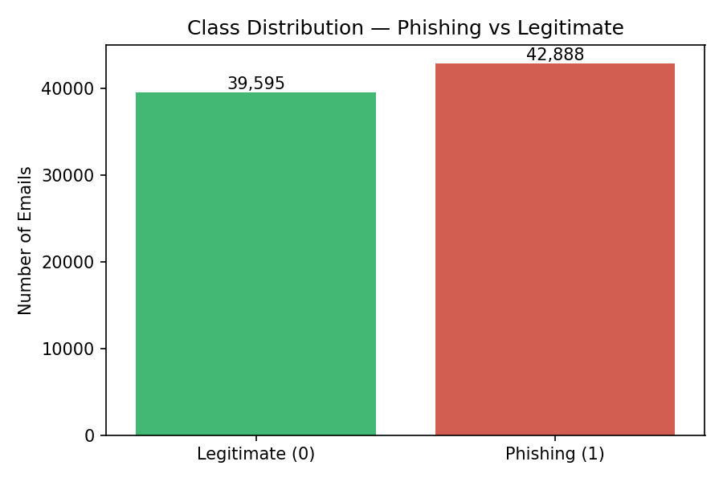
Figure 1 — Class distribution across the 82,483 emails used.
The token-length figures carry a practical consequence for the deep learning model. The median email reduces to 67 tokens after preprocessing, but the distribution has a long tail: 16.3% of emails exceed 200 tokens. Since sequences were padded and truncated to a fixed length of 200, roughly one email in six is truncated and its tail is not seen by the GRU. A longer sequence length would capture more of those emails, at a directly proportional cost in training time.

1.3 Preprocessing pipeline
A single preprocessing function was written using NLTK and applied to the full dataset. The steps, in order:
- Lowercasing, so that "URGENT" and "urgent" are treated as one token.
- Removal of URLs and email addresses. These are strong but brittle signals — a model that keys on specific domains will not generalise to new campaigns.
- Removal of punctuation and digits, which strip account numbers, prices and formatting noise.
- Whitespace normalisation.
- Word tokenisation using NLTK's word_tokenize.
- Removal of English stopwords and of all tokens of two characters or fewer.
- Lemmatisation with WordNetLemmatizer, so that "accounts" and "account" collapse to a single form.
Processing the full 82,486 rows took 82.5 seconds. The cleaned text was saved to disk as a checkpoint so that later experiments did not have to repeat the step.

1.4 Exploratory analysis
The fifty most frequent words in the phishing subset, after preprocessing, are shown below. The vocabulary that emerges is consistent with what the phishing literature describes: terms of account status and urgency (account, alert, please, information), financial lures (money), and generic mass-mailing vocabulary (email, company, news, offer). The single most frequent token is aug, a month abbreviation surviving from message headers — a reminder that header residue is still present in the text field.
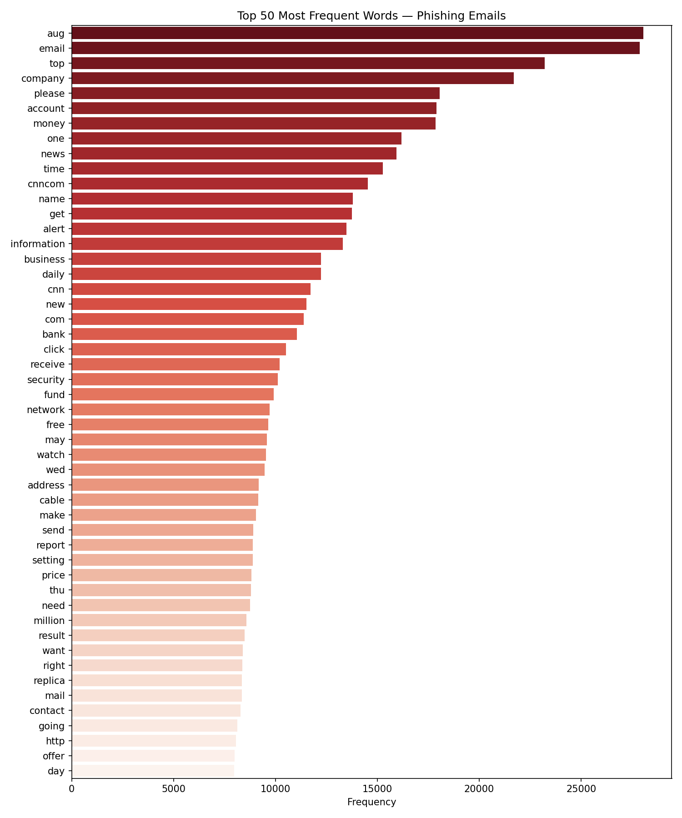
Figure 2 — The fifty most frequent words in phishing emails after preprocessing.

1.5 A limitation worth stating
Because the dataset is assembled by merging corpora that were collected separately, class membership is correlated with source. Almost all legitimate email comes from Enron and the academic mailing lists; almost all phishing comes from Nazario and the Nigerian Fraud archive. A classifier can therefore score well by learning which corpus an email came from rather than what phishing actually looks like. This is visible directly in the model coefficients reported in Section 2.5, where the strongest indicators of a legitimate email include enron, vince and louise — the names of Enron employees. The scores reported in this document should accordingly be read as performance on this benchmark, not as an estimate of performance on live mail, which would very likely be lower. A stronger evaluation would hold out an entire source corpus for testing.

2. Logistic Regression

2.1 Rationale
Logistic Regression was selected as the machine learning model for three reasons. It is a well-established baseline for binary text classification and pairs naturally with sparse TF-IDF features. It is fast enough to train and cross-validate repeatedly on 66,000 documents, which makes genuine hyperparameter search practical. Most importantly it is interpretable: the model learns one weight per feature, so the terms driving any prediction can be read off directly. That property is what makes the "which words triggered this?" explanation feature of the PhishGuard application possible.

2.2 Feature engineering
The cleaned text was converted to TF-IDF vectors with a vocabulary capped at 10,000 features, using unigrams and bigrams and requiring a minimum document frequency of two. Bigrams were included so that collocations such as "verify account" carry their own weight rather than being decomposed into two independent unigrams.
The dataset was split 80/20 with stratification before the vectoriser was fitted, and the vectoriser was fitted on the training portion only. Fitting TF-IDF on the full dataset first is a common and easily missed error: it lets test-set vocabulary and document frequencies inform the training representation, which inflates the reported scores.

2.3 Hyperparameter tuning
The inverse regularisation strength C was tuned with GridSearchCV over five candidate values, scored by F1 under 5-fold stratified cross-validation carried out entirely within the training set. The test set was not consulted during model selection and was evaluated once, after the final model had been fixed.
C | Cross-validated F1 (training folds)
0.01 | 0.9568 ± 0.0016
0.1 | 0.9721 ± 0.0011
1.0 | 0.9825 ± 0.0015
10.0 (selected) | 0.9850 ± 0.0010
100.0 | 0.9842 ± 0.0014
C = 10.0 was selected. Re-running 10-fold cross-validation on the training set with this value gave a mean F1 of 0.9832 with a standard deviation of 0.0023. The closeness of this figure to the 0.9859 eventually observed on the held-out test set indicates the model is not overfitting the training data. Class weighting was set to balanced.

2.4 Results
An untuned baseline with default settings reached an F1 of 0.9833. The tuned model improved on this modestly, as shown below.
Metric | Baseline (C = 1.0) | Tuned (C = 10.0)
Accuracy | 0.9826 | 0.9853
Precision | 0.9811 | 0.9857
Recall | 0.9855 | 0.9861
F1-score | 0.9833 | 0.9859
ROC-AUC | — | 0.9986
On the 16,497-email test set the tuned model made 242 errors in total: 123 legitimate emails wrongly flagged as phishing, and 119 phishing emails that were not caught.
 | Predicted Legitimate | Predicted Phishing
Actual Legitimate | 7,796 | 123
Actual Phishing | 119 | 8,459
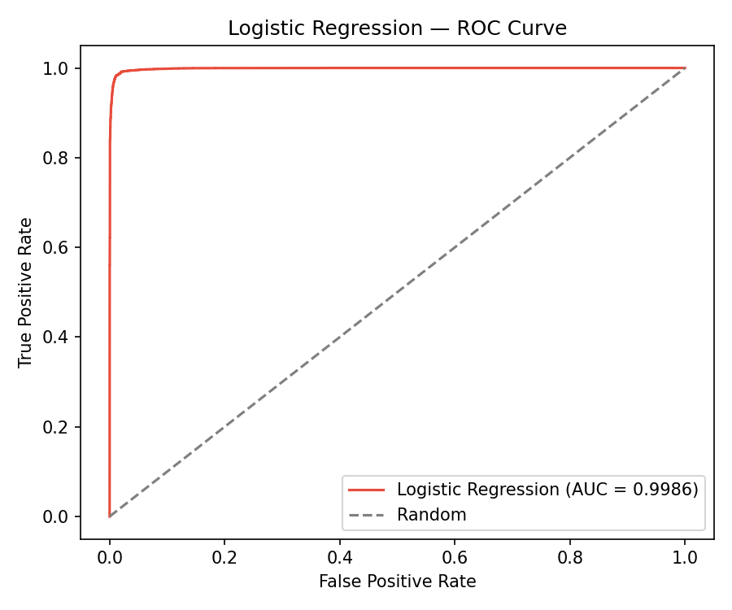
Figure 3 — Logistic Regression ROC curve (AUC = 0.9986).

2.5 Interpretability
Inspecting the learned coefficients gives a direct account of what the model has learned. The features pushing most strongly toward a phishing prediction are:
replica, http, remove, pill, medication, med, love, click, site, account, quality, viagra, life, money, investment
and those pushing toward legitimate:
enron, wrote, thanks, university, vince, louise, opensuse, tony, perl, question, python
The first list is broadly what one would hope for — pharmaceutical spam vocabulary, financial lures and calls to action. The second list is more revealing, and is the concrete evidence behind the limitation described in Section 1.5: enron, vince and louise are artefacts of the Enron corpus, not general properties of legitimate email.

3. GRU

3.1 Rationale
A Gated Recurrent Unit network was chosen as the deep learning model. A GRU is a recurrent architecture that processes text one token at a time while maintaining a hidden state, using an update gate and a reset gate to control how much earlier context is retained. This addresses the principal weakness of the TF-IDF representation used in Section 2, which discards word order entirely: a GRU can in principle represent "your account will be suspended" as a phrase rather than as four independent tokens.
A GRU was preferred over an LSTM because it achieves comparable accuracy on medium-sized text datasets with two gates instead of three, and therefore fewer parameters and shorter training time. Over 66,000 training sequences of 200 tokens, that saving is material.

3.2 Input representation
The GRU cannot consume TF-IDF vectors, so a separate representation was built. A Keras tokenizer with a 20,000-word vocabulary and an out-of-vocabulary token was fitted on the training text only — the same discipline applied to the TF-IDF vectoriser, and for the same reason. Each email was converted to a sequence of integer indices and padded or truncated to exactly 200 tokens. As noted in Section 1.2, this truncates roughly one email in six.

3.3 Architecture
Layer | Output shape | Parameters
Input | (200) | 0
Embedding (20,000 × 128) | (200, 128) | 2,560,000
GRU (128 units) | (128) | 99,072
Dropout (0.3) | (128) | 0
Dense (64, ReLU) | (64) | 8,256
Dense (1, Sigmoid) | (1) | 65
Total |  | 2,667,393
The embedding layer accounts for 96% of the parameters. It is learned from scratch rather than initialised from pretrained vectors such as GloVe; with 66,000 training documents there is enough data to learn task-specific representations, and this keeps the model self-contained.
Dropout of 0.3 sits between the recurrent layer and the classifier head, which is where overfitting was expected given the parameter count. The final sigmoid produces a probability of the email being phishing, thresholded at 0.5.

3.4 Training protocol
The model was compiled with the Adam optimiser at a learning rate of 1e-3 and binary cross-entropy loss, and trained with a batch size of 256 for a maximum of 15 epochs. Ten per cent of the training set was held back for validation. Class weights were computed with compute_class_weight. Two callbacks were used: ModelCheckpoint, saving whenever validation loss improved, and EarlyStopping with a patience of three epochs and restoration of the best weights.
Epoch | Training loss | Validation loss | Validation accuracy
1 | 0.6422 | 0.1941 | 0.9306
2 | 0.0867 | 0.0544 | 0.9821
3 (best) | 0.0345 | 0.0514 | 0.9844
4 | 0.0211 | 0.0544 | 0.9833
5 | 0.0131 | 0.0532 | 0.9859
6 | 0.0096 | 0.0538 | 0.9842
Training halted at epoch 6 and the epoch-3 weights were restored. The table shows exactly why the callbacks matter: training loss fell continuously from 0.0345 to 0.0096 over epochs 3 to 6, a reduction of more than two thirds, while validation loss reached its minimum at epoch 3 and then drifted upward. The model was memorising the training set with no corresponding gain in generalisation. Without checkpointing, the final epoch's weights would have been kept and the reported model would have been a measurably worse one. Total training time was 12.1 minutes.
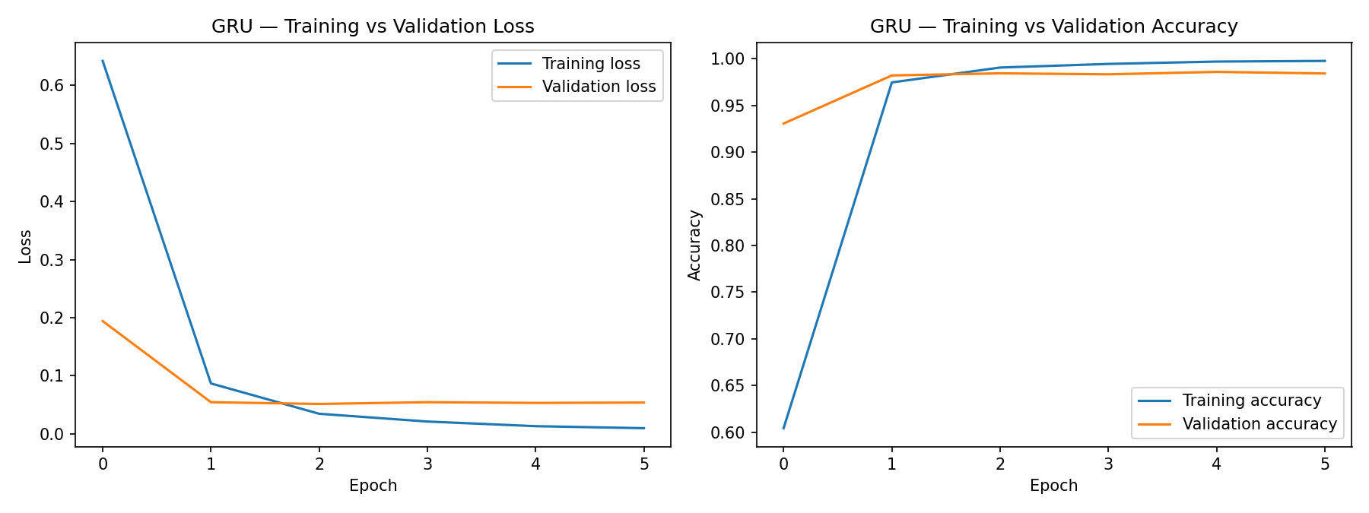
Figure 4 — GRU training and validation curves. The divergence after epoch 3 is the overfitting point that triggered early stopping.

3.5 Results
Metric | Value
Accuracy | 0.9861
Precision | 0.9850
Recall | 0.9882
F1-score | 0.9866
ROC-AUC | 0.9978
 | Predicted Legitimate | Predicted Phishing
Actual Legitimate | 7,790 | 129
Actual Phishing | 101 | 8,477
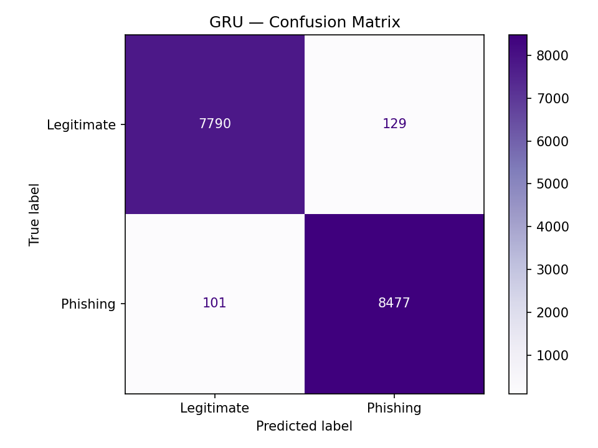
Figure 5 — GRU confusion matrix on the 16,497-email test set.

4. Comparison and Discussion
Model | Accuracy | Precision | Recall | F1 | ROC-AUC
Logistic Regression | 0.9853 | 0.9857 | 0.9861 | 0.9859 | 0.9986
GRU | 0.9861 | 0.9850 | 0.9882 | 0.9866 | 0.9978
Both models were trained and evaluated on identical splits with a fixed random seed of 42, so the comparison is like for like.
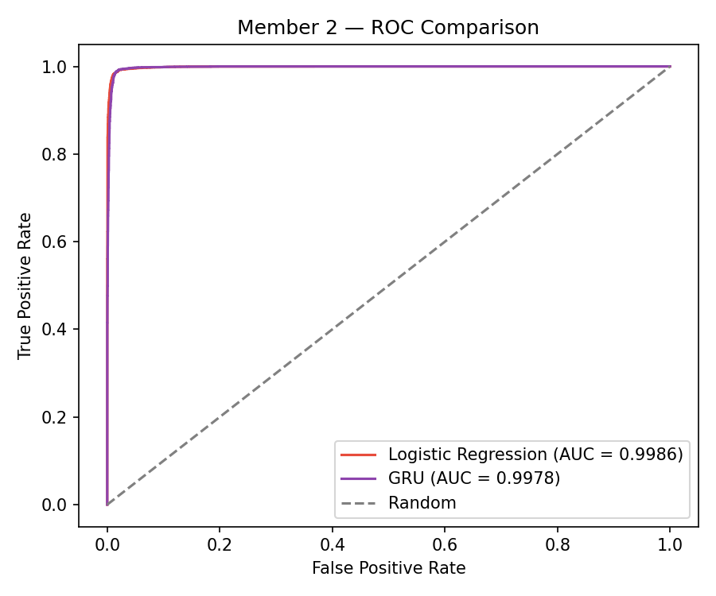
Figure 6 — ROC curves for both models. The two are near-indistinguishable.

4.1 The headline finding
The two models are separated by 0.07 percentage points of F1. On this dataset, a 2.7-million-parameter recurrent network trained for twelve minutes offers no meaningful accuracy advantage over a linear model that trains in seconds. Logistic Regression in fact holds the higher ROC-AUC, at 0.9986 against 0.9978, meaning its ranking of emails by phishing probability is marginally better across all decision thresholds.
This is a useful negative result rather than a disappointing one. It indicates that phishing emails in this corpus are largely separable from vocabulary alone, and that the sequential context a recurrent model adds contributes little beyond what a bag of unigrams and bigrams already captures.

4.2 Error profiles
The aggregate scores conceal a difference in the kind of mistakes each model makes.
 | False positives | False negatives | Total errors
Logistic Regression | 123 | 119 | 242
GRU | 129 | 101 | 230
The GRU caught 18 more phishing emails than Logistic Regression, at a cost of 6 additional false alarms. For a phishing filter these two errors are not equally serious: a false negative reaches the user's inbox and may lead to a compromise, whereas a false positive sends a legitimate email to a quarantine folder where it can be recovered. On that reading the GRU has the preferable error profile — though a difference of 18 emails in 16,497 is small enough that it may not survive a change of random seed, and this should not be presented as a robust finding without repeated runs.

4.3 Trade-offs
 | Logistic Regression | GRU
Training time | Seconds | 12.1 minutes
Parameters | 10,000 weights | 2,667,393
Hardware | CPU | GPU strongly preferred
Interpretability | Direct — one weight per term | Opaque
Word order | Discarded | Modelled
Input length limit | None | Truncated at 200 tokens
For deployment inside the PhishGuard application, Logistic Regression is the stronger candidate despite the GRU's marginally better recall. It is faster at inference, has no GPU dependency, and its coefficients supply the per-word explanation the application is designed to show the user. The GRU's value in this project is as a point of comparison: it establishes that the simpler model is not leaving accuracy on the table.

4.4 Threats to validity
- Corpus provenance leakage. As set out in Section 1.5, class membership correlates with source corpus, and the Logistic Regression coefficients confirm the models exploit this. Real-world performance would be lower.
- Single split. All figures come from one 80/20 split with one seed. The 10-fold cross-validation on the training set gives some confidence for Logistic Regression (0.9832 ± 0.0023), but the GRU was not cross-validated, as the compute cost was prohibitive.
- Truncation. 16.3% of emails exceed the 200-token sequence limit, so the GRU never sees the ends of longer messages. The effect of a longer limit was not measured.
- Fixed threshold. Both models are evaluated at a 0.5 decision threshold. A deployed filter would tune this against the relative cost of the two error types rather than assume they are equal.

4.5 Reproducibility
Random seeds were fixed at 42 for Python, NumPy and TensorFlow. The notebook, both trained models, the TF-IDF vectoriser, the Keras tokenizer and the complete console logs from both training runs are committed to the feature/nishen_CIT-24-01-0256 branch of the group repository, so every figure in this document can be regenerated.

