Part 1 – General Questions:

1. The constant brightness constraint is an assumption that if there are brightness changes, all pixels are changing together, so $I_{x}$ and $I_{y}$ doesn’t change. With that assumption we can assume that a window around corner will look the same after moving to another location. At the real world this assumption is incorrect. 3D movements change the brightness, objects like metals will have different brightness while moving, etc.
2. If we look on a window that shows an edge which look the same after moving up or down (like in Fig.1), We will have a problem when trying to find $I_{y}$ since we don’t know if the object moved up or down or neither. A solution is to use larger window that will contain the corner, but this solution can cause problems (LK pixel movement assumption).

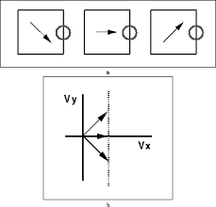

Figure 1: Example of Aperture Problem

1. LK method contain an assumption that the entire pixels in the target window move together, meaning they will have the same u and v. With that assumption we can solve our equation of 2 parameters, since now we have an equation for every pixel in the target window. For example, for a 5X5 window we will have 25 equations for 2 parameters.
2. That assumption is not correct when we look at boundaries of objects. Since only part of the pixels are moving, the u and v will be different for the object pixels and the background pixels. Solving the equation for the same u and v will give us a wrong answer.
3. In case we could run a segmentation or get a label image where every object is labeled, we could different “window” sizes, so every window will be at the size of the labeled object. With such a window we would not include different objects at the same window, so the assumption that u and v are the same at each window is correct.