Practical-1

LINUX

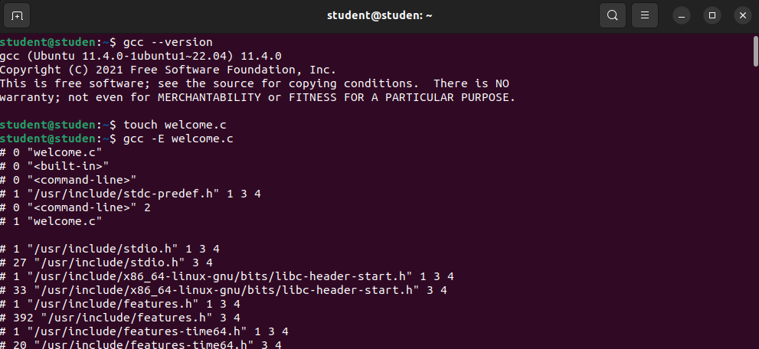

* the first file is formed by the touch tool
* It is named as “name.c”

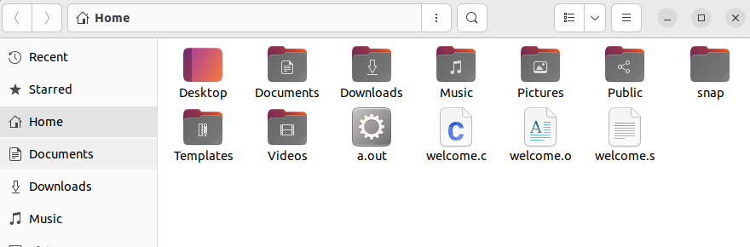

* The other folder id is named as welcome.s
* And the third one is named as welcome.o
* As it has codes which is not shown as someone might copy it so the file welcome.o will not open

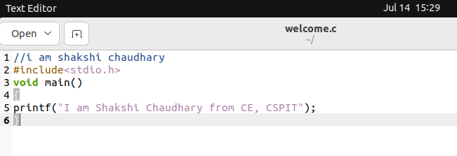

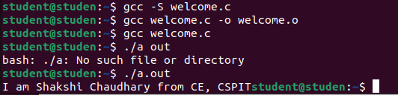

. we got the output by “./a.out” which creates a folder of it

Code Blocks

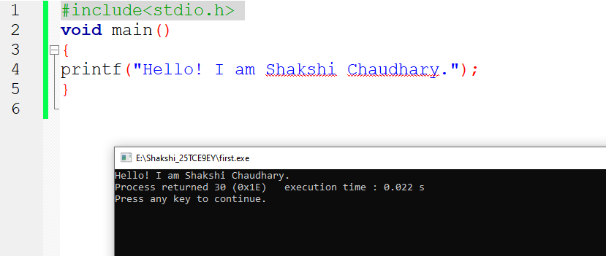

Practical 2

Integer Que

To find the area and the perimeter of the rectangular park whose length is 70 and breadth is 90 in the codeblock

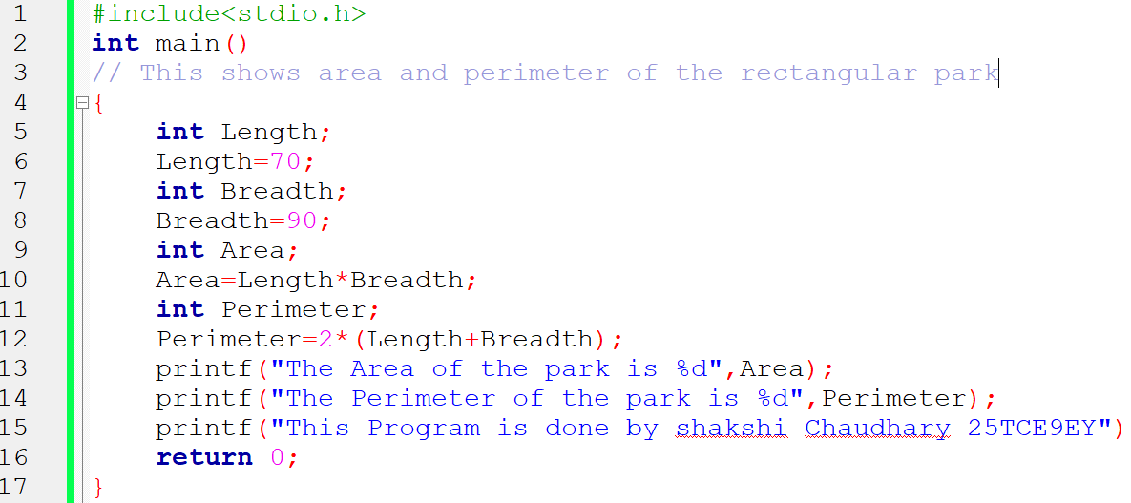

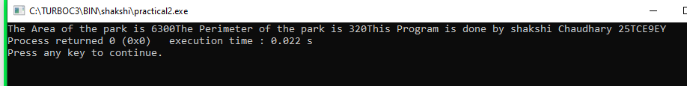

Practical 3

Measurements

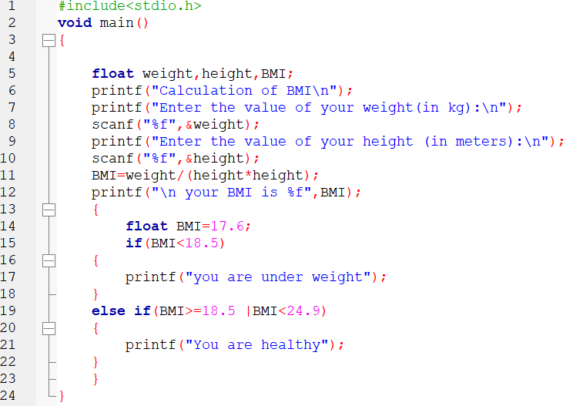

. Here the float express the variables.

. scanf is used for the next line and for that we use “%f”.

. BMI = weight/height*height.

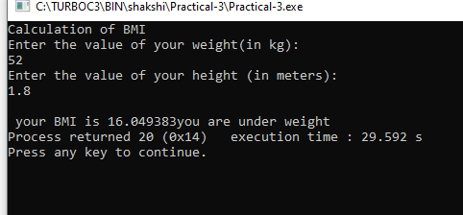

**Practical 5**

Population

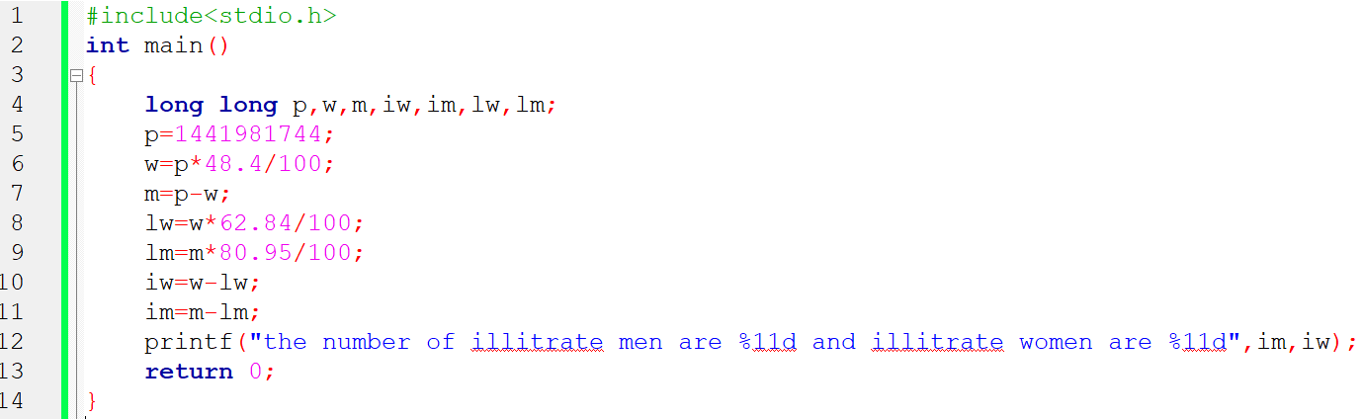

. Here there is calculation of illitrate men and women from total population of 1,44,19,81,744.

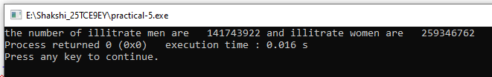

. Here we get the illitrate men 141743922 and illitrate women are 259346762.