**Queries**

**1.Give details of vehicle booked between particular date(e.g 2016-04-12 and 2016-09-12)**

select vehicle.*from vehicle natural join(

select * from booking where booking_date between '2016-04-12'and'2016-09-12')as r1;

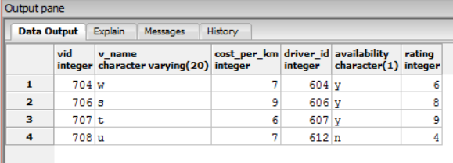

**2.List customer id who have got discount more than 5**

select customer_id from bill join (

select *from discount where dis_amount>5

) as r

on r.dis_id=bill.discount_id;

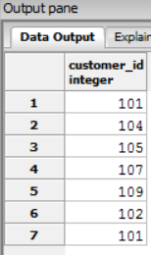

**3.Details of employee where dname is driver and branch name is B**

select r1.*from branch join (select *from employee natural join department where dname='driver')as r1 on branch.branch_id=r1.bid where branch_name='B';

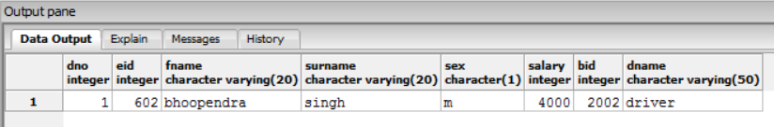

**4.List down all the vehicles available with rating greater than 4**

select *from vehicle where availability='y'and rating>4;

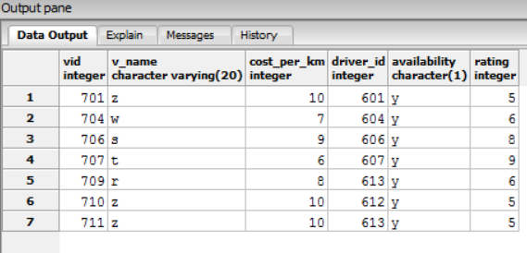

**5.list down details of customer including email and phone who have booked the service more than once**

select * from customer natural join customer_email natural join customer_phone natural join pin_code

where customer_id in

(select cid from (select cid,count(booking_no) as number from booking group by cid having count(booking_no)>1)as r2

);

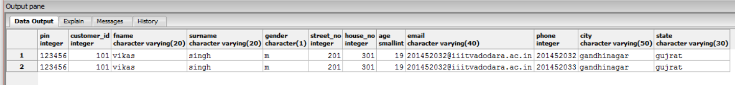

**6.list employees of dno 1 who were free on particular date(e.g 2016-12-01)**

select * from employee where eid not in(select driver_id from vehicle natural join booking where booking_date='2016-12-01');

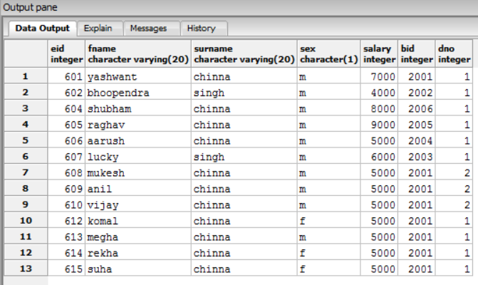

**7. find the date on which total amount is maximum;**

select sum(total_amount),booking_date from bill join booking on (bill.booking_no=booking.booking_no) group by booking_date order by sum desc limit 1;

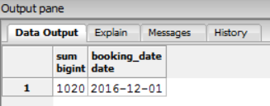

**8. Number of bookings by customer_id 101**

select count(booking_no) from booking where cid=101;

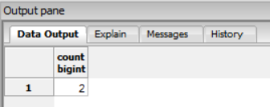

**9. total bill amount on particular date(e.g 2016-12-01)**

select sum(total_amount) from (select booking_no from booking where booking_date='2016-12-01') as r1 natural join bill;

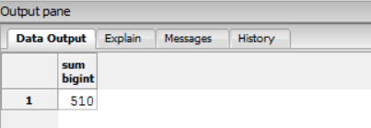

**10.list down salary along with other details of female drivers having salary greater than 4000**

select * from employee natural join department where dname='driver' and sex='f' and salary>4000;

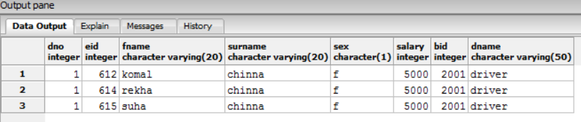

**11.list down all journey and customer detail of journey from Gandhinagar to Jaipur**

select * from customer natural join customer_email natural join customer_phone join (select * from booking where source_pin in(select pin from pin_code where city='gandhinagar') and destination_pin in(select pin from pin_code where city='jaipur'))as r1 on r1.cid=customer.customer_id;

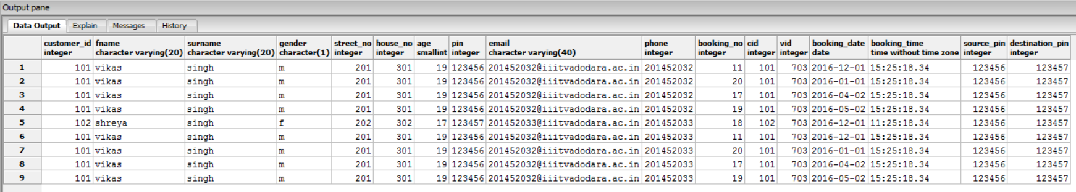

**12.find customer detail who have gone with female driver**

select * from customer join (select cid,vid,booking_date from booking natural join (select * from vehicle join (select * from employee natural join department where sex='f'and dname='driver')as r1 on r1.eid=vehicle.driver_id)as r2)as r3 on r3.cid=customer.customer_id;

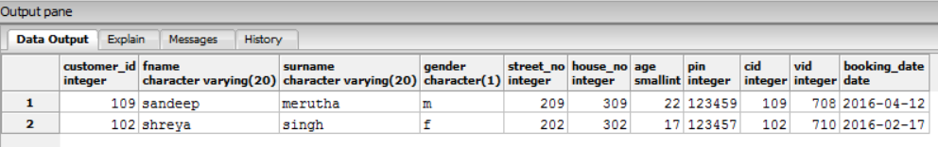

**13.** **find customer id who have got maximum total amount**

select sum(dis_amount),cid from discount join bill on bill.discount_id=discount.dis_id join booking on (bill.booking_no=booking.booking_no) group by cid order by sum desc limit 1;

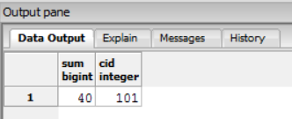

**14.find out the vehicle which have earned maximum revenue**

select * from vehicle natural join (select vid,sum(total_amount) from bill group by vid order by sum desc limit 1)as r1;

