Given below is a rough schema of database of a cab service provider.

The company stores details of customer who used their service , details of vehicle, details of journey made and details of drivers.

Company has discount scheme. Discount id determines the discount amount.

Customer ID(cid) is given to each customer.If the same customer comes who has used the service in past then also he is assigned a new customer id.

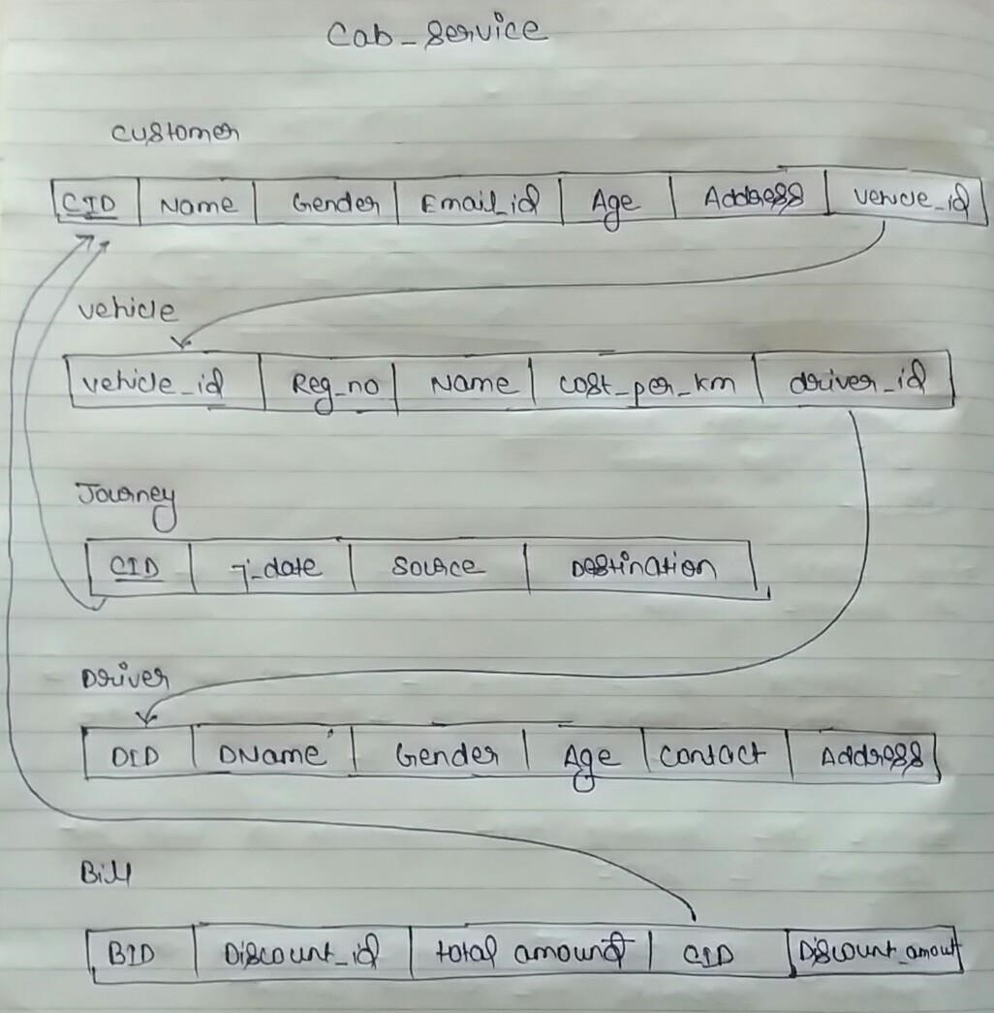

Q.A

1.List down all the functional dependencies.

2.write minimal set of functional dependencies.

3.Check if these relations are in BCNF?

If yes ,prove it.

If no, comment upon their normal form. Also write what are the changes we need to do to decompose into BCNF.

Q.B

Write relational algebra for following-

1.List details of customers who have used vehicle with male driver.

2.calculate total revenue generated from vehicle id 101.

3.List all vehicles used on a particular day.

4.List details of drivers who has given service to customer of age greater than 40.

Lalit Singh

ID: 201452049