Lab 2: Agile Backlog Creation and Sprint Simulation in Jira
Name: Shakthi Raja G P
SRN: PES1UG25CS843
Problem Statement: #60, Podcast Guest Scheduling and Outline Builder
(Media, Events and Community)

Backlog and user stories

Backlog with the epic panel, Sprint 1 and Sprint 2, and the first set of stories.:
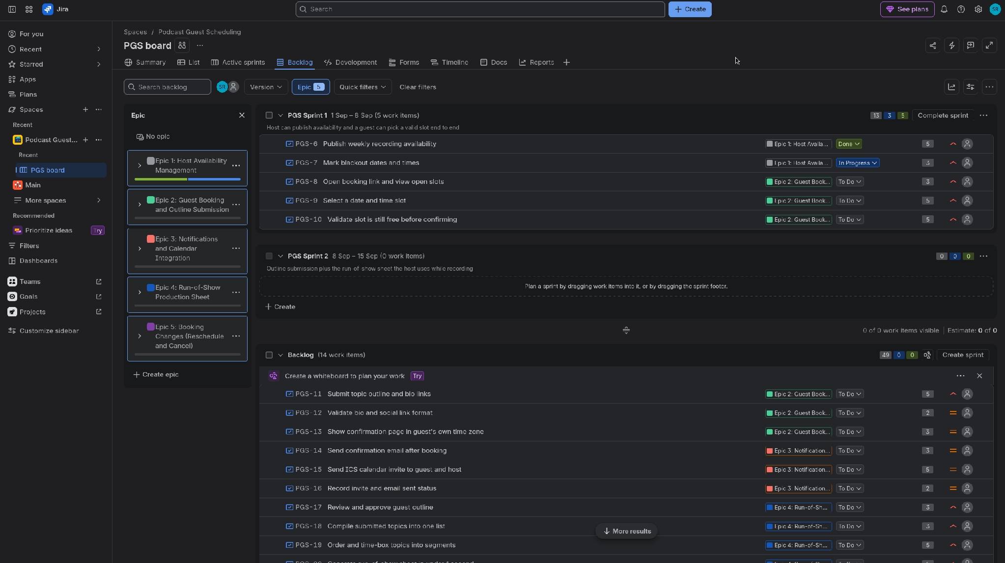

The rest of the backlog (PGS-11 to PGS-24) with epic labels and priorities:
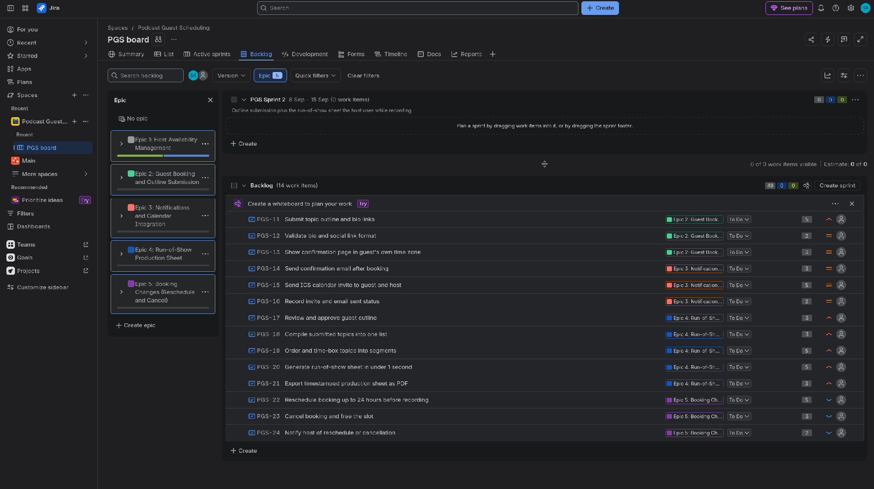

Sprint 1
Sprint 1 ran from 1 to 8 September with 5 stories worth 21 points. The goal was for the host to publish availability and for a guest to book a valid slot end to end. I moved the cards from To Do to In Progress to Done over a few days and finished the sprint early.

Sprint 1 board partway through, one story done and one in progress.
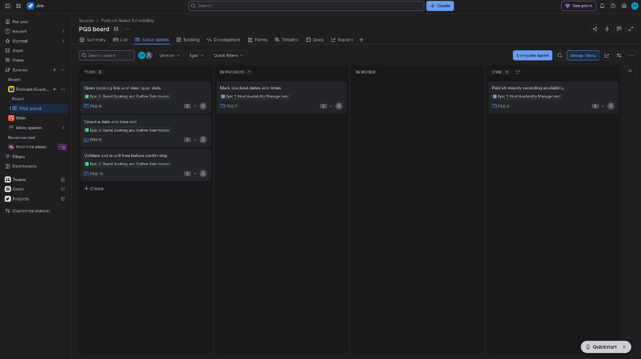

Sprint 1 board with all five stories done.
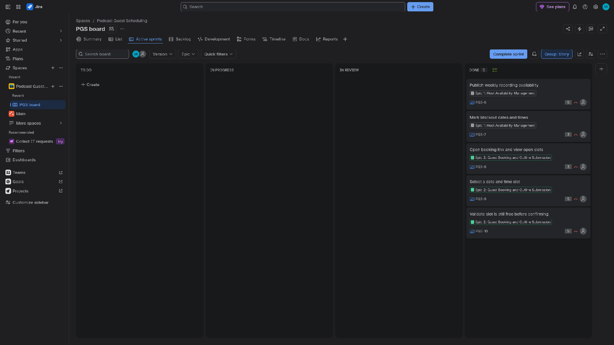

Sprint 2
Sprint 2 covered outline submission and the run-of-show sheet, another 5 stories and 21 points. I completed it the same way, moving each card across the board in priority order.

Sprint 2 board partway through:
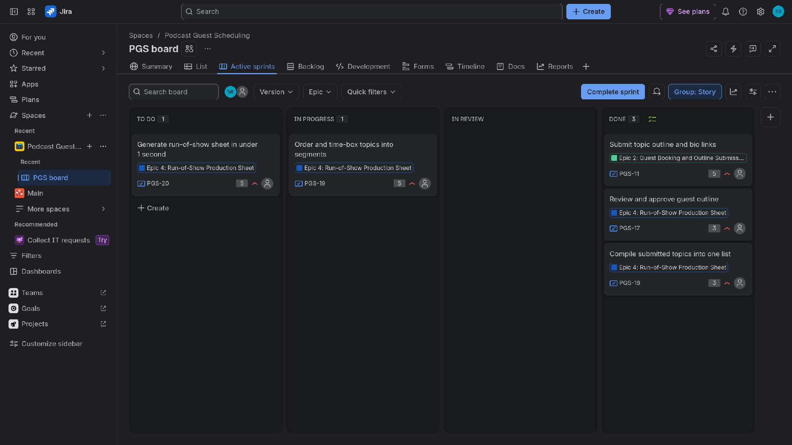
Sprint 2 board with all stories done.
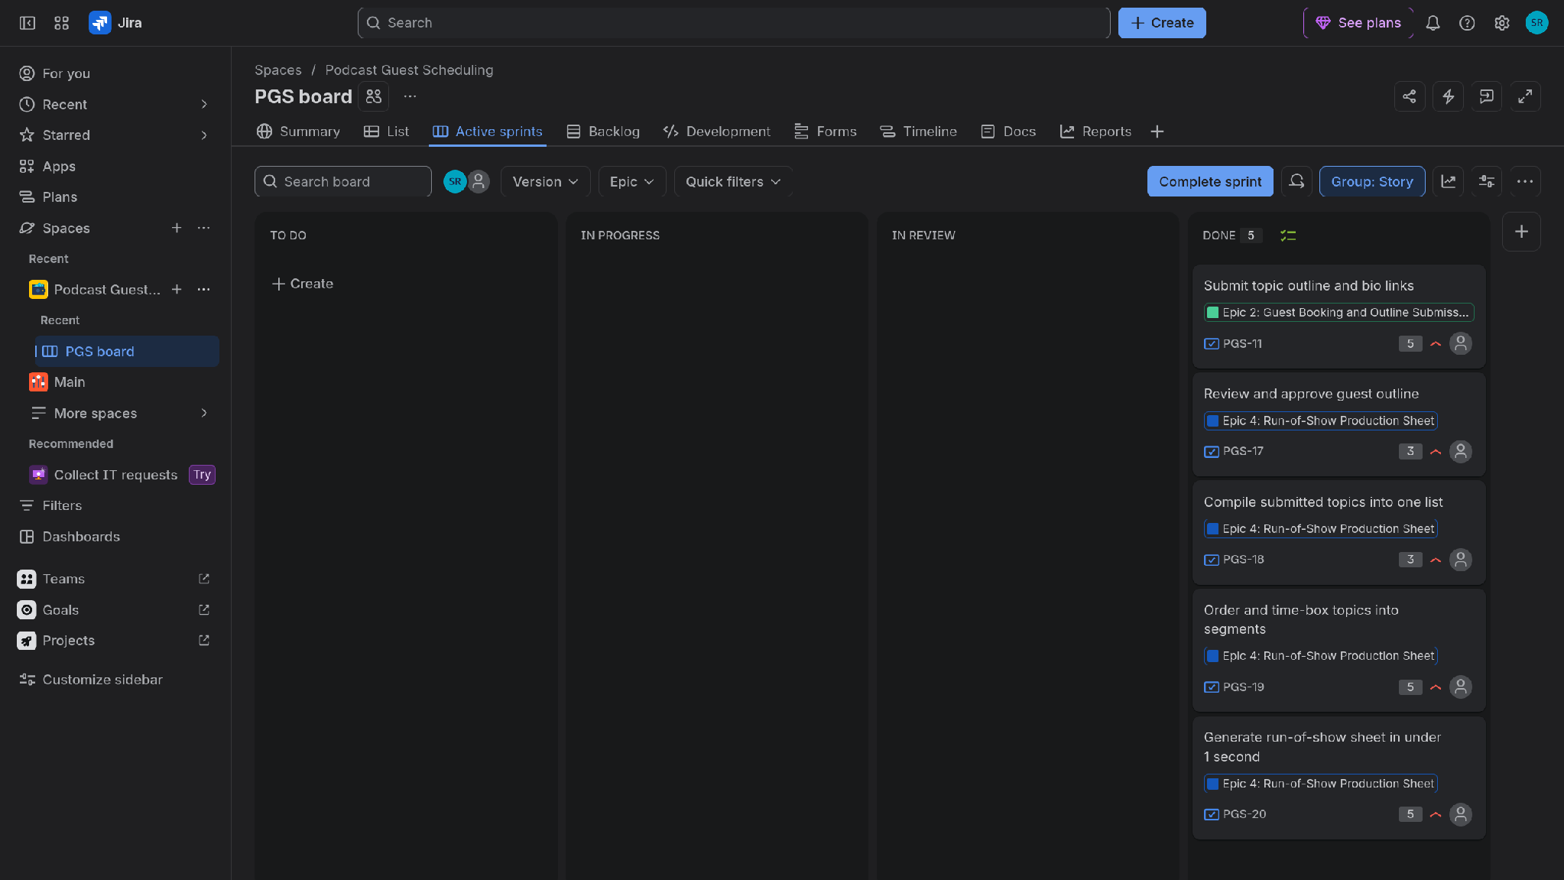

Burndown charts
The Sprint 1 burndown steps down over the week as each story was completed, and it hits zero before the sprint end date. Sprint 2's chart drops almost straight away because the simulation was done in one day.

Burndown chart for Sprint 1 (21 points, finished early):
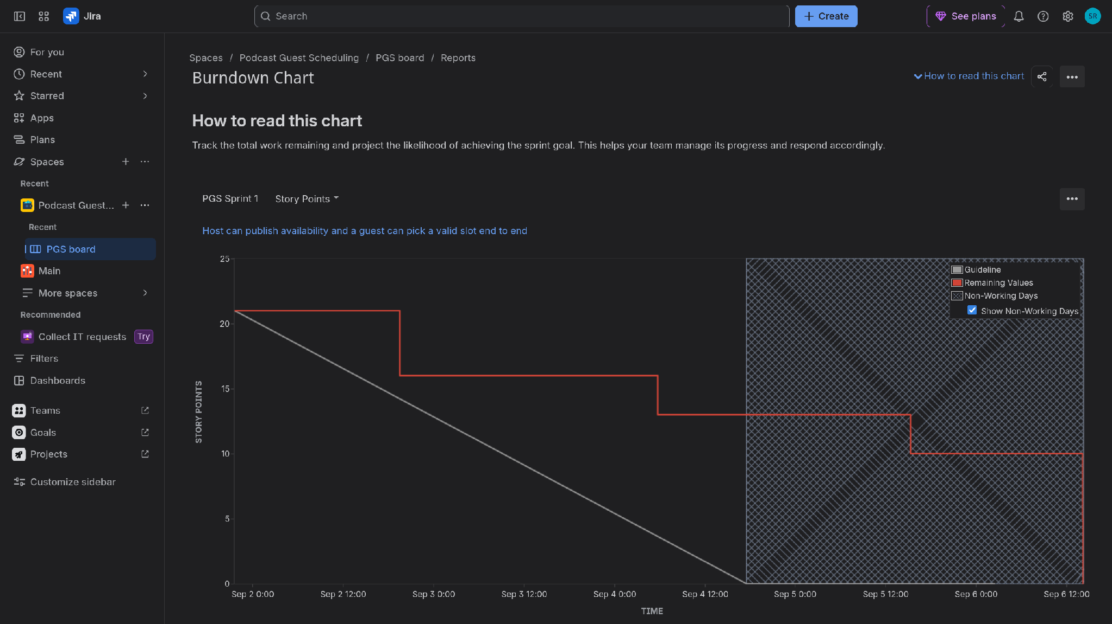
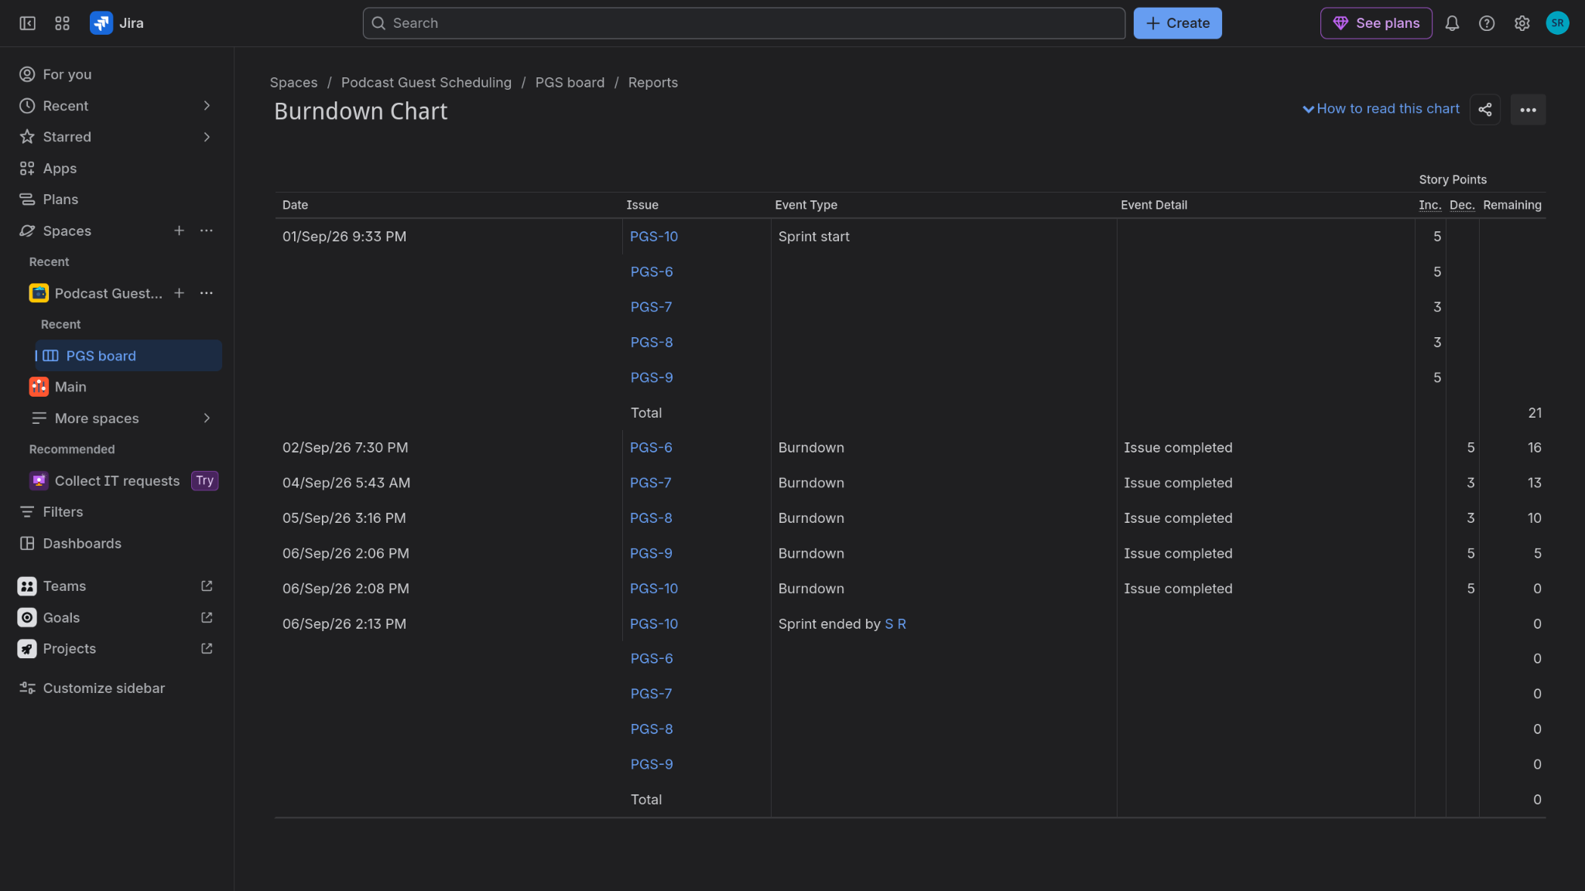

Burndown chart for Sprint 2:
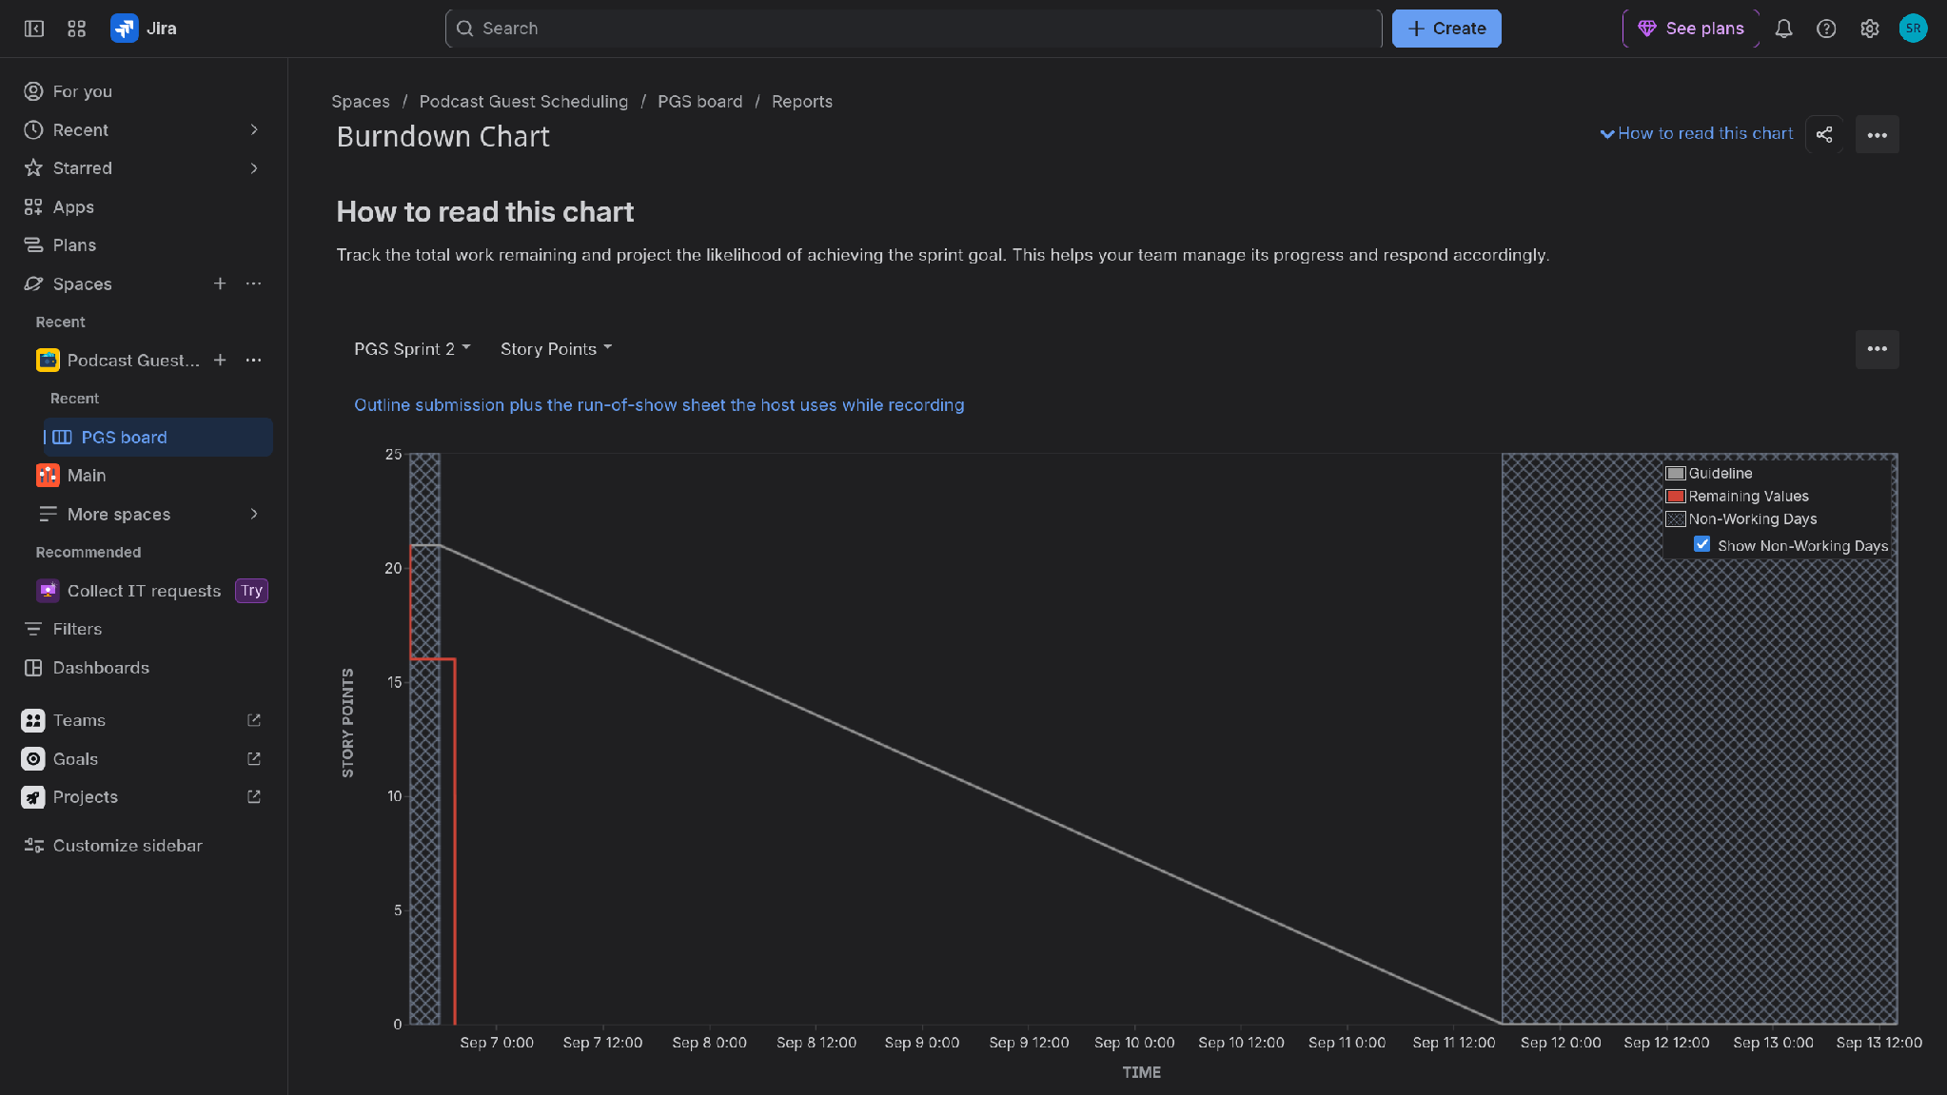
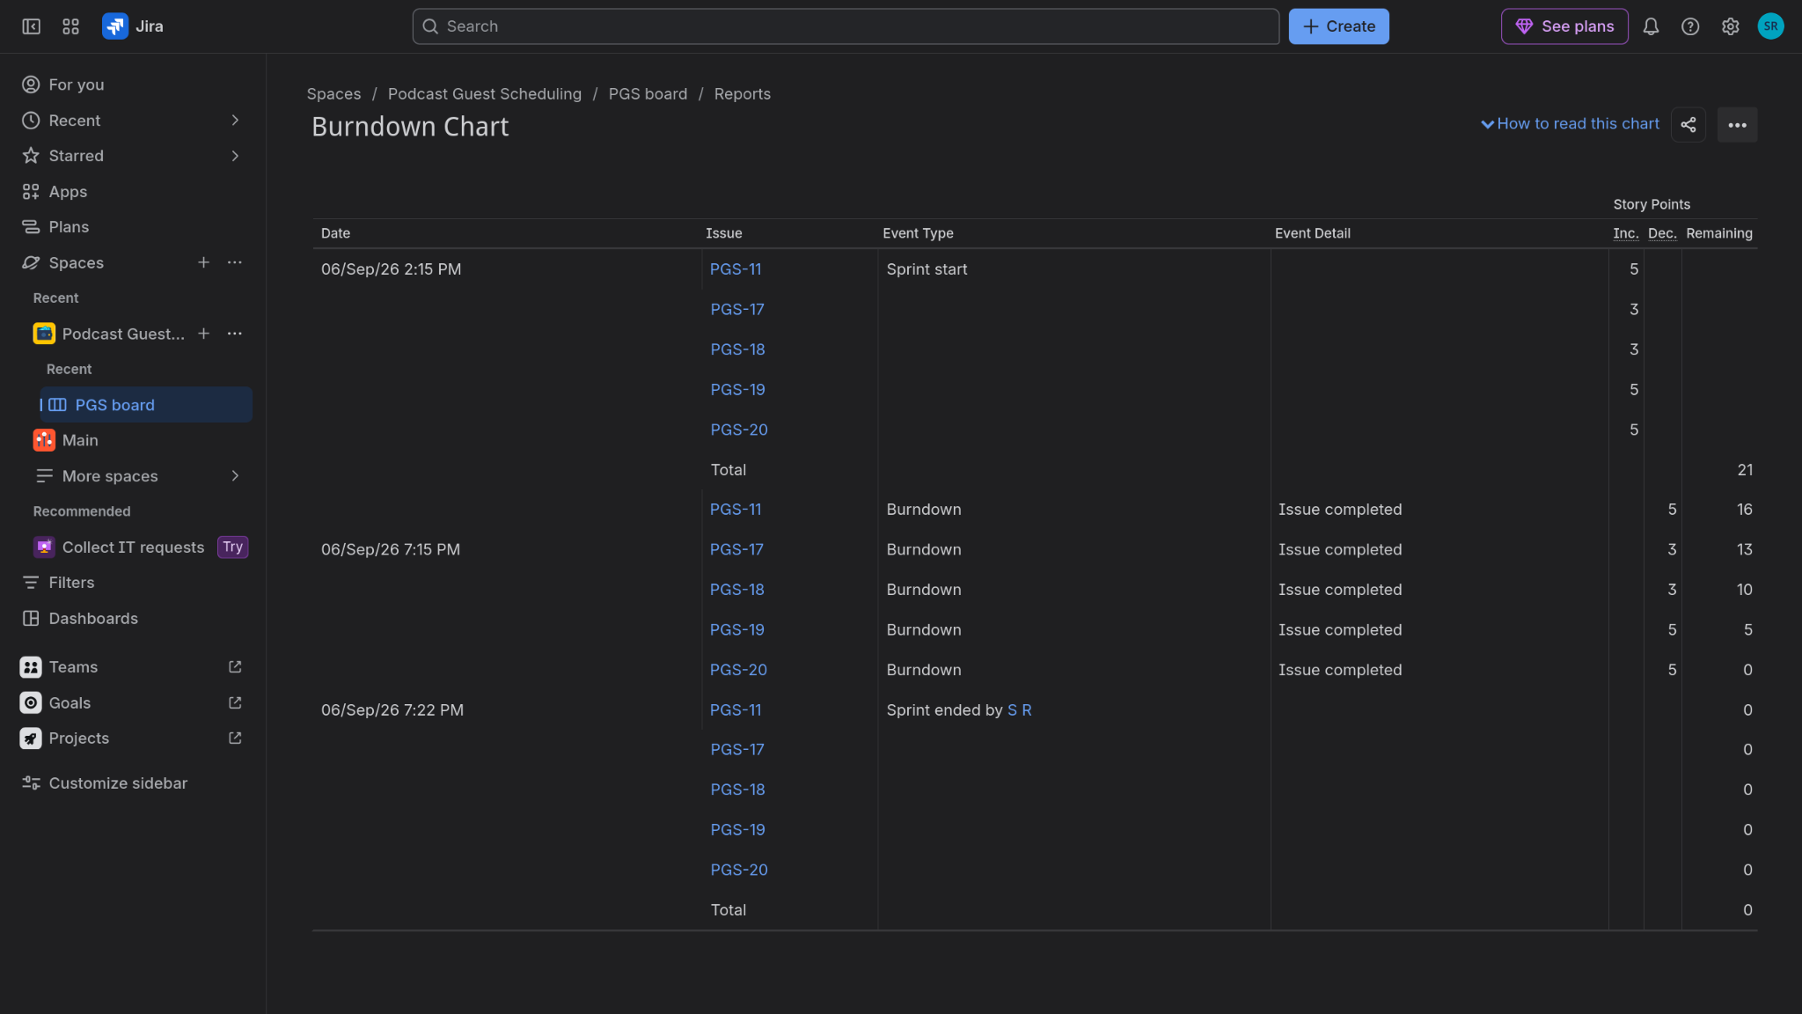

Reflection questions:

1. Did your estimations reflect the actual effort?
Mostly yes. The stories I gave 5 points, like validating the slot before confirming, were the ones that needed the most thought, and the 2 and 3 point stories were as quick as expected. Since this was a simulated sprint I couldn't compare against real hours, but the relative sizing felt right and nothing had to be re-estimated halfway through.

2. Was your backlog well-prioritized?
Yes. The host availability stories sit at the very top because the guest flow is useless without slots to book. Booking changes and cancellations are at the bottom since they only matter after a booking exists. The priority flags in the backlog match that order.

3. How did your simulated sprint align with your plan?
Sprint 1 followed the plan: all 5 stories moved across the board and the sprint closed early with nothing carried over. Sprint 2 was done in one sitting for the simulation, so its board went from full to done within minutes. Both sprints ended at zero remaining points, which matched the 21 points I committed to each time.

4. What insights did the burndown chart give about your team's capacity?
Sprint 1's remaining line stayed above the grey guideline until the last stretch, so the work burned down slower than an even pace even though it still finished on time. That tells me 21 points a week is manageable but leaves little slack if a story gets stuck. The sharp drops also suggest breaking the 5 point stories into smaller pieces next time.

