**Instructions**

Programs that are relevant:

* Arg_test.py (Gives alarms at specific time interval and day of the week)
* Final_code.py (Percentile distribution of the network elements)
* PCA.py (Analysis is shown as plots.)

1. **Arg_test.py** is an argument-based program where you run the program on command prompt. The program accepts certain arguments based on which it will give the analysis. The arguments are:
   1. File location
   2. Severity
   3. Top count (Top n most frequently occurred data. N has to be passed as an argument)
   4. Time diff – Will display alarms where the duration between alarm time and terminated time is more than Time Diff (Minutes).
   5. DayofWeek – will give alarms on that particular day. (First letter should be capital. Eg. Monday)
   6. Hourofday – will give alarms that has occurred on that particular hour (24 hr format).

The result of this program will display the network elements in which the alarms occurred based on the arguments that has been passed. 2 graphs will be plotted. One of them will show the alarm time and terminated time of all the network elements in which the alarm has occurred. The other will show the same but only for the Network elements which has been specified in the arguments.

The black dots are Alarm time and the red dots are terminated time.

Sample:

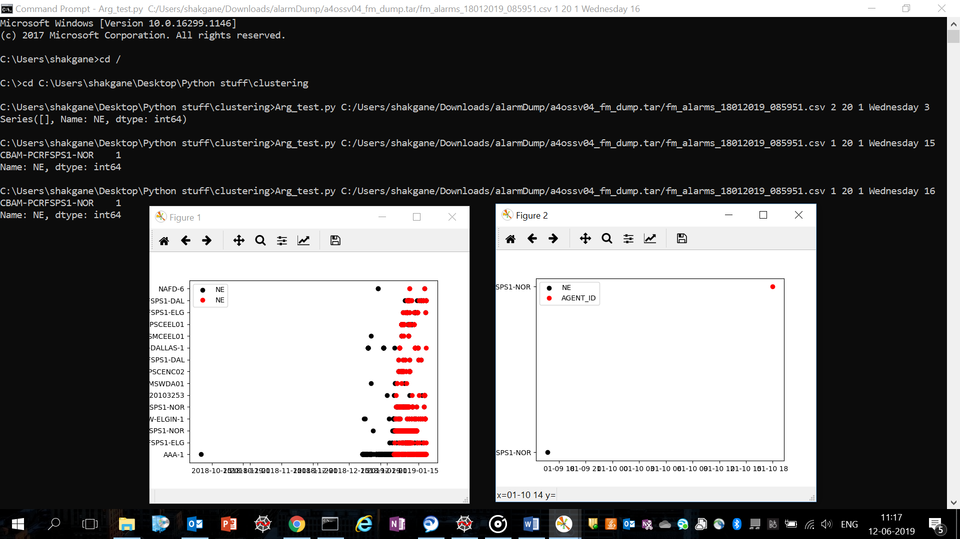

1. **Final_code.py** will give you the percentile of all the network elements which has produced an alarm. It will give you the 25th, 50th and 75th percentile along with the box plot of the distribution of network elements that has produced alarms.

The file location of the data set should be specified on the black arrow in the below picture.

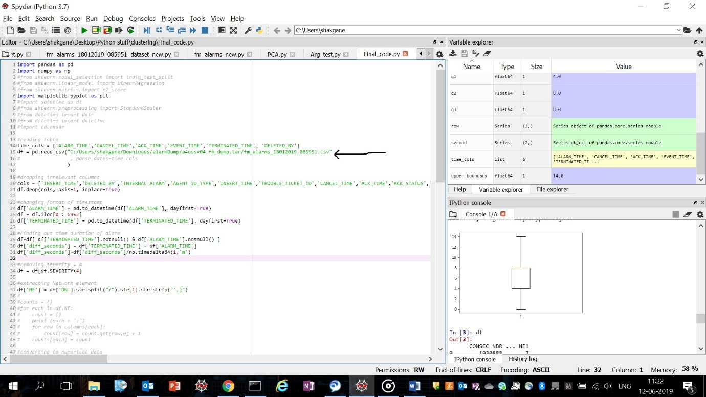

1. **PCA.py** will produce graph plots incurring to the analysis of the alarm data sets. The graphs will include the following:
   1. Network elements (NE) vs severity of the alarms produced by it
   2. Alarm time and terminated time of all the Network Elements that produced an alarm
   3. NE vs the day of the week the alarm occurred
   4. NE vs the hour of the day the alarm occurred.

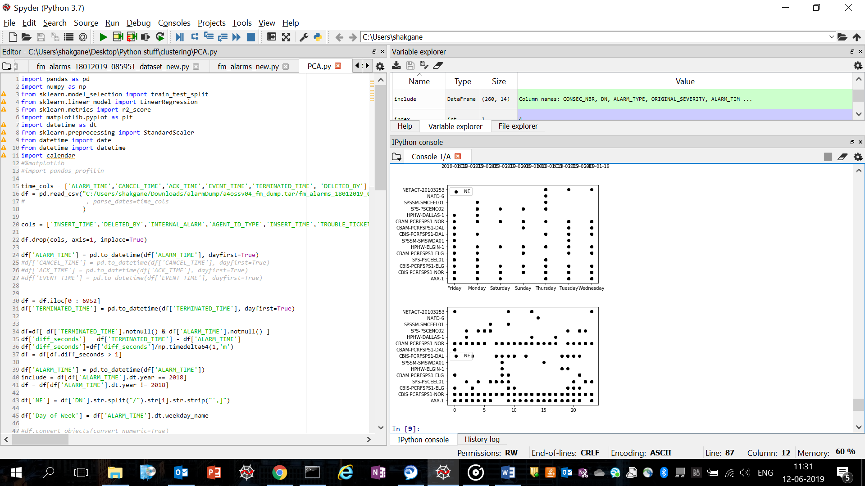

1. The other programs are sample programs that was created during the learning process of data analytics.
2. Few pictures of the graph have also been uploaded as png files for better understanding and clarity.