In [6]:
import pandas as pd
df = pd.read_csv("C:/Users/Admin/Downloads/index_data.csv") print(df.head()) print(df.info())
Creditability Account Balance Duration of Credit (month) \
- 1 1 18
- 1 1 9
- 1 2 12
- 1 1 12
- 1 1 12
Payment Status of Previous Credit Purpose Credit Amount \
- 4 2 1049
- 4 0 2799
- 2 9 841
- 4 0 2122
- 4 0 2171
Value Savings/Stocks Length of current employment Instalment per cent \
0 1 2 4
1 1 3 2
2 2 4 2
3 1 3 3

4 1 3 4
Sex & Marital Status ... Duration in Current address \
0 2 ... 4

3 ... 2

2 ... 4
- 3 ... 2
- 3 ... 4
Most valuable available asset Age (years) Concurrent Credits \
- 2 21 3
- 1 36 3
- 1 23 3

1 39 3
4 2 38 1
Type of apartment No of Credits at this Bank Occupation \
- 1 1 3
- 1 2 3
- 1 1 2
- 1 2 2
- 2 2 2
No of dependents Telephone Foreign Worker
- 1 1 1
- 2 1 1
- 1 1 1
- 2 1 2
- 1 1 2
[5 rows x 21 columns]
<class 'pandas.core.frame.DataFrame'>
RangeIndex: 1000 entries, 0 to 999
Data columns (total 21 columns):
# Column Non-Null Count Dtype
--- ------ -------------- -----
- Creditability 1000 non-null int64
- Account Balance 1000 non-null int64
- Duration of Credit (month) 1000 non-null int64
- Payment Status of Previous Credit 1000 non-null int64
- Purpose 1000 non-null int64
- Credit Amount 1000 non-null int64
- Value Savings/Stocks 1000 non-null int64
- Length of current employment 1000 non-null int64
- Instalment per cent 1000 non-null int64
- Sex & Marital Status 1000 non-null int64
- Guarantors 1000 non-null int64
- Duration in Current address 1000 non-null int64
- Most valuable available asset 1000 non-null int64
- Age (years) 1000 non-null int64
- Concurrent Credits 1000 non-null int64
- Type of apartment 1000 non-null int64
- No of Credits at this Bank 1000 non-null int64
- Occupation 1000 non-null int64
- No of dependents 1000 non-null int64
- Telephone 1000 non-null int64 20 Foreign Worker 1000 non-null int64 dtypes: int64(21) memory usage: 164.2 KB
None
In [10]:
print(df.describe(include='all'))
Creditability Account Balance Duration of Credit (month) \ count 1000.000000 1000.000000 1000.000000 mean 0.700000 2.577000 20.903000 std 0.458487 1.257638 12.058814 min 0.000000 1.000000 4.000000
25% 0.000000 1.000000 12.000000
50% 1.000000 2.000000 18.000000 75% 1.000000 4.000000 24.000000 max 1.000000 4.000000 72.000000
Payment Status of Previous Credit Purpose Credit Amount \ count 1000.00000 1000.000000 1000.00000 mean 2.54500 2.828000 3271.24800 std 1.08312 2.744439 2822.75176 min 0.00000 0.000000 250.00000
25% 2.00000 1.000000 1365.50000
50% 2.00000 2.000000 2319.50000 75% 4.00000 3.000000 3972.25000 max 4.00000 10.000000 18424.00000
Value Savings/Stocks Length of current employment \ count 1000.000000 1000.000000 mean 2.105000 3.384000 std 1.580023 1.208306 min 1.000000 1.000000
25% 1.000000 3.000000
50% 1.000000 3.000000 75% 3.000000 5.000000 max 5.000000 5.000000
Instalment per cent Sex & Marital Status ... \ count 1000.000000 1000.00000 ... mean 2.973000 2.68200 ... std 1.118715 0.70808 ... min 1.000000 1.00000 ...
25% 2.000000 2.00000 ...
50% 3.000000 3.00000 ... 75% 4.000000 3.00000 ... max 4.000000 4.00000 ...
Duration in Current address Most valuable available asset \ count 1000.000000 1000.000000 mean 2.845000 2.358000 std 1.103718 1.050209 min 1.000000 1.000000
25% 2.000000 1.000000
50% 3.000000 2.000000 75% 4.000000 3.000000 max 4.000000 4.000000
Age (years) Concurrent Credits Type of apartment \ count 1000.00000 1000.000000 1000.000000 mean 35.54200 2.675000 1.928000 std 11.35267 0.705601 0.530186 min 19.00000 1.000000 1.000000
25% 27.00000 3.000000 2.000000
50% 33.00000 3.000000 2.000000 75% 42.00000 3.000000 2.000000 max 75.00000 3.000000 3.000000
No of Credits at this Bank Occupation No of dependents Telephone \ count 1000.000000 1000.000000 1000.000000 1000.000000 mean 1.407000 2.904000 1.155000 1.404000 std 0.577654 0.653614 0.362086 0.490943 min 1.000000 1.000000 1.000000 1.000000
25% 1.000000 3.000000 1.000000 1.000000
50% 1.000000 3.000000 1.000000 1.000000 75% 2.000000 3.000000 1.000000 2.000000 max 4.000000 4.000000 2.000000 2.000000
Foreign Worker count 1000.000000 mean 1.037000 std 0.188856 min 1.000000
25% 1.000000
50% 1.000000 75% 1.000000 max 2.000000
[8 rows x 21 columns] In [11]:
print(df.isnull().sum())
Creditability 0
Account Balance 0
Duration of Credit (month) 0
Payment Status of Previous Credit 0
Purpose 0
Credit Amount 0
Value Savings/Stocks 0
Length of current employment 0
Instalment per cent 0
Sex & Marital Status 0
Guarantors 0
Duration in Current address 0
Most valuable available asset 0
Age (years) 0
Concurrent Credits 0 Type of apartment 0
No of Credits at this Bank 0
Occupation 0
No of dependents 0
Telephone 0 Foreign Worker 0 dtype: int64
In [13]:
import seaborn as sns import matplotlib.pyplot as plt
sns.countplot(x='Creditability', data=df) plt.title("Distribution of Credit Risk") plt.show()
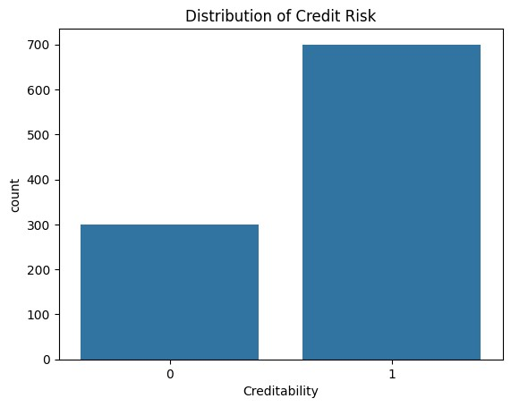
In [14]: df.hist(figsize=(15,10), bins=20) plt.tight_layout() plt.show()
In [16]:
for col in df.select_dtypes(include='object').columns:
sns.countplot(y=col, data=df) plt.title(f"Distribution of {col}") plt.show()
In [17]:
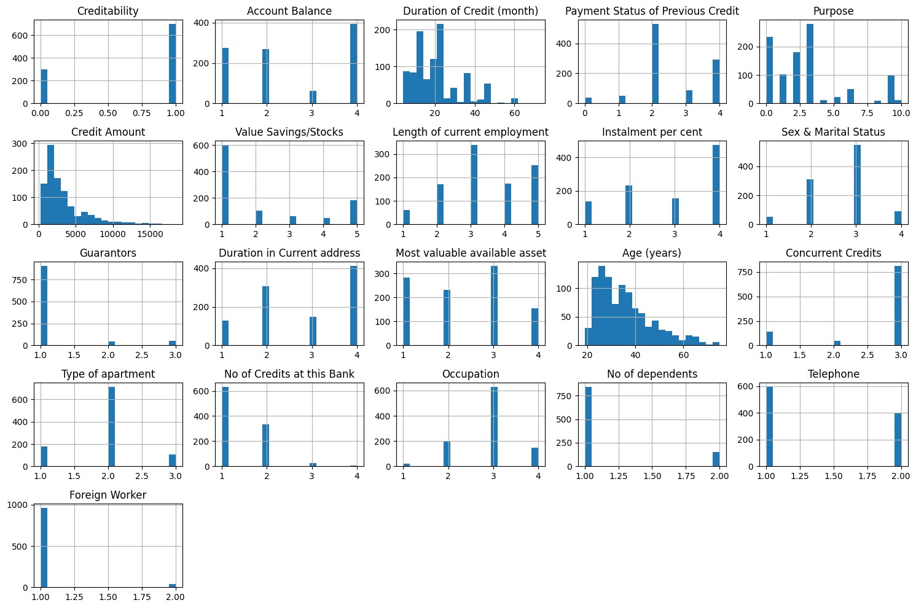
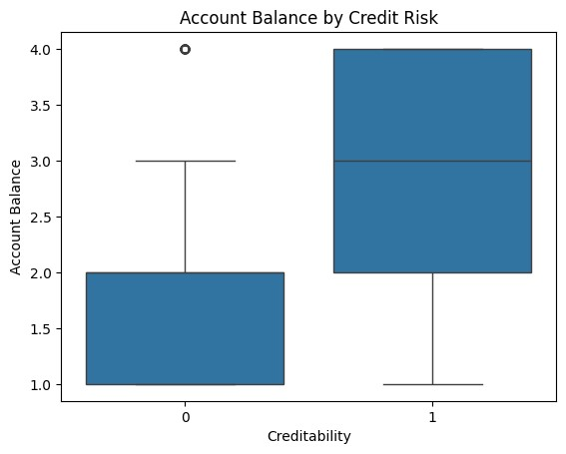
import seaborn as sns
for col in df.select_dtypes(include='number').columns:
if col != 'Creditability':
sns.boxplot(x='Creditability', y=col, data=df) plt.title(f"{col} by Credit Risk") plt.show()
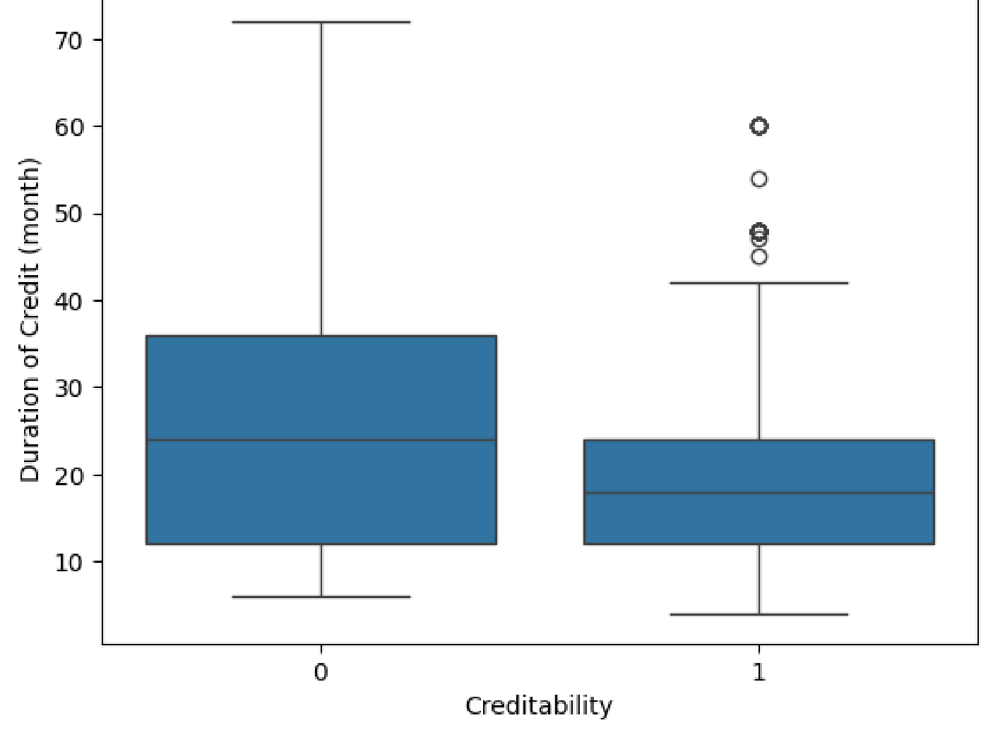
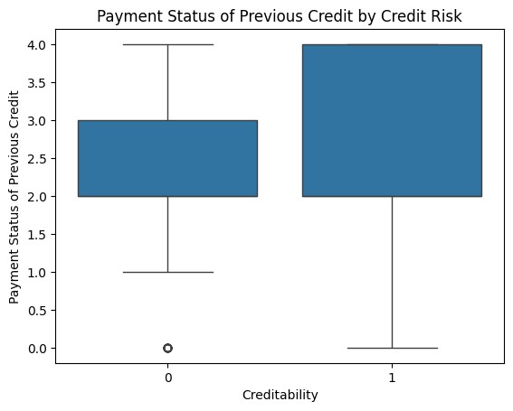
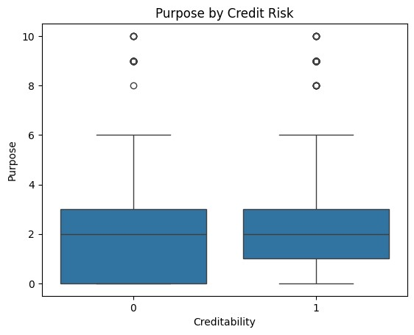

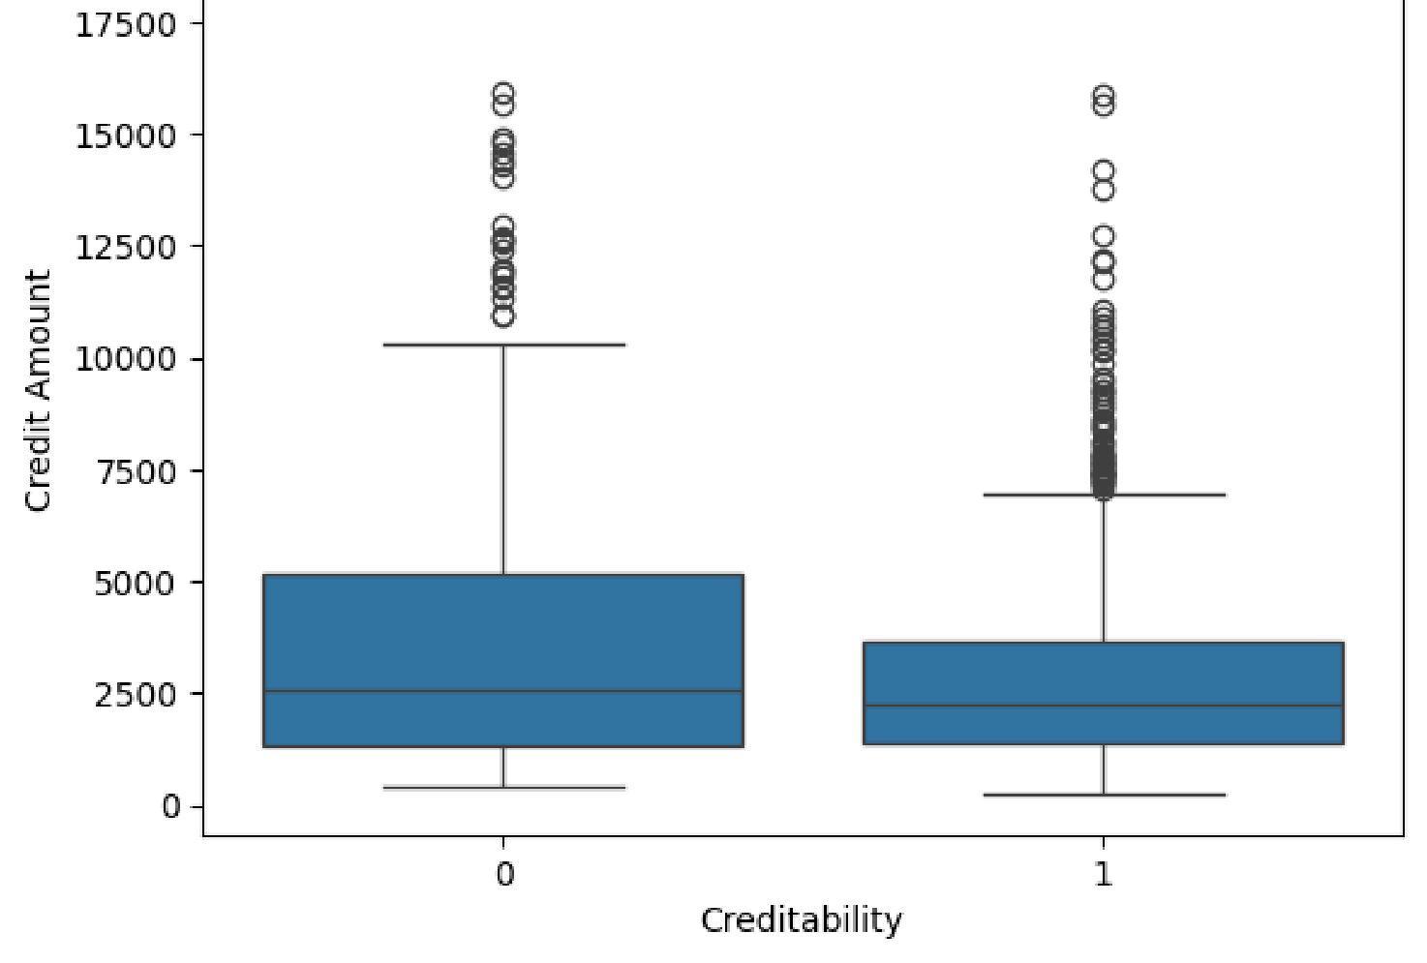
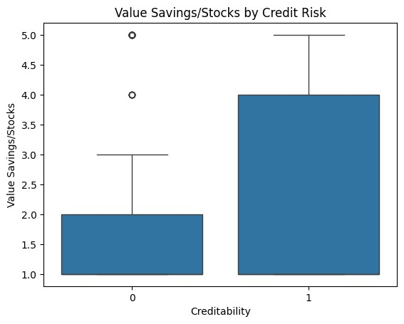
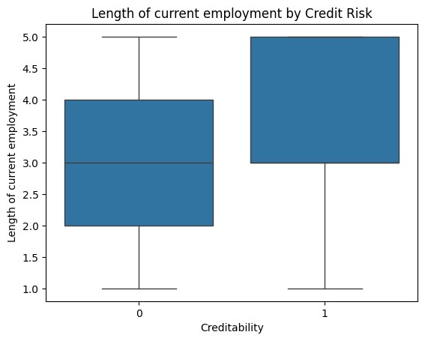
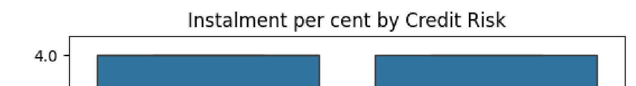

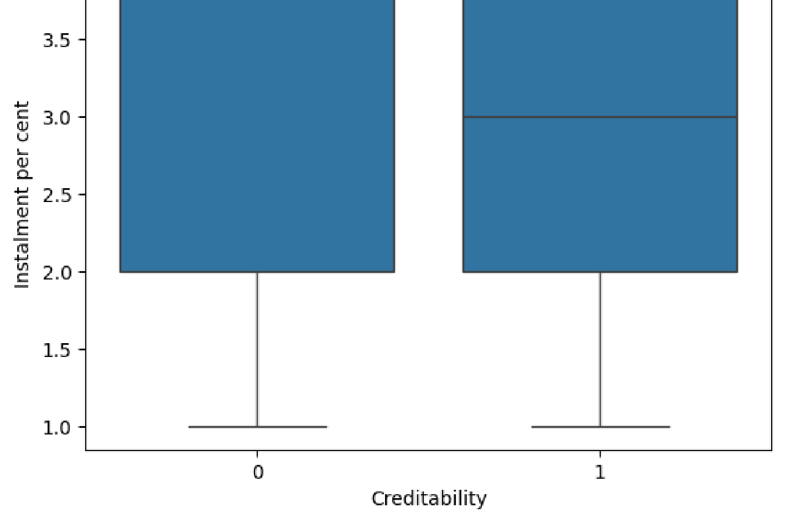
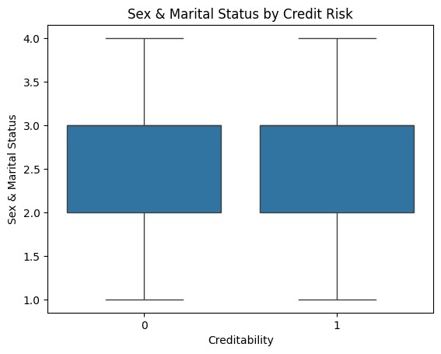
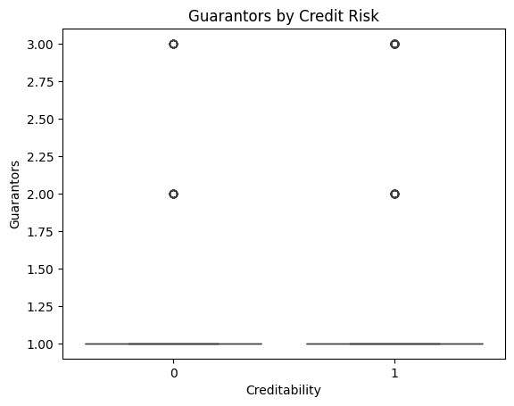
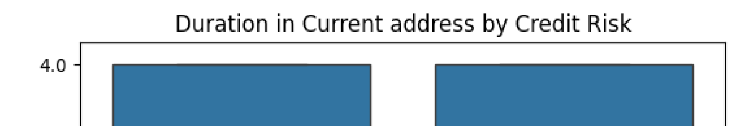

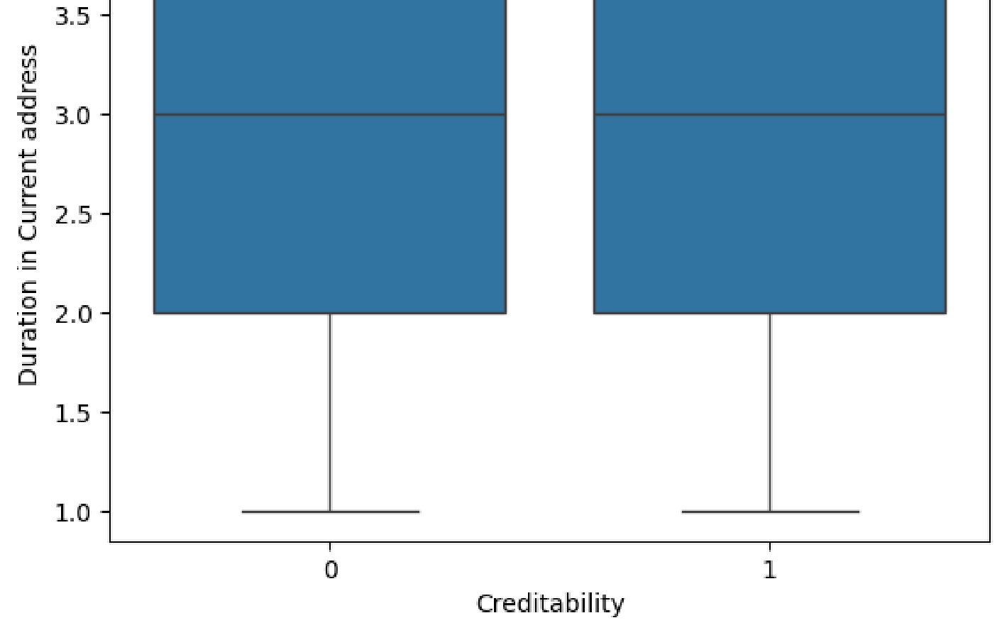
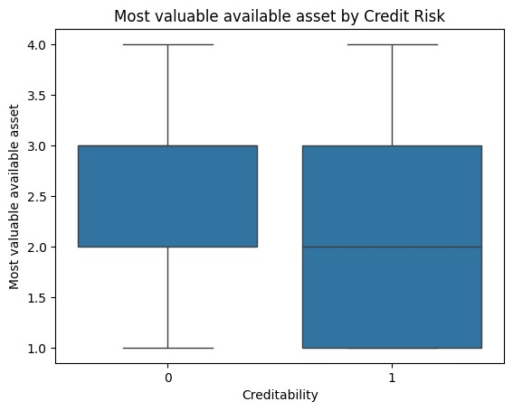
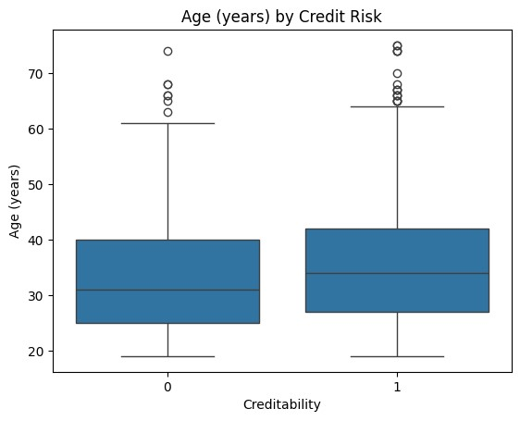
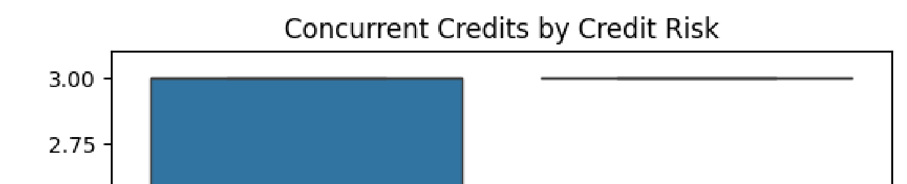

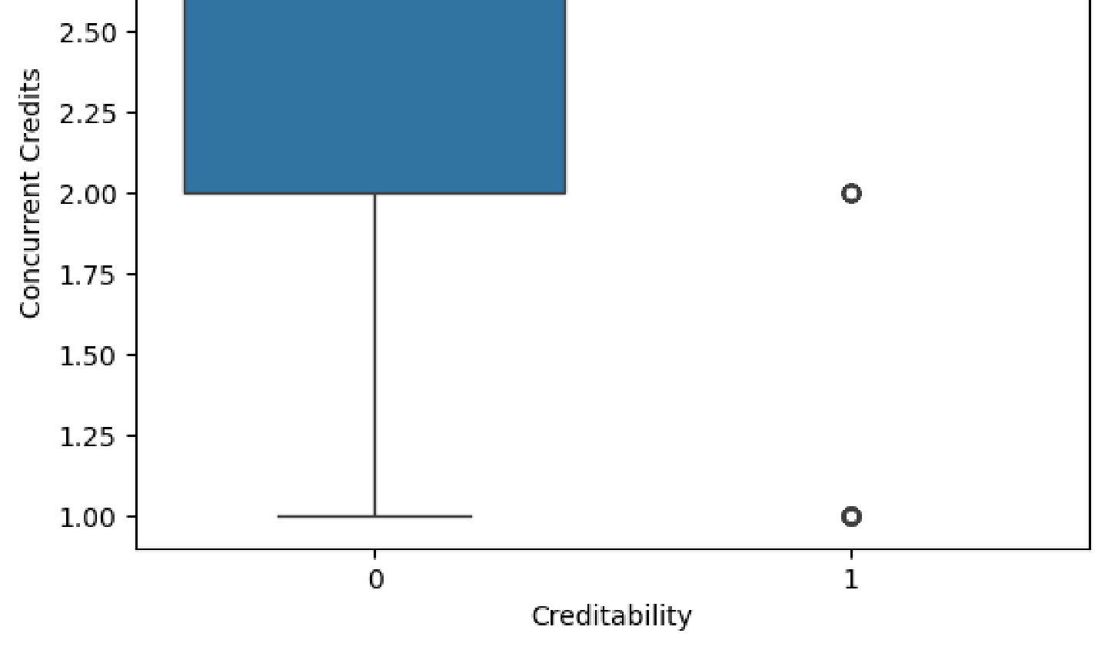
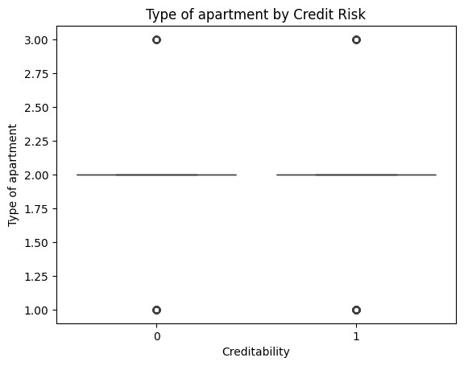
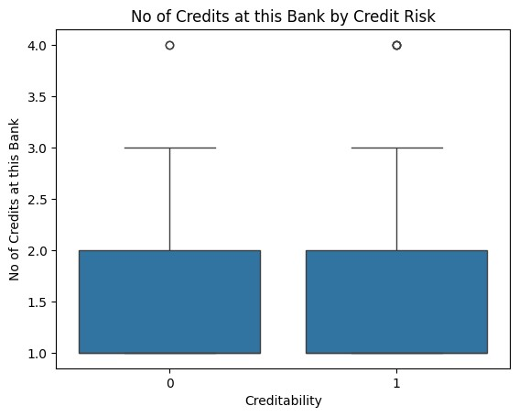
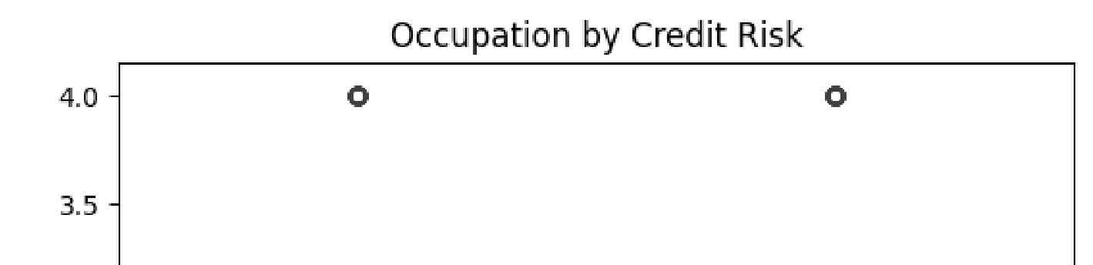

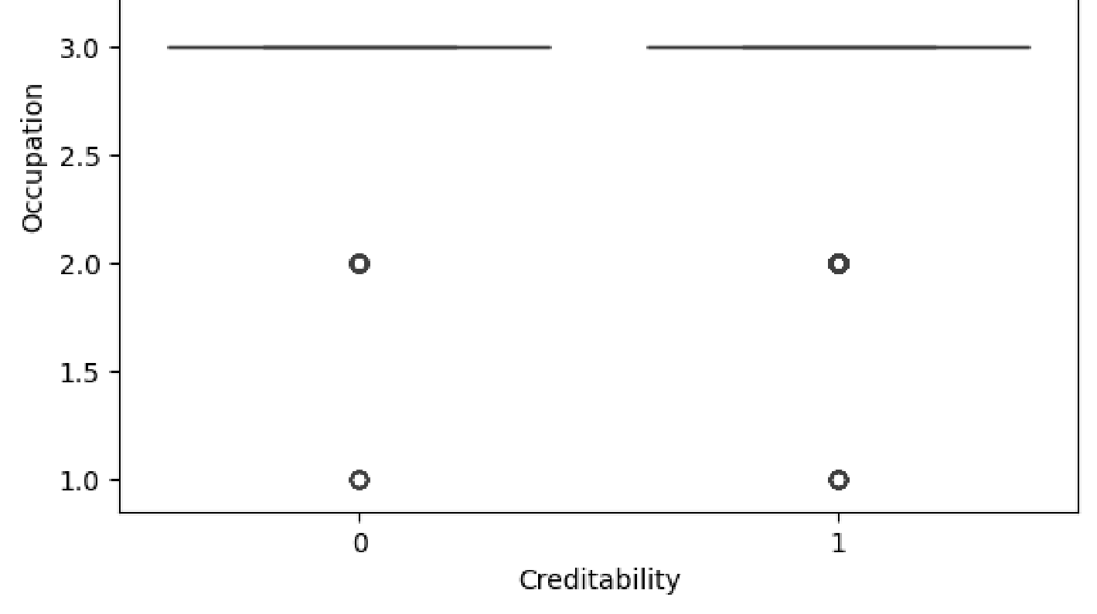
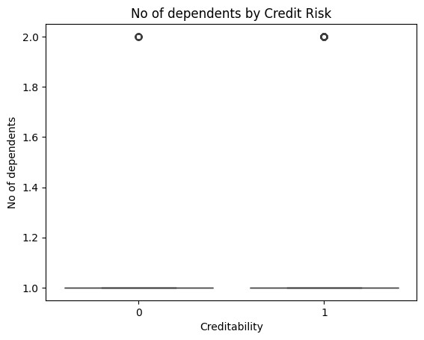
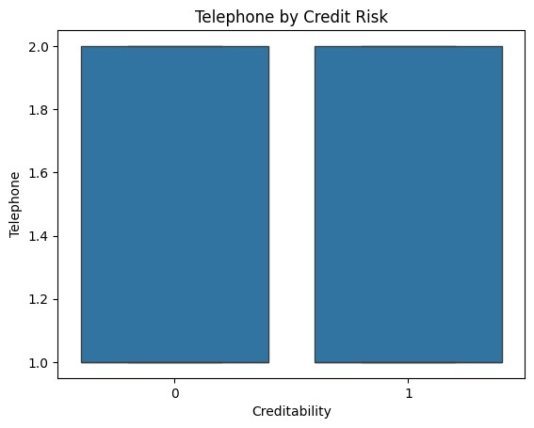
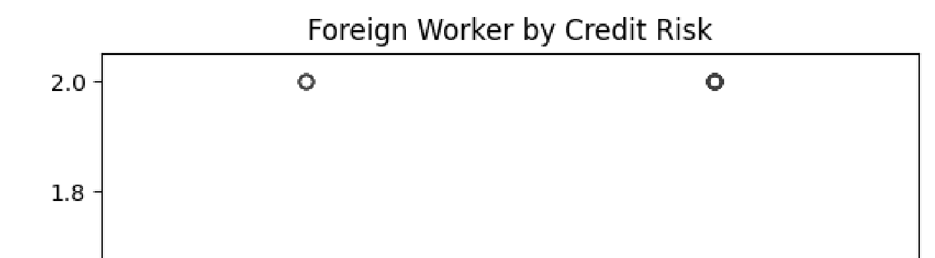
In [19]:
for col in df.select_dtypes(include='object').columns:
ct = pd.crosstab(df[col], df['CreditRisk'], normalize='index') ct.plot(kind='bar', stacked=True) plt.title(f"Creditability by {col}") plt.ylabel("Proportion") plt.show()
In [20]:
import numpy as np
corr = df.corr(numeric_only=True) sns.heatmap(corr, annot=True, cmap='coolwarm')
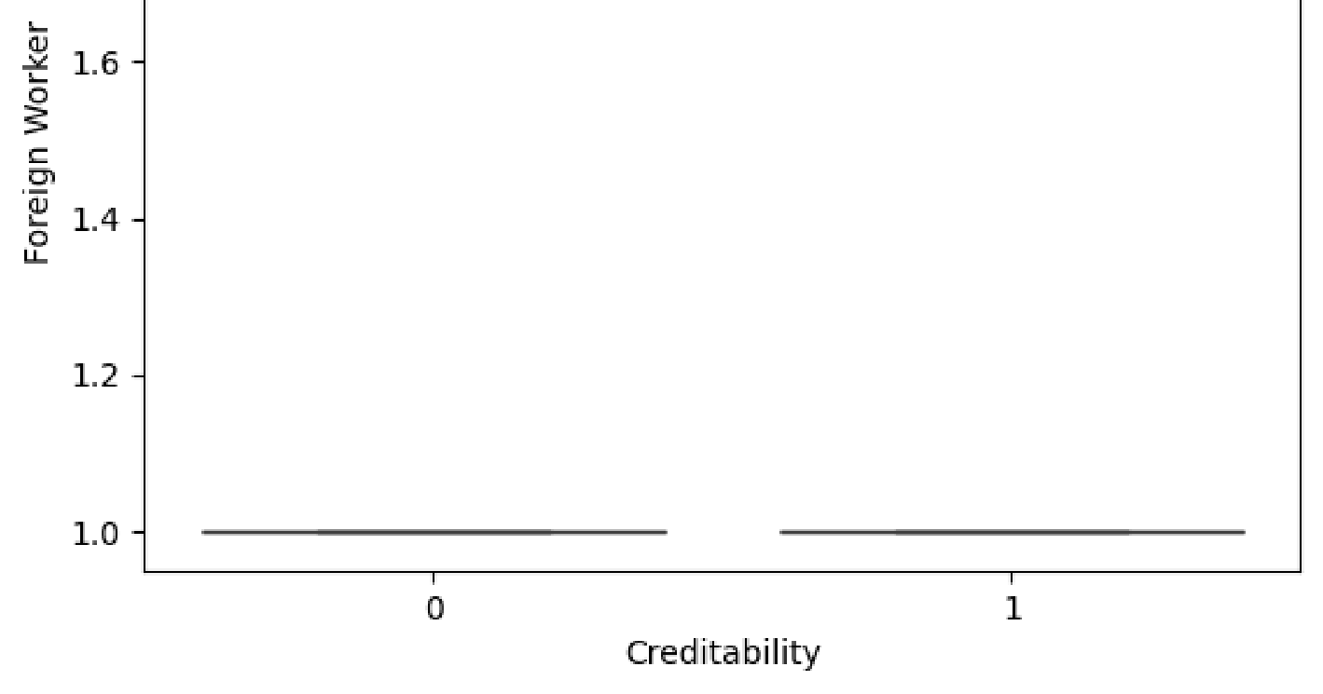
plt.title("Correlation Matrix") plt.show()
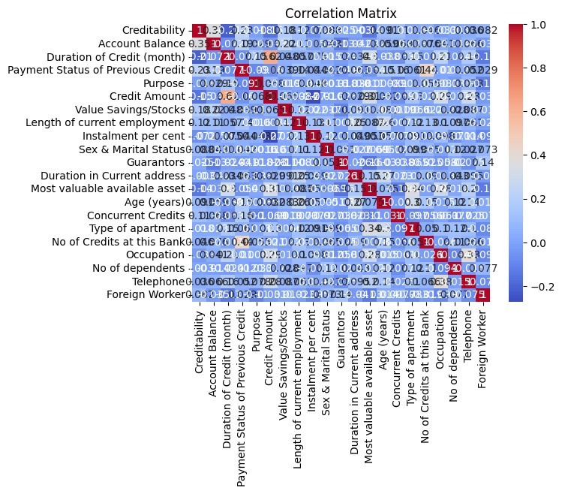
In [23]:
from sklearn.decomposition import PCA from sklearn.preprocessing import StandardScaler
X = df.drop("Creditability", axis=1).select_dtypes(include='number') X_scaled = StandardScaler().fit_transform(X)
pca = PCA(n_components=2) components = pca.fit_transform(X_scaled)
sns.scatterplot(x=components[:,0], y=components[:,1], hue=df['Creditability']) plt.title("PCA Plot") plt.show()
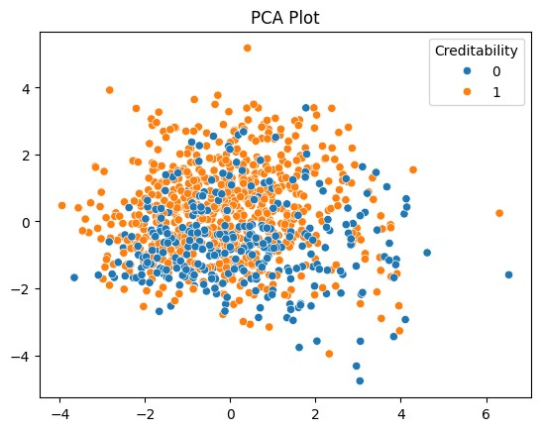
In [83]:
print("Class balance in full target y:") print(y.value_counts())
Class balance in full target y:
Creditability
1 1000
Name: count, dtype: int64
In [85]: print(df['Creditability'].describe())
count 1000.0 mean 1.0 std 0.0 min 1.0
25% 1.0
50% 1.0 75% 1.0 max 1.0
Name: Creditability, dtype: float64
In [87]:
import pandas as pd
df = pd.read_csv("C:/Users/Admin/Downloads/index_data.csv") print(df['Creditability'].value_counts())
Creditability
1 700
0 300
Name: count, dtype: int64
In [88]:
X = df.drop(columns=['Creditability']) y = df['Creditability']
In [89]:
X = pd.get_dummies(X, drop_first=True)
In [90]:
from sklearn.preprocessing import StandardScaler scaler = StandardScaler() X_scaled = scaler.fit_transform(X)
In [91]:
from sklearn.model_selection import train_test_split X_train, X_test, y_train, y_test = train_test_split(
X_scaled, y, test_size=0.3, random_state=42, stratify=y
)
In [92]:
from sklearn.linear_model import LogisticRegression model = LogisticRegression(max_iter=1000) model.fit(X_train, y_train)
Out[92]:
▾
LogisticRegression
i ?
Parameters
In [93]:
from sklearn.metrics import classification_report print(classification_report(y_test, model.predict(X_test)))
precision recall f1-score support
0 0.70 0.48 0.57 90 1 0.80 0.91 0.86 210
accuracy 0.78 300 macro avg 0.75 0.70 0.71 300 weighted avg 0.77 0.78 0.77 300
In [119]:
from sklearn.metrics import roc_curve, auc import matplotlib.pyplot as plt
# Get probability scores for the positive class y_score_lr = model.predict_proba(X_test)[:, 1]
# Calculate False Positive Rate and True Positive Rate fpr, tpr, _ = roc_curve(y_test, y_score_lr) roc_auc = auc(fpr, tpr)
# Plot ROC curve
plt.figure(figsize=(7, 5)) plt.plot(fpr, tpr, color='green', lw=2, label=f'Logistic Regression (AUC = {roc_auc:.2f})') plt.plot([0, 1], [0, 1], color='gray', linestyle='--') plt.xlabel('False Positive Rate') plt.ylabel('True Positive Rate') plt.title('ROC Curve - Logistic Regression') plt.legend(loc='lower right') plt.grid(True) plt.tight_layout() plt.show()
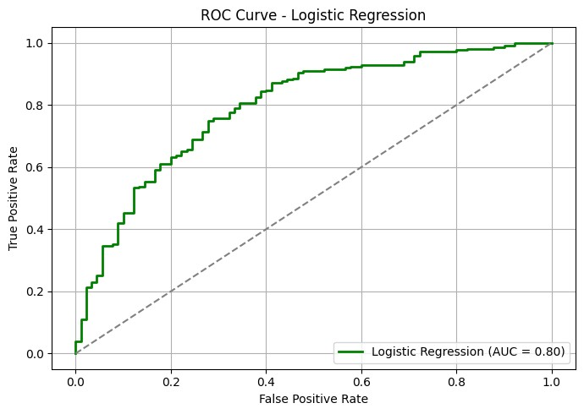
In [95]:
import pandas as pd
# Load the correct dataset (use lrgc_data.csv if you know it's clean) df = pd.read_csv("C:/Users/Admin/Downloads/index_data.csv")
# Confirm target balance print(df['Creditability'].value_counts()) # Expect both 0 and 1
Creditability
1 700
0 300
Name: count, dtype: int64
In [96]:
# Separate features and target
X = df.drop(columns=['Creditability']) y = df['Creditability']
# Encode categorical variables
X = pd.get_dummies(X, drop_first=True)
# Scale numerical features from sklearn.preprocessing import StandardScaler scaler = StandardScaler() X_scaled = scaler.fit_transform(X)
In [97]:
from sklearn.model_selection import train_test_split
X_train, X_test, y_train, y_test = train_test_split(
X_scaled, y, test_size=0.3, random_state=42, stratify=y
) In [98]:
from sklearn.ensemble import RandomForestClassifier
rf_model = RandomForestClassifier(n_estimators=100, random_state=42) rf_model.fit(X_train, y_train)
Out[98]:
▾
RandomForestClassifier
i ?
Parameters
In [99]:
from sklearn.metrics import classification_report, confusion_matrix
y_pred_rf = rf_model.predict(X_test)
print("Confusion Matrix:") print(confusion_matrix(y_test, y_pred_rf))
print("\nClassification Report:") print(classification_report(y_test, y_pred_rf))
Confusion Matrix:
[[ 40 50]
[ 16 194]]
Classification Report:
precision recall f1-score support
0 0.71 0.44 0.55 90 1 0.80 0.92 0.85 210
accuracy 0.78 300 macro avg 0.75 0.68 0.70 300 weighted avg 0.77 0.78 0.76 300
In [100]:
from sklearn.metrics import roc_curve, auc import matplotlib.pyplot as plt
# Predict probabilities y_score_rf = rf_model.predict_proba(X_test)[:, 1]
fpr, tpr, _ = roc_curve(y_test, y_score_rf) roc_auc = auc(fpr, tpr)
plt.figure(figsize=(6, 5)) plt.plot(fpr, tpr, label=f'Random Forest (AUC = {roc_auc:.2f})') plt.plot([0, 1], [0, 1], linestyle='--', color='gray') plt.xlabel('False Positive Rate') plt.ylabel('True Positive Rate') plt.title('ROC Curve - Random Forest') plt.legend(loc='lower right') plt.grid(True) plt.show()
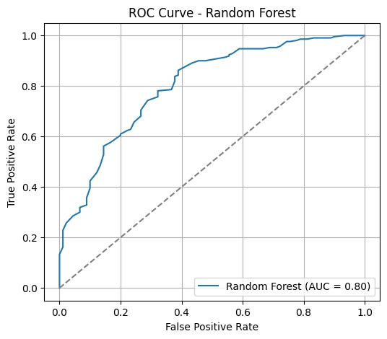
In [101]:
import pandas as pd from sklearn.model_selection import train_test_split from sklearn.preprocessing import StandardScaler from sklearn.metrics import classification_report, confusion_matrix from xgboost import XGBClassifier
In [103]: df = pd.read_csv("C:/Users/Admin/Downloads/index_data.csv")
In [104]:
target_column = 'Creditability' if 'Creditability' in df.columns else df.columns[-1]
In [105]:
X = df.drop(columns=[target_column]) y = df[target_column]
In [106]:
X = pd.get_dummies(X, drop_first=True)
In [139]: X = X.loc[y.notna()] y = y.loc[y.notna()]
In [108]:
scaler = StandardScaler() X_scaled = scaler.fit_transform(X)
In [109]:
X_train, X_test, y_train, y_test = train_test_split(
X_scaled, y, test_size=0.3, random_state=42, stratify=y
) In [110]: xgb_model = XGBClassifier( use_label_encoder=False, eval_metric='logloss', n_estimators=50, random_state=42
)
In [138]: xgb_model.fit(X_train, y_train)
C:\Users\Admin\AppData\Local\Programs\Python\Python313\Lib\site-packages\xgboost\training.py:183: UserWarning: [14:23:07] WARNING: C:\actions-runner\_work\xgb oost\xgboost\src\learner.cc:738:
Parameters: { "use_label_encoder" } are not used.
bst.update(dtrain, iteration=i, fobj=obj)
Out[138]: ▾ XGBClassifier
i ?
Parameters
In [114]:
y_pred = xgb_model.predict(X_test)
In [115]:
print("Confusion Matrix:\n", confusion_matrix(y_test, y_pred)) print("\nClassification Report:\n", classification_report(y_test, y_pred))
Confusion Matrix:
[[ 44 46]
[ 27 183]]
Classification Report:
precision recall f1-score support
0 0.62 0.49 0.55 90 1 0.80 0.87 0.83 210
accuracy 0.76 300 macro avg 0.71 0.68 0.69 300 weighted avg 0.75 0.76 0.75 300
In [116]:
from sklearn.metrics import accuracy_score, classification_report
# Predictions y_pred_train = model.predict(X_train) y_pred_test = model.predict(X_test)
# Training performance print(" Training Accuracy:", accuracy_score(y_train, y_pred_train)) print(" Training Report:\n", classification_report(y_train, y_pred_train))
# Testing performance print(" Testing Accuracy:", accuracy_score(y_test, y_pred_test)) print(" Testing Report:\n", classification_report(y_test, y_pred_test))
Training Accuracy: 0.78
Training Report:
precision recall f1-score support
0 0.69 0.49 0.57 210 1 0.81 0.90 0.85 490
accuracy 0.78 700 macro avg 0.75 0.70 0.71 700 weighted avg 0.77 0.78 0.77 700
Testing Accuracy: 0.7833333333333333
Testing Report:
precision recall f1-score support
0 0.70 0.48 0.57 90 1 0.80 0.91 0.86 210
accuracy 0.78 300 macro avg 0.75 0.70 0.71 300 weighted avg 0.77 0.78 0.77 300
In [121]:
print(" y_train sample:") print(y_train.head())
print("\n y_test sample:") print(y_test.head())
y_train sample: 247 1
667 1
191 1
181 1
368 1 Name: Creditability, dtype: int64
y_test sample: 521 0
124 1
51 1
366 1
602 1
Name: Creditability, dtype: int64 In [122]:
print(" y_train class distribution:") print(y_train.value_counts())
print("\n y_test class distribution:") print(y_test.value_counts())
y_train class distribution:
Creditability
1 490
- 210 Name: count, dtype: int64
y_test class distribution:
Creditability
- 210
0 90
Name: count, dtype: int64
In [123]:
print("y_train shape:", y_train.shape) print("y_test shape:", y_test.shape)
y_train shape: (700,) y_test shape: (300,)
In [124]:
print("y_train class distribution:") print(y_train.value_counts()) print("\ny_test class distribution:") print(y_test.value_counts())
y_train class distribution:
Creditability
1 490
- 210 Name: count, dtype: int64
y_test class distribution:
Creditability
- 210
0 90
Name: count, dtype: int64
In [117]:
from sklearn.metrics import roc_curve, auc import matplotlib.pyplot as plt
# Predict probabilities for test set y_score = xgb_model.predict_proba(X_test)[:, 1]
# Compute ROC curve and AUC
fpr, tpr, _ = roc_curve(y_test, y_score) roc_auc = auc(fpr, tpr)
# Plot ROC curve
plt.figure(figsize=(7, 5)) plt.plot(fpr, tpr, color='blue', lw=2, label=f'XGBoost (AUC = {roc_auc:.2f})') plt.plot([0, 1], [0, 1], color='gray', lw=1, linestyle='--') plt.xlabel('False Positive Rate') plt.ylabel('True Positive Rate') plt.title('ROC Curve - XGBoost Classifier') plt.legend(loc='lower right') plt.grid(True) plt.tight_layout() plt.show()
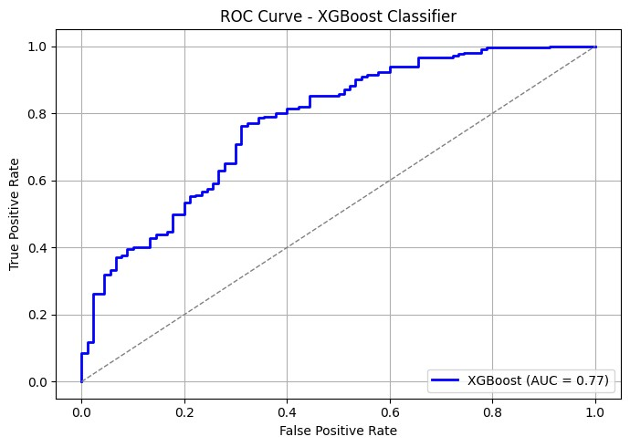
In [135]:
from sklearn.metrics import confusion_matrix
print("Logistic Regression") print(confusion_matrix(y_test, y_pred_lr))
print("\nRandom Forest") print(confusion_matrix(y_test, y_pred_rf))
print("\nXGBoost") print(confusion_matrix(y_test, y_pred_xgb))
Logistic Regression
[[ 43 47]
[ 18 192]]
Random Forest
[[ 40 50]
[ 16 194]]
XGBoost
[[ 43 47]
[ 28 182]] In [126]:
from sklearn.linear_model import LogisticRegression
lr_model = LogisticRegression(max_iter=1000) lr_model.fit(X_train, y_train)
Out[126]:
▾
LogisticRegression
i ?
Parameters
In [134]:
y_pred_lr = lr_model.predict(X_test)
In [133]: y_pred_xgb = xgb_model.predict(X_test)
In [136]: from sklearn.metrics import classification_report
print("Logistic Regression:\n", classification_report(y_test, y_pred_lr)) print("Random Forest:\n", classification_report(y_test, y_pred_rf)) print("XGBoost:\n", classification_report(y_test, y_pred_xgb))
Logistic Regression:
precision recall f1-score support
0 0.70 0.48 0.57 90 1 0.80 0.91 0.86 210
accuracy 0.78 300 macro avg 0.75 0.70 0.71 300 weighted avg 0.77 0.78 0.77 300
Random Forest:
precision recall f1-score support
0 0.71 0.44 0.55 90 1 0.80 0.92 0.85 210
accuracy 0.78 300 macro avg 0.75 0.68 0.70 300 weighted avg 0.77 0.78 0.76 300
XGBoost:
precision recall f1-score support
0 0.61 0.48 0.53 90 1 0.79 0.87 0.83 210
accuracy 0.75 300 macro avg 0.70 0.67 0.68 300 weighted avg 0.74 0.75 0.74 300
In [137]:
from sklearn.metrics import roc_curve, auc import matplotlib.pyplot as plt
# Get probabilities lr_probs = lr_model.predict_proba(X_test)[:, 1] rf_probs = rf_model.predict_proba(X_test)[:, 1] xgb_probs = xgb_model.predict_proba(X_test)[:, 1]
# Calculate ROC curve and AUC
fpr_lr, tpr_lr, _ = roc_curve(y_test, lr_probs) fpr_rf, tpr_rf, _ = roc_curve(y_test, rf_probs) fpr_xgb, tpr_xgb, _ = roc_curve(y_test, xgb_probs)
auc_lr = auc(fpr_lr, tpr_lr) auc_rf = auc(fpr_rf, tpr_rf) auc_xgb = auc(fpr_xgb, tpr_xgb)
# Plot plt.figure(figsize=(8, 6)) plt.plot(fpr_lr, tpr_lr, label=f"Logistic (AUC = {auc_lr:.2f})", color='blue') plt.plot(fpr_rf, tpr_rf, label=f"Random Forest (AUC = {auc_rf:.2f})", color='green') plt.plot(fpr_xgb, tpr_xgb, label=f"XGBoost (AUC = {auc_xgb:.2f})", color='red')
plt.plot([0, 1], [0, 1], 'k--')
plt.title('ROC Curve Comparison') plt.xlabel('False Positive Rate') plt.ylabel('True Positive Rate') plt.legend() plt.grid(True) plt.tight_layout() plt.show()
In [140]:
print("X_train shape:", X_train.shape) print("X_test shape:", X_test.shape) print("y_train shape:", y_train.shape) print("y_test shape:", y_test.shape)
X_train shape: (700, 20) X_test shape: (300, 20) y_train shape: (700,) y_test shape: (300,)
In [141]:
print("y_train class distribution:\n", y_train.value_counts(normalize=True)) print("y_test class distribution:\n", y_test.value_counts(normalize=True))
y_train class distribution:
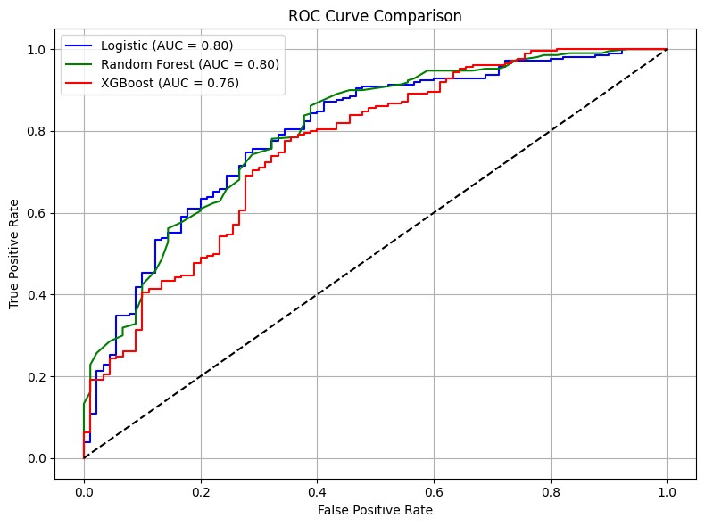
Creditability
1 0.7
- 0.3
Name: proportion, dtype: float64 y_test class distribution:
Creditability
- 0.7
0 0.3
Name: proportion, dtype: float64
In [142]:
import pandas as pd
X_train_df = pd.DataFrame(X_train) X_test_df = pd.DataFrame(X_test)
print("\nX_train summary:\n", X_train_df.describe()) print("\nX_test summary:\n", X_test_df.describe())
X_train summary:
0 1 2 3 4 5 \
count 700.000000 700.000000 700.000000 700.000000 700.000000 700.000000 mean -0.011251 -0.003212 -0.020454 -0.024790 -0.035779 -0.012212 std 1.007111 0.998880 0.993524 0.994291 0.969851 0.997579 min -1.254566 -1.402415 -2.350870 -1.030963 -1.070856 -0.699707
25% -1.254566 -0.738668 -0.503428 -0.666407 -0.683894 -0.699707
50% -0.459026 -0.240857 -0.503428 -0.301852 -0.360909 -0.699707 75% 1.132053 0.256953 1.344014 0.062704 0.210539 0.566731 max 1.132053 3.243815 1.344014 2.614592 4.492104 1.833169
6 7 8 9 10 11 \
count 700.000000 700.000000 700.000000 700.000000 700.000000 700.000000 mean -0.009226 -0.021847 -0.016956 0.037400 0.011007 0.003266 std 1.009840 1.006961 0.992341 1.049240 1.012296 0.996993 min -1.973997 -1.764514 -2.376626 -0.303686 -1.672459 -1.293723
25% -0.317959 -0.870183 -0.963650 -0.303686 -0.765977 -1.293723
50% -0.317959 0.024147 0.449326 -0.303686 0.140505 -0.341055 75% 1.338078 0.918477 0.449326 -0.303686 1.046987 0.611613 max 1.338078 0.918477 1.862303 3.885083 1.046987 1.564281
12 13 14 15 16 17 \
count 700.000000 700.000000 700.000000 700.000000 700.000000 700.000000 mean 0.013924 -0.011141 0.017253 -0.017073 -0.001749 0.005921 std 1.016168 1.008277 1.002401 0.988305 1.005136 1.006330 min -1.457831 -2.375050 -1.751205 -0.704926 -2.914492 -0.428290
25% -0.752799 0.460831 0.135869 -0.704926 0.146949 -0.428290
50% -0.224024 0.460831 0.135869 -0.704926 0.146949 -0.428290 75% 0.569138 0.460831 0.135869 1.027079 0.146949 -0.428290 max 3.477397 0.460831 2.022944 4.491089 1.677670 2.334869
18 19
count 700.000000 700.000000 mean -0.011063 0.038597 std 0.998485 1.090667 min -0.823318 -0.196014
25% -0.823318 -0.196014
50% -0.823318 -0.196014 75% 1.214598 -0.196014 max 1.214598 5.101669
X_test summary:
0 1 2 3 4 5 \
count 300.000000 300.000000 300.000000 300.000000 300.000000 300.000000 mean 0.026253 0.007495 0.047726 0.057843 0.083485 0.028495 std 0.986069 1.005904 1.016664 1.014156 1.065616 1.008381 min -1.254566 -1.402415 -2.350870 -1.030963 -1.061640 -0.699707
25% -0.657911 -0.738668 -0.503428 -0.666407 -0.649159 -0.699707
50% -0.459026 -0.240857 -0.503428 0.062704 -0.297110 -0.699707 75% 1.132053 0.568085 1.344014 0.062704 0.399634 0.566731 max 1.132053 4.239436 1.344014 2.614592 5.370764 1.833169
6 7 8 9 10 11 \
count 300.000000 300.000000 300.000000 300.000000 300.000000 300.000000 mean 0.021528 0.050977 0.039563 -0.087266 -0.025684 -0.007621 std 0.979690 0.985040 1.019862 0.871709 0.973600 1.010269 min -1.973997 -1.764514 -2.376626 -0.303686 -1.672459 -1.293723
25% -0.317959 -0.870183 -0.963650 -0.303686 -0.765977 -1.293723
50% -0.317959 0.024147 0.449326 -0.303686 0.140505 -0.341055 75% 1.338078 0.918477 0.449326 -0.303686 1.046987 0.611613 max 1.338078 0.918477 1.862303 3.885083 1.046987 1.564281
12 13 14 15 16 17 \
count 300.000000 300.000000 300.000000 300.000000 300.000000 300.000000 mean -0.032490 0.025996 -0.040258 0.039836 0.004082 -0.013816 std 0.963830 0.983290 0.996556 1.028967 0.991256 0.988293 min -1.369702 -2.375050 -1.751205 -0.704926 -2.914492 -0.428290
25% -0.752799 0.460831 0.135869 -0.704926 0.146949 -0.428290
50% -0.224024 0.460831 0.135869 -0.704926 0.146949 -0.428290 75% 0.481009 0.460831 0.135869 1.027079 0.146949 -0.428290 max 3.477397 0.460831 2.022944 4.491089 1.677670 2.334869
18 19
count 300.000000 300.000000 mean 0.025814 -0.090061 std 1.006385 0.742915 min -0.823318 -0.196014
25% -0.823318 -0.196014
50% -0.823318 -0.196014 75% 1.214598 -0.196014 max 1.214598 5.101669
In [143]:
from sklearn.metrics import accuracy_score
train_preds = model.predict(X_train) test_preds = model.predict(X_test)
print("Train Accuracy:", accuracy_score(y_train, train_preds)) print("Test Accuracy :", accuracy_score(y_test, test_preds))
Train Accuracy: 0.78 Test Accuracy : 0.7833333333333333
In [ ]:

