Faster than maven

Maven executes the same task again even if nothing has changed

Gradle skips the task if nothing has changed, hence faster (incremental build)

Written in Groovy or Kotlin

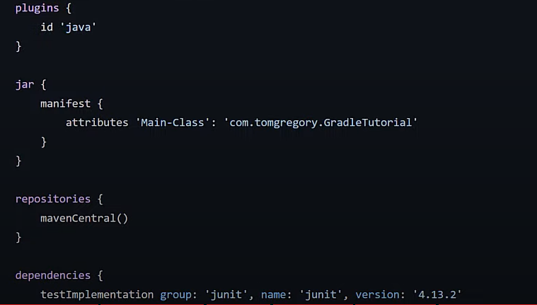

The above is Groovy

Plugins attribute tells which type of language gradle need to build

Jar specifies the manifest file without which the built jar file cannot run

Repositories – specifies the location used to download the dependency classes

Dependencies – list of all class file required to run the project