FD(fixed deposit)

* One time payment
* Fixed tenure - 7days – 10year
* Interest amount will be credited monthy or quarterly
* taxable
* TDS – if annual interest accumulates more than 40k, will be deducted
* Choose good banks always (small banks like yes banks crash)

T-bills (treasury bills)

* Safer than FD, since money is being handled by state/central govt.
* Cannot withdraw money in between tenure, if done will lose principal amt

RD

* Monthly payment
* Fixed interest
* Fixed tenure
* taxable
* TDS – if annual interest accumulates more than 40k, will be deducted

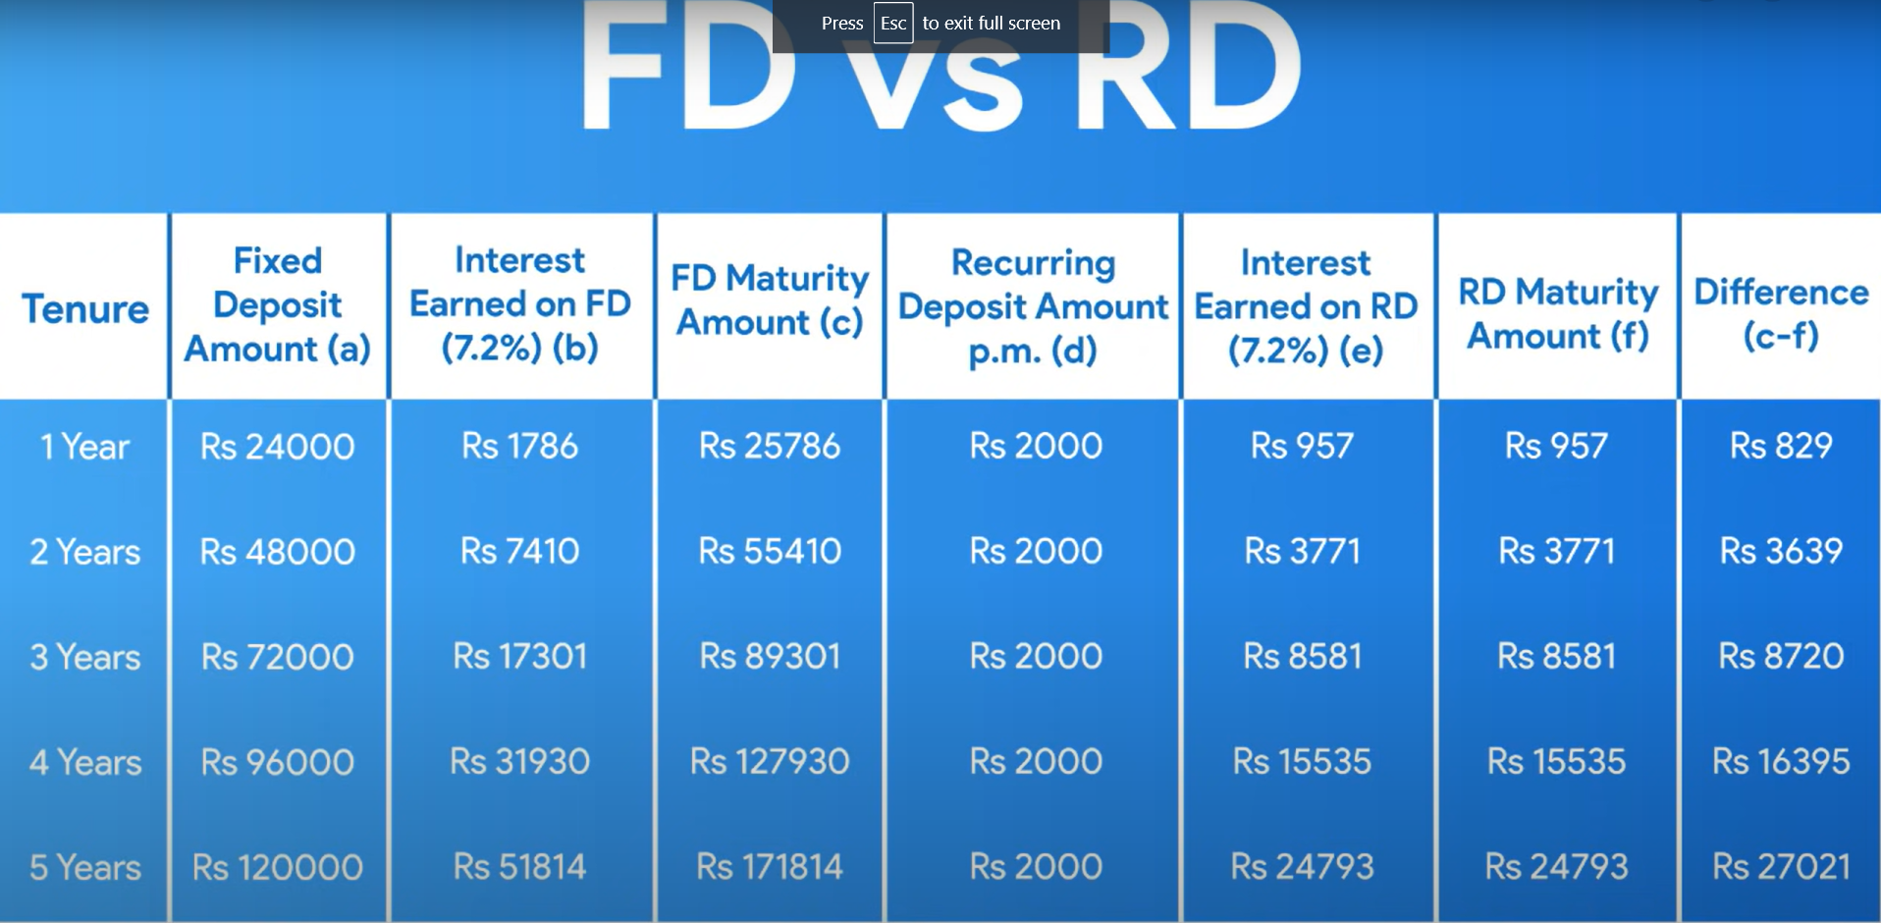

FD is better than RD

We get better interest returns in FD

PPF(public provident fund)

* By government
* Principal and interest amount guaranteed
* Interest is tax free
* Can open with post office, nationalised banks, major private banks

PPF better than FD

* We get better interest returns in PPF
* Will get pass book, can check status online
* NRI cant open account
* Min contribution – 500 /-
* Max contribution – 1.5lacs
* Matures after 15th year of plan’s start date
* Transferable from post office to bank, vice versa, within banks
* Can not close within 5 years
* Can extend the plan after 15th year also, but can extend only for 5 years and later 5 years..

Mutual fund

- ask about entry load , exit load , expense ratio while starting a SIP

- Great returns only after a long period of time

- if not able to pay monthly, can take the money out(exit load), a penalty will be imposed

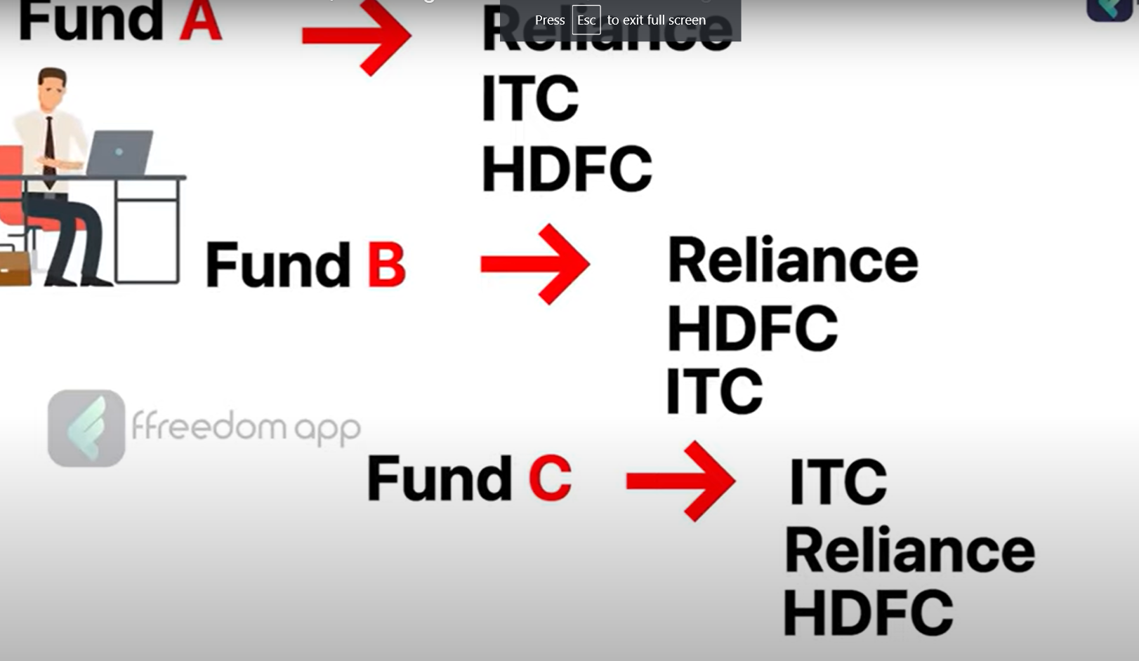

- make sure to the investor invests in separate companies and not just in the same set of companies, because if ITC fails, it will affect all three funds of yours

* Invest in a pool of different companies
* Invest in different sectors (IT , retail , government)

How Mutual fund companies operate

* They get money from many people on a monthly basis
* Pool that money, invest in different things
* Get profit thru interest, gain, dividend
* Give back a part of this money as profit to investors
* Rest profit is taken by the MF company for their profit (expense ratio)

Types of MF

* Equity MF – collects the money, pools it, and invests in stock
* Debt MF – Invests in debt
* Hybrid MF – invests in both debt and equity
* Solution oriented MF – invest in solutions like child education
* Other MF – invests in sensex, nifty

If u r investing in

AUM (asset under management)

-if AUM is more -> implies more investors have participated in that asset, therefore less EXPENSE RATIO

-less AUM does not always mean less returns and bad profit

-preferable to go with high AUM

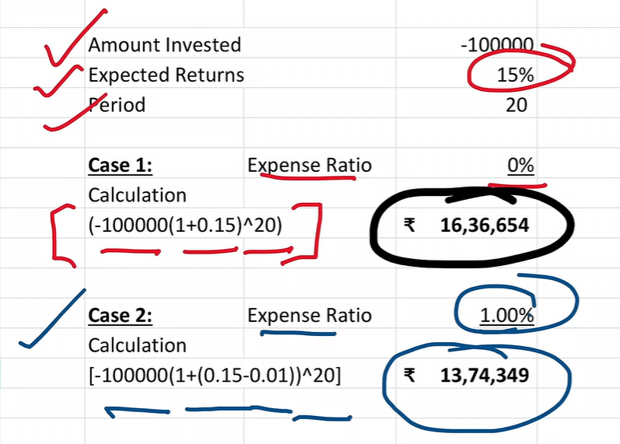

The above shows the returns when expense ratio is 0% and 1% for period of 20 yrs

-always choose an SIP with less expense ratio

Index fund

* Same as MF
* Expense ratio is less
* Invests in top 50 nifty companies, no thought process is involved, therefore less expense ratio