Addition of Two Numbers Using Lex Program

AIM:
To write a Lex program to accept two numbers from the user and calculate their sum.

PSEUDOCODE:
- Start.
- Declare variables num1, num2, and count.
- Read the input using the Lex analyzer.
- Store the first number in num1 and the second number in num2.
- Calculate the sum of the two numbers.
- Display the sum.
- Stop.

SOURCE CODE:
%{
#include <stdio.h>
#include <stdlib.h>
int num1, num2, count = 0;
%}
%%
[0-9]+ {
if (count == 0)
num1 = atoi(yytext);
else
num2 = atoi(yytext);
count++;
if (count == 2) {
printf("Sum = %d\n", num1 + num2);
return 0;
}
}
[ \t\n]+ ;
. { printf("Invalid input\n"); }
%%
int yywrap(void)
{
return 1;
}
int main(void)
{
printf("Enter two numbers: ");
yylex();
return 0;
}

OUTPUT:

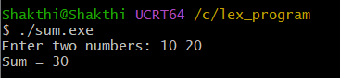

RESULT: Thus, the Lex program to add two numbers was implemented and executed successfully, producing the sum as output.

