(6115) MAHENDRA INSTITUTE OF ENGINEERING AND TECNOLOGY
ENVIRONMENTAL MONITORING

TEAM MEMBERS:
✯ M.SARATHI
✯ M.PUGAZHENTHI
✯ S.OMKAR SATYAVAN SURYAVANSHI
✯ S.SANJAI
✯ E.SAKTHIVEL
✯ M.RAGHUVARAN
Mentor Name:
✯ M.SANTHANA RAJ
IOT Innovation in Environmental Monitorig
Monitoring
Proposed System:
In this proposed model the climatic changes are frequently monitoring through IOT using sensor nodes. Internet of Things (IoT) is a recent communication paradigm, in which the objects will be equipped with microcontrollers, transceivers and suitable protocol stack that will make them to communicate with one another and with user. This paper designs a prototype of wireless environmental monitoring system to upload information from array of sensors to the database. This application allows us to observe or measuring the environmental parameters from anywhere in real time. This system consist of main three modules namely sensor nodes, the wireless communication and the web server. The sensor nodes in remote location collect the information from surrounding environmental conditions and send the data wirelessly using Arduino microcontroller and ESP8266 Wi-Fi module to the server. This paper presents a system that can be used to measure the toxic gases in surrounding area like Industrial area by using various sensor nodes. All sensors are connected on the arduino microcontroller and the status of the sensors is send to the control section continuously. The data uploading is done by ESP 8266 Wi-Fi module. The data is updated on internet. The values of sensors are displayed on LCD. The buzzer is used to make sound, if the sensor beyond its threshold value for saving the people immediately. The device developed in this project is based Arduino UNO. The Arduino board connects with Thing Speak platform using ESP8266 Wi-Fi Module. The Thing Speak is a popular IOT platform which is easy to use and program.
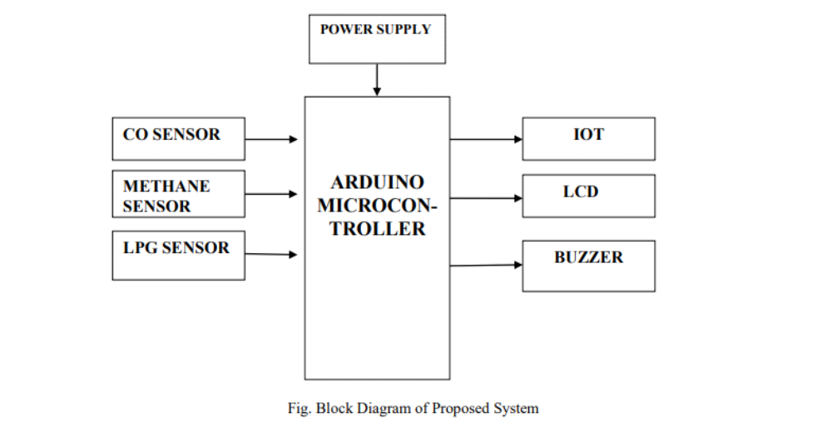
Wi-Fi module is managed by the Arduino Sketch. The Arduino sketch is written, compiled and loaded to the Arduino board using Arduino IDE.From the above model, process is divided in 5 layers. The environmental parameters which are to be measured are introduced in layer 1. Study of the characteristics and features of sensor devices is in layer 2. In layer 3, there is decision making on sensing, measuring and fixing the threshold value, periodicity of sensitivity, timing, space and Led.
Importance of environmental monitoring:
Environmental monitoring is essential that helps us keep tabs health of the environment, air, water, and soil quality. By monitoring these critical aspects, we can quickly identify any negative trends or changes that could be harmful to human health or ecosystems. The primary objectives of environmental monitoring include identifying sources of environmental pollution, tracking the movement of pollutants, monitoring changes in environmental conditions over time, assessing the effectiveness of pollution control measures, and providing data for decision making and policy development.
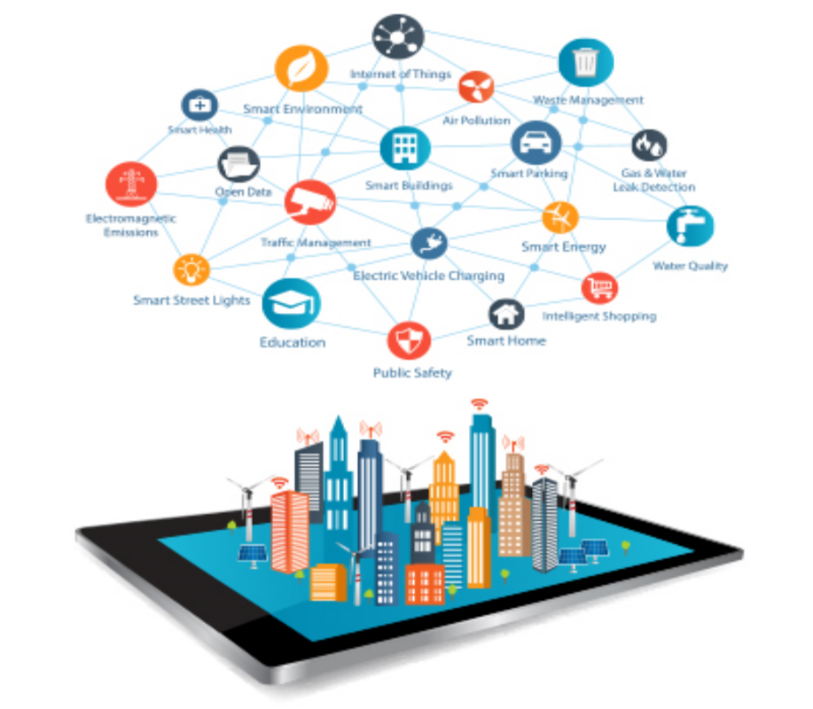
Challenges in Environmental monitoring:
The challenges in environmental monitoring are multiple – improving sample throughput; handling a variety of gaseous, liquid and solid matrices; reliably sampling a wide range of VOCs and SVOCs… the list goes on!
This will be my first time at these shows, so I’m looking forward to going along and meeting the major players in the UK environmental scene, as well as seeing the latest developments in monitoring technology to tackle emerging challenges.

Implementation pollution control measures:
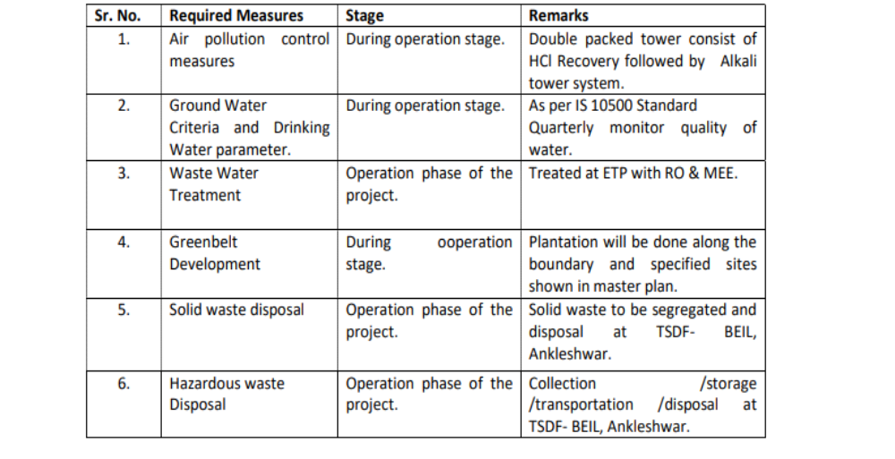
Conclusion:
Environmental monitoring is critical to the protection of human health and the environment. As the human population continues to increase, as industrial development and energy use continues to expand, and despite advances in pollution control, the continued production of pollution remains inevitable.

