Google Data Analytics: Case Study

Marketing Strategy

**Scenario**

Assisting in data analysis of the marketing analyst team at Bellabeat, a high-tech manufacturer of health-focused products for women. Bellabeat is a successful small company, but they have the potential to become a larger player in the market. Urška Sršen, cofounder and Chief Creative Officer of Bellabeat, believes that analyzing smart device fitness data could help unlock new growth opportunities for the company. Analyzing one of Bellabeat’s products and smart device data to gain insight into how consumers are using their smart devices. The insights discovered will then help guide marketing strategy for the company. The analysis will be presented to Bellabeat’s executive team along with high-level recommendations for Bellabeat’s marketing strategy.

**Products**

* + - **Bellabeat app:** The Bellabeat app provides users with health data related to their activity, sleep, stress, menstrual cycle, and mindfulness habits. This data can help users better understand their current habits and make healthy decisions. The Bellabeat app connects to their line of smart wellness products.
    - **Leaf:** Bellabeat’s classic wellness tracker can be worn as a bracelet, necklace, or clip. The Leaf tracker connects to the Bellabeat app to track activity, sleep, and stress.
    - **Time:** This wellness watch combines the timeless look of a classic timepiece with smart technology to track user activity, sleep, and stress. The Time watch connects to the Bellabeat app to provide you with insights into your daily wellness.
    - **Spring:** This is a water bottle that tracks daily water intake using smart technology to ensure that you are appropriately hydrated throughout the day. The spring bottle connects to the Bellabeat app to track your hydration levels.

**Summary of the dataset:**

● **FitBit Fitness Tracker Data** (CC0: Public Domain, dataset made available through Mobius): This Kaggle data set contains personal fitness tracker from thirty fitbit users. Thirty eligible Fitbit users consented to the submission of personal tracker data, including minute-level output for physical activity, heart rate, and sleep monitoring. It includes information about daily activity, steps, and heart rate that can be used to explore users’ habits.

**The total number of users in the data set is: 34.**

**Marketing Strategies:**

When looking at the marketing strategies bellabeat has the following advantages compared to the other competitors.

* The water bottle app to track hydration.
* The menstrual cycle tracker is not available in the competitor.
* I also observed that majority of the users have low very active minutes, encouraging users to log in more active minutes and giving some perks will be a good marketing strategy.

**Demographics to market:**

* Clearly the app is catered to attract more female audience.
* While observing the pattern with users BMI, we observed that the majority of the users are in overweight category and therefore we should cater the app with overweight demographics.
* The next group of people would be users who would like to have a sound sleep or have trouble sleeping.

**Data Format and Storage:**

The data collected is all in csv format. I stored it in my local computer and also in the google drive, so that I can clean and analyze the data using various online tools. I used google sheets to clean the data. I used RStudio cloud and jyputer notebook for viewing patterns and building visualizations. I also used google sheets for building charts.

**Data organization:**

Data is organized in both long and short format. I used both the formats.

**Lets study some of the trends in the other smart devices:**

**1.Actual time in bed Vs time slept:**

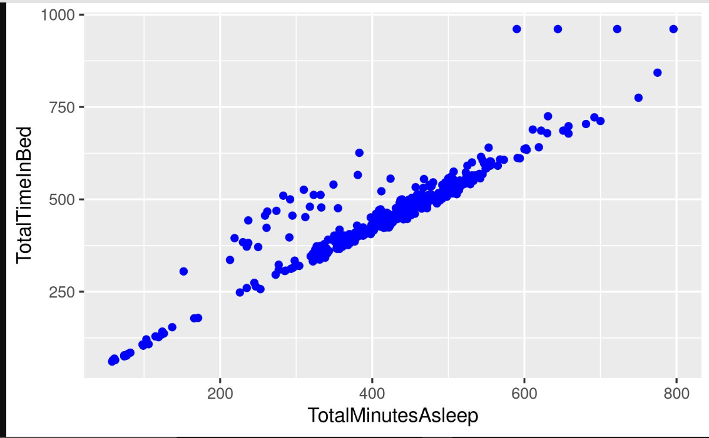

We can observe that time slept and the total time in bed is directly proportional. Meaning that you have a better sleep when you spend more time in bed. Therefore the smart devices can be used to monitor and follow a healthy sleep pattern.

**2. Steps recorded by various users.**

All the users have recorded the number of steps according to the date. Studying the data we can see that the minimum steps recorded is **15352** and maximum number of steps recorded for the entire time period is **7179636.**

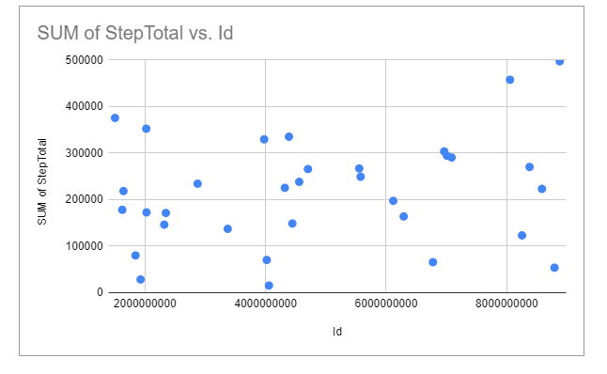

10,000-30,000 steps- Majorities

<10,000 steps-6

30,000-40,000 steps-4

>40,000 steps-2.

From this above chart we can clearly see that there are users with different level of physical fitness.

**3.BMI Info:**

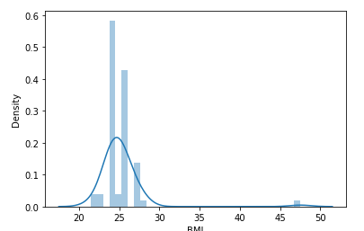

When digging deep into the BMI data we can see the mean BMI of the users is 25.

>25<30-Overweight range-32

>30-Obesity range-1

Majority of the users are in over weight category and 1 person is in the obesity range. So catering the app and marketing in the overweight category will give us better sales.

**4. Total Distance VS Calories:**

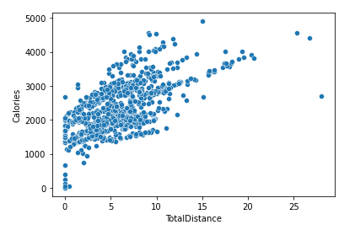

We can see that more the distance walked more is the calories. This shows that we can actually work out a lot and eat proportionally to maintain a healthy lifestyle.

**Very Active minutes Vs steps:**

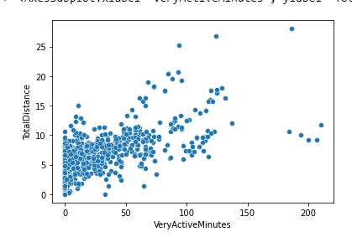

We can observe that more very active minutes more the total distance. But majority of the users do not have the very active minutes. Encouraging the users for move active minutes will be a good marketing strategy.

**Weight Info:**

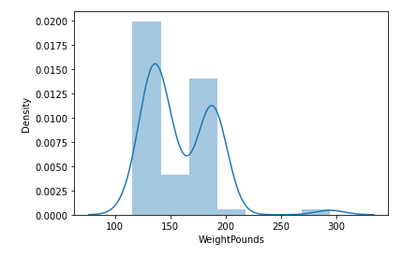

The mean weight of the users is 158lbs.The maximum weight is: 294lbs

**Key findings and patterns:**

* Majority of the users fall under the overweight category.
* Majority of the users sleep pattern looks good.
* Majority of the users have low very active minutes.

