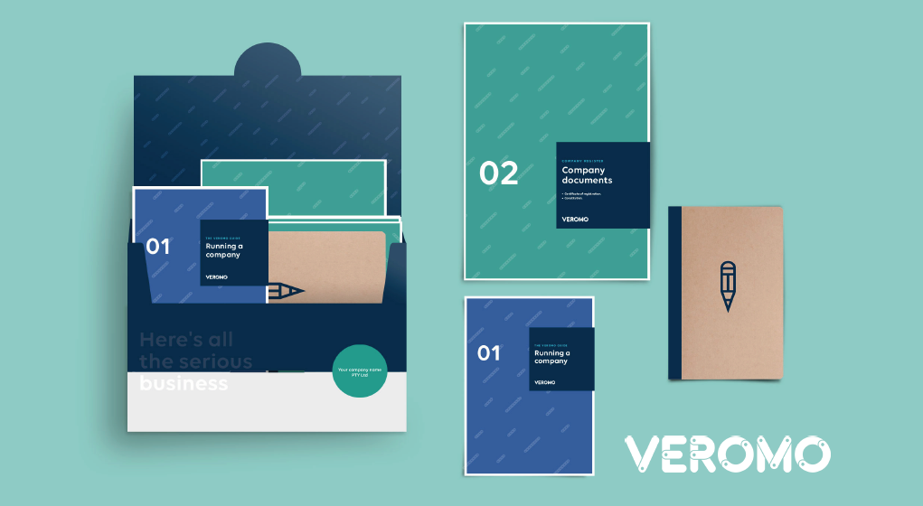

MARKETING PLAN TEMPLATE

**Welcome to the world of start-up.**

Veromo provides you with an Automated Business Registration platform that helps you set up the necessary legal framework for your business in one seamless process. And our smart reminders, help you work smarter, not harder. In addition, our smart business resources and templates are provided to help you with your business planning.

This comprehensive Marketing Plan template can be used in support of your Business Plan. It will help you define your marketing strategy in a disciplined way and provides clear direction on how you will achieve your business goals.  
  
Your Marketing Plan is an important document. Take your time to consider each section on its merit as it is important that you get it right.  
  
Good luck.   
  
**The Team at Veromo.***Note: This is an editable word document, so you can remove or add to its pages as you see fit.*

**Marketing Plan Template**

***Why do I need a Marketing Plan?***

In addition to preparing your Business Plan, a well prepared and thought out Marketing Plan helps you plan how you will go about promoting your products and/or services to ensure that they meet the needs of your customers.   
  
A Marketing Plan assists you to integrate your total marketing effort in support of your Business Plan.

Unlike a business plan, a Marketing Plan focuses on meeting short to near term objectives. In addition, it is an ongoing activity that needs to be monitored and evolved depending on the business results that are being delivered.

To develop a good Marketing Plan requires research, time and commitment. It is a very valuable process that can greatly contribute to your business success.

***Marketing* *Planning***

When you're writing a Marketing Plan you need to be clear about your objectives and how you'll achieve them.

A good Marketing Plan sets clear, realistic and measurable objectives. It includes deadlines, provides a budget and allocates responsibilities.   
  
Your plan should consist of these elements:

* Analysis of your current market including competitors, clearly identifying your unique selling point
* Your business objectives
* Key strategies
* Tactical Advertising and Promotional strategies
* Steps that will be taken to achieve your objectives
* Proposed budget
* Timing

**[*INSERT YOUR BUSINESS LOGO*]**

|  |  |
| --- | --- |
| Your Business Name |  |
| Year Started |  |

Marketing Plan

|  |  |
| --- | --- |
| Prepared by: |  |
| Date: |  |
| Version: |  |

## The Marketing Plan Summary

Your marketing summary should be no longer than ONE page and should focus on why your business is going to be successful. It should summarise the key points of your document with the focus on “*why you will be successful*” and “*how this will be achieved”. Y*ou can refer to the relevant questions below to help guide and formulate your answers.

### **If you have not yet started your business, provide your preferred business name.**

|  |  |  |
| --- | --- | --- |
| **Details** | **Explanation** | **Other** |
| **Your Company/Business Name** | Enter your business name as registered.  Company – Pty Ltd  Sole Trader – Registered Name | If you have not yet done so, reserve your name and register your business here:  [www.veromo.com](http://www.veromo.com) |
| **Your name** | Enter your name and your title e.g. Founder/Owner/Manager. |  |
| **Your partners, Co-Founders** | The names and titles of the other business owner(s) e.g. Founder/Owner/Manager. |  |
| **Your Website** | Enter your Website URL as registered  Enter your Social Media Handles as registered | If you have not yet secured a website or searched your Social Media Handles, visit us at [www.veromo.com](http://www.veromo.com) |
| **Main business address** | Enter your main business address. (Your home address if you are a home-based business or your head office if you have more than one location. |  |
| **ABN/ACN** | Enter your Australian Company and/or Business Number. If you are a Sole-Trader and have registered for an ABN enter it here. | If you need an ABN or to register your company, visit us on [www.veromo.com](http://www.veromo.com) |
| **Relevant owner experience** | Briefly outline your experience and/or years in the industry and any major achievements/awards. |  |
| **How long have you been in business?** |  |  |

### **Your Products or Services**

|  |  |  |
| --- | --- | --- |
| **Question** | **Explanation** | **Qualifications and Detail** |
| **Products/services** | What products/services are you selling? What is the anticipated demand for your products/services? These answers should briefly summarise your answers under the main products/services section. |  |

### **Your Future Vision**

|  |  |
| --- | --- |
| **Question** | **Explanation** |
| **Vision statement** | The vision statement briefly outlines your future plan for the business. It should state clearly what your overall goals for the business are. To keep it brief you may prefer to use dot points in your summary. |
| **Goals/objectives** | What are your short and long term goals? What activities will you undertake to meet them? |

**Your Market**

|  |  |
| --- | --- |
| **Question** | **Explanation** |
| **Target market** | Who are you selling to? Why would they buy your products/services over others?  This answer should briefly summarise your answers under the main market section. |
| **Marketing strategy** | How do you plan to enter the market? How do you intend to attract customers? How and why will this work?  This answer should briefly summarise your answers under the main market section. |

**Your Finances**

|  |  |  |
| --- | --- | --- |
| **Question** | **Explanation** | **More information** |
| **Your finances** | Briefly outline your sales forecast. How much money will you need up-front?   Where will you obtain these funds? What portion will you be seeking from other sources?  How much of your own money are you contributing towards marketing the business and the products/services? | Does your Business Plan include this information? |

## The Business

## Business Overview

|  |  |  |
| --- | --- | --- |
| **Details** | **Explanation** | **Other** |
| **Your Company/Business Name** | Enter your business name as registered.  Company – Pty Ltd  Sole Trader – Registered Name | If you have not yet done so, reserve your name and register your business here:  [www.veromo.com](http://www.veromo.com) |
| **Your name** | Enter your name and your Title e.g. Founder/Owner/Manager. |  |
| **Your partners, Co-Founders** | The names and titles of the other business owner(s) e.g. Founder/Owner/Manager. |  |
| **Your Website** | Enter your website URL as registered (If you have not yet secured a website or searched your Social Media Handles, visit us at [www.veromo.com](http://www.veromo.com) ) |  |
| **Main business address** | Enter your main business address. This can be your home address if you are a home-based business or your head office if you have more than one location. |  |
| **ABN/ACN** | Enter your Australian Company and/or Business Number. If you are a Sole-Trader and have registered for an ABN enter it here. | If you need an ABN or to register your company, visit us on [www.veromo.com](http://www.veromo.com) |
| **Relevant owner experience** | Briefly outline your experience and/or years in the industry and any major achievements/awards. |  |

### 

## SWOT Analysis List all your businesses identifiable Strengths / Weaknesses / Opportunities / Threats

|  |  |
| --- | --- |
| **Strengths** | **Weaknesses** |
|  |  |

### 

|  |  |
| --- | --- |
| **Opportunities** | **Threats** |
|  |  |

### SWOT description template

|  |  |  |
| --- | --- | --- |
| **SWOT Description (Weakness /Threat)** | **Activity to Address** | **Date of completion** |
|  |  |  |
|  |  |  |
|  |  |  |

## Your Products/Services - Provide an explanation / description for each of the questions below. Complete the Template where appropriate.

|  |  |
| --- | --- |
| **Question** | **Explanation** |
| **Product/Services table** | List each product/service your business currently offers in the template provided below. Provide a description and unit price (including GST) amount for each. |
| **Market position** | Where do your products/services fit in the market? Are they high-end, competitive or a low-cost alternative to the products/services offered by your competitors? How does this compare to your competitors? |
| **Unique selling position** | How will your products/services succeed in the market where others may have failed? What gives your products/services a distinctive edge? |
| **Anticipated demand** | What is the anticipated quantity of products/services your customers are likely to purchase? For example, how much will an individual customer buy in 6 months or 12 months? |
| **Pricing strategy** | Do you have a particular pricing strategy? Why have you chosen this strategy?  To help you develop your pricing strategy, you could refer to your customer research, market position, anticipated demand and costs/expenses to get an idea.  Whatever strategy you use when setting your price, you will also need to adhere to any relevant fair trading legislation or codes of conduct. |
| **Value to customer** | How do your customers value your products/services? Are they a necessity, luxury or something in between? |
| **Growth potential** | What is the anticipated percentage growth of the product in the future? What will drive this growth?  To help you determine this growth potential, you could refer to your region/industry research to get an idea of any industry/regional growth that could affect your business in a positive way. You could also look up any social trends that may have a positive affect on your business. |

Product Services Table Template

|  |  |  |
| --- | --- | --- |
| **Product/Service** | **Description** | **Price incl GST** |
|  |  |  |
|  |  |  |

## 

## Your Sales and Marketing Team members

|  |  |
| --- | --- |
| **Question** | **Explanation** |
| **Sales/marketing personnel table** | List your current and future staff in the table provided.   Outline each job title, name of the employee in the position and the main responsibilities related to the position.  You may also like to attach a copy of their resume to the back of your plan. |

Sales & Marketing Team Member Template

|  |  |  |  |
| --- | --- | --- | --- |
| **Name** | **Job Title** | **Responsibilities** | **Employed already?** |
|  |  |  | Y/N |
|  |  |  | Y/N |
|  |  |  | Y/N |
|  |  |  |  |

## The Market – What is your Unique Selling Proposition

Key questions to ask when defining your market:

* How is your business unique in the market?
* What is your value proposition?
* What differentiates your product/service from others in the market?
* What makes your business stand out from your competition?
* What product gap or service need does it fill for your customers?

## Your customers and clients – Actual and Potential

|  |  |
| --- | --- |
| **Question** | **Explanation** |
| **Customer demographics** | Define who your target customers are and how they behave. You can include age, gender, social status, education and attitudes. What are their lifestyles, activities, values, needs, interests or opinions? Where are they located?  Primary / Secondary / Tertiary |
| **Key customers** | Identify your key customers. (These can be large consumers of your products or individuals whose satisfaction is key to the success of your business.) How will you target your products/service to them? How will you deliver your product/service to them? |
| **Customer management** | How will you maintain a good relationship with your customers? What techniques will you use? How will you keep your customers coming back? Have you introduced customer service standards? Do you follow any particular code of practice? |

#### Customer / Target Market Profile Template

|  |  |  |  |  |
| --- | --- | --- | --- | --- |
| **Customer Type** | **Demographics**:   Age / Gender / location ? socio-economic status / occupation etc | **Purchasing habits:** Control over purchase habits/ previous purchasing behaviour | **Motivations** Criteria for selecting service / product | **Touchpoints**  Point of contact with customers - websites / social media / traditional media etc |
|  |  |  |  |  |
|  |  |  |  |  |
|  |  |  |  |  |

## Your competitors

|  |  |
| --- | --- |
| **Question** | **Explanation** |
| **Your competitors** | How do you rate against your competitors? How can your business improve on what they offer? |
| **Competitor details table** | List at least 5 competitors in the table below. For each competitor enter:   * **Competitor:** Competitor name. * **Established date:** When were they established? * **Size:** Number of staff and/or turnover. * **Market share (%):** Estimated percentage of market share. * **Value to customers:** Unique value to customers. Why would customers buy their product instead of yours? For example: convenience, quality, price or service? * **Strengths:** What are your competitor's main strengths? * **Weaknesses:** What are your competitor's main weaknesses? |
| **Market research** | What statistical research have you completed to help you analyse your market? Did you use a survey/questionnaire? If so, you may like to attach a copy of your survey/questionnaire to the back of this plan. |

#### Competitor details Template List at least 5 competitors in the table below.

|  |  |  |  |  |  |
| --- | --- | --- | --- | --- | --- |
| **Competitor** | **Established date** | **Size - Turnover//Staff number** | **Market share (%)** | **Value to customers** | **Strengths / Weaknesses** |
|  |  |  |  |  |  |
|  |  |  |  |  |  |
|  |  |  |  |  |  |
|  |  |  |  |  |  |

### 

## Market Objectives and Research

|  |  |
| --- | --- |
| **Market Objectives** | Outline your planned sales targets. These targets need to be realistic and achievable. What quantity of your products/services do you plan to sell in a planned time frame? Are they monthly or yearly targets? For example, you may set yourself a goal of selling 1,000 products in 12 months. |
| **Research - Environmental/industry analysis** | Detail the results of the market research you have performed. Is the area experiencing population growth? Are there long-term employers in the area? Is the region's economy stable? Are there seasonal variations?  What is the size of the market? What recent trends have emerged in the market? What growth potential is available and where do you fit in? How will the market/customers change when you enter the market? What external factors will affect your customers?  A good place to start when researching your regional profile is the Australian Bureau of Statistics website. The regional profile information includes economy, population/people, industry and environment/energy statistics. |
| **Marketing strategy** | *What is your overall marketing strategy?* What steps or activities will you undertake to achieve your goals/objectives?For each marketing activity/milestone:  *Marketing activity/milestone:*  Print advertising, online advertising, mail-out, giveaway, media release, event, website, blog/social media, public relations, branding and artwork, or publications and catalogues.  *Person responsible:*  Who is responsible for completing this task?  *Date of expected completion:*  When do you expect to complete the marketing activity?  *Cost ($):*  Estimated cost of activity.  *Success indicator:*  What indicator/ measurement result will need to be met before this activity is considered a success? |

#### Marketing / Activity Milestone Template

|  |  |  |  |  |
| --- | --- | --- | --- | --- |
| **Marketing Activity/Milestones** | **Person responsible** | **Date of expected completion** | **Cost ($)** | **Success indicator** |
|  |  |  |  |  |
|  |  |  |  |  |
|  |  |  |  |  |

## 

## Advertising and Marketing Strategy

**Advertising & Promotions**

|  |  |
| --- | --- |
| **Questions** | **Explanation** |
| **Advertising and promotional table** | For each promotion and/or advertising program planned:   * **Planned promotion/advertising channel:**  What is the promotion/advertising type being used (e.g. Print media advertising, online advertising, SMS, mail-out, giveaway, media release, social media campaign or event)? * **Target Audience:** Why have you decided to use this promotion/advertising type - who are you targeting? * **Expected business improvement:**  How do you expect it will improve your business success? * **Cost ($):**  What is the cost of each planned activity? * **Target date:**  When do you expect to complete each activity? |
| **Social media strategy** | What do you want to achieve/communicate (brand awareness, online sales etc)? What social media tools do your customers use (e.g. Blogs, Twitter, Facebook etc)? What strategies can you use to network and communicate effectively with these customers? Who will upkeep your social media presence? Do you have internal staff or would you need to engage an external organisation? |

#### Advertising & Promotions Template

|  |  |  |  |  |
| --- | --- | --- | --- | --- |
| **Channel** | **Target Audience** | **Expected business improvement** | **Cost ($)** | **Target date** |
|  |  |  |  |  |
|  |  |  |  |  |
|  |  |  |  |  |

#### Social Media Strategy Template

|  |  |  |  |  |
| --- | --- | --- | --- | --- |
| **Social Media** | **Strategy** | **Who will be Responsible** | **Cost ($)** | **Target date** |
|  |  |  |  |  |
|  |  |  |  |  |

#### Customer Retention and CRM Strategy

|  |  |  |  |  |
| --- | --- | --- | --- | --- |
| **Planned to Achieve** | **Strategy** | **Who will be Responsible** | **Cost ($)** | **Target date** |
|  |  |  |  |  |
|  |  |  |  |  |

## Sales & Customer Retention What sales techniques do you use? What are your strategies behind these techniques? How is this different/better than your competitors?

|  |  |
| --- | --- |
| **Questions** | **Explanation** |
| **Sales strategy** | What sales techniques do you use? What are your strategies behind these techniques? How is this different/better than your competitors? |
| **Sales and distribution channels table** | For each channel enter:   * **Channel type:** What channel will you be using (e.g. Shopfront, internet, direct mail, export or wholesale)?. * **Products/services:** List all the products/services sold via this channel. * **Percentage of sales:** What percentage of overall sales do you expect to sell via this channel? * **Distribution strategy:** Why have you decided to use this channel type? How and when will you use it? What is the strategy behind using this channel type for this particular product/service? |
| **Customer Retention (Loyalty and CRM)** | Do you have a loyalty or CRM program in place?  Are you planning one?  What will it look like? Will it be points based/cashback/other? |

#### Sales and distribution channels

|  |  |  |  |
| --- | --- | --- | --- |
| **Channel type** | **Products/services** | **Percentage of sales (%)** | **Distribution strategy** |
|  |  |  |  |
|  |  |  |  |

## Your Finances

To complete the finances portion of this Marketing Plan, you should rely heavily on your financial statements and projections as per your Business Plan.   
  
The Veromo Business Plan template is available for you at [www.veromo.com](http://www.veromo.com) with a start-up costing, balance sheet profit and loss, cash flow and a break-even analysis template.

|  |  |
| --- | --- |
| **Question** | **Explanation** |
| **Price** | What price have you determined for your products/services? Does this price take into account all your costs including personal, start-up, operational, cash flow and working capital? Have you also allocated a profit margin in your costing? What price will your target market bear? Do your prices take into account any seasonal variation to your suppliers’ costs? |
| **Expected sales** | What are your expected sales? When do you hope to achieve these figures? Are there seasonal influences? |
| **Marketing budget [YEAR] table** | **Using the table**  The marketing budget table example contains a list of suggested marketing items a typical business may use.  **Please note:** The table assumes all figures are GST inclusive.  **Attach your own**  If you have your own marketing budget or your accountant has already prepared one, please attach it here. If it is a large sheet, you can always attach it to the back of the plan and make reference to it from this section. |

### Marketing budget for the Year

Consider the example below when developing a budget to include in your business plan. It can be easily set up on a Google or excel spreadsheet.

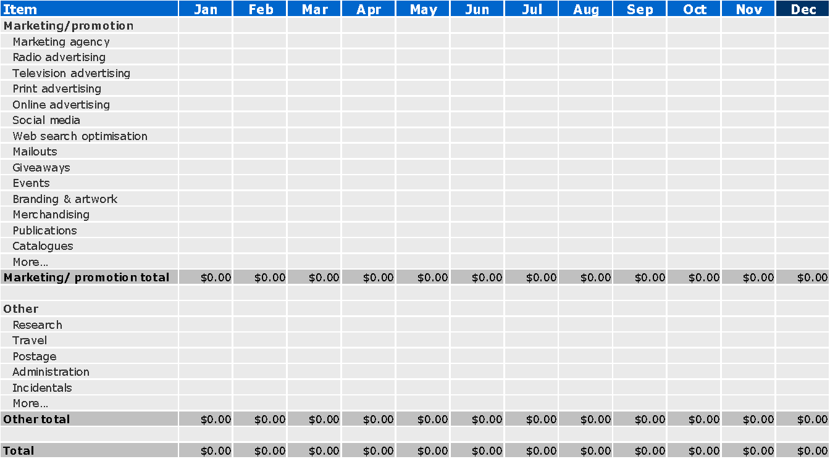

### 

## Monitoring/measurement activities

|  |  |
| --- | --- |
| **Question** | **Explanation** |
| **Monitoring/measurement activities table** | Reviewing the impact of your marketing should be a periodic activity. List the details of each review in the table provided.For each marketing activity:   * **Marketing activity:** Print advertising, online advertising, mail-out, giveaway, media release, event, website, blog/social networking, public relations, branding and artwork, or publications and catalogues. * **Date of review:** (e.g. Month/Year or 6 monthly). * **Monitoring methods:** What tools did you use to measure/monitor the impact of your marketing activities? * **Review outcomes:** What were the results for the promotional period? What were your sales/profit figures?  How many new/repeat customers did you receive? How many visitors to your website? |

Marketing review Template

|  |  |  |  |
| --- | --- | --- | --- |
| **Marketing activity** | **Date of review** | **Monitoring methods** | **Review outcomes** |
|  |  |  |  |
|  |  |  |  |

## 

## Supporting documentation

|  |  |
| --- | --- |
| **Question** | **Explanation** |
| **Supporting documentation** | List all of your attachments here. These may include resumes, customer surveys/questionnaires and/or financial documents. |