Task 1: Repository Setup & First Branch
- Create a new GitHub repository.
Ans :
https://github.com/shakti101101/Deveops_Git_-_Github_assign
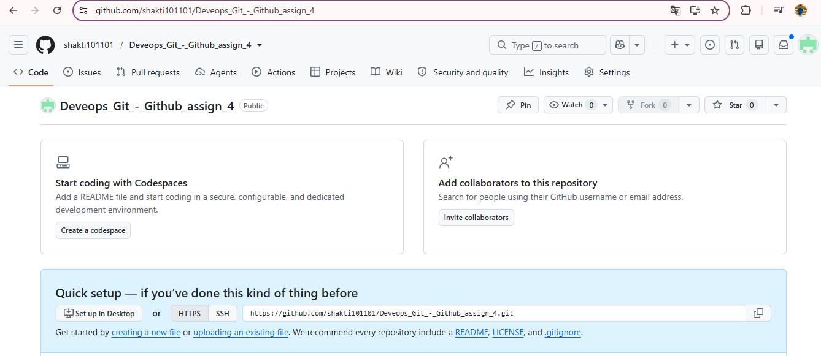
2. Clone the repository to your local machine using SSH (generate an SSH key if needed, and add the public key to your GitHub account).
Ans :
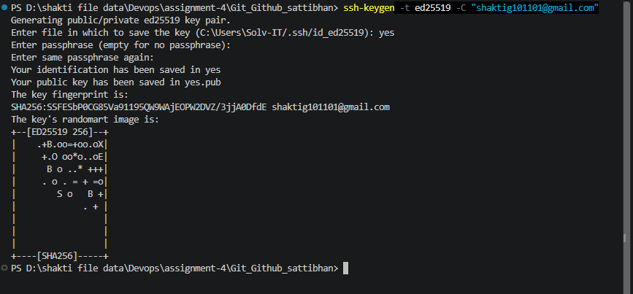
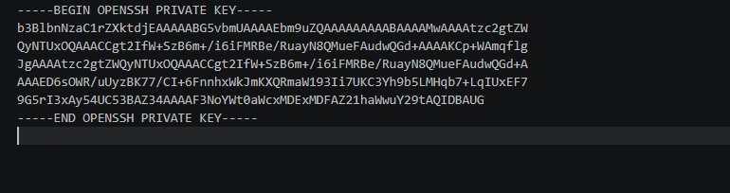
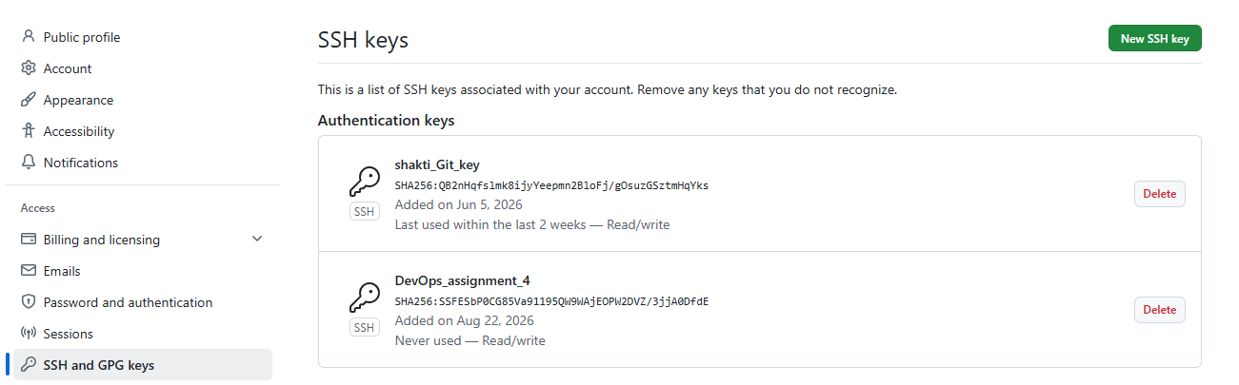
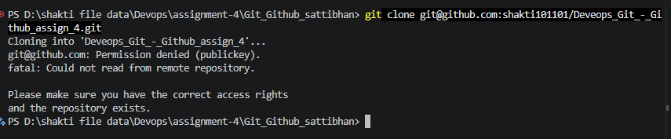
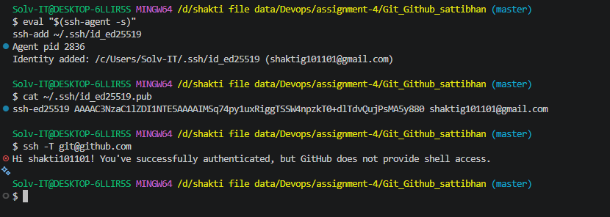
3 . Create a new branch named after your username (e.g., Tutedude).
ans :
command : git checkout -b Tutedude_sattibhan
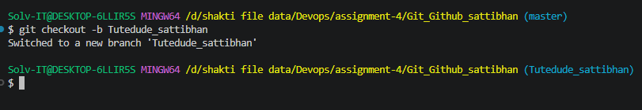

- Add your Flask project files to this branch.
Ans :
command :
git add .
git commit -m "Initial commit with SSH key configured"
git push -u origin Tutedude_sattibhan "
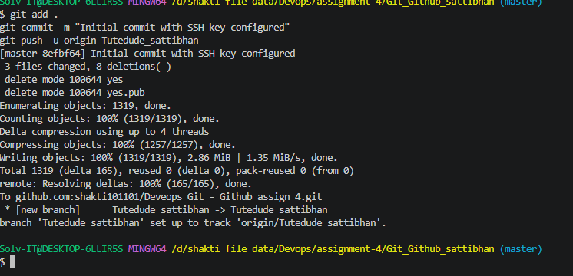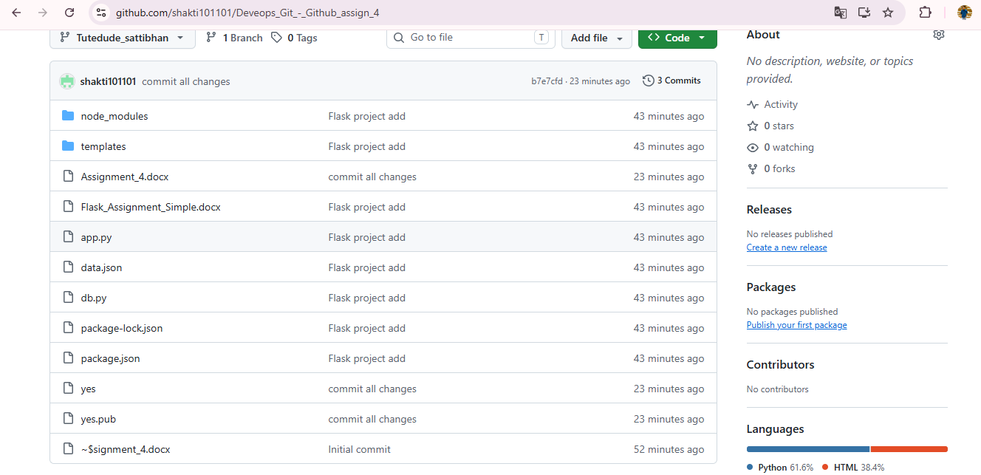

- Commit the changes and merge the branch into the main branch.
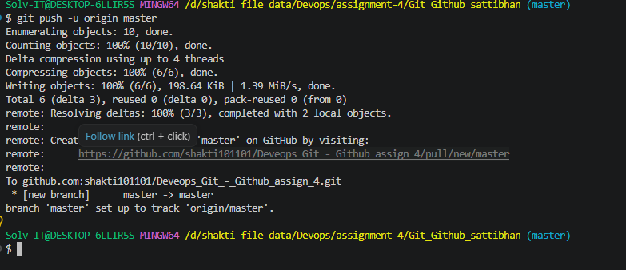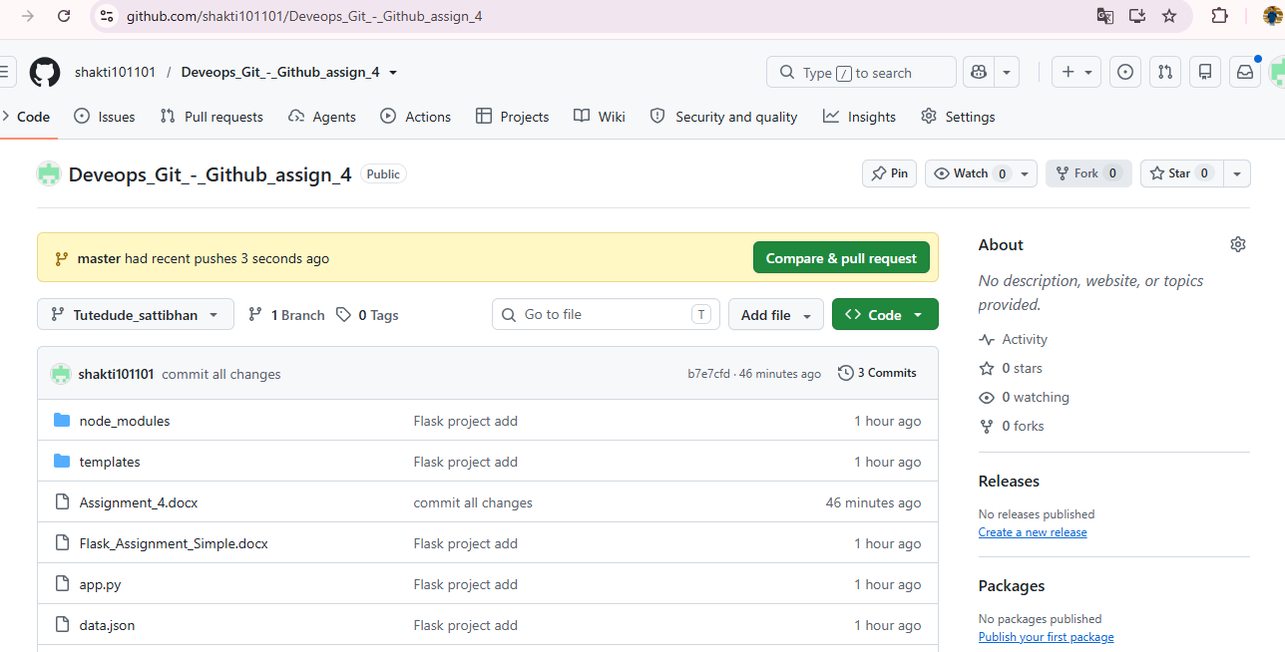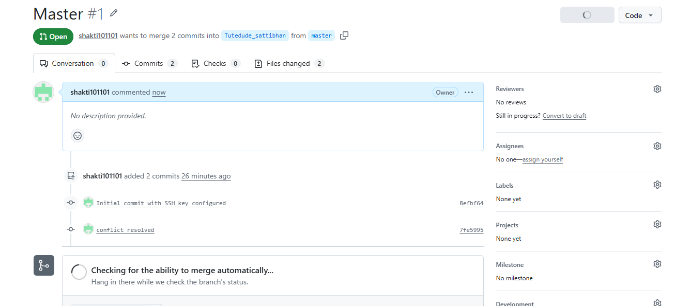

Task 2: Update JSON & Resolve Conflicts
6. Create a new branch named _new (e.g., Tutedude_new).
ans : git checkout -b Tutedude_new
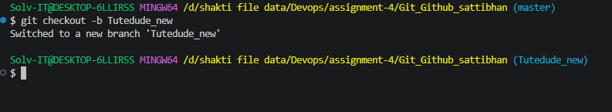
7. Update the content of the JSON file used for the /api route in this branch.
ans :
command :
git add .
git commit -m " Update JSOn file and Ad new data"
- 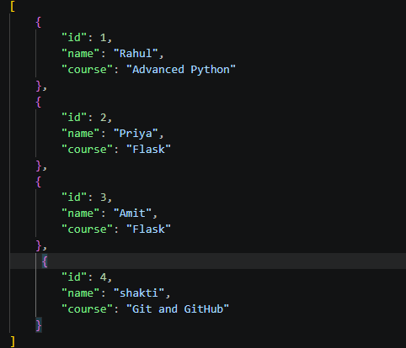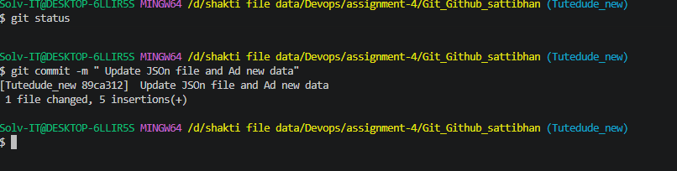

8. Merge the _new branch into the main branch.
ans :
- git merge Tutedude_new 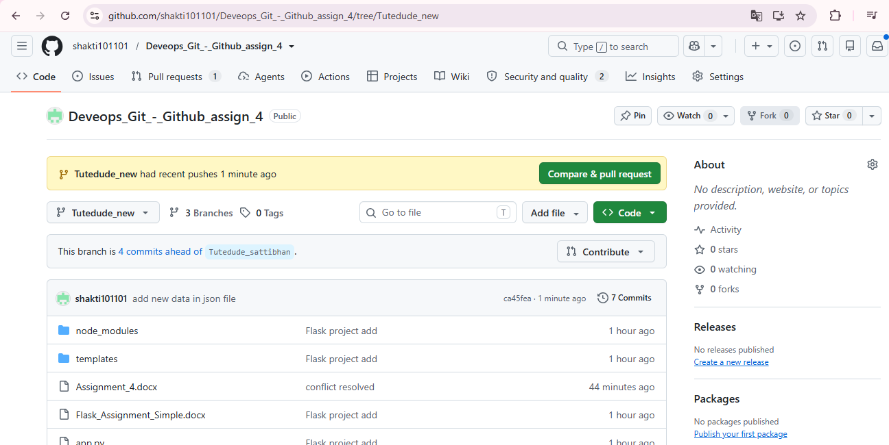
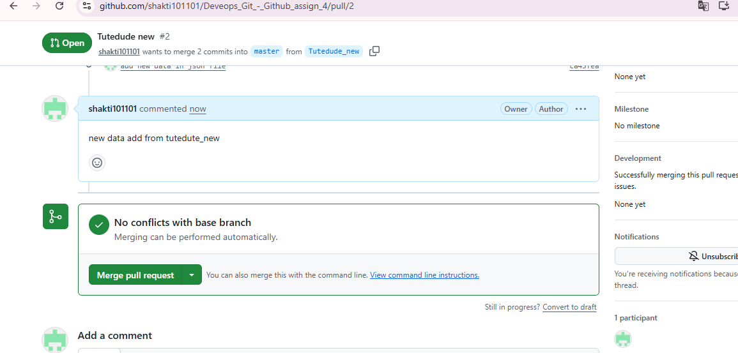
9. If there are conflicts during the merge, resolve them by accepting the changes from the _new branch.
ans :
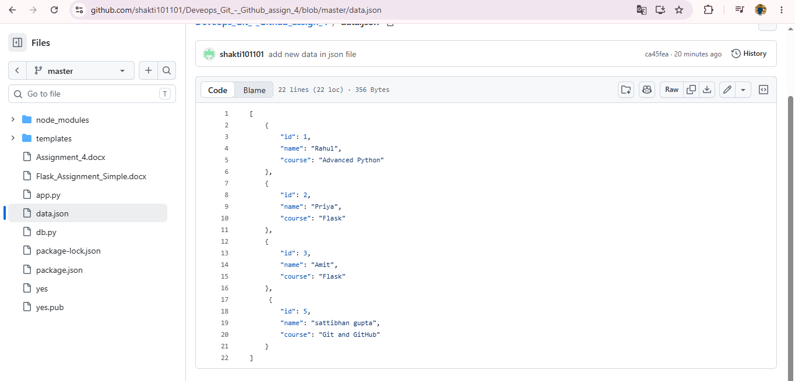
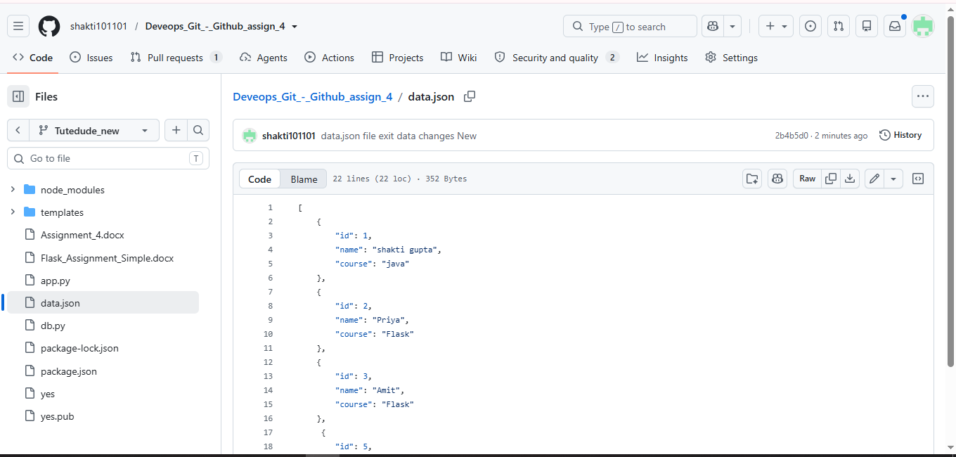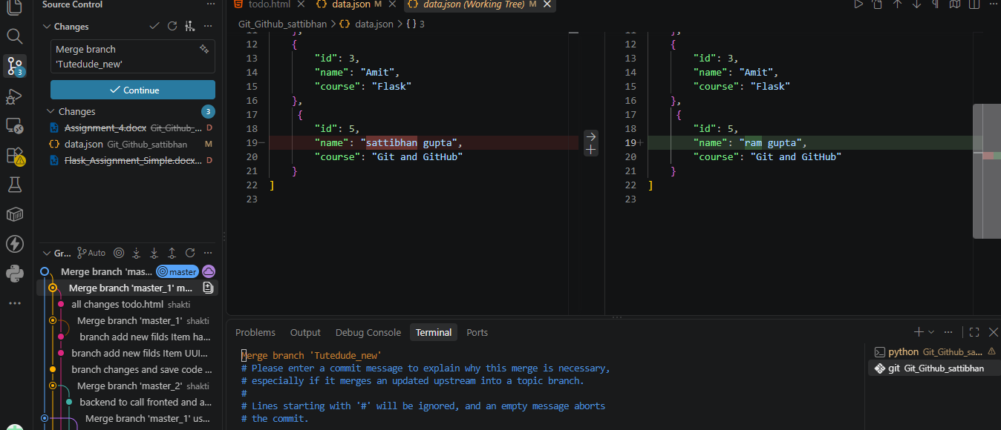

Task 3: Parallel Feature Development
- Branch Creation: Create two branches, master_1 and master_2, from the main branch.
ans :
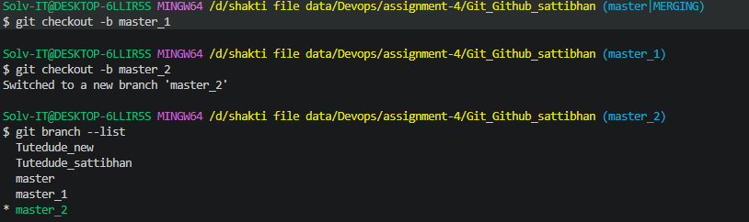

- Feature Development in master_1: Create a To-Do Page in the frontend with a form containing the fields Item Name and Item Description.
ans :
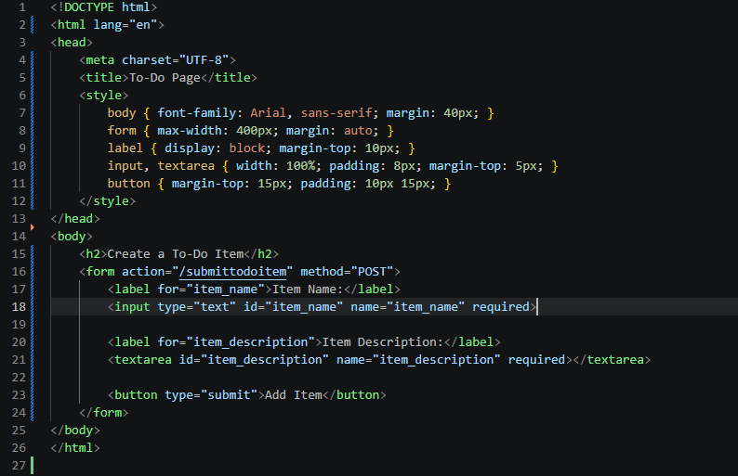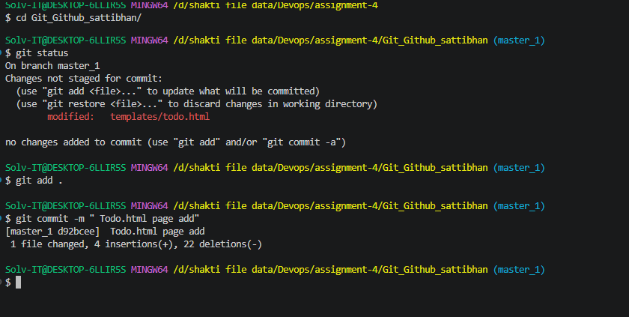

- Backend API in master_2: Create a backend route named /submittodoitem that accepts itemName and itemDescription via a POST request and stores these details in a MongoDB database.
ans :
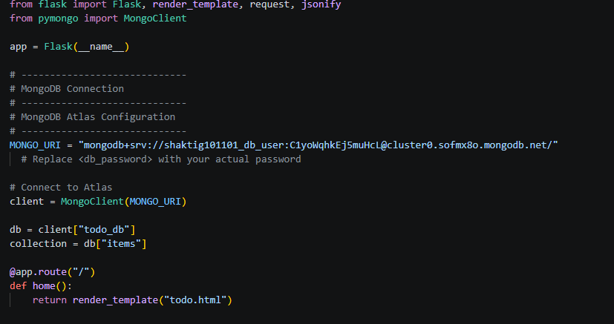 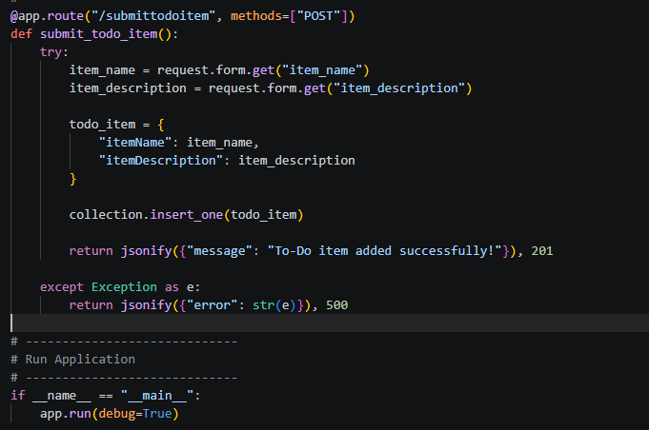
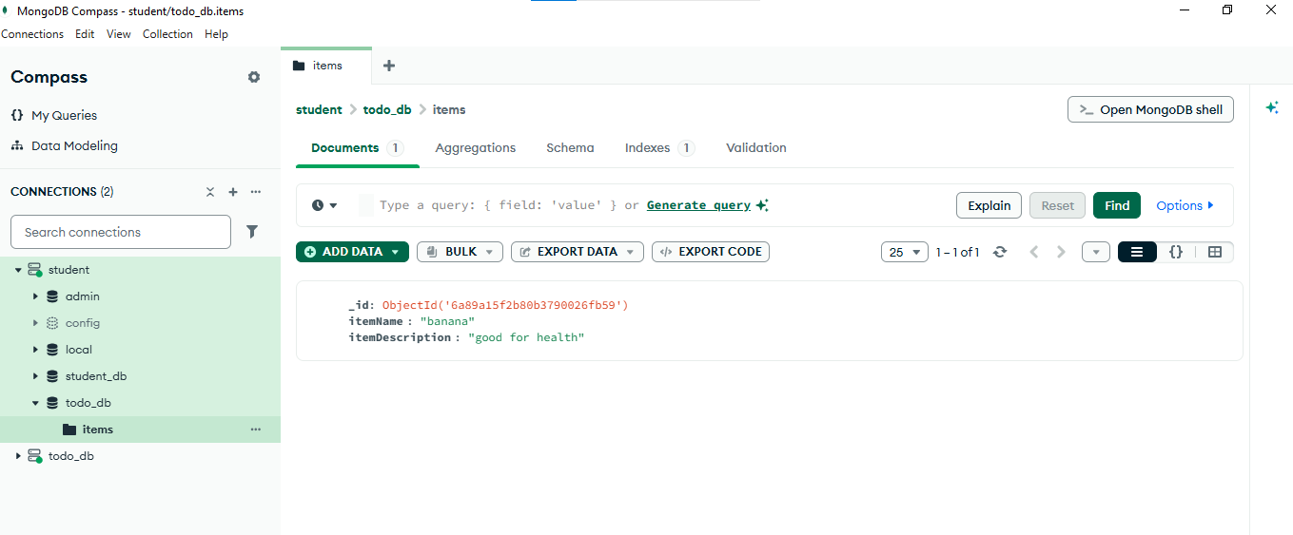
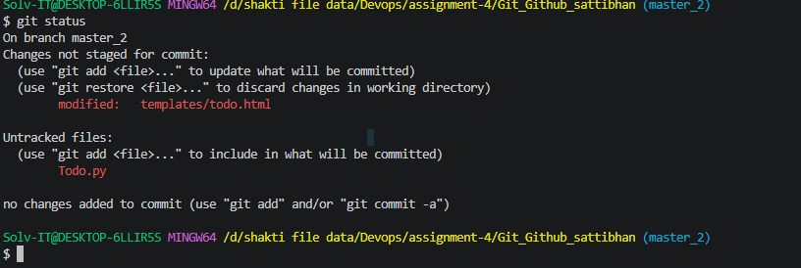
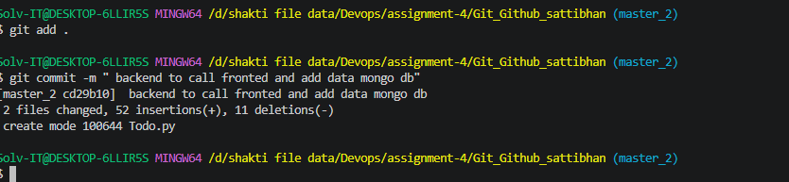
https://github.com/shakti101101/Deveops_Git_-_Github_assign_4/blob/master_2/Todo.py
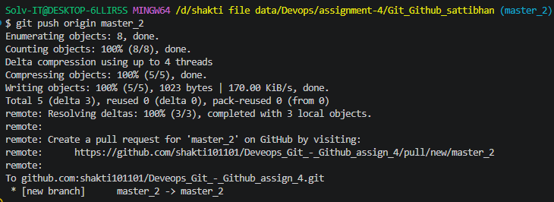

- Merging Changes: Merge the changes from both master_1 and master_2 into the main branch.
ans :
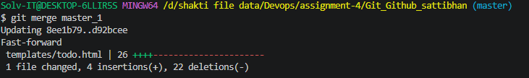
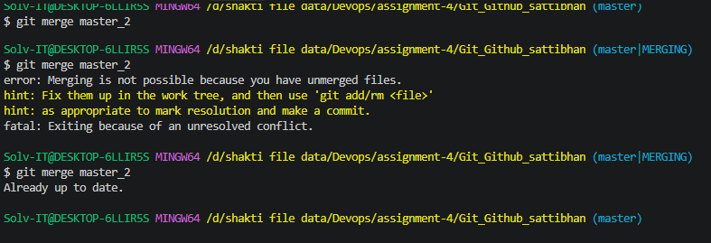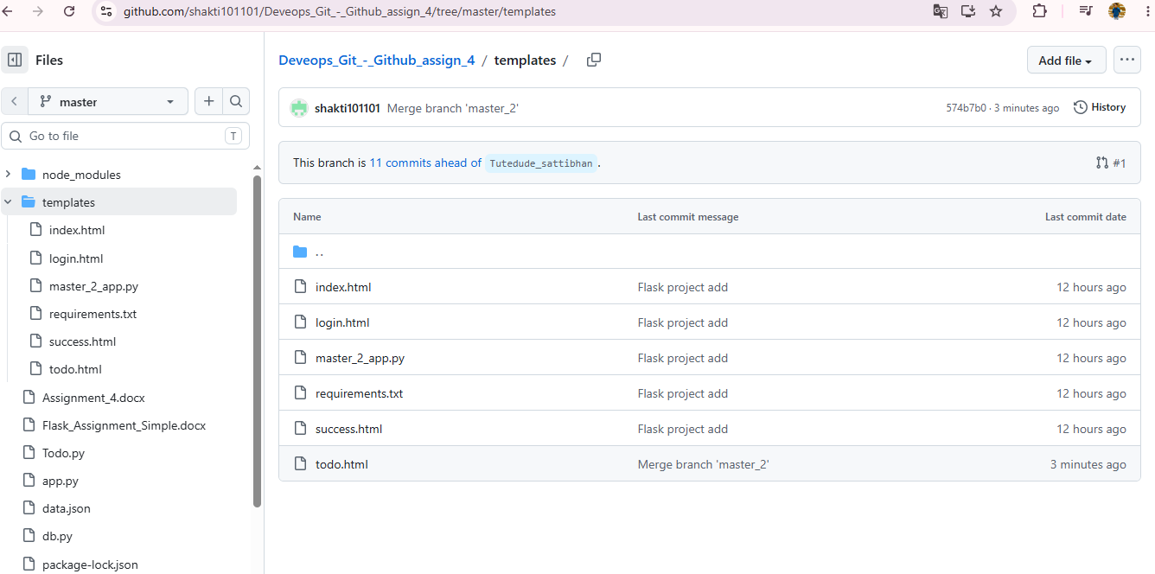

Task 4: Sequential Commits, Reset & Rebase
- Enhancing the To-Do Form in master_1: Add the following fields to the To-Do form: Item ID, Item UUID, Item Hash.
ans :
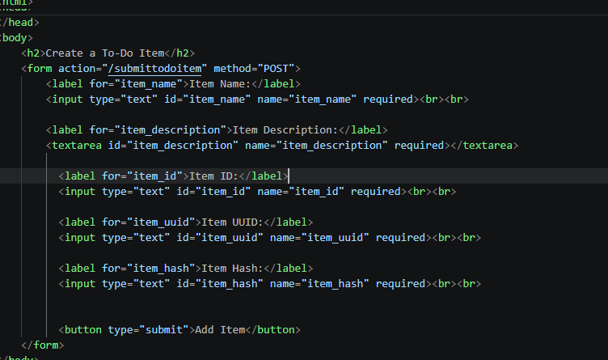
- Committing in Sequence: Add and commit each field separately — first commit: Item ID; second commit: Item UUID; third commit: Item Hash.
ans :
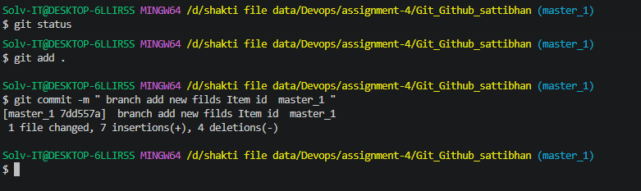

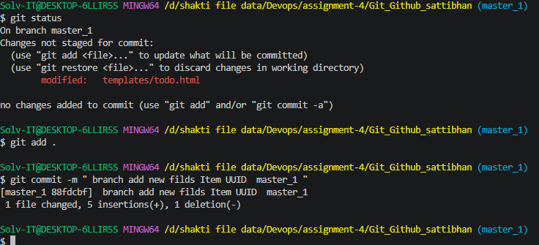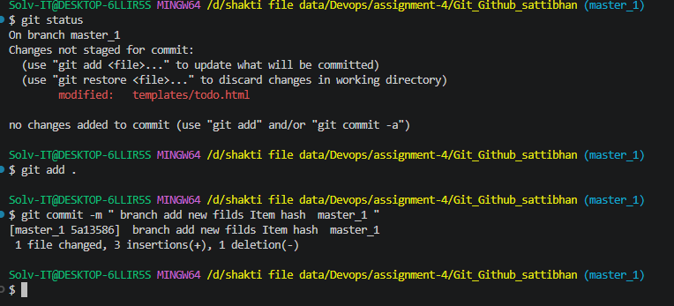
- Merging to main: Merge the master_1 branch into the main branch.
ans : command :
git checkout master
git merge master_1
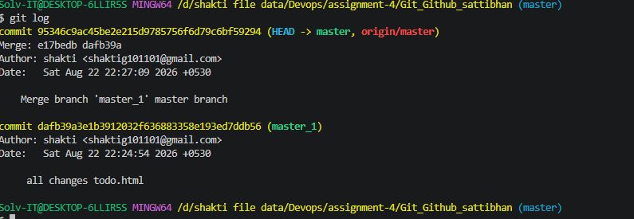
Git Reset: In the main branch, roll back to the commit where only the Item ID field was added. Use git reset --soft to ensure changes remain staged, then re-commit this state and merge it to main.
ans:
Command :
git log –oneline
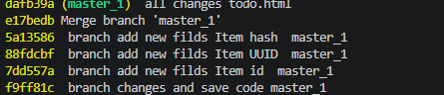
git reset –soft
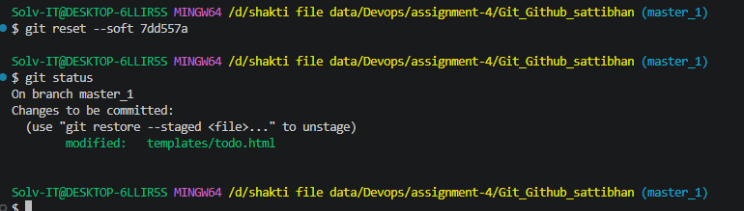
all fildes rollback use command :
git reset –soft (hashvalue)
then merge master branh
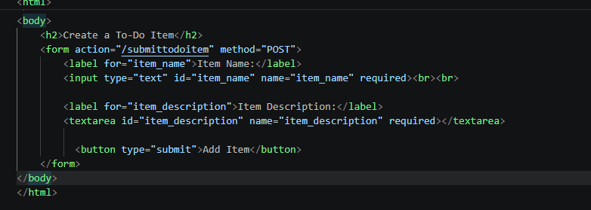

- Rebasing: Rebase the updated main branch changes onto master_1 using git rebase main master_1. Preserve individual commits (do NOT squash) to maintain commit history.
Ans:
git checkout master_1
git fetch origin
git rebase master
$ git log --oneline
8727062 (HEAD -> master_1, origin/master, master) Merge branch 'master' of github.com:shakti101101/Deveops_Git_-_Github_assign_4
77fa1cd Merge branch 'master_1' use with rollback all fildes remove
d74f612 rollback item id in master_1 branch
c7e5f84 Rollback: Keep only Item ID field
95346c9 Merge branch 'master_1' master branch
dafb39a all changes todo.html
e17bedb Merge branch 'master_1'
5a13586 branch add new filds Item hash master_1
:...skipping...
8727062 (HEAD -> master_1, origin/master, master) Merge branch 'master' of github.com:shakti101101/Deveops_Git_-_Github_assign_4
77fa1cd Merge branch 'master_1' use with rollback all fildes remove
d74f612 rollback item id in master_1 branch
c7e5f84 Rollback: Keep only Item ID field
95346c9 Merge branch 'master_1' master branch
dafb39a all changes todo.html
e17bedb Merge branch 'master_1'
5...skipping... add new filds Item hash master_1
8727062 (HEAD -> master_1, origin/master, master) Merge branch 'master' of github.com:shakti101101/Deveops_Git_-_Github_assign_4ranch add new filds Item id master_1
77fa1cd Merge branch 'master_1' use with rollback all fildes remove
d74f612 rollback item id in master_1 branch
c7e5f84 Rollback: Keep only Item ID fieldend to call fronted and add data mongo db
95346c9 Merge branch 'master_1' master branch
dafb39a all changes todo.htmlof github.com:shakti101101/Deveops_Git_-_Github_assign_4
e17bedb Merge branch 'master_1'utedude_new) data.json file exit data changes New
5a13586 branch add new filds Item hash master_1
88fdcbf branch add new filds Item UUID master_1utedude_new
7dd557a branch add new filds Item id master_1
f9ff81c branch changes and save code master_1
574b7b0 Merge branch 'master_2'
cd29b10 (origin/master_2, master_2) backend to call fronted and add data mongo db
d92bcee (origin/master_1) Todo.html page add
8ee1b79 Merge branch 'master' of github.com:shakti101101/Deveops_Git_-_Github_assign_4
2b4b5d0 (origin/Tutedude_new, Tutedude_new) data.json file exit data changes New
b1eeb99 data.json file exit data changes
1b70c01 Merge pull request #2 from shakti101101/Tutedude_new
ca45fea add new data in json file
89ca312 Update JSOn file and Ad new data
7fe5995 conflict resolved
8efbf64 Initial commit with SSH key configured
...skipping...
8727062 (HEAD -> master_1, origin/master, master) Merge branch 'master' of github.com:shakti101101/Deveops_Git_-_Github_assign_4
77fa1cd Merge branch 'master_1' use with rollback all fildes remove
d74f612 rollback item id in master_1 branch
c7e5f84 Rollback: Keep only Item ID field
95346c9 Merge branch 'master_1' master branch
dafb39a all changes todo.html
e17bedb Merge branch 'master_1'
5a13586 branch add new filds Item hash master_1
88fdcbf branch add new filds Item UUID master_1
7dd557a branch add new filds Item id master_1
f9ff81c branch changes and save code master_1
574b7b0 Merge branch 'master_2'
cd29b10 (origin/master_2, master_2) backend to call fronted and add data mongo db
d92bcee (origin/master_1) Todo.html page add
8ee1b79 Merge branch 'master' of github.com:shakti101101/Deveops_Git_-_Github_assign_4
2b4b5d0 (origin/Tutedude_new, Tutedude_new) data.json file exit data changes New
b1eeb99 data.json file exit data changes
1b70c01 Merge pull request #2 from shakti101101/Tutedude_new
ca45fea add new data in json file
89ca312 Update JSOn file and Ad new data
7fe5995 conflict resolved
8efbf64 Initial commit with SSH key configured
