Task 1: Repository Setup & First Branch
- Create a new GitHub repository.
Ans :
https://github.com/shakti101101/Deveops_sattibhan_Git_4
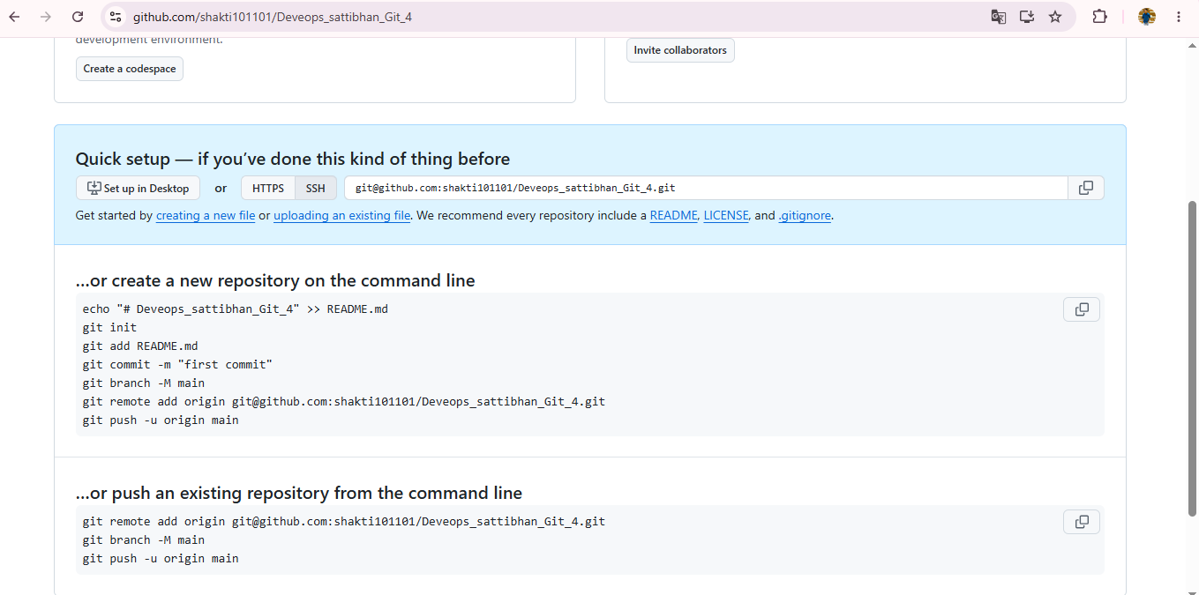
2. Clone the repository to your local machine using SSH (generate an SSH key if needed, and add the public key to your GitHub account).
Ans :
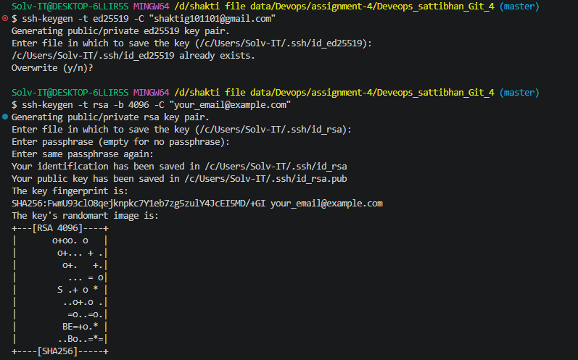
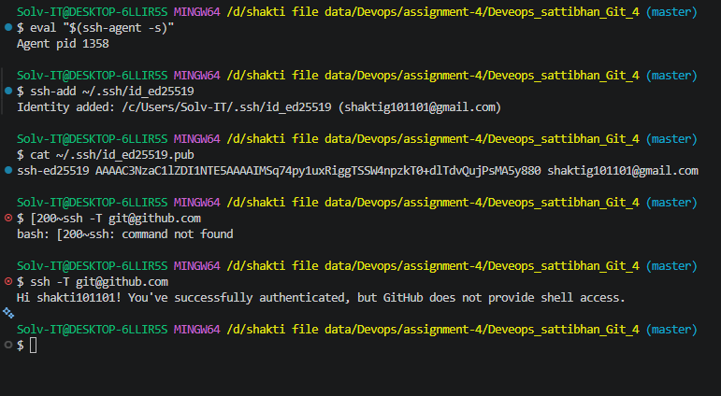
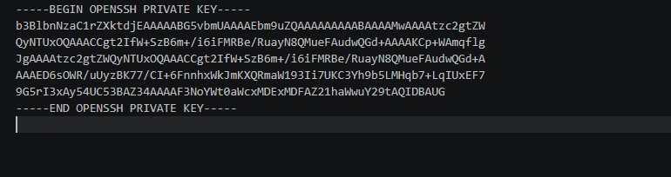
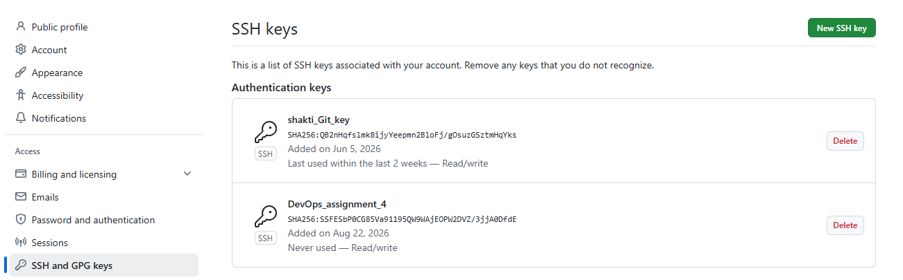
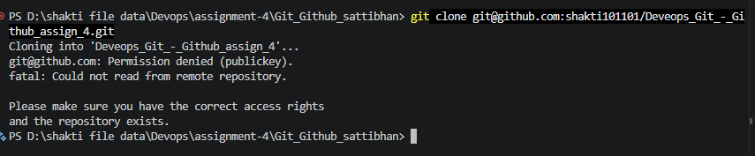
3 . Create a new branch named after your username (e.g., Tutedude).
ans :
command : git checkout -b Tutedude_sattibhan
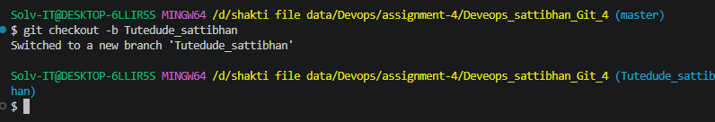

- Add your Flask project files to this branch.
Ans :
command :
git add .
git commit -m "Initial commit with SSH key configured"
git push -u origin Tutedude_sattibhan "
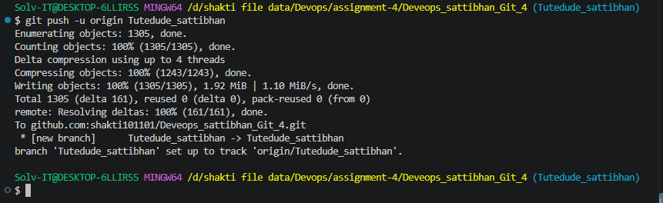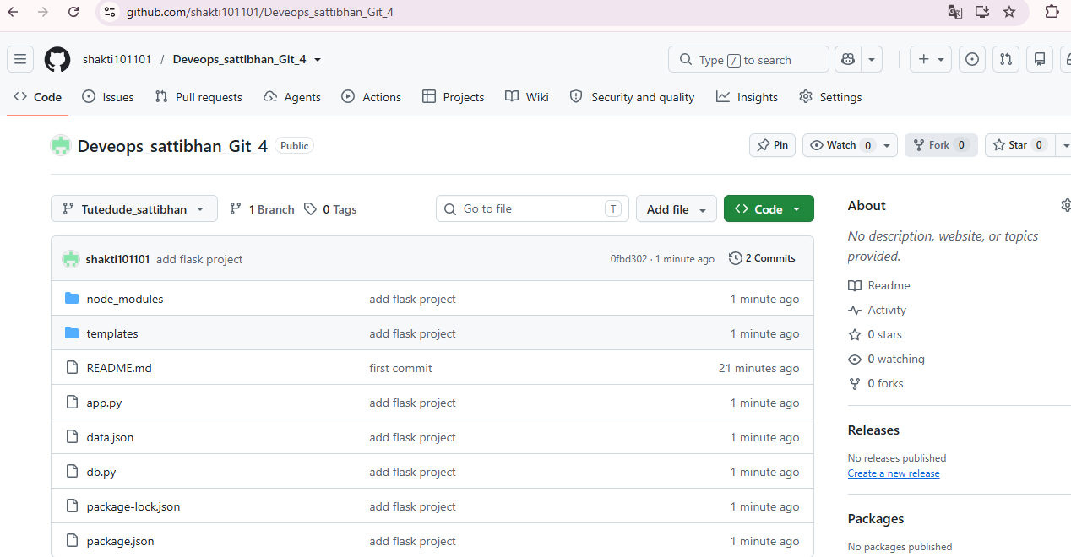

- Commit the changes and merge the branch into the main branch.
ans:
command: git merge Tutedude_sattibhan
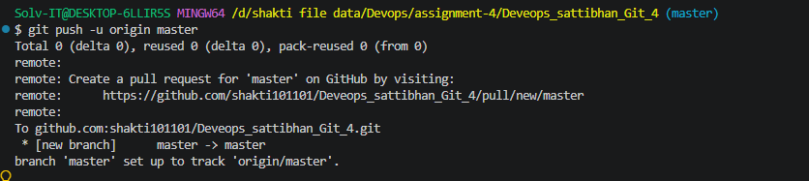
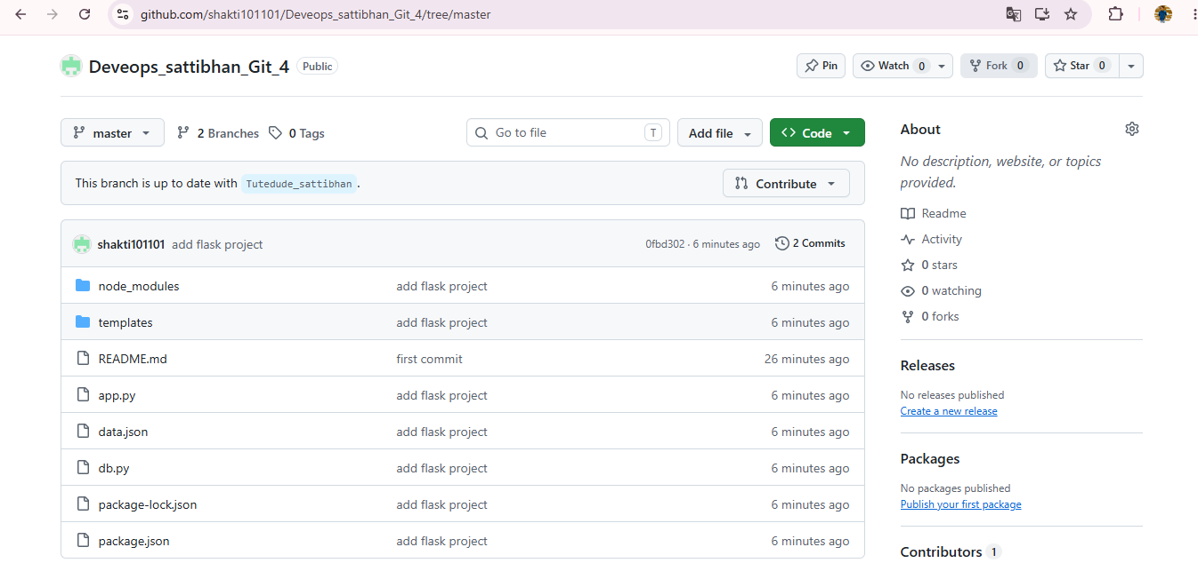Task 2: Update JSON & Resolve Conflicts
6. Create a new branch named _new (e.g., Tutedude_new).
ans : git checkout -b sattibhan_Tutedude_new
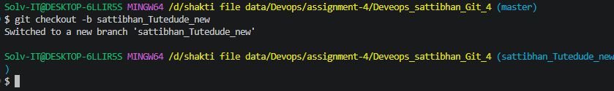
7. Update the content of the JSON file used for the /api route in this branch.
ans :
command :
git add .
git commit -m "data.json file add data"
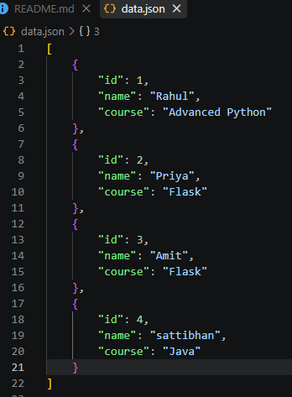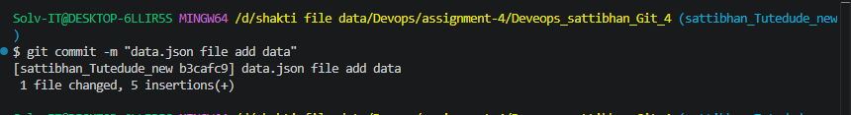

8. Merge the _new branch into the main branch.
ans :
git checkout master
git merge sattibhan_Tutedude_new
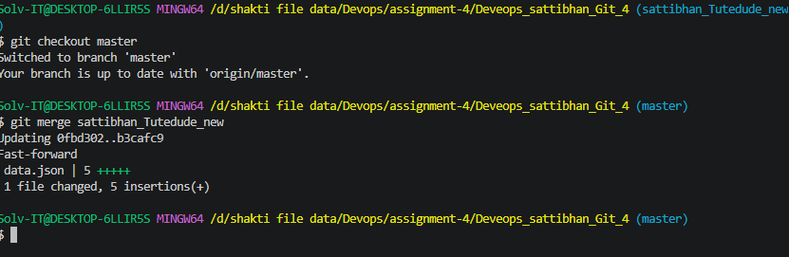
9. If there are conflicts during the merge, resolve them by accepting the changes from the _new branch.
ans :
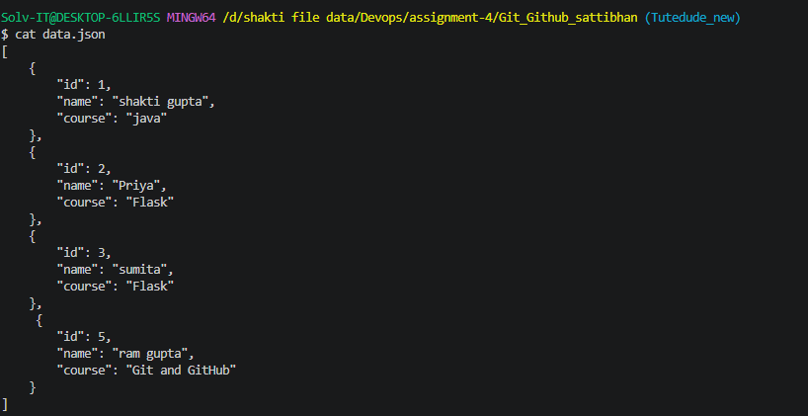
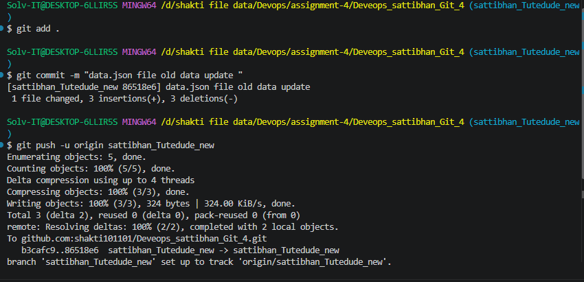
git checkout master
git merge sattibhan_Tutedude_new

master : branch change same line number data.json file so that confilict show.
Because two different branch change code same file and same data line number changes that reason conflict code.
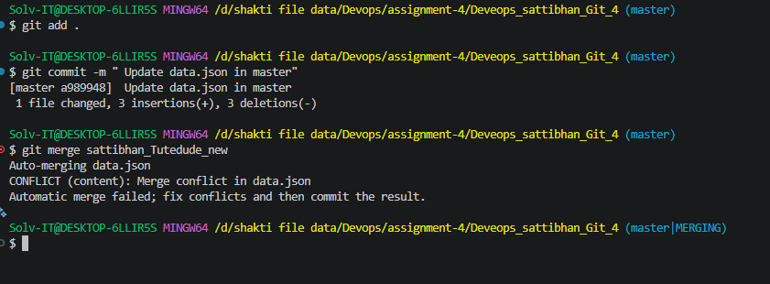
conflict show :
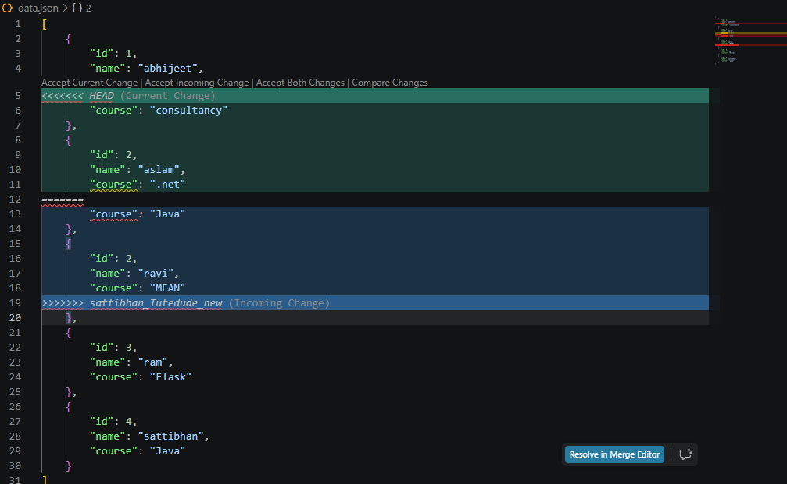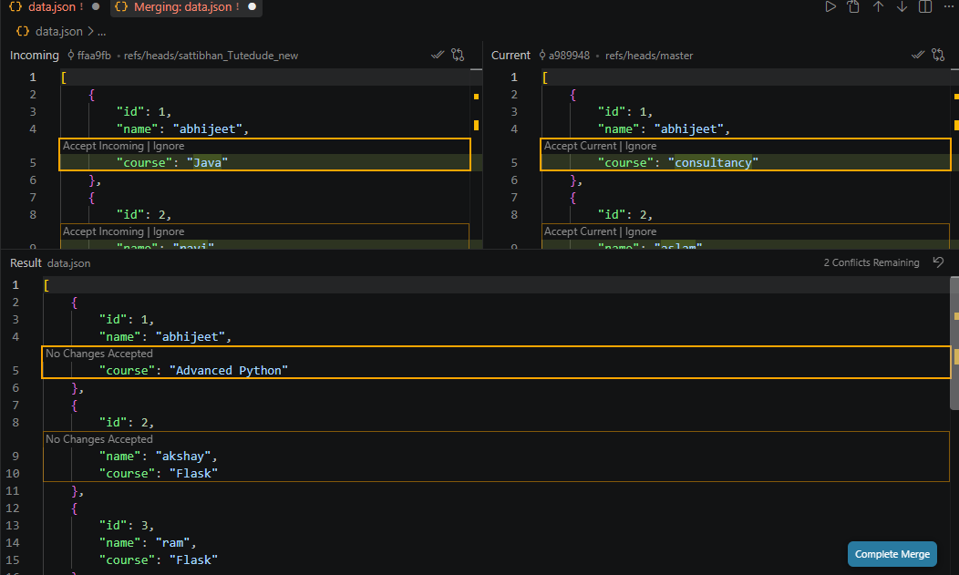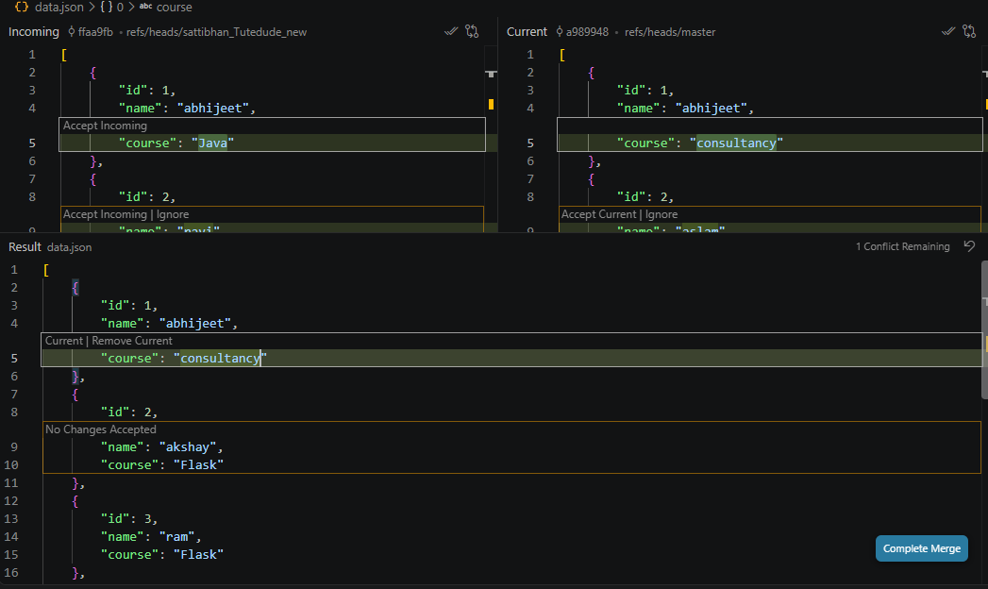
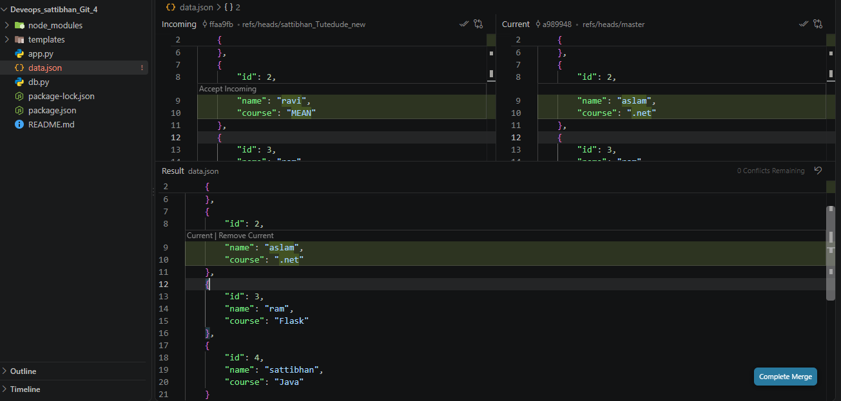
resolved conflict :
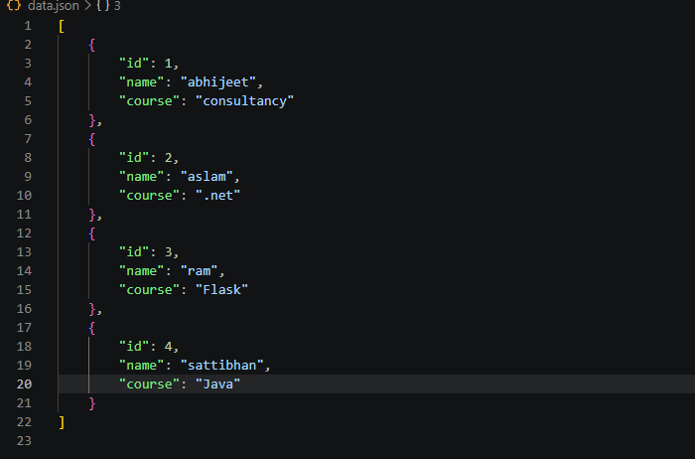

Task 3: Parallel Feature Development
- Branch Creation: Create two branches, master_1 and master_2, from the main branch.
ans :
git checkout -b master_1
git checkout -b master_2
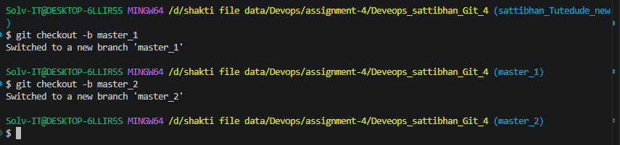

- Feature Development in master_1: Create a To-Do Page in the frontend with a form containing the fields Item Name and Item Description.
ans :
git checkout master_1
git add todo.html
git commit –m “ add todo.html file”
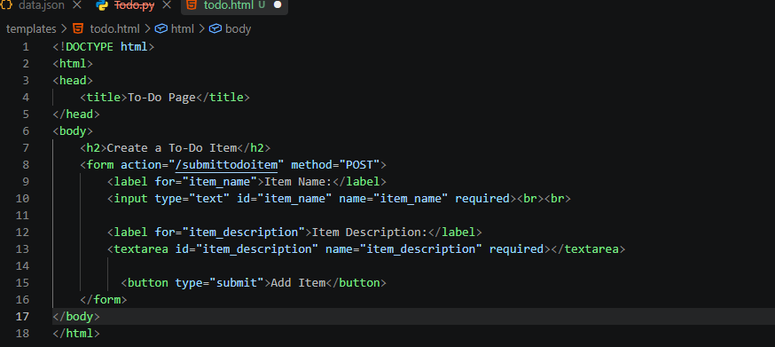
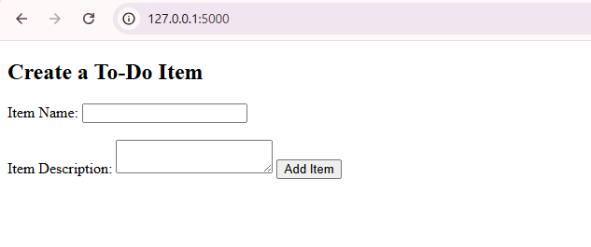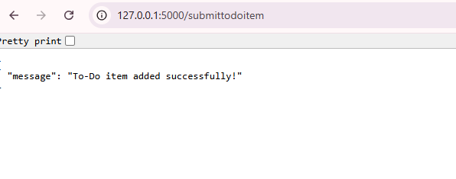
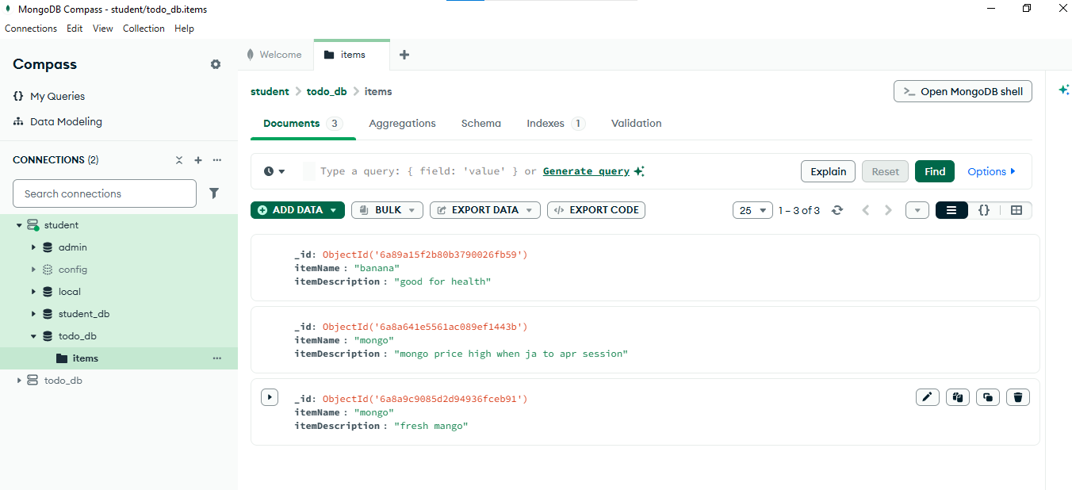

- Backend API in master_2: Create a backend route named /submittodoitem that accepts itemName and itemDescription via a POST request and stores ans :
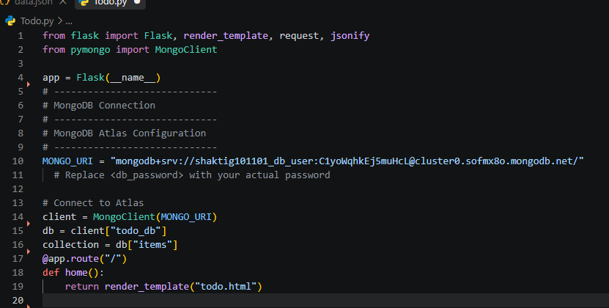 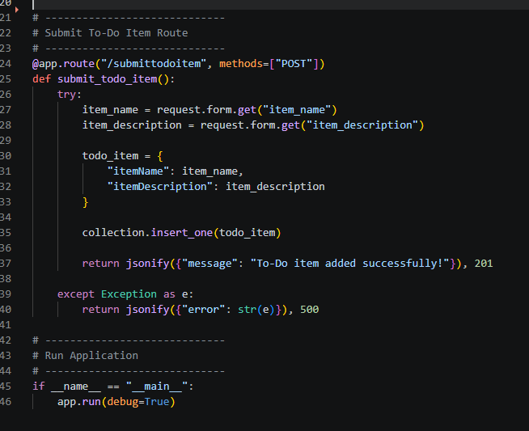
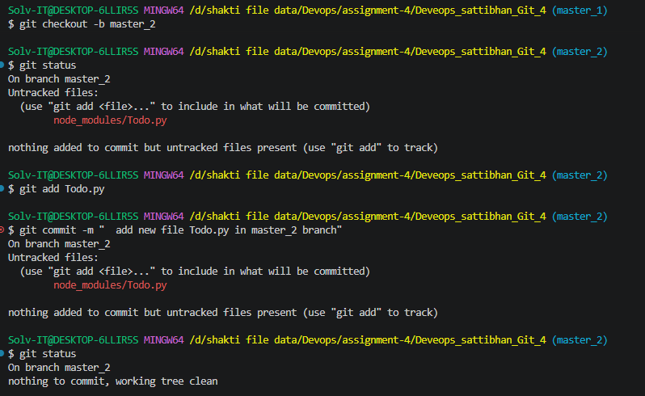
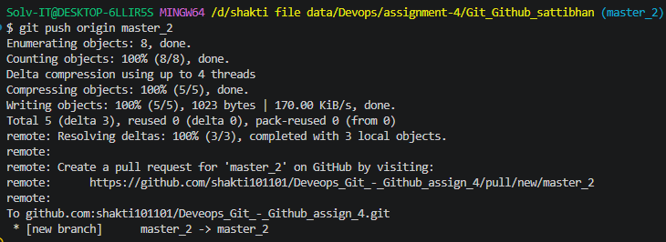

- Merging Changes: Merge the changes from both master_1 and master_2 into the main branch.
ans :
https://github.com/shakti101101/Deveops_sattibhan_Git_4/blob/master/Todo.py

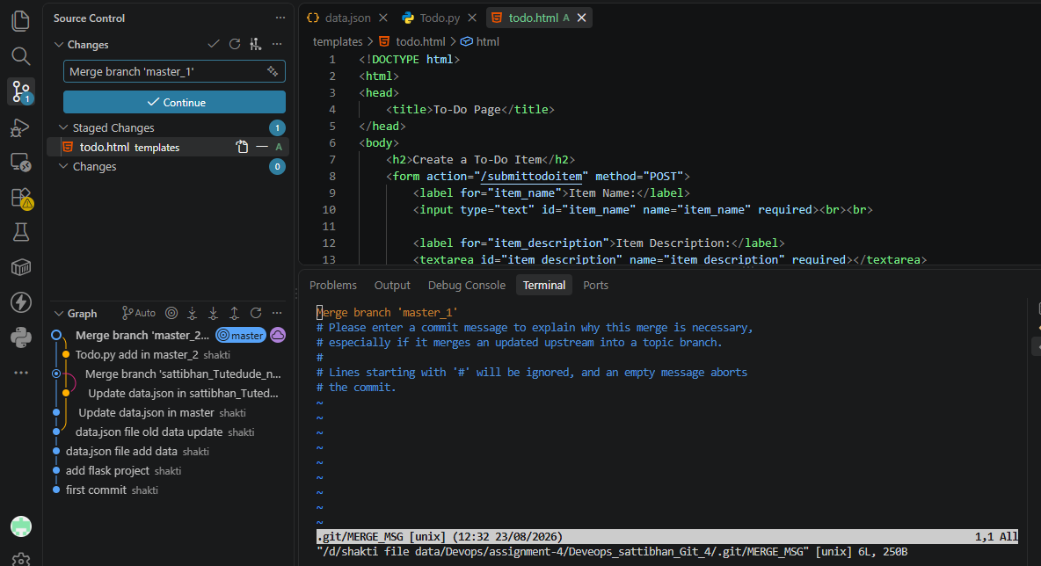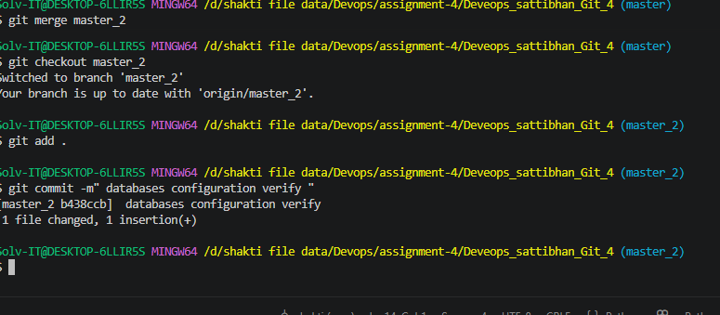
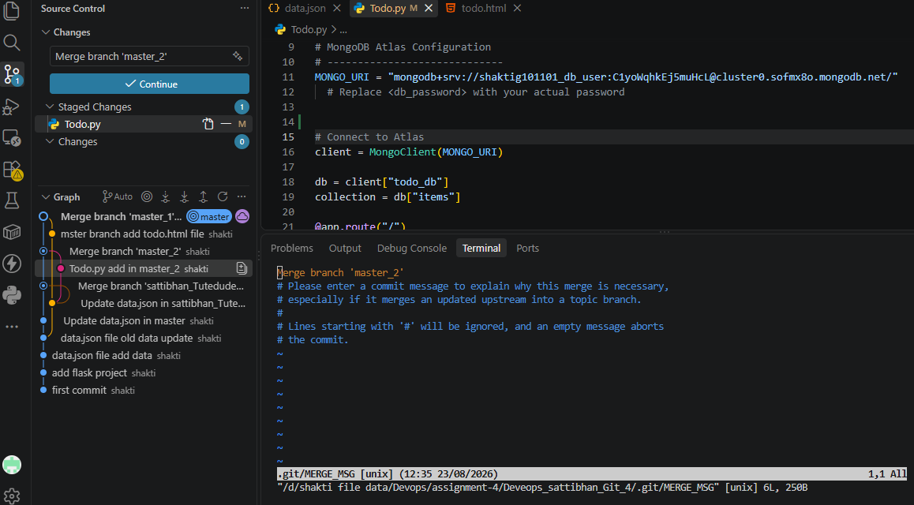
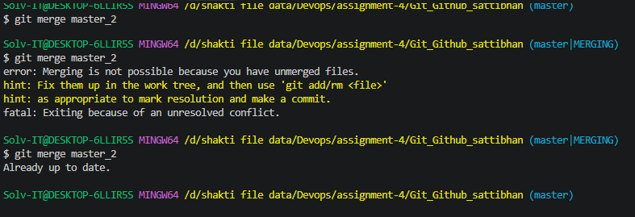
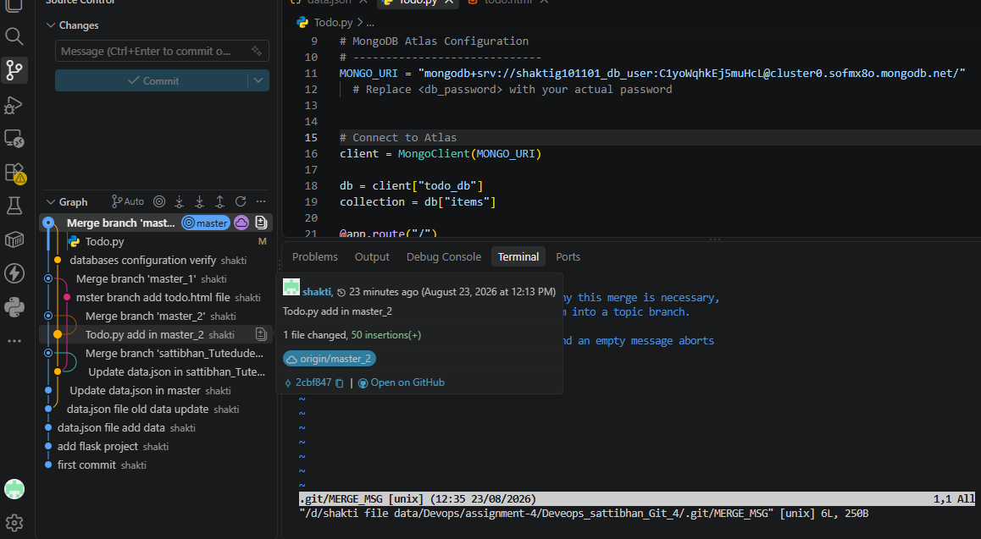
Finally code merge master branch : master_1 , master_2
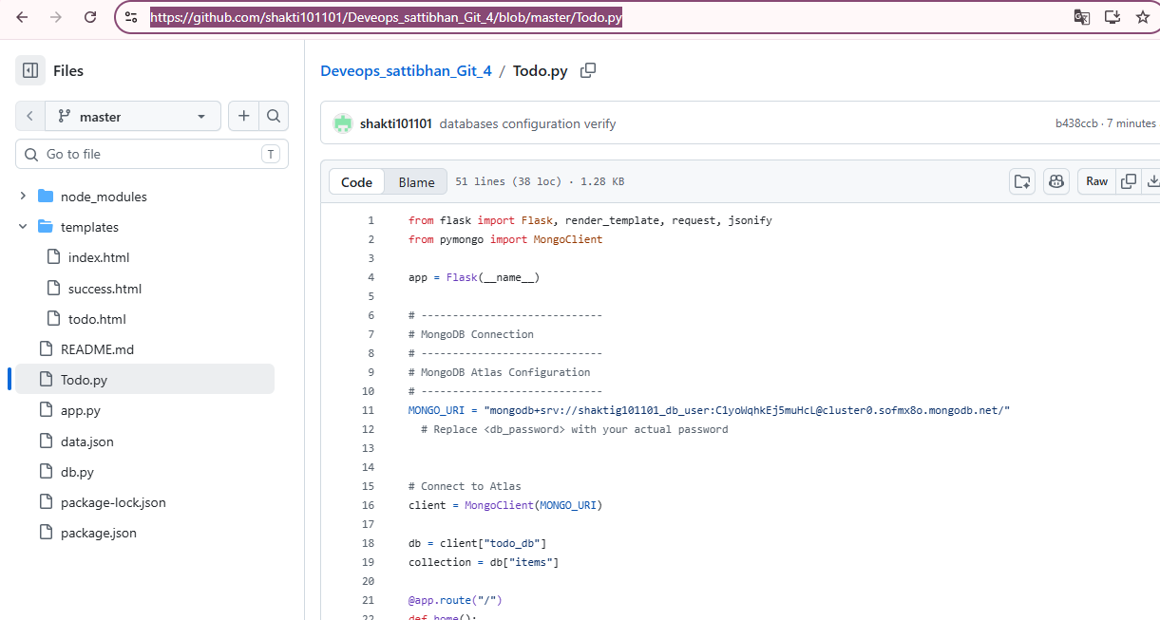

Task 4: Sequential Commits, Reset & Rebase
- Enhancing the To-Do Form in master_1: Add the following fields to the To-Do form: Item ID, Item UUID, Item Hash.
ans :
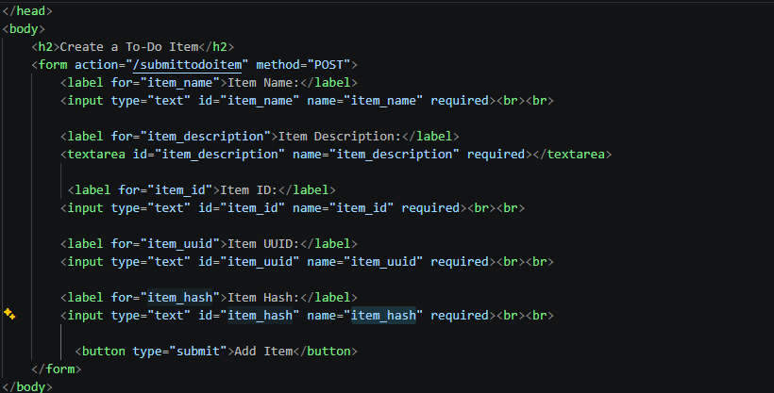
- Committing in Sequence: Add and commit each field separately — first commit: Item ID; second commit: Item UUID; third commit: Item Hash.
ans :
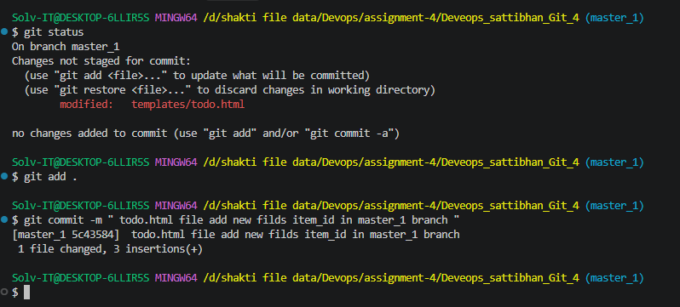 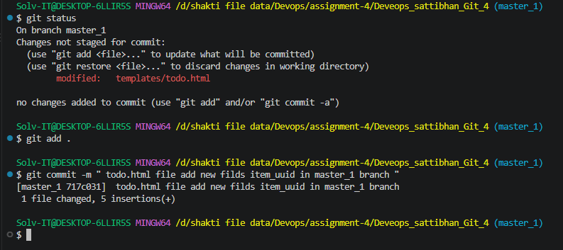
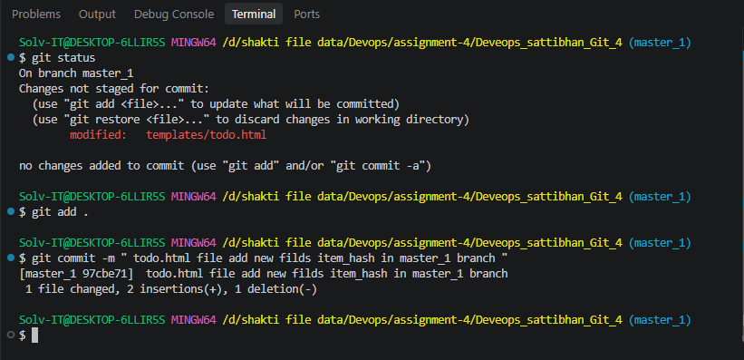
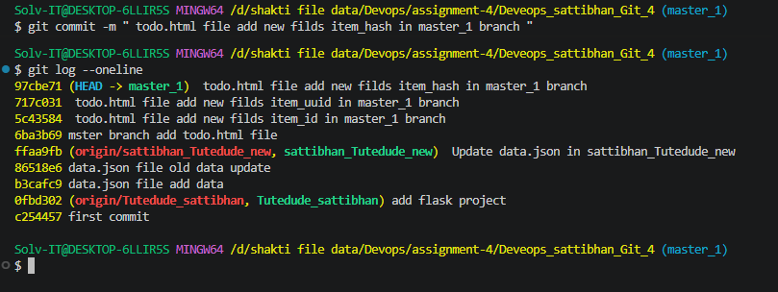

- Merging to main: Merge the master_1 branch into the main branch.
ans : command :
git checkout master
git merge master_1
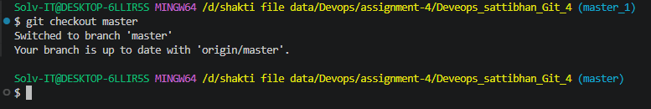
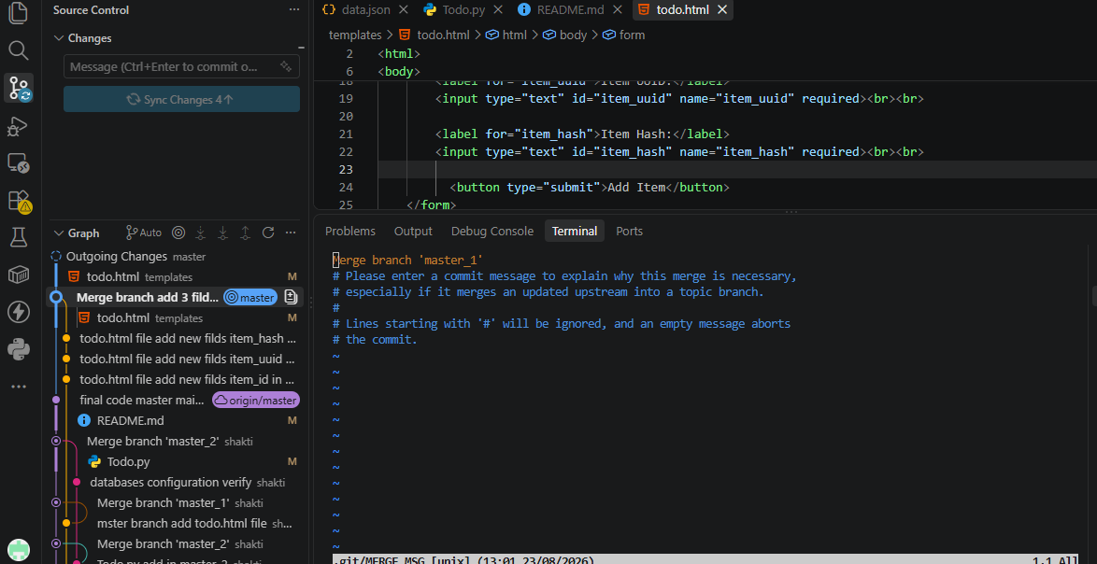
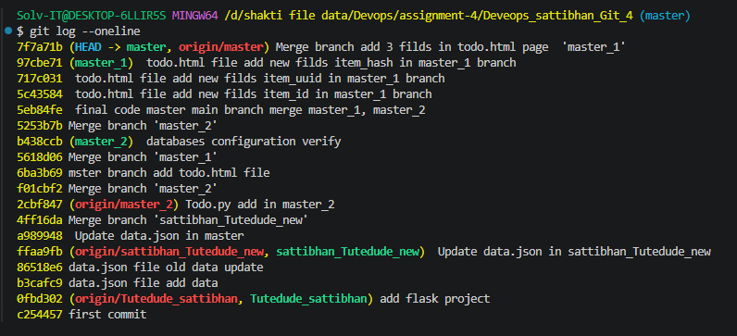
Git Reset: In the main branch, roll back to the commit where only the Item ID field was added. Use git reset --soft to ensure changes remain staged, then re-commit this state and merge it to main.
ans:
Command :
git log –oneline
Before :

rollback use command commit area :
git reset –soft (hashvalue)
again commit
git commit -m "Rollback: Keep only Item ID field"
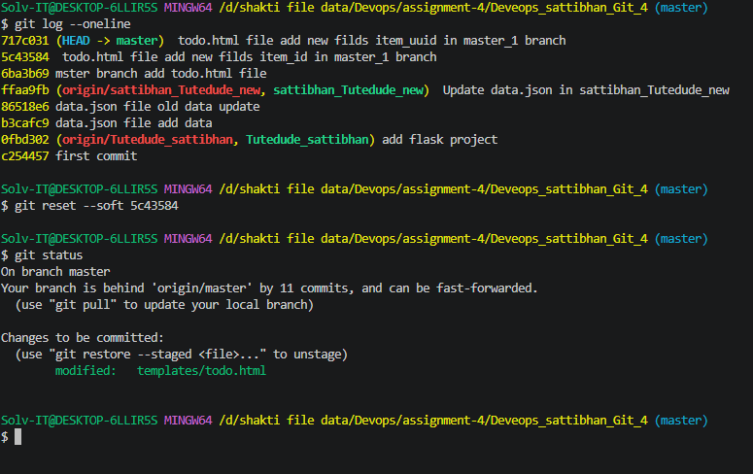

- Rebasing: Rebase the updated main branch changes onto master_1 using git rebase main master_1. Preserve individual commits (do NOT squash) to maintain commit history.
Ans:
git checkout master_1
git fetch origin
git rebase master
conflict occuer reolved.

