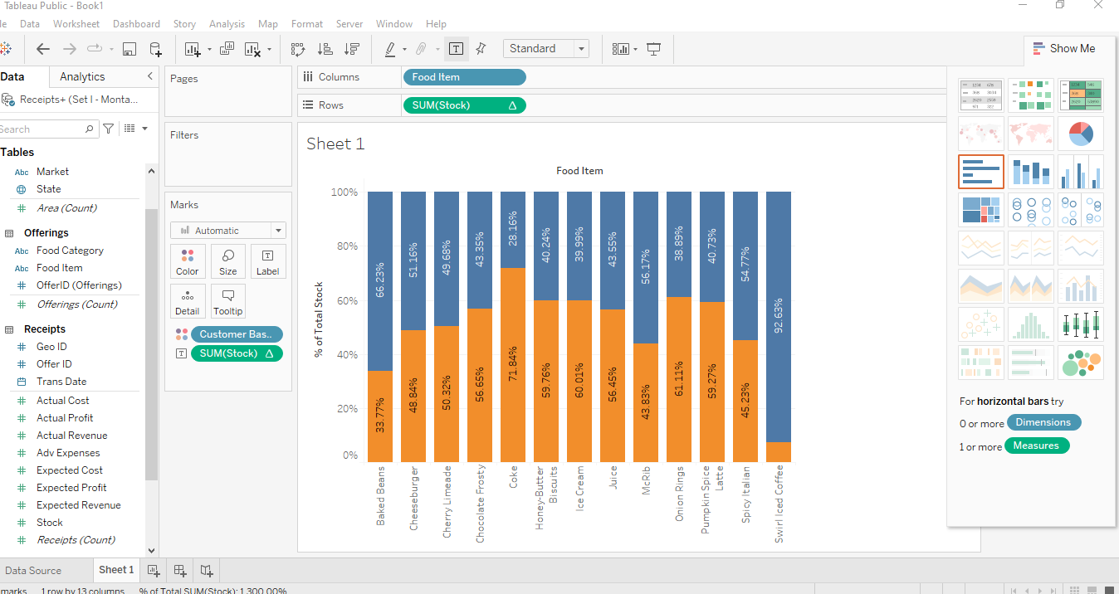

**Q1: 1:** Cock Food item have highest moderate customer base 71.18%

**Q 1: 2: There are two state having loss New Maxico and Massorri**

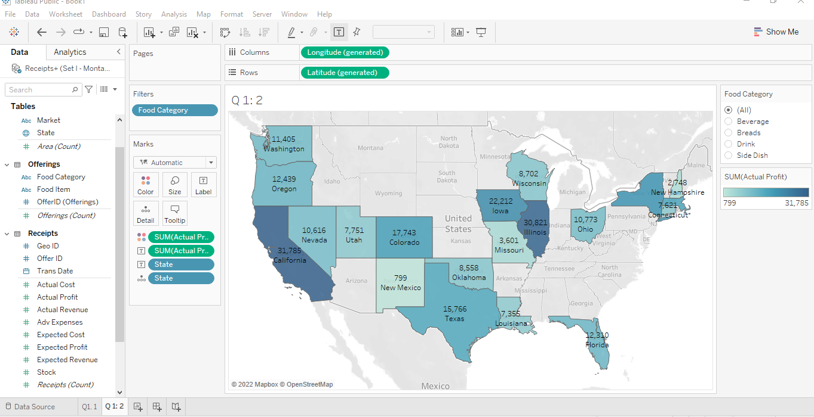

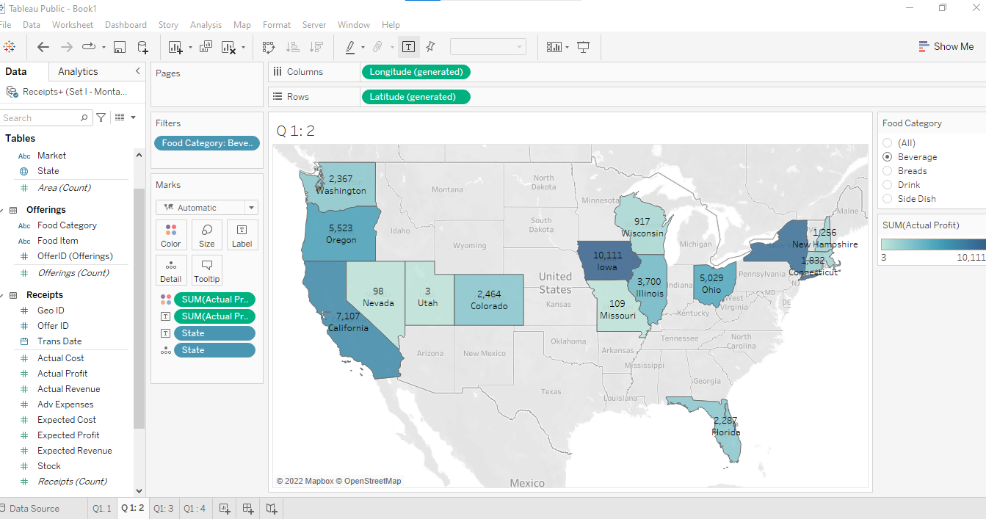

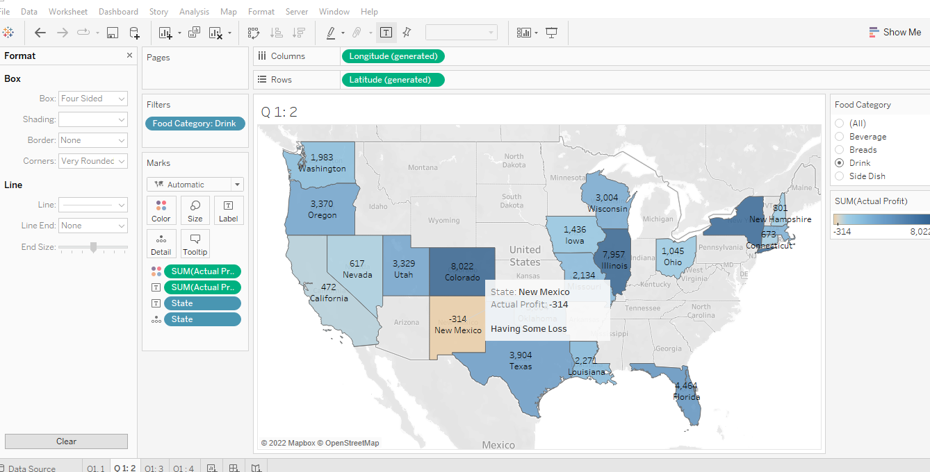

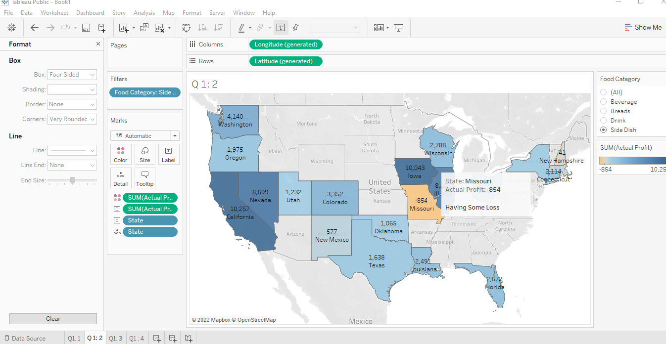

**Q 1: 3: The months were actual profit is less than expected profit February 2020,April 2020,Aug 2020,June 2020,OCT 2020,Feb 2021,Aug 2021,Nov 2021**

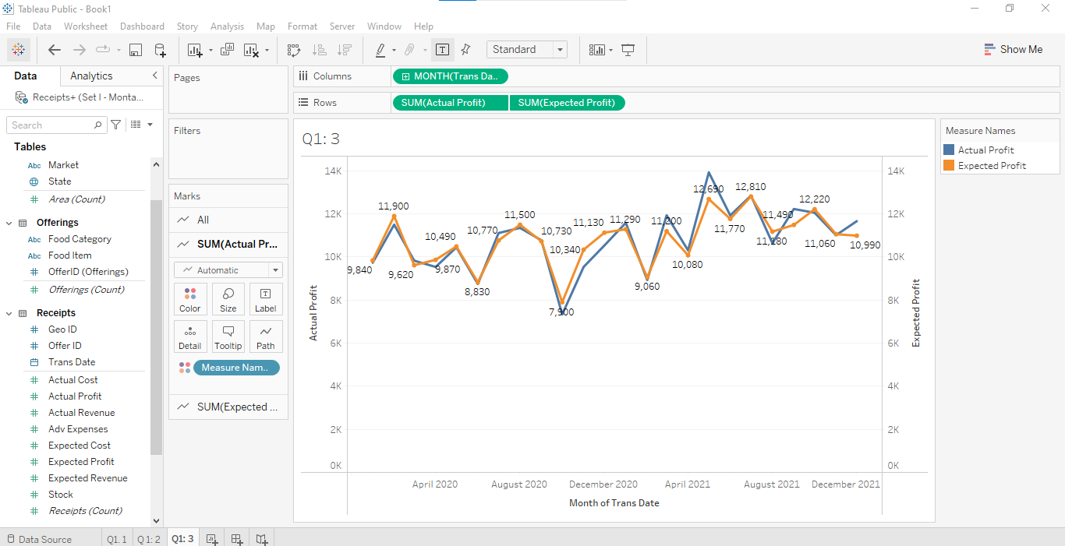

**Q 1: 4: There are 7 states having outliers**

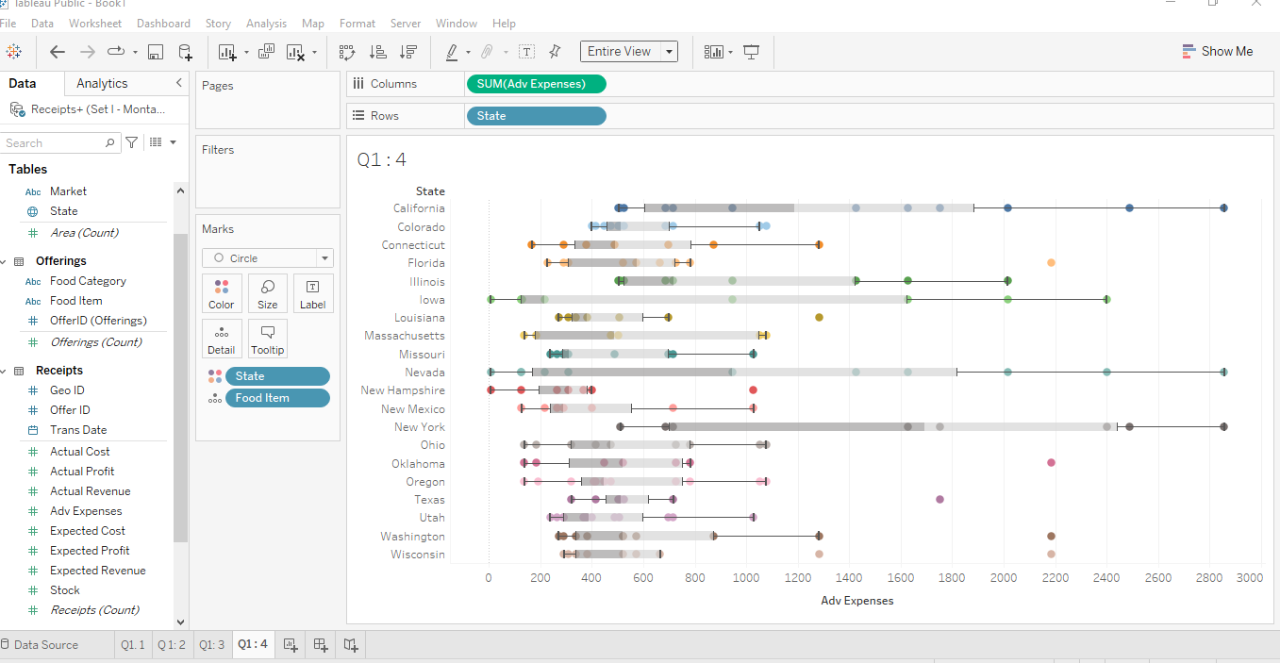

**Q 1: 5:**

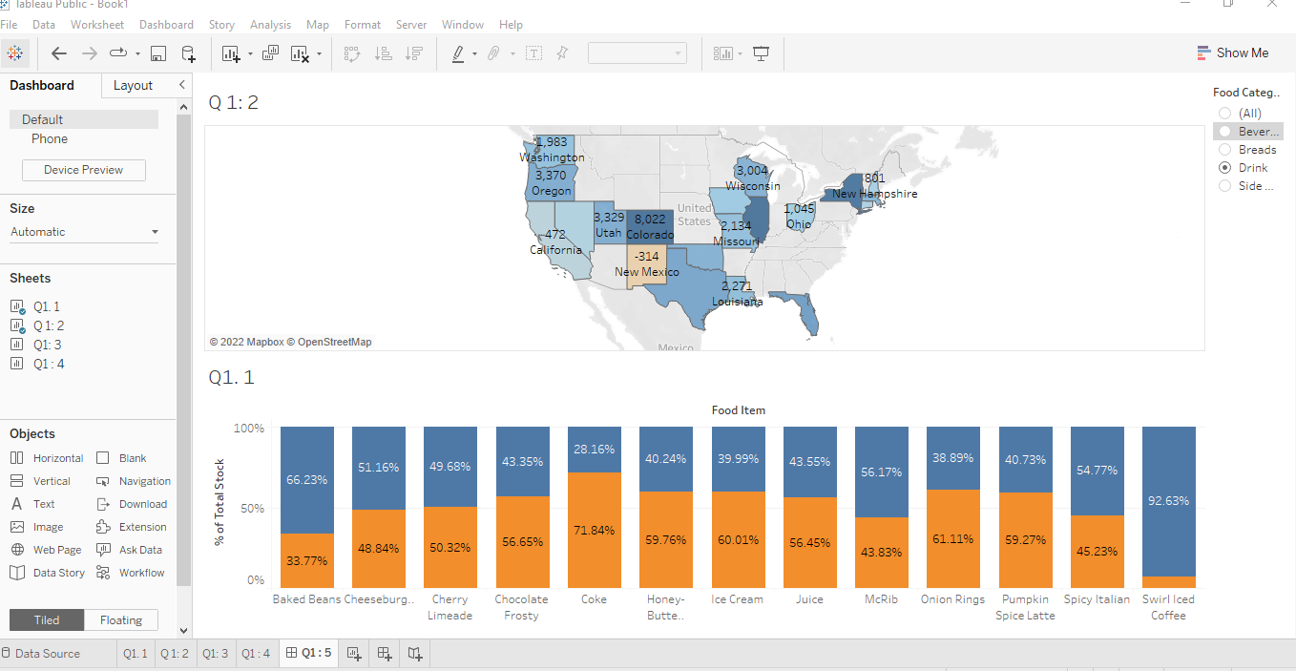

**Q 2: 1**

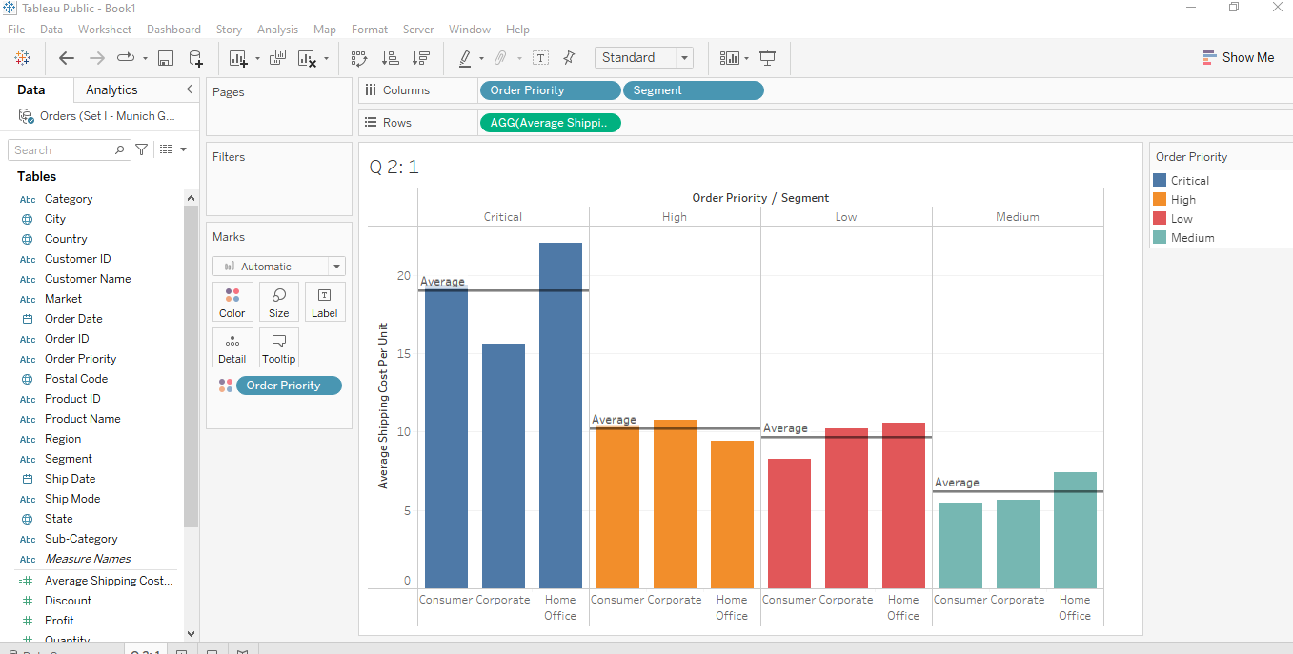

**Q 2 : 2 Home office segment has more no of state below 1000**

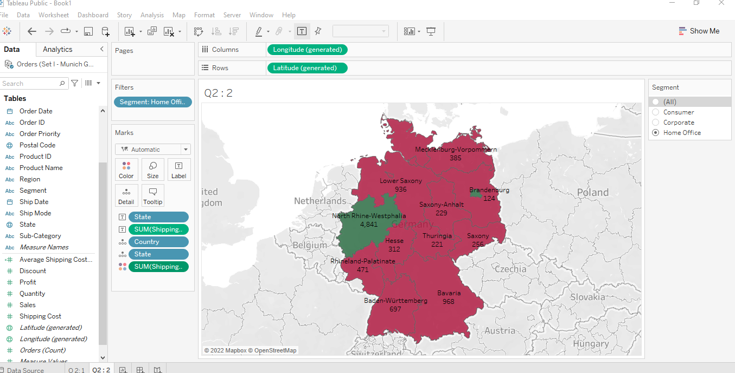

**Q2: 3:**

**Q2: 4 * Arrange in Rank Wise**

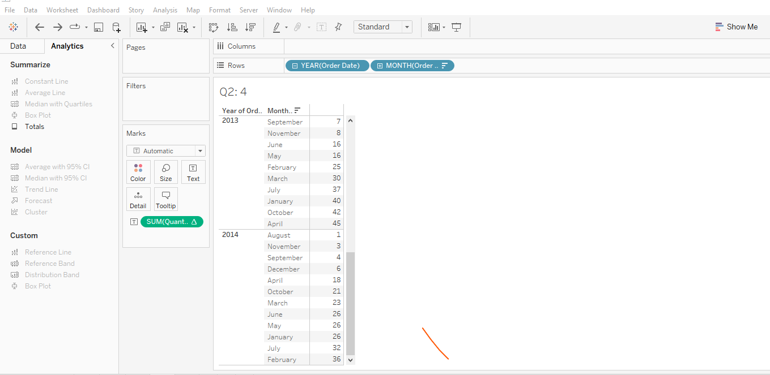

**Q 2: 4 % Differnce is**

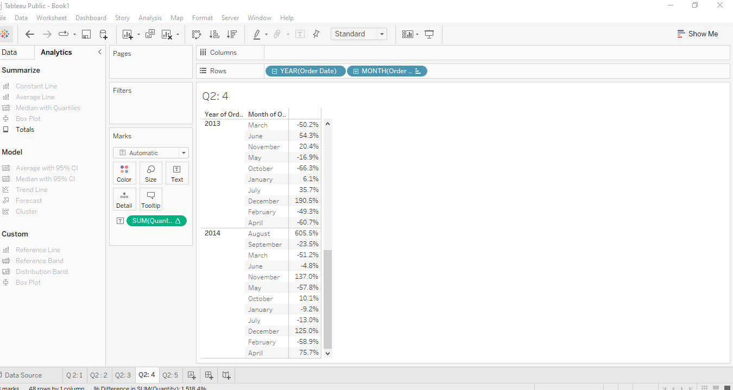

**Q 2: 5 Profit is 3999.954 if we achieve sales of 6000**

**Sales is 3114.806 if we want to achieve profit of 2000**

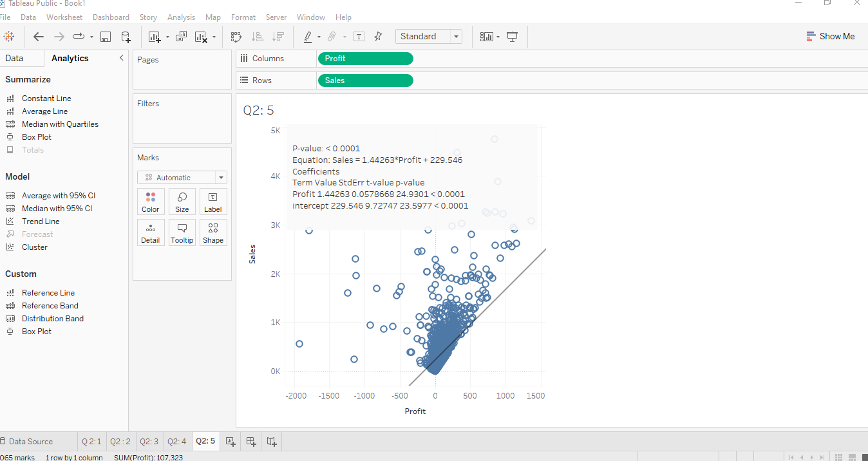

**Q 1: a Average CTC of Finance Depeartment is 111479.37**

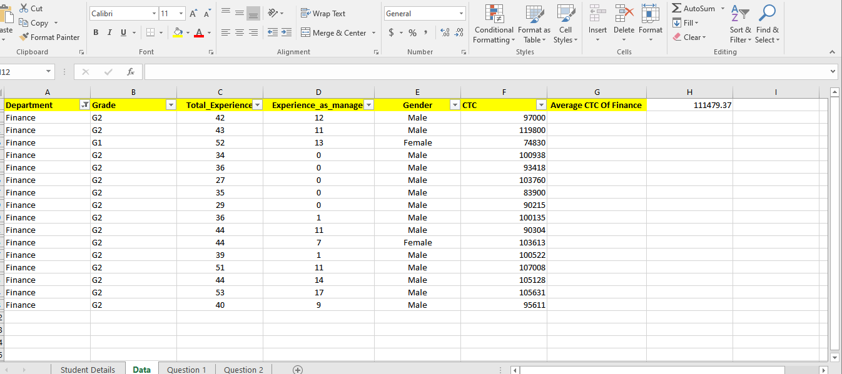

**Q 1 : b**