# **Genco SOA Support Process**

1. A Genco SOA team member will be added to Xmatters by Sal/Praveen (?).
2. The SOA team member will login to Xmatters and add his phone number under the Devices tab as seen below.

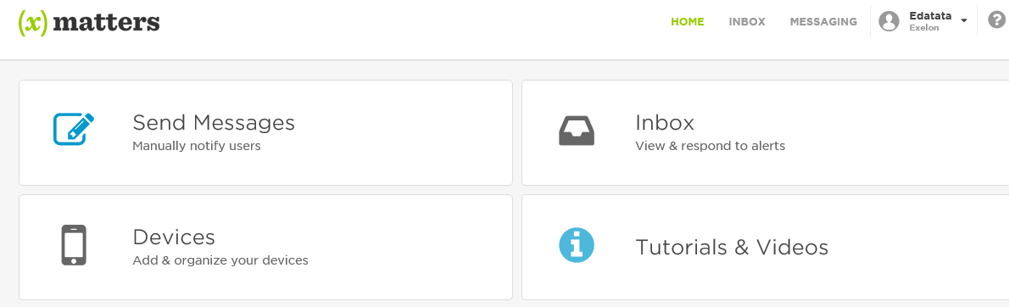

Click on Devices and add your phone number and make sure your email id is setup correctly. These can then be tested individually to make sure you receive notifications.

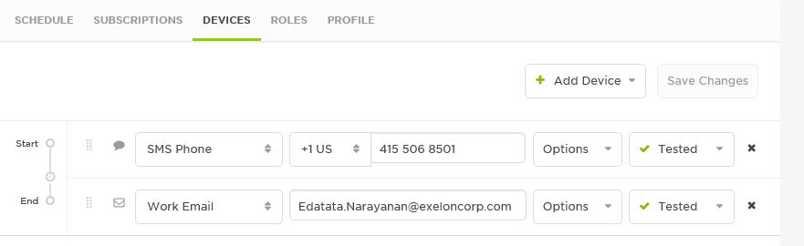

1. [TBD] The assumption is that the scheduling of resources will happen outside of Xmatters. Xmatters includes a section for scheduling of resources if needed as seen below:

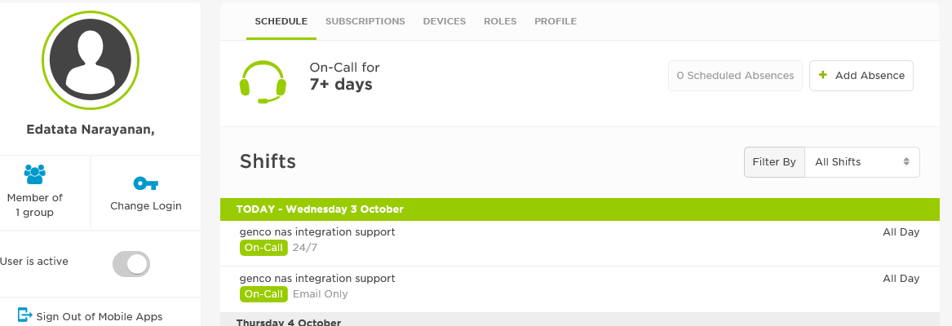

1. When an incident is created by someone in Service Manager, Xmatters will send out a notification to all the registered devices (email, sms). An example email is seen below:

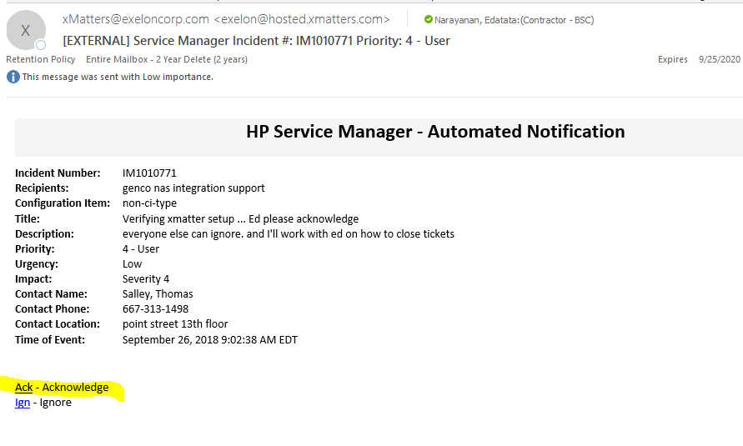

The recipient will click on the Ack link to acknowledge receipt of this incident. They should then send an email to this DL [#GencoFusionSupport@exeloncorp.com](mailto:#GencoFusionSupport@exeloncorp.com) so that everyone is aware that someone has acknowledged and is working the ticket.

[TBD] Currently the Ack link was not functioning as desired as the Acknowledgement was not registered in Service Manager. Sal to follow up on this.

1. The SOA support member will receive notifications when an incident is assigned to them.

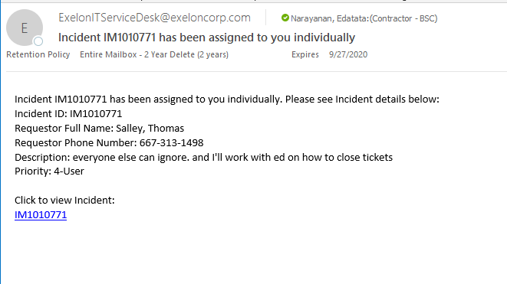

1. Once logged into Service Manager, the incident can be reassigned to another user or the issue can be resolved and closed.

To reassign after adding comments, use the Assignee (highlighted):

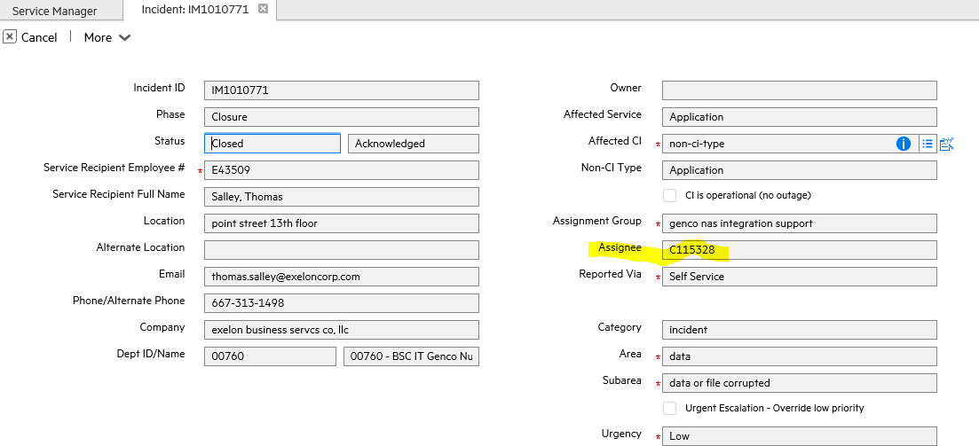

To close, you will have to provide a closure code and solution as seen below:

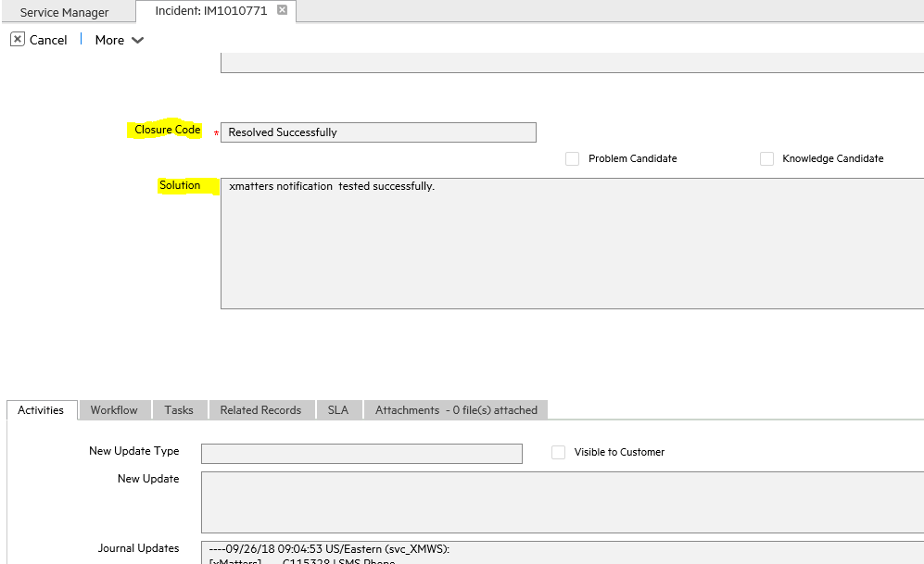

[TBD] If an issue is determined to be not a SOA issue or needs clarification from someone , who should the incident be assigned to ? Need to know app owners etc to assign to.

Useful Documentation and URL links

* Online User Guide
  + [https://help.xmatters.com/5.5.76/#cshid=HomePagePlace](https://help.xmatters.com/5.5.76/)
* xMatters release schedule
  + <https://support.xmatters.com/hc/en-us/sections/200440465-On-Demand-Service-Updates>
* News and Updates
  + <https://support.xmatters.com/hc/en-us/sections/200416825-On-Demand-Platform>