Genco FTPS Setup

1. Here is the Server and SOA Service account you will authorize.

mftwstg-ccc-01: svc_fmw_padsstg

1. Authorize the above account for the overall site following these instructions:

Log onto server mftwstg-ccc-01 as svc_mft_stg. (Note the password for this account is in MFTPasswords.xlsx)

Go into Internet Information Systems (IIS) Manager

Click on Default FTP site and double click FTP Authorization Rules

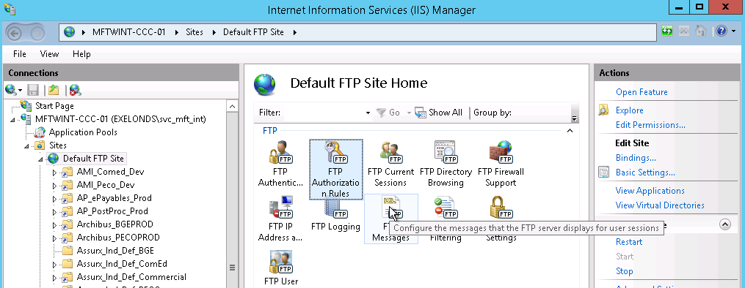

* 1. Add Allow Rule

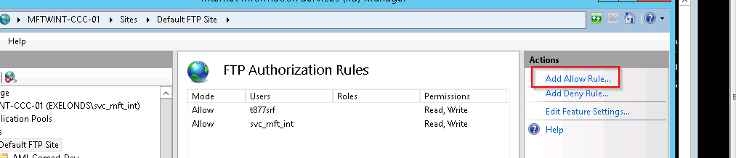

* 1. Click “Specified users” and add in the new account. The account you will add will be **svc_fmw_padsstg**, then click **Read** and **Write**, then click OK

