* Week 3/Milestone 2 – Draft of White Paper
  + See template below
  + 3-5 pages (illustrations do not count toward page count)
  + APA References.
  + Include at least 3-5 illustrations (not included in page count)
  + 1 Appendix (Supporting documentation)
  + 10 Questions an audience would ask you (Answer in Milestone 4)

**Business Problem**

Delhi is one of the world’s most polluted cities through the year and facing a major challenge with its polluted air having long lasting consequences. Since air pollution varies from good to moderate to unhealthy for sensitive groups. It is also resulting in health issues and significant impact on the capital’s economy and businesses.

Toxicity in its air is increasing every year causing severe health issues to Delhi residents every year. This is due to various factors, including burning of crop remains by farmers, low wind speeds and bursting of firecrackers during festivals.

Below are few illustrations related to the current scenario of air pollution in Delhi:

**NEW DELHI STREET LIFE**

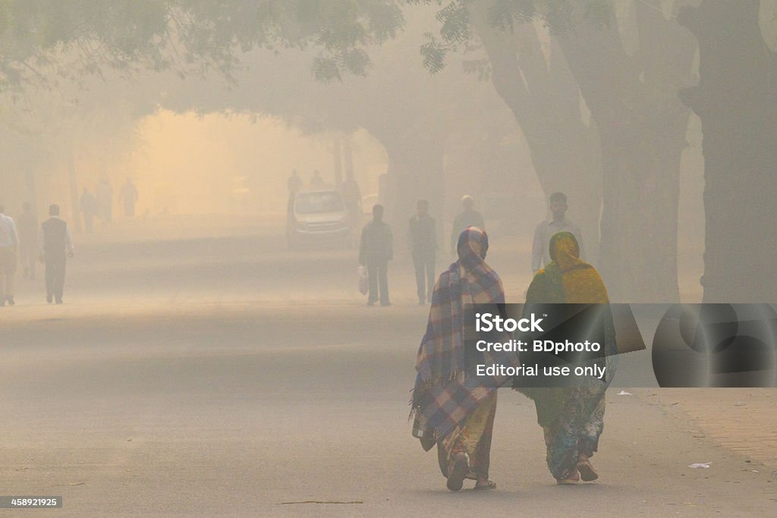

**DELHI CITYSCAPE**

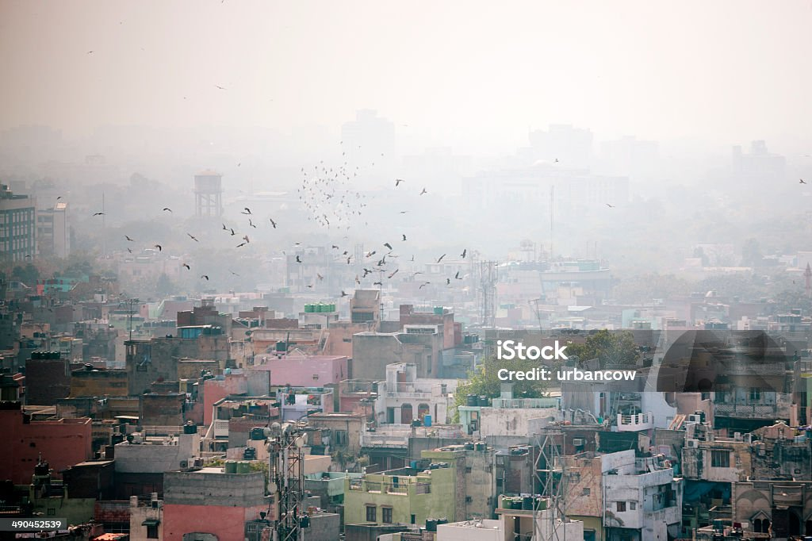

**INDIA GATE**

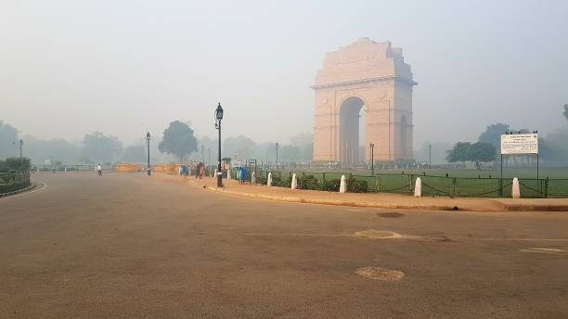

**FOG IN DELHI**

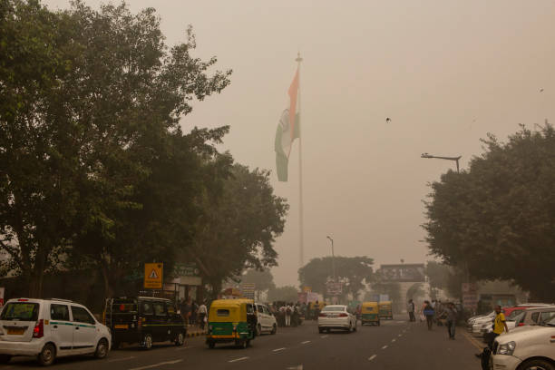

**A MAN WEARING THE FACE MASK DUE TO POLLUTION**

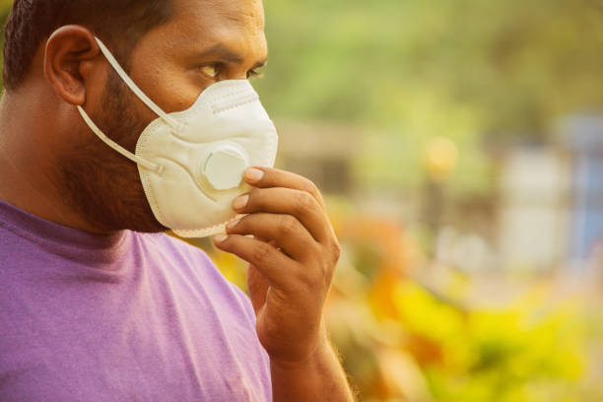

**Background/History**

Since 1990s air pollution in Delhi has gained increased attention due to various factors:

* Vehicle Pollution: Growing vehicle population caused carbon monoxide emissions in 1996 and increased by 92% compared to 1989.
* Coal based thermal power plants contributed 12% of pollution in Delhi.
* The practice of crop stubble burning by farmers in the winter season contributes 45% of Delhi’s air pollution. Farmers burn leftover plant remains to clear land after the harvest. Northwestern winds also affect air quality during this time.
* Diwali celebration in which firecrackers are used also worsens the air quality.

**Data Explanation (Data Prep/Data Dictionary/etc) – Done by shakti**

**Methods**

Government authorities have taken strong measures to fix the deteriorating environmental conditions in Delhi. Few of them are mentioned below:

* Judgment passed by the Supreme court in 1985 to shut down the hazardous industries and hot mix plants and bricks kilns operating in Delhi.
* Central pollution control board set up in 1974 under the Water Act is the principal measure for implementation of national air quality monitoring program and taking responsibility at the state level for carrying out the functions stated in the environmental acts.
* Important measures have been taken to control vehicle pollution in 1995 and 1998 with the introduction of unleaded petrol and catalytic converter in passenger cars. In 2000, reduction of sulfur content in diesel and reduction of benzene content in fuels. Other vehicle pollution control includes construction of flyovers and subways for smooth traffic flow, introduction of metro rail in the capital and CNG for commercial transport vehicles like buses, taxi and auto rickshaws.
* Introduction of first industrial policy in 1982 with a subsequent second policy in 2010-2021 with a mandate to develop clean and non-polluting industries. Organizations like Centre for Science and Environment, the energy and resources institute and Indian association for air pollution control are working continuously and contributing to reduce air pollution.

**Analysis**

* Summary statistics and analysis of time series.

SPSS 25 version of the software is used to analyse the climatic variables, air pollutants and hospital visits of the patients such as mean, standard deviation, maximum and minimum and different quartiles were computed. Daily hospital visits for three years (2016-2018) in SMCH were based on the age, sex and visit dates of the patient. Violin plots were developed for three air pollutants (PM10, PM2.5, and CO), two climatic variables (T, RH), and hospital visits of patients regarding five seasons of Delhi, indicating the distribution of data prevailing in the city during different seasons. Violin plots have been drawn with XLSTAT statistical software. Time series plots were developed using the SPSS 25 version of the software with time dimensions on the horizontal axis and hospital visits, pollutants and, meteorological variables on the vertical coordinate axes to shed light on the data distribution for three years.

* Frequency analysis

Frequency analysis is used to analyze the seasonal distribution of PM2.5 and PM10 concentrations in Delhi during 2016–18. In this analysis,the city level average concentrations of PM per day were calculated by averaging the concentration of 11 monitoring stations. Then, PM concentrations (both for PM10 and PM2.5), i.e., number of per day observations for the period 2016–18 falling under six categories like 0–25, 25–50, 50–100, 100–200, 200–300, and more than 300 μg m-3 worked out. So, the three-year period (2016–18) data or 1096 observations were segregated session-wise for each of the six categories, and the frequency of their appearances was then expressed in percentage terms. The calculations were done with the help of data analysis ’ToolPak’ of excel. As per the air quality index (AQI) Of India, the range 0–100 is considered a good category, 100–200 as moderate, 200–300 as poor, and above 300 as very poor or severe.

- Correlation analysis

Pearson correlation is used to understand the relationship between climatic variables and air pollutants data for Delhi during 2016-2018.The coefficients of correlations were established between daily meteorological variables and air pollutants for Delhi. The correlation coefficients at p < .01 were accepted as statistically significant. For better visualization, correlation matrix plots have been drawn with R software’s ’corrplot’ package.

- Generalized Additive Models (GAM)

GAM model helps in explaining the nonlinear associations of various independent variables like climatic variables and criteria pollutants and the outcome variable like hospital visits due to respiratory diseases. This model allows the relationship between outcome variables and independent variables to be developed based on the functions fitted to some independent variables, hence bringing the parametric relationships of the covariates in a regression model. In this study, the potential confounding effects of few independent variables that entered the regression model were controlled with non-parametric smoothening splines.

The respective coefficients of pollutants of the multi-pollutant and single-pollutant GAM models, found out as regression model output, were the inputs in deriving the relative risk (RR) of hospital visits due to one unit rise of each modelled air pollutants in the ambient air.

* Relative Risk (RR)
* This analysis helps in understanding the risk of the outcome of an intervened event with non-intervened events. Thus RR compares one group with another group.

In this study, the exposure-response coefficient *β* of pollutants obtained from the GAM models under different lag conditions have been used to estimate RR and their 95% confidence intervals (95% CIs). RR for the *ith* predictor variable and its confidence intervals were calculated using the following Equation.

RRi=exp(ΔCixβi)

(2)

CI=exp{ΔCix(βi−1.96xS.Ei)}lowerlimit(LL)

(3)

CI=exp{ΔCix(βi−1.96xS.Ei)}upperlimit(UL)

(4)

where Δ*Ci* is the rise of the *ith* pollutant concentration in air and S.E*i* is the standard error of *ith* pollutants. Here, Δ*C* will be 1 unit increase in CO and 10 units increase in all other pollutants. RR provides information on the rise of hospital visits due to each unit increase of a pollutant’s concentration level. To make the RR estimates of daily hospital visits due to air pollution more expressive, we also calculated the percentage change (PC, %,) at 95% CI in the following way

PC = Percentage change of daily hospital visits due to air pollution

PC=(eβ−1)x100%

(5)

In all analyses p-value < 0.05 considered significant.

**Conclusion**

The magnitude of air pollution in Delhi is massive and it is causing devastating impact on people’s health, the city’s environment and economy. The consequences of air pollution in Delhi include Environmental harm, Health risks, reduce life expectancy and lung damage. Both government and citizens should take responsibility and necessary action to reduce air pollution such as:

* Enforcing and implementing legislation.
* Complying with laws and regulations
* Encouraging afforestation
* Adopting renewable energy sources
* Encouraging the use of electric vehicles
* Providing farmers with alternatives to crop burning.

In conclusion, air pollution in Delhi is a serious health hazard. It is now a global challenge, as evidence shows that adverse effects still exist and can cause serious issues in city’s environment and people’s health.

**Assumptions**

* Air Quality in Delhi is likely to remain poor until the end of the year and especially around Diwali festival when firecracker displays add to the pollution. In winter season, cool temperatures and slow winds trap pollutants and dust near the ground, forming smog and mist.
* Vehicle pollution is a major contributor to air pollution in Delhi, accounting 67 per cent of emissions, followed by Coal based thermal power plants at 12 per cent. Rapid industrialization and weak environmental laws have also contributed to Delhi’s air pollution.
* Air pollution in Delhi can cause health problems including allergies, respiratory conditions, reduced lung functions and increased risk of cancer. Children are particularly affected by long term exposure to PM2.5, with millions of people suffering from serious lung damage.

Limitations

Sources like vehicles, power plants, refineries, crop burning and inefficient household fuels like firewood are contributing to Delhi’s air pollution on a regular basis. In addition to this Delhi’s growing population, lack of education and knowledge and law enforcement plays a vital role in increasing the pollution with adverse effects.

* Respiratory issues

Air pollution can cause allergies, asthma, reduced lung function, and an increased number of patients with breathing problems. It can also worsen respiratory complications from COVID-19.

* Cardiovascular issues

Delhi's air contains high levels of particulate matter (PM2.5 and PM10), sulfur dioxide, nitrogen oxide, and carbon monoxide, which can increase the risk of strokes, heart attacks, and high blood pressure.

* Other health issues

Air pollution can also cause chronic headaches, eye irritation, sore throat, skin irritation, hypertension, and an increased incidence of cancers.

* Effects on children

Children are more vulnerable to air pollution's negative effects because they breathe more air per kilogram of body weight and spend more time outside. Air pollution can cause irreversible lung damage in children, lower their immune systems, and increase the risk of cancer, epilepsy, diabetes, and multiple sclerosis. It can also reduce children's IQ and increase the risk of attention-deficit hyperactivity disorder.

* Shortened life expectancy

Air pollution can increase all-natural-cause mortality and morbidity.

**Challenges**

Delhi's air pollution is caused by many sources, including garbage, road dust, power plant waste, and transportation gases. Some challenges to reducing air pollution in Delhi include:

* Waste management

Landfill fires are difficult to control and contribute to air pollution. Proper waste management can help avoid these fires.

* Transportation

The Delhi government has proposed introducing electric public transport buses and a goal of 25% of private vehicles being electric by 2023. However, some say that banning private vehicles without a public transport system to meet demand would be impractical.

* Construction

Construction and demolition sites can contribute to air pollution, so it's important to cover materials and use windbreakers and chutes during concrete batching.

* Enforcement

Some say that measures to reduce air pollution need to be combined with strong standards and improved enforcement.

**Future Uses/Additional Applications**

Government authorities are taking necessary steps to control the current scenario of rapid increase in air pollution in Delhi, however, there are also additional measures that could help in controlling the situation.

* Deregister old cars – The national green tribunal had ordered the deregistration of cars that are more than 15 years old.
* Use public transportation – Using public transportation can help in reducing the carbon dioxide released into the atmosphere. Fewer cars on the road means fewer traffic jams and less pollution.
* Stopping burning garbage can reduce pollutants in Delhi’s air by up to 10%.
* Avoid plastic bags – Plastic bags pollute the environment and can increase the heat on Earth. Burning plastic waste produces harmful gases that contribute to air pollution.
* Trees plantation – Planting trees or afforestation increases the supply of oxygen and reduces the amount of carbon dioxide in the atmosphere.
* Recycle and reuse – Recycling and reusing resources help reduce pollution emissions and requires less power to make new products.
* Usage of air purifiers – Air purifiers can capture airborne allergens and irritants, improving indoor air quality.
* Wear a properly fitted mask – An N95 mask can reduce the amount of dangerous PM2.5 pollution breathed in by at least 95%.

**Recommendations**

Air pollution and climate change are closely connected. So preventive measures should be taken by the citizens and government to protect the climate and the city from the drastic impact of the pollution on their health. Below are a few suggestions or recommendations to help reduce air pollution.

* Install air purifier
* Using public transports
* Air quality Management Program
* Reduction of Forest fires and smoking
* Air purifying indoor plants
* Implement afforestation
* Wear masks
* Avoid exercise during Delhi pollution
* Outdoor recreation
* Right Dietary choices
* Monitor air quality
* Stay hydrated
* Avoid usage of crackers
* Buying cars with lower emissions
* Use filters for chimneys

**Implementation Plan**

Government is taking significant measures to make air breathable in the capital of India. Few measures are listed below:

* Water sprinklers: The government has planned to install 530 water sprinklers at 13 main hotspots for dust pollution.
* Pusa Bio-decomposer: It controls stubble burning, water will be sprayed on 5000 hectares of agricultural land.
* Monitoring industrial areas: In the capital, 66 teams will monitor 1727 industrial units.
* Afforestation: Over 1 crore of plants will be planted to reduce carbon dioxide.
* Vehicle Pollution: A total of 385 teams will examine vehicle pollution certifications and prevent overage cars from being driven.
* Garbage burning: It is prohibited in Delhi, and 611 teams will oversee its enforcement.
* 13 Pollution hotspots mapped: The Delhi pollution control committee (DPCC) has previously mapped and created an inventory of all major and small pollution sources as well as their geo coordinates at the city’s 13 hotspots. The government has identified 13 pollution hotspots, and a special control room will monitor them.
* GRAP: Strict implementation of the Graded response action plan (GRAP) in the city.

Delhi had mapped 470 major and minor pollution sources in Delhi last year, which helped improve the air quality as compared to the winter of 2021.

**Ethical Assessment**

Air pollution level in Delhi has exceeded the National Ambient Air Quality standards (NAAQS), however, Government has implemented various scattered and in-quantified control actions. The present study has been designed to assess the air quality status, identify Air Quality Control Region (AQCR), and evaluate control strategies in the city. Out of eight selected locations, ambient PM10, PM2.5, and NO2 concentrations were found exceeding the daily as well as annual standards at selected AQCR with peak levels during post-monsoon than winter and summer. Anand Vihar was found to be most polluted and thus selected as an AQCR. AERMOD performed satisfactorily in predicting pollutant concentration during winter and summer having an index of agreement in the range 0.54-0.80. PM10 and PM2.5 can be reduced substantially by increasing frequency of efficient mechanized cleaning of roads and sprinkling of water on the roads. Progressive decrease in NO2 concentrations can be achieved by restricting entry of truck in the study area through alternate path. The cumulative impact of all selected control strategies indicates a substantial decrease in air pollution within AQCR. The study also suggests a policy framework to manage urban air quality through local scale air quality guidelines.

**Questions asked by audience:**

1. What causes air pollution in Delhi?
2. How does air pollution affect the citizens and children of Delhi?
3. What can be done to reduce air pollution?
4. How long has air pollution been a problem?
5. What effect does air pollution have on Food, crops, Forests and Biodiversity?
6. What actions can the government take to improve air quality?
7. What is the role of air quality monitoring to reduce air pollution?
8. What actions can businesses and industry take to reduce air pollution?
9. How are air pollution and climate change connected?
10. Is there a safe level of air pollution to protect the health of people?

**References:**

* <https://www.ncbi.nlm.nih.gov/pmc/articles/PMC3612296/>
* <https://economictimes.indiatimes.com/news/india/delhi-winter-air-pollution-plan-here-is-how-arvind-kejriwals-govt-plans-to-make-air-breathable-this-year/articleshow/104042337.cms?from=mdr>