- How will you manage when you will have very big data of json or xml
- Multi Threading.
- How will you manage when a task is finished or not…
- Explain about the architecture of your project.
- Dependencies of a spring application
- Why we have Dao Layer
- Advantages of Dao Layer
https://stackoverflow.com/questions/1748238/pros-and-cons-of-the-use-of-the-dao-pattern

Benefits of using DAO design pattern
DAO or Data Access Object design pattern is a good example of abstraction and encapsulation object oriented principles. It separates persistence logic is a separate layer called Data access layer which enables application to react safely to change in Persistence mechanism. For example, if you shift from File-based persistence mechanism to Database, your change will be limited to data access layer and won't impact Service layer or domain Objects. Data Access Object or DAO pattern is pretty much standard in Java application being it core Java, web application or enterprise application. Following are couple of more benefits of using DAO pattern in Java application:
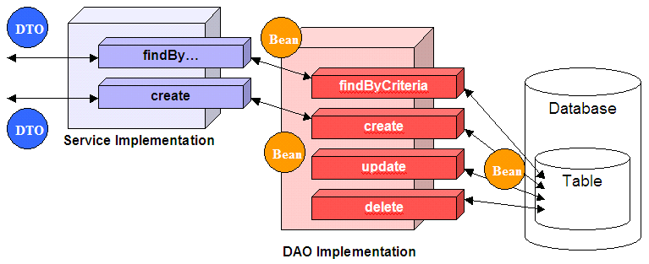
- DAO design pattern also keeps coupling low between different parts of an application. By using DAO design pattern your View Layer is completely independent of DAO layer and only Service layer has the dependency on it which is also abstracted by using DAO interface.
- DAO design pattern allows JUnit test to run faster as it allows to create Mock and avoid connecting to database to run tests. It improves testing because it's easy to write test with Mock objects, rather than an Integration test with the database. In the case of any issue, while running Unit test, you only need to check code and not database. Also shields with database connectivity and environment issues.
- Since DAO pattern is based on interface, it also promotes Object oriented design principle "programming for interface than implementation" which results in flexible and quality code.

- Security
- How you have managed security of your services
- How you have secured your APIS.
- How you prepare the token
- Why passwords are stored in encrypted format.
- How passwords are stored.

