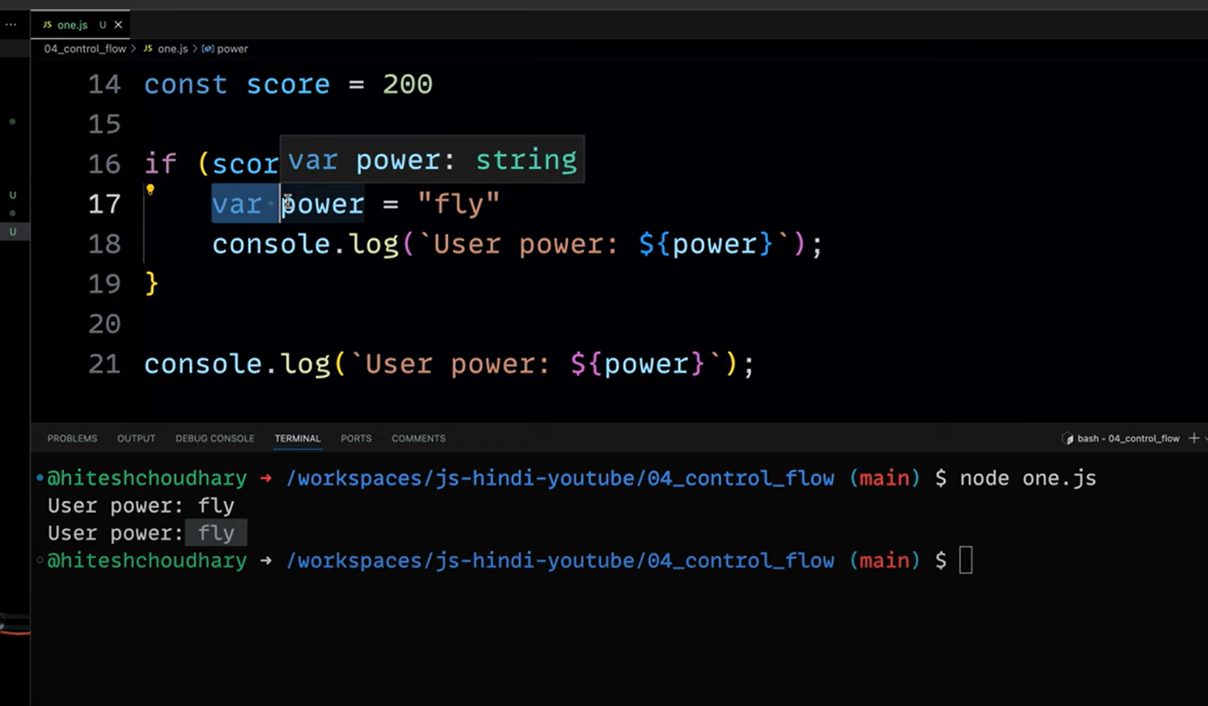

Var keyword is globally also accessible so caused prblm



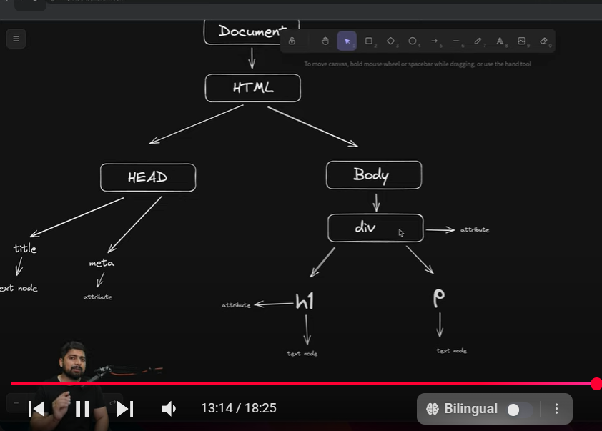

Direction of arrows can be anywhere,,,,,it doesn’t matters

This diagram is imp. To know which object has how many childs and how many siblings

Paragaphs can be firstChild, secondChild or may identified by some attribute they have

Above shows DOM structure which is vimp. For interviews

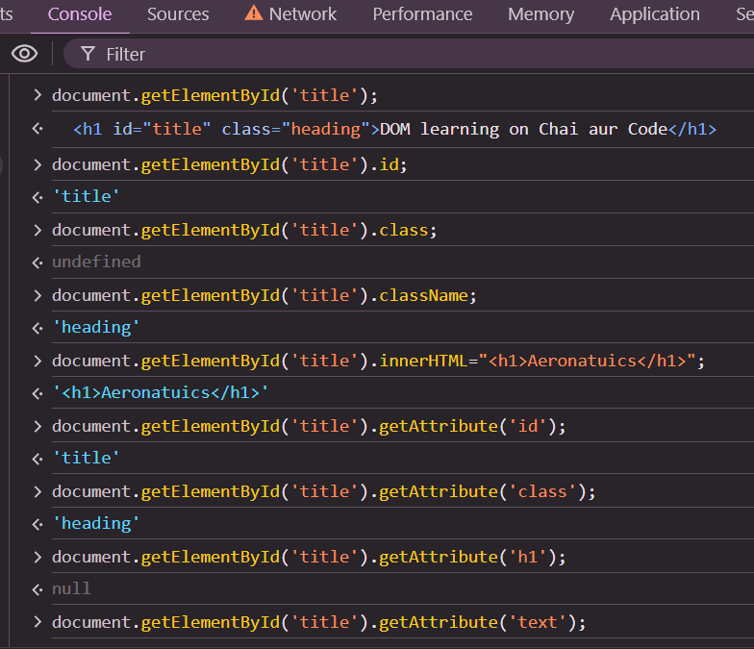

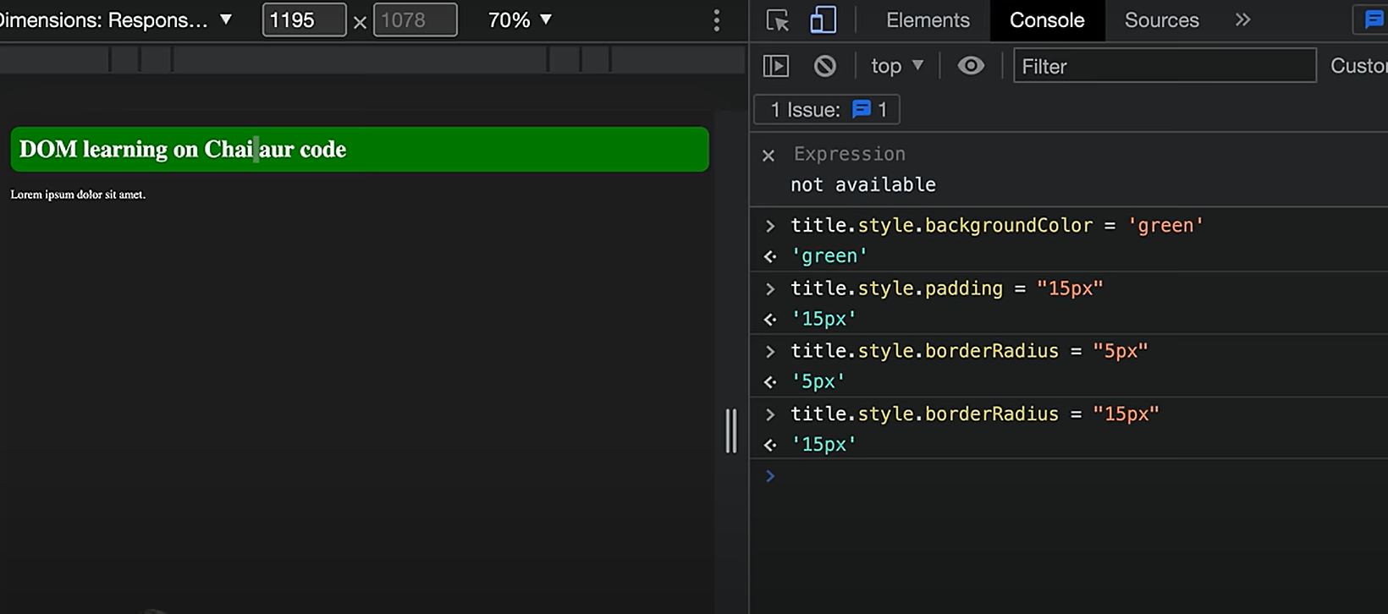

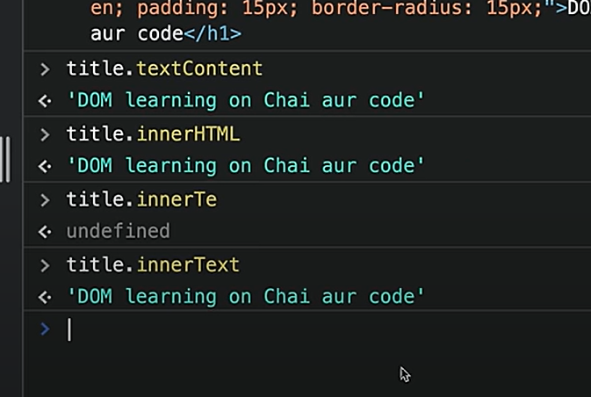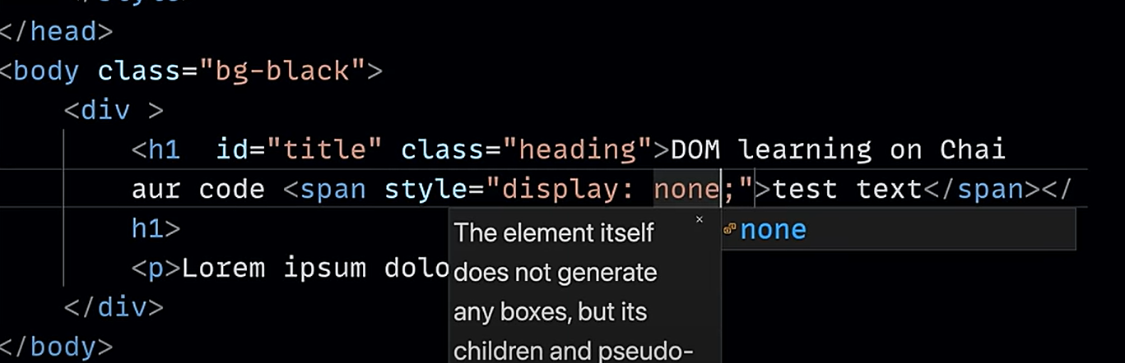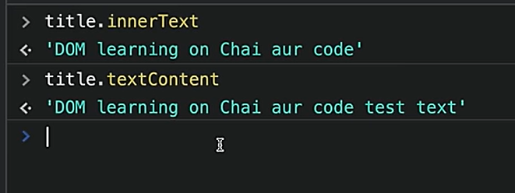

Hidden data ko bhi if u want to display then use textcontent

innerHTML andar ki html tags bhi dega

innertext and textcontent don’t supports html tags

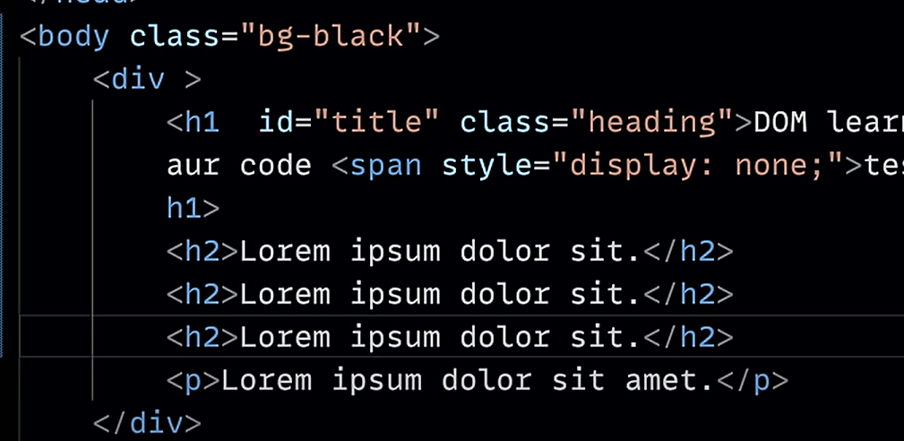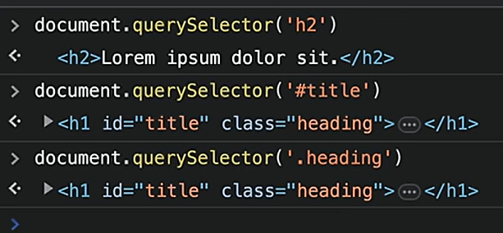

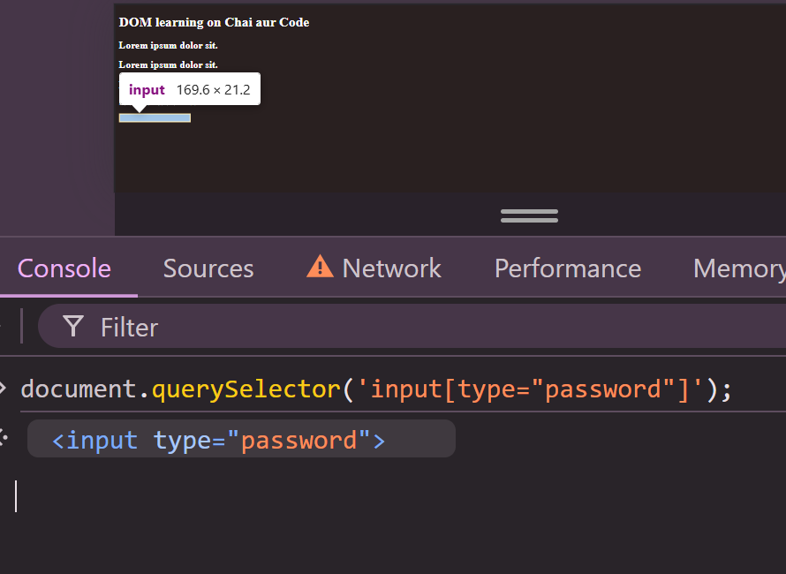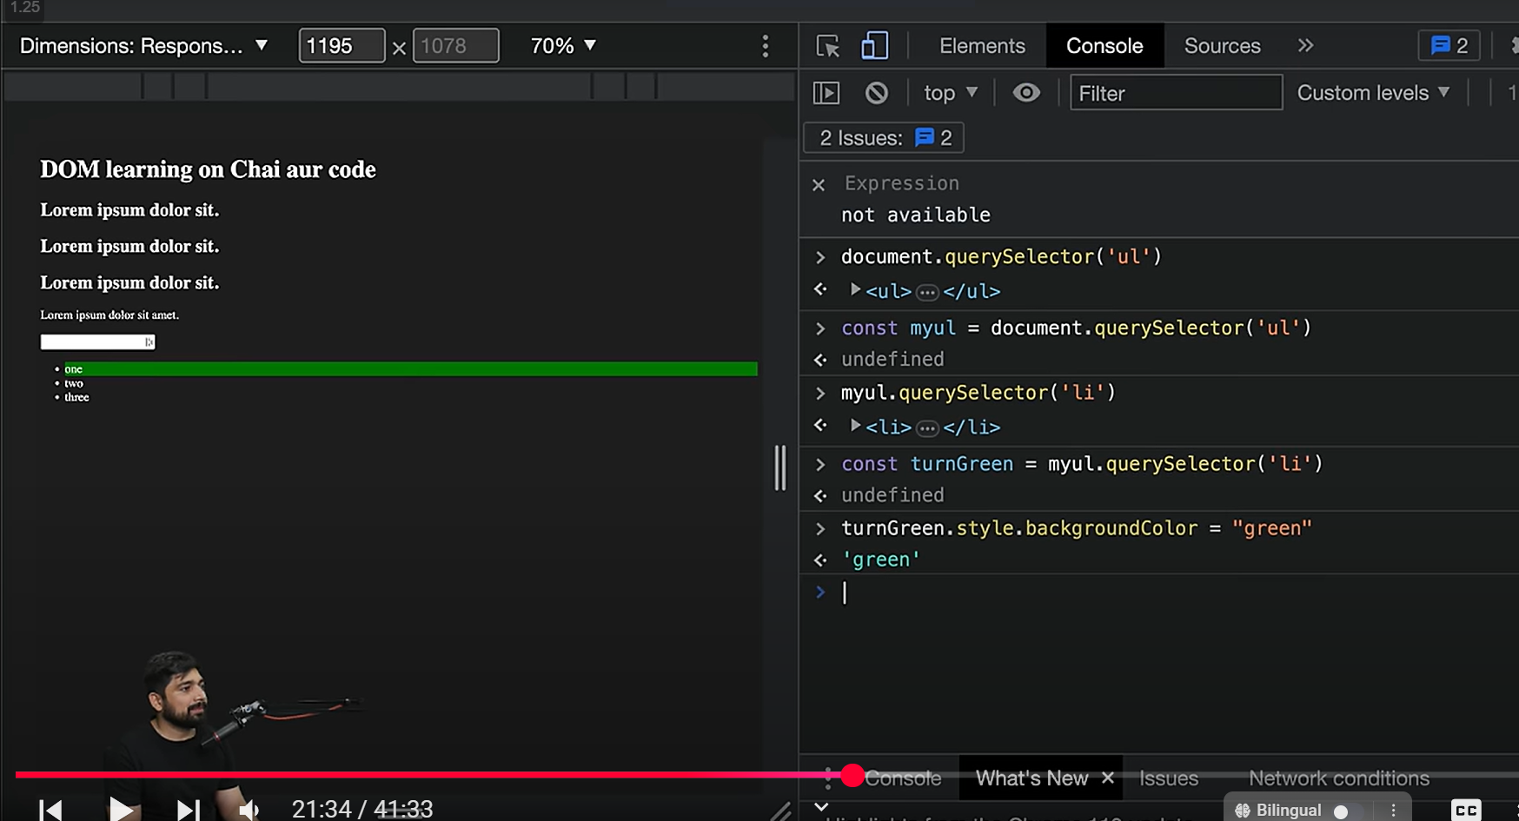

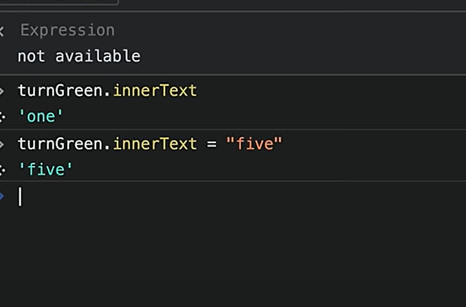

The node list and html collections are not pure arrays.

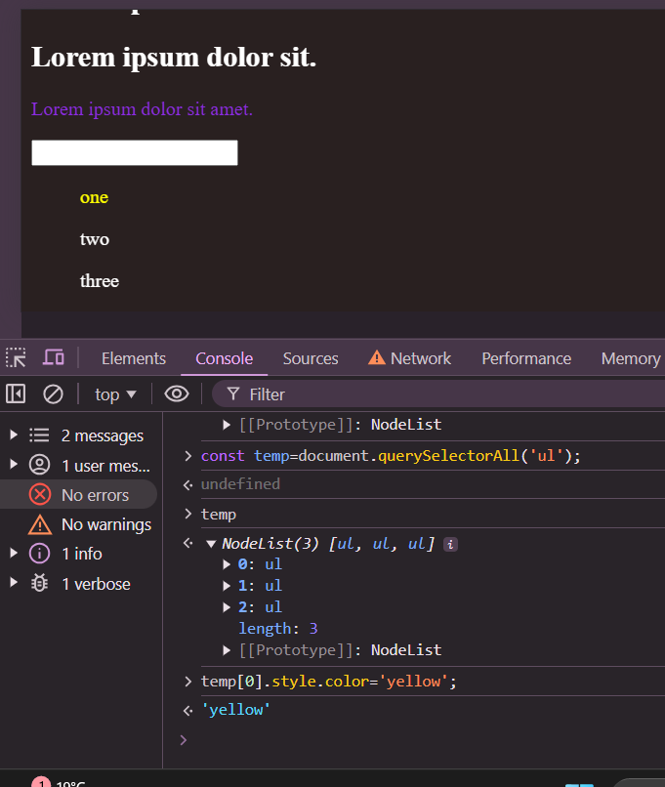

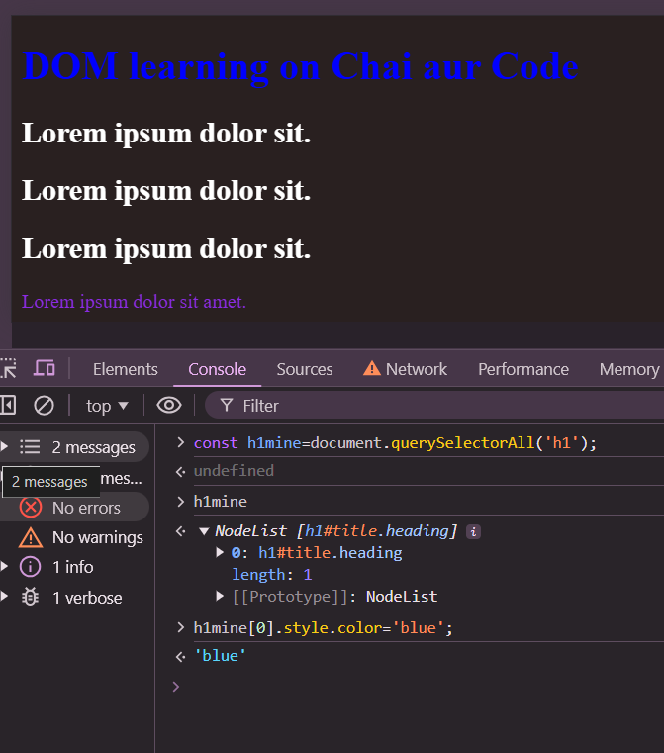

Queryselector all returns node list and queryselectoer returns • A **single Element** (or null if no matching element is found).

• **querySelectorAll:**

* **Returns:** A **static NodeList** of all elements in the DOM that match the given CSS selector.
* **Type of return value:** A **NodeList object**, which is **array-like** but not a real array. It supports iteration (forEach) and indexing, but lacks array-specific methods like .map() or .filter().