Imp. For interviews: watch this video again please

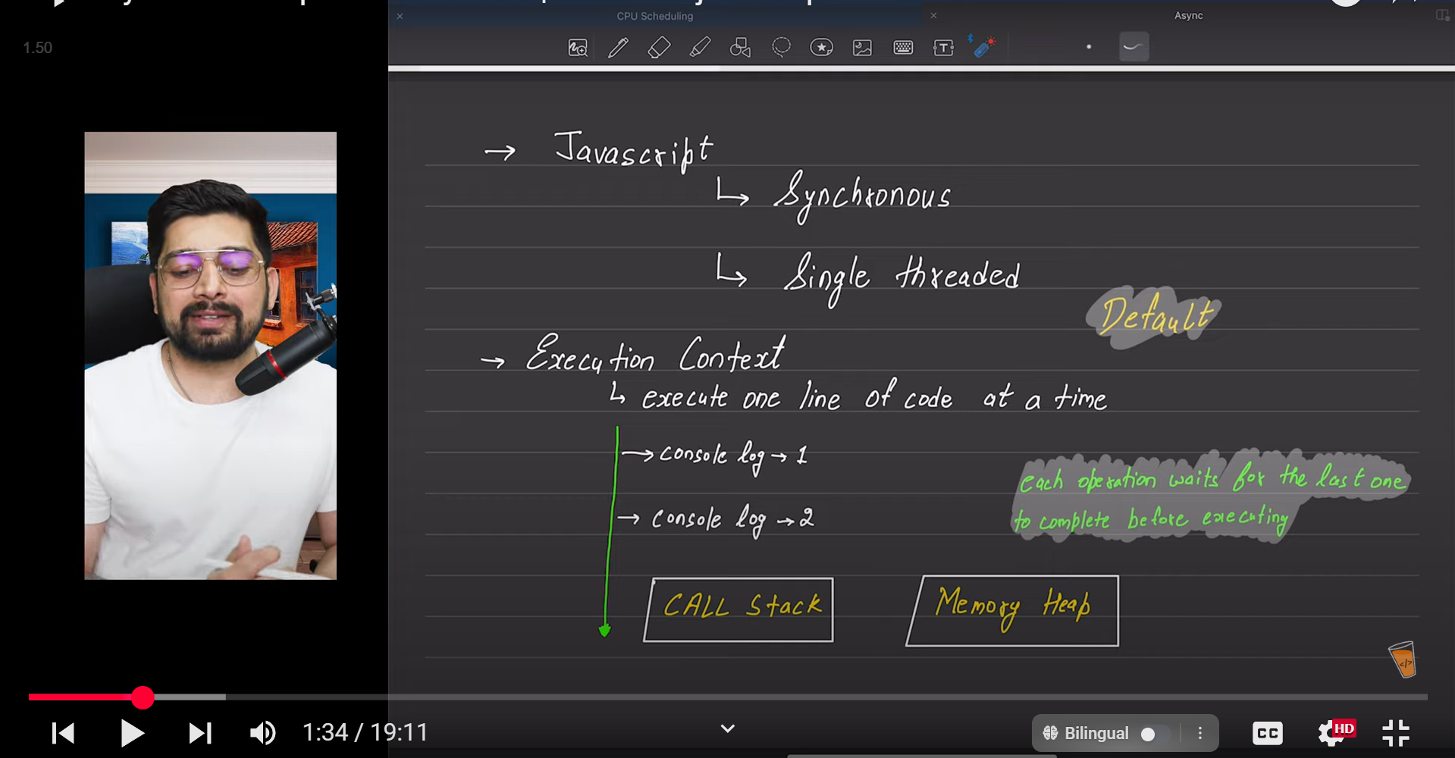

Synchronous means step by step execution. Javascript is slower than those languages which have multiple threads.

JS ka Engine Akela Kabhi Nahi milta Wo Hamesha PC runtime envrnmt ke sath milta ha

Behaviour of default JS includes synchronous and single threaded

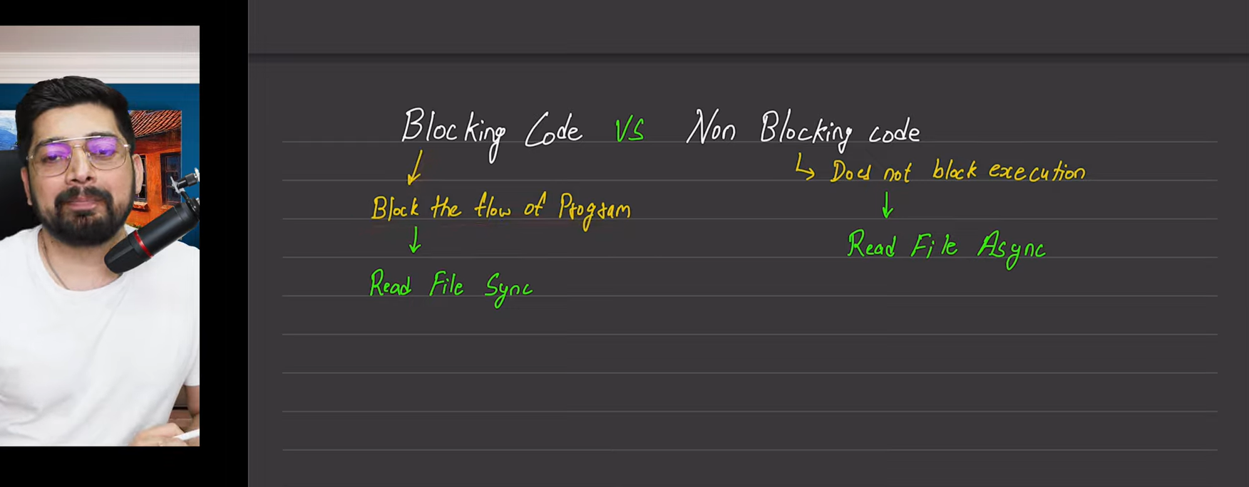

File read krne ka aceess node js me milta ha na ki browser me

Which is good blocking or non blocking code depends upon the usecase

