Virtualbox humlog islie install kr rhe Thaki Uski Ander Ham Ubuntu ko install krke apna linux usme chala skte windows me rhte hue bhi

There are only some official and trusted distributions like Ubuntu

Virtualbox bas ek utility application ha , jo hume Virtual Machine Banane may help karegi, but Uske bhi Virtual Machine. Maybe Hume Linux ko instal Karnahi Hoga

Shell : Shell is a programme that takes command from the keyboard And gives them to the operating system to perform

The command line or shell is also called as the CLI Command line interface

Terminal: A terminal is a tool which you can use to pass your shell commands. This is a programme that opens the window and lets you interact with the shell.

Right ctrl is the host key.

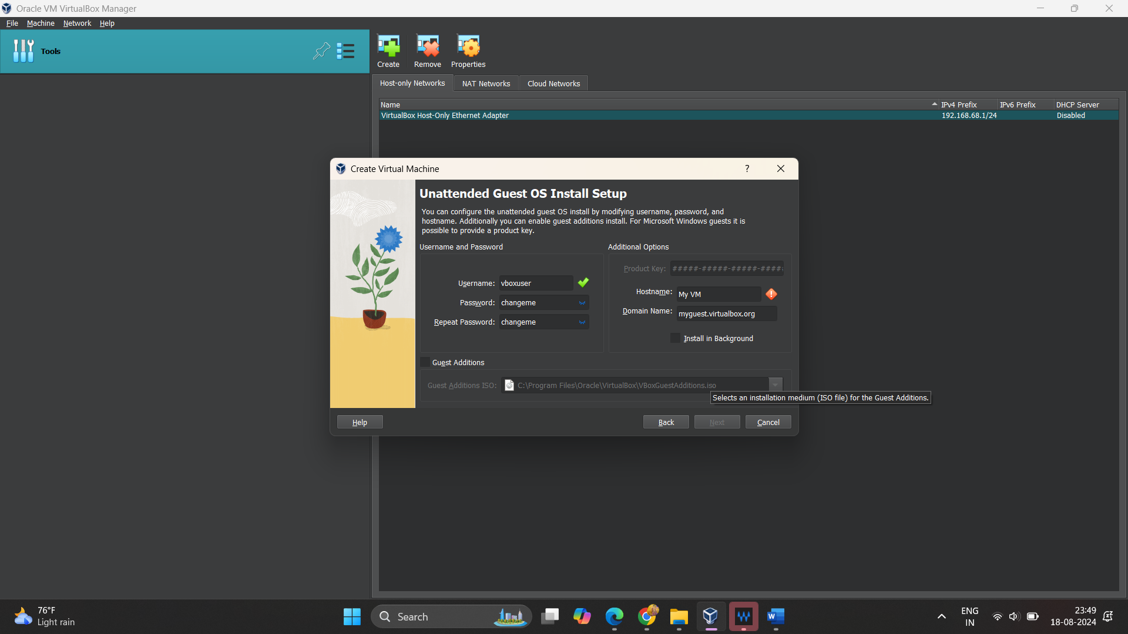

//to see clipboard windows+v

Password : Radhey (small case)

Terminal commands are all almost same on all distributions of Linux

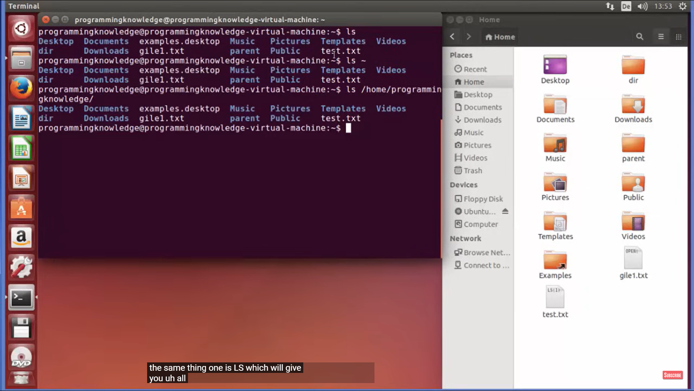all 3 commnds prints the same thing

* Ctrl +alt+ t -> open terminal in VM
* What is a file system. How does different file systems work on Linux.. Files in Linux are arranged in a hierarchical structure like tree.
* In Windows directories are called as folders
* The most basic directory in the Linux is the root directory
* Command to enter in root directory: cd /
* Ls is a Linux shell command.
* ls [options] [fd]

Doubt:  
-> how to open the root folder?