K A T H M A N D U U N I V E R S I T Y
Department of Artificial Intelligence
Dhulikhel, Kavre


A Project Proposal
on
“GeoOptima”
Advanced Geospatial AI for Business Site Selection

Submitted by:
Aaryan Shakya (Roll No. 20)
Tishya Dhakal (Roll No. 07)
Sujal Bajracharya (Roll No. 04)

Submitted to:
Bidur Devkota, PhD
GCES Pokhara
Department of Artificial Intelligence
Submission Date: 13th June 2026

Background
Site selection is a critical hurdle for new businesses, as the choice of location directly dictates the potential return on investment. While international franchises utilize structured, data-driven frameworks, small-to-medium enterprises (SMEs) in Nepal typically rely on intuitive, localized observation. However, characterizing this as "no analysis" is inaccurate; SME owners perform informal, observational assessments. Despite this, many are forced into high-stake financial gambling on prime properties, often paying steep salaami or exorbitant rents. The consequences of miscalculating consumer demographics and spatial accessibility are visible across Kathmandu and Lalitpur, where retail shutters frequently change ownership every six months.
There remains a significant gap in the systematic application of geospatial data to support SME decision-making. The integration of location intelligence provides businesses with a competitive edge by enhancing customer accessibility and operational efficiency. "GeoOptima" is a GeoAI system designed specifically for the unique constraints of the Nepalese market. GeoOptima identifies "red-flag" high-churn properties while highlighting optimal locations for growth. Ultimately, GeoOptima shifts the narrative from "Location, Location, Location" to "Efficiency, Audience, and Access." It provides an independent restaurant owner in Dhulikhel or a specialized boutique owner on New Road with the same analytical precision as a multimillion-rupee retail chain—allowing them to compete on the quality of their service rather than the depth of their real estate budget
Keywords: SME, Salaami

Objective
- To develop a machine-learning-based site suitability profiling model to recommend optimal business locations
- To address the systematic gap in performance evaluation by presenting a structured data-driven approach for transforming raw geospatial information into analytical datasets
- To clarify how geospatial analytics can enhance strategic decision-making to ultimately improve retail business outcomes

Dataset
1. The Raw Population Source Layer (WorldPop Raster)
- Data Type: Continuous Spatial Raster (GeoTIFF)
- Spatial Resolution: 30 arc-seconds (approx. 1km x 1km grid cells)
Each pixel value represents the estimated number of residents living within that specific square kilometer. Figure 1
2. Target Classes Layer: Commercial Spatial Signatures (OSM Vectors)
- Data Type: Spatial Point Vectors (Vector Layer with Attributes)
- Source: OpenStreetMap (OSM) via OSMnx
This map captures the distribution of businesses across Kathmandu. Figure 2
3. Structural Connectivity Layer: Road Network Hierarchy
- Data Type: Spatial Line Vectors (Graph Edges Layer)
- Source: OpenStreetMap Driving Network
This map establishes the physical hierarchy of movement across the valley. It segments roads into Major Arterials (e.g., the Ring Road) highlighted in bright red/orange, Secondary Feeders (yellow), and Local Alleys/Gallis (faint gray lines). Figure 3
4. Daytime Demand Layer: Daytime Pedestrian & Demand Generators
- Data Type: Spatial Point Vectors (Categorized)
- Source: OpenStreetMap Features
This isolates non-commercial anchor points specifically Education Hubs (Schools/Colleges) and Corporate/Government Offices. Figure 4

Methodology
The primary objective of this framework is to engineer a location intelligence recommendation engine for the Kathmandu Valley by mapping the unique geographic, demographic, and infrastructure footprints of various business sectors. Due to the lack of transparent, localized revenue data in the domestic market, the problem is formulated as a supervised multi-class spatial signature classification and probabilistic threshold inference task.
The complete architectural workflow is divided into four main phases:
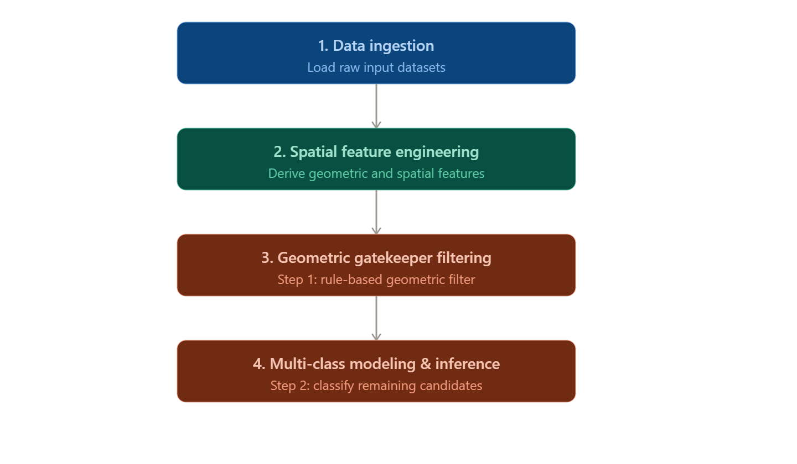
- Data Ingestion
  - Point Vectors: Target Distribution & Economic Anchors
Using OSMnx and the Overpass API, point features across the Kathmandu Valley are harvested and categorized into two distinct vector matrices:
    - Target Vector (Y): Ground-truth business locations representing C distinct commercial categories (e.g. Cafe, Bank, Restaurant, Hotel, Clothes).
    - Daytime Demand Generators: Points of Interest (POIs) representing schools, universities, financial institutions, and public offices. These serve as spatial proxy vectors for daytime pedestrian convergence.
  - Raster Matrix: Socio-Demographic GridHigh-resolution population density grids (1 Km x 1 Km cells) are acquired from WorldPop. This dataset distributes total population counts via a Random Forest-based dasymetric redistribution of census data, capturing residential consumer volume across the valley.
- Spatial Feature Engineering
To construct the tabular feature matrix $X∈R^{n×d}$, every business point coordinate $x_{i}=\left({\text{lat}}_{i},{\text{lon}}_{i}\right)$ is processed through a spatial transformation pipeline to extract a d-dimensional feature vector.
  - Instead of using coarse administrative boundaries, a continuous spatial approach is implemented. For each point, concentric metric buffer zones are projected at specific radii (500 meters, 1 kilometer, and 2 kilometers). The population raster grid is overlaid onto these vector shapes. Using Zonal Statistics, the matrix cells overlapping the vector buffers are aggregated to extract the localized population count inside that specific walking catchment area.
  - To calculate commercial clustering and market saturation, point-pattern density scores are computed. For any location, the framework evaluates the count of identical business classes (competitors) and contrasting business classes (complements) within the concentric walking buffers. This maps whether an area behaves as an established market hub or an isolated market spot.
  - Using the topological road graph, the geographic distances from each business coordinate to the nearest network edges are computed. The features include the shortest distance to the nearest primary or trunk arterial corridor, alongside structural network centrality metrics that serve as mathematical proxies for traffic exposure and vehicular bottlenecks.
- Geometric Gatekeeper Filtering (Query Verification)
A deterministic preprocessing layer is deployed.
  - A custom vector polygon layer is engineered to outline the established commercial corridors, mixed-use market markets, and designated business districts of Kathmandu. It explicitly excludes off-limits zones like rivers, heritage boundaries, and strictly residential strips.
  - When a coordinate query is executed, the system runs a geometric polygon intersection check.
  - If the query coordinate falls outside these valid commercial polygons, it is immediately rejected by the system backend, bypassing the machine learning model entirely. This eliminates the need for a noisy "Unsuited" training class and keeps the machine learning model focused strictly on commercial pattern discrimination.
- Modeling Framework & Threshold Inference Logic
  - Pattern-Matching Optimization
Coordinates that pass the geometric filter are sent to Step 2: the machine learning classifier. The tabular dataset is trained using high-performance algorithms (such as XGBoost, Random Forest or Neural Network). Because the dataset is composed entirely of verified, operational business locations, the model does not try to guess if a location is "good or bad." Instead, it performs pure commercial pattern matching, analyzing the spatial signatures to calculate a normalized probability distribution across all available business classes.
  - Probabilistic Inference and Recommendation Engine
During runtime inference, a user queries a specific coordinate and selects a desired business category (e.g., "Is this corner suitable for a Cafe?").
The spatial engine extracts the local feature variables for that coordinate and runs the model. Rather than utilizing a rigid, highest-value ranking approach, the system applies a calibrated multi-class confidence threshold vector.
Since the probability space is split across multiple business options, individual class scores are naturally distributed. If the model's confidence probability for the user's chosen business category crosses its specific baseline threshold, the system flags the location as viable and recommended. This allows the pipeline to flexibly suggest multiple distinct business types for a single high-potential coordinate based entirely on matching successful spatial profiles across Kathmandu.

Expected Outcome
The developed framework will deliver an end-to-end GeoAI site selection system that transforms raw spatial datasets into a production-ready web application for the Kathmandu Valley. By leveraging a high-performance machine learning classifier, such as XGBoost, Random Forest, or a Graph Neural Network, the engine learns the explicit geographic, infrastructural, and demographic signatures of existing successful business sectors. When evaluated, the system functions as a dual-action recommendation engine: it can instantly verify if a single user-selected coordinate is viable for a specific business type based on a calibrated probability threshold, and it can run grid-wide inferences to generate dynamic suitability heatmaps showing high-potential pockets across the valley. Finally, these models are integrated into a prototype interactive map interface built with frameworks like Streamlit or Folium. This dashboard equips small-business owners with explainable recommendations by visually breaking down the underlying factors including localized population density overlays, nearby daytime demand anchors, and competitor clusters giving users transparent, data-driven context for their real estate and site selection decisions.

Appendix
Figure 1 Raw Population Source Layer
Figure 2 Distribution of businesses across the Kathmandu Valley
Figure 3 Road Network Hierarchy
Figure 4 Non-commercial anchor points

